practice: working with files

Submitted by : Thanuj Kumar S

1. List the files in the /bin directory

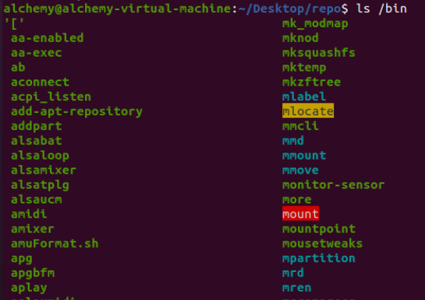

1. Display the type of file of /bin/cat, /etc/passwd and /usr/bin/ passwd.

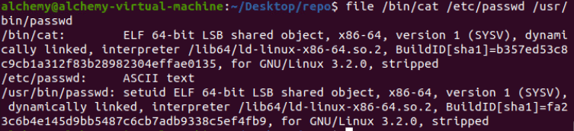

1. Create a directory ~/touched and enter it.



1. Create the files today.txt and yesterday.txt in touched.



1. Change the date on yesterday.txt to match yesterday's date.



1. Copy yesterday.txt to copy.yesterday.txt



1. Rename copy.yesterday.txt to kim



1. Create a directory called ~/testbackup and copy all files from ~/ touched into it.



1. Use one command to remove the directory ~/testbackup and all files into it.



1. Create a directory ~/etcbackup and copy all \*.conf files from / etc into it. Did you include

all subdirectories of /etc ?



Only \*.conf files that are directly in /etc/ are copied.

1. Use rename to rename all \*.conf files to \*.backup . (if you have more than one distro

available, try it on all!)

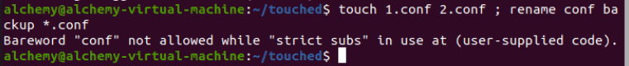



Submitted by : Thanuj Kumar S