Assignment- **practice: file system tree**

**Submitted By**

**Thanuj Kumar S**

1. Does the file **/bin/cat** exist ? What about **/bin/dd** and **/bin/echo**. What is the type of these files ?

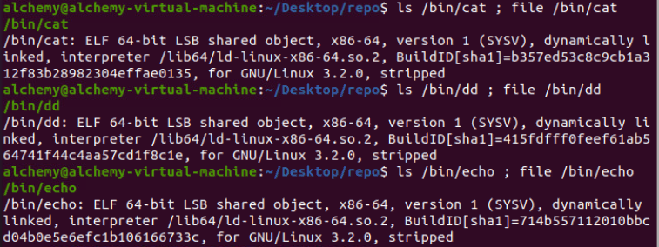

1. What is the size of the Linux kernel file(s) (vmlinu*) in **/boot** ?

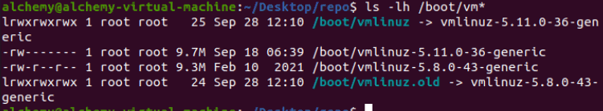

1. Create a directory ~/test. Then issue the following commands:

cd ~/test

dd if=/dev/zero of=zeroes.txt count=1 bs=100 od zeroes.txt

**dd** will copy one times (count=1) a block of size 100 bytes (bs=100) from the file **/dev/zero** to ~/test/zeroes.txt. Can you describe the functionality of **/dev/zero** ?

**Answer:** /dev/zero is a Linux special device. It can be considered a source of zeroes. You cannot send something to /dev/zero, but you can read zeroes from it

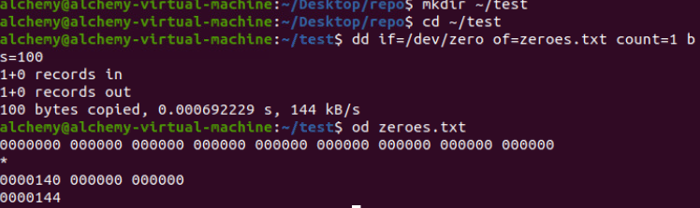

1. Now issue the following command:

dd if=/dev/random of=random.txt count=1 bs=100 ; od random.txt

**dd** will copy one times (count=1) a block of size 100 bytes (bs=100) from the file **/dev/ random** to ~/test/random.txt. Can you describe the functionality of **/dev/random** ?

**Answer:** /dev/random acts as a random number generator on your Linux machine.

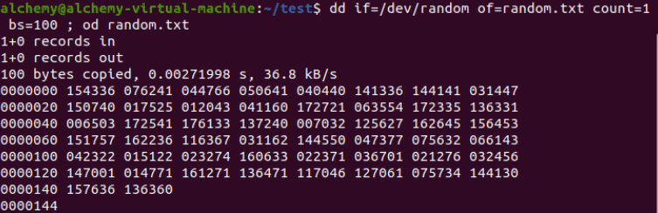

1. Issue the following two commands, and look at the first character of each output line.

ls -l /dev/sd* /dev/hd*

ls -l /dev/tty* /dev/input/mou*

The first ls will show block(b) devices, the second ls shows character(c) devices. Can you tell the difference between block and character devices ?

**Answer:** Block devices are always written to (or read from) in blocks. For hard disks, blocks of 512 bytes are common. Character devices act as a stream of characters (or bytes). Mouse and keyboard are typical character devices.

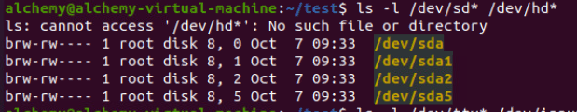

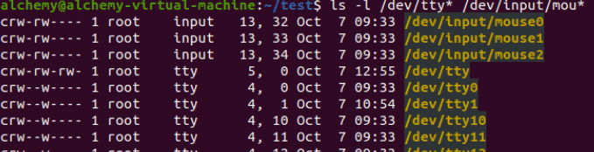

1. Use cat to display **/etc/hosts** and **/etc/resolv.conf**. What is your idea about the purpose of these files ?

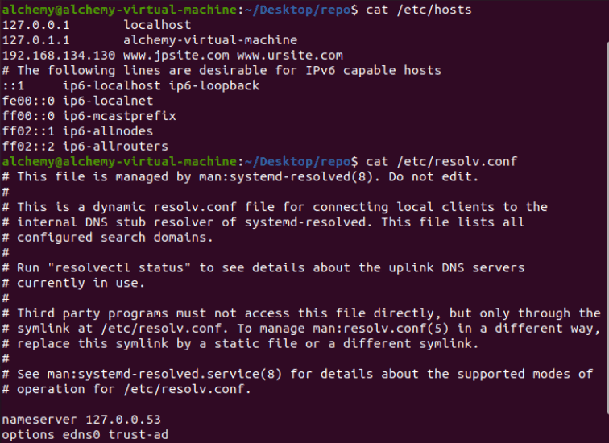

/etc/hosts contains hostnames with their ip address

/etc/resolv.conf should contain the ip address of a DNS name server

1. Are there any files in **/etc/skel/** ? Check also for hidden files.

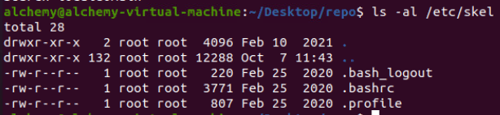

1. Display **/proc/cpuinfo**. On what architecture is your Linux running ?

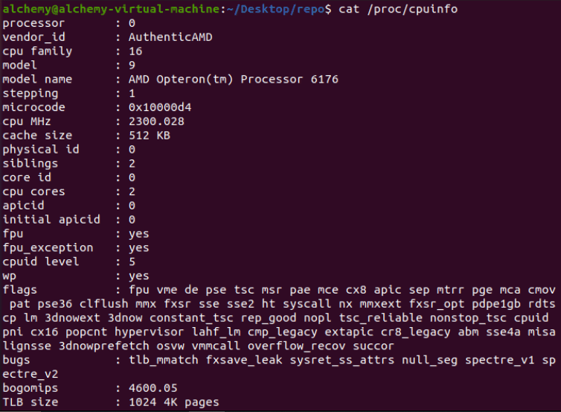

1. Display **/proc/interrupts**. What is the size of this file ? Where is this file stored ?

**Answer:**

The size is zero, yet the file contains data. It is not stored anywhere because /proc is a virtual file system that allows you to talk with the kernel.

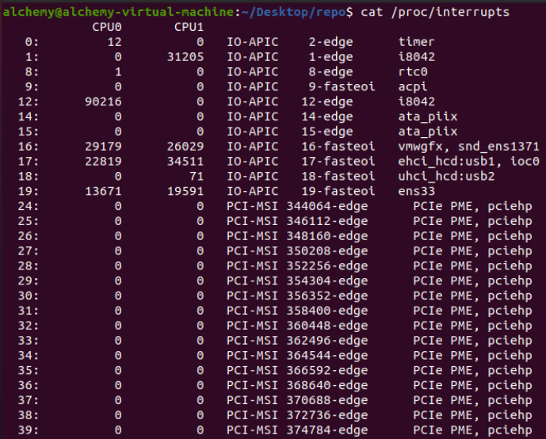

1. Can you enter the **/root** directory ? Are there (hidden) files ?

**Answer:** Yes there are (hidden) files there

1. Are ifconfig, fdisk, parted, shutdown and grub-install present in **/ sbin** ? Why are these binaries in **/sbin** and not in **/bin** ?

**Answer:** Because those files are only meant for system administrators

1. Is **/var/log** a file or a directory ? What about **/var/spool** ?

**Answer:** Both are directories.

1. Open two command prompts (Ctrl-Shift-T in gnome-terminal) or terminals (Ctrl-Alt-F1, Ctrl-Alt-F2, ...) and issue the **who am i** in both. Then try to echo a word from one terminal to the other



1. Read the man page of **random** and explain the difference between **/dev/random** and **/ dev/urandom**.

**Answer:**

/dev/random

It will only return Random bytes from entropy pool. If entropy pool is empty, reads to /dev/random will be blocked until additional environmental noise is gathered. This is suited to high quality randomness, such as one-time pad or key generation.

/dev/urandom

It will return as many random bytes as requested. But if the entropy pool is empty, it will generate data using SHA, MD5 or any other algorithm. It never blocks the operation. Due to this, the values are vulnerable to theoretical cryptographic attack, though no known methods exist.