**INSURANCE FRAUD DETECTION USING MACHINE LEARNING**

## A SYNOPSIS OF UNIVERSITY PROJECT

***Submitted by***

**Mr. Syed Atif - 20171CSE0702**

**Mr. Syed Shoaib - 20171CSE0709**

**Mr. Tejas Bhatnagar – 20171CSE0721**

**Mr. Thanuj Kumar S – 20171CSE0726**

**Mr. Utsav Deep – 20171CSE0734**

### *Under the guidance of*

**Prof. T. Ramesh - Asst Prof CSE**

***in partial fulfillment for the award of the degree of***

**BACHELOR OF TECHNOLOGY**

**IN**

**COMPUTER SCIENCE AND ENGINEERING**

**AT**



**Department of Computer Science and Engineering**

**School of Engineering**

**PRESIDENCY UNIVERSITY**

**BANGALORE**

**Title of the Project:** Insurance Fraud Detection using Machine Learning

**Abstract:**

Fraud is one of the largest and most well-known problems that insurers face. Fraudulent claims can be highly expensive for each insurer.  Therefore, it is important to know which claims are correct and which are not. So that the companies can save money and people doing these frauds can be punished accordingly. Different types of insurance are prone to different crimes, however, in most cases, it manifests deliberate damage to the insured item or the purpose to obtain goods without paying. Detecting insurance fraud can be difficult since not every claim can be investigated thoroughly.

**Rationale:**

Insurance fraud has been around since the beginning of insurance organizations. These are varied and complex crimes that often go unnoticed and cost the insurance industry billions a year. It is not doable for insurance companies to check all claims personally since this will cost simply too much time and money. Only in the U.S., the loss on fraudulent insurance claims last year reached [$34 billion](https://knowledge.friss.com/survey-insurance-fraud-2019).

Ideally, an insurance agent would have the capacity to investigate each case and conclude whether it is genuine or not. However, this process is not only time consuming, but costly. Sourcing and funding the skilled labor required to review each of the thousands of claims that are filed a day is simply unfeasible.

**Objectives:**

To build a classification methodology to determine whether a customer is placing a fraudulent insurance claim.

**Requirements:** Valid Data Set, Required Python Libraries

**Planning of work:**

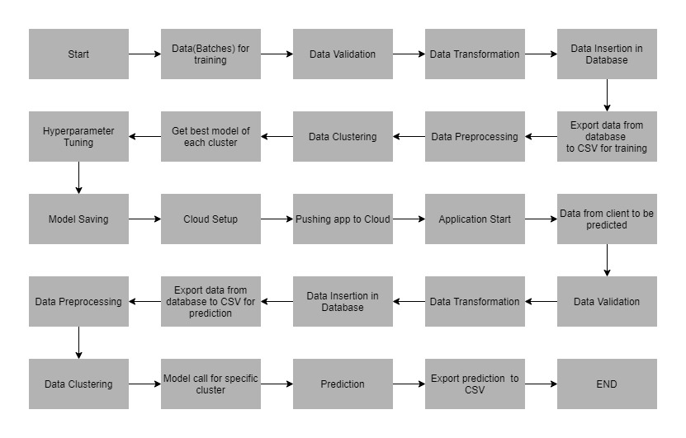

**Expected outcomes:**

Based on the data set being used, this model will be able to detect the instances where a person is trying falsely claim insurance. We will be deploying the model to a cloud platform.

**References:**

1. E. Belhadji, G. Dionne and F. Tarkhani, A Model for the Detection of Insurance Fraud Geneva Papers on Risk and Insurance Theory, vol. 25, pp. 517-538, may 2012**.** [[Link](https://scholar.google.com/scholar?as_q=A+Model+for+the+Detection+of+Insurance+Fraud%2C+Geneva+Papers+on+Risk+and+Insurance+Theory&as_occt=title&hl=en&as_sdt=0%2C31)]
2. K. J. Crocker and S. Tennyson, "Insurance Fraud and Optimal Claims Settlement Strategies: An Empirical Investigation of Liability Insurance Settlements", The Journal of Law and Economics, vol. 45, no. 2, april 2010. [[Link](https://scholar.google.com/scholar?as_q=Insurance+Fraud+and+Optimal+Claims+Settlement+Strategies%3A+An+Empirical+Investigation+of+Liability+Insurance+Settlements&as_occt=title&hl=en&as_sdt=0%2C31)]
3. Kajia Muller, The Identification of Insurance Fraud-an Empirical Analysis Working papers on Risk Management and Insurance, no. 137, June 2013. [[Link](https://scholar.google.com/scholar?as_q=The+Identification+of+Insurance+Fraud-an+Empirical+Analysis+Working+papers+on+Risk+Management+and+Insurance&as_occt=title&hl=en&as_sdt=0%2C31)]

**Date of Submission: 22-02-2021**

**Signature(s) of Student(s) Name and Signature of Guide**

1.

2.

3.

4.

5.

**Contact Details of the Students:**

|  |  |  |  |
| --- | --- | --- | --- |
| **Roll No** | **Name** | **E-Mail ID** | **Contact Number** |
| 20171CSE0709 | Syed Shoaib | 201710100881@presidencyuniversity.in | 8951791714 |
| 20171CSE0702 | Syed Atif | 201710100874@presidencyuniversity.in | 9880194742 |
| 20171CSE0721 | Tejas Bhatnagar | 201710100893@presidencyuniversity.in | 9738898069 |
| 20171CSE0726 | Thanuj Kumar S | 201710100898@presidencyuniversity.in | 8147120321 |
| 20171CSE0734 | Utsav Deep | 201710100906@presidencyuniversity.in | 8867834645 |