Cable tray report

Cable tray name: A101

Cable tray type: Niedax WSL 105.600 F

Cable tray purpose: Type A (Pink color) for MV cables

# Cable tray dimensions:

Height: 100 [mm], Width: 600 [mm], Length: 28231.64 [mm],

Weight: 7.191 [kg/m],

# Cable tray mounting accessories:

## Supports:

Count: (28.232 * 1000) / 5.5 ≈ 6.133 = 7 [pcs.],

Weight per piece: 5.416 [kg]

# Cables laying on the tray:

|  |  |  |  |  |
| --- | --- | --- | --- | --- |
| **No.** | **Cable name** | **Cable type** | **Cable diameter [mm]** | **Cable weight [kg/m]** |
| 1 | H1=KF1=MAA1=WBB1 | N2XS(FL)H 12/20kV (24)kV 1x185/25mm² | 35.0 | 2.500 |
| 2 | H1=KF1=MAA1=WBB2 | N2XS(FL)H 12/20kV (24)kV 1x185/25mm² | 35.0 | 2.500 |
| 3 | H1=KF1=MAA1=WBB3 | N2XS(FL)H 12/20kV (24)kV 1x185/25mm² | 35.0 | 2.500 |
| 4 | H1=KF1=MAA1=WBB4 | N2XS(FL)H 12/20kV (24)kV 1x185/25mm² | 35.0 | 2.500 |
| 5 | H1=KF1=MAA1=WBB5 | N2XS(FL)H 12/20kV (24)kV 1x185/25mm² | 35.0 | 2.500 |
| 6 | H1=KF1=MAA1=WBB6 | N2XS(FL)H 12/20kV (24)kV 1x185/25mm² | 35.0 | 2.500 |
| 7 | H1=KF1=MAA1=WBB7 | N2XS(FL)H 12/20kV (24)kV 1x185/25mm² | 35.0 | 2.500 |
| 8 | H1=KF1=MAA1=WBB8 | N2XS(FL)H 12/20kV (24)kV 1x185/25mm² | 35.0 | 2.500 |
| 9 | H1=KF1=MAA1=WBB9 | N2XS(FL)H 12/20kV (24)kV 1x185/25mm² | 35.0 | 2.500 |
| 10 | H1=KF1=MAA1=WBB10 | N2XS(FL)H 12/20kV (24)kV 1x185/25mm² | 35.0 | 2.500 |
| 11 | H1=KF1=MAA1=WBB11 | N2XS(FL)H 12/20kV (24)kV 1x185/25mm² | 35.0 | 2.500 |
| 12 | H1=KF1=MAA1=WBB12 | N2XS(FL)H 12/20kV (24)kV 1x185/25mm² | 35.0 | 2.500 |

# Weight calculations:

## Supports weight calculations:

The supports weight calculations depends on the distance between the supports based on the tray length and the count. For “WSL 105.600 F” type the maximal distance between two supports is 5.5 meters. For trays that the length is less than 5.5 meters we have 2 pieces of supports. For trays that the length is bigger than 20% from the base 5.5 meters, there is an additional support.

The total weight of the supports is calculated by the count of the supports, multiplied by the weight per piece:

Supports total weight: 7 * 5.416 = 37.912 [kg]

The total weight per meter is calculated by division of the tray length and the total weight of the supports:

Supports weight load per meter: 37.912 / (28231.64 * 1000) = 1.343 [kg/m]

## Tray own weight calculations:

Tray weight load per meter is calculated by the sum of cable tray weight and support weight per meter:

Tray weight load per meter: 7.191 + 1.343 = 8.534 [kg/m]

Total tray weight is calculated by combining the own weight per meter with added supports weight per meter, then multiplied by the tray total length.

Tray total own weight: 8.534 * (28231.64 / 1000) = 240.929 [kg]

## Cables on tray weight calculations:

Cables weight load per meter is calculated by the sum of cables weight per meter:

Cables weight load per meter: 2.5 + 2.5 + 2.5 + 2.5 + 2.5 + 2.5 + 2.5 + 2.5 + 2.5 + 2.5 + 2.5 + 2.5 = 30 [kg/m]

Total weight of all the cables on the tray is the sum of the cables weights.

Total weight on the tray: 30 * (28231.64 / 1000) = 846.949 [kg]

## Total weight:

Total weight load per meter: 8.534 + 30 = 38.534 [kg/m]

Total weight: 240.929 + 846.949 = 1087.878 [kg]

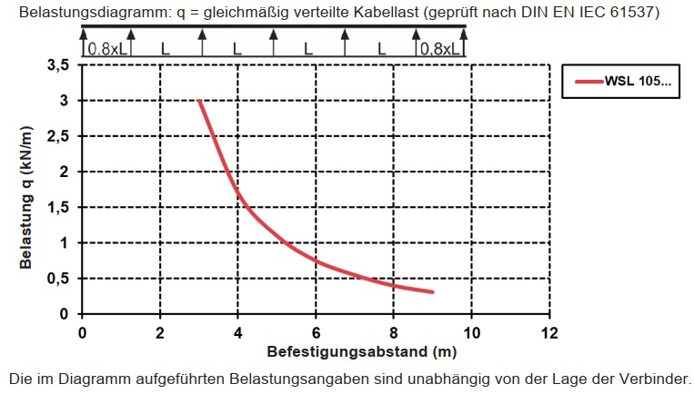

Picture 1. – Load per meters diagram regarding the distance between the supports.

# Free space calculations:

All trays “WSL 105.600 F” type are ladder type trays. Rung spacing 300 [mm], with continuously perforated side rails, with riveted, upwardly open rungs made of C-profiles.

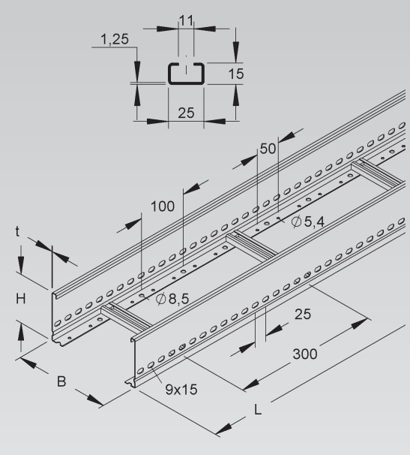

Picture 2. – Cable tray type overview.

Tray board height is 100 [mm], but the C-profiles occupies a part of the volume space. So, the useful height for the tray is 100 – 15 = 85 [mm]. Medium voltage cables are laid and grouped in triangle (“trefoil”) formation, forming each a 3-phase system.

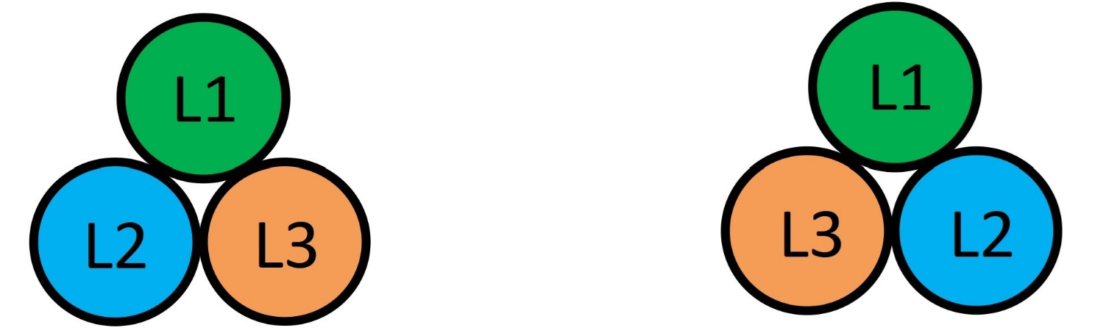

Picture 3. – Trefoil cables formation type overview.

Minimum distance of cable bundle/trefoil is 2x outer cable diameter (2d). Between parallel laid power cables minimum distances have to be complied with along the entire laying distance (exception for building-pass-through / penetrations). Power cables laid in parallel shall have the same cable lengths. A maximum cable length difference of 3% can be accepted if properly considered in cable dimensioning (de-rating).

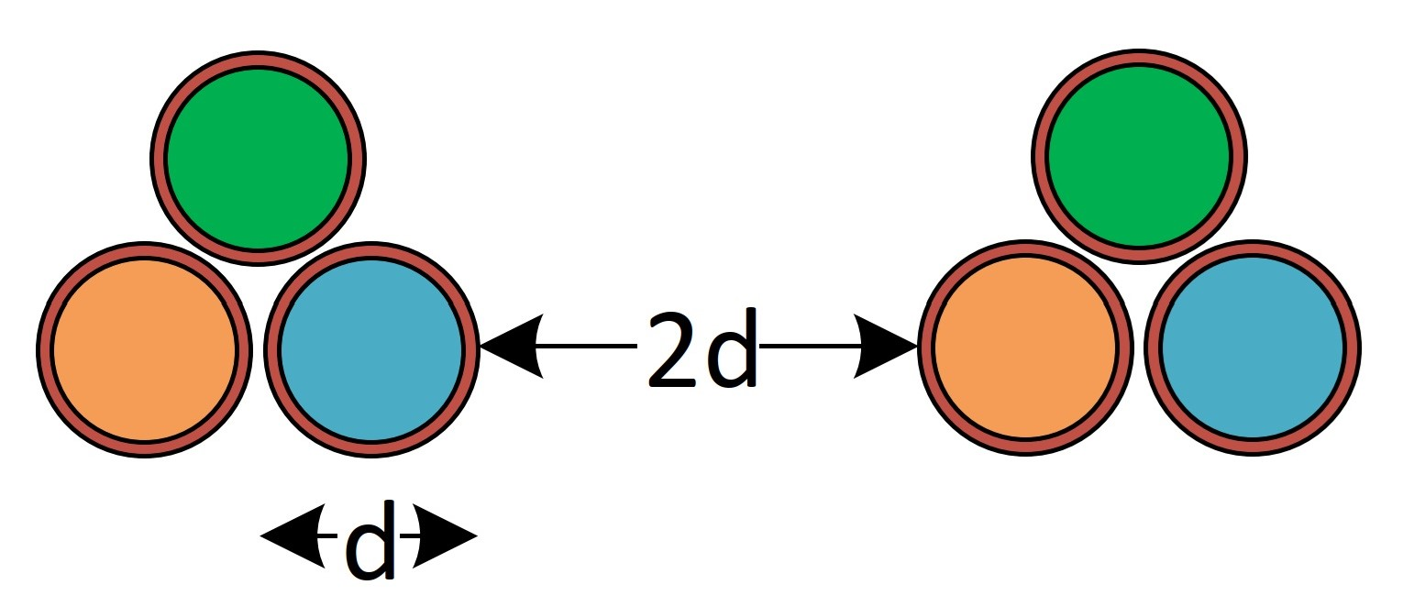

Picture 4. – Minimum distance of cable trefoil.