**Game story:**

Legend has it that two demons were jailed in the Calabash Mountain, one a Scorpion spirit and the other a Snake spirit. One day, a pangolin happens to drill a hole on the slope and the two spirits escape from the cave, causing grave harm to the nearby residents. The pangolin hurries to an old man and says that only by growing calabashes in seven colors can they annihilate the spirits. So the old man spares no time in growing seven calabashes, each a different color of the rainbow: red, orange, yellow, green, cyan, blue, and purple.

The calabashes ripen sequentially, falling off their stems to the ground, and transforming into seven boys. Each has a unique supernatural ability such as super-strength, enhanced hearing and sight, invisibility, and pyrokinesis, as well as a weakness. Each of them also have above average strength and speed given that all of them have shown the ability to lift items several times their own weight and leap several metres. With a combined effort, they set on a mission to defeat the demons in a 13 episode-long adventure. Upon defeating the demons, the seven brothers seal themselves together into a mountain with all the colours of the rainbow, ready to awaken to fight evil should it ever arise again.

**Game play:**

2d game is a game that can not rotate and has no depth, but with character images, background, background will give users nostalgic features, this is something that 3D games are less likely to can do. The battle process in each level is very fun because the character system is designed fancy, in addition, the design of each level is also focused with beautiful context, and additional traps are added Danger

**Player character:**

When entering the game, players are required to choose one of the seven characters in the game to pass. The seven characters have different looks and skills such as fire, water, earth, electricity, ice, wind, and armor. The player must use that character from the beginning until the end of the game.

The character's skill is to destroy the zoom energy that requires the monster from the character's position to the bottom of the screen and in a straight line

During the game, players will receive items to increase power such as rice balls. Players will die when falling off a cliff, hitting the target and hitting the skill of the last boss.

**Player controls:**  
W – jump, A – move left, D - move right, Space – use skill’s character

**Game world:**

**In-game controls:**

basic hitting skills:



skill hitting energy:



Go. When the player character is moving forward, press this button to move the character, if you want to move quickly, press twice continuously and hold your hand.



Back, when the player character is facing the opposite direction, press this button to let the character move, if you want to move quickly, press twice continuously and hold your hand.





In addition, players can control the direction of the character by touching the screen in the direction the player wants

experience the game

Physical properties

The physics in the game is generally expressed when the character flies up and down, when the character runs and stops.

The physics in the game in particular is shown through each different screen, because each screen character will fight in each different terrain. For example, when the character is fighting in a place with ice, the move will be difficult to slip or when the character is in the water level, the movement will be subject to water resistance, so the movement will also be slower than. the screens are on the mainland.

Screen play

The game has a story based on the legend of the Seven Brothers of China, promising to lead players to an exciting fantasy world, meet the lovely character system of the original and experience the mechanics. Fun horizontal screen action combat mode in classic style. In the game, players will be role-playing as a hero with the mission of destroying monsters.

The game consists of 8 main levels, in which 7 levels and the last level is combined with 7 guys and using cunning to defeat and destroy Xa Tinh each level will go from easy to difficult. Since each level is seven different terrains, the first seven levels of each level will correspond to the terrain where the player's task is to destroy all the elves and minions of the Serpent, and overcome the traps in the game ( nail holes, deep holes, ...) to rescue the old man, will also go from easy to difficult.

Scenario play

At the start of the game, the player will see all the levels that the player must pass, but only the first stage opens, the remaining levels will be locked, when the player passes the first level, the next screen will be opened. .

When the player chooses to enter a screen, the sub-stages of that screen will open, the player must also follow the sub-stages of that screen in sequence, just like for the main screen.

After all that have been passed to play, the player will be allowed to enter the battle screen with soap

Boss:

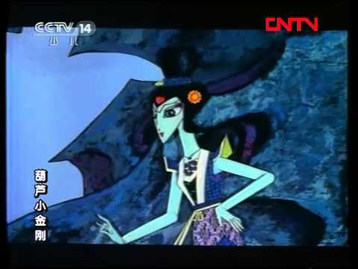

soap crystals

description :

A demon whose upper half is a woman, the lower half is a snake body. The serpent can create attacks out of ice, is a cunning scholar, is very good at using illusion. Her abilities are almost nothing special, but she knows how to take advantage of the weaknesses of each pond to win each person. She often uses the Ascended treasure to freeze things and her weapon is a sword.

skill:

The soapstone is capable of going indefinitely (cannot be selected as an attack target) for 10 seconds and then becomes immobilized.

when it is in motionless, the chimpanzee will call for the other goblins to assist

Poisoning skills: normal damage 10% of character's health, 30% of character's health indefinite.

Summon: Paralyze for 5 seconds and heal over time 5% / 15% / 25% / 35% / 36% and call 1 of 5 monsters and last for 5 seconds

how to beat

Wait for the bar to fall into a stationary state, then attack will be doubled, the character's damage will be doubled, special skills will triple

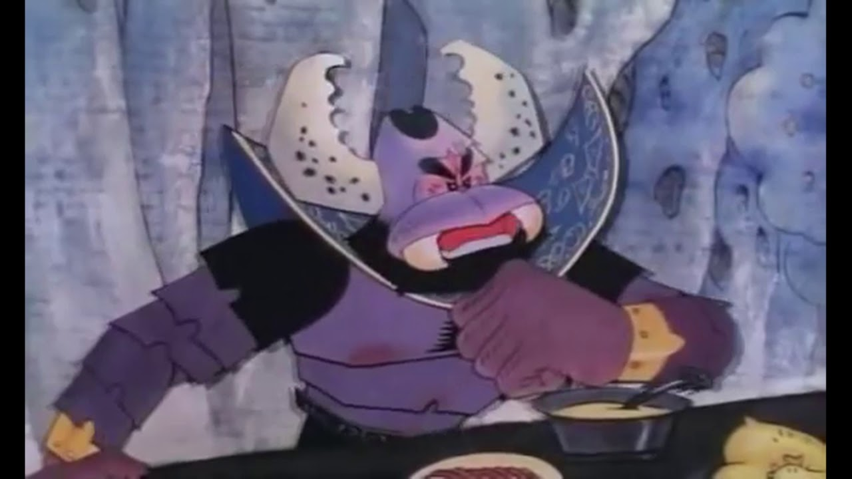

Scorpio

description :

An ugly scorpion, Serpent's husband. Big body, good at fighting leaf armor, able to control wind, creating a black tornado to increase movement speed. But in general, the mind is mediocre, stupid, cowardly, only good at torturing the men under his command.

skill:

I have iron skin:

Scorpio will increase defense over time by 5% / 25% / 35% / 55% and endure for 10 seconds

volunteer:

Scorpio rushes into the character causing stunned, slow and dealing 10% damage to the character

where is the soldier:

Scorpion calls out minions and gives 20% bonus to all monsters including Scorpions

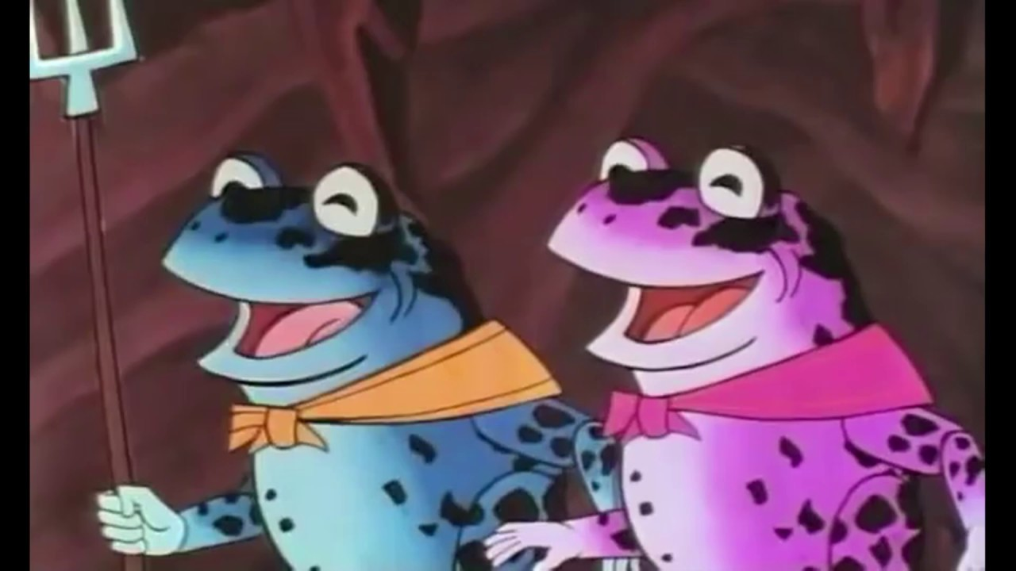

sentinel

description :

is a grown toad

skill:

Not available

**Game experience:** The game is divided into levels with increasing difficulty

**Buying:** Players are allowed to buy defensive weapons, attack and medicine to equip in the game screen

**Boss:** Equipped with weapons, skill and magnitude depending on strength

**How to win:** The player has passed the monster requirement and completed the level

**How to close:** layers will die when falling off a cliff, hitting the target and hitting the skill of the last boss

**Game mechanics:**

2D battle mechanism, players must choose 1 of 7 characters to fight goblins. Each character has a unique skill. The game consists of 7 levels, the difficulty increases with each level. The final level will fight with snake monster

**Enemies:**

Each Boss animal not only has its own devastating attacks and Deth-Tech mecha, but is usually accompanied by minions that escalate in power as each game season progresses. Below is a small sample of animal enemy's attacks and minions:

Sinister snake snake Centipede: uses a freeze technique to damage and immobilize the defense.

Ferocious scorpion: Use two hammer weapons. Utilizes immense power to deal damage based on critical attacks

Sophisticated centipede: take advantage of the agility and small body to attack the opponent continuously.

Henchman: Use the formula and basic hitting.

**Cutscenes:**

Narrative cutscenes will use in-game assets to create short puppet-show sequences.

**Bonus Materials:**

Material enjoyment: We plan to support Farm Wars with at least six months of extensive downloadable content on the existing game:

• Additional battle maps

• Selection of items, new weapons

• New site upgrade

• Holiday-themed player costumes

• Upgrade character's skills