PERLA LUTCHMAN BRAND
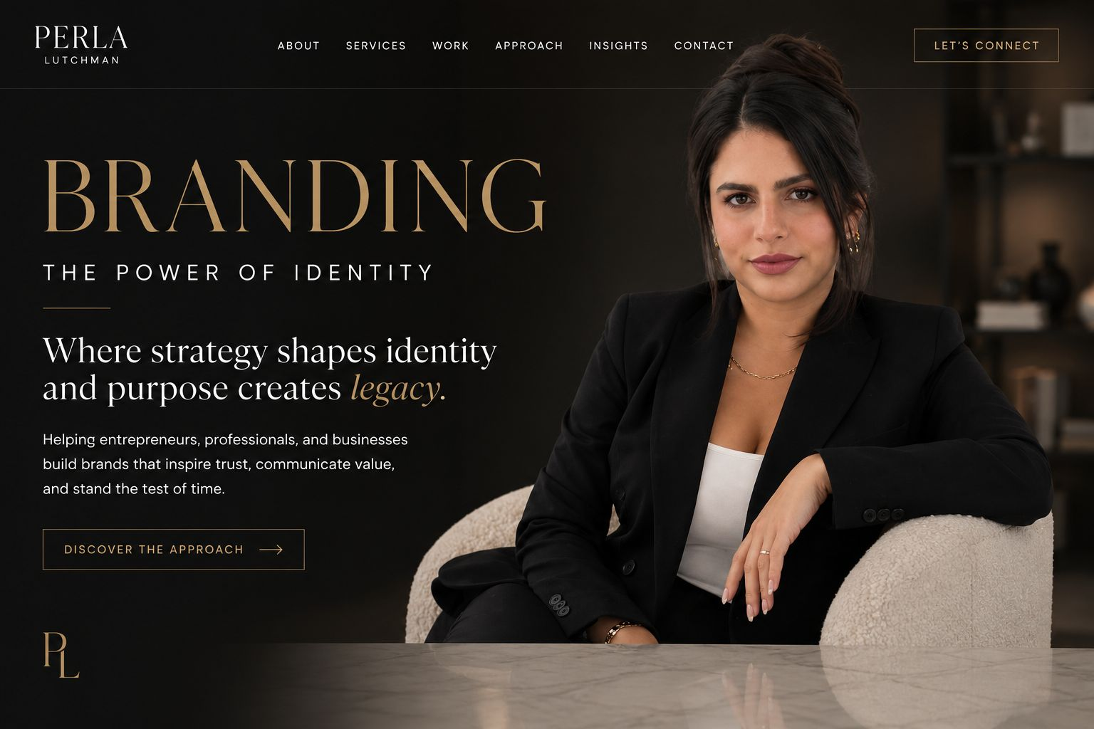

ABOUT ME SECTION
I believe the strongest brands are built with purpose, strategy, and authenticity.
I’m Perla Lutchman, a Brand Strategist, entrepreneur, and business professional with over 12 years of experience building businesses, developing brands, and creating experiences that leave a lasting impression.
Throughout my career, I’ve learned that successful brands aren’t built by chance. They are built through intentional decisions, clear positioning, and a deep understanding of the people they serve. Whether launching a new business, refining an existing brand, or preparing for the next stage of growth, every step should be guided by a strategy that creates long-term value.
Today, I work with entrepreneurs, professionals, and growing businesses to transform ideas into brands that are memorable, credible, and positioned for success. From brand development and positioning to business strategy and customer experience, my goal is to help clients build brands that not only look exceptional but also communicate with clarity, inspire trust, and support sustainable growth.
My approach combines creativity with business thinking because I believe great branding isn’t just about how a brand looks it’s about how it makes people feel, what it stands for, and the experience it consistently delivers.
Above all, I believe every person and every business has a unique story worth telling. My mission is to help bring that story to life with intention, confidence, and purpose.
In addition to my branding practice, I also specialize in luxury real estate and strategic real estate investments in Miami, helping clients make informed property decisions that support their long-term financial goals.
If you’re looking for real estate or insurance services, I’d love to connect with you through my dedicated real estate platform.
GALLERY.
WHY WORK WITH ME?
The Perla Difference
Business Experience. Strategic Thinking. Purposeful Branding.
Building a great brand takes more than creativity, it takes experience.
After more than 12 years of building and growing businesses, I’ve learned that the strongest brands are built with intention, not trends. My approach combines real-world business experience, strategic thinking, and thoughtful branding to help entrepreneurs create businesses that inspire trust, stand out, and grow with purpose.
Building businesses with purpose. Creating brands with intention.
Business Experience
Strategy built from experience.
I’ve spent more than a decade building, operating, and growing businesses firsthand. That journey has given me a practical understanding of entrepreneurship—from branding and customer experience to operations, leadership, and long-term growth. My guidance is grounded in real-world experience, not just theory.
Purpose-Driven Branding
Your brand should reflect who you are and where you’re going.
Every business has a unique story. Together, we’ll uncover what makes yours different and translate it into a clear identity, meaningful messaging, and a brand that genuinely connects with your audience.
Strategic Thinking
Building brands with long-term vision.
Great branding is about more than appearance it’s about creating a business that people recognize, trust, and remember. Every recommendation is guided by strategy, helping you build a brand that’s positioned for sustainable growth and lasting impact.
A Boutique Experience
Thoughtful collaboration. Personalized guidance.
No two businesses are alike, and neither is my approach. I work closely with every client to understand their goals, challenges, and vision, creating tailored strategies that reflect who they are and where they want to go.
I’m Perla. Let’s build something meaningful together.

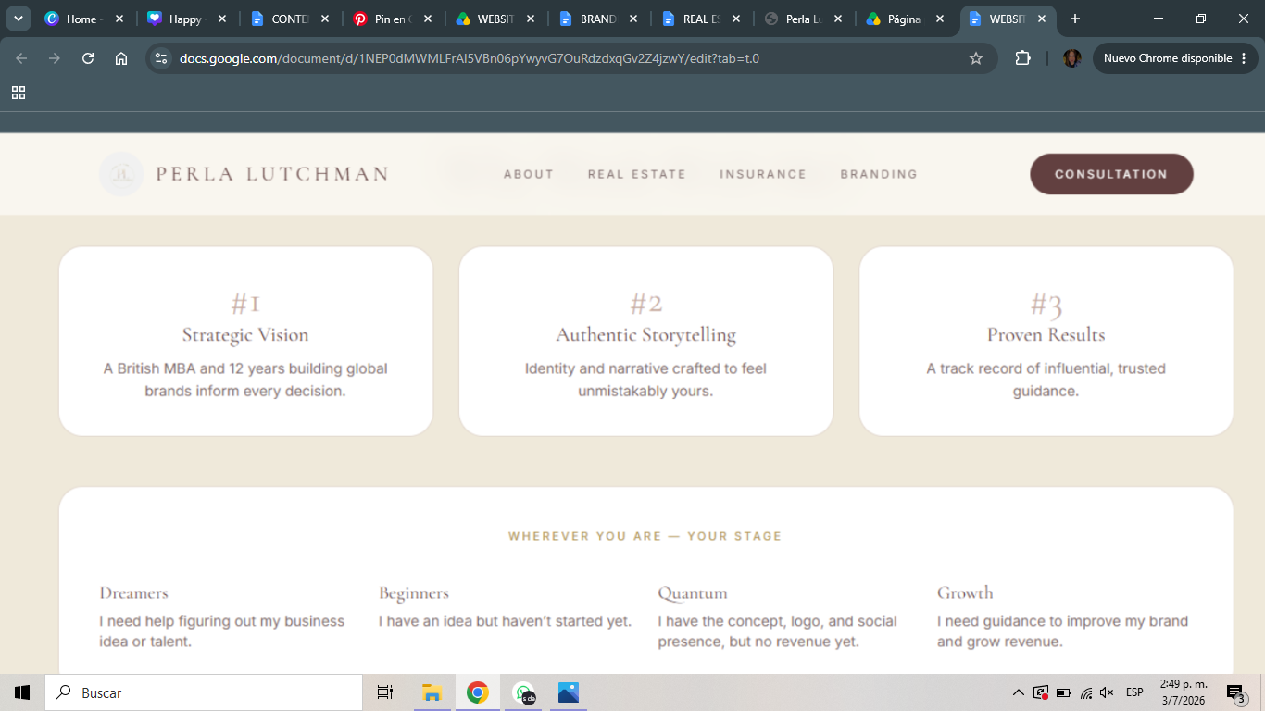

Where Are You in Your Journey?
Every successful brand starts somewhere. Whether you’re exploring a new idea, launching your first business, refining your positioning, or preparing to scale, every stage requires a different strategy.
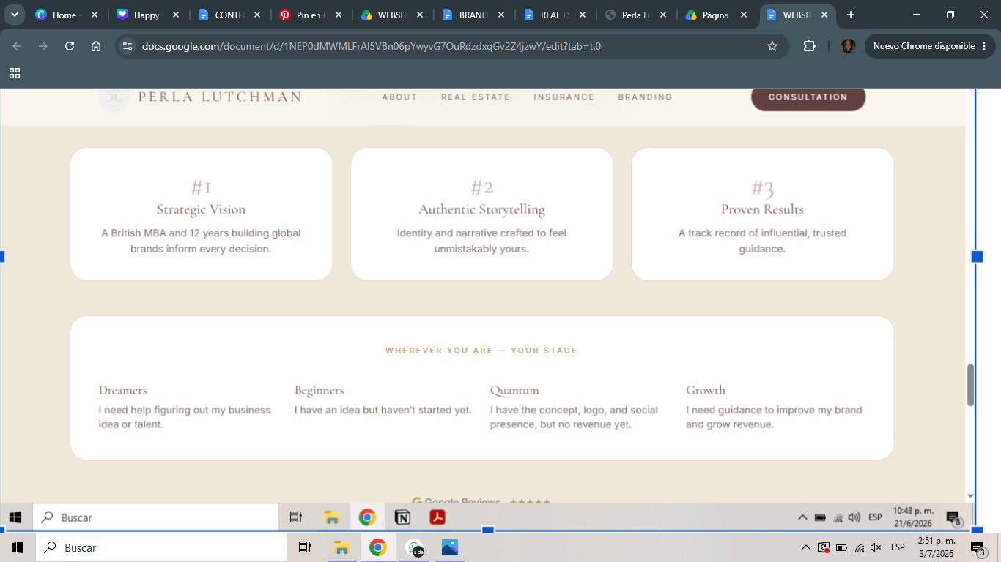

Vision → Launch → Momentum → Growth → Legacy
01 | Vision

From Idea to Opportunity

You have the passion, expertise, or ambition—but you’re not yet sure how to transform it into a business. Together, we’ll define your vision, identify your unique value, and create a strategic foundation that turns your ideas into real opportunities.

02 | Launch

Building Your Foundation

Your vision is clear, and you’re ready to bring it to life. Now it’s time to build the essentials from your brand identity and positioning to your business strategy and launch plan so you begin with confidence and purpose.

03 | Momentum

Turning Visibility into Growth

Your business is established. Your brand is live. You’ve built the foundation, but growth has slowed, or your brand no longer reflects where you’re headed. Together, we’ll refine your positioning, strengthen your messaging, and align your strategy to generate sustainable momentum.

04 | Growth

Scaling with Purpose

Your business is successful, but you’re ready for the next chapter. Whether you’re expanding, repositioning, or elevating your brand, we’ll develop a strategy that strengthens your market presence, enhances your customer experience, and supports long-term growth.

05 | Legacy

Building Something That Lasts

You’ve built a successful business. Now it’s time to think beyond growth. Together, we’ll refine your long-term brand strategy, strengthen your leadership presence, and create a brand that continues to create value, inspire trust, and leave a lasting impact for years to come

SPOTLIGHT
News, Moments

Contact
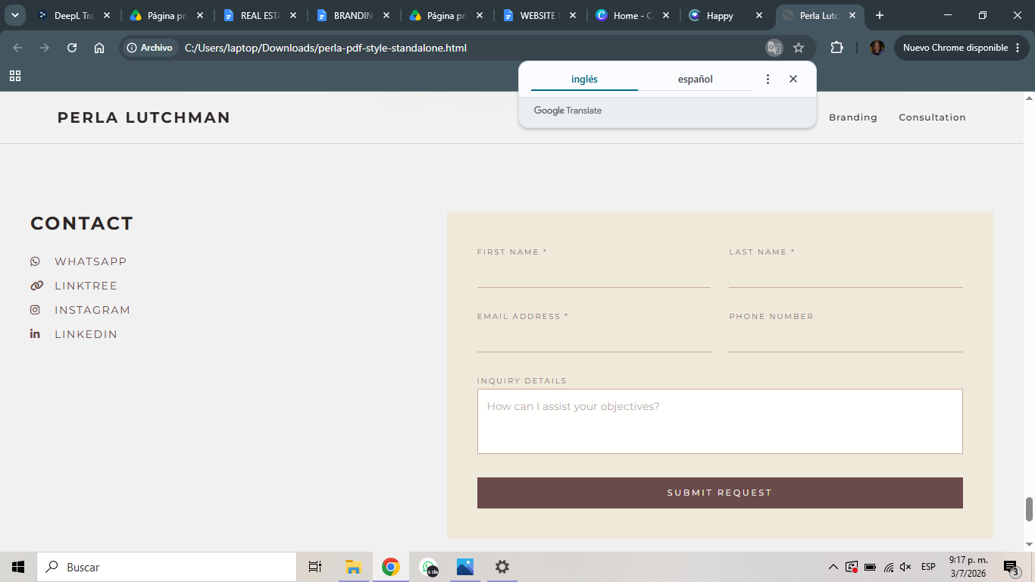

COLOR PALLETTE.

Colors:
BARS: DARK GRAY BROWN #11100E
DARK GRAY BROWN #322921
GRAY ORANGE #AA9C8F
GRAY ORANGE #B78161

Fonts:
Names and Titles: Tenor Sans
Big Titles: Alice
Content: Montserrat

