(You may browse this at https://github.com/ocornut/imgui/blob/master/docs/FONTS.md or view this file with any Markdown viewer)

Dear ImGui: Using Fonts
The code in imgui.cpp embeds a copy of 'ProggyClean.ttf' (by Tristan Grimmer), a 13 pixels high, pixel-perfect font used by default. We embed it in the source code so you can use Dear ImGui without any file system access. ProggyClean does not scale smoothly, therefore it is recommended that you load your own file when using Dear ImGui in an application aiming to look nice and wanting to support multiple resolutions.

You may also load external .TTF/.OTF files. In the misc/fonts/ folder you can find a few suggested fonts, provided as a convenience.

Also read the FAQ: https://www.dearimgui.org/faq (there is a Fonts section!)

Index
- Readme First
- How should I handle DPI in my application?
- Fonts Loading Instructions
- Using Icon Fonts
- Using FreeType Rasterizer (imgui_freetype)
- Using Colorful Glyphs/Emojis
- Using Custom Glyph Ranges
- Using Custom Colorful Icons
- Using Font Data Embedded In Source Code
- About filenames
- Credits/Licenses For Fonts Included In Repository
- Font Links

Readme First
- You can use the Metrics/Debugger window (available in Demo>Tools) to browse your fonts and understand what's going on if you have an issue. You can also reach it in Demo->Tools->Style Editor->Fonts. The same information are also available in the Style Editor under Fonts.

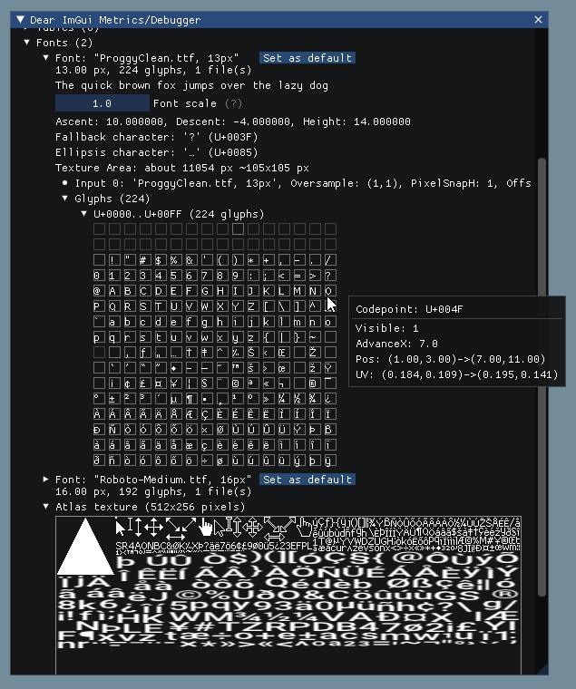

- All loaded fonts glyphs are rendered into a single texture atlas ahead of time. Calling either of io.Fonts->GetTexDataAsAlpha8(), io.Fonts->GetTexDataAsRGBA32() or io.Fonts->Build() will build the atlas.

- Make sure your font ranges data are persistent (available during the calls to GetTexDataAsAlpha8()/GetTexDataAsRGBA32()/Build()`.

- Use C++11 u8"my text" syntax to encode literal strings as UTF-8. e.g.:

u8"hello"

u8"こんにちは" // this will be encoded as UTF-8

Return to Index

How should I handle DPI in my application?
See FAQ entry.

Return to Index

Font Loading Instructions
Load default font:

ImGuiIO& io = ImGui::GetIO();

io.Fonts->AddFontDefault();

Load .TTF/.OTF file with:

ImGuiIO& io = ImGui::GetIO();

io.Fonts->AddFontFromFileTTF("font.ttf", size_pixels);

If you get an assert stating "Could not load font file!", your font filename is likely incorrect. Read "About filenames" carefully.

Load multiple fonts:

// Init

ImGuiIO& io = ImGui::GetIO();

ImFont* font1 = io.Fonts->AddFontFromFileTTF("font.ttf", size_pixels);

ImFont* font2 = io.Fonts->AddFontFromFileTTF("anotherfont.otf", size_pixels);

// In application loop: select font at runtime

ImGui::Text("Hello"); // use the default font (which is the first loaded font)

ImGui::PushFont(font2);

ImGui::Text("Hello with another font");

ImGui::PopFont();

For advanced options create a ImFontConfig structure and pass it to the AddFont() function (it will be copied internally):

ImFontConfig config;

config.OversampleH = 2;

config.OversampleV = 1;

config.GlyphExtraSpacing.x = 1.0f;

ImFont* font = io.Fonts->AddFontFromFileTTF("font.ttf", size_pixels, &config);

Combine multiple fonts into one:

// Load a first font

ImFont* font = io.Fonts->AddFontDefault();

// Add character ranges and merge into the previous font

// The ranges array is not copied by the AddFont* functions and is used lazily

// so ensure it is available at the time of building or calling GetTexDataAsRGBA32().

static const ImWchar icons_ranges[] = { 0xf000, 0xf3ff, 0 }; // Will not be copied by AddFont* so keep in scope.

ImFontConfig config;

config.MergeMode = true;

io.Fonts->AddFontFromFileTTF("DroidSans.ttf", 18.0f, &config, io.Fonts->GetGlyphRangesJapanese()); // Merge into first font

io.Fonts->AddFontFromFileTTF("fontawesome-webfont.ttf", 18.0f, &config, icons_ranges); // Merge into first font

io.Fonts->Build();

Add a fourth parameter to bake specific font ranges only:

// Basic Latin, Extended Latin

io.Fonts->AddFontFromFileTTF("font.ttf", size_pixels, NULL, io.Fonts->GetGlyphRangesDefault());

// Default + Selection of 2500 Ideographs used by Simplified Chinese

io.Fonts->AddFontFromFileTTF("font.ttf", size_pixels, NULL, io.Fonts->GetGlyphRangesChineseSimplifiedCommon());

// Default + Hiragana, Katakana, Half-Width, Selection of 1946 Ideographs

io.Fonts->AddFontFromFileTTF("font.ttf", size_pixels, NULL, io.Fonts->GetGlyphRangesJapanese());

See Using Custom Glyph Ranges section to create your own ranges.

Example loading and using a Japanese font:

ImGuiIO& io = ImGui::GetIO();

io.Fonts->AddFontFromFileTTF("NotoSansCJKjp-Medium.otf", 20.0f, NULL, io.Fonts->GetGlyphRangesJapanese());

ImGui::Text(u8"こんにちは！テスト %d", 123);

if (ImGui::Button(u8"ロード"))

{

// do stuff

}

ImGui::InputText("string", buf, IM_ARRAYSIZE(buf));

ImGui::SliderFloat("float", &f, 0.0f, 1.0f);

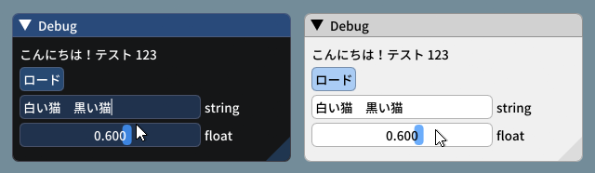

_(settings: Dark style (left), Light style (right) / Font: NotoSansCJKjp-Medium, 20px / Rounding: 5)_

Font Atlas too large?

- If you have very large number of glyphs or multiple fonts, the texture may become too big for your graphics API. The typical result of failing to upload a texture is if every glyphs appears as white rectangles.
- Mind the fact that some graphics drivers have texture size limitation. If you are building a PC application, mind the fact that your users may use hardware with lower limitations than yours.

Some solutions:

- Reduce glyphs ranges by calculating them from source localization data. You can use the ImFontGlyphRangesBuilder for this purpose and rebuilding your atlas between frames when new characters are needed. This will be the biggest win!
- You may reduce oversampling, e.g. font_config.OversampleH = 2, this will largely reduce your texture size. Note that while OversampleH = 2 looks visibly very close to 3 in most situations, with OversampleH = 1 the quality drop will be noticeable.
- Set io.Fonts.TexDesiredWidth to specify a texture width to minimize texture height (see comment in ImFontAtlas::Build() function).
- Set io.Fonts.Flags |= ImFontAtlasFlags_NoPowerOfTwoHeight; to disable rounding the texture height to the next power of two.
- Read about oversampling here.
- To support the extended range of unicode beyond 0xFFFF (e.g. emoticons, dingbats, symbols, shapes, ancient languages, etc...) add #define IMGUI_USE_WCHAR32in your imconfig.h.

Return to Index

Using Icon Fonts
Using an icon font (such as FontAwesome or OpenFontIcons) is an easy and practical way to use icons in your Dear ImGui application. A common pattern is to merge the icon font within your main font, so you can embed icons directly from your strings without having to change fonts back and forth.

To refer to the icon UTF-8 codepoints from your C++ code, you may use those headers files created by Juliette Foucaut: https://github.com/juliettef/IconFontCppHeaders.

So you can use ICON_FA_SEARCH as a string that will render as a "Search" icon.

Example Setup:

// Merge icons into default tool font

#include "IconsFontAwesome.h"

ImGuiIO& io = ImGui::GetIO();

io.Fonts->AddFontDefault();

ImFontConfig config;

config.MergeMode = true;

config.GlyphMinAdvanceX = 13.0f; // Use if you want to make the icon monospaced

static const ImWchar icon_ranges[] = { ICON_MIN_FA, ICON_MAX_FA, 0 };

io.Fonts->AddFontFromFileTTF("fonts/fontawesome-webfont.ttf", 13.0f, &config, icon_ranges);

Example Usage:

// Usage, e.g.

ImGui::Text("%s among %d items", ICON_FA_SEARCH, count);

ImGui::Button(ICON_FA_SEARCH " Search");

// C string _literals_ can be concatenated at compilation time, e.g. "hello" " world"

// ICON_FA_SEARCH is defined as a string literal so this is the same as "A" "B" becoming "AB"

See Links below for other icons fonts and related tools.

Here's an application using icons ("Avoyd", https://www.avoyd.com): 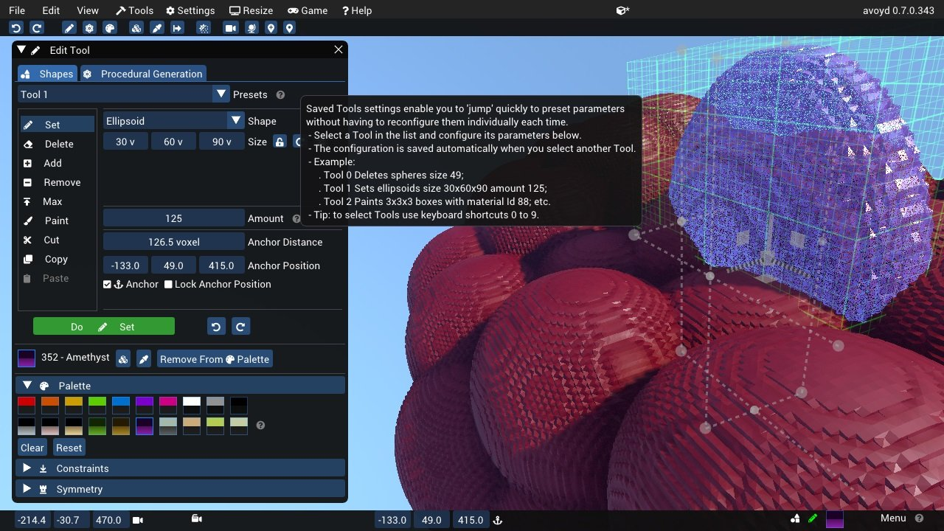

Return to Index

Using FreeType Rasterizer (imgui_freetype)
- Dear ImGui uses imstb_truetype.h to rasterize fonts (with optional oversampling). This technique and its implementation are not ideal for fonts rendered at small sizes, which may appear a little blurry or hard to read.
- There is an implementation of the ImFontAtlas builder using FreeType that you can use in the misc/freetype/ folder.
- FreeType supports auto-hinting which tends to improve the readability of small fonts.
- Read documentation in the misc/freetype/ folder.
- Correct sRGB space blending will have an important effect on your font rendering quality.

Return to Index

Using Colorful Glyphs/Emojis
- Rendering of colored emojis is only supported by imgui_freetype with FreeType 2.10+.
- You will need to load fonts with the ImGuiFreeTypeBuilderFlags_LoadColor flag.
- Emojis are frequently encoded in upper Unicode layers (character codes >0x10000) and will need dear imgui compiled with IMGUI_USE_WCHAR32.
- Not all types of color fonts are supported by FreeType at the moment.
- Stateful Unicode features such as skin tone modifiers are not supported by the text renderer.

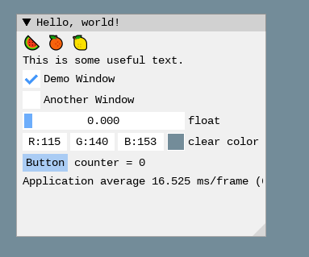

io.Fonts->AddFontFromFileTTF("../../../imgui_dev/data/fonts/NotoSans-Regular.ttf", 16.0f);

static ImWchar ranges[] = { 0x1, 0x1FFFF, 0 };

static ImFontConfig cfg;

cfg.OversampleH = cfg.OversampleV = 1;

cfg.MergeMode = true;

cfg.FontBuilderFlags |= ImGuiFreeTypeBuilderFlags_LoadColor;

io.Fonts->AddFontFromFileTTF("C:\\Windows\\Fonts\\seguiemj.ttf", 16.0f, &cfg, ranges);

Return to Index

Using Custom Glyph Ranges
You can use the ImFontGlyphRangesBuilder helper to create glyph ranges based on text input. For example: for a game where your script is known, if you can feed your entire script to it and only build the characters the game needs.

ImVector<ImWchar> ranges;

ImFontGlyphRangesBuilder builder;

builder.AddText("Hello world"); // Add a string (here "Hello world" contains 7 unique characters)

builder.AddChar(0x7262); // Add a specific character

builder.AddRanges(io.Fonts->GetGlyphRangesJapanese()); // Add one of the default ranges

builder.BuildRanges(&ranges); // Build the final result (ordered ranges with all the unique characters submitted)

io.Fonts->AddFontFromFileTTF("myfontfile.ttf", size_in_pixels, NULL, ranges.Data);

io.Fonts->Build(); // Build the atlas while 'ranges' is still in scope and not deleted.

Return to Index

Using Custom Colorful Icons
As an alternative to rendering colorful glyphs using imgui_freetype with ImGuiFreeTypeBuilderFlags_LoadColor, you may allocate your own space in the texture atlas and write yourself into it. (This is a BETA api, use if you are familiar with dear imgui and with your rendering backend)

- You can use the ImFontAtlas::AddCustomRect() and ImFontAtlas::AddCustomRectFontGlyph() api to register rectangles that will be packed into the font atlas texture. Register them before building the atlas, then call Build()`.
- You can then use ImFontAtlas::GetCustomRectByIndex(int) to query the position/size of your rectangle within the texture, and blit/copy any graphics data of your choice into those rectangles.
- This API is beta because it is likely to change in order to support multi-dpi (multiple viewports on multiple monitors with varying DPI scale).

Pseudo-code:
// Add font, then register two custom 13x13 rectangles mapped to glyph 'a' and 'b' of this font

ImFont* font = io.Fonts->AddFontDefault();

int rect_ids[2];

rect_ids[0] = io.Fonts->AddCustomRectFontGlyph(font, 'a', 13, 13, 13+1);

rect_ids[1] = io.Fonts->AddCustomRectFontGlyph(font, 'b', 13, 13, 13+1);

// Build atlas

io.Fonts->Build();

// Retrieve texture in RGBA format

unsigned char* tex_pixels = NULL;

int tex_width, tex_height;

io.Fonts->GetTexDataAsRGBA32(&tex_pixels, &tex_width, &tex_height);

for (int rect_n = 0; rect_n < IM_ARRAYSIZE(rect_ids); rect_n++)

{

int rect_id = rects_ids[rect_n];

if (const ImFontAtlas::CustomRect* rect = io.Fonts->GetCustomRectByIndex(rect_id))

{

// Fill the custom rectangle with red pixels (in reality you would draw/copy your bitmap data here!)

for (int y = 0; y < rect->Height; y++)

{

ImU32* p = (ImU32*)tex_pixels + (rect->Y + y) * tex_width + (rect->X);

for (int x = rect->Width; x > 0; x--)

*p++ = IM_COL32(255, 0, 0, 255);

}

}

}

Return to Index

Using Font Data Embedded In Source Code
- Compile and use binary_to_compressed_c.cpp to create a compressed C style array that you can embed in source code.
- See the documentation in binary_to_compressed_c.cpp for instructions on how to use the tool.
- You may find a precompiled version binary_to_compressed_c.exe for Windows inside the demo binaries package (see README).
- The tool can optionally output Base85 encoding to reduce the size of source code but the read-only arrays in the actual binary will be about 20% bigger.

Then load the font with:

ImFont* font = io.Fonts->AddFontFromMemoryCompressedTTF(compressed_data, compressed_data_size, size_pixels, ...);

or

ImFont* font = io.Fonts->AddFontFromMemoryCompressedBase85TTF(compressed_data_base85, size_pixels, ...);

Return to Index

About filenames
Please note that many new C/C++ users have issues loading their files because the filename they provide is wrong.

Two things to watch for:

- Make sure your IDE/debugger settings starts your executable from the right working directory. In Visual Studio you can change your working directory in project Properties > General > Debugging > Working Directory. People assume that their execution will start from the root folder of the project, where by default it oftens start from the folder where object or executable files are stored.

// Relative filename depends on your Working Directory when running your program!

io.Fonts->AddFontFromFileTTF("MyImage01.jpg", ...);

// Load from the parent folder of your Working Directory

io.Fonts->AddFontFromFileTTF("../MyImage01.jpg", ...);

- In C/C++ and most programming languages if you want to use a backslash \ within a string literal, you need to write it double backslash \\. At it happens, Windows uses backslashes as a path separator, so be mindful.

io.Fonts->AddFontFromFileTTF("MyFiles\MyImage01.jpg", ...); // This is INCORRECT!!

io.Fonts->AddFontFromFileTTF("MyFiles\\MyImage01.jpg", ...); // This is CORRECT

In some situations, you may also use / path separator under Windows.

Return to Index

Credits/Licenses For Fonts Included In Repository
Some fonts files are available in the misc/fonts/ folder:

Roboto-Medium.ttf, by Christian Robetson
Apache License 2.0

https://fonts.google.com/specimen/Roboto

Cousine-Regular.ttf, by Steve Matteson
Digitized data copyright (c) 2010 Google Corporation.
Licensed under the SIL Open Font License, Version 1.1

https://fonts.google.com/specimen/Cousine

DroidSans.ttf, by Steve Matteson
Apache License 2.0

https://www.fontsquirrel.com/fonts/droid-sans

ProggyClean.ttf, by Tristan Grimmer
MIT License
(recommended loading setting: Size = 13.0, GlyphOffset.y = +1)

http://www.proggyfonts.net/

ProggyTiny.ttf, by Tristan Grimmer
MIT License
(recommended loading setting: Size = 10.0, GlyphOffset.y = +1)

http://www.proggyfonts.net/

Karla-Regular.ttf, by Jonathan Pinhorn

SIL OPEN FONT LICENSE Version 1.1

Return to Index

Font Links

ICON FONTS
- C/C++ header for icon fonts (#define with code points to use in source code string literals) https://github.com/juliettef/IconFontCppHeaders
- FontAwesome https://fortawesome.github.io/Font-Awesome
- OpenFontIcons https://github.com/traverseda/OpenFontIcons
- Google Icon Fonts https://design.google.com/icons/
- Kenney Icon Font (Game Controller Icons) https://github.com/nicodinh/kenney-icon-font
- IcoMoon - Custom Icon font builder https://icomoon.io/app

REGULAR FONTS
- Google Noto Fonts (worldwide languages) https://www.google.com/get/noto/
- Open Sans Fonts https://fonts.google.com/specimen/Open+Sans
- (Japanese) M+ fonts by Coji Morishita http://mplus-fonts.sourceforge.jp/mplus-outline-fonts/index-en.html

MONOSPACE FONTS
Pixel Perfect:

- Proggy Fonts, by Tristan Grimmer http://www.proggyfonts.net or http://upperbounds.net
- Sweet16, Sweet16 Mono, by Martin Sedlak (Latin + Supplemental + Extended A) https://github.com/kmar/Sweet16Font (also include an .inl file to use directly in dear imgui.)

Regular:

- Google Noto Mono Fonts https://www.google.com/get/noto/
- Typefaces for source code beautification https://github.com/chrissimpkins/codeface
- Programmation fonts http://s9w.github.io/font_compare/
- Inconsolata http://www.levien.com/type/myfonts/inconsolata.html
- Adobe Source Code Pro: Monospaced font family for ui & coding environments https://github.com/adobe-fonts/source-code-pro
- Monospace/Fixed Width Programmer's Fonts http://www.lowing.org/fonts/

Or use Arial Unicode or other Unicode fonts provided with Windows for full characters coverage (not sure of their licensing).

Return to Index

