# Ministerul Educatiei si cercetarii al Republicii Moldova

Colegiul Universității tehnice A Republicii Moldovei

Specialitatea: „Programarea și Analiza Produselor Program”

**Raport**

Laboratorul Nr.4

Disciplina: „Asistență pentru programarea client-side a site-urilor WEB”

|  |
| --- |
| A Efectuat: |
| Baban Adrian |
| A verificat: |
| Alexandru Negară |

Chisinau 2025

**Obiectivele:**

21. Pagini web de prelucrarea a tablourilor.

22. Pagini web cu utilizarea evenimentelor mouse-ului, tastaturii, ferestrei browser-ului.

23. Scripturi client-side pentru definirea comportamentului elementelor dintr-un document Web.

**Sarcinile:**

**##1 Laborator4.html.**

<!DOCTYPE html>

<html lang="ro">

<head>

    <meta charset="UTF-8">

    <meta name="viewport" content="width=device-width, initial-scale=1.0">

    <title>Laborator 4</title>

    <link rel="stylesheet" href="styles.css">

</head>

<body>

    <header>

        <h1>Temă JavaScript</h1>

    </header>

    <main>

        <section>

            <h2>Prelucrarea tablourilor cu numere</h2>

            <input type="number" id="numInput" placeholder="Adaugă număr">

            <button onclick="addNumber()">Adaugă</button>

            <button onclick="sortNumbers()">Sortează</button>

            <p id="arrayOutput">Tabloul: []</p>

        </section>

        <section>

          <h2>Tablouri cu Stringuri</h2>

          <input type="text" id="strInput" placeholder="Adaugă un cuvânt">

          <button onclick="addString()">Adaugă</button>

          <button onclick="sortStrings()">Sortează</button>

          <p id="stringOutput">Șiruri: []</p>

      </section>

        <section>

            <h2>Evenimente (Mouse, Tastatură, Fereastră)</h2>

            <button id="hoverButton">Plasează cursorul</button>

            <p id="keyEvent">Apasă o tastă...</p>

            <p id="windowSize">Dimensiuni: </p>

        </section>

<section>

            <h2>Elemente interactive</h2>

            <button onclick="generateBox()">Generează pătrat</button>

            <div id="boxContainer"></div>

        </section>

    </main>

    <footer>

      <div class="footer-container">

        <div class="footer-section">

          <h3>Legături rapide</h3>

          <ul>

            <li><a href="../main.html">Acasă</a></li>

            <li><a href="#">Despre</a></li>

            <li><a href="#">Contact</a></li>

            <li><a href="#">Servicii</a></li>

            <li><a href="#">Politica de confidențialitate</a></li>

          </ul>

        </div>

        <div class="footer-section">

          <h3>Contact</h3>

          <p>Email: <a href="mailto:adry4work@gmail.com">adry4work@gmail.com</a></p>

          <p>Telefon: +373 784 00 000</p>

        </div>

        <div class="footer-section">

          <h3>Urmărește-ne</h3>

          <div class="social-icons">

            <a href="https://www.facebook.com/Adry.baban"><img src="https://upload.wikimedia.org/wikipedia/commons/5/51/Facebook_f_logo_%282019%29.svg" alt="Facebook"></a>

            <a href="https://www.instagram.com/mr_void26"><img src="https://upload.wikimedia.org/wikipedia/commons/9/95/Instagram_logo_2022.svg" alt="Instagram"></a>

            <a href="https://github.com/MrVoid10"><img src="https://upload.wikimedia.org/wikipedia/commons/9/91/Octicons-mark-github.svg" alt="GitHub"></a>

          </div>

        </div>

      </div>

      <p class="footer-bottom">&copy; 2025 Pagina Responsivă - Toate drepturile rezervate</p>

    </footer>

    <script src="../extra_cod/taste.js"></script>

    <script src="script.js"></script>

</body>

</html>

**##2 script.js**

let numbers = [];

let strings = [];

function addNumber() {

    let num = document.getElementById('numInput').value;

    if(num) {

        numbers.push(parseInt(num));

        document.getElementById('arrayOutput').innerText = `Tabloul: [${numbers.join(', ')}]`;

        document.getElementById('numInput').value = '';

    }

}

function sortNumbers() {

    numbers.sort((a, b) => a - b);

    document.getElementById('arrayOutput').innerText = `Tabloul: [${numbers.join(', ')}]`;

}

function addString() {

  let str = document.getElementById('strInput').value;

  if(str) {

      strings.push(str);

      document.getElementById('stringOutput').innerText = `Șiruri: [${strings.join(', ')}]`;

      document.getElementById('strInput').value = '';

  }

}

function sortStrings() {

  strings.sort((a, b) => a.localeCompare(b, undefined, { sensitivity: 'base' }));

  document.getElementById('stringOutput').innerText = `Șiruri: [${strings.join(', ')}]`;

}

document.getElementById('hoverButton').addEventListener('mouseover', function() {

    this.style.backgroundColor = 'red';

});

document.getElementById('hoverButton').addEventListener('mouseout', function() {

    this.style.backgroundColor = '';

});

document.addEventListener('keydown', function(event) {

    document.getElementById('keyEvent').innerText = `Ai apăsat: ${event.key}`;

});

window.addEventListener('resize', function() {

    document.getElementById('windowSize').innerText = `Dimensiuni: ${window.innerWidth} x ${window.innerHeight}`;

});

function generateBox() {

    let box = document.createElement('div');

    box.style.width = '50px';

    box.style.height = '50px';

    box.style.backgroundColor = 'blue';

    box.style.margin = '5px';

    boxContainer.appendChild(box);

}

**##3 styles.css**

body {

  font-family: Arial, sans-serif;

  margin: 0;

  padding: 0;

  background-color: #121212;

  color: #e0e0e0;

}

header {

  background-color: #1f1f1f;

  padding: 20px;

  text-align: center;

  border-bottom: 2px solid #333;

}

h1 {

  margin: 0;

  font-size: 24px;

  display: inline-block;

  background: linear-gradient(90deg, #ff00ff, #ff4500, #ffd700, #00ff00, #00ffff, #0000ff, #800080);

  background-clip: text;

  -webkit-background-clip: text;

  -webkit-text-fill-color: transparent;

  background-size: 100% 100%;

}

@keyframes gradientAnimation {

  0% { background-position: 0% 50%; }

  50% { background-position: 100% 50%; }

  100% { background-position: 0% 50%; }

}

footer {

  background: linear-gradient(90deg, #1f1f1f, #222, #1f1f1f);

  text-align: center;

  padding: 20px 0;

  margin-top: 30px;

  border-top: 2px solid #333;

  font-size: 14px;

}

.footer-container {

  display: flex;

  justify-content: space-around;

  flex-wrap: wrap;

  padding: 20px;

  max-width: 100%;

  margin: 0 auto;

}

.footer-section {

  flex: 1;

  display: inline-block;

  min-width: auto;

  margin: 10px;

}

.footer-section h3 {

  font-size: 18px;

  margin-bottom: 10px;

  color: #bb86fc;

}

.footer-section a {

  color: #e0e0e0;

  text-decoration: none;

  transition: color 0.3s ease;

}

.footer-section a:hover {

  color: #03dac6;

  text-decoration: underline;

}

.social-icons {

  display: flex;

  justify-content: center;

  gap: 15px;

  margin-top: 10px;

}

.social-icons img {

  width: 32px;

  height: 32px;

  transition: transform 0.3s ease, filter 0.3s ease;

  filter: brightness(0.8);

}

.social-icons img:hover {

  transform: scale(1.1);

  filter: brightness(1);

}

.footer-bottom {

  margin-top: 20px;

  font-size: 12px;

  color: #aaa;

  padding-top: 10px;

  border-top: 1px solid #444;

}

/* Stilizarea pagini */

section {

  background-color: #1f1f1f;

  margin: 20px auto;

  padding: 20px;

  border-radius: 10px;

  box-shadow: 0px 4px 10px rgba(0, 0, 0, 0.5);

  max-width: 600px;

}

button {

  background-color: #6200ea;

  color: white;

  border: none;

  padding: 10px 15px;

  border-radius: 5px;

  cursor: pointer;

  transition: 0.3s;

}

button:hover {

  background-color: #3700b3;

}

input {

  padding: 10px;

  border: 1px solid #333;

  border-radius: 5px;

  background-color: #2c2c2c;

  color: #e0e0e0;

}

#boxContainer {

  display: flex;

  justify-content: center;

  flex-wrap: wrap;

  margin-top: 10px;

}

#boxContainer div {

  width: 50px;

  height: 50px;

  background-color: blue;

  margin: 5px;

  border-radius: 5px;

  transition: transform 0.3s;

}

#boxContainer div:hover {

  transform: scale(1.1);

}

/* Aici sunt marimile incat sa fie pentru mai multe dispozitive */

/* iPhone-uri mici (SE, 5, 5S) */

@media only screen and (max-width: 375px) {

  body {background-color: #44ff44;}

  .form-container{

    max-width: 100%;

  }

}

/* iPhone-uri medii (6, 7, 8, X, 11, 12 Mini) */

@media only screen and (max-width: 430px) and (max-height: 932px) {

  body {background-color: #00ff00;}

  .form-container{max-width: 100%;}

}

/* iPhone-uri mari (Pro Max, 14 Plus) */

@media only screen and (min-width: 431px) and (max-width: 480px) {

  body {background-color: #cc0000;}

  .form-container{max-width: 100%;}

}

/* iPad-uri (portret) */

@media only screen and (min-width: 768px) and (max-width: 1024px) and (orientation: portrait) {

  body {background-color: #ff9900;}

}

/* iPad-uri (landscape) */

@media only screen and (min-width: 768px) and (max-width: 1366px) and (orientation: landscape) {

  body {background-color: #ffcc00;}

}

/* Telefoane (portrait) - Android & iOS */

@media only screen and (max-width: 600px) and (orientation: portrait) {

  body {background-color: #ff0000;}

  .form-container{max-width: 100%;}

}

/* Telefoane (landscape) - Android & iOS */

@media only screen and (max-width: 900px) and (orientation: landscape) {

  body {background-color: #ff66b2;}

}

/* Tablete Android & iPad (portrait) */

@media only screen and (min-width: 601px) and (max-width: 900px) and (orientation: portrait) {

  body {background-color: #ff8800;}

}

/* Tablete Android & iPad (landscape) */

@media only screen and (min-width: 601px) and (max-width: 1200px) and (orientation: landscape) {

  body {background-color: #ffff00;}

}

**##5 Navigarea unui utilizator.**

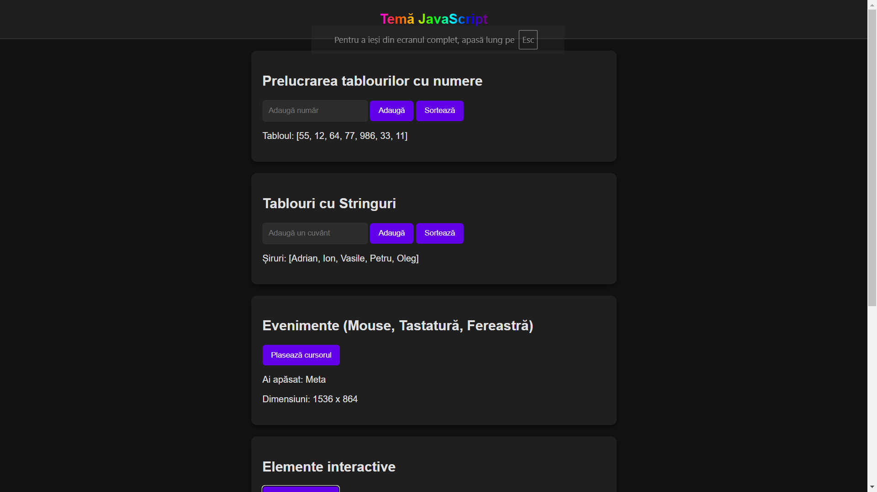

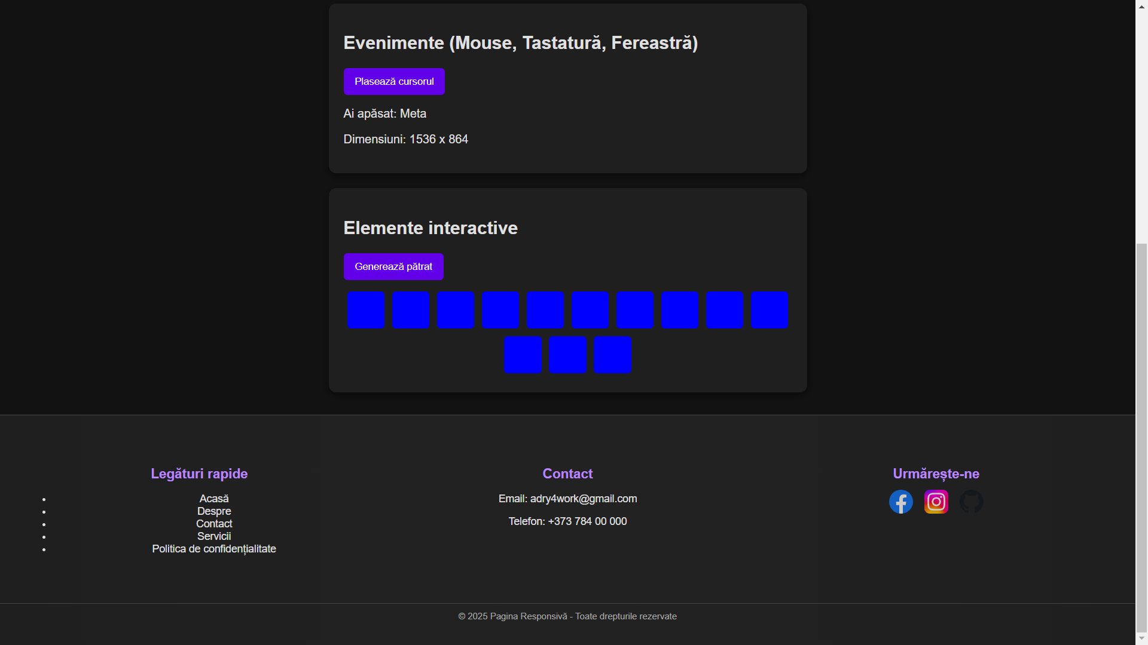

**Sortat:**

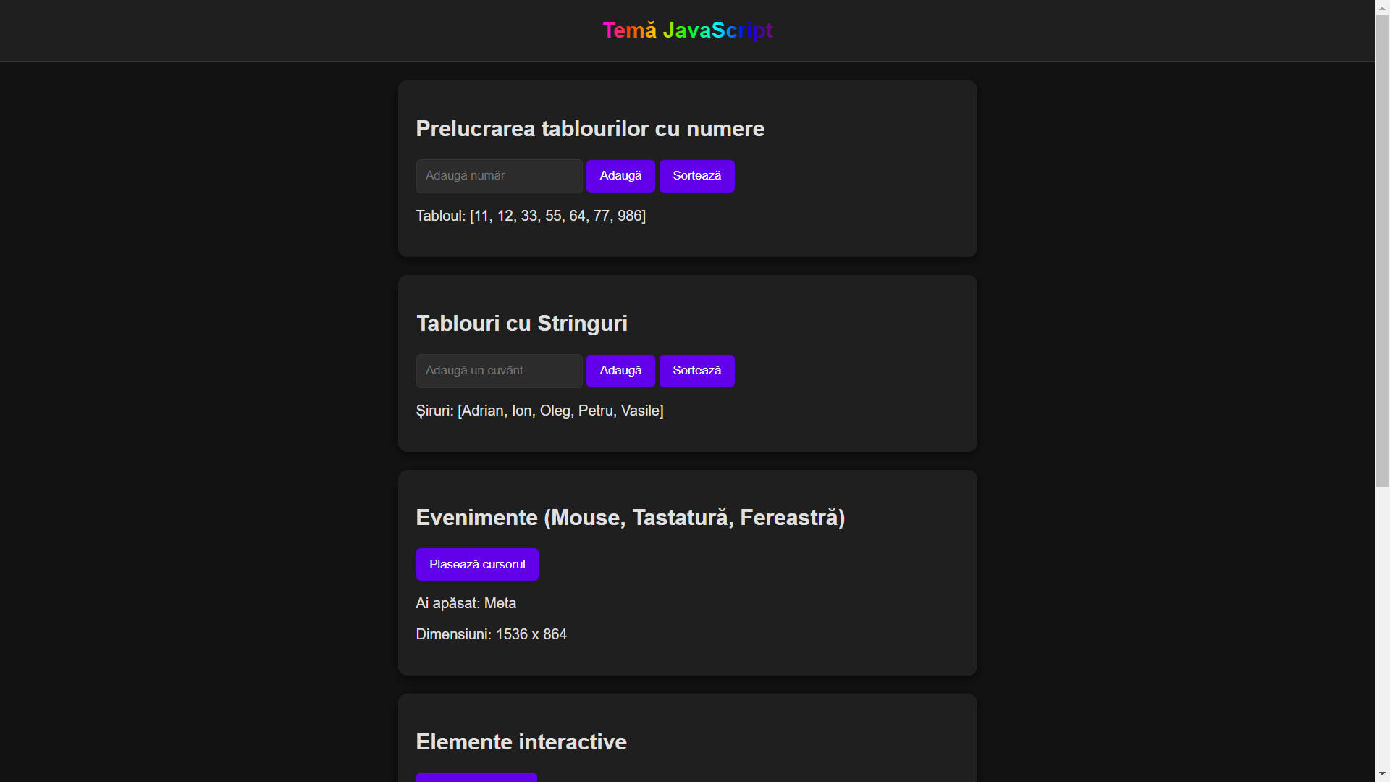

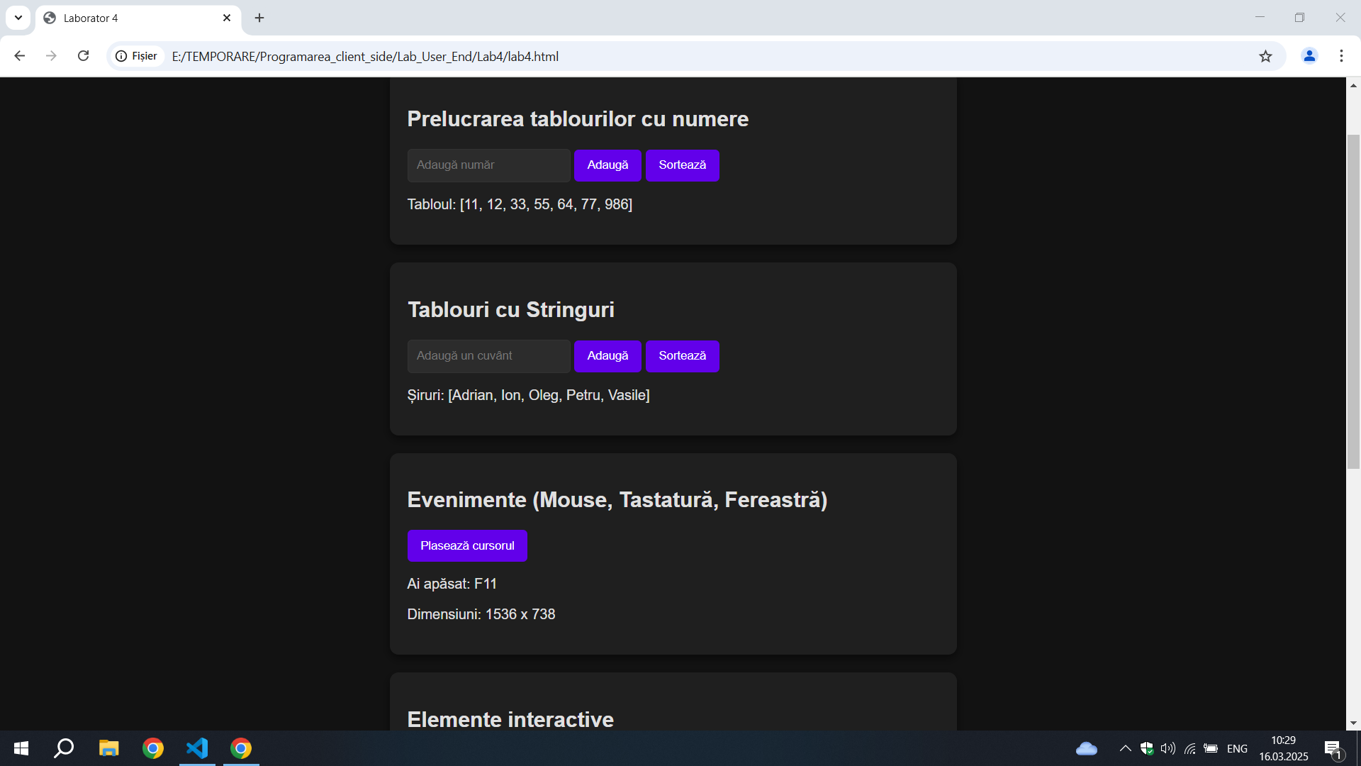**Concluzie:**

La aceasta lucrare de laborator am invatat a face un site html care manipuleaza tablouri (Array),detectarea modificari dimesiunii paginii, detectarea apasarii tastelor, schimbarea elementelor bazate pe pozitia mausului (Hover)

Și scripturi care definesc comportamentul elementelor Web.