# Ministerul Educatiei si cercetarii al Republicii Moldova

Colegiul Universității tehnice A Republicii Moldovei

Specialitatea: „Programarea și Analiza Produselor Program”

**Raport**

Laboratorul Nr.5

Disciplina: „Asistență pentru programarea client-side a site-urilor WEB”

|  |
| --- |
| A Efectuat: |
| Baban Adrian |
| A verificat: |
| Alexandru Negară |

Chisinau 2025

**Obiectivele:**

24. Pagini web cu verificarea datelor din formular.

25. Pagini web de gestionare a obiectelor modelului BOM.

26. Pagini web cu utilizarea metodelor de stocare a datelor.**Sarcinile:**

**##1 Laborator4.html.**

<!DOCTYPE html>

<html lang="ro">

  <head>

    <meta charset="UTF-8">

    <meta name="viewport" content="width=device-width, initial-scale=1.0">

    <title>Laborator 5</title>

    <link rel="stylesheet" href="styles.css">

  </head>

  <body>

    <header>

      <h1>Laborator 5</h1>

    </header>

    <section>

      <h2>Formular utilizator</h2>

      <form id="userForm">

        <label for="firstName">Nume:</label><br>

        <input type="text" id="firstName" name="firstName" required><br>

        <label for="lastName">Prenume:</label><br>

        <input type="text" id="lastName" name="lastName" required><br>

        <label for="email">Email:</label><br>

        <input type="email" id="email" name="email" required><br>

        <label for="birthDate">Data Nașterii:</label><br>

        <input type="date" id="birthDate" name="birthDate" required><br><br>

        <button type="submit">Salvează utilizator</button>

      </form>

      <div id="error-message" class="error"></div>

      <div id="warning-message" class="warning"></div>

    </section>

    <section>

      <div id="user-list">

        <h3>Utilizatori salvați:</h3>

        <ul id="users"></ul>

      </div>

    </section>

    <footer>

      <div class="footer-container">

        <div class="footer-section">

          <h3>Legături rapide</h3>

          <ul>

            <li><a href="../main.html">Acasă</a></li>

            <li><a href="#">Despre</a></li>

            <li><a href="#">Contact</a></li>

            <li><a href="#">Servicii</a></li>

            <li><a href="#">Politica de confidențialitate</a></li>

          </ul>

        </div>

        <div class="footer-section">

          <h3>Contact</h3>

          <p>Email: <a href="mailto:adry4work@gmail.com">adry4work@gmail.com</a></p>

          <p>Telefon: +373 784 00 000</p>

        </div>

        <div class="footer-section">

          <h3>Urmărește-ne</h3>

          <div class="social-icons">

            <a href="https://www.facebook.com/Adry.baban"><img src="https://upload.wikimedia.org/wikipedia/commons/5/51/Facebook_f_logo_%282019%29.svg" alt="Facebook"></a>

            <a href="https://www.instagram.com/mr_void26"><img src="https://upload.wikimedia.org/wikipedia/commons/9/95/Instagram_logo_2022.svg" alt="Instagram"></a>

            <a href="https://github.com/MrVoid10"><img src="https://upload.wikimedia.org/wikipedia/commons/9/91/Octicons-mark-github.svg" alt="GitHub"></a>

          </div>

        </div>

      </div>

      <p class="footer-bottom">&copy; 2025 Pagina Responsivă - Toate drepturile rezervate</p>

    </footer>

    <script src="../extra_cod/taste.js"></script>

    <script src="script.js"></script>

  </body>

</html>

**##2 script.js**

function loadUsers() {

  const users = JSON.parse(localStorage.getItem("users")) || [];

  const userList = document.getElementById("users");

  userList.innerHTML = "";

  users.forEach(user => {

    const li = document.createElement("li");

    li.textContent = `Nume: ${user.firstName} ${user.lastName}, Email: ${user.email}, Data Nașterii: ${user.birthDate}`;

    userList.appendChild(li);

  });

}

function saveUser(user) {

  const users = JSON.parse(localStorage.getItem("users")) || [];

  users.push(user);

  localStorage.setItem("users", JSON.stringify(users));

  loadUsers();

}

function checkAge(birthDate) {

  const birthYear = new Date(birthDate).getFullYear();

  const currentYear = new Date().getFullYear();

  return currentYear - birthYear >= 18;

}

function checkNameFormat(firstName, lastName) {

  let errorMessage = "";

  if (firstName.charAt(0) !== firstName.charAt(0).toUpperCase()) {

    errorMessage += "Numele trebuie să înceapă cu literă mare. ";

  }

  if (lastName.charAt(0) !== lastName.charAt(0).toUpperCase()) {

    errorMessage += "Prenumele trebuie să înceapă cu literă mare. ";

  }

  return errorMessage;

}

document.getElementById("userForm").addEventListener("submit", function(event) {

  event.preventDefault();

  const firstName = document.getElementById("firstName").value;

  const lastName = document.getElementById("lastName").value;

  const email = document.getElementById("email").value;

  const birthDate = document.getElementById("birthDate").value;

  if (!checkAge(birthDate)) {

    document.getElementById("error-message").textContent = "Nu ai vârsta legală (minim 18 ani).";

    return;

  } else {

    document.getElementById("error-message").textContent = "";

  }

  const nameError = checkNameFormat(firstName, lastName);

  if (nameError) {

    document.getElementById("warning-message").textContent = nameError;

  } else {

    document.getElementById("warning-message").textContent = "";

  }

  const user = {

    firstName: firstName,

    lastName: lastName,

    email: email,

    birthDate: birthDate

  };

  saveUser(user);

  this.reset();

});

loadUsers();

**##3 styles.css**

body {

  font-family: Arial, sans-serif;

  margin: 0;

  padding: 0;

  background-color: #121212;

  color: #e0e0e0;

}

header {

  background-color: #1f1f1f;

  padding: 20px;

  text-align: center;

  border-bottom: 2px solid #333;

}

h1 {

  margin: 0;

  font-size: 24px;

  display: inline-block;

  background: linear-gradient(90deg, #ff00ff, #ff4500, #ffd700, #00ff00, #00ffff, #0000ff, #800080);

  background-clip: text;

  -webkit-background-clip: text;

  -webkit-text-fill-color: transparent;

  background-size: 100% 100%;

}

@keyframes gradientAnimation {

  0% { background-position: 0% 50%; }

  50% { background-position: 100% 50%; }

  100% { background-position: 0% 50%; }

}

footer {

  background: linear-gradient(90deg, #1f1f1f, #222, #1f1f1f);

  text-align: center;

  padding: 20px 0;

  margin-top: 30px;

  border-top: 2px solid #333;

  font-size: 14px;

}

.footer-container {

  display: flex;

  justify-content: space-around;

  flex-wrap: wrap;

  padding: 20px;

  max-width: 100%;

  margin: 0 auto;

}

.footer-section {

  flex: 1;

  display: inline-block;

  min-width: auto;

  margin: 10px;

}

.footer-section h3 {

  font-size: 18px;

  margin-bottom: 10px;

  color: #bb86fc;

}

.footer-section a {

  color: #e0e0e0;

  text-decoration: none;

  transition: color 0.3s ease;

}

.footer-section a:hover {

  color: #03dac6;

  text-decoration: underline;

}

.social-icons {

  display: flex;

  justify-content: center;

  gap: 15px;

  margin-top: 10px;

}

.social-icons img {

  width: 32px;

  height: 32px;

  transition: transform 0.3s ease, filter 0.3s ease;

  filter: brightness(0.8);

}

.social-icons img:hover {

  transform: scale(1.1);

  filter: brightness(1);

}

.footer-bottom {

  margin-top: 20px;

  font-size: 12px;

  color: #aaa;

  padding-top: 10px;

  border-top: 1px solid #444;

}

/* Stilizarea pagini */

section {

  background-color: #1f1f1f;

  margin: 20px auto;

  padding: 20px;

  border-radius: 10px;

  box-shadow: 0px 4px 10px rgba(0, 0, 0, 0.5);

  max-width: 600px;

}

button {

  background-color: #6200ea;

  color: white;

  border: none;

  padding: 10px 15px;

  border-radius: 5px;

  cursor: pointer;

  transition: 0.3s;

}

button:hover {

  background-color: #3700b3;

}

input {

  padding: 10px;

  border: 1px solid #333;

  border-radius: 5px;

  background-color: #2c2c2c;

  color: #e0e0e0;

}

/* Aici sunt marimile incat sa fie pentru mai multe dispozitive */

/* iPhone-uri mici (SE, 5, 5S) */

@media only screen and (max-width: 375px) {

  body {background-color: #44ff44;}

  .form-container{

    max-width: 100%;

  }

}

/* iPhone-uri medii (6, 7, 8, X, 11, 12 Mini) */

@media only screen and (max-width: 430px) and (max-height: 932px) {

  body {background-color: #00ff00;}

  .form-container{max-width: 100%;}

}

/* iPhone-uri mari (Pro Max, 14 Plus) */

@media only screen and (min-width: 431px) and (max-width: 480px) {

  body {background-color: #cc0000;}

  .form-container{max-width: 100%;}

}

/* iPad-uri (portret) */

@media only screen and (min-width: 768px) and (max-width: 1024px) and (orientation: portrait) {

  body {background-color: #ff9900;}

}

/* iPad-uri (landscape) */

@media only screen and (min-width: 768px) and (max-width: 1366px) and (orientation: landscape) {

  body {background-color: #ffcc00;}

}

/* Telefoane (portrait) - Android & iOS */

@media only screen and (max-width: 600px) and (orientation: portrait) {

  body {background-color: #ff0000;}

  .form-container{max-width: 100%;}

}

/* Telefoane (landscape) - Android & iOS */

@media only screen and (max-width: 900px) and (orientation: landscape) {

  body {background-color: #ff66b2;}

}

/* Tablete Android & iPad (portrait) */

@media only screen and (min-width: 601px) and (max-width: 900px) and (orientation: portrait) {

  body {background-color: #ff8800;}

}

/* Tablete Android & iPad (landscape) */

@media only screen and (min-width: 601px) and (max-width: 1200px) and (orientation: landscape) {

  body {background-color: #ffff00;}

}

**##5 Navigarea unui utilizator.**

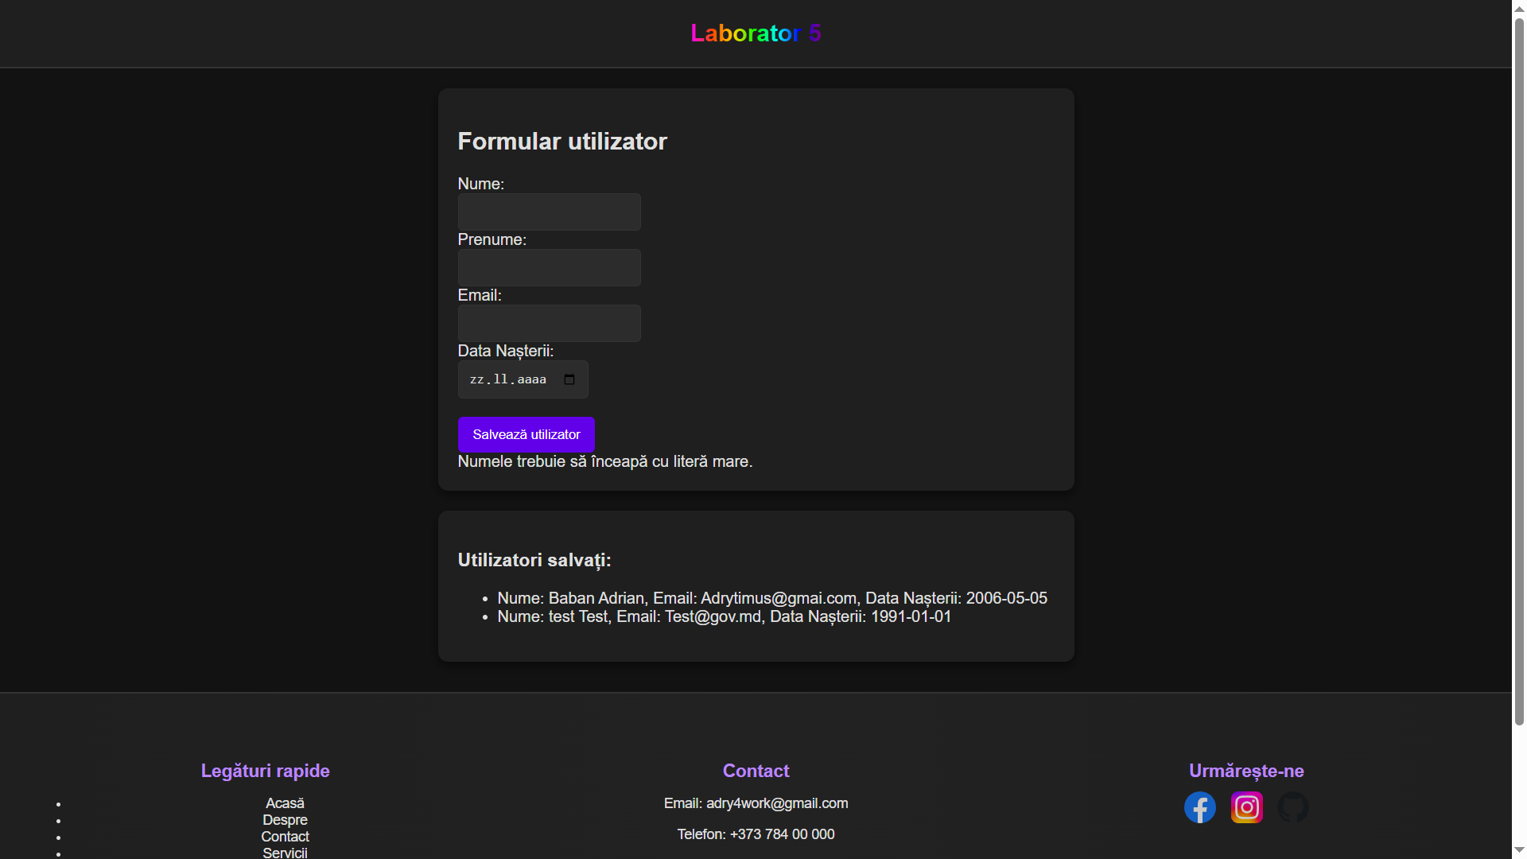

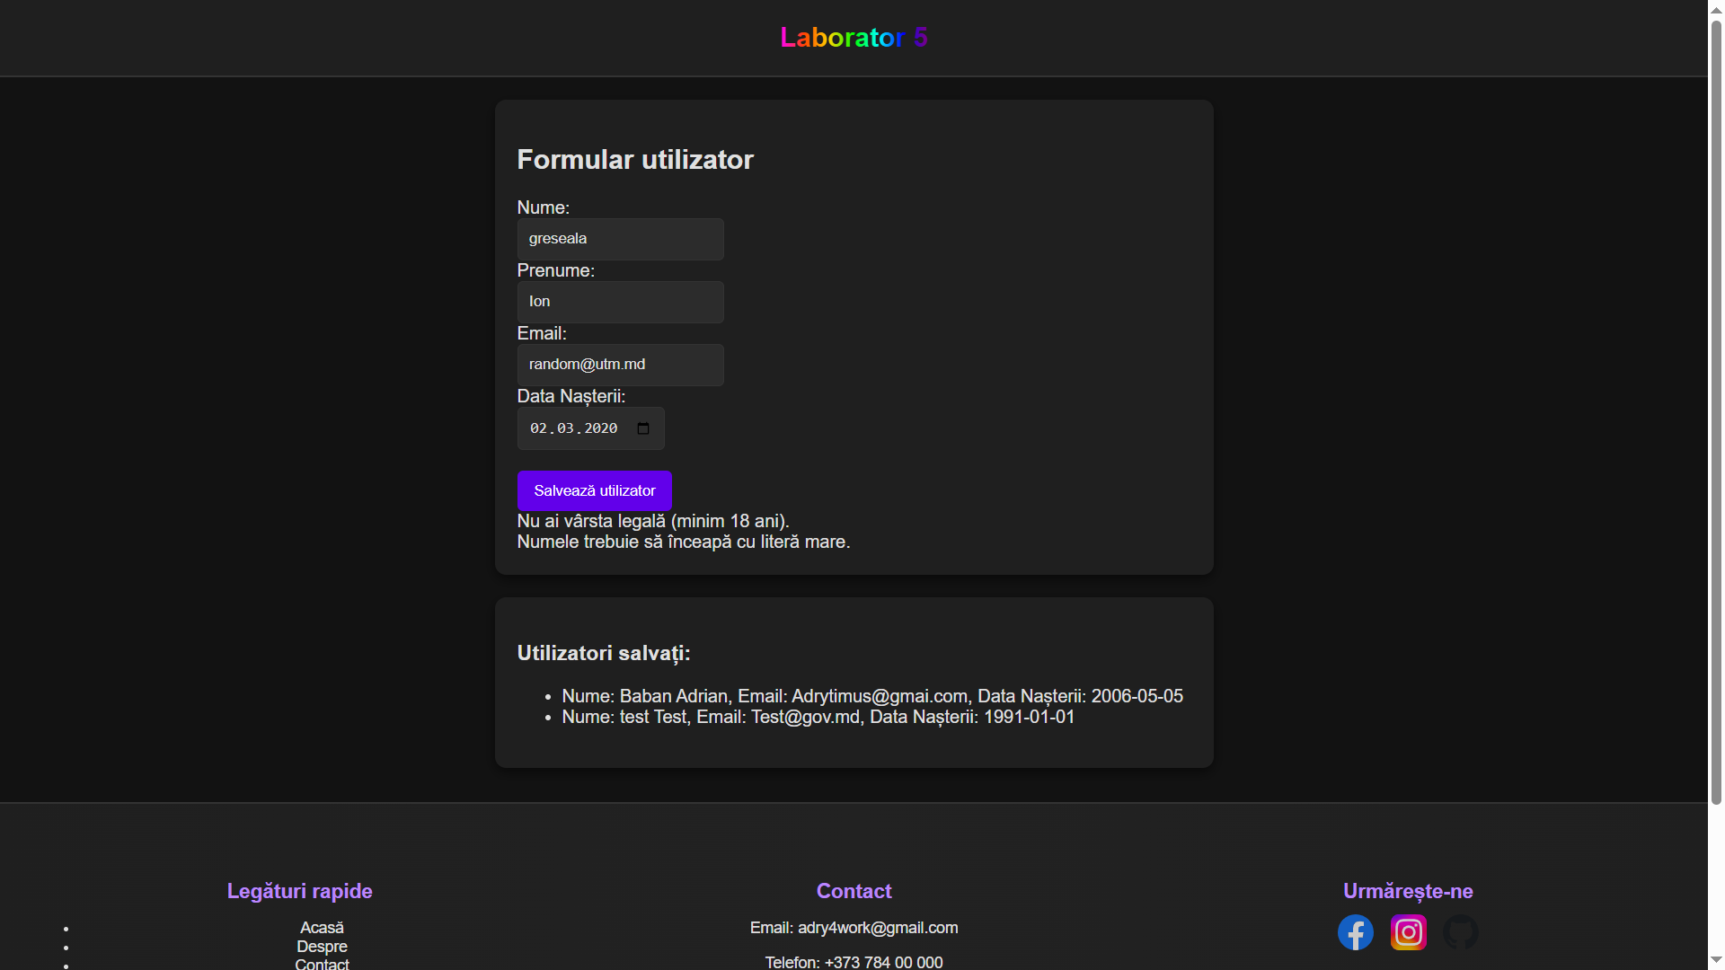

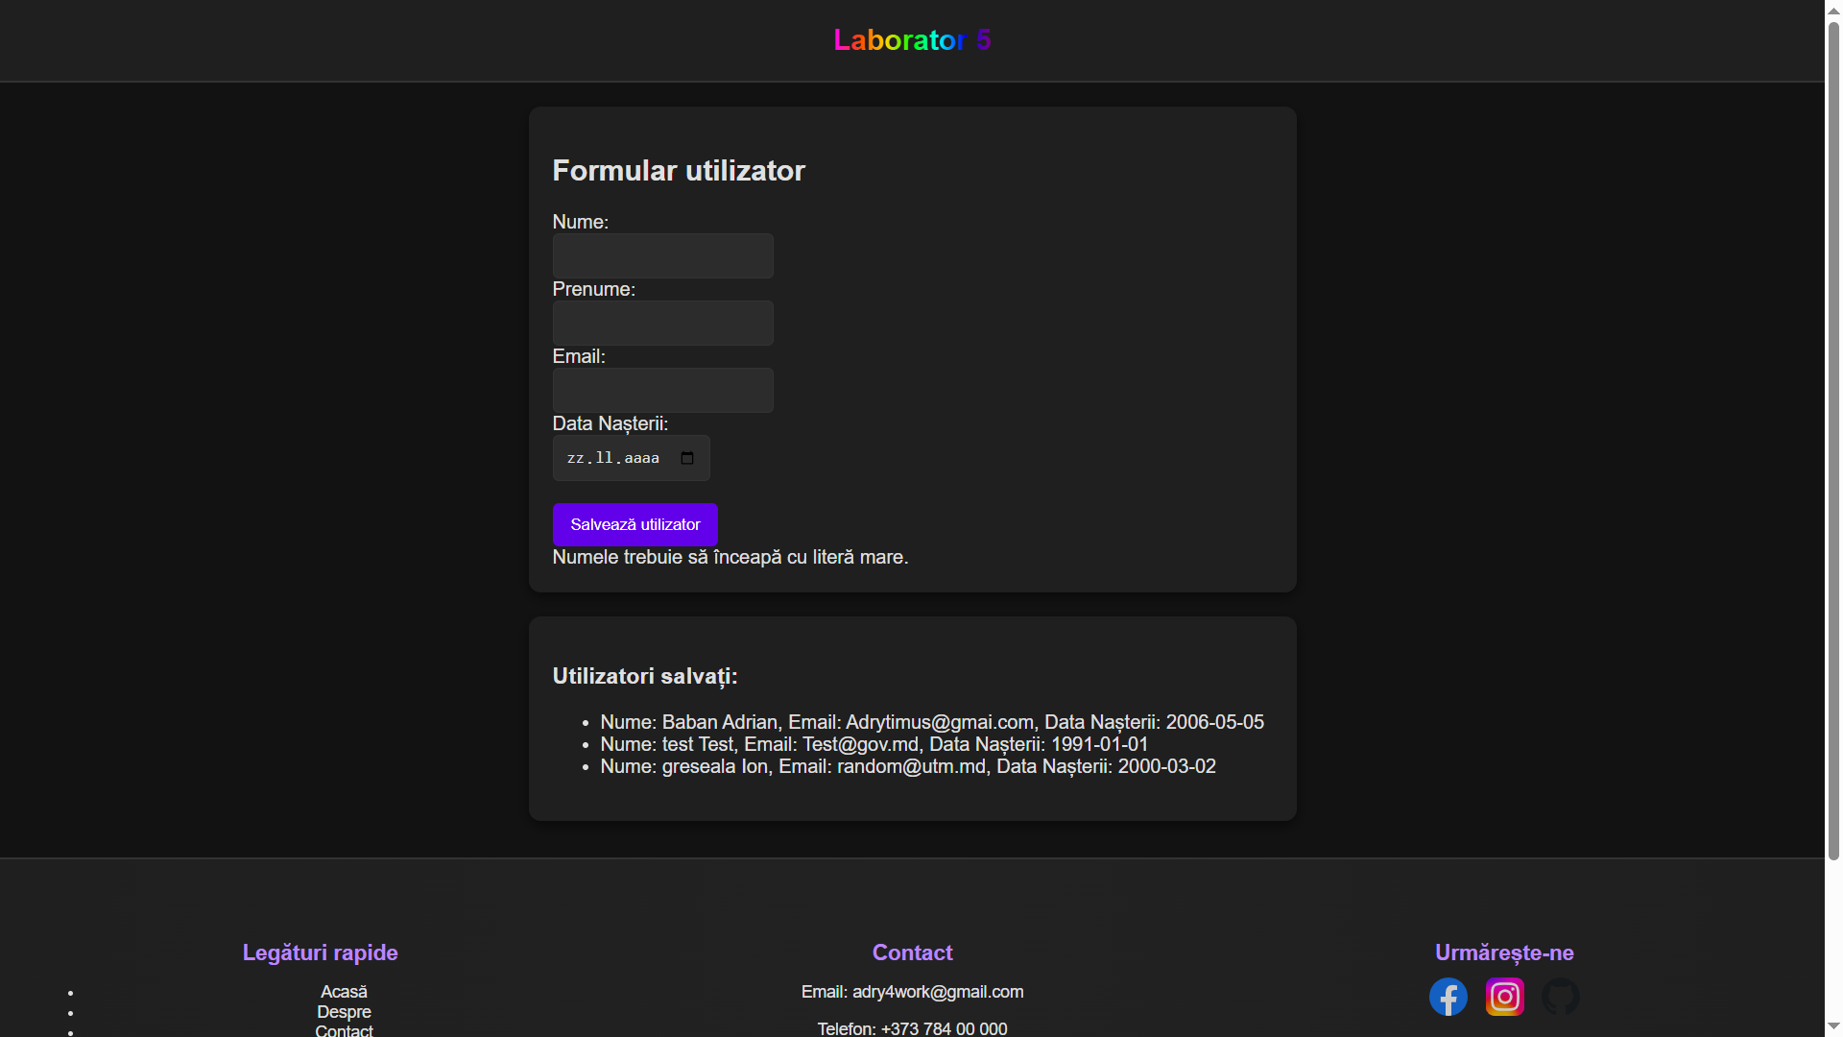**Concluzie:**

La aceasta lucrare de laborator am invatat a face un site html care

Care verifica un formular, varsta persoanei si gramatica.  
Datele sunt salvate in browser local