# Ministerul Educatiei si cercetarii al Republicii Moldova

Colegiul Universității tehnice A Republicii Moldovei

Specialitatea: „Programarea și Analiza Produselor Program”

**Raport**

Studiu Individual Nr.3

Tema:”Elaborarea unui slideshow și integrarea lui în pagina web”

Disciplina: „Asistență pentru programarea client-side a site-urilor WEB”

|  |
| --- |
| A Efectuat: |
| Baban Adrian |
| A verificat: |
| Alexandru Negară |

Chisinau 2025

**Sarcinile:**

**##1 studiu3.html.**

<!DOCTYPE html>

<html lang="en">

<head>

  <meta charset="UTF-8">

  <meta name="viewport" content="width=device-width, initial-scale=1.0">

  <title>Image Slideshow</title>

  <link rel="stylesheet" href="styles.css">

  <link rel="stylesheet" href="slideshow.css">

</head>

<body>

  <header>

    <h1>Slideshow cu Imagini</h1>

  </header>

  <div class="slideshow-container">

    <span class="prev" onclick="prevImage()">&#10094;</span>

    <img id="currentImage" src="" alt="Slideshow Image" width=100%>

    <span class="next" onclick="nextImage()">&#10095;</span>

  </div>

  <div class="dots"></div>

  <footer>

    <div class="footer-container">

        <div class="footer-section">

            <h3>Legături rapide</h3>

            <ul>

                <li><a href="../main.html">Acasă</a></li>

                <li><a href="#">Despre</a></li>

                <li><a href="#">Contact</a></li>

                <li><a href="#">Servicii</a></li>

                <li><a href="#">Politica de confidențialitate</a></li>

            </ul>

        </div>

        <div class="footer-section">

            <h3>Contact</h3>

            <p>Email: <a href="mailto:adry4work@gmail.com">adry4work@gmail.com</a></p>

            <p>Telefon: +373 784 00 000</p>

        </div>

        <div class="footer-section">

            <h3>Urmărește-ne</h3>

            <div class="social-icons">

                <a href="https://www.facebook.com/Adry.baban"><img src="https://upload.wikimedia.org/wikipedia/commons/5/51/Facebook_f_logo_%282019%29.svg" alt="Facebook"></a>

                <a href="https://www.instagram.com/mr_void26"><img src="https://upload.wikimedia.org/wikipedia/commons/9/95/Instagram_logo_2022.svg" alt="Instagram"></a>

                <a href="https://github.com/MrVoid10"><img src="https://upload.wikimedia.org/wikipedia/commons/9/91/Octicons-mark-github.svg" alt="GitHub"></a>

            </div>

        </div>

    </div>

    <p class="footer-bottom">&copy; 2025 Pagina Responsivă - Toate drepturile rezervate</p>

  </footer>

  <script src="script.js"></script>

  <script src="../extra_cod/taste.js"></script>

</body>

</html>

**##2 script.js (Functiile ce fac ca slideshow sa mearga)**

// JSON care Teoretic trebuie primit de site

const imageData = {

  "images": [

    "images/evening.jpeg",

    "images/firewatch.jpg",

    "images/winter.jpg",

    "https://wallpapersmug.com/download/3840x2160/11a3dc/firewatch-game-sunset-artwork.jpg"

  ]

};

// Create dots and initialize the slideshow

const dotsContainer = document.querySelector('.dots');

const currentImage = document.getElementById('currentImage');

const DEFAULT_INTERVAL  = 3000;

const COOLDOWN_INTERVAL = 5000;

let currentIndex = 0;

let slideInterval;

let isCooldown = false;

function createDots() {

  imageData.images.forEach((_, index) => {

    const dot = document.createElement('div');

    dot.classList.add('dot');

    dot.addEventListener('click', () => showImage(index));

    dotsContainer.appendChild(dot);

  });

  updateDots();

}

function showImage(index) {

  currentImage.src = imageData.images[index];

  currentIndex = index;

  updateDots();

}

function updateDots() {

  const dots = document.querySelectorAll('.dot');

  dots.forEach((dot, index) => {

    dot.classList.toggle('active', index === currentIndex);

  });

}

function nextImage() {

  currentIndex = (currentIndex + 1) % imageData.images.length;

  showImage(currentIndex);

  if (isCooldown) {

    isCooldown = false;

    resetSlideInterval(undefined, true); // seteaza la timpul default

  }

}

function prevImage() {

  currentIndex = (currentIndex - 1 + imageData.images.length) % imageData.images.length;

  showImage(currentIndex);

  if (!isCooldown) {

    isCooldown = true;

    resetSlideInterval(COOLDOWN_INTERVAL, true); // pauza pentru 5 secunde, dupa reincepe cu default secunde slide-show-ul

  }

}

function resetSlideInterval(delay = DEFAULT_INTERVAL, resetToNormal = false) {

  clearInterval(slideInterval);

  slideInterval = setInterval(() => {

    nextImage();

    if (resetToNormal) {

      resetSlideInterval();

      isCooldown = false;

    }

  }, delay);

}

// Initialize slideshow

createDots();

showImage(currentIndex);

// Start auto-slideshow

resetSlideInterval();

**##3 slideshow.css (Grafica la slideshow)**

/* Basic styles */

.slideshow-container {

  position: relative;

  max-width: 65%;

  margin: auto;

  text-align: center;

}

.dots {

  text-align: center;

  padding: 10px;

}

.dot {

  display: inline-block;

  height: 15px;

  width: 15px;

  margin: 0 2px;

  background-color: #bbb;

  border-radius: 50%;

  cursor: pointer;

}

.active {

  background-color: #5050f0;

}

.prev, .next {

  cursor: pointer;

  position: absolute;

  top: 50%;

  width: auto;

  padding: 16px;

  margin-top: -22px;

  color: white;

  font-weight: bold;

  font-size: 18px;

  transition: 0.6s ease;

  border-radius: 0 3px 3px 0;

  user-select: none;

}

.next {

  right: 0;

  border-radius: 3px 0 0 3px;

}

.prev {

  left: 0;

  border-radius: 3px 0 0 3px;

}

**##4 style.css (formatarea a siteului complet)**

body {

  font-family: Arial, sans-serif;

  margin: 0;

  padding: 0;

  background-color: #121212;

  color: #e0e0e0;

}

header {

  background-color: #1f1f1f;

  padding: 20px;

  text-align: center;

  border-bottom: 2px solid #333;

}

h1 {

  margin: 0;

  font-size: 24px;

  display: inline-block;

  background: linear-gradient(90deg, #ff00ff, #ff4500, #ffd700, #00ff00, #00ffff, #0000ff, #800080);

  background-clip: text;

  -webkit-background-clip: text;

  -webkit-text-fill-color: transparent;

  background-size: 100% 100%;

}

@keyframes gradientAnimation {

  0% { background-position: 0% 50%; }

  50% { background-position: 100% 50%; }

  100% { background-position: 0% 50%; }

}

ul {

  list-style: none;

  padding: 0;

  margin: 0;

  width: auto;

  max-width: none;

}

footer {

  background: linear-gradient(90deg, #1f1f1f, #222, #1f1f1f);

  text-align: center;

  padding: 20px 0;

  margin-top: 30px;

  border-top: 2px solid #333;

  font-size: 14px;

}

.footer-container {

  display: flex;

  justify-content: space-around;

  flex-wrap: wrap;

  padding: 20px;

  max-width: 100%;

  margin: 0 auto;

}

.footer-section {

  flex: 1;

  display: inline-block;

  min-width: auto;

  margin: 10px;

}

.footer-section h3 {

  font-size: 18px;

  margin-bottom: 10px;

  color: #bb86fc;

}

.footer-section a {

  color: #e0e0e0;

  text-decoration: none;

  transition: color 0.3s ease;

}

.footer-section a:hover {

  color: #03dac6;

  text-decoration: underline;

}

.social-icons {

  display: flex;

  justify-content: center;

  gap: 15px;

  margin-top: 10px;

}

.social-icons img {

  width: 32px;

  height: 32px;

  transition: transform 0.3s ease, filter 0.3s ease;

  filter: brightness(0.8);

}

.social-icons img:hover {

  transform: scale(1.1);

  filter: brightness(1);

}

.footer-bottom {

  margin-top: 20px;

  font-size: 12px;

  color: #aaa;

  padding-top: 10px;

  border-top: 1px solid #444;

}

/* iPhone-uri mici (SE, 5, 5S) */

@media only screen and (max-width: 375px) {

  body {background-color: #44ff44;}

}

/* iPhone-uri medii (6, 7, 8, X, 11, 12 Mini) */

@media only screen and (max-width: 430px) and (max-height: 932px) {

  body {background-color: #00ff00;}

}

/* iPhone-uri mari (Pro Max, 14 Plus) */

@media only screen and (min-width: 431px) and (max-width: 480px) {

  body {background-color: #cc0000;}

}

/* iPad-uri (portret) */

@media only screen and (min-width: 768px) and (max-width: 1024px) and (orientation: portrait) {

  body {background-color: #ff9900;}

}

/* iPad-uri (landscape) */

@media only screen and (min-width: 768px) and (max-width: 1366px) and (orientation: landscape) {

  body {background-color: #ffcc00;}

}

/* Telefoane (portrait) - Android & iOS */

@media only screen and (max-width: 600px) and (orientation: portrait) {

  body {background-color: #ff0000;}

}

/* Telefoane (landscape) - Android & iOS */

@media only screen and (max-width: 900px) and (orientation: landscape) {

  body {background-color: #ff66b2;}

}

/* Tablete Android & iPad (portrait) */

@media only screen and (min-width: 601px) and (max-width: 900px) and (orientation: portrait) {

  body {background-color: #ff8800;}

}

/* Tablete Android & iPad (landscape) */

@media only screen and (min-width: 601px) and (max-width: 1200px) and (orientation: landscape) {

  body {background-color: #ffff00;}

}

**##5 Navigarea unui utilizator.**

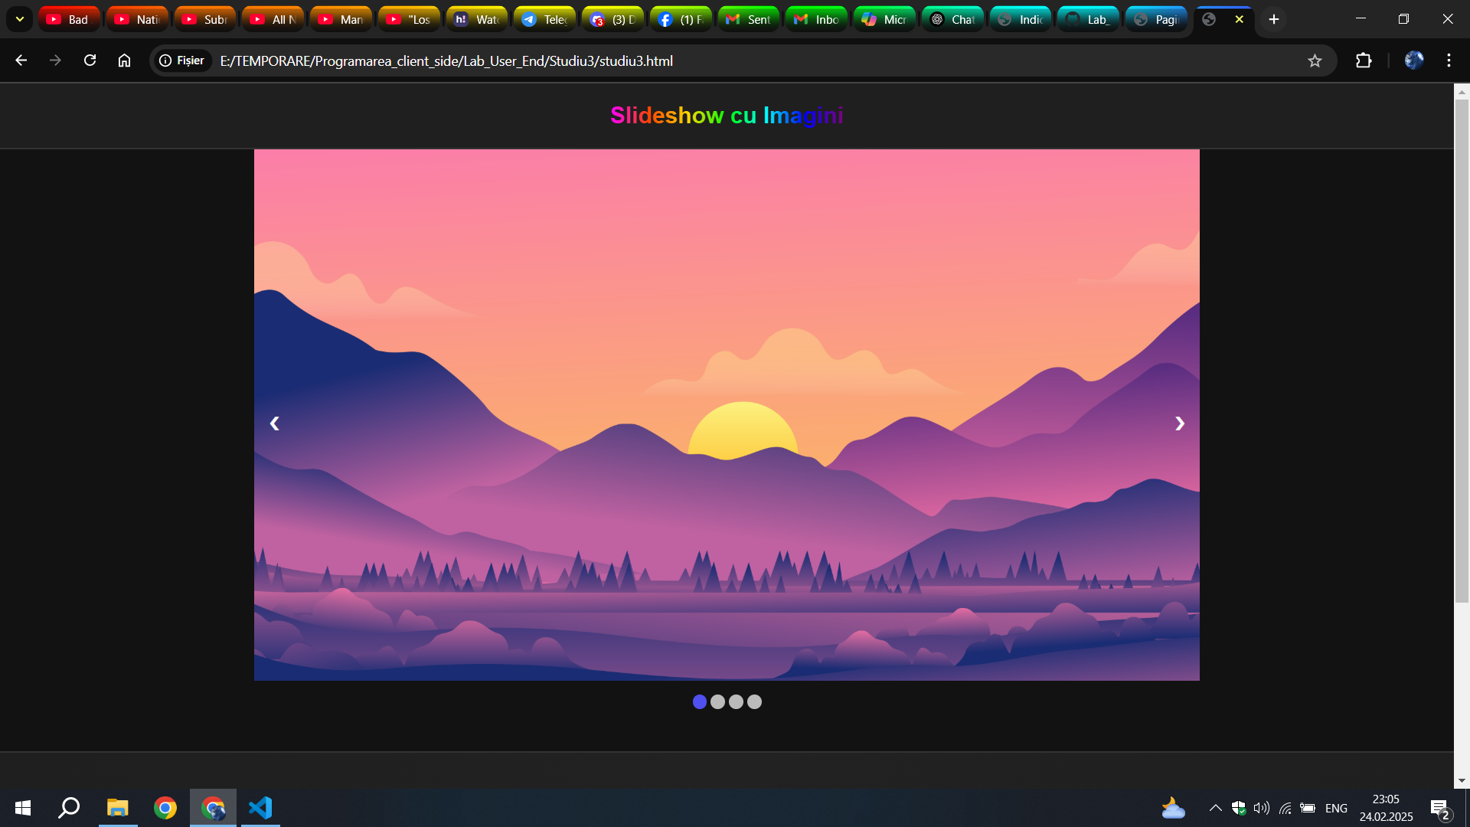

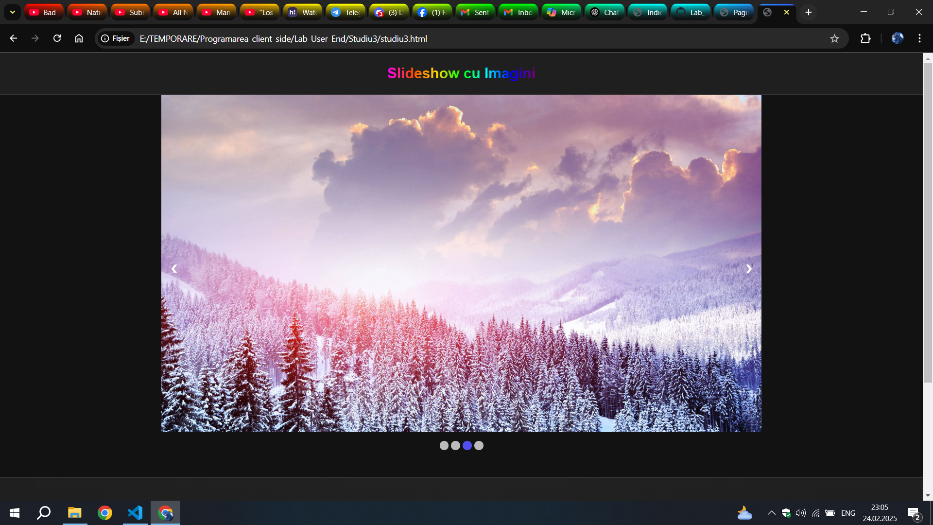

**Concluzie:**

La aceast Studiu Individual, am învățat să creez un site web care are un slideshow care poate avea un numar n de imagini(locale sau WEB).

SlideShow-ul are 2 butoane principale, care de dat imaginea inapoi si de schimbat cu urmatoarea.  
Mai sunt si cerculetele de mai jos de imagine care indica a cata imagine este, dar este posibil de dat clic pe un cerculet si va selecta imanica cutare.