# Ministerul Educatiei si cercetarii al Republicii Moldova

Colegiul Universității tehnice A Republicii Moldovei

Specialitatea: „Programarea și Analiza Produselor Program”

**Raport**

Studiu Individual Nr.4

Tema:” Elaborarea unui formular web care include validare dinamică”

Disciplina: „Asistență pentru programarea client-side a site-urilor WEB”

|  |
| --- |
| A Efectuat: |
| Baban Adrian |
| A verificat: |
| Alexandru Negară |

Chisinau 2025

**Sarcinile:**

**##1 studiu4.html (codul principal al formularului)**

<body>

  <header><h1 class="centered-text">Contact Us</h1></header>

  <form id="contactForm" class="centered-text form-container" enctype="multipart/form-data">

    <div class="form-group">

      <label for="name">Name:</label>

      <input type="text" id="name" name="name" required>

    </div>

    <div class="form-group">

      <label for="email">Email:</label>

      <input type="email" id="email" name="email" required>

    </div>

    <div class="form-group">

      <label for="phone">Phone:</label>

      <input type="tel" id="phone" name="phone">

    </div>

    <div class="form-group">

      <label for="newsletter">Subscribe to Newsletter:</label>

      <input type="checkbox" id="newsletter" name="newsletter">

    </div>

    <div class="form-group">

      <label>Preferred Contact Method:</label>

      <input type="radio" id="email_contact" name="contact_method" value="email" checked>

      <label for="email_contact">Email</label>

      <input type="radio" id="phone_contact" name="contact_method" value="phone">

      <label for="phone_contact">Phone</label>

    </div>

    <div class="form-group">

      <label for="category">Category:</label>

      <select id="category" name="category">

        <option value="general">General Inquiry</option>

        <option value="support">Support</option>

        <option value="feedback">Feedback</option>

      </select>

    </div>

    <div class="form-group">

      <label for="file_upload">Upload File:</label>

      <input type="file" id="file_upload" name="file_upload">

    </div>

    <div class="form-group">

      <button type="button" onclick="submitForm()">Submit</button>

    </div>

  </form>

**##2 script.js (Functiile ce fac formularul sa mearga)**

  <script>

    async function submitForm() {

      const form = document.getElementById('contactForm');

      const formData = new FormData(form);

      try {

        const response = await fetch('/submit_contact_form', {

          method: 'POST',

          body: formData

        });

        if (!response.ok) {

          throw new Error(`Eroare server: ${response.status} ${response.statusText}`);

        }

        const result = await response.json();

        alert(result.message);

      } catch (error) {

        alert("Nu s-a putut trimite formularul către server. Verifică conexiunea la internet sau încearcă din nou.");

        console.error("Eroare la trimiterea formularului:", error);

      }

    }

  </script>

**##3 styles.css (Principalul la formular)**

.form-container {

  display: flex;

  flex-direction: column;

  align-items: center;

  background-color: #1d1d1d;

  padding: 20px;

  border-radius: 10px;

  box-shadow: 0 4px 8px rgba(0, 0, 0, 0.5);

  width: 600px;

  max-width: 60%;

  margin: 0 auto;

}

.form-group {

  margin-bottom: 15px;

  width: 90%;

  text-align: left;

}

.form-group label {

  display: block;

  color: #e0e0e0;

  margin-bottom: 5px;

}

.form-group input,

.form-group select {

  width: 90%;

  padding: 10px;

  border: 1px solid #333;

  border-radius: 5px;

  background-color: #2c2c2c;

  color: #e0e0e0;

}

.form-group input[type="checkbox"],

.form-group input[type="radio"] {

  width: auto;

  margin-right: 5px;

}

.form-group button {

  background-color: #6200ea;

  color: #fff;

  border: none;

  padding: 10px 20px;

  border-radius: 5px;

  cursor: pointer;

}

.form-group button:hover {

  background-color: #3700b3;

}

.action_button {

  background-color: #6200ea;

  color: #fff;

  border: none;

  padding: 10px 20px;

  border-radius: 5px;

  cursor: pointer;

}

.action_button:hover {

  background-color: #3700b3;

}

**##5 Navigarea unui utilizator.**

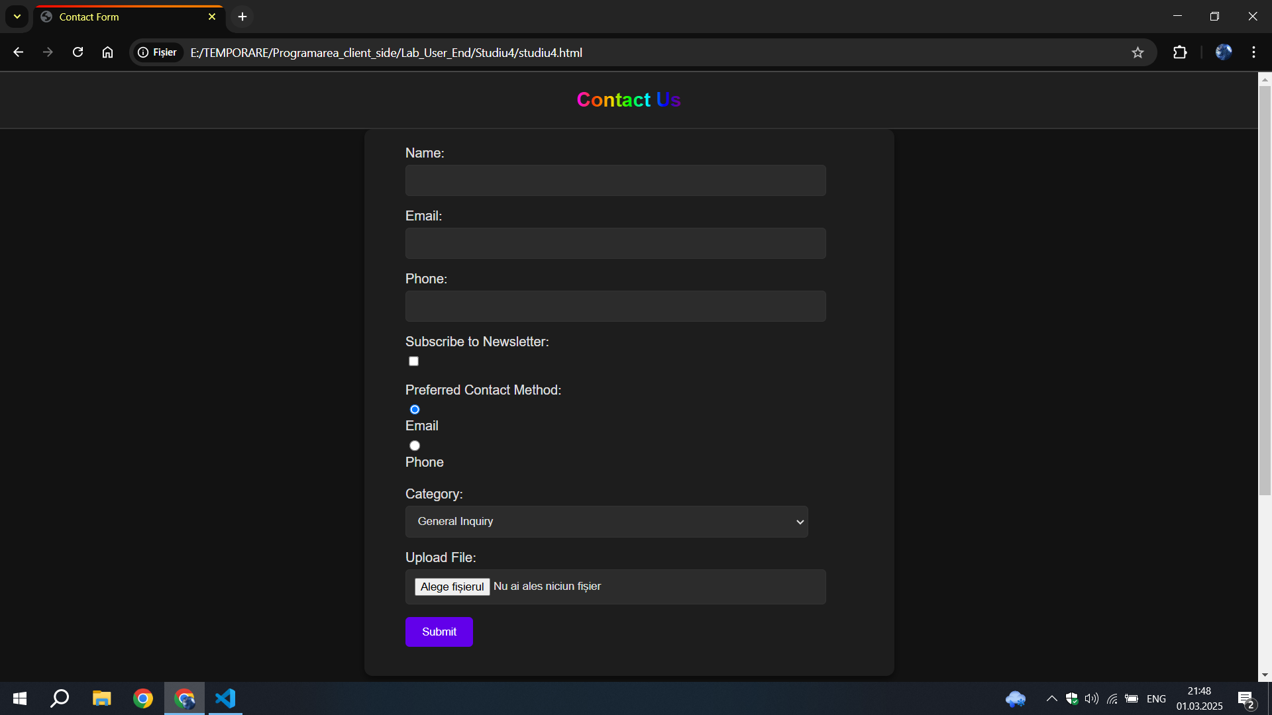

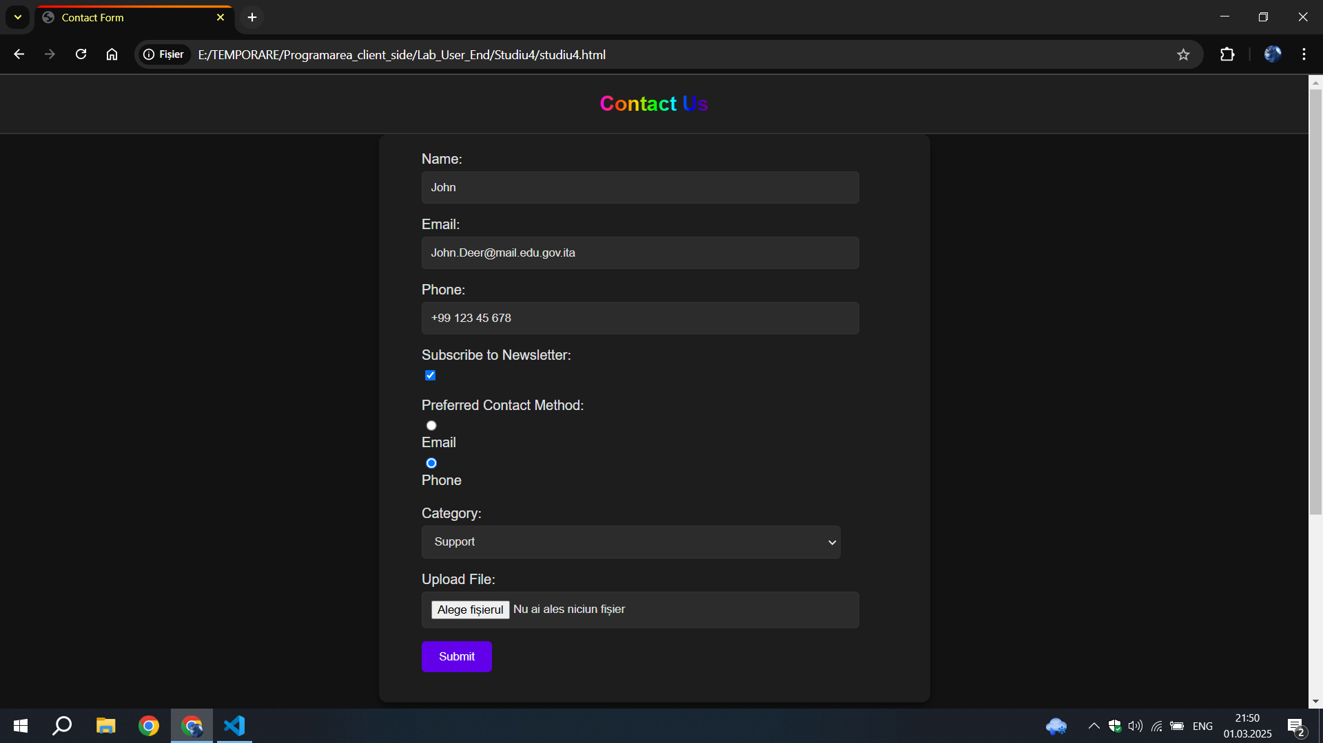

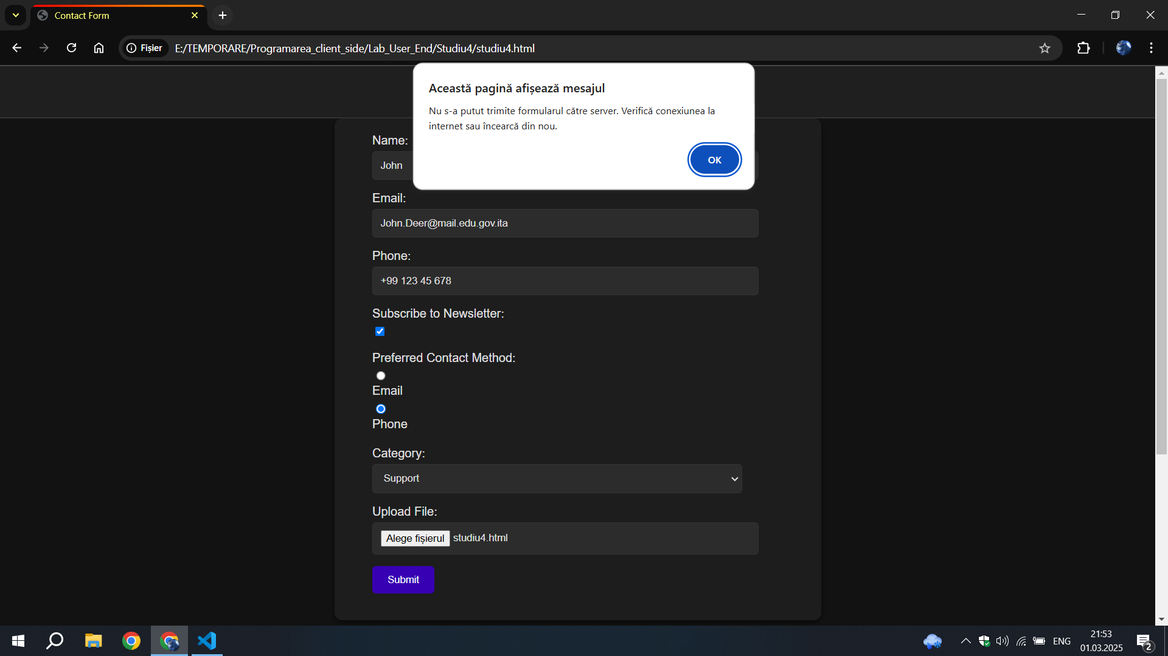

**Concluzie:**

La aceast Studiu Individual, am învățat să creez un site web care are un formular care poate transmite atat date in format json cat si fisiere.

Validarea este facuta local utilizand clasele default html precum email,

Si fa fi afisat un mesaj in caz de formularul nu a fost putut transmite