# (Ministerul Educatiei si cercetarii al Republicii Moldova)

Colegiul Universității tehnice A Republicii Moldovei

Specialitatea: „Programarea și Analiza Produselor Program”

**Raport**

Laboratorul Nr.3

Disciplina: „Asistență pentru programarea Vizuală”

|  |
| --- |
| A Efectuat: |
| Baban Adrian |
| A verificat: |
| Alexandru Negară |

Chisinau 2025

**Sarcinile:**

**##1 Form1.cs (cod incomplet)**

using System;

using System.Collections.Generic;

using System.ComponentModel;

using System.Data;

using System.Drawing;

using System.Linq;

using System.Text;

using System.Threading.Tasks;

using System.Windows.Forms;

using static System.Windows.Forms.VisualStyles.VisualStyleElement;

namespace Laborator4

{

    public partial class MenuForm: Form

    {

        public MenuForm()

        {

            InitializeComponent();

        }

        private void newToolStripMenuItem_Click(object sender, EventArgs e)

        {

            System.Diagnostics.Process.Start("notepad");

            //se va deschide aplicația NotePad

        }

        private void boldToolStripMenuItem_Click(object sender, EventArgs e)

        {

            boldToolStripMenuItem.Checked = boldToolStripMenuItem.Checked;

            TextBox1.Font = new Font(TextBox1.Font.FontFamily, 14,

            TextBox1.Font.Style ^ FontStyle.Bold);

        }

        private void blueToolStripMenuItem_Click(object sender, EventArgs e)

        {

            ClearColor();

            displayLabel.ForeColor = Color.Blue;

            redItem.Checked = true;

        }

        private void aboutItem_Click(object sender, EventArgs e)

        {

            MessageBox.Show("Exemplu de utilizare a meniurilor","Informatii", MessageBoxButtons.OK, MessageBoxIcon.Information);

        }

**##1 Form1.designer.cs (obiectele importante)**

        private void InitializeComponent(){

            this.displayLabel = new System.Windows.Forms.Label();

            this.menuStrip1 = new System.Windows.Forms.MenuStrip();

            this.fileItem = new System.Windows.Forms.ToolStripMenuItem();

            this.newToolStripMenuItem = new System.Windows.Forms.ToolStripMenuItem();

            this.clearToolStripMenuItem = new System.Windows.Forms.ToolStripMenuItem();

            this.formatTextBoxToolStripMenuItem = new System.Windows.Forms.ToolStripMenuItem();

            this.boldToolStripMenuItem = new System.Windows.Forms.ToolStripMenuItem();

            this.italicToolStripMenuItem = new System.Windows.Forms.ToolStripMenuItem();

            this.toolStripSeparator1 = new System.Windows.Forms.ToolStripSeparator();

            this.colorToolStripMenuItem1 = new System.Windows.Forms.ToolStripMenuItem();

            this.redToolStripMenuItem1 = new System.Windows.Forms.ToolStripMenuItem();

            this.greebToolStripMenuItem = new System.Windows.Forms.ToolStripMenuItem();

            this.blueToolStripMenuItem1 = new System.Windows.Forms.ToolStripMenuItem();

            this.blackToolStripMenuItem1 = new System.Windows.Forms.ToolStripMenuItem();

            this.closeToolStripMenuItem = new System.Windows.Forms.ToolStripMenuItem();

            this.editTextBoxToolStripMenuItem = new System.Windows.Forms.ToolStripMenuItem();

            this.cutToolStripMenuItem = new System.Windows.Forms.ToolStripMenuItem();

            this.copyToolStripMenuItem = new System.Windows.Forms.ToolStripMenuItem();

            this.pasteToolStripMenuItem = new System.Windows.Forms.ToolStripMenuItem();

            this.formatItem = new System.Windows.Forms.ToolStripMenuItem();

            this.colorItem = new System.Windows.Forms.ToolStripMenuItem();

            this.redItem = new System.Windows.Forms.ToolStripMenuItem();

            this.blueItem = new System.Windows.Forms.ToolStripMenuItem();

            this.greenItem = new System.Windows.Forms.ToolStripMenuItem();

            this.blackItem = new System.Windows.Forms.ToolStripMenuItem();

            this.fontItem = new System.Windows.Forms.ToolStripMenuItem();

            this.timesItem = new System.Windows.Forms.ToolStripMenuItem();

            this.courierItem = new System.Windows.Forms.ToolStripMenuItem();

            this.comicItem = new System.Windows.Forms.ToolStripMenuItem();

            this.boldItem = new System.Windows.Forms.ToolStripMenuItem();

            this.italicItem = new System.Windows.Forms.ToolStripMenuItem();

            this.regularItem = new System.Windows.Forms.ToolStripMenuItem();

            this.toolStripSeparator2 = new System.Windows.Forms.ToolStripSeparator();

            this.aboutItem = new System.Windows.Forms.ToolStripMenuItem();

            this.exitItem = new System.Windows.Forms.ToolStripMenuItem();

            this.TextBox1 = new System.Windows.Forms.TextBox();

            this.toolStripSeparator3 = new System.Windows.Forms.ToolStripSeparator();

            this.menuStrip1.SuspendLayout();

            this.SuspendLayout();}

**##3 Vizual dupa compilare**

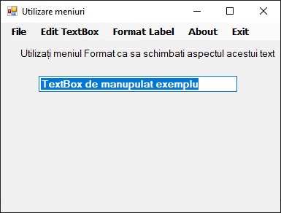

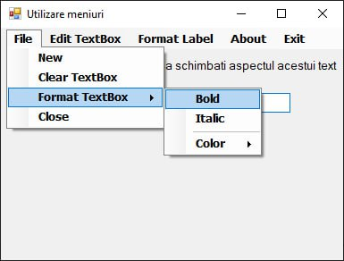

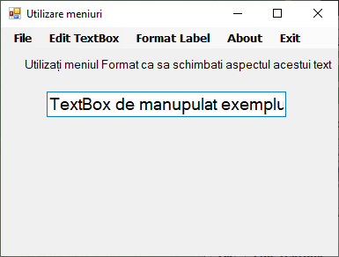

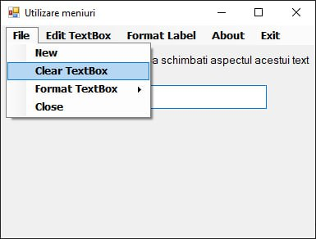

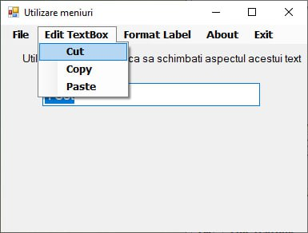

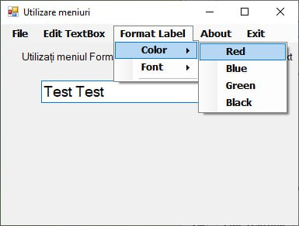

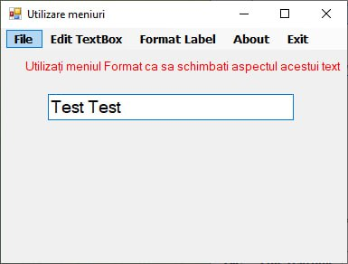

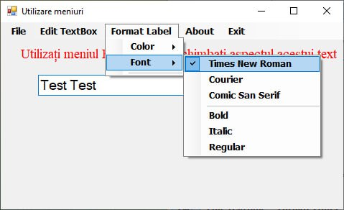

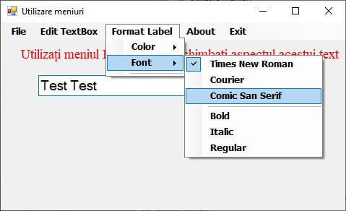

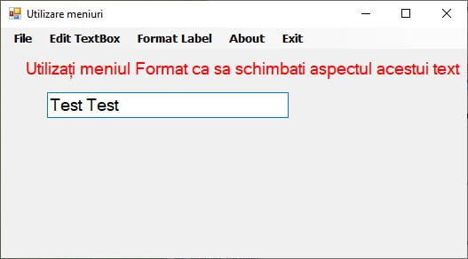

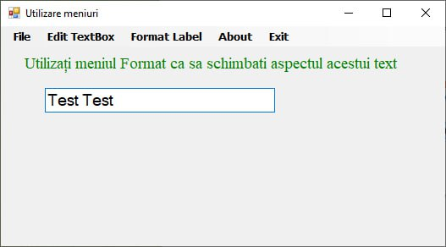

**Concluzie:**

La acesta lucrare de laborator am invatat a crea un program simplu ulilizand Windows Forms (API) parte din limbajul C#,  
Programul crează o bară de meniuri cu diferite câmpuri care manupuleaza aspectul texului, și câmpul unde utilizatorul poate introduce date

(Codul comptet pe [Github](https://github.com/MrVoid10/Lab_User_End/tree/main/Visual_Lab4))

<https://github.com/MrVoid10/Lab_User_End/tree/main/Visual_Lab4>