# HELPMATE_AI Project Report

1. **Introduction**

The HELPMATE_AI project aimed to develop a semantic search system utilizing a RAG (Retrieval-Augmented Generation) pipeline. The system was designed to extract information from PDF documents, generate vector representations, and implement a caching layer to improve performance.

1. **Objectives**
   * To develop an efficient document retrieval system with a focus on semantic search.
   * To generate structured data from PDF documents for indexing.
   * To enhance system performance with caching of queries and results.
2. **System Design**

The system was designed with a three-layer RAG pipeline.

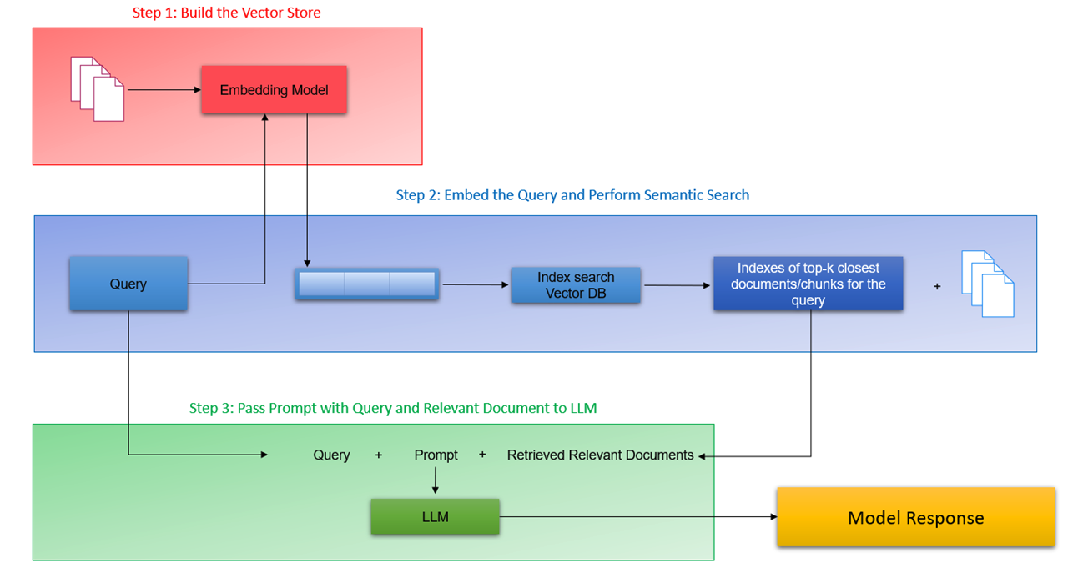

**3.1. Embedding Layer**

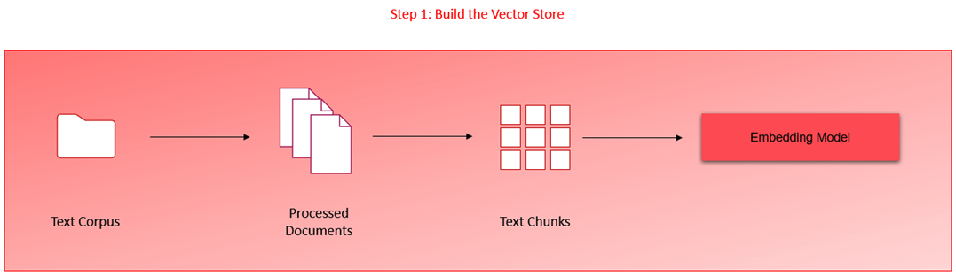

* Text and tables extracted from PDFs were converted into dataframes.
* OpenAI's text-embedding model generated vector representations stored in ChromaDB.
* Documents were processed and chunked for optimized retrieval.

**3.2. Search and Rank Layer**

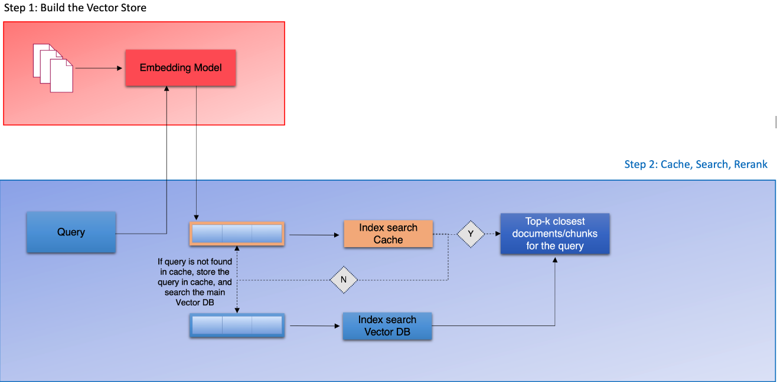

* Semantic searches performed on queries to retrieve top K relevant documents or chunks.
* A re-ranking block utilized cross-encoders to refine search accuracy.

**3.3. Generation Layer**

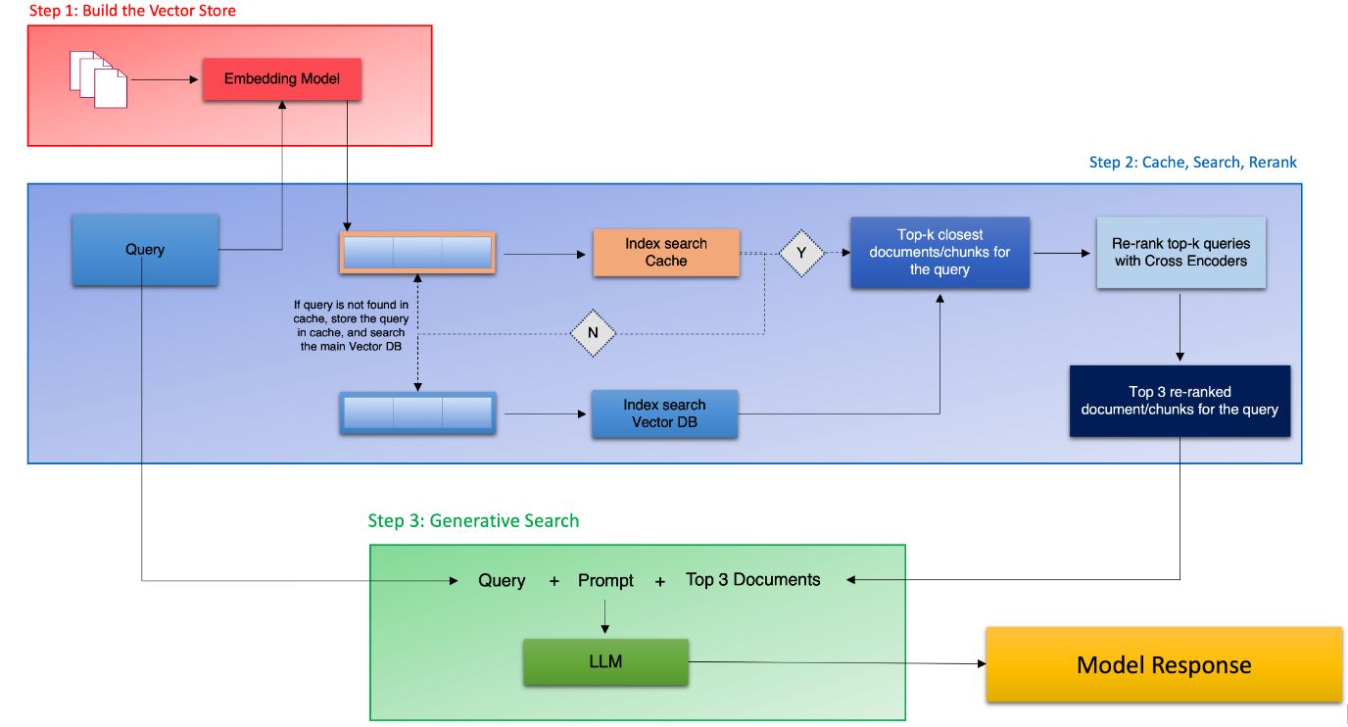

* A well-constructed prompt, including the original query and retrieved documents, was used by a language model to generate coherent responses.

**3.4. Cache Implementation**

* A cache layer with a threshold for semantic similarity was integrated.
* Queries and results were stored for quick retrieval in future searches.

1. **Implementation**

Leveraging tools like pdfplumber, tiktoken, openai, chromaDB, and sentence-transformers, we:

* Extracted and processed PDF document content.
* Generated vector embeddings.
* Implemented the RAG pipeline for semantic search.
* Developed a cache system for efficiency.

1. **Challenges and Lessons Learned**

* **Document Processing:** Efficient processing is crucial, and tools like pdfplumber are essential.
* **Semantic Search:** Optimization of search parameters and thresholds is necessary for relevancy.
* **Cache Management:** Effective cache strategies are vital for system efficiency.

1. **Conclusion**

The project achieved its objectives, with the RAG pipeline and caching layer providing a scalable and efficient solution for document retrieval and information extraction.

The project’s codebase is accessible at [HelpMateAI RAG GitHub Repository](https://github.com/MrVuTuanAnh/HELPMATE_AI/blob/main/main.ipynb).

<https://github.com/MrVuTuanAnh/HELPMATE_AI/> Branches: Main