

**Query 1 (query_1)**

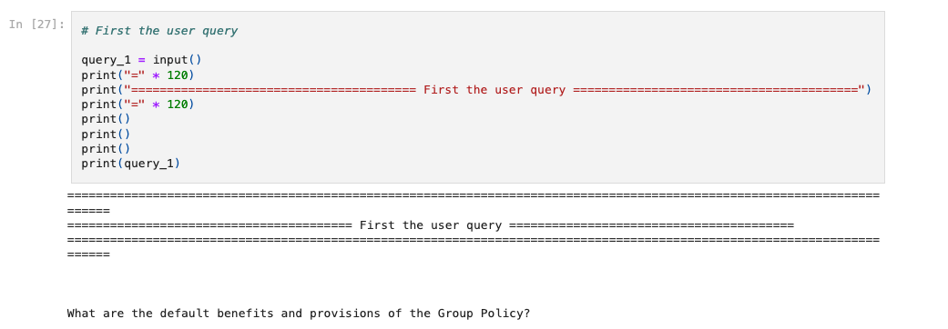

**Top 3 Results from the Search Layer**

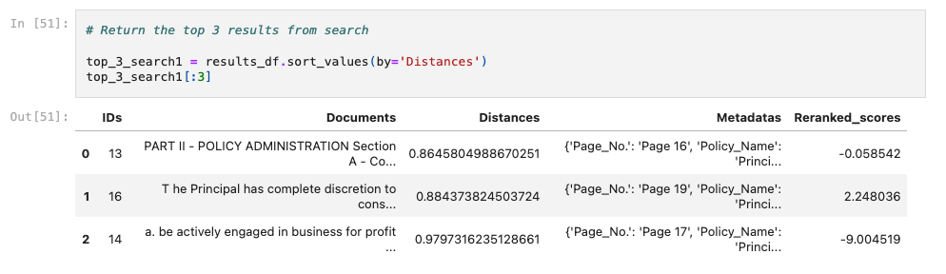

**Final Generated Answer from the Generation Layer**

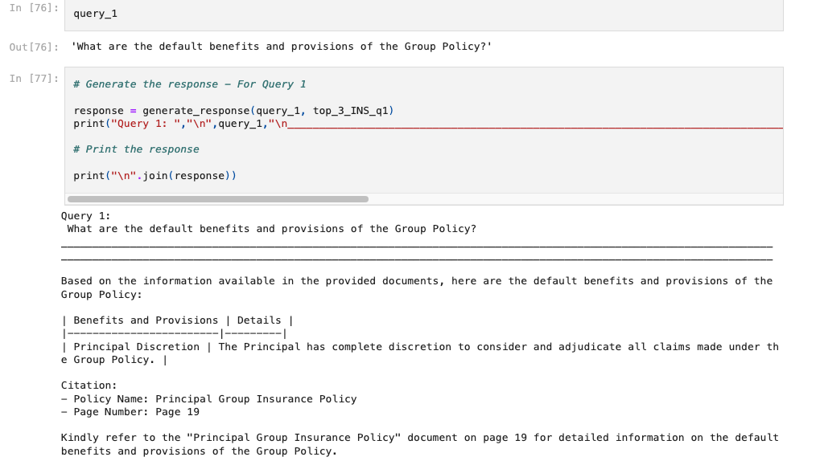

**Query 2 (query_2)**

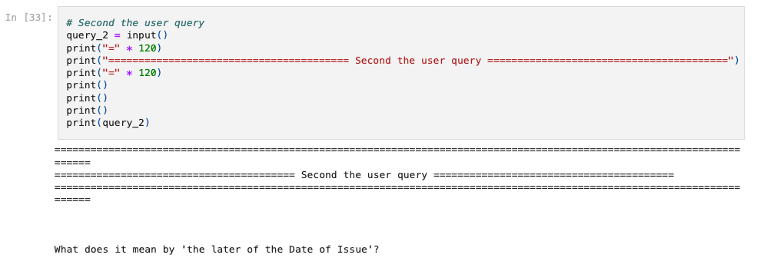

**Top 3 Results from the Search Layer**

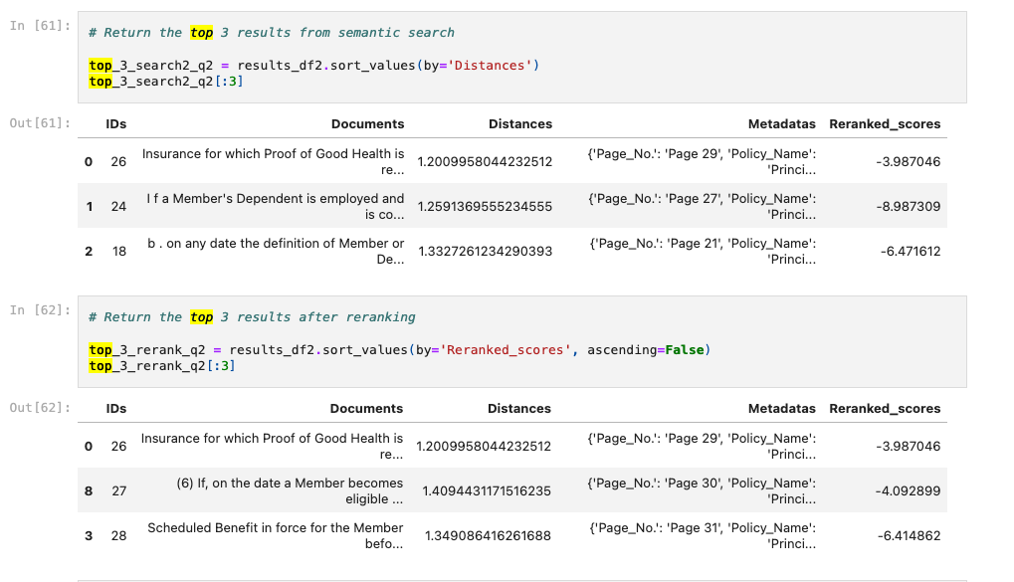

**Final Generated Answer from the Generation Layer**

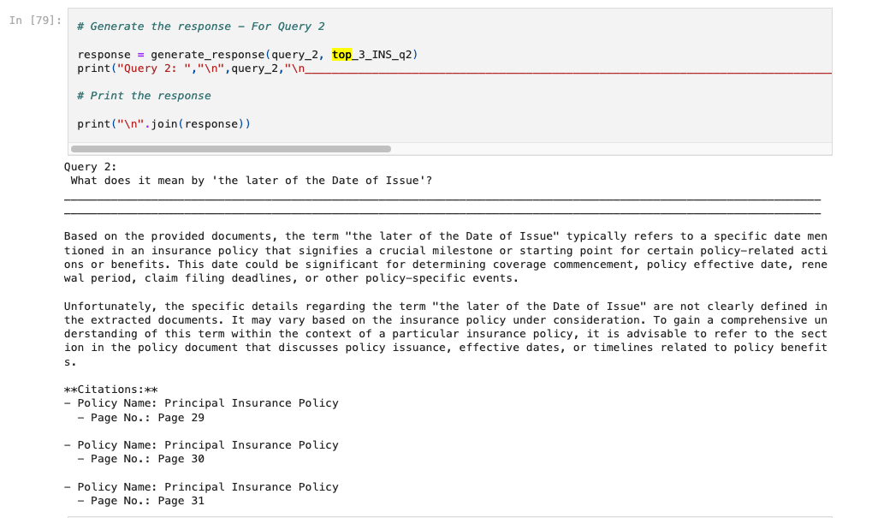

**Query 3 (query_3)**

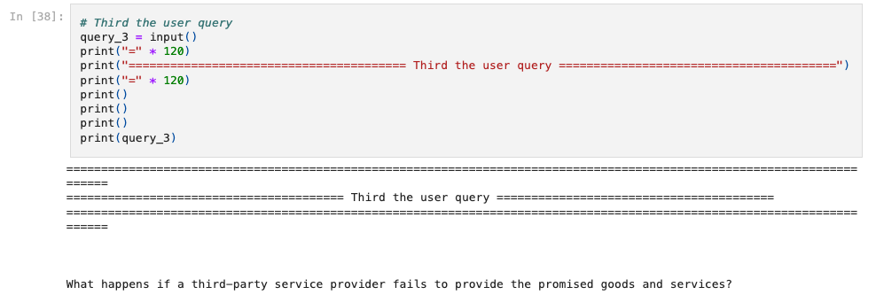

**Top 3 Results from the Search Layer**

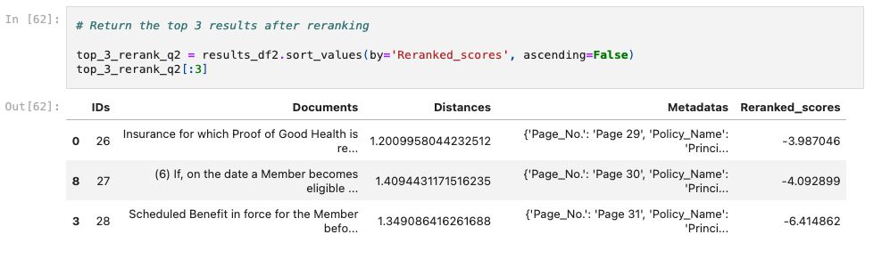

**Final Generated Answer from the Generation Layer**

