CT331 Assignment 2
Raphaël Marzat 18101202

https://github.com/MrWazzat/ct331_assignment2

Question 1 :
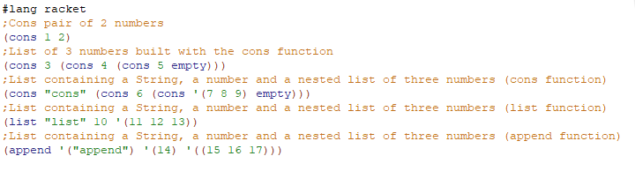
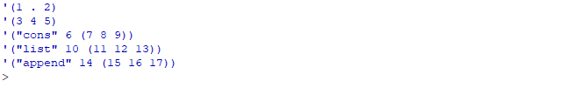
Code :
Output :
Comment :
The results are always the same. Nevertheless, when using cons, we have to "pair" everything, and if we don't want the dot before the last element, we have to pair it with an empty element.
When using the list function, everything is simpler, because we just have to pass the elements we want as arguments and it builds a list with them.
When using the append function, we have to pass all the elements as lists (because append only takes lists parameter). Thus if we want the last element to be a nested list, we have to make a list where the only element is the nested list.

Question 2:
Code :
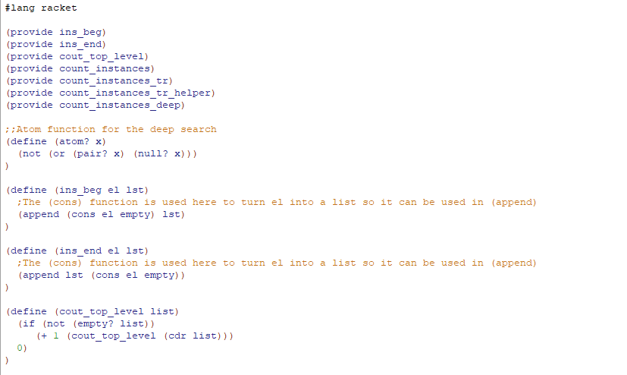
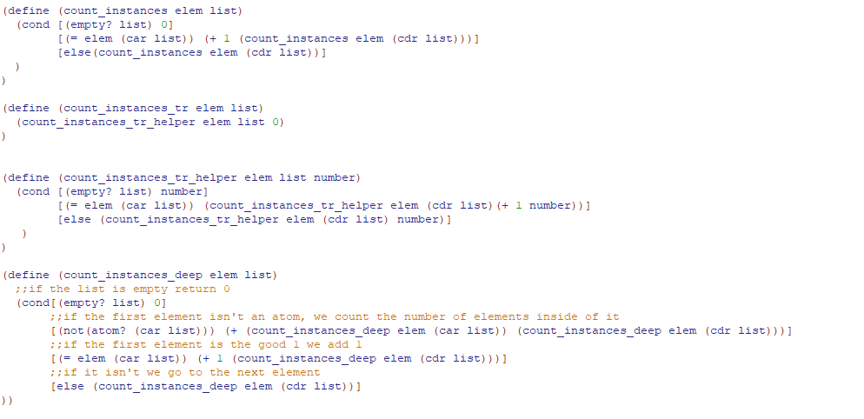

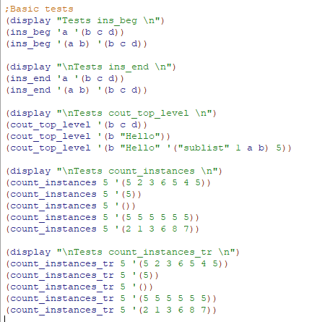
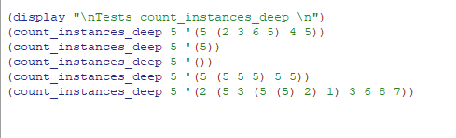

Output question 2 :
