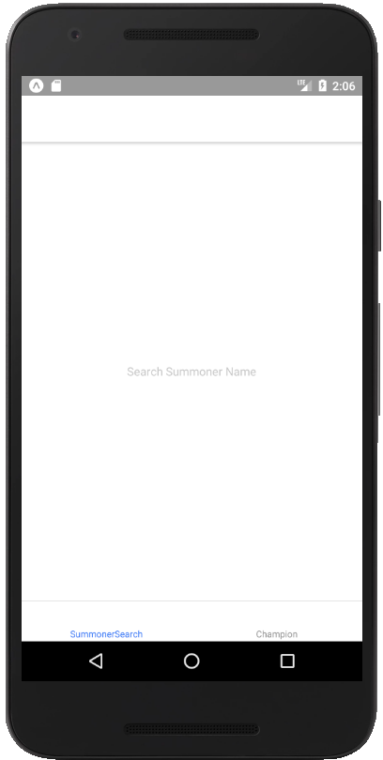

At launch you should see a simple screen for searching summoner names. There is a tab navigation bar at the bottom for Summoner and Champion screens. (Champion screen isn’t implemented. Should just say Champion)

Tap “Search Summoner Name” and type “Wedge18” (not case sensitive) and tap return. You should see the following:

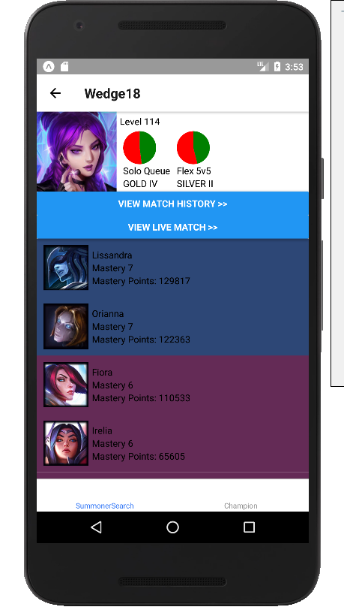

The champion list is ordered from highest mastery points to lowest.

The champion list is scrollable. At this point, switching between summoner and champion tabs should preserve the current summoner info.

Searching for a nonexistent summoner (such as “Wedge6”) should show an error alert. (Any API error will cause this to popup)

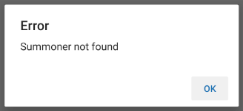

Tapping “View Match History” should bring up a screen with a list of matches after a brief loading screen.

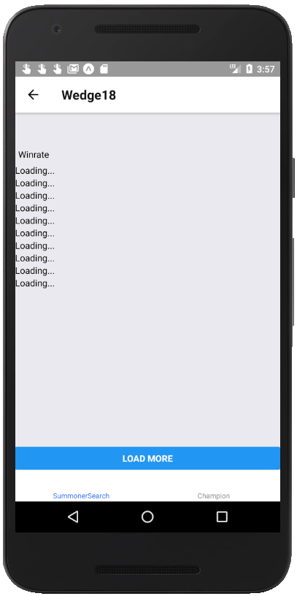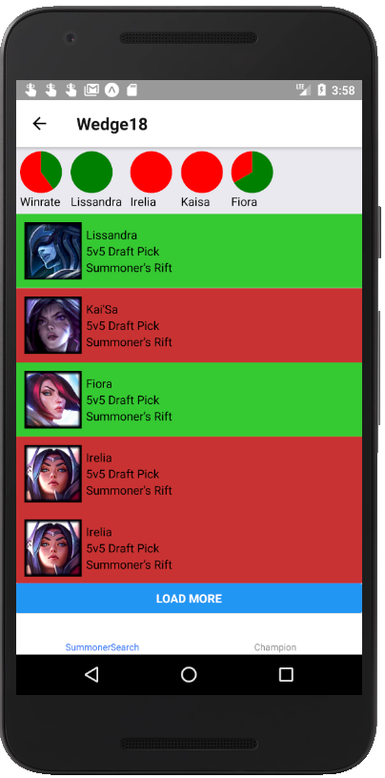

There should only be 10 matches visible at the start. Tapping “Load More” should load 10 more matches, meaning a total of 20 matches are visible. You should be able to keep tapping “Load More” to load more matches until there are no more matches left to show.

At the top there are pie charts displaying winrates for all loaded matches and for each individual champion. Champion charts can be scrolled through horizontally.

Tap on a match in the list.

You should see something similar to the following:

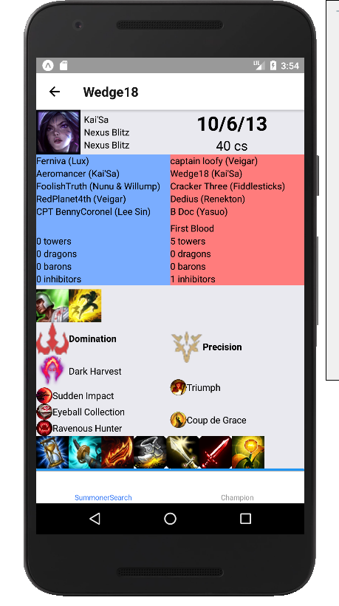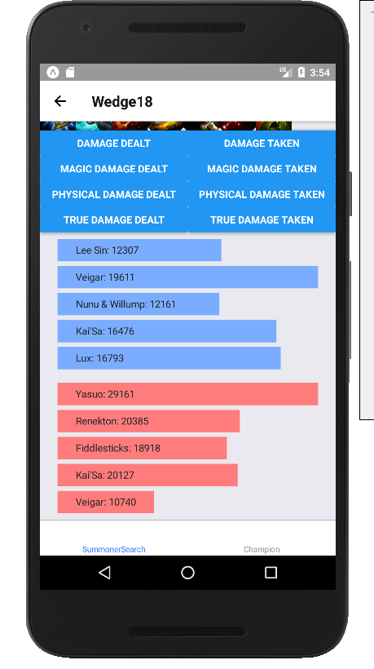

Tap the buttons above the graphs to change what information is displayed

Go back to the summoner search screen. Search for someone currently in a game. Click on View Live Match. You should see information from the current game.

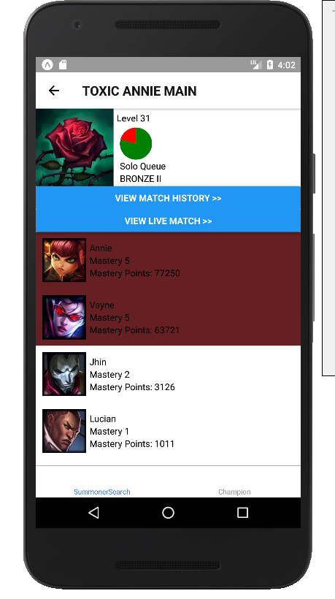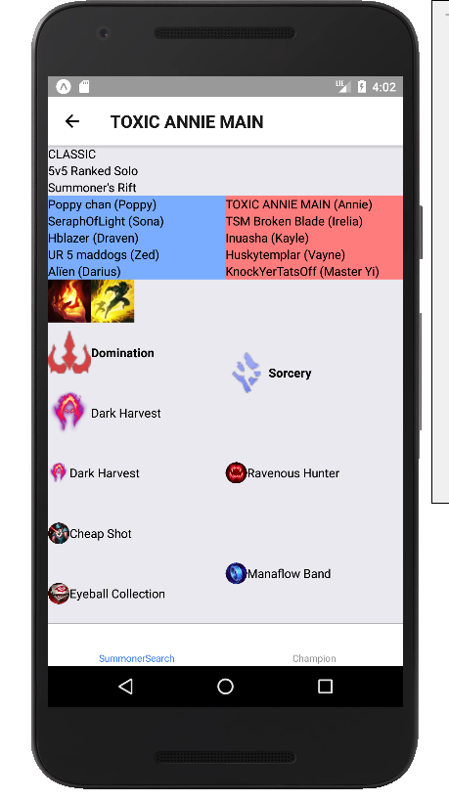

If the summoner is not in a game, you will see an error and a blank screen.

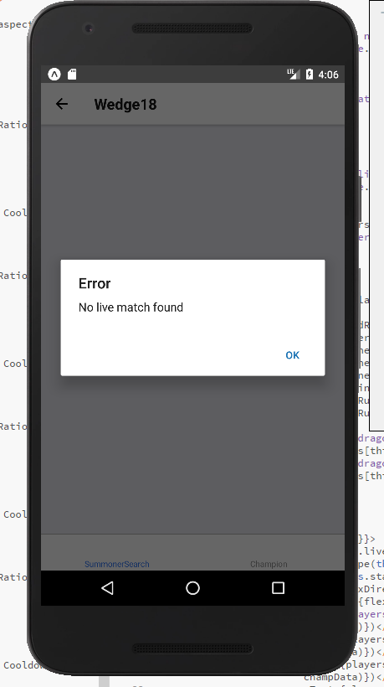

Now tap on the ‘Champion’ tab. You should see a list of all champions in alphabetical order. Tapping on a champion should open a screen with information about that individual champion including: base splash art; champion title (in italics); attack, magic, defense, and difficulty scores; and ability descriptions with cost and cooldown scalings. The splash art at the top can be scrolled horizontally to view other skins

