Pretest

David E. Wells

CS-230 Data Structures

DEWells@CapTechU.edu

# Introduction

The materials used in making this lab include: Windows 10, C++ lde(Dev-Cpp 5.11 TDM-GCC 4.9.2), Malgun Gothic( font uses “\” for a “\”). Files includes: Main.cpp, Students.cpp, Students.h, Lab1.docx

## Procedure/Methodology

#### Analysis.

**Conclusion**

References

Professor Andrew Mehri’s class files

David Wells C++ class notes

Footnotes

1Add footnotes, if any, on their own page following references. The body of a footnote, such as this example, uses the Normal text style. (Note: If you delete this sample footnote, don’t forget to delete its in-text reference as well. That’s at the end of the sample Heading 2 paragraph on the first page of body content in this template.)

Tables

Table 1

Table Title

| Column Head | Column Head | Column Head | Column Head | Column Head |
| --- | --- | --- | --- | --- |
| Row Head | 123 | 123 | 123 | 123 |
| Row Head | 456 | 456 | 456 | 456 |
| Row Head | 789 | 789 | 789 | 789 |
| Row Head | 123 | 123 | 123 | 123 |
| Row Head | 456 | 456 | 456 | 456 |
| Row Head | 789 | 789 | 789 | 789 |

Note: Place all tables for your paper in a tables section, following references (and, if applicable, footnotes). Start a new page for each table, include a table number and table title for each, as shown on this page. All explanatory text appears in a table note that follows the table, such as this one. Use the Table/Figure style, available on the Home tab, in the Styles gallery, to get the spacing between table and note. Tables in APA format can use single or 1.5-line spacing. Include a heading for every row and column, even if the content seems obvious. A table style has been setup for this template that fits APA guidelines. To insert a table, on the Insert tab, click Table.

Figures

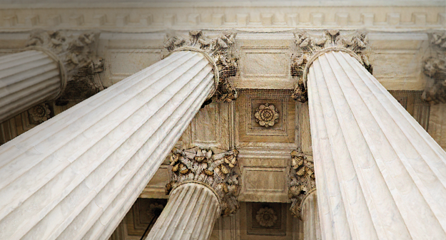

Figure 1. Include all figures in their own section, following references (and footnotes and tables, if applicable). Include a numbered caption for each figure. Use the Table/Figure style for easy spacing between figure and caption.

For more information about all elements of APA formatting, please consult the APA Style Manual, 6th Edition.