Pretest

David E. Wells

CS-230 Data Structures

DEWells@CapTechU.edu

# Introduction

The materials used in making this lab include: Windows 10, C++ lde(Dev-Cpp 5.11 TDM-GCC 4.9.2), <https://github.com/TheTrueMalkavian/CS-230_Lab1>

## Procedure/Methodology

I started this project thinking this was a group project and going with what I knew. I started with the menu and building what was gone over in class. The hardest part that I got stuck on and was waiting on partners to accomplish was assigning the courses. I had then realized after a classmate brought up that the project also had to have a little bit of error catching as well. This I knew how I would accomplish forcing the user to enter a minimum of 4 students or a minimum of 10 courses. But I wasn’t sure how to make option 3 not to work if students and course arrays were empty. 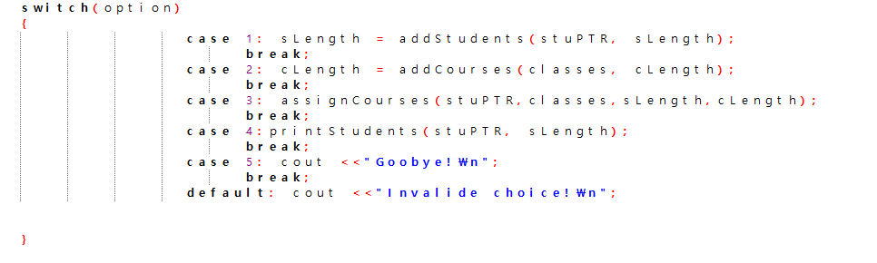

*Figure 1*

After it was brought to my attention that this was not a group project I proceded to use all my time to try and figure out how my other class made accomplished option three. I ran in to boundless errors. I found that the way he coded things seemed a little foreign to me and it was rather fun trying to deconstruct everything.

One problem area that I took me a long time to figure out was in figure 2. I didn’t have time to look up exactly what strcmp does or c_str.

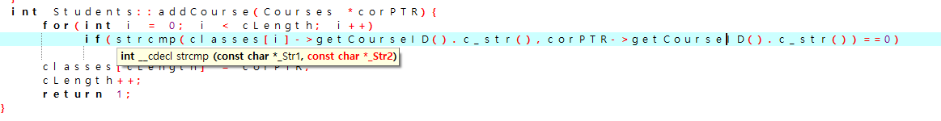

*Figure 2*

I think it would be interesting working in a group and more having the people explain why they did certain things the way they did. This is something that is kind of still hard for me with programing. I will try and look something up in a library and still have problems getting it to work. But when I see it in working code it is a little easier to get it to work.

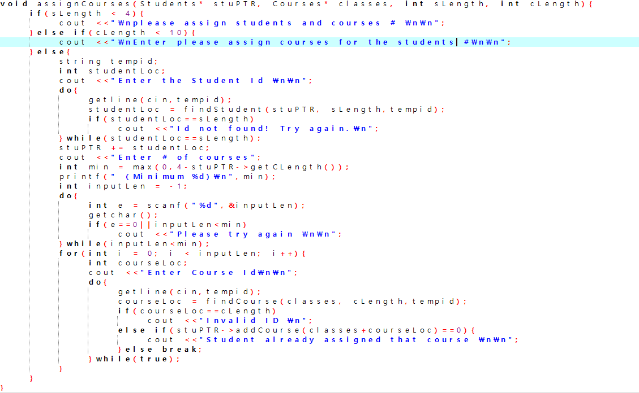

*Figure 3*

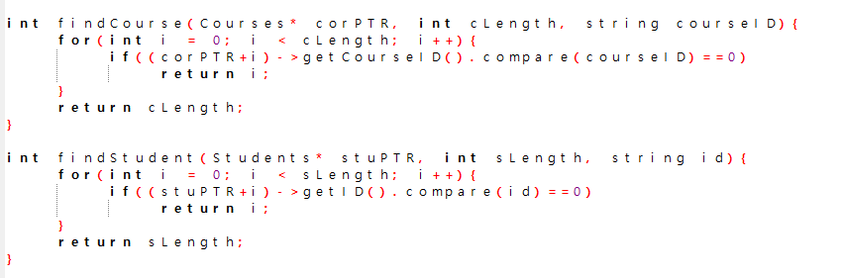

*Figure 4*

Figure 2, 3, and 4 all show the code that I had to add last minute as well as the third case statement in Figure 1.

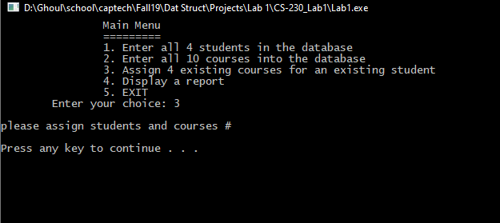

*Figure 5*

At least I have some of the intended functionality I had hoped for in a rushed attempt.

#### Analysis & Conclusion

I found myself in a rush, and with all the errors I kept running into I didn’t think I was going to have any working code to turn in. I just barely got to test a little bit of functionality and found that it does not work. I kind of wish I had time to go back in and tweak some things so that would logically work properly. I think I put in a character in the credits by accident and it hung up on me. I have learned from working with some of the other students in this class that I feel behind where I should be in coding.

Sources cited

Steven Savedge, Jacob Rush, Prof Andrew Mehri