Portfolio

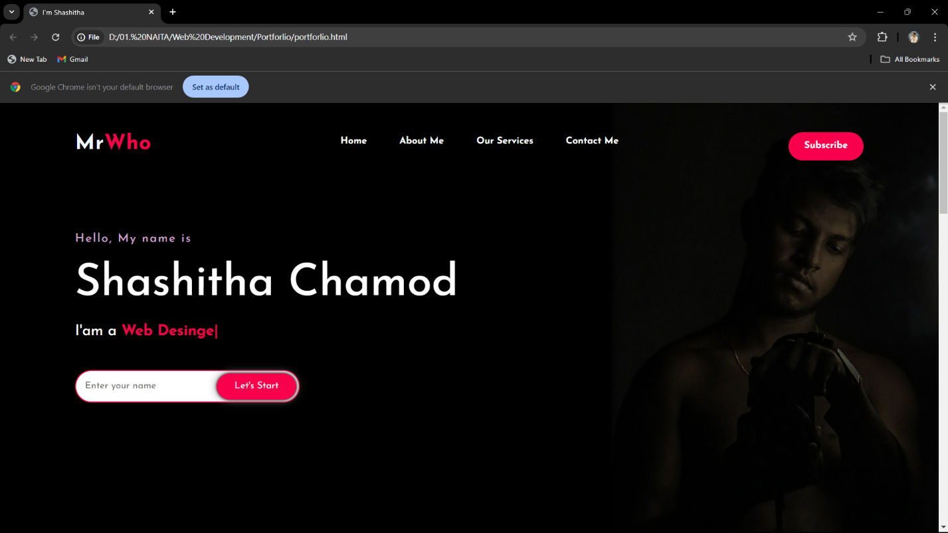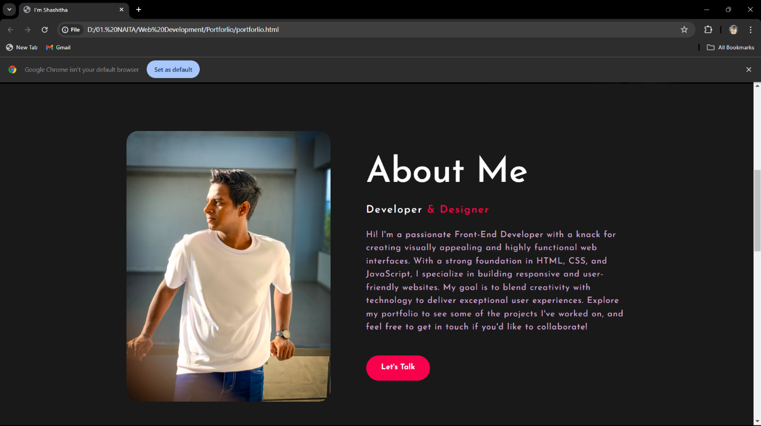

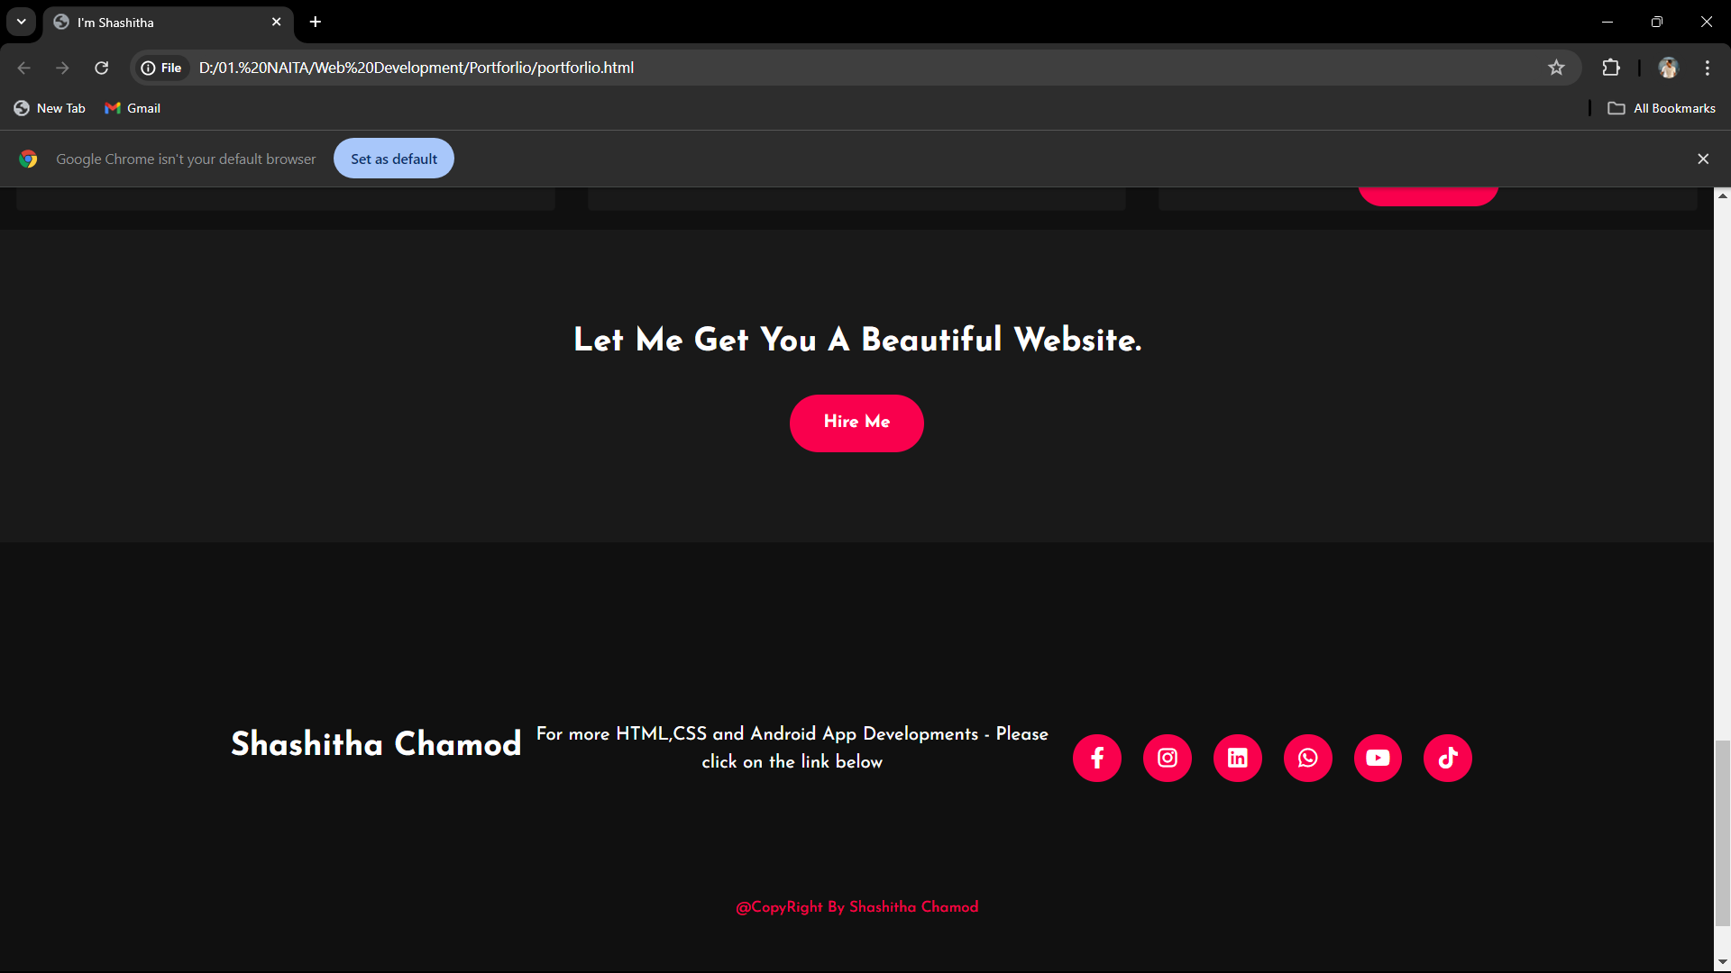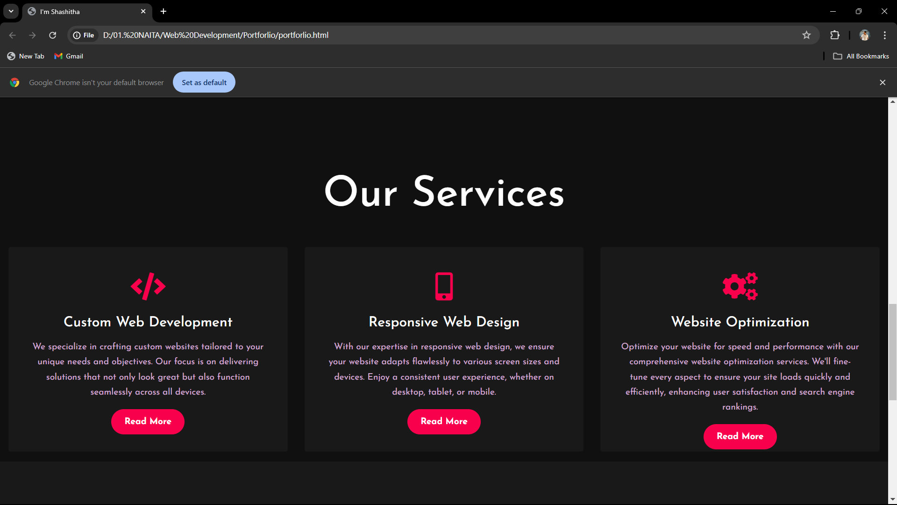

HTML Code

<!DOCTYPE html>

<html>

    <head>

        <title>I'm Shashitha</title>

        <link href="https://cdn.jsdelivr.net/npm/bootstrap@5.1.3/dist/css/bootstrap.min.css" rel="stylesheet" integrity="sha384-1BmE4kWBq78iYhFldvKuhfTAU6auU8tT94WrHftjDbrCEXSU1oBoqyl2QvZ6jIW3" crossorigin="anonymous">

        <link rel="stylesheet" href="styles.css">

        <link rel="preconnect" href="https://fonts.googleapis.com">

        <link rel="preconnect" href="https://fonts.gstatic.com" crossorigin>

        <link href="https://fonts.googleapis.com/css2?family=Josefin+Sans:ital,wght@0,100..700;1,100..700&display=swap" rel="stylesheet">

        <link rel="stylesheet" href="https://cdnjs.cloudflare.com/ajax/libs/font-awesome/5.15.3/css/all.min.css" integrity="sha512-iBBXm8fW90+nuLcSKlbmrPcLa0OT92xO1BIsZ+ywDWZCvqsWgccV3gFoRBv0z+8dLJgyAHIhR35VZc2oM/gI1w==" crossorigin="anonymous" referrerpolicy="no-referrer" />

    </head>

    <body>

        <div class="hero">

            <nav>

                <h2 class="logo">Mr<span>Who</span></h2>

                <ul>

                    <li><a href="#home">Home</a></li>

                    <li><a href="#about">About Me</a></li>

                    <li><a href="#services">Our Services</a></li>

                    <li><a href="#contact">Contact Me</a></li>

                </ul>

                <a href="#" class="btn">Subscribe</a>

            </nav>

            <div id="home" class="content">

                <h4>Hello, My name is</h4>

                <h1>Shashitha Chamod</h1>

                <h3>I'am a <span class="multiText">Coder</span></h3>

                <script src="https://unpkg.com/typed.js@2.1.0/dist/typed.umd.js"></script>

                <script>

                    var typingEffect = new Typed(".multiText",{

                        strings : ["Coder","Web Desinger","Free Launcher","Youtuber"],

                        loop : true,

                        typeSpeed : 100,

                        backSpeed : 80,

                        backDelay : 1500

                    })

                </script>

                <div class="newsletter">

                    <form>

                        <input type="email" name="email" id="mail" placeholder="Enter your name">

                        <input type="submit" name="submit" value="Let's Start">

                    </form>

                </div>

            </div>

        </div>

        <section id="about" class="about">

            <div class="main">

                <img src="IMG-20240106-WA0008.jpg" alt="">

                <div class="about-text">

                    <h2>About Me</h2>

                    <h5>Developer <span>& Designer</span></h5>

                    <p>Hi! I'm a passionate Front-End Developer with a knack for creating visually appealing and highly functional web interfaces. With a strong foundation in HTML, CSS, and JavaScript, I specialize in building responsive and user-friendly websites. My goal is to blend creativity with technology to deliver exceptional user experiences. Explore my portfolio to see some of the projects I've worked on, and feel free to get in touch if you'd like to collaborate!</p>

                    <button type="button"> Let's Talk</button>

                </div>

            </div>

        </section>

        <div id="services" class="service">

            <div class="title">

                <div class="title">

                    <h2>Our Services</h2>

                </div>

                <div class="box">

                    <div class="card">

                        <i class="fas fa-code"></i>

                        <h5>Custom Web Development</h5>

                        <div class="pra">

                            <p>We specialize in crafting custom websites tailored to your unique needs and objectives. Our focus is on delivering solutions that not only look great but also function seamlessly across all devices.</p>

                            <p style="text-align: center;">

                                <a class="button" href="#">Read More</a>

                            </p>

                        </div>

                    </div>

                    <div class="card">

                        <i class="fas fa-mobile-alt"></i>

                        <h5>Responsive Web Design</h5>

                        <div class="pra">

                            <p>With our expertise in responsive web design, we ensure your website adapts flawlessly to various screen sizes and devices. Enjoy a consistent user experience, whether on desktop, tablet, or mobile.</p>

                            <p style="text-align: center;">

                                <a class="button" href="#">Read More</a>

                            </p>

                        </div>

                    </div>

                    <div class="card">

                        <i class="fas fa-cogs"></i>

                        <h5>Website Optimization</h5>

                        <div class="pra">

                            <p>Optimize your website for speed and performance with our comprehensive website optimization services. We'll fine-tune every aspect to ensure your site loads quickly and efficiently, enhancing user satisfaction and search engine rankings.</p>

                            <p style="text-align: center;">

                                <a class="button" href="#">Read More</a>

                            </p>

                        </div>

                    </div>

                </div>

        <div id="contact" class="contact">

            <p>Let Me Get You A Beautiful Website.</p>

            <a class="button-two" href="#">Hire Me</a>

        </div>

        <footer>

            <p>Shashitha Chamod</p>

            <p>For more HTML,CSS and Android App Developments - Please click on the link below</p>

            <div class="social">

                <a href="https://www.facebook.com/share/MuJ7kLafPshs5TbU/?mibextid=qi2Omg"><i class="fab fa-facebook-f"></i></a>

                <a href="https://www.instagram.com/mr_who593?igsh=MTZ0Ym13b3JtZmw5Mg=="><i class="fab fa-instagram"></i></a>

                <a href="https://www.linkedin.com/in/shashitha-chamod-338556297?utm_source=share&utm_campaign=share_via&utm_content=profile&utm_medium=android_app"><i class="fab fa-linkedin"></i></a>

                <a href="https://wa.me/message/3CRANWX7IVKQE1"><i class="fab fa-whatsapp"></i></a>

                <a href="https://youtube.com/@mr_who593?si=qZkaVrHvvLws7l6P "><i class="fab fa-youtube"></i></a>

                <a href="https://www.tiktok.com/@mr_who593?_t=8mirTysU5U0&_r=1"><i class="fab fa-tiktok"></i></a>

            </div>

            <p class="end">@CopyRight By Shashitha Chamod</p>

        </footer>

    </body>

</html>

CSS Code

*{

    padding: 0;

    margin: 0;

    font-family: 'josefin Sans', sans-serif;

    box-sizing: border-box;

}

.hero{

    height: 100vh;

    width: 100%;

    background-color: black;

    background-image: url(../Portforlio/Untitled-1.jpg);

    background-size: cover;

    background-position: center;

}

nav{

    display: flex;

    align-items: center;

    justify-content: space-between;

    padding-top: 45px;

    padding-left: 8%;

    padding-right: 8%;

}

.logo{

    color: aliceblue;

    font-size: 35px;

    letter-spacing: 1px;

    cursor: pointer;

    font-weight: bold;

}

span{

    color: #f9004d;

}

nav ul li{

    list-style-type: none;

    display: inline-block;

    padding: 10px 25px;

}

nav ul li a{

    color: white;

    text-decoration: none;

    font-weight: bold;

    text-transform: capitalize;

}

nav ul li a:hover{

    color: #f9004d;

    transform: .4s;

}

.btn{

    background-color: #f9004d;

    color: white;

    text-decoration: none;

    border: 2px solid transparent;

    font-weight: bold;

    padding: 10px 25px;

    border-radius: 30px;

    transition: transfrom.4s;

}

.btn:hover{

    transform: scale(1.2);

}

.content{

    position: absolute;

    top: 50%;

    left: 8%;

    transform: translateY(-50%);

}

h1{

    color: white;

    margin: 20px 0px 20px;

    font-size: 75px;

}

h3{

    color: white;

    font-size: 25px;

    margin-bottom: 50px;

}

.multiText{

    color: #f9004d;

    text-transform: capitalize;

    font-weight: bold;

}

h4{

    color: #fcfc;

    letter-spacing: 2px;

    font-size: 20px;

}

.newsletter form{

    width: 380px;

    max-width: 100%;

    position: relative;

}

.newsletter form input:first-child{

    display: inline-block;

    width: 100%;

    padding: 14px 130px 14px 15px;

    border: 2px solid #f9004d;

    outline: none;

    border-radius: 30px;

}

.newsletter form input:last-child{

    position: absolute;

    display: inline-block;

    outline: none;

    border: none;

    padding: 10px 30px;

    border-radius: 30px;

    background-color: #f9004d;

    color: white;

    box-shadow: 0px 0px 5px #000, 0px 0px 15px #858585;

    top: 6px;

    right: 6px;

}

.about{

    width: 100%;

    padding: 100px 0px;

    background-color: #191919;

}

.about img{

    height: auto;

    width: 430px;

    border-radius: 25px;

}

.about-text{

    width: 550px;

}

.main{

    width: 1130px;

    max-width: 95%;

    margin: 0 auto;

    display: flex;

    align-items: center;

    justify-content: space-around;

}

.about-text h2{

    color: white;

    font-size: 75px;

    text-transform: capitalize;

    margin-bottom: 20px;

}

.about-text h5{

    color: white;

    letter-spacing: 2px;

    font-size: 22px;

    margin-bottom: 25px;

    text-transform: capitalize;

}

.about-text p{

    color: #fcfc;

    letter-spacing: 1px;

    line-height: 28PX;

    font-size: 18PX;

    margin-bottom: 45PX;

}

button{

    background-color: #f9004d;

    color: white;

    text-decoration: none;

    border: 2px solid transparent;

    font-weight: bold;

    padding: 13px 30px;

    border-radius: 30px;

    transition: .4s;

}

button:hover{

    background-color: transparent;

    border: 2px solid #f9004d;

    cursor: pointer;

}

.service{

    background: #101010;

    width: 100%;

    padding: 100px 0px;

}

.title h2{

    color: white;

    font-size: 75px;

    width: 1130px;

    margin: 30px auto;

    text-align: center;

}

.box{

    display: flex;

    justify-content: center;

    align-items: center;

    min-height: 400px;

}

.card{

    height: 365px;

    width: 3356px;

    padding: 20px 35px;

    background: #191919;

    margin: 15px;

    position: relative;

    overflow: hidden;

    text-align: center;

}

.card i{

    font-size: 50px;

    display: block;

    text-align: center;

    margin: 25px 0px;

    color: #f9004d;

}

h5{

    color: white;

    font-size: 25px;

    margin-bottom: 15px;

}

.pra p{

    color: #fcfc;

    font-size: 16px;

    margin-bottom: 25px;

    line-height: 27px;

}

.card .button{

    background-color: #f9004d;

    color: white;

    text-decoration: none;

    border: 2px solid transparent;

    font-weight: bold;

    padding: 13px 22px;

    border-radius: 30px;

    transition: .4s;

}

.card .button:hover{

    background-color: transparent;

    border: 2px solid #f9004d;

    cursor: pointer;

}

.contact {

    width: 100%;

    height: 290px;

    background: #191919;

    align-items: center;

    display: flex;

    flex-direction: column;

    justify-content: center;

}

.contact p{

    color: white;

    font-size: 30px;

    font-weight: bold;

    margin-bottom: 25px;

}

.contact .button-two{

    background-color: #f9004d;

    color: white;

    text-decoration: none;

    border: 2px solid transparent;

    font-weight: bold;

    padding: 13px 30px;

    border-radius: 30px;

    transition: .4s;

}

.contact .button-two:hover{

    background-color: transparent;

    border: 2px solid #f9004d;

    cursor: pointer;

}

footer{

    position: relative;

    width: 100%;

    height: 400px;

    background: #101010;

    display: flex;

    align-items: center;

    justify-content: center;

}

footer p:nth-child(1){

    color: white;

    font-size: 30px;

    margin-bottom: 20px;

    font-weight: bold;

}

footer p:nth-child(2){

    color: white;

    font-size: 17px;

    width: 500px;

    text-align: center;

    line-height: 26px;

}

.social{

    display: flex;

}

.social a{

    width: 45px;

    height: 45px;

    display: flex;

    align-items: center;

    justify-content: center;

    background: #f9004d;

    border-radius: 50%;

    margin: 22px 10px;

    color: white;

    text-decoration: none;

    font-size: 20px;

}

.social a:hover{

    transform: scale(1.3);

    transition: .3s;

}

.end{

    position: absolute;

    color: #f9004d;

    bottom: 35px;

    font-size: 14px;

}