

BookWAis
Workshop Booking Application
WA26-1 Wilson Arlando

Introduction

Background
Workshops and conference events often provide multiple sessions with limited seating capacity. A manual or poorly synchronized booking process can cause duplicate reservations, inaccurate seat counts, and overbooking when many participants attempt to reserve seats at the same time.
BookWAis is an online workshop booking application developed to manage sessions, speakers, participants, and reservations in one system. Participants can browse available sessions, reserve seats, and cancel their reservations. Administrators can manage sessions and speakers while monitoring the number of reservations for each session.

Problem Statement
The main challenge is maintaining correct booking data when multiple users access the application simultaneously. The system must ensure that confirmed reservations never exceed the configured session capacity. It must also prevent duplicate bookings, provide clear feedback when a session is full, and handle capacity changes and cancellations consistently.
The application must also remain stable when many users browse sessions or submit booking requests concurrently.

Objectives
The objectives of this project are:
- To develop an online workshop booking application.
- To allow participants to browse sessions and manage their reservations.
- To provide administrators with session, speaker, and booking management features.
- To prevent overbooking and duplicate reservations.
- To maintain consistent data during concurrent requests.
- To evaluate the system using performance and concurrency tests.
- To provide a repeatable deployment setup using Docker Compose.

Scope
The application includes participant registration and login, session browsing, seat reservation, reservation cancellation, speaker management, session management, and an administrator dashboard.
The backend is implemented using .NET 10 ASP.NET Core Web API with Entity Framework Core and PostgreSQL. The frontend is implemented using React, TypeScript, and Vite. Concurrency control is implemented using database transactions, row-level locking, and a unique database constraint for duplicate reservations.

System Requirements

Functional Requirements
The system shall provide the following functions:
- Participants can register and log in to the application.
- Participants can browse available workshop sessions.
- Participants can view session details, including title, speaker, room, schedule, capacity, and remaining seats.
- Participants can reserve one seat in a session.
- Participants can view their existing reservations.
- Participants can cancel their reservations.
- Administrators can create, update, and delete sessions.
- Administrators can create, update, and delete speakers.
- Administrators can view booking information for each session.
- The system prevents duplicate reservations by the same participant for the same session.
- The system prevents the number of reservations from exceeding session capacity.
- The system provides an appropriate response when a session is full.
- The system validates capacity changes against the current number of reservations.

Non-Functional Requirements
The application shall satisfy the following non-functional requirements:
- The system must maintain consistent booking data during concurrent requests.
- The system must remain stable when many users browse sessions simultaneously.
- The system must handle simultaneous booking requests without overbooking.
- The system must provide clear success and failure responses.
- The application must separate frontend and backend responsibilities.
- The codebase must be maintainable and organized by feature.
- The application must be runnable in a repeatable environment using Docker Compose.
- Database changes must be managed through Entity Framework Core migrations.

User Roles
Participant
A participant can:
- Register and log in.
- Browse available sessions.
- Reserve a seat.
- View personal reservations.
- Cancel personal reservations.
Administrator
An administrator can:
- Log in using an administrator account.
- Manage sessions.
- Manage speakers.
- Update session capacity.
- Monitor reservations through the dashboard.

Main Use Cases
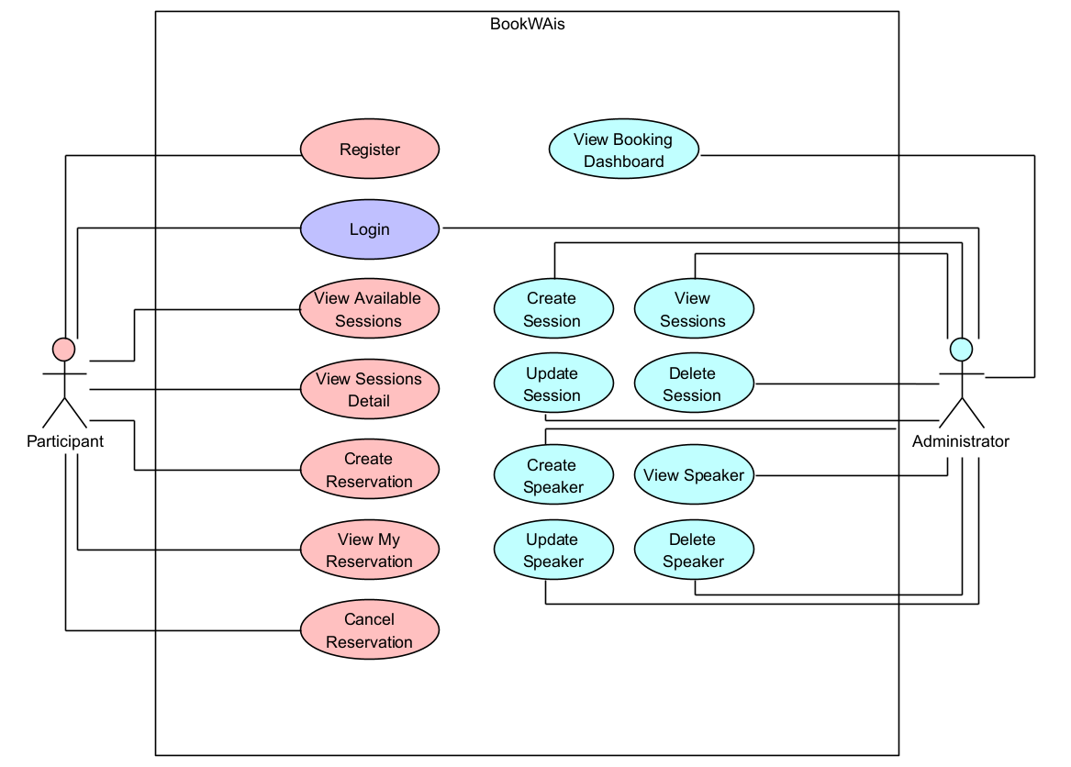
Figure 1. Main participant and administrator use cases
The main use cases are:
- Participant registration and login
- Browse available sessions
- View session details
- Create a reservation
- View personal reservations
- Cancel a reservation
- Create, view, update, and delete sessions
- Create, view, update, and delete speakers
- View the booking dashboard

System Architecture

Architectural Style
BookWAis uses a simple modular monolith architecture. The backend and frontend are separated into two applications. The frontend communicates with the backend through REST API endpoints.
This structure keeps the application simple while separating user interface responsibilities from business logic and database operations.

System Components
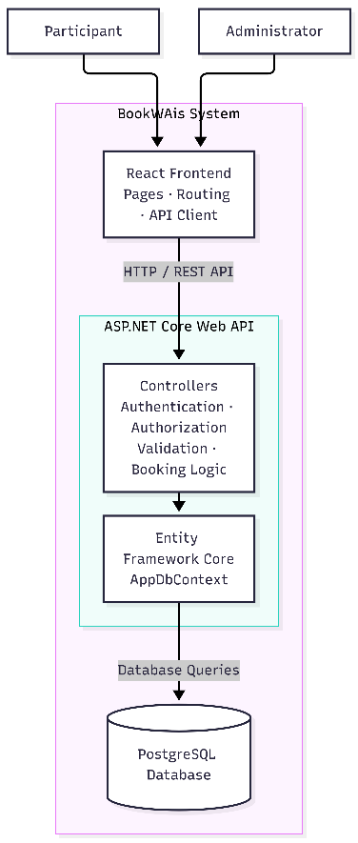
Figure 2. BookWAis system architecture
The system consists of the following components:
- React frontend for participant and administrator interfaces.
- ASP.NET Core Web API for application logic and request handling.
- Entity Framework Core for database access.
- PostgreSQL for persistent data storage.
- Docker Compose for running the frontend, backend, and database together.

Request Flow
The general request flow is:
- A user interacts with the React frontend.
- The frontend sends an HTTP request to the ASP.NET Core API.
- The API authenticates the user and checks authorization when required.
- The controller validates the request and applies the application logic.
- Entity Framework Core communicates with PostgreSQL.
- The API returns the result to the frontend.
- The frontend displays the result or an error message to the user.

Backend Structure
backend/
- BookWAis.Api/
- Controllers/
- Models/
- Data/
- Migrations/
- Program.cs
- BookWAis.Api.csproj
- Dockerfile
The backend uses a monolithic ASP.NET Core Web API architecture. Authentication, session management, speaker management, and reservation processing run within a single application and share one PostgreSQL database.
The implementation follows a controller-based structure. Each controller handles requests for a specific resource. Controllers perform validation and application logic, then access the database through AppDbContext using Entity Framework Core. A separate service or repository layer is not introduced because the current application scope is small. The request flow is:
HTTP Request > Authentication and Authorization > Controller > AppDbContext > PostgreSQL > HTTP Response
For a booking request, ReservationsController obtains the authenticated participant’s identity, starts a transaction, locks the selected session row, checks for duplicate reservations and available capacity, and saves the reservation. The transaction is committed before a success response is returned.
This architecture keeps the implementation straightforward and allows the booking rules and transaction boundaries to be inspected in one place. If the application grows, shared business logic can be extracted into services.

Frontend Structure
frontend/
- public/
- src/
- api/
- pages/
- types/
- App.tsx
- main.tsx
- package.json
- .env.example
- Dockerfile
The frontend is implemented as a React single-page application using TypeScript and Vite. The application uses client-side routing to display different pages without reloading the browser.
The frontend follows a page-based structure:
- pages contains the application screens, including session browsing, reservations, login, registration, session management, speaker management, and the administrator dashboard.
- api contains typed functions for calling the backend REST API.
- types contains TypeScript definitions for users, sessions, speakers, and reservations.
- App.tsx defines the application routes, authentication state, navigation menu, and role-based route protection.
- App.css and index.css define the shared layout, colors, spacing, buttons, forms, and responsive styles.
- main.tsx is the application entry point.
- package.json defines the frontend dependencies and development scripts.
The frontend request flow is:
User Interaction > React Page > API Function > ASP.NET Core REST API > Page State Update
After login, the backend returns the authenticated user information through the cookie session. The frontend uses the user role to control navigation and protected routes:
- Participants can access session browsing and personal reservations.
- Administrators can access session management, speaker management, and the booking dashboard.
- Unauthenticated users are redirected to the login page.
The frontend does not decide whether a booking is valid. It sends the booking request to the backend, and the backend performs authentication, validation, capacity checks, duplicate checks, and concurrency control.

Deployment Structure
The application can be run using Docker Compose. The composition contains three services:
- PostgreSQL database
- ASP.NET Core backend
- React frontend
The backend connects to PostgreSQL through the Docker service name database. The frontend communicates with the backend through the configured API URL.
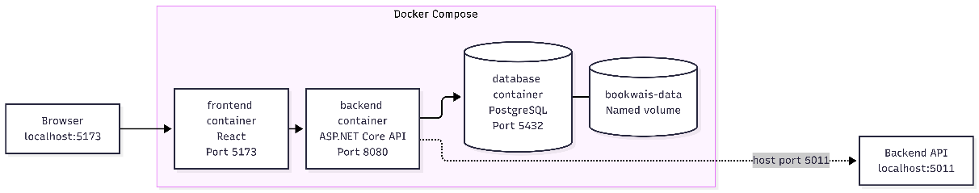
Figure 3. Docker Compose deployment structure
The environment can be started with:
Docker compose up --build

Maintainability Considerations
The application uses a simple modular monolith structure. Backend controllers are separated by resource, while the frontend separates pages, API functions, TypeScript types, and shared styling.
This structure makes the code easier to analyze because each feature has a clear location. It also supports modification because changes to sessions, speakers, reservations, or authentication can be made independently.
Database schema changes are managed through Entity Framework Core migrations. The load-testing project separates browsing, booking, capacity update, and cancellation scenarios so that each test can be repeated independently.
The application avoids unnecessary abstraction for its current scope. If the system grows, shared business logic can be extracted into application services without changing the frontend API structure.

Database Design

Entities
The database contains four main entities:
- User stores participant and administrator accounts.
- Speaker stores speaker profile information.
- Session stores workshop details, schedule, room, speaker assignment, and capacity.
- Reservation stores the relationship between a participant and a session.

Entity Relationships
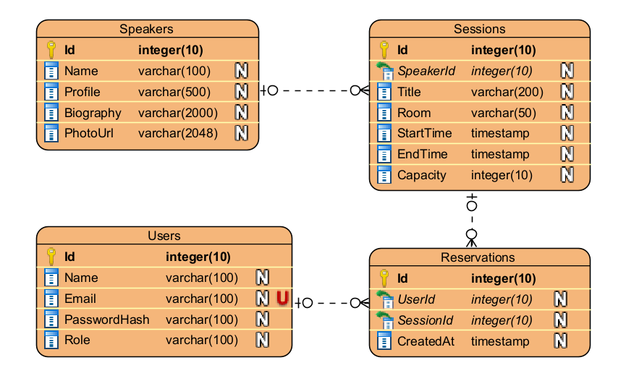
Figure 4. BookWAis Entity Relationship Diagram
The relationships are:
- One user can have many reservations.
- One session can have many reservations.
- One speaker can be assigned to many sessions.
- Each reservation belongs to one user and one session.
- Each session belongs to one speaker.

Constraints and Indexes
The ERD represents the logical relationships between users, speakers, sessions, and reservations. The current implementation enforces the unique constraint on (UserId, SessionId) and the index on Reservation.SessionId through Entity Framework Core. The controller uses these identifiers to maintain the relationships between records. The ERD relationships are therefore used to describe the data model and application behavior.

Database Migrations
The schema is managed through Entity Framework Core migrations. Migrations create and update tables, relationships, constraints, and indexes. This allows the database schema to be reproduced consistently in local and Docker environments.

Concurrency Control and Booking Logic
BookWAis uses database transactions and row-level locking to keep session capacity consistent when multiple users send booking requests simultaneously.

Booking Transaction
The booking process is implemented in POST /api/Reservations. The process is:
- Start a database transaction.
- Lock the selected session row using PostgreSQL SELECT ... FOR UPDATE.
- Check whether the session exists.
- Check whether the participant already has a reservation for the session.
- Count the current reservations.
- Compare the reservation count with the session capacity.
- Insert the reservation when a seat is available.
- Save the changes.
- Commit the transaction.
The row lock makes concurrent requests for the same session execute sequentially. This prevents two requests from using the same remaining seat.

Prevention of Overbooking
The system checks the current reservation count while the session row is locked. If the reservation count has reached the configured capacity, the request is rejected with a conflict response. As a result, the number of confirmed reservations cannot exceed the session capacity.

Duplicate Booking Prevention
Duplicate bookings are prevented in two ways:
- The controller checks whether the same user has already reserved the session.
- The database contains a unique constraint on the combination of UserId and SessionId.
The second protection ensures that duplicate records cannot be inserted even if multiple requests are received at the same time.

Capacity Updates During Booking
Capacity changes are implemented in PUT /api/Sessions/{id}.
The session row is locked before the update. The system counts the existing reservations and rejects the update when the new capacity is lower than the current reservation count. This prevents an administrator from changing the capacity to a value that would make existing reservations invalid.

Reservation Cancellation
Reservation cancellation is implemented in DELETE /api/Reservations/{id}.
The system locks the related session row before deleting the reservation. After the transaction is committed, the deleted reservation no longer contributes to the reservation count, so the seat becomes available again. This locking strategy keeps cancellation and new booking requests consistent when they occur at the same time.

Application Features and User Interface
BookWAis provides separate interfaces for participants and administrators. Public authentication pages are available before login, while the available pages after login depend on the user's role.

Login and Registration
The application starts with the login page. Existing users enter their credentials to access the application. New participants can create an account through the registration page. After authentication, the system redirects users according to their role. Participants access booking features, while administrators access management and monitoring features.

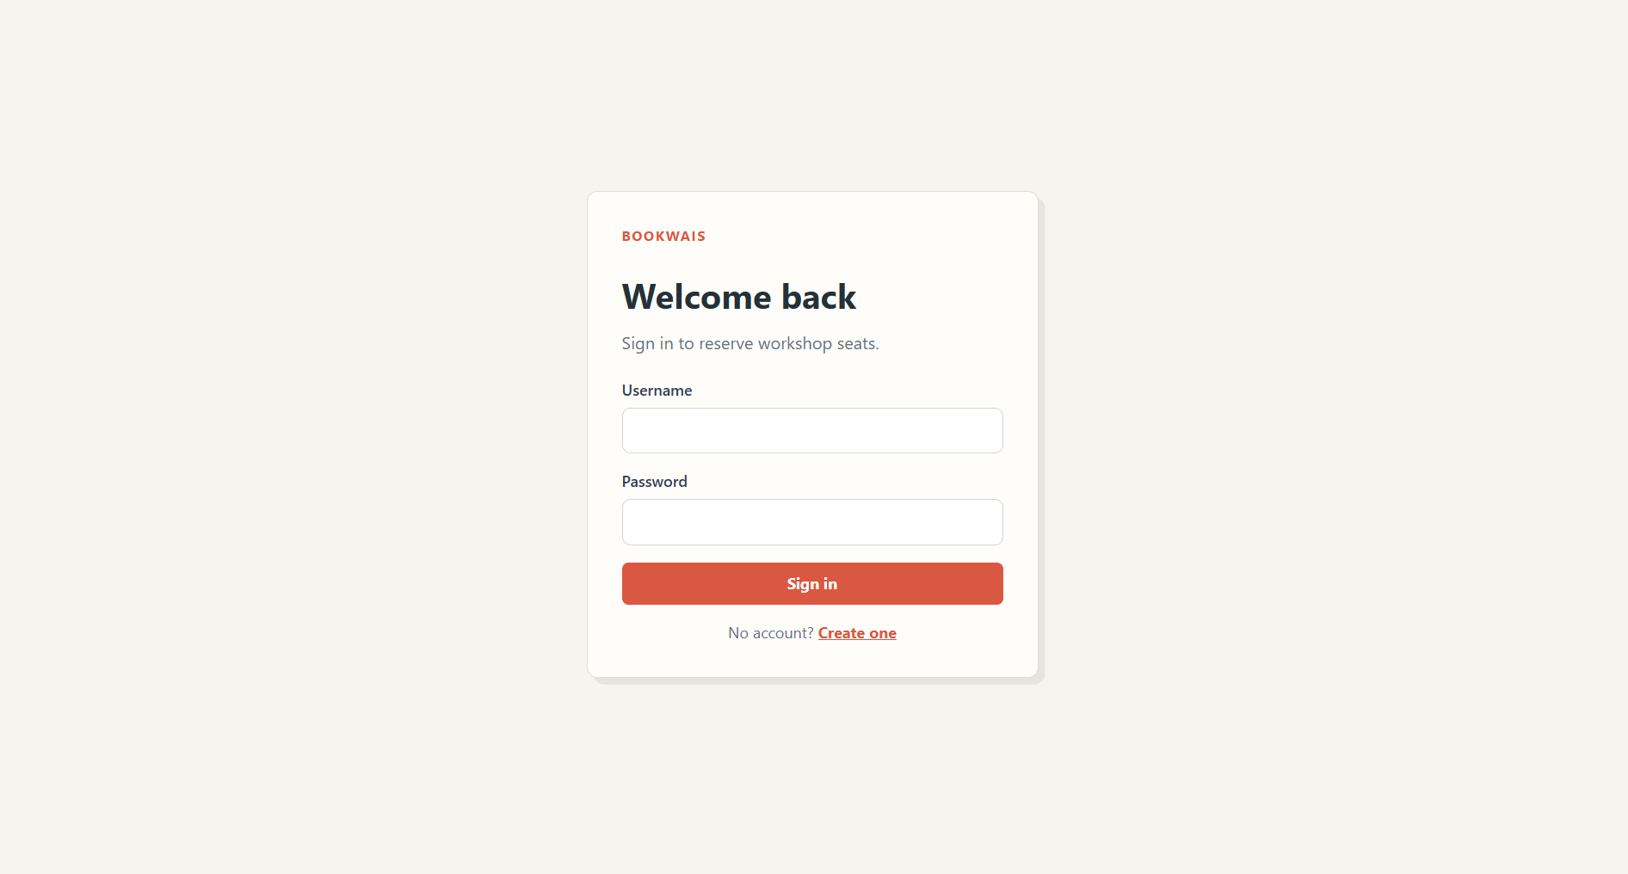
Figure 5. Login page
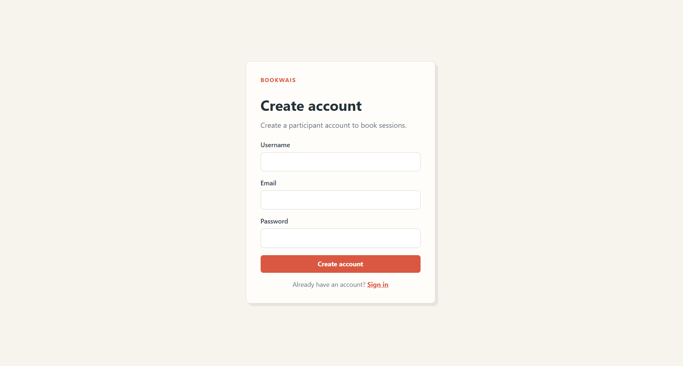
Figure 6. Registration page

Participant Available Sessions
The Available Sessions page is used by participants to browse event sessions. Each session displays its title, speaker, room, schedule, capacity, and remaining seats. Participants can reserve a seat by selecting the Reserve button. The button is disabled when the session has no remaining seats.
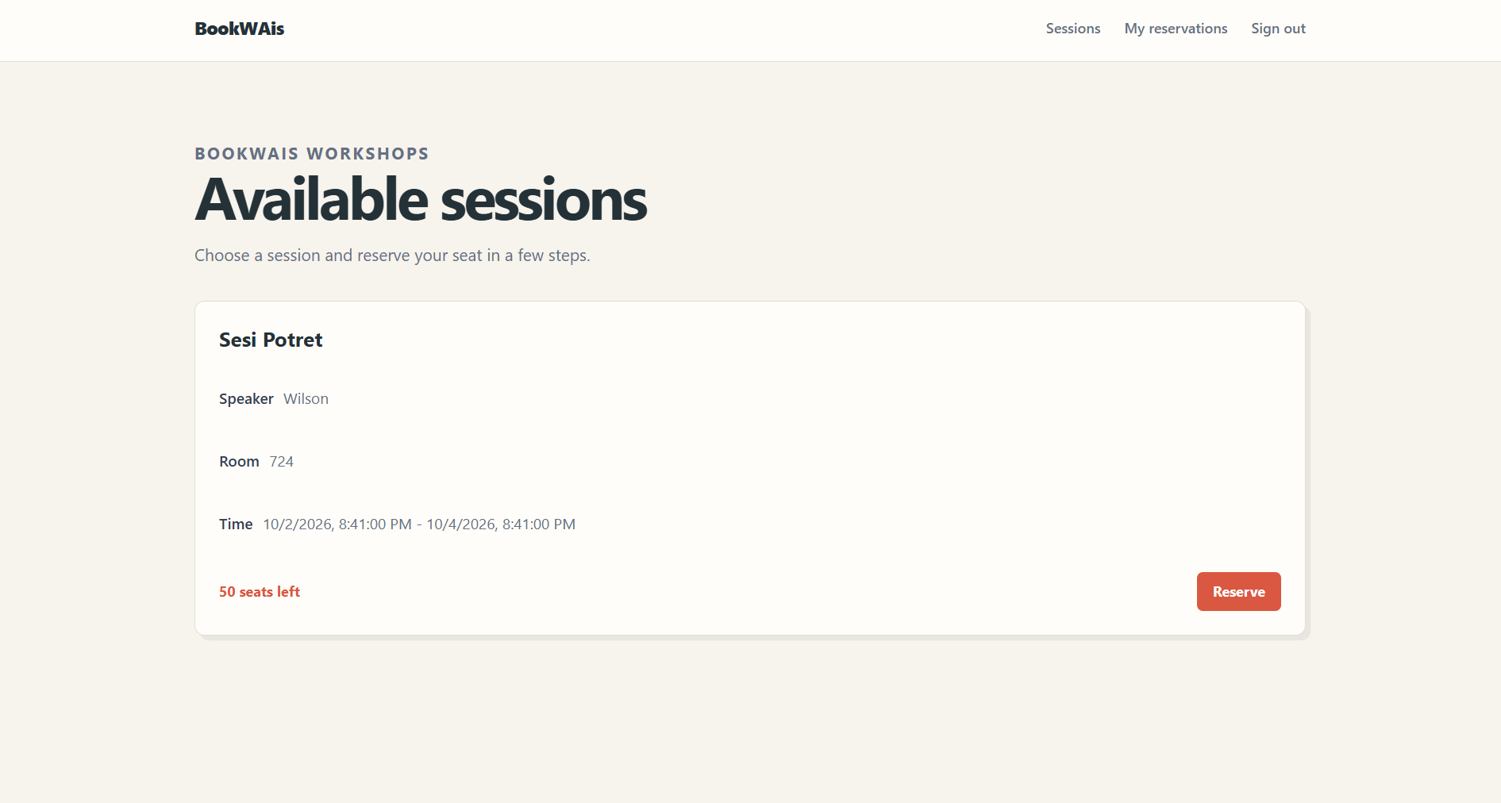
Figure 7. Available Sessions page

Participant My Reservations
The My Reservations page displays reservations belonging to the currently logged-in participant. The participant identity is obtained from the authenticated session, so users do not need to enter a participant ID manually. Participants can review their reservations and cancel a reservation when necessary.
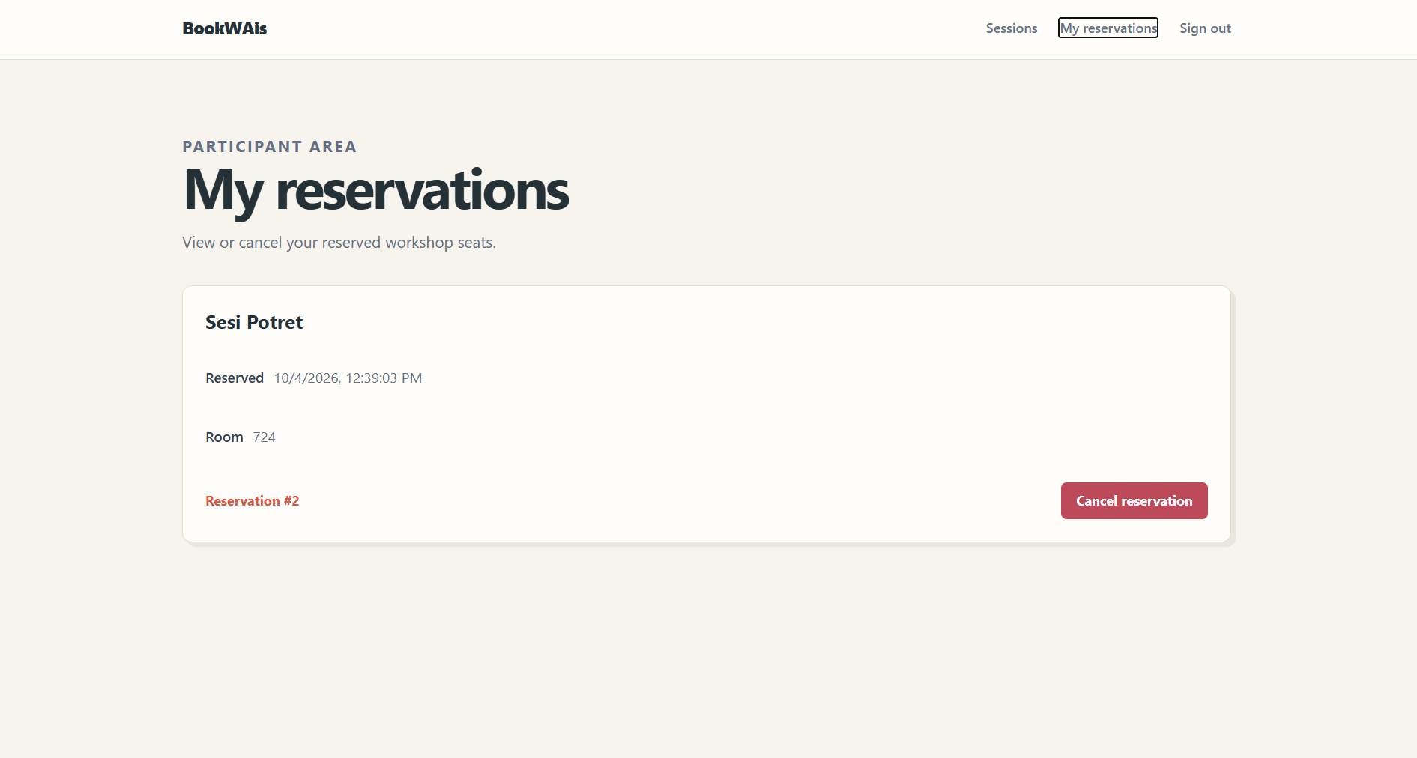
Figure 8. My Reservations page

Administrator Session Management
The Admin Sessions page allows administrators to create, view, update, and delete sessions. The session form contains the title, speaker, room, start time, end time, and maximum capacity. Administrators can also update the session capacity while the system validates existing reservations.
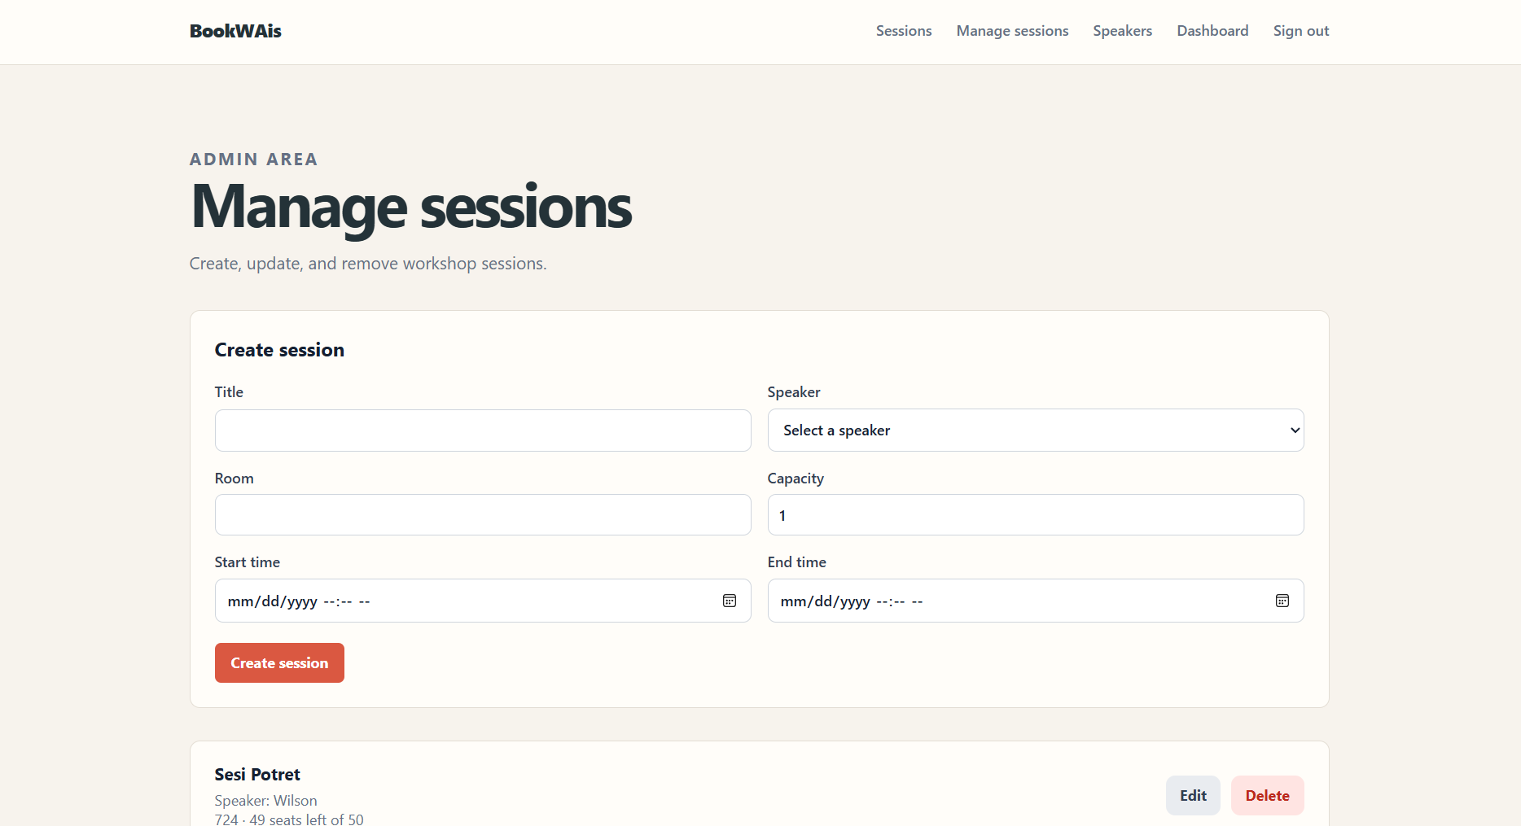
Figure 9. Admin Session Management page

Administrator Speaker Management
The Admin Speakers page allows administrators to create, view, update, and delete speaker records. Each speaker record contains the name, profile, biography, and photo URL. The page also displays sessions assigned to each speaker.
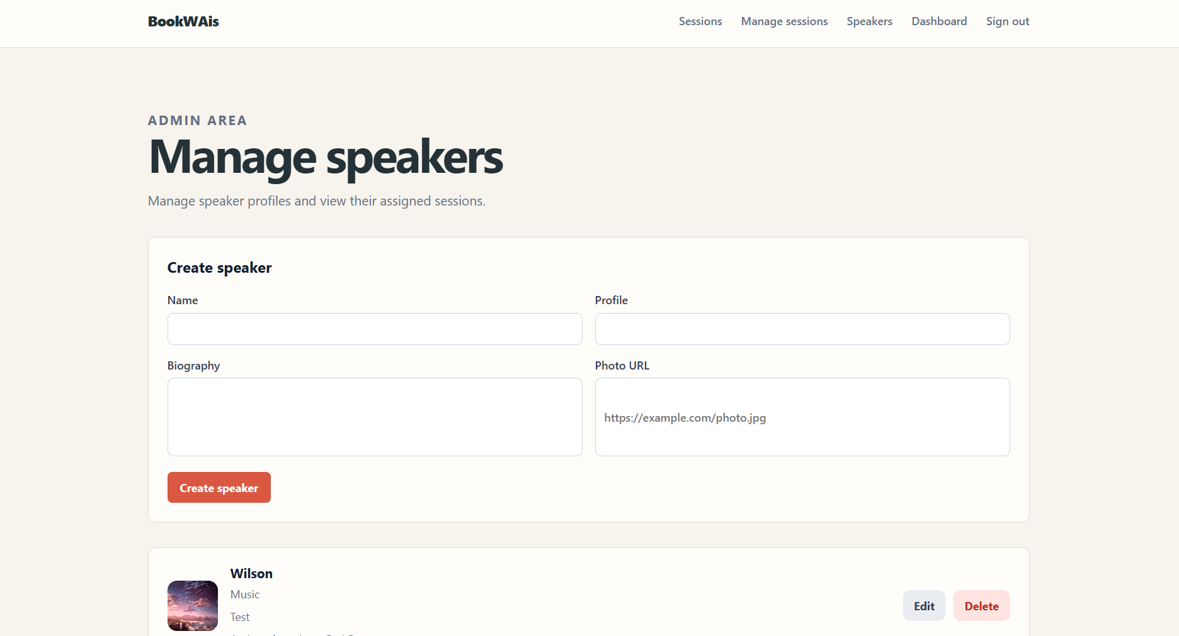
Figure 10. Admin Speaker Management page

Administrator Booking Dashboard
The Admin Dashboard page allows administrators to monitor session occupancy. For each session, the dashboard displays the number of registered participants and the maximum capacity. The data is retrieved from the backend and reflects the reservations stored in PostgreSQL.
The administrator dashboard refreshes its data automatically every five seconds. It retrieves the latest session capacity and reservation count from the backend, allowing administrators to monitor booking changes without manually reloading the page.

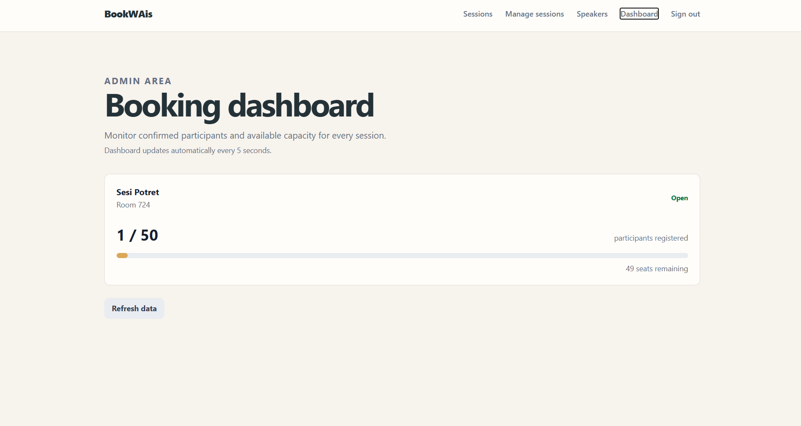
Figure 11. Admin Booking Dashboard page

Performance and Concurrency Testing
The application was tested using the BookWAis.LoadTests project and NBomber. The tests focused on page-load performance, simultaneous booking requests, capacity updates, and reservation cancellation.

Test Environment
The test environment consisted of:
- ASP.NET Core backend running at http://localhost:5011
- PostgreSQL database
- NBomber load-testing project
- PostgreSQL session capacity configured according to each test scenario

Concurrent Session Browsing
This test simulated 1,000 users requesting the available sessions endpoint at the same time. The response includes session information and remaining seats. The test evaluates whether the backend remains stable under a high number of read requests.
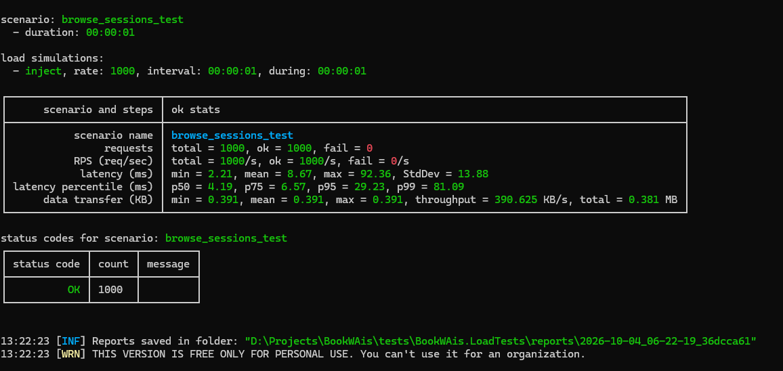
Figure 12. Concurrent session browsing result
The test generated 1,000 requests to the available sessions endpoint. All 1,000 requests returned successfully and no request failed. The mean latency was 8.67 milliseconds and the p99 latency was 81.09 milliseconds.

Final Five Seats Booking Test
This test simulated 50 users attempting to reserve the final five seats of the same session. Expected result:
- Five requests return success.
- Forty-five requests return conflict.
- The number of reservations does not exceed five.
- No duplicate reservations are created.
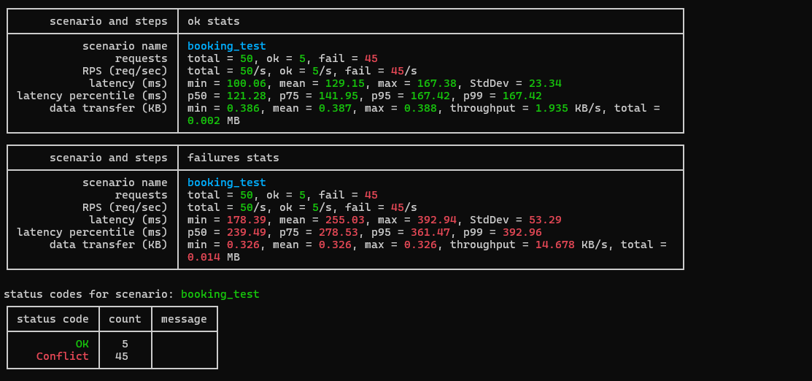
Figure 13. Final five seats booking result
The test generated 50 simultaneous booking requests for a session with five available seats. Five requests succeeded and 45 requests returned a conflict response after the session reached capacity. The final number of reservations did not exceed five.

Capacity Decrease During Booking
This test sent booking requests while an administrator attempted to decrease the session capacity. The update is accepted only when the new capacity is not lower than the number of existing reservations. If the new capacity would invalidate existing reservations, the backend rejects the update with a conflict response.
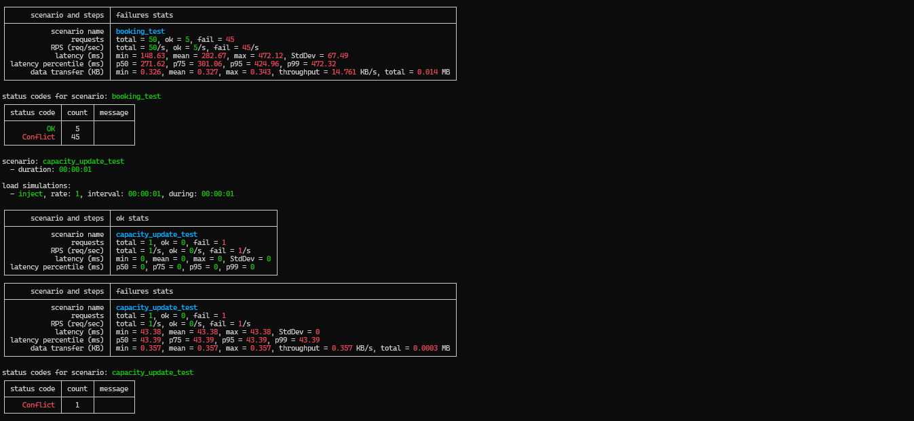
Figure 14. Capacity decrease test result
The test ran booking requests while the administrator attempted to reduce the session capacity. Five booking requests succeeded and 45 requests returned conflict responses. The capacity update from 10 to 7 returned a conflict response because the session already had 10 reservations. This shows that the administrator cannot reduce capacity below the number of existing reservations.

Cancellation and Rebooking Test
This test simulated participants cancelling reservations while other participants attempted to book the newly available seats.
The cancellation and booking operations use the same session row lock. Therefore, the reservation count remains consistent and the number of reservations does not exceed the configured capacity.
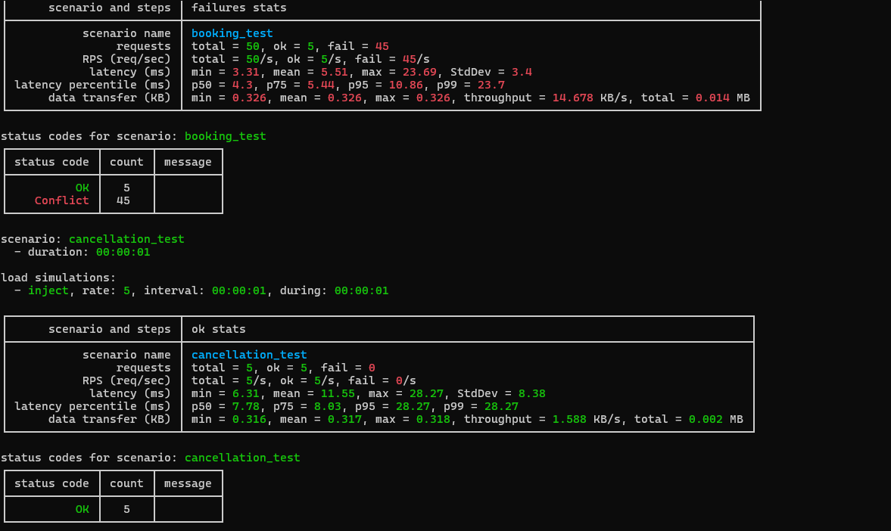
Figure 15. Cancellation and rebooking test result

The test ran five cancellation requests while 50 users attempted to book the newly available seats. All five cancellation requests succeeded. Five booking requests succeeded and 45 requests returned conflict responses. The final reservation count remained within the configured capacity, and no duplicate reservations were created.

Test Verification
The test results are evaluated using the following conditions:
- Confirmed reservations never exceed session capacity.
- Duplicate reservations are rejected.
- Concurrent requests receive appropriate success or conflict responses.
- Capacity changes are rejected when they are lower than existing reservations.
- Cancelled reservations make seats available again.
- The backend remains operational during concurrent requests.

Test Result Summary
Test | Result
1,000 concurrent browsing requests | 1,000 successful, 0 failed
50 users competing for five seats | 5 successful, 45 conflict
Capacity decrease during booking | Capacity update rejected when lower than existing reservations
Cancellation and rebooking | 5 cancellations successful, 5 new bookings successful, no overbooking

Conclusion and Future Improvements
BookWAis provides the main features required for an online workshop booking application. Participants can register, log in, browse available sessions, reserve seats, view their reservations, and cancel reservations. Administrators can manage sessions and speakers and monitor booking capacity through the dashboard.
The backend uses ASP.NET Core Web API, Entity Framework Core, and PostgreSQL. The frontend uses React with TypeScript. Docker Compose provides a consistent environment for the frontend, backend, and database.
Concurrency tests demonstrated that the application prevents overbooking, rejects duplicate bookings, handles capacity changes safely, and keeps cancellation and rebooking operations consistent. The 1,000-request browsing test also completed successfully without failed requests.
Future improvements may include real-time dashboard updates, stronger production authentication, distributed caching, and more detailed monitoring. These improvements are outside the current assignment scope.

