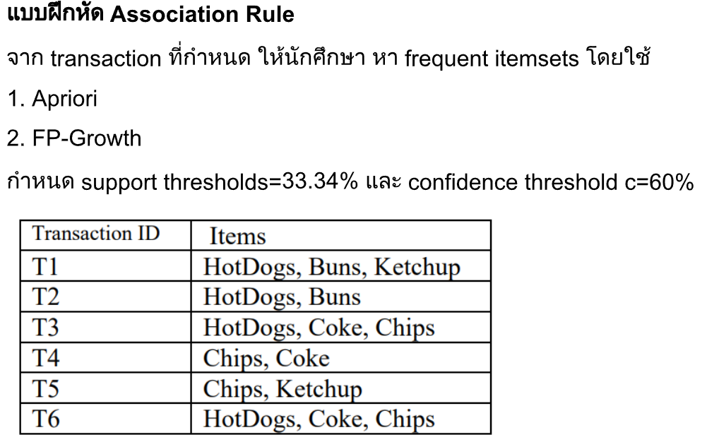

|  |  |
| --- | --- |
| Transaction ID | Items |
| T1 | Hotdogs, Buns, Ketchup |
| T2 | Hotdogs, Buns |
| T3 | Hotdogs, Coke, Chips |
| T4 | Chips, Coke |
| T5 | Chips, Ketchup |
| T6 | Hotdogs, Coke, Chips |

1. **Apriori Algorihm**
   1. .

|  |  |  |
| --- | --- | --- |
| Items | Support Count | Support |
| Hotdogs | 4 | 66.67% |
| Buns | 2 | 33.34% |
| Ketchup | 2 | 33.34% |
| Coke | 3 | 50.00% |
| Chips | 4 | 66.67% |

* 1. Support >= 33.34%

|  |  |  |
| --- | --- | --- |
| Itemset | Support Count | Support |
| {Hotdogs, Buns} | 2 | 33.34% |
| {Hotdogs, Ketchup} | 1 | 16.67% |
| {Hotdogs, Coke} | 2 | 33.34% |
| {Hotdogs, Chips} | 2 | 33.34% |
| {Buns, Ketchup} | 1 | 16.67% |
| {Buns, Coke} | 0 | 0% |
| {Buns, Chips} | 0 | 0% |
| {Ketchup, Coke} | 0 | 0% |
| {Ketchup, Chips} | 1 | 16.67% |
| {Coke, Chips} | 2 | 33.34% |

* {Hotdogs, Buns}
* {Hotdogs, Coke}
* {Hotdogs, Chips}
* {Coke, Chips}
  1. Support >= 33.34%

|  |  |  |
| --- | --- | --- |
| Itemset | Support Count | Support |
| {Hotdogs, Coke, Chips} | 2 | 33.34% |
| {Hotdogs, Buns, Chips} | 0 | 0% |

* {Hotdogs, Coke, Chips}
  1. Confidence >= 60%

|  |  |  |
| --- | --- | --- |
| Rule | Confidence | Result |
| {Hotdogs} 🡪 {Chips} | 50% | 0 |
| {Hotdogs} 🡪 {Coke} | 50% | 0 |
| {Coke} 🡪 {Chips} | 66.67% | 1 |
| {Chips, Coke} 🡪 {Hotdogs} | 100% | 1 |

* {Coke} 🡪 {Chips}
* {Chips, Coke} 🡪 {Hotdogs}

1. **FP-Growth Algorithm**
   1. .

T1: Hotdogs, Buns, Ketchup

T2: Hotdogs, Buns

T3: Hotdogs, Chips, Coke

T4: Chips, Coke

T5: Chips, Ketchup

T6: Hotdogs, Chips, Coke

* 1. Support >= 33.34%
* {Hotdogs} (66.67%)
* {Chips} (66.67%)
* {Coke} (50.00%)
* {Hotdogs, Chips} (33.34%)
* {Hotdogs, Coke} (33.34%)
* {Coke, Chips} (33.34%)
* {Hotdogs, Coke, Chips} (33.34%)
  1. Confidence >= 60%

|  |  |  |
| --- | --- | --- |
| Rule | Confidence | Result |
| {Hotdogs} 🡪 {Chips} | 50% | 0 |
| {Hotdogs} 🡪 {Coke} | 50% | 0 |
| {Coke} 🡪 {Chips} | 66.67% | 1 |
| {Chips, Coke} 🡪 {Hotdogs} | 100% | 1 |

* {Coke} 🡪 {Chips}
* {Chips, Coke} 🡪 {Hotdogs}

**Frequent Itemsets**

* {Hotdogs}
* {Chips}
* {Coke}
* {Hotdogs, Chips}
* {Hotdogs, Coke}
* {Coke, Chips}
* {Hotdogs, Coke, Chips}