

**GE401: ENGINEERING PROBLEM SOLVING AND PROJECT**

**INSTRUCTOR**

Assoc. Prof. Ahmet Deniz Yücekaya

**Project: Vertigo File Hosting Platform**

**Prepared by:**

F. Talha Altınel

Furkan Akyıldız

Emre Şentürk

Cenk Tuna

**CONTENTS**

**1.Introduction**

1.1 File Hosting Service Overview

1.2 Local Storage Problem

1.3 Survey Results

1.4 Problem 5N1K

1.5 File Hosting Platform

**2. 7K Quality Tools**

2.1 Brainstorming

2.2 Gantt Chart

2.3 Flowchart Diagram

2.4 Cause and Effect Diagram

2.5 Pareto Chart

2.6 Affinity Diagram

2.7 Tree Diagram

**3. Solution 5N1K**

3.1 Matrix System

3.2 Matrix Data Analysis

**4. Design**

4.1 File Hosting Platform Design

**5. Cost Analysis**

**6. Solution**

**7 .References**

**2**

**INTRODUCTION**

* 1. **File Hosting Service Overview**

File hosting services provide many benefits to the people who are willing to keep their digital files. In the modern day evolution which started in 2006 with the first cloud storage service by Amazon, file hosting services became super useful and popular for the people with the power of major cloud providers.

* 1. **Local Storage Problem**

While file sizes get bigger and people demand more reliable storage, people started to rely on more file hosting services. People who are already using local storage on limited devices like phones started to prefer cloud storage over local storage due to the fact that they have limited SD card slots on their phones. Big tech companies who heavily use lots of retrievable precious datas also picked cloud storage over local storage. The reasons were many such as; easy to maintain, manage and back-up with the ease of use and benefits of less cost.

**3**

* 1. **Survey Results**

A total of 104 people participated in our survey. The questions we asked in this participation and the rates we received were as follows;

**4**

**5**

**6**

* 1. **Problem 5N-1K**

Q: Who reported the problem?

A: People who want to use file hosting services instead of managing their files or freeing up their space or buying local storage constantly

Q: Where did problem appeared?

A: This problem has become fundamental since people’s files get larger and difficulty of file management emerged

Q: What is the problem?

A: People are constantly in need of storage for their files. Buying local storages is not just enough for individual’s time and money. And freeing up space with fixed memory slots on mobile is a continuous struggle.

Q: Why is this a problem?

A: Mismanagement of files which result in loss of a file sometimes can be so crucial for an individual or a company. Mobile devices also have limited memory slots.

**7**

* 1. **File Hosting Platform**

As a result of our findings, we have started to develop a file hosting platform which heavily uses the latest cloud technologies and modern software development methodologies.

Generally we have observed that file hosting platforms use cloud storage from cloud platform providers and full-stack web frameworks which consists of one complete backend and frontend system. To look briefly over a full-stack web frameworks, we researched how it can be used.

**Ruby On Rails(Full-stack web framework)**

Ruby on Rails is a server-side rendering web application framework which follows MVC pattern to make use of model, view and controller. In addition to MVC which provides default structures for a database, a web service and web pages, Ruby on Rails emphasizes other software paradigms such as convention over configuration(CoC) and don’t repeat yourself(DRY). Ruby on Rails is an open source software which is used and supported by big tech companies like Basecamp, GitHub, Shopify, Airbnb, Twitch, SoundCloud…

Features of rails are listed as follows;

* Based on ruby language, which also has clear syntax and friendly ruby gem community
* Doesn’t need semicolon and curly braces
* Database backed web application, meta-programming
* ERB is default rendering engine for web pages
* ActiveRecord is the used ORM(Object Relational Mapper)
* Solid maintenance support by open source community since 2004
* Lots of documents are provided by RailsCasts community to learn quickly
* Customized URL become friendly for search engine integrations inside Rails

**8**

**Microsoft Azure(Cloud Platform)**

Microsoft Azure is cloud computing service created by Microsoft for building, testing, deploying and managing applications and services through Microsoft-managed data centers. Microsoft Azure was launched in 2010 and it emerged as one of the biggest commercial cloud service providers. It offers a wide range of integrated cloud services and functionalities such as analytics, computing, networking, database, storage, mobile and web applications that seamlessly integrate with your environment in order to achieve high efficiency and scalability. It is a really great candidate for our storage service due to ease of use, great speed, customizable region and back-up options.

Features of azure are listed as follows;

* It has pay as you go billing model
* On-demand self service
* Easy maintenance
* High security
* Uses storage blob for storage which are comprised of blocks and uploads large blobs efficiently.
* It uses storage cool and storage archive for archiving dataty
* Uses a virtual network for networking or content delivery and uses VPN gateway for cross-premises connectivity
* Super easy to use user interface for managing storage containers and buckets
* Simple process of deploying an application
* Azure cloud platform runs .Net framework on Windows, Linux and MacOS
* For computing purpose, Azure uses VMs alongside with Docker which helps people to scale very well with Docker containers

**9**

**7K QUALITY TOOLS**

* 1. **Brainstorming**

**10**

* 1. **Gantt Chart**

|  |  |  |
| --- | --- | --- |
| TASK | STARTING DATE | TIME(DAY) |
| **Documentation Research** | **10.10.2019** | **30** |
| Ruby On Rails Docs Reading | 15.10.2019 | 10 |
| **Determining the Problems** | **25.10.2019** | 5 |
| **Design** | **30.10.2019** | 5 |
| Frontend Programming for  User Interface | 8.11.2019 | 8 |
| Backend Programming for Database and Storage | 8.11.2019 | 12 |
| **Determination of the Solutions** | **16.11.2019** | **8** |
| **Draft Design** | **24.11.2019** | **5** |

**11**

* 1. **Flowchart Diagram**

**12**

* 1. **Cause and Effect Diagram**

* 1. **Pareto Chart**

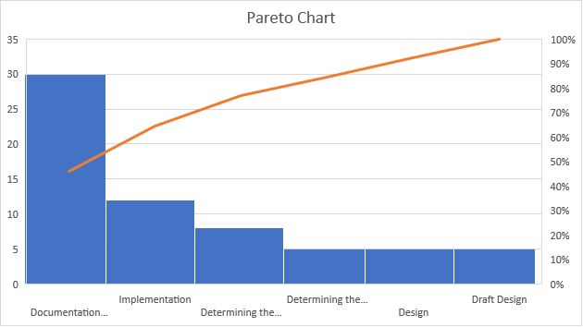

**13**

* 1. **Affinity Diagram**

* 1. **Tree Diagram**

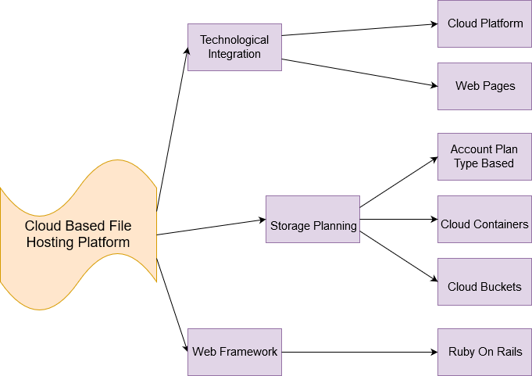

**14**

**SOLUTION 5N1K**

Q: Who can use the solution?

A: Every people who are in need of storage to store their files.

Q: Where can the solution be implemented?

A: The solution can be implemented on a website so that others can access from any device.

Q: When should the solution be established and implemented?

A: It should be implemented after planning, analyzing and designing processes are done. It can be established when the budget is certain and the cloud costs are calculated

Q: What should the solution necessarily provide?

A: The solution should definitely provide basic file upload/download with a convenient speed and easy to use user interface. The other important things that solution should cover is reliability, security and privacy.

Q: Why do we need a solution?

A: Since file sizes get bigger, it becomes hard to manage and pricey to get space. It is also possible to reduce carbon footprints for the environment with manageable cloud platforms.

Q: How should the solution be?

A: There must be a 3rd party cloud provider for us to use for the file storage hosting. 3rd party cloud provider should be trustable and hardworking to maintain the cloud service for 7/24 with no down time and reliable back-ups. It is also important to keep files encrypted for the security and the privacy. Our website which is our product will be using APIs to connect the cloud service platform and upload/download files from there. With the understandable user interface, users will create their accounts, choose their storage plan and pay us monthly to keep up with our 3rd party cloud provider service costs.

**15**

**3.1 Matrix System**

|  |  |  |  |  |
| --- | --- | --- | --- | --- |
| **Symbol** | **Symbol’s Value** | **Relation** | **Supportive** | **Responsibility** |
| **◈** | 8 | Strong | Strong | Primary |
| **▣** | 5 | Some | Some | Seconday |
| **⦿** | 2 | Weak | Weak | Keep it for information |

|  |  |  |  |  |
| --- | --- | --- | --- | --- |
| **Operation** | **Talha** | **Furkan** | **Emre** | **Cenk** |
| **Reading Documents** | **◈** | **◈** | **⦿** | **⦿** |
| **Cloud System**  **Research** | **◈** | **⦿** | **⦿** | **⦿** |
| **Cloud Web Services Research** | **◈** | **⦿** | **⦿** | **⦿** |
| **Determination of the the Problems** | **▣** | **◈** | **⦿** | **▣** |
| **Survey** |  | **▣** | **▣** | **⦿** |
| **5N-1K Problem** | **⦿** |  | **▣** | **▣** |
| **7K Quality Tools** | **◈** | **◈** |  |  |
| **Determination of the the Solutions** | **▣** | **◈** | **▣** | **▣** |
| **Draft Design** | **◈** |  |  |  |
| **5N-1K Solution** | **⦿** |  | **▣** | **▣** |

**16**

**3.1 Matrix Data Analysis**

We have analyzed the importance of people and subject topics in the matrix table. When we add the technical features to our file hosting platform, we provide manageable and simple to use website for all users. Users can pick an account plan and use the service as long as they pay monthly since our cloud provider fees depend on it. In terms of reliability, we will be providing daily back-ups for all users. Users can pick an account plan and use the service as long as they pay monthly since our cloud provider fees depend on it. In terms of reliability, we will be providing daily back-ups for all users. In terms of privacy, we will provide accounts to users which will require at least 6 characters for their password. For security, user accounts will be retrievable and it will be locked after unsuccessful 5 attempts. One of the most important feature of this platform will be very simple to use user interface. Platform will also providing trial or free plan until a certain storage limit exceeds so that all users can have an account and give it a try.

**DESIGN**

The platform will be ruby on rails web app which will run on a hosted domain. But for

development purposes we will be using localhost server. It will consist of 2 different stages;

first one is backend programming and second one is frontend programming. Most of the

functionality will be provided in the first stage and second stage will be focused on simple user

interface. All of the files will be stored in 3rd party cloud provider since we don’t have enough

budget to run our cloud. 3rd party cloud provider will provide a cloud for us in europe region

and they will do daily auto back-ups for us. The cloud provider will also do maintanence from

time to time.

**17**

**4.1 File Hosting Platform Design**

This platform , which will contribute to the solution of the storage problem and environmental carbon footprint problem, will satisfy the people’s storage needs. It will also solve manageability issue on files and prevent couple of file loss cases.

Backend diagram will be as follows:

Frontend Diagram will be as follows:

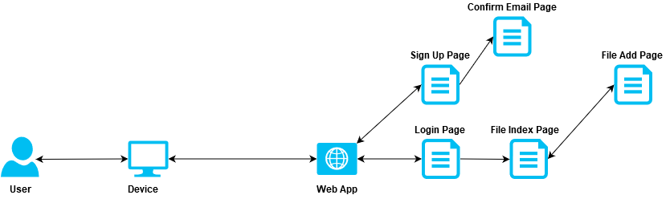

**18**

**COST ANALYSIS**

Cost is the monetary expression of sacrifices that are made to achieve a certain purpose. Cost analysis is an economic calculation adn evaluation method that provides systematic collection, classification and examination of the costs of goods and services in an enterprise or a start-up.

Since our platform depends on 3rd party cloud, a database and a hosting service, cost is calculated for monthly. To reduce the costs, it might make sense to purchase a server machine and handle all the service by ourselves but in the long run, 3rd party pay for what you use make more sense since it is easy to decide on costs of what people used.

As a start-up model, we will be using 1TB space with the exchange of 0.99$ and SQL database which has 10 million rows to record users and their related file attachment URLs. Hosting will be done with the exchange of 2.00$.

|  |  |  |  |
| --- | --- | --- | --- |
| **TYPE** | **Quantity** | **Price(Monthly)** | **COST** |
| **Microsoft Azure** | **1000(GB)** | **$0.00099** | **$0.99** |
| **SQL Database** | **10.000.000(Rows)** | **$0.000009** | **$9.00** |
| **Hosting** | **1** | **$2.00** | **$2.00** |
| **TOTAL** |  |  | **$11.99** |

As a result of cost analysis, we see that our total montly cost is;

**$11.99**

**19**

**SOLUTION**

There is a growing space problem in this digital age. In all digital devices, most importantly

mobiles devices, 76.9% of people who attended in our survey find themselves short in storage.

The another indicator also shows that mobile users which is 92.3% of surveyed people

complain more than the desktop users due to fixed memory slots in their device. That’s why we

came up with a solution which can help people’s lives. Especially for large companies, file

hosting service platform can help them to save billions of dollars data loss with the proper

back-up timing for scalability and ease of use for manageability. Our findings also show that

users familiarity of file hosting services with 86.5% of the surveyed people. Without a doubt,

our solution is demanded by people.

People also ranked most important features; first as speed, second as security, third as reliability

and forth as usability in our survey. Even though speed and security ranked highest among

others, we believe reliablity and usability are important key factors to successful solution for

the users.

In our cost analysis, we found the most effective way as using 3rd party cloud provider and

another 3rd party web hosting service with database. In future, web hosting service and database

also could be provided by our same existing 3rd party cloud provider to maximize the profit

and reduce to costs with pay for what you use business model.

In survey results, we also noticed the users’ deep concerns about privacy about their files and

personal datas that are kept by file hosting services. To improve user’s privacy, it is a must to

have a file server which does all the file handling process, database process and hosting process

which can be quite pricey to keep up. This will maximize the costs in the beginning and

minimize the profits so it will be impossible for a business model to work. Since files and

personal datas can be encrypted. We will do the best end-to-end point encryption to keep

privacy at the highest level in 3rd party provider cloud.

**20**

**REFERENCES**

<https://stackshare.io/frameworks>

<https://www.wikizeroo.org/wiki/en/Ruby_on_Rails>

<https://www.educba.com/laravel-vs-ruby-on-rails/>

<https://www.educba.com/oracle-vs-postgresql/>

<https://www.tutorialspoint.com/ruby/index.htm>

<https://guides.rubyonrails.org>

<http://railscasts.com/>

<https://gorails.com/>

<https://docs.microsoft.com/en-us/azure/storage/>

<https://docs.microsoft.com/en-us/azure/storage/blobs/storage-upload-process-images?tabs=dotnet>

<https://github.com/Azure/azure-storage-ruby>

<https://github.com/plataformatec/devise>

<https://getbootstrap.com/docs/4.3/getting-started/introduction/>

<https://www.cloudberrylab.com/resources/blog/amazon-s3-azure-and-google-cloud-prices-compare/>