HXR原始数据结构说明

数据格式简介：
HXR相机有2块FPGA 板，每个板子输出有效的数据格式如下：
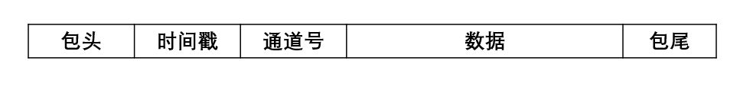
图 1 FPGA输出数据格式

- 包头：每个数据包的起点，采用16位二进制数表示（以十六进制显示则为：AABB）；
- 时间戳：该数据包相对于硬件触发时刻的绝对时间，一般为数据刷新时间的整倍数，单位为毫秒，采用16位二进制数表示；
注：波形数据的时间戳单位为10ms;分时能谱以及能量道的时间戳单位为1ms;
- 通道号：该数据包由哪一个通道测试得到，采用16位二进制数表示，具体表示公式为：$2^{n-1}$ ;n表示第几个通道（HXR相机16通道信号由2块FPGA 板采集处理，每块FPGA 板16通道，因此n取1～16）；具体数据如下表所示：
通道信息 | 0x0001 | 0x0002 | 0x0004 | 0x0008 | 0x0010 | 0x0020 | 0x0040 | 0x0080
通道号 | CH1 | CH2 | CH3 | CH4 | CH5 | CH6 | CH7 | CH8
通道信息 | 0x1000 | 0x2000 | 0x4000 | 0x8000 | 0x1000 | 0x2000 | 0x4000 | 0x8000
通道号 | CH9 | CH10 | CH11 | CH12 | CH13 | CH14 | CH15 | CH16

- 数据：数据分为三种格式，波形为580个数据点，分时能谱为512个数据点，能量道为16个数据点，每个数据点均采用16位二进制数表示；
- 包尾：每个数据包的末尾，采用16位二进制数表示（以十六进制显示则为：CCDD）。

波形数据格式：
HXR相机有2块FPGA 板，每个板子输出的数据格式如下：
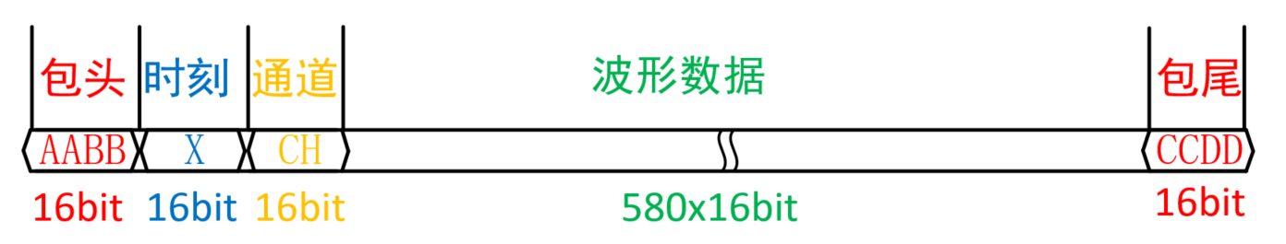
图 2 FPGA波形输出数据格式

能谱512道格式：

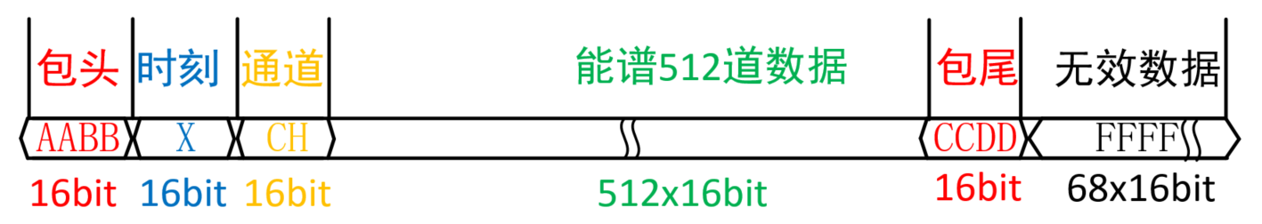
图 3 FPGA分时能谱输出数据格式

能谱16道格式：

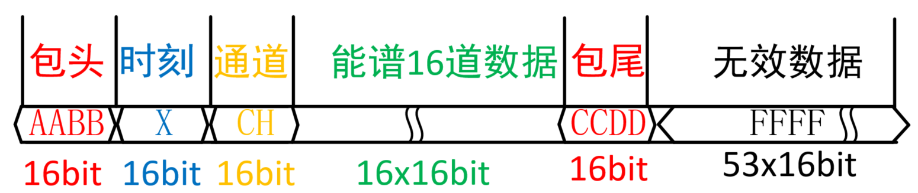
图 4 FPGA能量道输出数据格式

原始数据示例：
接下来是三种不同的原始数据示例，其中红色的是包头和包尾，蓝色的是时间戳，黄色的是通道号，绿色是测试数据，黑色是无效字节。

波形原始数据示例：（以16进制表示）
AA BB 00 01 00 01 21 20 21 30 21 09 21 1B 21 25 21 32 21 10 21 29 20 FD 21 08 21 1D 21 07 21 21 21 1B 21 2C 21 45 21 1C 21 2A 21 06 21 18 20 EE 21 0E 20 ED 21 1C 21 2E 21 2C 20 EF 21 35 21 1A 21 0B 21 45 21 02 21 26 20 F9 20 FA 21 38 21 2E 21 06 21 3B 21 1F 21 33 21 1D 21 0A 21 12 21 2B 21 31 21 03 21 0D 21 36 21 29 21 12 21 19 20 E0 21 40 21 19 20 F2 20 FD 21 06 20 FA 21 11 20 FF 21 0D 21 39 21 30 21 09 21 06 21 0F 21 44 20 ED 21 1B 21 0A 21 45 21 09 21 50 21 18 21 10 21 1E 21 05 21 09 21 1E 21 44 21 2F 20 D9 21 0B 21 21 21 1E 21 09 21 39 21 25 21 06 21 45 21 11 21 12 21 2C 21 04 21 12 21 11 21 1D 21 00 21 40 21 03 21 08 21 26 21 03 21 3B 21 14 21 31 21 1A 21 29 20 ED 21 3E 21 01 21 23 21 1B 21 28 21 16 21 11 21 1B 21 19 21 19 21 0C 21 23 21 05 21 21 21 1D 21 2E 21 1E 21 19 21 15 21 04 21 26 21 0E 21 2D 20 F7 21 24 21 32 20 F3 21 08 20 F9 20 FE 21 02 21 1E 21 27 20 EB 21 30 21 07 21 31 21 21 21 0B 21 17 21 1C 21 36 20 F7 20 FB 21 0D 21 15 21 06 21 12 21 03 21 07 21 3B 21 03 21 01 21 14 21 01 21 02 21 4E 21 03 21 20 21 3D 21 1A 21 18 21 29 21 04 21 0D 21 54 20 F6 20 FA 21 50 20 F1 21 0A 21 13 21 2A 21 20 21 07 21 21 21 24 21 25 21 05 21 0B 21 06 21 18 21 17 21 1D 21 2F 21 0F 21 15 21 30 21 41 21 38 21 36 21 30 21 00 21 1C 21 30 21 07 21 1D 21 18 21 1E 21 14 21 22 21 24 21 35 20 F4 21 1E 20 FC 20 F9 21 22 21 19 20 FF 20 F8 21 15 21 04 21 1D 21 1D 21 12 21 49 21 01 21 25 21 19 21 1E 21 1C 21 17 21 17 21 27 20 FB 21 0F 20 EF 21 07 21 0E 21 18 21 1A 21 03 20 F0 21 08 21 12 21 32 21 27 21 1B 21 04 21 1F 21 28 20 F5 21 1B 21 1A 21 17 21 0D 21 15 21 34 21 1A 21 16 20 E1 21 29 21 14 21 24 21 05 21 3D 21 10 21 32 21 44 21 0B 21 23 21 1C 21 12 21 0E 21 0E 21 04 21 31 20 E9 21 17 21 24 20 ED 20 F4 21 22 21 1D 21 1A 21 13 21 19 21 0A 21 1B 20 FB 21 20 21 0D 21 3D 21 1A 21 16 21 24 21 39 21 39 21 1A 21 23 20 FF 21 0C 21 18 21 30 21 0F 21 0C 21 1A 21 0C 21 25 20 F6 21 3B 21 0B 21 18 21 0B 21 2E 21 25 21 06 21 0A 21 00 21 2B 21 1A 21 33 20 F2 21 0E 21 1B 20 FA 21 1C 21 0D 21 08 21 32 21 1C 21 28 21 1C 20 FB 20 FB 21 1E 21 16 21 3C 21 19 21 0F 21 0A 21 34 21 08 21 2F 21 08 21 25 21 03 21 15 20 EB 21 22 21 1C 20 EB 21 2B 21 21 20 F6 21 17 21 25 20 F4 21 1D 21 20 21 03 21 17 21 42 20 F7 21 1C 21 07 21 10 21 28 21 0C 21 16 21 18 21 2D 21 1C 20 F4 21 3A 21 23 21 1F 21 35 20 F3 21 0E 21 4B 21 0E 21 14 21 1D 21 20 21 2A 21 0A 21 14 21 09 21 25 21 27 21 15 21 1D 21 1D 21 31 20 EF 21 10 21 15 21 2B 21 1E 21 14 21 0C 21 1B 21 06 21 33 21 2E 21 2F 21 1A 21 0E 21 15 20 F3 21 27 21 1C 21 2E 21 05 21 05 21 3F 21 2F 20 FC 21 3C 21 02 21 13 21 0E 21 01 21 40 21 35 20 FD 21 26 21 10 21 31 20 E6 21 49 21 1A 21 38 21 0D 21 27 21 34 21 1D 21 09 21 08 21 21 21 28 21 0E 21 39 20 F1 20 FD 21 17 20 F5 21 10 21 1E 20 F2 21 41 21 39 21 32 21 01 21 28 21 40 21 20 20 FA 21 19 21 22 21 0F 21 22 21 34 20 FE 21 10 21 03 20 FF 20 F6 21 10 21 35 21 08 21 1D 21 0D 21 15 21 36 21 12 21 1F 21 23 21 26 20 FA 21 1A 20 F3 21 28 21 36 21 0A 21 1C 20 E9 21 01 21 07 21 1D 21 14 21 15 21 2B 21 03 21 1B 21 02 20 F8 21 5D 21 1E 21 08 21 04 21 24 21 24 21 10 21 41 21 3A 21 14 21 37 21 18 21 18 21 1D 21 38 21 01 21 35 21 1C 21 01 21 3F 21 0C 21 20 21 34 21 0C 21 1A 21 22 21 0B 21 35 21 43 21 04 21 1D 21 05 21 1B 21 31 20 EB 21 33 21 20 21 32 21 31 20 FD 20 E9 21 26 21 1C 21 1D 21 19 21 28 21 1E 20 F5 21 07 21 3A 20 F9 21 21 20 F7 21 05 21 19 21 1F 21 14 20 E4 21 4D 21 24 21 22 21 4A 21 1B 21 42 21 19 21 1A 21 20 21 2B 21 03 21 14 21 1E 21 38 21 18 21 1A 21 24 21 01 21 3C 21 1B 21 14 21 06 21 06 CC DD

分时能谱原始数据示例：（以16进制表示）
AA BB 00 01 00 0A 00 00 00 00 00 00 00 00 00 00 00 00 00 00 00 00 00 00 00 00 00 00 00 00 00 00 00 00 00 00 00 00 00 00 00 00 00 00 00 00 00 00 00 00 00 00 00 00 00 00 00 00 00 00 00 00 00 00 00 00 00 00 00 00 00 00 00 00 00 00 00 00 00 00 00 00 00 00 00 00 00 00 00 00 00 00 00 00 00 00 00 00 00 00 00 00 00 00 00 00 00 00 00 00 00 00 00 00 00 00 00 00 00 00 00 00 00 00 00 00 00 00 00 00 00 00 00 00 00 00 00 00 00 00 00 00 00 00 00 00 00 00 00 00 00 00 00 00 00 00 00 00 00 00 00 00 00 00 00 00 00 00 00 00 00 00 00 00 00 00 00 00 00 00 00 00 00 00 00 00 00 00 00 00 00 00 00 00 00 00 00 00 00 00 00 00 00 00 00 00 00 00 00 00 00 00 00 00 00 00 00 00 00 00 00 00 00 00 00 00 00 00 00 00 00 00 00 00 00 00 00 00 00 00 00 00 00 00 00 00 00 00 00 00 00 00 00 00 00 00 00 00 00 00 00 00 00 00 00 00 00 00 00 00 00 00 00 00 00 00 00 00 00 00 00 00 00 00 00 00 00 00 00 00 00 00 00 00 00 00 00 00 00 00 00 00 00 00 00 00 00 00 00 00 00 00 00 00 00 00 00 00 00 00 00 00 00 00 00 00 00 00 00 00 00 00 00 00 00 00 00 00 00 00 00 00 00 00 00 00 00 00 00 00 00 00 00 00 00 00 00 00 00 00 00 00 00 00 00 00 00 00 00 00 00 00 00 00 00 00 00 00 00 00 00 00 00 00 00 00 00 00 00 00 00 00 00 00 00 00 00 00 00 00 00 00 00 00 00 00 00 00 00 00 00 00 00 00 00 00 00 00 00 00 00 00 00 00 00 00 00 00 00 00 00 00 00 00 00 00 00 00 00 00 00 00 00 00 00 00 00 00 00 00 00 00 00 00 00 00 00 00 00 00 00 00 00 00 00 00 00 00 00 00 00 00 00 00 00 00 00 00 00 00 00 00 00 00 00 00 00 00 00 00 00 00 00 00 00 00 00 00 00 00 00 00 00 00 00 00 00 00 00 00 00 00 00 00 00 00 00 00 00 00 00 00 00 00 00 00 00 00 00 00 00 00 00 00 00 00 00 00 00 00 00 00 00 00 00 00 00 00 00 00 00 00 00 00 00 00 00 00 00 00 00 00 00 00 00 00 00 00 00 00 00 00 00 00 00 00 00 00 00 00 00 00 00 00 00 00 00 00 00 00 00 00 00 00 00 00 00 00 00 00 00 00 00 00 00 00 00 00 00 00 00 00 00 00 00 00 00 00 00 00 00 00 00 00 00 00 00 00 00 00 00 00 00 00 00 00 00 00 00 00 00 00 00 00 00 00 00 00 00 00 00 00 00 00 00 00 00 00 00 00 00 00 00 00 00 00 00 00 00 00 00 00 00 00 00 00 00 00 00 00 00 00 00 00 00 00 00 00 00 00 00 00 00 00 00 00 00 00 00 00 00 00 00 00 00 00 00 00 00 00 00 00 00 00 00 00 00 00 00 00 00 00 00 00 00 00 00 00 00 00 00 00 00 00 00 00 00 00 00 00 00 00 00 00 00 00 00 00 00 00 00 00 00 00 00 00 00 00 00 00 00 00 00 00 00 00 00 00 00 00 00 00 00 00 00 00 00 00 00 00 00 00 00 00 00 00 00 00 00 00 00 00 00 00 00 00 00 00 00 00 00 00 00 00 00 00 00 00 00 00 00 00 00 00 00 00 00 00 00 00 00 00 00 00 00 00 00 00 00 00 00 00 00 00 00 00 00 00 00 00 00 00 00 00 00 00 00 00 00 00 00 00 00 00 00 00 00 00 00 00 00 00 00 00 00 00 00 00 00 00 00 00 00 00 00 00 00 00 00 00 00 00 00 00 00 00 00 00 00 00 00 00 00 00 00 00 00 00 00 00 00 00 00 00 00 00 00 00 00 00 00 00 00 00 00 00 00 00 00 00 00 00 00 00 00 00 00 00 00 00 00 00 00 00 00 00 00 00 00 00 00 00 00 00 00 00 00 00 00 00 00 00 00 00 00 00 00 00 00 00 00 00 00 00 00 00 00 00 00 00 00 00 00 00 00 00 00 00 00 00 00 00 00 00 00 00 00 00 00 00 00 00 00 00 00 00 00 00 00 00 00 00 00 00 00 00 00 00 00 00 00 00 00 00 00 00 00 00 00 00 00 00 00 00 00 00 00 00 00 00 CC DD FF FF FF FF FF FF FF FF FF FF FF FF FF FF FF FF FF FF FF FF FF FF FF FF FF FF FF FF FF FF FF FF FF FF FF FF FF FF FF FF FF FF FF FF FF FF FF FF FF FF FF FF FF FF FF FF FF FF FF FF FF FF FF FF FF FF FF FF FF FF FF FF FF FF FF FF FF FF FF FF FF FF FF FF FF FF FF FF FF FF FF FF FF FF FF FF FF FF FF FF FF FF FF FF FF FF FF FF FF FF FF FF FF FF FF FF FF FF FF FF FF FF FF FF FF FF FF FF FF FF FF FF FF FF FF FF

能量道原始数据示例：（以16进制表示）
AA BB 00 01 00 01 00 00 00 00 00 00 00 00 00 00 00 00 00 00 00 00 00 00 00 00 00 00 00 00 00 00 00 00 00 00 00 00 CC DD FF FF FF FF FF FF FF FF FF FF FF FF FF FF FF FF FF FF FF FF FF FF FF FF FF FF FF FF FF FF FF FF FF FF FF FF FF FF FF FF FF FF FF FF FF FF FF FF FF FF FF FF FF FF FF FF FF FF FF FF FF FF FF FF FF FF FF FF FF FF FF FF FF FF FF FF FF FF FF FF FF FF FF FF FF FF FF FF FF FF FF FF FF FF FF FF FF FF FF FF FF FF FF FF FF FF

