Long-Short Term Memory Networks
Hand-Writing Generator
  - Anirudh A C | BL.EN.U4RAE23003
  - Click Here to Access the GitHub Repo for Code

Introduction
Handwriting can be represented as a sequence of pen positions over time, making it a time-series problem. Each point in the sequence depends on previous points, which makes sequential models suitable for learning handwriting dynamics. Traditional approaches focus on image-based handwriting recognition, but this project models handwriting as a trajectory generation problem.
The objective is to train a model that learns how a pen moves and generates new handwriting trajectories. This is achieved using Long Short-Term Memory (LSTM) networks, which are capable of modeling temporal dependencies in sequential data.
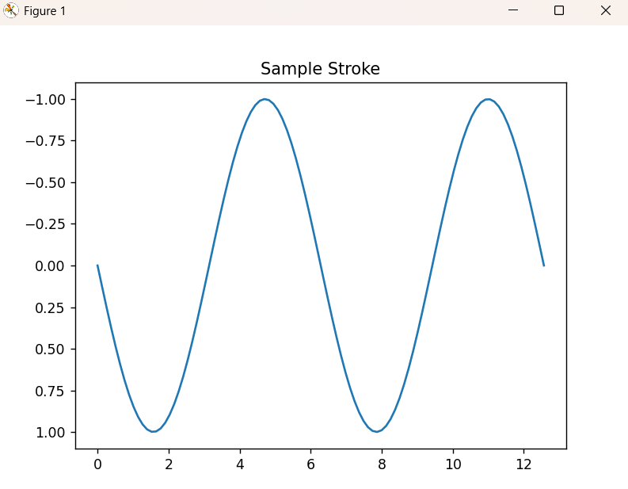
The system takes real handwriting data, processes it into coordinate sequences, and trains models to predict the next point in a sequence. Generated sequences are then combined to form complete words and visualized as handwriting.
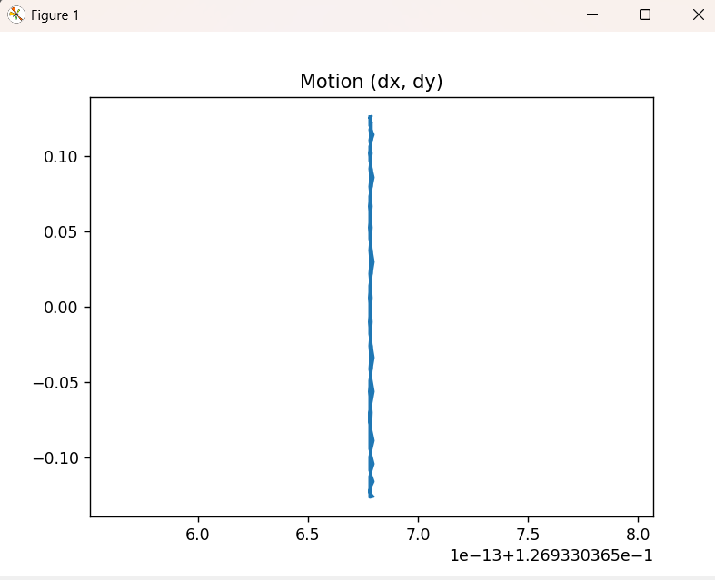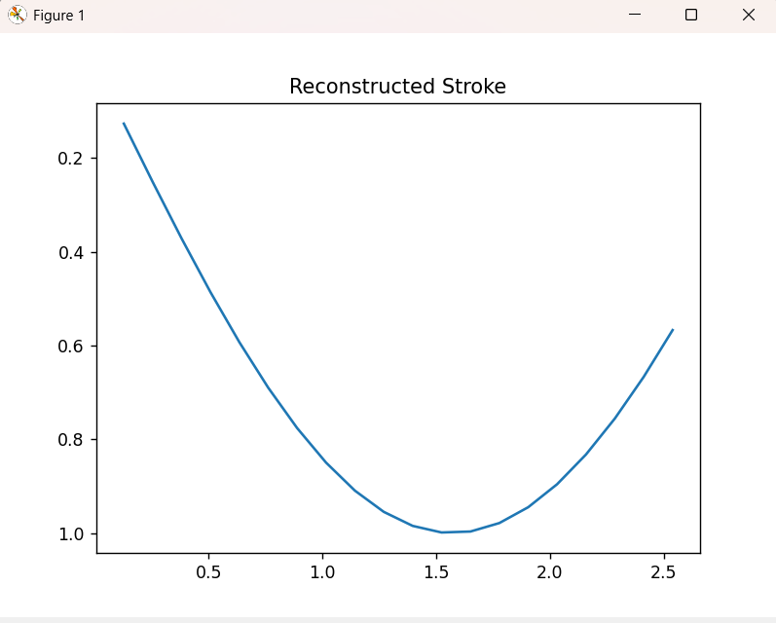

Dataset
The dataset used is the UJI Pen Characters dataset, which contains online handwriting data captured as sequences of pen coordinates.
Each sample consists of:
- multiple strokes
- each stroke containing (x, y) points
- pen-up and pen-down information
The data is stored in a structured text format with markers such as:
- .SEGMENT → new character
- .PEN_DOWN → start of stroke
- .PEN_UP → end of stroke
Component | Description
Character | Label (A–Z)
Stroke | Sequence of points
Coordinates | (x, y) values
Pen State | Stroke boundaries
Preprocessing Steps
- Extract strokes and labels
- Flatten strokes into sequences
- Normalize coordinates:
$$x^{'}=\frac{x-μ_{x}}{σ_{x}},y^{'}=\frac{y-μ_{y}}{σ_{y}}$$
- Create sliding windows of length $L$

Methodology
The system is designed to learn handwriting trajectories using sequence prediction.
Training Process
- Input: sequence of length $L$
- Output: next sequence shifted by 1
$$X=[(x_{1},y_{1}),…,(x_{L},y_{L})] \\ Y=[(x_{2},y_{2}),…,(x_{L+1},y_{L+1})]$$
The model learns to predict the next point in the sequence.

Per-Character Modeling
Instead of a single model, separate models are trained for each character:
- reduces variation
- improves shape consistency

Generation
- Take initial seed sequence
- Predict next point
- Append prediction
- Repeat for $T$steps

Word Formation
Words are generated by:
- generating individual letters
- aligning them
- adding spacing

Model Architecture
The model used is a multi-layer LSTM network.
Layer | Description
Input | 2 (x, y)
LSTM | 128 hidden units
Layers | 2
Dropout | 0.2
Output | 2 (next x, y)
Forward pass:
$$\hat{Y}=\text{Linear}(\text{LSTM}(X))$$

Implementation
The system is implemented in Python using PyTorch.
Component | Description
Data Loader | Parses UJI dataset
Preprocessing | Normalization + sequences
Model | LSTM network
Training | MSE loss + Adam optimizer
Inference | Generates handwriting

Training Configuration
Parameter | Value
Sequence Length | 40
Batch Size | 64
Epochs | 40
Learning Rate | 0.001

Results and Limitations
The model is able to generate smooth handwriting trajectories and construct words.
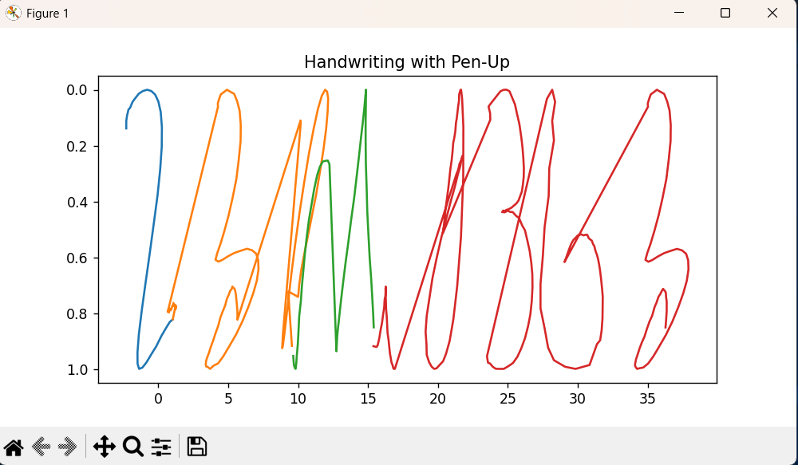
The model tried to write 23RAI313. Since it has no pen-up function, it looks shabby.
Observations
- LSTM captures local motion dynamics
- Generated strokes are smooth
- Per-character models improve consistency
- Pen-up handling improves readability

Limitations
- Model learns local motion, not full shape
- No explicit pen-state prediction
- Drift occurs in long sequences
- Limited dataset size

Conclusion
This project demonstrates that LSTM networks can effectively model handwriting as a sequence of pen movements. While the model captures motion dynamics well, it does not fully learn global character structure.
Future improvements include:
- pen-state prediction
- advanced generative models
- integration with robotic systems

