A review of principles of MEMS pressure sensing with its aerospace applications
Yaser Javed, Mohtashim Mansoor and Irtiza Ali Shah College of Aeronautical Engineering, National University of Sciences and Technology, Islamabad, Pakistan

Abstract
Purpose - Pressure, being one of the key variables investigated in scientific and engineering research, requires critical and accurate measurement techniques. With the advancements in materials and machining technologies, there is a large leap in the measurement techniques including the development of micro electromechanical systems (MEMS) sensors. These sensors are one to two orders smaller in magnitude than traditional sensors and combine electrical and mechanical components that are fabricated using integrated circuit batch- processing technologies. MEMS are finding enormous applications in many industrial fields ranging from medical to automotive, communication to electronics, chemical to aviation and many more with a potential market of billions of dollars. MEMS pressure sensors are now widely used devices owing to their intrinsic properties of small size, light weight, low cost, ease of batch fabrication and integration with an electronic circuit. This paper aims to identify and analyze the common pressure sensing techniques and discuss their uses and advantages. As per our understanding, usage of MEMS pressure sensors in the aerospace industry is quite limited due to cost constraints and indirect measurement approaches owing to the inability to locate sensors in harsh environments. The purpose of this study is to summarize the published literature for application of MEMS pressure sensors in the said field. Five broad application areas have been investigated including: propulsion/turbomachinery applications, turbulent flow diagnosis, experimental aerodynamics, micro- flow control and unmanned aerial vehicle (UAV)/micro aerial vehicle (MAV) applications.
Design/methodology/approach - The first part of the paper deals with an introduction to MEMS pressure sensors and mathematical relations for its fabrication. The second part covers pressure sensing principles followed by the application of MEMS pressure sensors in five major fields of aerospace industry.
Findings - In this paper, various pressure sensing principles in MEMS and applications of MEMS technology in the aerospace industry have been reviewed. Five application fields have been investigated including: Propulsion/Turbomachinery applications, turbulent flow diagnosis, experimental aerodynamics, micro- flow control and UAV/MAV applications. Applications of MEMS sensors in the aerospace industry are quite limited due to requirements of very high accuracy, high reliability and harsh environment survivability. However, the potential for growth of this technology is foreseen due to inherent features of MEMS sensors’ being light weight, low cost, ease of batch fabrication and capability of integration with electric circuits. All these advantages are very relevant to the aerospace industry. This work is an endeavor to present a comprehensive review of such MEMS pressure sensors, which are used in the aerospace industry and have been reported in recent literature.
Originality/value - As per the author’s understanding, usage of MEMS pressure sensors in the aerospace industry is quite limited due to cost constraints and indirect measurement approaches owing to the inability to locate sensors in harsh environments. Present work is a prime effort in summarizing the published literature for application of MEMS pressure sensors in the said field. Five broad application areas have been investigated including: propulsion/turbomachinery applications, turbulent flow diagnosis, experimental aerodynamics, micro- flow control and UAV/MAV applications.
Keywords MEMS, MEMS aerospace applications, MEMS pressure sensing principles
Paper type Literature review

1. Introduction
The pressure is an important and widely measured physical quantity in various research fields. Majority of the micro pressure sensor uses integrated circuit fabrication technology to sense, gauge and transmit the information in the form of electrical signals. Different types of pressures such as absolute, vacuum, gauge and differential pressure can be measured through the use of pressure sensors. Pressure sensors, being the most mature MEMS technology, cover a large segment of the sensor market by volume. The worldwide pressure sensor market is expected to cross () 10$ by 2022, expanding at a compound annual growth rate of 6.5 per cent from 2016 to 2022 (Alliedmarketresearch.com, 2017).
Taking leverage of the recent advancements in microfabrication and MEMS sector, pressure sensors have successfully exploited the broad benefits of these technologies. MEMS technology has been particularly successful in the pressure sensing context. Majority of today’s pressure sensors used in industrial, biological, automotive and mechanical setups are based on MEMS due to their capability of smaller size, higher performance, lesser power consumption and integration of electronic circuitry on the same chip (Bogue, 2013). Silicon piezorestive pressure sensors and
capacitive sensors are increasingly being used worldwide to tackle these requirements.
In 1960, Honeywell and Bell labs described the first ever piezoresistive pressure sensors based on silicon technology. The earlier silicon pressure sensors consist of silicon piezoresistors that are attached to metal diaphragms with glue and epoxy. The pressure change causes the diaphragm to deflect and subsequently the resistance of piezoresistors changes. This change is picked up by the strain gages. Single- crystal silicon diaphragms with diffused piezoresistors quickly out fashioned the metal diaphragms. Because of the improvements in microfabrication technology, the advanced micro- pressure sensors used today are made by anisotropic etching of silicon. The inherent benefits associated with this technique include well- controlled diaphragm sizes and locations, improved strain gauge placements, batch fabrication of diaphragms and size reduction (Eaton and Smith, 1997).
Subsequent paragraphs of the paper classify several pressure sensing techniques followed by a detailed review of pressure sensors applications in the aerospace industry.

2. Micro pressure sensors
The micro pressure sensing technique is not different than that of the conventional techniques. Deformation created in a diaphragm due to the applicability of applied pressure is decoded for the calculation of pressure. Generally, three types of diaphragm shapes are used i.e. circle, rectangle and square. For a circular shaped diaphragm with deflection less than half of the diaphragm thickness, the deflection relation is given by:
$$w(r)=\frac{Pa^{4}}{64D}{\left[1−{\left(\frac{r}{R}\right)}^{2}\right]}^{2}$$
where $w,r,R$ and $P$ are a deflection, the radial distance from the diaphragm center, radius of the diaphragm and applied pressure, respectively. $D$ is the Flexural rigidity given by:
$$D=\frac{Eh^{3}}{12(1−θ^{2})}$$
where $E,h$ and $θ$ are the Youngs’ Modulus, diaphragm thickness and Poisson ratio, respectively. For rectangular shaped diaphragm, deflection is given by:
$$w=α\frac{Pa^{3}}{D}$$
$$α=1.26x{10}^{−3}x12\left(1−θ^{2}\right)$$
where a is the plate length, $P$ is the applied pressure and $α$ is the numerical factor depending on the ratio between length and width of the rectangular diaphragm. The square diaphragm is found to be preferred geometry as it has the highest induced stress for applied pressure. For a square- shaped diaphragm, the maximum stress is at the middle of each edge and the maximum deflection is given by:
$$w=\frac{0.00674Pa^{3}}{D}$$
where $P,a$ and $D$ are the applied pressure, side length and flexural rigidity, respectively.

3. Pressure sensing principles
There are different principles used for sensing pressure, which include piezoelectric, piezoresistive, capacitive, resonant, optical, electromagnetic techniques, etc. Though few principles for measuring the vibrating motion of a diaphragm have been known for ages, but the cutting edge CMOS and SOI technologies have fueled the sensors utilization as this technology gives added advantages of low cost per unit, high resolution and small fabrication tolerance (Löfdahl and Gad- el- Hak, 1999a). Sensing principles for MEMS devices with respect to integration can be classified into two broad categories. One is the fully integrated device while the other is semi- integrated, which requires peripheral devices to be positioned accurately with respect to it (Cimalla et al., 2007). A brief overview of various techniques is presented in succeeding paragraphs.

3.1 Piezoresistive sensors
A piezoresistive pressure sensor consists of a diaphragm having piezoresistors in Wheatstone bridge configuration. With the application of pressure, the diaphragm deflects and the strains on the diaphragm are calculated through strain gauges (Sensing.honeywell.com, 2018). The resistance changes linearly with applied pressure for thin diaphragms and small deflections. A general layout of the Wheatstone bridge circuit is shown in Figure 1. All resistances are having similar resistance values. When excitation voltage $V_{ex}$ is applied across the bridge, the signal output is read as half the applied voltage. On the application of pressure, opposite resistances change their resistance. Resultantly, voltage changes and this change is calibrated as to indicate the applied pressure. For measurement purpose, the change in voltage is the difference of voltages between two terminals output signal value. i.e.:
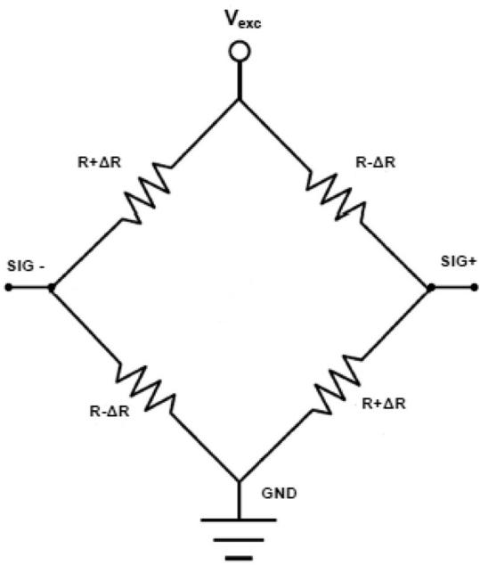
Figure 1 Four piezoresistors are arranged in a Wheatstone bridge configuration Note: Change in pressure causes variation in voltage across sensing terminals as $SIG+$ and SIG-
Yaser Javed, Mohtazhim Mansoor and Iritza Ali Shah
$$V_{o}=(Sig+)−(Sig−)$$
This is the most common and mature sensing principle because of its high sensitivity, small size, simple fabrication and low cost. Piezoresistive sensors can be used for measurement of absolute, gauge or differential pressure on wide spectrum pressure applications. Another distinction between them can be made on the type of material used for piezoresistors. The electronic response of semiconductor material drastically changes with temperature. Therefore, SiC, group III nitrides and diamond are the potential candidates for high- temperature applications of pressure sensors (Werner and Fahrner, 2001). The evolution of piezoresistive sensors over the period of time has been thoroughly covered by Eaton and Smith (1997).
Silicon is the most common material used for piezoresistive pressure sensors because of its excellent nature of high sensitivity and mechanical stability. However, at the same time, a drawback is the high sensitivity of piezoresistive material to temperature effects. Silicon piezoresistors experience junction leakage at high temperatures and resultantly, their performance degrades. To overcome this problem, the SOI pressure sensor is the preferred choice for high- temperature environment usage. The buried oxide layer in SOI pressure sensor is used for isolating the resistors from each other and from bulk. A schematic view of a piezoresistor pressure sensor with four piezoresistors is shown in Figure 2(a) while a comparative view of a conventional and an SOI pressure sensor is presented in Figure 2(b). An excellent overview on the design principles and requirements for silicon piezoresistive pressure sensors is given by (Kumar and Pant, 2014).

3.2 Capacitive pressure sensors
A capacitive pressure sensor operates on the principle of capacitance variance between a metal diaphragm and a fixed metal plate. The structure has a chamber with a reference pressure and is closed off by an elastic membrane that is exposed to an external pressure. The applied pressure decreases the distance between two plates and subsequently results in capacitance change (Eswaran and Malarvizhi, 2013) A schematic diagram of the capacitive pressure sensor is shown in Figure 3. The two plates do not remain parallel, which results in a nonlinear relation between deflection and capacitance. Thus, the response of the capacitive sensor becomes non- linear with applied pressure. The basic schematic of a capacitive pressure sensor consists of a set of plates with Volume 39- Number 5- 2019- 652- 664
surface area $A$ separated by a distance $d$ as shown in Figure 3. The capacitance value is given by the following relation:
$$C_{o}=ϵ\frac{A}{d}$$
where $ϵ$ is the permittivity of the medium between the plates. There are various techniques to cater for the non- linear behavior of capacitive sensors. In one of such techniques, the center of diaphragm is brought to touch the second plate as shown in Figure 4. As the applied pressure increases, the contact area of the diaphragm increases, resulting into a linear response of the
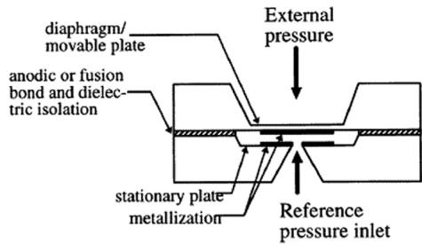
Figure 3 Schematic diagram of a capacitive pressure sensor
Note: Capacitance changes as diaphragm deforms under external pressure Source: Eaton and Smith, 1997
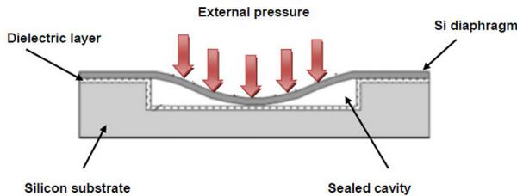
Figure 4 Schematic diagram of the capacitive pressure sensor operated in contact mode
Note: Capacitance is directly proportional to the contact area Source: Frobenius et al., 1973
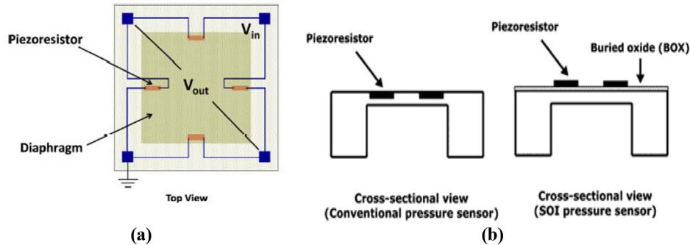
Figure 2 (a) Schematic view of a piezoresistive pressure sensor with four piezoresistors placed in Wheatstone bridge arrangement; (b) comparison of a conventional and SOI piezoresistive pressure sensor where later can be used at high temperatures due to the presence of thin oxide layer
sensor. Another technique is the use of bossed diaphragm in which the cross- section is non- uniform as shown in Figure 5. On the application of pressure, the thicker portion does not change its shape and two plates remain parallel to each other resulting in a linear response of the sensor. There are many associated advantages with capacitive sensing technique as compared to other methods. One of the major advantages is insensitivity to temperature changes and slow drift besides high pressure sensitivity, less power consumption, etc., (Puers, 1993). The main difference between capacitive sensors and piezoresistive sensors is the measurement of different physical variables. Capacitive sensors measure the displacement of the membrane instead of stress, which is measured in piezoresistive sensors. Resultantly, fewer package related problems are faced in capacitive sensing. However, a compatible sensing circuit for measuring extremely high sensitivity and design complexity are few of the challenges in this domain.
Organic field effect transistors (OFETs) are the modern form of capacitive pressure sensors. Gate voltage controls the charge status of a dielectric layer that is used as a capacitor. OFET incorporates an exclusive signal amplification function, and thus, effectively detects an applied pressure with high sensitivity and low power consumption (Zang et al., 2015). Review of silicon capacitive type sensors fabricated over the years is thoroughly presented by Puers (1993).

3.3 Piezoelectric pressure sensors
Piezoelectricity is a phenomenon exhibited by a certain class of solid materials including crystals and ceramics. An electric charge is induced in these materials on the application of stress. Changes in the molecular structure of crystals upon application of pressure results in dipoles which subsequently polarize the material (Cook- Chennault et al., 2008). The charge from the crystals to an in- built amplifier is ensued through electrodes as shown in Figure 6. In a Transverse mode of operation, a force applied in a normal direction over the surface of piezoelectric material results in disturbance or displacement of charges along the horizontal direction i.e. normal to the applied force (Figure 7). The amount of charge is given by the following relation:
$$C_{x}=d_{xy}F_{y}\frac{b}{a}$$
where $C_{x}$ is the amount of charge, $a$ is the dimension along with applied force, $b$ is the dimension along horizontal of material and $d$ is the corresponding piezoelectric coefficient. Advantage of piezoelectric sensors is that no external excitation source is Note: An electric polarization is induced in the material upon the application of stress Source: Razak et al., 2012
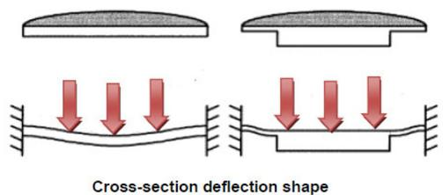
Figure 5 Comparison of cross sections of uniform thickness (left) and bossed (right) diaphragms
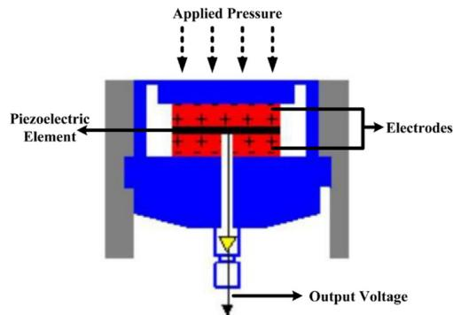
Figure 6 Construction of a piezoelectric pressure sensor
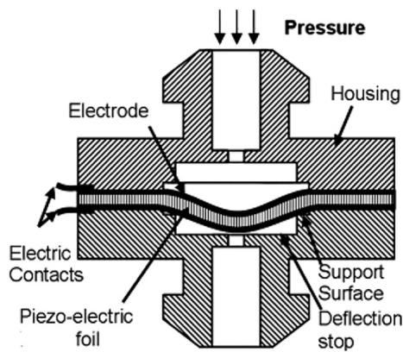
Figure 7 Schematic cross section of a piezoresistive pressure sensor
Note: The thin piezoelectric material film deflects on the application of pressure Source: Shirinov and Schomburg, 2008
required for this class. However, shock and vibration effects are prominent and special packaging techniques are required to use these sensors.
A major area of application for piezoelectric sensors includes acoustics and detection of dynamic pressures due to their highly sensitive and fast response nature. Piezoelectric sensors are commonly used for fabricating sensing devices that do not require an external power source to operate (Xu et al., 2010).

3.4 Optical pressure sensors
Optical pressure sensors work on the principle of measuring light intensity and wavelength of the applied pressure signal. A source focuses light on a membrane and the corresponding change in light intensity due to applied pressure and deflection of membrane is picked up by a detector set as shown in Figure 8. Optical pressure sensors find their application in turbomachinery, touch screen devices such as pads, smart- phones, etc., (Zang et al., 2015).
Characteristic advantages associated with optical fiber pressure sensors include harsh environment survivability
Yaser Javed, Mohtashim Mansoor and Irtiza Ali Shah
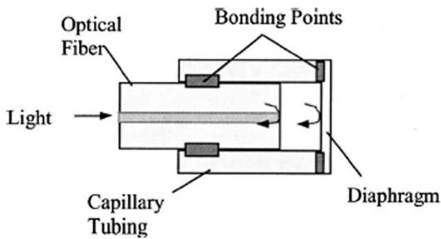
Figure 8 Construction of a diaphragm based fiber optic pressure sensor
Note: Difference of Light intensity reflection from the diaphragm and optical fiber end face is demodulated to measure applied pressure Source: Xu et al.,2005a
including high- temperature and corrosion. Besides, optical pressure sensors are of appropriate choice for requirements including high resolution, high sensitivity and resistance to electromagnetic interference. However, fabrication of optical sensors is tricky as it usually involves several materials. Severe stresses are generated amongst the materials due to a mismatch in their respective coefficient of thermal expansion values (Wang et al., 2006). Other Challenges include alignment of the optics and calibration of the sensor (Gander et al., 2003).
Many researchers have reported optical sensors that incorporate diaphragm to measure pressure- induced deflections that vary in a linear way. Interferometric techniques include Michelson method, Fabry- Perot method and fiber Bragg grating (FBG) method for the nanometer scale range optical measurement of the displacement in mechanical systems. The most commonly used method in sensor technology is FBG method. The FBG reflect specific wavelengths of light close to its resonance wavelength and the remaining optical spectrum is allowed to pass through as shown in Figure 9. The Bragg resonant wavelength is defined as (Urban et al., 2010):
$$λ_{Bragg}=2n_{eff}λ$$
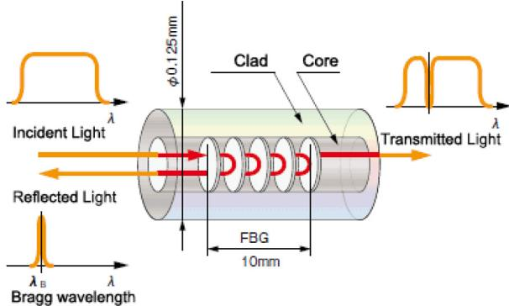
Figure 9 Schematic of a fiber Bragg grating optical sensor
Note: When light passes through the FBG, only the light of a particular wavelength is reflected Source: Lab,2019

3.5 Resonant pressure sensors
A resonant sensor comprises of an element vibrating at resonance. When an external stimulus is applied, the output frequency of the element changes. The applied pressure results in a change in stress, which is recorded as the resonance frequency of the vibrating element (Stemme, 1991). Three basic resonant structures used in resonant pressure sensors are depicted in Figure 10. The resonance frequency is related with applied pressure through the following relation:
$$f=f_{0}{\left(1+αp^{2}\right)}^{\frac{1}{2}}$$
where $f_{0}$ is the resonance frequency at zero pressure, $P$ is the pressure and $α$ is the sensitivity (Smiths et al., 1983).A schematic diagram of a resonant pressure sensor with a beam made up of silicon nitride is shown in Figure 11. Another approach is to coating a resonant mechanical element with a compound that will bind specific molecules. Once the mass of the element increases because of the presence of specific molecules, its corresponding resonant frequency would change. Surface acoustic waves (SAW) resonant sensors are commonly used as chemical sensors. SAW travel along with a thin surface layer of a membrane in elliptic paths. The frequency of oscillation is determined by exciting surface waves through two pairs of electrodes. Other methods of surface excitation includes laser driven optical excitation and photodetector based sensing (Burns et al., 1996) or electrostatically driven excitation and capacitive sensing (Welham et al., 1996).
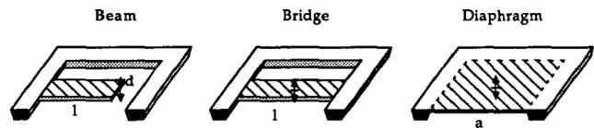
Figure 10 Three basic resonant structures used in resonant pressure sensors
Note: Each structure has several different resonant modes Source:Stemme,1991
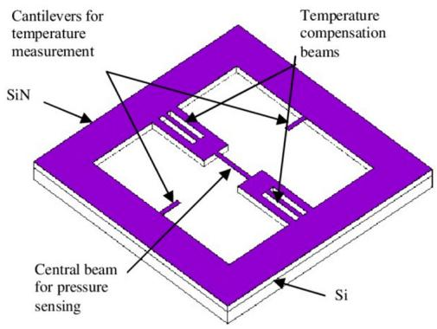
Figure 11 Schematic of the resonant pressure sensor with silicon nitride resonant beams
Source:Chen et al.,2005)
Resonant sensors made up of single crystal materials like silicon and quartz are widely used because of high accuracy, repeatability, low cost and very low power consumption (Langdon, 1985). However, there are certain design challenges associated with the fabrication of resonant sensors that include temperature sensitivity, binding compound selection and binding and mass loading process reversibility.

4. Aerospace applications
Aerospace stands amongst the top few technology- intensive industries in the world. With the technology readiness level, this industry is expanding by leaps and bounds and facing new challenges with every passing day. The factors, which prominently affect the expansion of the aerospace industry include less maintenance cycles, fuel economy, robust and optimized vehicle design, thereby, resulting in improvised jet engines and lightweight aerial platforms. Aircraft health monitoring to minimize unnecessary inspection cycles is one of the emerging fields that encompasses state of the art sensor technology for aerospace applications (Senesky et al., 2009).
However, at the same time, sensor application to the aerospace industry could not grow extensively due to the fact that aerospace applications operate in extreme harsh environments including high temperature and corrosive atmosphere. It is quite challenging to develop micro devices capable of making measurements in harsh environments because most of the semiconductor- based sensors comprise of silicon, which is ill- suited to extreme environments (Horsfall and Wright, 2006). Silicon operating temperature is limited to below ${175}^{∘}C$ and it gets easily eroded in chemically aggressive environments. As a result, mechanically and thermally stable semiconductors along with stable electronic and optoelectronic properties at elevated temperatures are the need of the hour.
For harsh environment applications (above ${300}^{∘}C$ ), researchers have been exploring the use of wide- bandgap semiconductors such as diamond, group III- nitrides and silicon carbide (Werner and Fahrner, 2001). Key advantages associated with wide bandgap semiconductor materials are high thermal conductivity, high breakdown field and high- saturated electron velocity. Additionally, such materials exhibit chemical inertness and good mechanical properties (Hariz, 1999). A brief description of some of the important application area where MEMS pressure sensors have been used in the aerospace industry is given below while a summary is given in Table I.

4.1 Propulsion/turbomachinery applications
Ever since the invention of gas turbine engines, pressure measurements at various engine stages for performance improvement have remained an important area of investigation for researchers. The principal applications in the turbomachinery field include pressure measurements on the turbine aerofoils and effects of pitch angle and velocity fluctuations on aerodynamic probes. Initially, silicon piezoresistive pressure sensors are mounted on these surfaces but their application remained limited to low- temperature areas. Where temperature measurements between ${175}^{∘}C$ and ${500}^{∘}C$ are required, a layer of silicon oxide needs to be introduced to avoid leakage currents from p- n junctions. Silicon carbide is generally used for temperatures above ${500}^{∘}C$ till ${700}^{∘}C$ while diamond is a material of choice for temperatures up till ${800}^{∘}C$
Ainsworth et al. (2000) discussed the silicon piezoresistive transducers’ usage in turbomachinery applications for unsteady pressure measurements. An excellent agreement between computational fluid dynamics (CFD) results and data obtained from pressure sensors installed on rotating turbine blades encouraged the use of sensors in unsteady pressure measurements and helped in understanding physics of fluctuating compressible flows. The second important area for application of silicon pressure sensors in turbomachinery is the location for installation of fast response aerodynamic probes, which are used to determine pulsating pressures and velocities in the flows. The disrupting effects of the vortices that shed off from the rear of a two- dimensional probe are also important for the placement of pressure sensors on the flanks of the probe. Experimental studies for the probe geometry for studying stall and circulation induced lift were carried out by Humm et al. (1994). Conclusively, literature agrees on keeping the sensors spatially closer for accurate pressure measurements. Gander et al. (2003) has presented unsteady pressure measurements through a MEMS optical pressure sensor embedded in a nozzle guide vane (NGV) for the first time. Transient pressure measurements inside the turbine were carried out in this work, which were not possible with conventional sensors. A schematic view of a gas turbine engine and an optical measurement system used for pressure measurements inside the engine is shown in Figure 12. Similarly, Dasgupta (2001) demonstrated shock survivability of MEMS optical fiber sensor. They presented suitability of optically interrogated MEMS sensors for many propulsion applications through experimentation for static and dynamic pressures using shock tube. A detailed experimental analysis was carried out on the unsteady flow in high- pressure turbine stages using a cylindrical aerodynamic pressure probe by Gaetani et al. (2007). Francioso et al. (2016) demonstrated the use of capacitive pressure sensors to detect flow separation and subsequently control it through the use of plasma actuators to improve the efficiency of propulsion systems. Numerical simulation were performed and results were validated through wind tunnel testing for flow separation control. Traditionally, the pressure sensors used in instrumentation had been based on electrical techniques. However, optical sensors provide improved spatial and temporal resolution in pressure measurement. Therefore, optical pressure sensors are used in the majority of turbomachinery applications. MacPherson et al. (1999) tested an optical fiber sensor and demonstrated high temporal and spatial resolution measurement with frequency response greater than $200kHz$ .

4.2 Turbulent flow diagnosis
Turbulence is one of the unresolved phenomena in classical physics and many researchers are actively pursuing experiments to predict quantitative predictions for structures within turbulent flows. As turbulent flows are characterized with fluctuating pressure and velocities, it is necessary to use small and fast sensors to measure spatial and temporal scales generated due to high Reynold’s number in a turbulent flow. MEMS pressure sensors, being small in size and time scale, are the appropriate choice for the correct resolution of the flow field
Table I Comparative analysis of key MEMS pressure sensors used in aerospace applications
Volume 39 · Number 5 · 2019 · 652–664
Reference | Application | Technique | Sensor size | Diaphragm size | Sensitivity | Range | Comments
Gander et al. (2003) | Turbomachinery | Optical | 500 × 500 × 300 μm | 2 μm | 1.6 rad/bar | Vacuum to 600 kPa | Transient pressure measurements inside the turbine, which were not possible with conventional sensors
Xu et al. (2005b) |  | Optical | 1.5 mm dia | 40 μm | 2.9 nm/psi | 0–200 psi | A diaphragm-based sensor that exhibits low-temperature dependence and can operate up to temperatures of 700°C
Dasgupta (2001) |  | Optical | 0.53 × 4 × 26.2 μm | 600 μm | 1.77 mV/psi | 0–30 psi | Shock survivability of MEMS optical fiber sensor
MacPherson et al. (1999) |  | Optical | 1 mm | 3 μm | 2.9 rad/bar | 7 bar | High temporal and spatial resolution measurement with measured frequency response greater than 200 kHz
Kalvesten et al. (1995) | Turbulent Flow | Piezoresistive | 4 × 2 × 0.5 mm | 100 × 100 | 0.9 μV/Pa | – | Acoustic sensors were used for turbulent gas flow measurements and its sensitivity relation with diaphragm side length was demonstrated
Berns and Obermeier (2009) |  | Piezoresistive | 2 × 3 mm | 300 × 300 μm 800 × 800 × 4 μm | 0.3 μV/Pa 3.5 μV/Pa | – | Wall pressure and wall shear stress measurements in fluid flows through an array of MEMS sensors
White et al. (2012) |  | Microphones | 0.6 mm × 3.5 μm | 2 μm | 0.1 to 0.25 mV/ pa | – | Wall pressure spectra for duct flow at Mach 0 to 0.6
Takahashi et al. (2010) | Experimental Aerodynamics | Piezoresistive | 0.29 × 0.4 × 300 μm | 250 × 200 × 0.3 μm | 0.2 Pa | –100 to 100 Pa | Differential pressure between the upper and lower wing surfaces using MEMS piezoresistive sensors
Castracane et al. (1996) |  | Optical | 0.81 × 0.81 mm | 900 × 900 × 20 μm | – | 0 to 10 psi | Multichannel transducer array to measure high spatial and temporal measurement for wind tunnel application
Schwerter et al. (2017b) |  | Piezoresistive | 2.8 × 2.8 × 0.22 mm | – | 10 mV/V/bar | 0.5–3.4 bar | Flexible sensor system with integrated hot-film and pressure transducer for curved surfaces
Mansoor et al. (2016) |  | Piezoresistive | 3.8 × 3.8 mm | 400 × 400 μm | 69 μV/V kPa | 0–75 kPa | Multisensor SOI CMOS MEMS chip for simultaneous measurements of flow rate, pressure and temperature
Tsao et al. (1994) | Microfluidics | Piezoresistive | – | 250 × 250 × 1.5 μm | 245 μV/V psi | – | Micro magnetic actuators for active fluid control
Xu et al. (2005c) |  | Piezoresistive | 2 × 1 cm | 210 × 210 μm | 82 μV/V kPa | – | Multisensor MEMS chip for simultaneous measurements of pressure, temperature and shear stress inside microchannels
Schwerter et al. (2016) |  | Piezoresistive | 2.8 × 2.8 mm | 600 × 600 μm | 10 mV/V/bar | 7 bar | A passive pressure sensor without any functional and susceptible element in the femtosecond laser chamber
Lofdahl and Gad- el- Hak, 1999b). Additionally, MEMS sensors can be packaged in arrays on the same silicon chip and used for measurement of fluctuating wall pressure underneath a turbulent boundary layer that is vital for modeling of turbulent flow. Gad- el- Hak and Bandyopadhyay (1994) studied the Reynolds number effects on viscous boundary layers and concluded that to get effective results for turbulence measurements, the sensors need to be of the order of the viscous sublayer thickness, which is approximately 5 wall units. Kalvesten et al. (1995) designed and fabricated piezoresistive transducers for turbulent gas flow measurements. They verified the ability of the transducer to measure the pressure eddies of
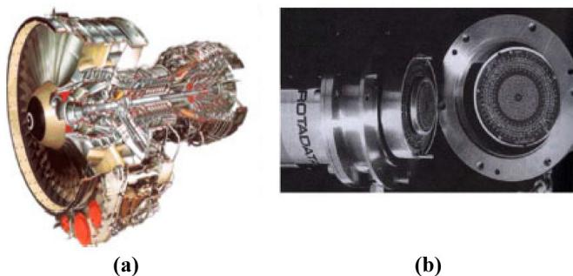
Figure 12 (a) Schematic of a jet engine; and (b) an optical measurement system used for turbine diagnostics in jet engines
Source: Senesky et al., 2009
$0.3−0.9μV/Pa$ in a turbulent boundary layer for different diaphragm sizes of 100 and $300μm$ . Acoustic sensors were used for turbulent gas flow measurement and its sensitivity relation with diaphragm side length was discussed. The detailed fluctuating pressure statistics in high- Reynolds- number turbulent boundary layers were investigated for the first time using MEMS pressure sensors by Tsuji et al. (2007).
Similarly, a novel sensor array for measurement of fluctuating wall pressure and wall shear stress in fluid flows was presented by Berns and Obermeier (2009). The novelty of this work was the integration of pressure and wall shear stress sensor on a single chip. Moreover, the sensor chips’ electric connections were made from the back side to ensure uninterrupted flow when chips are embedded in the measured surface. A three- dimensional (3D) sensor array has been designed and fabricated using several pressure sensors to obtain minute surface pressure details on a cylinder as shown in Figure 13. White et al. (2012) has used a MEMS microphone array for wall pressure spectra measurement in the turbulent boundary layer at 0- 0.6 Mach numbers. Similarly, Sanders et al. (2018) studied the unsteady wall pressures at the trailing edge of a 3D printed NACA0012 airfoil. In this work, digital MEMS microphones were used to study turbulent boundary layer noise at Re range of 20,000- 700,000. Use of this novel wall pressure transducer approach has led another step towards improved predictions for turbulent boundary layer noise, which is not possible with conventional sensors.
As turbulence has been an unsolved subject, the quantitative predictions for turbulent flows rely heavily on empirical data. The formation of eddies of different sizes and orientation requires sophisticated small sized sensors for measurement and analysis of such small structures. Thus, MEMS sensors, through miniaturization, provide this critical information in high Re turbulent flows.

4.3 Experimental aerodynamics
Experimental aerodynamics is an important stream in which various phenomena like effects of shock wave, turbulent boundary layer interactions, heat transfer rates, complex unsteady separated flow, aerodynamic body optimization, etc. needs to be studied for design and improvement in aerospace vehicles (Dolling, 1993). Predictions of CFD codes can only be Source: Berns and Obermeier, 2009
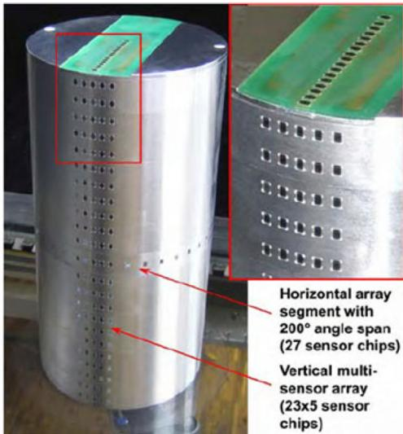
Figure 13 Cylinder model with horizontal and vertical sensor arrays used for measurements of fluctuating wall pressure and shear stress
validated through experimental data. For accurate analysis, precise pressure profiles measurements are required to comprehend the short- scaled time and space dimensions. However, when sensors are used for experimentation in wind tunnels, there are certain inherent problems such as the size of the sensor and their time response (Zagnoni et al., 2005). To address this issue, MEMS pressure sensors integrated arrays offer a solution. Castracane et al. (1996) presented a compact and fast response optical multichannel transducer array (OMTA) for real- time pressure measurements of the flow field with high spatial and temporal resolutions over an aerodynamic surface. Optical interferometer senses the deflection of silicon diaphragms and decipher the diaphragm movements into pressure values. Over a period of time, numerous customized and novel MEMS sensors have been developed. However, the intrusive and fragile nature of most of the sensors not only changes the streaming flow but also susceptible to damage due to exposure to the incoming flow. To overcome this issue, Beutel et al. (2012) introduced fiber material embedded piezoresistive pressure sensor for ensuring extremely flush mounting in the wall for the first time. The novel approach, in this case, was the integration of sensor and associated subsystems directly into the wall unlike other MEMS sensors reported earlier in literature. An epoxy resin embedded and waterproof shielded pressure and wall shear sensor has been developed and presented by Schwerter et al. (2017a) for harsh environments. The active sensing elements are arranged on the inner side of the sensor in contrast to the common piezoresistive chips to sustain the fast flow of liquid. There is a requirement of flexible sensors for mounting on the curved surfaces like the leading edge of a wing for research purposes. Additionally, these thin film sensors do not disturb the incoming flow and cavity is also not required to fix sensors on airfoil or wing. Schwerter et al. (2017b) introduced a foil based piezoresistive transducer for pressure and velocity
measurements on curved surfaces as shown in Figure 14. The flexible foil thickness is only $350μm$ and can be easily attached to curved surfaces. However, there is a requirement of recalibration after application on to the curved surface due to slight shifting in sensitivity of the sensor. Direct calculation of aerodynamic forces on the wing of an insect like ornithopter was demonstrated by Takahashi et al. (2010). In this work, the differential pressure between the upper and lower wing surfaces using piezoresistive MEMS pressure sensor was measured as shown in Figure 15. A piezoresistor is mounted on the cantilever and deformation due to pressure results in a change in their respective resistance. Subsequently, the change in resistance is decoded as differential pressure. Another stream of aerodynamics is the hypersonic flows, which are experimentally evaluated through shock tunnels. However, shock tunnel simulations are characterized by short run times generally around $1ms$ . Surface pressure measurements upto $50,000Pa$ using MEMS sensor array at Mach 5.96 and Mach 8.67 were carried out by Sriram et al. (2015). With the substantial growth in the MEMS industry over the past 20 years, the concept of multi- sensors over a single chip has emerged. In this approach, multiple variables like pressure, temperature, wall shear stress, acceleration, light intensity, wind speed, wind direction, humidity, etc., can be measured through a single MEMS chip. An SOI CMOS based multi- sensor MEMS chip capable of measuring temperature, pressure and flow rate simultaneously has been reported by Mansoor et al. (2016) for use in experimental aerodynamics.
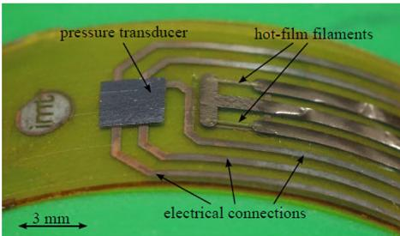
Figure 14 Sensor system in a foil bent over a curved surface for pressure and velocity measurements
Source: Schwerter et al., 2017b
Figure 15 Sensor installed on an ornithopter for differential pressure measurements
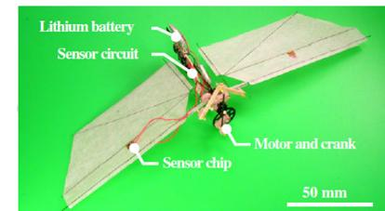
Note: A crank mechanism installed for vertical movement of wing flaps Source: Takahashi et al., 2010

4.4 Micro flow measurement
Microfluidics deal with the study of fluids that are confined to smaller scales typically millimeter or micrometer level. In the field of aerodynamics, microfluidics emerged mainly in the development of thin boundary layer on the aerodynamic surfaces that give rise to flow separation and skin friction drag. Development of micro- propulsion and micro- thermal technologies also revolve round the field of microfluidics (Huang et al., 2000). Moreover, with the advent of micro aerial vehicles (MAVs), the role of MEMS sensors in the autonomous control of such machines has grown manifold. The measurement of pressure distribution in micro channels is a challenging task. MEMS Pressure sensors, by virtue of their size, have been extensively used for the investigation of pressure distributions in the flows inside micro channels. As a matter of fact, microfluidics experimentation includes installation of sensors in confined spaces and that has not been possible without the availability of MEMS sensors. Pfahler et al. (1991) presented measurements of friction factor in silicon etched small channels during early research in this field. Pong et al. (1994) used an array of piezoresistive MEMS pressure sensors to obtain the pressure distribution along with the micro channel flow. Streamwise pressure distribution through micro channels helped in understanding surface slip phenomenon for such flows. An excellent review of fluid control through MEMS technology considering surface effects and requisite changes in momentum equation and boundary conditions has been presented by Ho and Tai (1998). Xu et al. (2005a) reported the development of a multi sensor chip to measure pressure, temperature and shear stress inside microchannels as shown in Figure 16. Tsao et al. (1994) fabricated a pressure sensor while proposing a magnetic actuator for a MEMS fluid control system. A novel piezoresistive pressure sensor has been designed for integration in flexible sensor arrays using flip- chip technology by Schwerter et al. (2016). The real time sensing and control of leading edge vortices is possible through MEMS sensors and actuators. MEMS technology in micro flow control needs some time to mature because the research activities are to be implemented in real world scenario under different Mach and Reynolds numbers.
Figure 16 A micro channel system with integrated multi sensor array chip used for measurement of pressure, temperature and shear stress inside a microchannel simultaneously
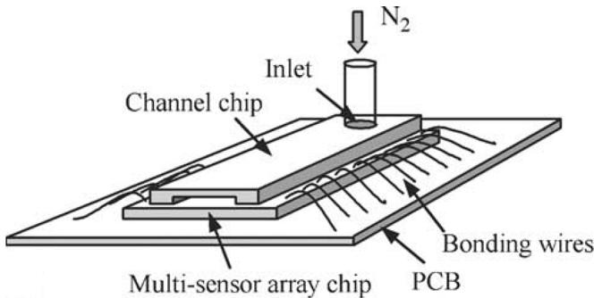
Source: Xu et al.,2005

Principles of MEMS pressure sensing
Yaser Javed, Mohtashim Mansoor and Irtiza Ali Shah

4.5 UAV/MAV applications
4.5 UAV/MAV applicationsWith the advances in materials and sensor technology, the production of unmanned aerial platforms has become highly feasible. The MAV is a new class of drones having abundant applications including reconnaissance and surveillance, search and rescue, digital mapping and traffic monitoring missions. Experimentation for a modern fighter aircraft that is more agile, stable and stealthy is underway and research on UAVs that are fully instrumented with such technology have been on the rise to achieve vortex flow control and manipulate resulting pressure field. The desire for enhancing the maximum lift and vortex control for the stability of aircraft during maneuvering has been an active area of research. Leading edge vortices can be manipulated through the use of micro actuators in real time (CHIH- MINGHO and J, 2012). Vortex flaps and vortex cavity flaps were conceived to control the leading edge vortex flow (Rao, 1986). In the mid- 1990s, the idea was conceived to control leading edge vortex flow through MEMS pressure sensors and actuators. Huang et al. (2001) demonstrated the use of MEMS sensors for locating the optimal actuation position for controlling a UAV sized aircraft through MEMS. MEMS pressure sensors are used for barometric altitude measurement and height control for MAV applications (Arning and Sassen, 2004). Use of microsensors for extremely low Reynolds number flow associated with MAVs has been discussed in Gad- el- Hak (2001) as shown in Figure 17. Park et al. (2008) used an off the shelf MEMS pressure sensor while developing an angle of attack sensor for evaluating the performance of an unmanned aerial system. Guo et al. (2016) developed a bio- inspired pressure sensor network for use on smart vehicles such as UAVs and MAVs. Pressure sensors are connected by stretchable polyimide wires for ease of mounting on curved surfaces. An adaptive hybrid sensor system comprising pressure and hot- film sensors for nonintrusive measurement of flow conditions is reported by Behr et al. (2016). This sensor is coupled with an actuator to monitor and control flow conditions over a high- lift flap and avoid flow separation over it. Encouraging results obtained through the usage of
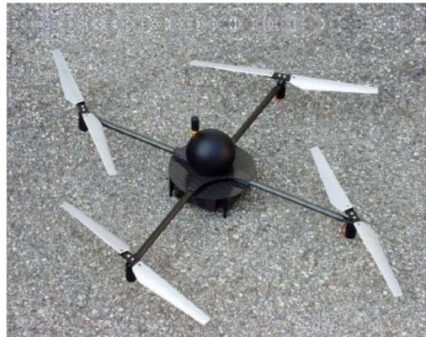
Figure 17 Micro Air Vehicle EAS Quadcopter used for MEMS-based sensors investigation
MEMS in unmanned aerial vehicles for performance improvement and flow separation control would be used as a benchmark for the application of the same technology in manned platforms (Schadow, 2004).

5. Future of micro electro mechanical systems pressure sensors in the aerospace industry
Technological advancements in the aerospace industry are the need of the hour. Smart and adaptive structures, efficient engines and miniaturized air vehicles are required for the growth of this industry and to reduce operational and maintenance costs. In this regard, the potential of MEMS is being exploited by the researchers to develop high pay- off applications. MEMS technology offers exciting opportunities for aerospace applications owing to their low cost, small size and high performance. Some of the prominent areas in the modern aerospace industry where MEMS have provided solutions include active flow control, autonomous aerospace miniature vehicles, micro engines, fuzing/ safety and weapon arming systems, smart and adaptive structures and micro rockets.
Future MEMS activities involve the development of intelligent engines, smart structures, high- end functionality stand- alone devices that provide safety, versatility, performance, reduced maintenance and cost savings to end user.

6.Conclusion
- ConclusionIn this paper, various pressure sensing principles in MEMS and applications of MEMS technology in the aerospace industry have been reviewed. Five application fields have been investigated including: propulsion/turbomachinery applications, turbulent flow diagnosis, experimental aerodynamics, micro-flow control and UAV/MAV applications. Applications of MEMS sensors in the aerospace industry are quite limited due to requirements of very high accuracy, high reliability and harsh environment survivability. However, the potential for growth of this technology is foreseen due to inherent features of MEMS sensors’ being light weight, low cost, ease of batch fabrication and capability of integration with electric circuits. All these advantages are very relevant to the aerospace industry. This work is an endeavor to present a comprehensive review of such MEMS pressure sensors, which are used in the aerospace industry and have been reported in recent literature.

References
ReferencesAinsworth, R., Miller, R., Moss, R. and Thorpe, S. (2000), “Unsteady pressure measurement”, Measurement Science and Technology, Vol. 11 No. 7, p. 1055. Alliedmarketresearch.com (2017), “Pressure sensor market by type and by application”, available at: www. alliedmarketresearch.com/pressure- sensor- market (accessed 23 July 2017). Arning, R.K. and Sassen, S. (2004), “Flight control of micro aerial vehicles”, in AIAA guidance, navigation, and control conference and exhibit, pp. 16- 19. Behr, C., Schwerter, M., Leester- Schädel, M., Wierach, P., Dietzel, A. and Sinapius, M. (2016), “Structural integrated sensor and actuator systems for active flow control”, in
Sensors and Smart Structures Technologies for Civil, Mechanical, and Aerospace Systems 2016, p. 980337. Berns, A. and Obermeier, E. (2009), “AeroMEMS sensor arrays for time resolved wall pressure and wall shear stress measurements” in Imaging Measurement Methods for Flow Analysis, Springer, Berlin, Heidelberg, pp. 227- 236. Beutel, T., Leester- Schadel, M. and Buttgenbach, S. (2012), “Design and evaluation process of a robust pressure sensor for measurements in boundary layers of liquid fluids”, Microsystem Technologies, Vol. 18 Nos 7/8, pp. 893- 903. Bogue, R. (2015), “Recent developments in MEMS sensors: a review of applications, markets and technologies”, Sensor Review, Vol. 33 No. 4, pp. 300- 304. Burns, D.W., Guckel, H. and Zook, J.D. (1996), Opto- electromechanical device or filter, process for making, and sensors made therefrom, ed: Google Patents. Castracane, J., Clow, L.P. and Seidler, G. (1996), “Optical multichannel transducer array for wind tunnel applications”, Optical Engineering, Vol. 35 No. 9, pp. 2627- 2634. Chen, D., Cui, D., Xia, S. and Cui, Z. (2005), “Design and modeling of a silicon nitride beam resonant pressure sensor for temperature compensation”, in Information Acquisition, 2005 IEEE International Conference on, 2005, p. 4. CHIH- MINGHO, P.- H.H. and J, M. (2012), “Active flow control by micro systems”, in IUTAM Symposium on Mechanics of Passive and Active Flow Control: Proceedings of the IUTAM Symposium held in Gottingen, Germany, 7- 11 September 1998, p. 195. Cimalla, V., Pezoldt, J. and Ambacher, O. (2007), “Group III nitride and SiC based MEMS and NEMS: materials properties, technology and applications”, Journal of Physics D: Applied Physics, Vol. 40 No. 20, pp. 6386- 6434. Cook- Chennault, K.A., Thambi, N. and Sastry, A.M. (2008), “Powering MEMS portable devices - a review of nonregenerative and regenerative power supply systems with special emphasis on piezoelectric energy harvesting systems”, Smart Materials and Structures, Vol. 17 No. 4, p. 43001. Dasgupta, S. (2001), “Optically interrogated MEMS pressure sensors for propulsion applications”, Optical Engineering, Vol. 40 No. 4, p. 598. Dolling, D.S. (1993), “Problems in the validation of CFD codes through comparison with experiment”, in AGARD, Theoretical and Experimental Methods in Hypersonic Flows 15 p (SEE N94- 10421 01- 02), Texas University, Austin. Eaton, W.P. and Smith, J.H. (1997), “Micromachined pressure sensors: review and recent developments”, Smart Materials and Structures, Vol. 6 No. 5, p. 530. Eswaran, P. and Malarvizhi, S. (2013), “MEMS capacitive pressure sensors: a review on recent development and prospective”, International Journal of Engineering and Technology, Vol. 5, p. 2734. Francioso, L., De Pascali, C., Pescini, E., De Giorgi, M. and Siciliano, P. (2016), “Modeling, fabrication and plasma actuator coupling of flexible pressure sensors for flow separation detection and control in aeronautical applications”, Journal of Physics D: Applied Physics, Vol. 49 No. 23, p. 235201. Frobenius, W.D., Sanderson, A. and Nathanson, H. (1973), “A microminiature solid- state capacitive blood pressure transducer with improved sensitivity”, IEEE Transactions on Biomedical Engineering, Vol. BME- 20 No. 4, pp. 312- 314. Gad- el- Hak, M. (2001), “Micro- air- vehicles: can they be controlled better?”, Journal of Aircraft, Vol. 38 No. 3, pp. 419- 429. Gad- el- Hak, M. and Bandyopadhyay, P.R. (1994), “Reynolds number effects in wall- bounded turbulent flows”, Applied Mechanics Reviews, Vol. 47 No. 8, pp. 307- 365. Gaetani, P., Persico, G., Dossena, V. and Osnaghi, C. (2007), “Investigation of the flow field in a high- pressure turbine stage for two Stator- Rotor axial gaps - part II: unsteady flow field”, Journal of Turbomachinery, Vol. 129 No. 3, p. 580. Gander, M.J., MacPherson, W.N., Barton, J.S., Reuben, R., Jones, J.D., Stevens, R., et al., (2003), “Embedded micromachined fiber- optic Fabry- Perot pressure sensors in aerodynamics applications”, IEEE Sensors Journal, Vol. 3 No. 1, pp. 102- 107. Guo, Y., Li, Y.- H., Guo, Z., Kim, K., Chang, F.- K. and Wang, S.X. (2016), “Bio- inspired stretchable absolute pressure sensor network”, Sensors, Vol. 16 No. 1, p. 55. Hariz, A. (1999), “Wide- bandgap materials for novel electronic devices and MEMS”, Asia Pacific Symposium on Microelectronics and MEMS, Gold Coast, Australia, Vol. 3891 available at: https://doi.org/10.1117/12.364431 Ho, C.- M. and Tai, Y.- C. (1998), “Micro- electro- mechanical- systems (MEMS) and fluid flows”, Annual Review of Fluid Mechanics, Vol. 30 No. 1, pp. 579- 601. Horsfall, A. and Wright, N. (2006), “Sensing the extreme”, Physics World, Vol. 19 No. 5, p. 34. Huang, A., Ho, C., Jiang, F. and Tai, Y.- C. (2000), “MEMS transducers for aerodynamics - a paradigm shift”, AIAA, 38th Aerospace Sciences Meeting and Exhibit, Reno, NV, 10- 13 January, available at: https://doi.org/10.2514/6.2000- 249 Huang, A., Folk, C., Silva, C., Christensen, B., Chen, Y.- F., C.- M, H., Jiang, F., Grosjean, C. and Tai, Y.- C. (2001), “Applications of MEMS devices to delta wing aircraft- From concept development to transonic flight test”, 39th Aerospace Sciences Meeting and Exhibit, p. 124. Humm, H., Gizzi, W. and Gyarmathy, G. (1994), “Dynamic response of aerodynamic probes in fluctuating 3D flows”, 12th Symposium on Measuring Techniques in Transonic and Supersonic Flow in Cascades and Turbomachines, Prague, Czech Republic, pp. 12- 12. Kalvesten, E., Lofdahl, L. and Stemme, G. (1995), “Small piezoresistive silicon microphones specially designed for the characterization of turbulent gas flows”, Sensors and Actuators A: Physical, Vol. 46 Nos 1/3, pp. 151- 155. accessed on 1 january 1995. Kumar, S.S. and Pant, B.D. (2014), “Design principles and considerations for the ‘ideal’ silicon piezoresistive pressure sensor: a focused review”, Microsystem Technologies, Vol. 20 No. 7, pp. 1213- 1247. Lab, T.M.I. (2019), “FBG Fibre- optic Sensing System accessed on 23 Jan”, available at: https://tml.jp/e/knowledge/special_ins/fiber_measurement.html (accessed 23 January 2018). Langdon, R. (1985), “Resonator sensors- a review”, Journal of Physics E: Scientific Instruments, Vol. 18 No. 2, p. 103. Lofdahl, L. and Gad- el- Hak, M. (1999a), “MEMS- based pressure and shear stress sensors for turbulent flows”, Measurement Science and Technology, Vol. 10 No. 8, p. 665.
Löfdahl, L. and Gad-el- Hak, M. (1999b), “MEMS applications in turbulence and flow control”, Progress in Aerospace Sciences, Vol. 35 No. 2, pp. 101- 203. MacPherson, W.N., Kilpatrick, J.M., Barton, J.S. and Jones, J. D.C. (1999), “Miniature fiber optic pressure sensor for turbomachinery applications”, Review of Scientific Instruments, Vol. 70 No. 3, pp. 1868- 1874. Mansoor, M., Haneef, I., Akhtar, S., Rafiq, M.A., De Luca, A., Ali, S.Z. and Udrea, F. (2016), “An SOI CMOS- based multi- sensor MEMS chip for fluidic applications”, Sensors, Vol. 16 No. 11, p. 1608. Park, M.- H., Kim, S.- S., Kyoo, C.- K., Choi, K. and Park, C. (2008), “Development of alpha sensor for unmanned aerial systems”, SICE Annual Conference, 2008, pp. 2131- 2134. Pfahler, J., Harley, J., Ban, H. and Zemel, J.N. (1991), “Gas and liquid flow in small channels”, Micromechanical Sensors, Actuators, and Systems, Vol. 32, pp. 49- 58. Pong, K.- C., C.- M, H., Liu, J. and Tai, Y.- C. (1994), “Nonlinear pressure distribution in uniform microchannels”, ASME- PUBLICATIONS- FED, Vol. 197, pp. 51- 51. Puers, R. (1993), “Capacitive sensors: when and how to use them”, Sensors and Actuators A: Physical, Vol. 37, pp. 93- 105. Rao, D.M. (1986), “Towards an advanced vortex flap system: the cavity flap”, NASA, Langley Research Center Vortex Flow Aerodynamics, Vol. 1, pp. 219- 230. Razak, A.H., Zayegh, A., Bagg, R.K. and Wahab, Y. (2012), “Foot plantar pressure measurement system: a review”, Sensors (Basel), Vol. 12, pp. 9884- 9912. Sanders, M.P., De Santana, L.D., Azarpeyvand, M. and Venner, C.H. (2018), “Unsteady surface pressure measurements on trailing edge serrations based on digital MEMS microphones”, 2018 AIAA/CEAS Aeronautics Conference, p. 3290. Santra, S., Udrea, F., Guha, P., Ali, S.Z. and Haneef, I. (2010), “Ultra- high temperature $(>{300}^{∘}$ C) suspended thermodiode in SOI CMOS technology”, Microelectronics Journal, Vol. 41 No. 9, pp. 540- 546. Schadow, K. (2004), “MEMS military Applications- RTO task group summary”, Proceedings of CANEUS 2004 Conference on Micro- Nano- Technologies, pp. 6.2004- 6749. Schwerter, M., Grabner, D., Hecht, L., Vierheller, A., Leester- Schadel, M. and Dietzel, A. (2016), “Surface- passive pressure sensor by femtosecond laser glass structuring for flip- chip- in- foil integration”, Journal of Microelectromechanical Systems, Vol. 25 No. 3, pp. 517- 523. Schwerter, M., Leester- Schadel, M. and Dietzel, A. (2017a), “Waterproof sensor system for simultaneous pressure and hot- film flow measurements”, Sensors and Actuators A: Physical, Vol. 257, pp. 208- 215. Schwerter, M., Gading, M., Leester- Schadel, M. and Dietzel, A. (2017b), “A flexible sensor system in foil for combined absolute pressure and flow velocity measurements”, in Solid- State Sensors, Actuators and Microsystems (TRANSDUCERS), 2017 19th International Conference on, 2017, pp. 1104- 1107. Senesky, D.G., Jamshidi, B., Cheng, K.B. and Pisano, A.P. (2009), “Harsh environment silicon carbide sensors for health and performance monitoring of aerospace systems: a review”, IEEE Sensors Journal, Vol. 9, pp. 1472- 1478. Sensing. honeywell.com (2018), “Effectively using pressure load and torque sensors with todays data acquisition systems”, available at: https://sensing.honeywell.com/white- paper-
effectively using pressure load and torque sensors with todays data acquisition systems- 008883- 2- en.pdf (accessed 20 February 2018). Shirinov, A. and Schomburg, W. (2008), “Pressure sensor from a PVDF film”, Sensors and Actuators A: Physical, Vol. 142 No. 1, pp. 48- 55. Smiths, J., Tilmans, H., Hoen, K., Mulder, H., Van Vuuren, J. and Boom, G. (1983), “Resonant diaphragm pressure measurement system with ZnO on Si excitation”, Sensors and Actuators, Vol. 4, pp. 565- 571. Sriram, R., Ram, S., Hegde, G., Nayak, M. and Jagadeesh, G. (2015), “Shock tunnel measurements of surface pressures in shock induced separated flow field using mems sensor array”, Measurement Science and Technology, Vol. 26 No. 9, p. 95301. Stemme, G. (1991), “Resonant silicon sensors”, Journal of Micromechanics and Microengineering, Vol. 1 No. 2, p. 113. Takahashi, H., Aoyama, Y., Ohsawa, K., Tanaka, H., Iwase, E., Matsumoto, K. and Shimoyama, I. (2010), “Differential pressure measurement using a free- flying insect- like ornithopter with an MEMS sensor”, Bioinspiration & Biomimetics, Vol. 5 No. 3, p. 036005. Tsao, T., Liu, C., Tai, Y.C. and Ho, C.M. (1994), “Micromachined magnetic actuator for active fluid control”, Proceedings of the 1994 International Mechanical Engineering Congress and Exposition. Tsuji, Y., Fransson, J.H., Alfredsson, P.H. and Johansson, A. V. (2007), “Pressure statistics and their scaling in high- Reynolds- number turbulent boundary layers”, Journal of Fluid Mechanics, Vol. 585, pp. 1- 40. Urban, F., Kadlec, J., Vlach, R. and Kuchta, R. (2010), “Design of a pressure sensor based on optical fiber bragg grating lateral deformation”, Sensors, Vol. 10 No. 12, pp. 11212- 11225. Wang, X., Xu, J., Zhu, Y., Cooper, K.L. and Wang, A. (2006), “All- fused- silica miniature optical fiber tip pressure sensor”, Optics Letters, Vol. 31 No. 7, pp. 885- 887. Welham, C.J., Gardner, J.W. and Greenwood, J. (1996), “A laterally driven micromachined resonant pressure sensor”, Sensors and Actuators A: Physical, Vol. 52 Nos 1/3, pp. 86- 91. Werner, M.R. and Fahrner, W.R. (2001), “Review on materials, microsensors, systems and devices for high- temperature and harsh- environment applications”, IEEE Transactions on Industrial Electronics, Vol. 48 No. 2, pp. 249- 257. White, R.D., Krause, J., De Jong, R., Holup, G., Gallman, J. and Moeller, M. (2012), “MEMS microphone array on a chip for turbulent boundary layer measurements”, in Proceedings of the 50th AIAA Aerospace Sciences Meeting including the New Horizons Forum and Aerospace Exposition, Nashville, TN, USA, pp. 9- 12. Xu, Y., Chiu, C.- W., Jiang, F., Lin, Q. and Tai, Y.- C. (2005c), “A MEMS multi- sensor chip for gas flow sensing”, Sensors and Actuators A: Physical, Vol. 121 No. 1, pp. 253- 261. Xu, J., Pickrell, G., Wang, X., Peng, W., Cooper, K. and Wang, A. (2005b), “A novel temperature- insensitive optical fiber pressure sensor for harsh environments”, IEEE Photonics Technology Letters, Vol. 17, pp. 870- 872.
Xu, S., Qin, Y., Xu, C., Wei, Y., Yang, R. and Wang, Z.L. (2010), “Self- powered nanowire devices”, Nature Nanotechnology, Vol. 5 No. 5, pp. 366- 373. Xu, J., Wang, X., Cooper, K.L. and Wang, A. (2005a), “Miniature all- silica fiber optic pressure and acoustic sensors”, Optics Letters, Vol. 30 No. 24, pp. 3269- 3271. Zagnoni, M., Golfarelli, A., Callegari, S., Talamelli, A., Bonora, V., Sangiorgi, E. and Tartagni, M. (2005), “A noninvasive capacitive sensor strip for aerodynamic pressure measurement”, Sensors and Actuators A: Physical, Vol. 123, pp. 240- 248.
measurement”, Sensors and Actuators A: Physical, Vol. 123, pp.240- 248. ZangY.ZhangF.DiC- a.and ZhuD.2015Advances of flexible pressure sensors toward artificial intelligence and health care applications”,Materials Horizons, Vol. 2 No.2, pp.140- 156.

Corresponding author
Yaser Javed can be contacted at: yaser.javed@cae.nust.edu. pk

