Review

Recent Trends in AI-Based Intelligent Sensing
Abhishek Sharma $​^{1,†}$ , Vaidehi Sharma $​^{1,†}$ , Mohita Jaiswal $​^{1,†}$ , Hwang- Cheng Wang $​^{2,†}$ , Dushantha Nalin K. Jayakody $​^{3,*}$ , Chathuranga M. Wijerathna Basnayaka $​^{3,4,†}$ and Ammar Muthanna $​^{5}$
Citation: Sharma, A.; Sharma, V.; Jaiswal, M.; Wang, H.- C.; Jayakody, D.N.K.; Basnayaka, C.M.W.; Muthanna, A. Recent Trends in AI- Based Intelligent Sensing. Electronics 2022, 11, 1661. https://doi.org/10.3390/electronics11101661
Academic Editor: Junseop Lee
Received: 31 January 2022 Accepted: 6 May 2022 Published: 23 May 2022
Publisher’s Note: MDPI stays neutral with regard to jurisdictional claims in published maps and institutional affiliations.
Copyright: © 2022 by the authors. Licensee MDPI, Basel, Switzerland. This article is an open access article distributed under the terms and conditions of the Creative Commons Attribution (CC BY) license (https://creativecommons.org/licenses/by/4.0/).
1 Department of Electronic and Communication Engineering, The LNM Institute of Information Technology, Jaipur 302031, India; abhisheksharma@hmuit.ac.in (A.S.); vaidehisharma444@gmail.com (V.S.); mohitajaiswal166@gmail.com (M.J.) 2 Department of Electronic Engineering, National Ilan University, Yilan 260007, Taiwan; hcwang@niu.edu.tw 3 COPELABS, Lusofona University, 1749- 024 Lisbon, Portugal; chathurangab@sltc.ac.lk 4 Centre for Telecommunication Research, School of Engineering, Sri Lanka Technological Campus, Padukka 10500, Sri Lanka 5 Department of Applied Probability and Informatics, Peoples’ Friendship University of Russia (RUDN University), Miklukho- Maklaya St, 117198 Moscow, Russia; ammarexpress@gmail.com * Correspondence: djayakody@autonoma.pt † These authors contributed equally to this work.
Abstract: In recent years, intelligent sensing has gained significant attention because of its autonomous decision- making ability to solve complex problems. Today, smart sensors complement and enhance the capabilities of human beings and have been widely embraced in numerous application areas. Artificial intelligence (AI) has made astounding growth in domains of natural language processing, machine learning (ML), and computer vision. The methods based on AI enable a computer to learn and monitor activities by sensing the source of information in a real- time environment. The combination of these two technologies provides a promising solution in intelligent sensing. This survey provides a comprehensive summary of recent research on AI- based algorithms for intelligent sensing. This work also presents a comparative analysis of algorithms, models, influential parameters, available datasets, applications and projects in the area of intelligent sensing. Furthermore, we present a taxonomy of AI models along with the cutting edge approaches. Finally, we highlight challenges and open issues, followed by the future research directions pertaining to this exciting and fast- moving field.
Keywords: artificial intelligence; machine learning; intelligent sensing; datasets; neural networks; IoT; learning algorithms

1. Introduction
The term “Smart Sensor” was coined in the 1970s [1]. The word “Smart” is related to the capability of microelectronic devices having operative intelligence features. The improvements observed in the 1980s, especially those related to the area of sensor technology, show perfection in signal extraction, real- time data transfer, and adaptability to the physical environment by sensors, which helps in fetching data that seemed to be inaccessible previously. In the 1990s, intelligence was added to devices and more promising results were observed in this area. The evolution in intelligence technology was due to the advancement in computational technologies. Such intelligent devices possess three main features: (i) extraction of signal information, (ii) signal processing, and (iii) instruction execution. It is interesting to observe that applied intelligence was also being advanced at the same time. In the 1980s, machine learning, and later, in the 1990s, deep- learning, were also in a progressive state. Artificial intelligence covers all the important technological development in this domain, including RNN, CNN, Transfer Learning, Continual AI, etc. Thus, both smart Sensors and AI are integrated to form intelligent sensing for the development of smart applications. It is important to observe that nowadays sensors are not just
used to extract information but are also involved in more complex tasks such as execution of different instructions based on the pattern of data sequence. Indeed, we encounter a vast amount of data in different forms on a daily basis. To extract useful information from the plethora of data, smart sensors are designed that perceive the environment, make decisions, and draw conclusions. Intelligent sensing is important for various reasons. It can be applied in different areas such as self- driving cars, autonomous flying droids, and Amazon Kiva systems.
In light of recent successes, AI is a trending field in the research areas of management science [2], operational research [3], and technology [4]. There is a broad array of applications of AI, ranging from expert systems to computer vision, which improves the everyday lives of ordinary people. For example, [5] investigated the application of machine learning to medicine and reported the diagnostic performance and caution of machine learning in dermatology, radiology, pathology, and microscopy. [6] examined the serious issues of modern transport systems and how AI techniques can be used to tackle the issues. The recent improvements in AI algorithms and computer hardware are expected to exceed human intelligence shortly. The current research on AI, including machine learning (ML) and deep learning (DL), uses real- time algorithms to enable machines to learn information from the sensing parameters. Recently, several AI- based approaches have witnessed rapid growth due to their sensing capability to learn feature representations for decision making and control problems [7]. Furthermore, the critical aspect of AI is to design efficient learning algorithms to unlock new possibilities in the field of intelligent sensing. Algorithms based on AI have been successfully utilized in myriads of areas such as mobile applications [8], social media analytics [9], healthcare [10], agriculture [11], manufacturing processes [12], logistics [13] and environmental engineering [14].

1.1. Related Works
Many researchers have conducted surveys related to intelligent sensing models to tackle challenging issues of particular applications and provide solutions to cope with existing vulnerabilities. However, most of the existing survey articles on intelligent sensing have not explicitly focused on new methods based on AI and ML/DL for real- time applications and associated research challenges. The survey in [15] was conducted from two viewpoints. The first is the intelligent approaches based on AI to solve issues related to wireless sensor networks (WSNs) and the second is to design intelligent applications that incorporate sensor networks. In [16], the authors have discussed the research directions of AI 2.0 and the new models based on AI technology. New forms of intelligent manufacturing systems are also explored. Various AI algorithms are implemented as estimators (i.e., software sensors) in chemical operating units and their advantages are shown. Practical implications and limitations were also discussed for the proper design of AI- based estimators in [17]. In [18], the authors have focused mainly on different intelligent techniques used in vehicular applications and listed research challenges and issues in the integration of AI and vehicular systems. In [19], the authors have discussed AI algorithms coupled with gas sensor arrays (GSAs) embedded in robots as electronic noses to explore potential applications such as gas explosive detection, environmental monitoring, beverage and food production and storage. They also discussed the types of gas sensors, gas sensor limitations and possible solutions.
Another application based on intelligent sensing was given in [20,21]. They focused on the use of ML and AI technology to fight the coronavirus pandemic. The studies used AI- based embedded sensors to track the spread of COVID- 19 infections and side effects, thereby helping health professionals to diagnose common symptoms of the virus. The article [22] surveys the future of healthcare technologies for H- IoT. It summarizes the features of H- IoT systems based on generic IoT systems.
Several ML and DL methods were reviewed in [23] for big data applications together with open issues and research directions. Different ML- based algorithms to address issues of WSNs (i.e., congestion control, synchronization, and energy harvesting) were surveyed
in [24] and their drawbacks were discussed. An overview of current data mining and ML techniques employed for activity recognition (AR) were presented in [25]. The authors also discussed how an activity is captured using different sensors. In [26], the authors reviewed how recent ML and DL algorithms can be coupled with sensor technologies for particular sensing applications. They have also compared a new smart sensing system based on ML with a conventional sensing system and discussed its future opportunities. A comprehensive survey of various DL algorithms that can be applied to sensor data for predictive maintenance was provided in [27]. Ref. [28] performs a comprehensive survey of the applications of the DL models for different network layers, that includes data link layer, physical layer, routing layer etc. Literature review in [29] is based on the ML algorithms, which were used to solve the WSN issues in the period of 2002- 2013. Also, this paper investigates the ML solutions to enhance the functional behaviors of WSNs, for example, quality of service (QoS) and data integrity. Table 1 summarizes some recent survey articles in the field of intelligent sensing with their advantages and limitations.
Table 1. Recent Survey Articles in Intelligent Sensing.
Reference Number | Year | Technology Used | Elucidation and Comments | Advantages | Limitations
[30] | 2019 | IoT scenarios variables, sensor analysis and application analysis. | The details of emerging IoT scenarios are discussed. | Classification is presented for analysis of variables and sensors in IoT scenarios that will help data analysis recognize the features of IoT applications in a better way. | The source (three publishers) and quantity of papers (48) reviewed are the main limitation of the paper.
[31] | 2019 | Coverage models and classification, network life maximization, data fusion, and reinforcement learning-based coverage optimization. | Methods for tackling the network lifetime and coverage optimization issues of a heterogeneous sensor network in geographically scattered and resource-constrained environments are discussed. | Extension of network lifetime and optimization of coverage based on data fusion and sensor collaboration are summarized in the paper. Coverage hole problems in realistic WSNs are also ameliorated using reinforcement learning (RL) approaches. | Some topics need further elaboration, e.g., how to elongate the lifetime and optimize the coverage of a wireless sensor network by various RL methods such as cellular learning automata.
[32] | 2019 | IoT data properties, fusion in IoT, data fusion requirements, smart grid, smart home, and smart transportation. | The data fusion helps to eliminate the imperfect data. | To evaluate performance of existing data fusion techniques, IoT data fusion is employed as an essential requirement. | The difference in data resolution, which affects the accuracy, reliability and privacy at some level, is not achieved.
[33] | 2019 | Feature selection, Feature fusion, adaptive fusion. | This survey is focused on the area of feature fusion, selection and adaptive multi-view problems. | This paper discusses the various feature selection approaches to tackle multiview problems. | To select the important features of unlabeled data, unsupervised feature selection faces some problems.
[34] | 2019 | Region-based fusion methods, evaluation of the performance of objective fusion. | Saliency map method is found to be an evolving technique for use in medical image fusion. | The region partition algorithms produce better fusion results in medical image fusion applications. | Image segmentation is not proper in region-based image fusion methods. Limiting factors are noise, misregistration, and blur.
[35] | 2019 | Environmental monitoring, autonomous systems for defense-missioning monitoring, MAS sensors, MAS data | Autonomy has changed the ocean-based science and monitoring of the marine environment. | Marine autonomous systems reduce the human risk of seagoing operations. | The main drawback of autonomy is its inability to collect physical samples in seabed sediments.
[36] | 2019 | Intelligent vehicle technologies, In-vehicle applied biometric grades, cognitive and context-aware intelligence. | This paper focused on improving safety of vehicles against theft using the selection of bio-metrics. | Traffic and vehicle data collection enhance the decision-making in transport systems. | This survey constrained to address bio-metric techniques used in emerging applications such as vehicular Ad hoc Network (VANET) and self-driving cars.
[37] | 2020 | Bio-inspired Embodiment, Design challenges and planning | Discussion on major challenges in Intelligent sensing for Bio-inspired Embodiment based on dynamics, work mechanism and technology involved | Activity skills and implication for bio-inspired robots using deep reinforcement learning, CNN and other methods were discussed. | Implication on robotic hand grasping was discussed with explanation of challenges and limitation related to distortion from sensor nodes.
[38] | 2020 | 6G networks with AI enabled Architectures for knowledge and decision making in telecom-munication | Application areas for 6G based intelligent networks and layers based Intelligent sensing network for various applications. | Methods and application for utilization AI technology in the area of 6G networks including resource management, traffic and signal optimization. | Well discussed content specifically on 6G current trends and challenges focusing on networks and resource utilization based on applications of 6G Network.

1.2. Overview of Intelligent Sensing Elements
A smart sensor is a sensor that can detect an object’s information, and can learn, judge, and process the data in the form of signals. It can calibrate automatically, collect data, and compensate it. In the 1980s, the effort was focused on integrating computer memory, signal processing circuit, interface circuit, and a microprocessor to one chip so that the sensor can achieve certain AI capability [39]. Smart sensors have emerged due to technological demands and feasibility [40]. The primary source is the sensing element, which can trigger the sensing component to deliver a self- test facility. For this, a reference voltage is applied to monitor the response of the sensor. Amplification is necessary, as most of the sensors produce signals that are lower than signal levels of a digital processor. For example, a piezoelectric sensor requires charge amplification, while resistive sensors need instrumentation amplification. Analog filtering is used to block the aliasing effect in the data conversion stage.
The data conversion is associated with the digitization process, wherein analog signals are converted into discrete signals [41]. In this stage, input from sensors is fed into the data conversion unit to implement different forms of compensation. Signals in the frequency domain like those from resonant sensors do not need conversion and can be fed directly into a digital system. Digital processors are required to implement sensor compensation like cross- sensitivity, linearization, offset, etc., for pattern recognition methods. Finally, data communication unit sends signals to the sensor bus and deals with the passing and receiving of data.

1.3. Contributions of This Work
To our knowledge, very little study in the form of review or survey in intelligent sensing has been done by taking into consideration all of the key aspects, specifically projects, application areas, state of the art approaches, datasets, and comparative analysis of existing research works. Thus, this is the first work that comprises various algorithms, approaches, and applications in these domains. Since all these techniques are essential for the understanding of ML and AI, therefore, it is crucial to highlight their interconnection in regards to intelligent sensing and its challenges. This work provides a systematic survey to understand and expand the perspective of AI technologies in intelligent sensing through different approaches to inspire and promote further research in the relevant areas.
The main contributions of this work are listed as follows:
Comprehensive discussion of AI techniques, specifically ML and DL algorithms for intelligent sensing- The most promising AI techniques, ML and DL algorithms, are briefly reviewed in the context of intelligent sensing. We also discuss the key factors that affect the efficiency of intelligent sensing and algorithms. Furthermore, we highlight the lessons learned and pitfalls when ML and DL methods are used for intelligent sensing. In- depth review of practical applications and datasets in intelligent sensing - We discuss a broad array of applications that have used ML and DL algorithms and also include a case study of intelligent sensing for pandemic monitoring and diagnosing. We present various publicly available datasets that can be used in different domains of intelligent sensing. Noteworthy projects based on the trending technologies - We enumerate several ongoing research projects around the world that make use of and contribute toward intelligent sensing. Challenges and future research directions - We highlight and discuss research challenges that need serious attention, along with possible future directions for the successful merging of AI and intelligent sensing technologies.
Tables 2 show the research and reviews in the area of intelligent sensing with the novelty components presented in this work. It is observed that most of the work available in this domain is application- specific. The work presented in this paper covers an in- depth review of various components such as the essential elements of intelligent sensing, machine
learning models, influential projects, datasets, and current technology trends such as future citizenship, explainable AI, 6G and beyond, healthcare, and usefulness of intelligent sensing in the pandemic.
Table 2. Comparative Analysis of Work Available in the Area of Intelligent Sensing and Contributions Presented in This Paper.
Ref | Title | Areas Addressed | Areas Not Addressed | Novel Contributions of This Work
[37] | Bioinspired for Intelligent Sensing and Dexterity in Fine Manipulation: A Survey | The operating mechanism, categorization, implications, issues, and methods for the industrial embodiment of intelligent sensing based on bioinspired mechanism. | Communication technology Dark data handling Performance analysis | Implementation of digital twins, communication features, and detailed discussion of AI approaches used in intelligent sensing are presented in this work
[42] | Intelligent Sensing for Citizen Science | Well presented work on mobile devices with embedded sensors using existing communication protocols | 5G and 6G communication protocols AI-inspired communication protocols Projects and Database in the area of intelligent sensing | Future-generation communication technology AI-based algorithms and models Future Citizenship are reviewed in detail
[43] | Toward Intelligent Sensing: Intermediate Deep Feature Compression | Well explained work related to compactly represented and layer-wise deep learning approach Result-based analysis of deep feature compression Major emphasis on Visual data | Nonvisual data Machine learning approaches Industrial Communication protocols and ISM band based communication protocol for intelligent sensing | Visual and nonvisual data Smart assistive technology Data security and privacy Intelligent sensing in healthcare data Both machine learning and deep learning approaches are reviewed for intelligent sensing algorithm
[44] | Intelligent Sensing Matrix Setting in Cognitive Radio Networks | Specificity sensing Cognitive radio Sensing sequence Well drafted work on matrix setting for cognitive radio includes timing analysis | Intelligent sensing related future challenges Application areas for intelligent sensing 5G and 6G communication for intelligent sensing | Learning models Analysis of their advantages and limitations Detailed review on influential parameters in intelligent sensing
[45] | Industrial Internet: A Survey on the Enabling Technologies, Applications, and Challenges | Industrial Internet Functional Safety E-government 5C architecture | General public utilities, beyond 5G communication Artificial intelligence in future challenges | Industry 4.0 Communication applications in intelligent sensing Project and data set available for intelligent sensing
[46] | Blockchain-based Secure and Intelligent Sensing Scheme for Autonomous Vehicles Activity Tracking Beyond 5G Networks | Intelligent sensing and tracking based on blockchain using 5G and beyond communication The application area is Autonomous Vehicle | Other application area such as assistive technology, health care Smart cities, etc | Smart city environment, healthcare, assistive technology are reviewed with respect to intelligent sensing
[47] | Intelligent Sensing in Multiagent-Based Wireless Sensor Network for Bridge Condition Monitoring System | Wireless Sensor Networks Multi-agent system Artificial intelligence Performance analysis using case study | Review of practical applications of intelligent sensing The data set in intelligent sensing More emphasis on communication technology | Reviews of projects and survey work in the area of intelligent sensing Covers all the aspects of intelligent sensing such as future direction challenges, learning models
[48] | Intelligent sensing and decision making in smart tech-nologies | Editorial on various works such as beamforming Path selection Data compression Intelligent sensing in health care | Comparative analysis of machine learning algorithms and models Influential parameters in Intelligent sensing | Communication network for intelligent sensing Smart communication network Latency and Q-learning
[49] | Smart city-oriented Ecological Sensitivity Assessment and Service Value Computing based on Intelligent sensing data processing | Sensing in Sustainable rural development Smart sensing and Computational algorithms in territorial rural planning | Smart city planning Communication technologies Application-oriented Health care | Convergence of AI and 6G Data security and Planning Intelligent sensing in pandemic monitoring
[50] | CRUISE research activities toward ubiquitous intelli-gent sensing environments | Ubiquitous Intelligent sensing environment Wireless Sensor Networks Research orientation and challenge | Hardware deployment Explainable AI for Intelligent sensing Next-generation communication protocols | Extended reality and AI Channel coding Software platforms in Intelligent sensing Lesson learned
The paper is structured as follows. In Section 2, an overview of recent learning models based on AI and used for intelligent sensing applications is presented. Key parameters
that affect the performance of intelligent sensing are also discussed. Section 3 describes the datasets used for intelligent sensing. Section 4 focuses on the numerous applications of intelligent sensing and also presents lessons learned in relation to AI techniques. The key challenges and future research opportunities are presented in Section 5. Several ongoing research projects based on AI technologies and intelligent sensing are summarized in Section 6. Finally, Section 7 concludes the paper. Figure 1 illustrates the structure of the paper.
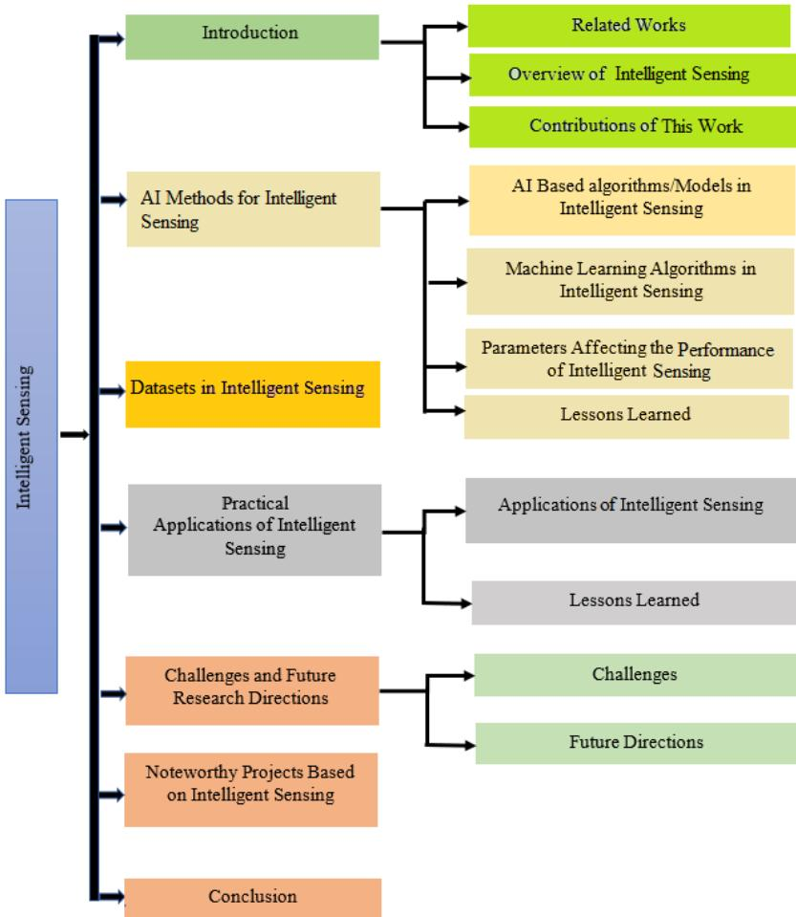
Figure 1. Structure of the Paper.

2. AI Methods for Intelligent Sensing
In this section, an overview of ML and DL algorithms from an intelligent sensing perspective is presented. The aim of this section is to highlight learning algorithms that are widely used in many real- time applications. Furthermore, parameters affecting the performance of intelligent sensing are also discussed. This section concludes with lessons learned.

2.1. AI Based Algorithms/Models in Intelligent Sensing
A machine that is able to make decisions on its own is said to possess AI. There is a broad spectrum of applications for AI, ranging from machine learning to robotics. By combining the current advancements in machine and deep learning, huge amounts of data from various sources are analyzed by utilizing AI to identify patterns and make intelligent predictions [51]. However, recent advances in artificial intelligence systems and robotics still need more research to solve complex problems. The tremendous growth in AI has ushered in a wave of applications using sensors. As a result, the demand for intelligent sensing increases in the market. Using sensor signals, the analysis of sensor data based on AI provides robust predictions and classifications. Hence, intelligent sensing will be the bright future of AI, where human behavior and emotions can be recognized by AI machines.
Although some prior works have provided an in- depth summary of AI and ML techniques in particular areas of applications, this survey shows AI and ML- based intelligent sensing which has not been explored in other works. We also identify current problems that have limited real- world implementations. This will provide helpful guidelines to researchers and practitioners interested in intelligent sensing.

2.2. Machine Learning Algorithms/Models in Intelligent Sensing
In the last few years, the tremendous growth of ML- based approaches has expanded the research area of intelligent sensing. Generally, ML can be considered to be a subset of AI which handles complexities to solve a specific task. In this subsection, a brief overview of existing ML algorithms that improve the functioning of sensing systems is presented together with their advantages and disadvantages. Various scenarios portraying how machine learning methods are applied in intelligent sensing is depicted in Figure 2. ML algorithms are divided into supervised, semi- supervised, unsupervised, and reinforcement learning.
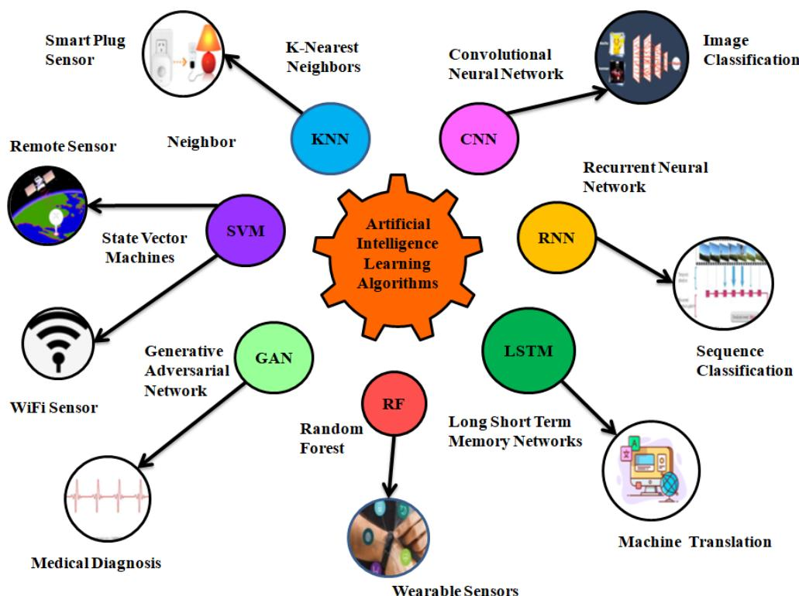
Figure 2. Various Scenarios Portraying ML and DL-based Intelligent Sensing.
- Supervised learning-based intelligent sensing—Supervised learning deals with the known and labeled data and is divided into two types: classification and regression. This approach has been successfully implemented for many years in the fields of image classification, fraud detection, medical diagnosis, weather forecasting, market forecasting, and life expectancy estimation. In [52], ECG data are collected via wearable sensors, which detect heartbeats automatically, and a supervised learning approach is used for arrhythmia classification. An artificial haptic neuron system is fabricated in [53]. The system comprises a Nafion-based memristor and a piezoelectric sensor. The sensory receptor converts external stimulus into an electric signal, and the memristor is used for further processing of the data collected from the sensor. A supervised learning method is implemented for the recognition of English letters by placing the sensor on the joint of a finger. A novel methodology proposed in [54] using supervised learning for resolving the collision of cash tags yields high classification accuracy of listed companies in London Stock Exchange. A hybrid model that
combines ML and game theory is proposed in [55] to solve issues related to network selection in ultra- dense heterogeneous networks.
- K-Nearest Neighbors (K-NN) is an effective classification algorithm used for large datasets. Here, $K$ represents the number of training samples that are near the test sample in the feature space [56]. In [57], a machine learning-based K-NN approach is used for load classification by collecting data from various smart plug sensors and other devices.- Support Vector Machine (SVM) is mainly used to categorize data attributes between classes by creating two-dimensional planes to minimize the classification error [58]. For example, Ref. [59] introduces a danger-pose detection system based on Wi-Fi devices that is used to monitor a bathroom while ensuring privacy. A machine learning-based detection approach usually requires large amount of data collected in target scenarios, which is challenging to detect danger situations. However, this work employed a machine learning-based anomaly-detection technique which requires a small amount of data in anomalous conditions. In this work, researchers first extracted the amplitude and phase shift from Wi-Fi Channel State Information (CSI) in order to detect low-frequency components associated with human activities. The static and dynamic features were then derived from the CSI changes over time. Finally, the static and dynamic characteristics are input into a one-class SVM which is employed as an anomaly-detection method to determine if a person is not in the bathtub, is bathing safely or in unsafe situations.
- Decision Tree (DT) model consists of branches and nodes, wherein every node represents a test on every feature, and each branch has a value that the associated node can use to classify a sample [60]. A decision tree-based approach was presented in [61] for an intelligent transportation system (ITS). LIDAR sensors obtain point cloud data, which are then projected onto the XOY plane. After that, the images are classified into road and background grids for monitoring road traffic.
- Ensemble Learning (EL) is a method based on combining the outputs of basic classification algorithms to boost the performance of classification. It is robust to data overfitting problem and is better than a single classifier [62]. This method is proposed in [63], where soft sensors are used to collect data to predict the composition, flow rate, and other features of the product, e.g., fatty acid methyl esters (FAME), in the procedure of production of biodiesel from vegetable oil.
- Random Forest (RF) is made of a combination of several DTs and constructed randomly to form a model for improving the overall results [64]. A random forest-based classifier is proposed in [65] for estimating the content of bulky metals in agricultural soil using hyperspectral sensor data and is shown to reduce computational cost and time.
- Unsupervised learning-based intelligent sensing—Due to the large amount of unlabeled data in our everyday life, researchers have emphasized the unsupervised learning-based algorithms for intelligent sensing applications. This method consists of dimensionality reduction, generative networks, and clustering. Unsupervised learning-based intelligent sensing is proposed in [66], which is applied for real-time environment sensing to detect rare event instances intelligently. An unsupervised clustering-based method is introduced in [67] to describe an individual’s behavioral pattern by analyzing 100 days of unlabeled sensor data of 17 older adults from their homes and extract information of their day-to-day activities at different times. To detect the change in Landsat images, unsupervised learning is used in [68] with mean-shift clustering and hybrid wavelet transform under the Multi-Objective Particle Swarm optimization (MO-PSO) framework.
- Semi-Supervised intelligent sensing—This method deals with the combination of labeled and unlabeled data. To reduce the complexity of labeling all data for large
datasets, semi- supervised methods are used. A robust model based on a semi- supervised approach is proposed in [69] to warn about the aircraft fault during the flight of a UAV by sensing real- time data such as angular velocity and pitch angle from flight sensors, and dramatically reduces the manual work. To detect faults in Additive Manufacturing (AM) products, a semi- supervised method with a few labeled data and a large number of unlabeled data is explored in [70].
- Reinforcement learning-based intelligent sensing—In the context of AI, reinforcement learning learns to make a sequence of decisions by interacting with its environment. One of the successful applications of this approach is to control autonomous cars by training the model. A deep reinforcement learning-based multi-sensor tracking fusion is proposed in [71] for vehicle tracking by learning on fused data from different sensors (camera and LIDAR). An intelligent sensing-based approach is introduced in [47] to autonomously monitor bridge conditions by collecting data from sensor nodes and make decisions using the reinforcement learning method. A novel approach based on YOLO V3 is proposed in [72] for multi-object tracking based on multi-agent deep reinforcement learning. This approach performs better in terms of precision, accuracy, and robustness. A routing protocol built on reinforcement learning is developed in [73] to find an optimal routing path for data transmission in a wireless network.
Table 3 shows the comparison of several ML and DL algorithms used in different areas of intelligent sensing. ML is a branch of AI that advocates the idea of acquiring the right data so that a machine can learn how to solve a particular problem by itself. The rise of ML is due to the availability of large datasets, and the adoption of ML algorithms in the field of intelligent sensing is to create smart devices that can take actions based on what they sense from the environment. With the implementation of ML in sensors, the efficiency and robustness of the system will reach the next level in smart sensing applications. Using sensor data, ML algorithms enable more robust predictions and classifications as compared to other physics- based models that envisage AI being added eventually to devices to adapt to the new circumstances. Therefore, the use of machine learning, including deep learning algorithms, is appropriate for performing challenging tasks in intelligent sensing, as shown in Figure 2.
The availability of datasets and the invention of new algorithms have increased the usage of ML and DL in the last few years. The supervised learning method has been used in numerous applications, such as object recognition, speech recognition, and spam detection. It predicts the value of one or more output variables (in the form of continuous or discrete) by observing input variables. The unsupervised learning method is generally used for gene clustering, social media analysis, and market research. The main focus of this method is to analyze unlabeled data. Semi- supervised learning is the hybrid model of supervised and unsupervised learning methods, which is used to solve problems with a few data points labeled and most of the data unlabeled. Reinforcement learning (RL) is used in applications such as finance, inventory management, and robotics, where the purpose is to learn a policy, i.e., to map situations between states of the environment to perform actions appropriately.
Table 3. Comparison of Machine Learning Algorithms/Models in Intelligent Sensing.
Reference Number | Machine Learning Algorithm/Model | Dataset Used | Description | Parameters Influencing the Performance | Advantages | Limitations
[74] | epsilon-SVR (eSVR), Linear regression (LR), Convolutional Neural Network (CNN), T-SVR. | DEAP Dataset [75]. | A Framework is proposed for stress recognition in real-time using peripheral physiological signals. | BVP and GSR. | - Less Prediction error; 2. Convenient for real-world applications. | The model is limited to the slight movement of physiological signals.
[76] | Linear regression (LR) and neural network (NN). | Chronic Kidney Disease (CKD) from patients. | A hybrid intelligent model is proposed to guess chronic kidney disease from a patient's data on the cloud environment to improve services in healthcare in smart cities. | Feature weights (FW). | The proposed model significantly improves accuracy compared to other models. | The hybrid model is limited to a small amount of data of a patient's record.
[77] | R.A.L.E sound [78]. | DEAP Dataset [75]. | Performance of K-NN and SVM classifiers are compared using the pulmonary acoustic signal from RALE database for diagnosing respiratory pathologies. | Mel-frequency cepstral coefficients (MFCC). | Analysis of feature vectors is via ANOVA and separately fed into SVM and K-NN classifiers. | - The amount of data used to train and test the classifier is very small. 2. Collection of data was carried out in a controlled environment.
[9] | Ranking SVM. | NUS-WIDE dataset [79]. | The interaction between so-cial images and online users is analyzed. | Color, texture, and GIST features. | Powellful method and heterogeneous social sensory data improve performance. | External factors such as images based on cultural and geographical locations are not considered for prediction.
[80] | K-NN, AdaBoost, SVM, RF and Lo-gistic (LR). | Non-contact sensor data. | The non-contact sensor the device is designed to predict the signs of HR, RR, HRV parameters from a patient's records during a period of 23 weeks of HD sessions. | Age and BMI (body mass index) of patients. | Using machine learning-based predictive models, high accuracy is obtained. | The main limitation is the prediction of clinical events in advance and the other parameters like BP and the patient's medical history using a multi-class prediction model.
[81] | Support Vector Machine (SVM). | CRCNS-ORIG and DIEM. | A model is proposed to detect mental weakness of older and younger people by collecting their eye-tracking data while watching a video. | Pupil diameters, eye blinking, gaze allocation, and saccade mean velocity. | Imploves detection accuracy using an automated feature selection method. | - Limited no. of participants. 2. Eye-tracking data are collected in a controlled environment.

2.3. Deep Learning Algorithms/Models in Intelligent Sensing
Deep Learning is now dominating the industry and research spheres for the growth of a range of smart- world systems for good reasons. DL has shown considerable potential in approximating and reducing huge datasets into accurate predictive and transformational output, greatly facilitating human- centered smart systems. This section discusses deep learning models based on intelligent sensing.
Convolutional Neural Network- CNN is a robust supervised DL algorithm with better performance than other DL algorithms. IoT security is one of CNN’s applications where the features of the security data can be automatically learned by the sensors [82]. Deep CNN- based learning is proposed in [83] to recognize human emotions using electrodermal activity (EDA) sensors. These devices capture emotional patterns from a group of persons. The paper [84] proposed a system that detects the physical activity of older people from wearable sensors. For rotation- invariant features, each feature triplet is extracted from the X, Y, and Z axes and reduced to one feature represented by a 3D vector. Other works similar to this also achieve high accuracy in the study of younger people.
Recurrent Neural Network- RNN is an important algorithm of DL in which present and past inputs depend on the output of the neural network. It is used to handle sequential inputs, which can be speech, text, or sensor data [85]. An RNN- based approach is discussed in [86], which is meant to interpolate sparse geomagnetic data from lost traces to reduce the time taken by linear interpolation approaches. The study in [87] discussed a mobile positioning method using RNN to analyze the strength of received signals. The authors experiment with the training of two RNNs separately
for estimating latitude and longitude, which results in overfitting. An RNN- based learning model is proposed in [88] to monitor underwater sensor networks in real time, which improves the delay and reduces the cost of packet transmission.- Generative Adversarial Network—GAN comprises two models; one is the generator, and the other is the discriminator. The two are trained in tandem via an adversarial process. These networks have been implemented for the security of IoT systems [89]. A conditional GAN- based DL method is presented for the reconstruction of CS- MRI that is compressed sensing magnetic resource imaging using compressed MR data [90]. In [91], the authors proposed a GAN- based method to generate X- ray prohibited images with different item poses. According to the paper, the quality of the images is good as compared to DC- GAN and WGAN- GF. After the images are generated, they are added to the real images and FID (Fréchet inception distance) is used to evaluate the performance of GANs.- Long Short- Term Memory—LSTM is a type of recurrent neural network that is intended to model temporal sequences and their long- range dependencies more accurately than conventional RNNs [92]. The LSTM comprises units called memory blocks in the recurrent hidden layers. The memory blocks contain memory cells with self- connections that store the temporal state of the network in addition to special multiplicative units called gates to control the flow of information. A DL- based approach is used in [93] for emotion classification, dealing with a large number of sensor signals from different modalities. From the results presented in the paper, it came to be known that ad- hoc feature extraction may not be compulsory as DL models extract the high- level features automatically.

2.4. Parameters Affecting the Performance of Intelligent Sensing
This subsection presents a review of some of the parameters that affect the performance of intelligent sensing. Intelligent sensing methods have been promising with state- of- the- art results in several areas, such as healthcare, image segmentation, agriculture, soft sensors, etc. The use of sensor systems in industrial, scientific, and consumer equipment is extensive and is continuously increasing in domains like automation. Essentially, industrial information revolutions need more sensors of every kind. The focus of the sensor system is to provide reliable signals and evaluate information. The smart sensing units include a sensing element and proper signal processing function within the same package.
Tables 4 give a list of parameters that affect the performance of intelligent sensing based on the results reported in literature. Key information includes the title and year of publication of each paper, and parameters that influence the performance of the various intelligent sensing approaches, such as temperature, accuracy, cost, time, occupancy, dependency, etc. One of the parameters is feature extraction in image recognition. Several techniques of pre- processing are used for enhancing certain features and removing unnecessary data. These techniques include digital spatial filtering, contrast enhancement, gray level distribution linearization, and image subtraction [94]. Measurement of redundancy in test samples is attempted to achieve test loss minimization, which can lead to a reduction of test maintenance costs and also ensure the integrity of test samples [95]. Evaluating ML algorithms is an important part of any project. Accuracy is one of the essential parameters to judge the performance of the trained model. Classification accuracy is defined as the fraction of correct predictions relative to the total number of input samples.
Table 4. Parameters Influencing the Performance of Intelligent Sensing.
Ref. Number | Year | Title of Paper | Parameter 1 | Parameter 2 | Parameter 3 | Parameter 4 | Parameter 5 | Parameter 6 | Description
[96] | 2019 | A review on EMG based motor intention prediction of continuous human upper limb motion for human-robot collaboration. | EMG acquisition | Signal processing | Pre-processing | Feature extraction | Accuracy of continuous motion | Dependency autonomy | Redundancy
[97] | 2019 | Toward biotherapeutic product real time quality monitoring. | Dynamic nature | Adaptive model structure | High levels of noise | Complexity | Heterogeneity | Real-time monitoring | Researchers have explored several approaches and models for motor intention prediction based on EMG signals for estimation of continuous motion of the human upper limb and also discussed motion parameters for measuring the performance of the system.
[98] | 2019 | A novel segmentation based depth map up-sampling. | Depth maps | Geodesic distances | Dis- | Super pixels | Initial no. of pixels | Scale constant | Splitting threshold-
[99] | 2018 | Design and applications of soft sensors in polymer processing: A review. | Temperature | Pressure | Process speed | Flow index | Viscosity | Product dimensions | Researchers have done a comprehensive survey on soft sensing techniques applied for polymer processing and its importance for the growth of process monitoring, process control and fault diagnostics. These techniques have replaced the use of physical sensors for practical process measurements in industries.
[100] | 2019 | Prediction of occupancy level and energy consumption in an office building using blind system identification and neural network. | Occupancy | Prediction accuracy | Time factor | Historical inter-nal load | Energy consumption | Structure parameters | A prediction model based on the feed forward network, ensemble models as well as extreme learning machine (ELM) is established for measuring electricity consumption of the AC system, and based on the approach of blind system identification (BSI) model, the occupancy profile is estimated in an office building.
[101] | 2019 | Semi-supervised deep learning for hyperspectral image classifi-cation. | Training samples | Classification accuracy | Ac- | Bias parameters | Kappa coefficient | Weight decay | Momentum
The most crucial aspect of this matter is the collection of data from multiple sources. The data usually goes through several stages of pre- processing to make it in presentable form. Intelligent sensing approaches are in general associated with technological applications where they are applied. For example, in cognitive radio, the sensing approach will be different from applications in a smart grid. The work in [102] presented an artificial intelligence- based approach for high- speed data delivery with latency regulation. Compared to CogMAC (Cognitive Medium Access Control) and AHP (Analytic Hierarchy Process) protocols, the decentralized approach helps in creating opportunistic methods for spectrum access and better design of channel selection mechanisms. The work presented in [103] proposed a method for integrating intelligence close to the sensor, which will enable decision making in local nodes before transferring the information to cloud or server. The local intelligence will be helpful in producing smart data that can be used for analysis to produce effective outcomes. Techniques such as normalization, linearization, and data cleaning can be done at local nodes in a piconet. Such inclusion will be helpful in the elimination of unnecessary steps, which needs to be done very frequently before data is used in artificial intelligence algorithms.
It is very important to identify data anomalies as data sometimes are collected from multiple platforms. In such cases, the source of data needs to be tracked for threat and irregularity. The work presented in [104] proposed scheduling and anomaly handling mechanisms in cross- platform IoT systems using cognitive tokens. The proposed methods use intelligent sensing with fair play and exponential growth procedures. In contrast to current technology trends in full- stack system development, a layered architecture- based
approach was proposed in [105]. The proposed method will help to collect data, extract useful information, and transfer it for further processing. In the case of more sensitive data sensing, such as clinical or eHealth, Ref. [106] presented the implementation of gateway and scoring mechanisms to reduce the latency and to analyze the performance of systems. Such implementations have shown good performance in fog computing environments, where restricted resources are available at local nodes. The work presented in [107] shows the importance and challenges of IoT- based healthcare information sensing. The work presents challenges related to information acquisition, sensing, storage, processing, analytics, and presentation.
The studies reviewed in this section reveal that, although the new generation intelligence reduces the cost of devices and helps present the information more accurately for decision making, design and implementation as well as communication technologies still play important roles.

2.5. Lessons Learned
In this section, several approaches based on AI are reviewed that can analyze the complex characteristics of sensor data for various applications. Most of the ML and DL- based algorithms work with numerous types of sensory data that come from different sources. However, algorithms of supervised learning for classification (i.e., SVM, DT, and Rf) are mainly recommended when data have complex feature space (for example, hyperspectral sensor data). In particular, for data fusion from multiple devices, EL is more favorable because the fused data can be fed to an ensemble classifier for better results. For cases where the dataset size is small, K- NNs perform well as compared to other algorithms. The task is more challenging when the sensor data are unlabelled, and hence, the desired results can be obtained using unsupervised learning algorithms. Classification based on semi- supervised algorithms requires a limited set of annotated sensor data and performs well with time- series data. Another category is reinforcement learning that works well with the high- dimensional stream of input data. Its integration with deep learning is applied in new areas of research such as drone navigation. Furthermore, DL- based algorithms are also discussed and several conclusions are drawn. The variations of CNN are preferred when input sensor data is more than 1- D and are highly recommended due to their simultaneous feature extraction and classification capabilities. Most of the recent architectures such as RNN and LSTM perform well with sequential sensing data (i.e., sequence of words, images, etc.), but more favorably, LSTM is used due to its long- term dependencies among input data. For generating synthesized data that is different from actual sensor data, GAN is considered and has been proven to be successful in handling data privacy.
A few attempts were made to examine the parameters that affect the performance of intelligent sensing. Internal and external factors such as the collection of real- time environmental data from multiple sensors, the nature of datasets, the accuracy of the training datasets, optimization parameters, etc., may hinder the overall performance of intelligent sensing. Thus, to create an efficient and robust smart system, it is vital to identify anomalies in data and take appropriate measures to remove them.

3. Datasets in Intelligent Sensing
A dataset is an assemblage of information. Commonly, data are organized as a stream of bytes into a partitioned dataset, which may comprise multiple members, each containing a separate sub- dataset, similar to directories or folders. This organization is employed for the application requirements and to optimize communications. Examples of classic datasets include iris flower dataset [108], MNIST dataset [109,110] etc. Tables 5 present a variety of sources of data with comments on the merits and demerits of information. Intelligent sensing algorithms with appropriate datasets foster sensible and more accurate solutions.
Datasets can be categorized as
- File-based datasets: These are datasets that are entirely stored in a single file.
- Folder-based datasets: In this type of datasets, the dataset is a folder that holds the data.- Database datasets: This type of dataset is a set of data stored in a database, for example, the Oracle database.- Web datasets: Web datasets are the datasets that are stored on an internet site. An example is the WFS format.
Individual datasets are sets of data values in an organized way intended for automated analysis. The structure of a dataset can be as simple as a table of rows and columns or can be as complicated as a multidimensional structure. This section comprises different datasets that belong to the different fields of intelligent sensing. These datasets are used in various applications like image classification, gender recognition, speech recognition, obstacle detection, action detection, etc.
Table 5. Publicly Accessible Datasets for Intelligent Sensing.
Publicly Available Dataset | Sources of Data | Format | Exemplar Using the Dataset | Elucidation and Comments | Applications Deployed | Advantages/ Limitations
LILA | Labeled information Library of Alexandria: Biology and conservation | Images | [111] | Based on Deep Learning models, CNN, ResNet-18 Architecture used. | Image Classification. | Accuracy of images in the night time is less than images in day time.
Fashion-MNIST | [112] | Images | [113] | More challenging as compared to original MNIST. | Image Classification. | More challenging task than MNIST.
DEAP | [114] | xIs, csv, ods spreadsheet | [115] | In some cases, such as the scales of arousal, valence, liking, single trial classification is performed. | Human affective states. | Individual physiological difference and noise make single trial classification challenging.
Movie Tweetings | Dataset text collected from Twitter IMDb | Text | [116] | Automatically collects data from structured social media posts and involves recent and relevant movies. | Regard the and Classification label and Tweets. | Only well structured tweets are considered.
Toronto Rehab stoke Pose Dataset | [117] | CSV | [118] | Dataset meant to develop and evaluate an algorithm for monitoring of post stroke, upper body posture and motion. | Motion Tracking, Classification. | Tracking of Kinect posture is susceptible to noise and also unstable occasionally while tracking.
DBpedia Neural Question Answering (DBNAQ) dataset | Machines (NSpM) templates extracted from queries in QALD-7 training (QALD-7-train) in conjunction with the LC-QuAD dataset [119] | Question pair | [120] | A reusable and efficient method to generate pairs of natural language questions. | Questions and Answering. | Affecting the BLEU accuracy over large vocabularies.
The Zero Research speech Challenge 2015 | [121] | Sound | [122] | Focused on two levels of linguistic structure subword unit and word units. | Discovery of speech subword features/word units based on the unsupervised method. | NLP type and token metrics are not very good for a system that does not attempt to optimize a lexicon.
CORe50 | [123] | RBC-D images | [124] | Complex setting of acquisition in Dataset makes the problem harder to solve when learning is done on training data. | Classification object recognition. | Noticeable accuracy decrease with respect to the cumulative approach.
11k Hands | Biometric identification gender recognition using a huge hand data-base [125] | Images (txt, csv, .mat) label files | [126] | Gender recognition based on binary classification and biometric identification based on SVM classifier. | Gender recognition and biometric identification. | Can construct biometric identification and gender classification system that depends on images.
Field Safe | Computer vision and bio system signal processing group | Images and 3D point clouds | [127] | Supports object tracking, detection, classification, sensor fusion, and mapping. | Object detect- ion in agriculture. | Projecting explanations to local sen-sors frames inevitably causes local-ization errors.
MSPAvatar | A motion capture database of spontaneous improvisations [126] | Motion captured video, audio. | [129] | Relationship between speech, dis-course functions, and non-verbal behavior. | Classification action detection. | Cleaning of the motion capture data slower than expected.
Datasets have played a vital role in the development of sophisticated machine learning and deep learning algorithms, as documented in [130]. The importance of datasets is that they represent the relationship of the individual data items. Datasets vary in the types of manipulations, feature analysis, and other functionality closely related to the domains. In some areas, for example, astronomy and genetics, domain- specific software may be supreme. Thus, the data can be incorporated into the cumulative knowledge base of the respective disciplines.
In machine learning projects, there is a need for training datasets. The datasets are used to train the model for performing a variety of actions. It is impossible for a machine learning algorithm to learn without data. It is the most crucial aspect that makes algorithm training possible. Completeness and accuracy are the two necessities for any dataset [131]. In the absence of these characteristics, the final result is prone to wrong conclusions. Any investigation relies on the availability and quality of suitable datasets. For this reason, there is a need to verify the dependability of data before they are converted into valuable information. AI development heavily relies on data, from training, testing and tuning.
Three different types of datasets are the training set, the validation set, and the testing set. The training set is employed to train an algorithm to learn and produce results. The validation set is used to tune the final ML model. The testing dataset is used to evaluate how well the algorithm was trained on the training dataset. With the growing acceptance of AI by companies across all industries around the world, developing a strategy for ML is vital to gain a competitive edge. A significant component of this strategy is the data used to train machine learning- based algorithms.
It is very important to remember that good performance on datasets does not necessarily mean that a system with ML algorithms will perform well in real scenarios. Most people in AI forget that the crucial part of building a new AI solution is not the AI or algorithms—it is the data collection and labeling. Training datasets represent the majority (around $60\%$ ) of the total data, whereas the validation and testing datasets each account for $20\%$ and $20\%$ of the total data. Other ratios such as $70\%:15\%:15\%$ among the three datasets are also possible, depending on the application.
Overfitting takes place when a model learns too well about the training data. It learns all the features of training data with noise to a level that it adversely affects the performance of the model on fresh data [132]. If the training part takes too long on the dataset, the performance may decline because of overfitting of the model [133]. At the same time, the error for the test set begins to increase as the model’s ability to generalize decreases. Data augmentation [134] is an approach that allows practitioners to significantly increase the amount of data without actually collecting new data. It is a way of creating new ‘data’ with different orientations. The benefit of data augmentation is that it generates “more data” from a limited amount of data and prevents overfitting. Data augmentation techniques such as padding, cropping, and horizontal/vertical flipping are commonly used to train huge neural networks. An underfitting machine learning model is not an appropriate model [134] and will have poor performance on the testing data. The remedy is to try alternative machine learning algorithms.

4. Practical Applications of Intelligent Sensing
In this section, a plethora of applications based on intelligent sensing such as agriculture, surveillance, traffic management, healthcare, and assistive services are summarized.

4.1. Applications of Intelligent Sensing
The amount of data that is available on the internet and in our daily life in different forms is growing fast because of the rapid development of sensing and computing technologies.
- Smart Agriculture—Intelligent sensing applied to this domain, to fulfill the need of farmers, faces lots of problems on a daily basis, like crop disease infestations, weed management, pesticide control, etc. [135]. The gradient descent-based technique is used in [136] to train the network on a real field dataset consisting of various tea gardens. To identify tea pests, a radial basis function network is used for classification. Ref. [137] combines expert system technology and ANN to predict the nutrition level in the crop in order to help inexpert farmers. This system is developed as an application of Android, which could be installed on a smartphone [137]. The basic methodology is feed-forward and backpropagation. The neural process and recalling patterns are done by the feed-forward algorithm, and the training is done by the backpropagation algorithm. A study carried out in [138] considers the use of ANN in various techniques to estimate evapotranspiration (ET). The methods applied include the Penman-Monteith method and Levenberg-Marquardt backpropagation. Because of the increase in the number of hidden layers, an increase in the variability of the ET estimation was observed.
Figure 3 illustrates how smart sensors can be used in different areas of agriculture, i.e., soil, crop growth, disease identification, supply control, environment sensing, and bio- surveillance. Some key reasons for using sensors are real- time monitoring to
enable remedial measures, cost savings by reducing waste, remote sensing through wireless and IoT platforms, and automated agricultural produce monitoring.
- Intruder Detection and Surveillance—In IoT devices, attacks and threats have become more dominant as intrusion detection methodologies are hard to deploy. The most effective intrusion detection systems apply signature-matching methods for detecting vicious activities [139]. These systems have low false alarm rates and perform well in the various attacks. Another is anomaly detection; it maps ordinary behaviors to a certain baseline and detects eccentricities. For creating a baseline profile, a supervised learning algorithm is used, which uses previous data samples to train a model. In [140], the knowledge discovery in databases (KDD) is saved to the Oracle database server to extract the proper dataset for a set of classifiers. After preparing the dataset by removing the attacks, the most common experimental techniques are multilayer perception, Bayesian algorithm, and J48 trees for classification. In [141], the dataset from the 1998 DARPA intrusion detection program is pre-processed in binary TCP dump format readable by the neural network. Backpropagation is the supervised learning method used to accomplish this task.
An intelligent video surveillance system (IVSS) composed of an IP camera and a human- computer interface is presented in [142]. IVSS has modules for image analysis, image understanding, video capture, and event generation. In the video capture module, input data can be accessed from different IP addresses of cameras over a LAN. Image analysis comprises image processing tasks, for example, extracting relevant information, including tracking, motion detection, etc. Image understanding includes AI techniques to understand the significance of the scene captured by a camera. The abnormal behavior is then forwarded to an event generation module, which helps the user by generating an alarm. The use of intelligent sensing in intrusion detection and remote surveillance for monitoring applications is shown in Figure 4. The use of smart sensors will greatly help improve the existing systems in terms of cost, energy, and performance.
- Intelligent Traffic Management- AI-based techniques have been applied in this field to control road traffic. To optimize the traffic light cycles, a technique based on genetic algorithm (GA) is used to improve the traffic light configuration [143]. Ref. [144] discusses the design of a traffic light controller that varies the cycle time according to the number of vehicles behind the red and green traffic lights. Another technique based on extension neural network (ENN) is used in outdoor environments to recognize the objects. A traffic light can be monitored by gathering data from the number of vehicles passing and then processing that data. Here, how intelligent sensing is used in traffic management is shown in Figure 5. With the emergence of smart sensors, various challenges faced by traffic management authorities such as traffic congestion, optimum route, travel cost, average waiting time, etc. can be solved.
- Smart Healthcare—Unsupervised learning algorithms like clustering and principal component analysis (PCA) are used in [145]. In this technique, by maximizing and minimizing the resemblance of patients, the clustering algorithm outputs the labels within the clusters. PCA mainly focuses on reducing the dimension, especially when the features are achieved in a considerable number of dimensions. In [146], SVM is applied to classify imaging biomarkers of nervous and psychiatric diseases. Recently, CNN has been successfully implemented in the healthcare domain through knowledge from ocular images to assist in diagnosing congenital cataract disease [147]. Natural language processing (NLP) aims at better clinical decision making from the narrative text [148]. In [149], NLP is used to read chest X-ray reports to alert physicians to the possible requirement for anti-infective therapy.
In healthcare organizations like insurance companies, the use of sensors is to provide accurate and reliable diagnostic results, which can be monitored remotely irrespective of whether the patient is at a clinic, hospital, or home, thereby improving healthcare
efficiency. Healthcare management uses intelligent sensing for different purposes, as shown in Figure 6.
Mass spreading diseases are not rare nowadays; in such cases, fast and reliable information helps to stop the infection to the general public. The mitigation is facilitated by early detection, identification of the cause, and finding a cure. In healthcare, DL and AI have been implemented to control such diseases. Intelligent sensing is also implemented for vaccine detection. In the case of COVID- 19, WHO has recommended a swab- based SARS- CoV- 2 test. From the swabbed samples, the information related to E- gene from SARS- CoV- 2 and gene from enzyme RNA- dependent polymerase, which is in charge of the copying of a DNA sequence into an RNA sequence during the transcription process, plays a key role in the identification of symptoms. Many researchers have observed that real- time PCR methods are also effective for diagnosing the test results [150- 152]. In these approaches, the protein related to immunological defense is tagged to identify the potential targets using fluorescent tubes. A CRISPR (Clustered Regularly Interspaced Short Palindromic Repeats)- Cas13- based strategy for viral inhibition has been found to be effective for dealing with SARS- CoV- 2, which caused COVID- 19, and emerging pan- coronavirus pandemic strains [153].
Intelligent sensing techniques can be employed to determine the diseases that cause the epidemic and pandemic. In [154], Santosh suggested active learning algorithms with cross- population datasets to test and train models that can compute the data with multiple mini- batches of information to help in detection and decision making. The work presented in [21] proposed an AI- based framework with the use of sensors already mounted on palmtop devices, like smartphones, cameras, inertial, microphone, temperature, and fingerprint sensors to collect information from patients. Deep Learning algorithms are implemented to do the multimodal analysis to detect the presence of COVID- 19 symptoms.
The use of intelligent sensing with edge computing and cloud services are also encouraging several corporations and startups to work in the area. UNet++ [155] was proposed for medical image segmentation and has been successfully implemented on computed tomography scan, microscopy, and RGB video data. The UNet++ architecture is the new version in the series of U- Net and wide U- Net architecture. It has been observed that with deep supervision, UNet++ has demonstrated better performance than its predecessors. The common issue in implementing the intelligence for disease detection using sensors is that the raw data need to be segmented and labeled for further analysis. In case urgent or fast results are required, a manual method is preferred as in incorporating intelligence to algorithms, training needs to be done by feeding information in significant amounts. If the system is not trained, the accuracy of such a model will be degraded, which will affect the end result, i.e., successful prediction of true positive cases.
The nucleic acid test is a method used to identify the cases related to the diagnosis of Gonococcal and other Neisserial infections, HIV RNA, Severe Acute Respiratory Syndrome (SARS), coronaviruses, etc. A recent study shows that it is also being considered for the diagnosis of COVID- 19 patients. This test helps detect specific nucleic acid sequences and organisms in blood, tissue, urine, or stool. The work in [156] proposed nucleic acid amplification tests (NAATs) using stacked denoising autoencoders (SDAE) for feature extraction. It is also observed that DeepGene, a cancer type classifier, can be essential [157]. In another work [158], Wang et al. have implemented CNN to recognize the behavior of pulmonary nodules and also to extract features for machine- generated endoscopy images in low light. As observed, artificial intelligence algorithms are increasingly implemented in pathology devices with assistive methods to achieve high accuracy results. In the monitoring of pandemic and epidemic also, such intelligent sensing plays a vital role. Thermography devices can be easily found in public places, especially in the case of mass spreading diseases.
Thermal scanner is a commonly known device to identify the fever by interpreting the data (heat map) in human- readable forms.
Figure 7 is a case study on the importance of intelligent sensing in epidemic and pandemic. To detect the symptoms related to the infection, multiple tests are proposed, and in most of the cases, a combination of such tests needs to be performed. WHO suggests swab test, which requires the sample collection from nose and throat. On the other hand, in CT scan images are used, and test data need to be further analyzed in thermography to sort out potential patients based on the heat analysis. The tissues collected by biopsy and bronchoscopy are examined to understand the symptoms. Urine and stool tests have also shown the presence of infection in patients. In the case of COVID- 19, urine samples are not adequate, and stool analysis has helped detect the presence of infection, similar to SARS and MERS. Blood tests will help analyze cell culture, and multiple serology assays will help identify the virus growth and immune system status. Tests such as RDT, ELISA, and Neutralization assay indicate the presence of antibodies with the possibility of protection against infection. Data from multiple test sources shown in Figure 8 are helpful for training and testing algorithms. Deep learning and artificial intelligence algorithms trained with such data will further help in symptom identification.
- Smart Assistive technology—In [159], a navigation system for visually impaired people is developed. This project focuses on how place cells, grid cells, and track integration along with AI can be helpful. Artificial intelligence with grid cells uses deep Q learning with an RNN-based ANN architecture. In [160], cash recognition for blind people is designed to allow those people to identify the notes correctly. In this project, an AI-powered application uses a smartphone to capture the image of a cash note. After recognizing the value of that particular note, an audio sequence signifies the value of the note. In order to work on realistic images taken from a smartphone, a transfer learning-based pre-trained model on ImageNet of VGG-16 is used for training deep neural networks and for verifying the approach. Recently, ML algorithms have improved the intelligibility of speech in both hearing-impaired and normal-hearing listeners. In [161], speech separation is considered as a binary classification problem in which each true or false unit needs to classify noise dominant as 0 and speech dominant as 1. In speech recognition for normal-hearing persons, Gaussian mixture models have been used.
Figure 9 shows how AI, ML, and DL techniques are used for the visually impaired by taking gestures as input and converting text to speech using algorithms. These technologies improve the way of communication between ordinary people and visually impaired people.
- Smart Communication Networks—As a recent trend in communication technologies, it is observed through 4G, 5G, and ongoing research in 6G networks, that ubiquitous sensor network is going to be a feature of intelligence sensing, which means that information of sensor nodes could be easily retrieved remotely and processed. This also requires adopting new techniques related to nondestructive data transfer mechanism, fast and lightweight computational nodes for signal and communication requirements, multichannel modulation schemes, and opportunistic channel sensing schemes. To control, transfer, and supervision of sensor information, Intelligent sensing can be observed in Internet of Things, Industry 4.0, etc. [162] presents the behavior analysis using the Latent Dirichlet Allocation (LDA), the Non-negative Matrix Factorization (NMF) and the Probabilistic Latent Semantic Analysis (PLSA) for a comparative study using three different datasets from ubiquitous sensors. LDA, NMF, and PLSA have all been successfully used in text analysis tasks such as document clustering and are closely related to each other. In particular, [163] has formally shown the equivalence between NLM and PLSA. The PLSA, also known as the probabilistic latent semantic indexing (PLSI), is a statistical approach used to analyze two-mode and co-occurrence data. Further, PLSA can be treated as LDA with a uniform Dirichlet prior distribution.
The semi- supervised learning approach was implemented in [164] for gait recognition for person identification using ubiquitous sensor data. Sparse labels and low modality factors were analyzed in [165].
For intelligent sensing in communication, the steps illustrated in Figure 8 can be used. The initial steps include basic signal processing with sensing, filtering, amplification, sampling, quantization, data acquisition, and conversion. After that, information processing and digital communication procedures need to be adopted, where edge computing plays an important role. The edge computing system includes a low- power compute unit specifically tailored to the requirements. In such scenarios, it is important to notice that hardware restrictions exist. Because of this, the algorithm development should take all such limitations into account. The gateway is an important medium to transfer data from local nodes to the main computational platform, i.e., the server node. Communication protocols such as 4G, 5G, UWB, WiMax, etc. can be implemented as per the design requirements.
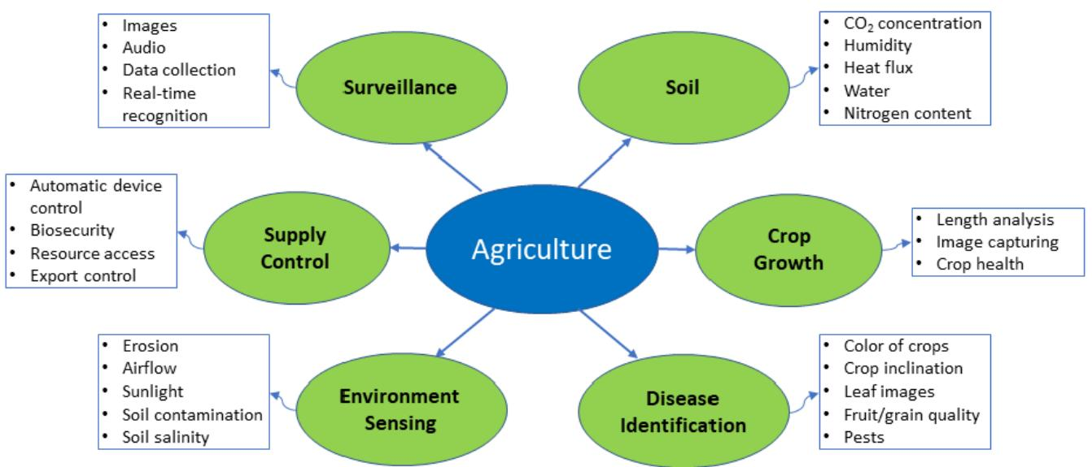
Figure 3. Intelligent Sensing in Agriculture.
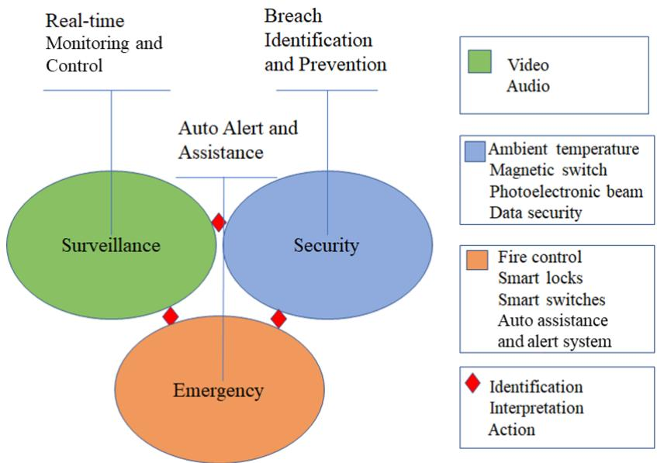
Figure 4. Intelligent Sensing in Intruder Detection and Surveillance.
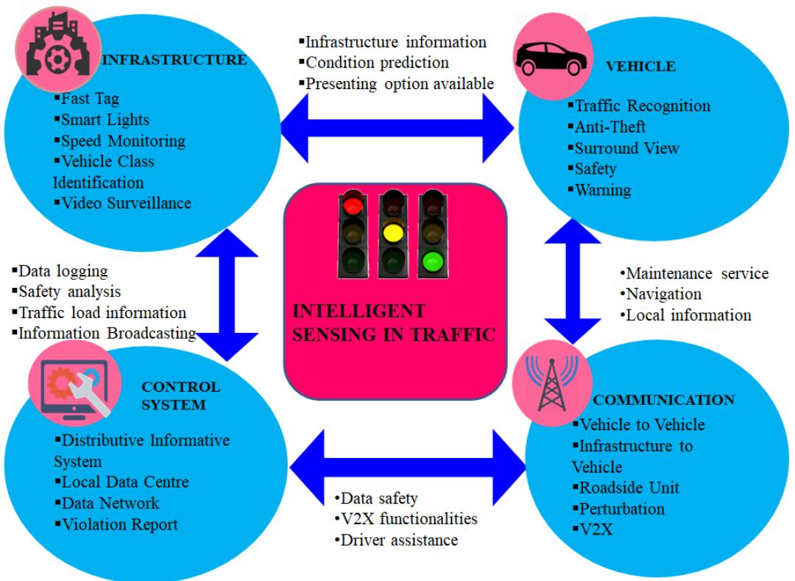
Figure 5. Intelligent Sensing in Traffic Management.
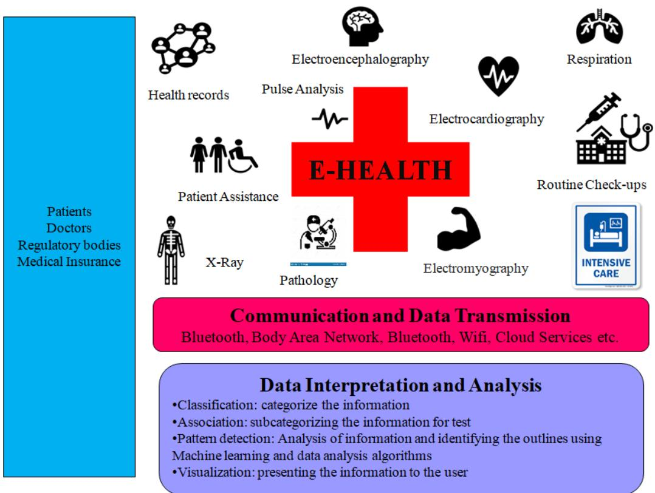
Figure 6. Intelligent Sensing in Healthcare Management.
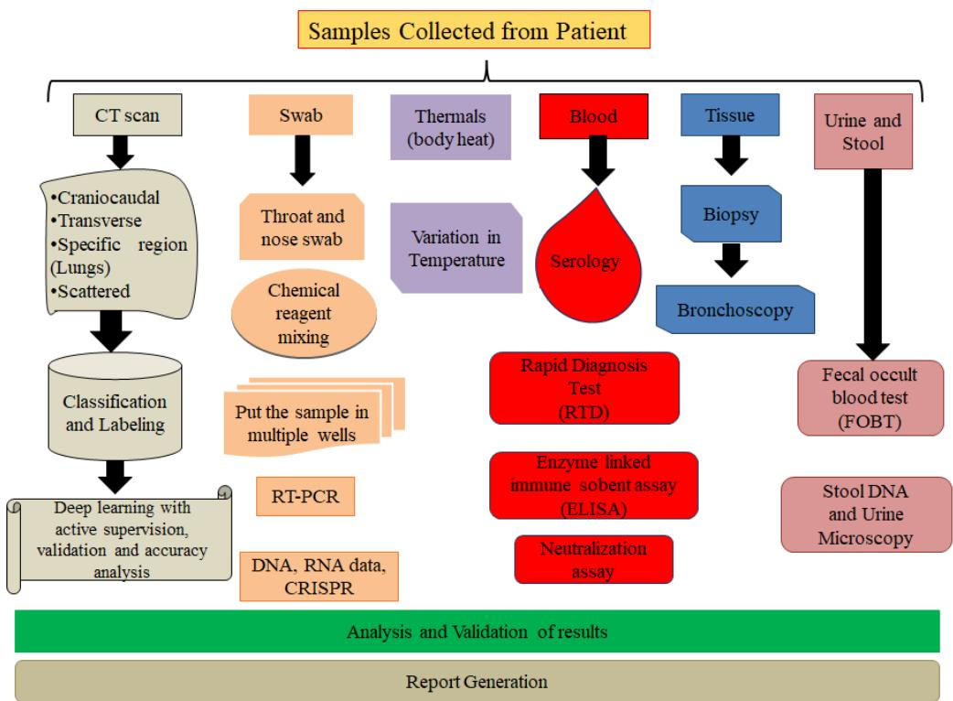
Figure 7. Intelligent Sensing in Pandemic Monitoring.
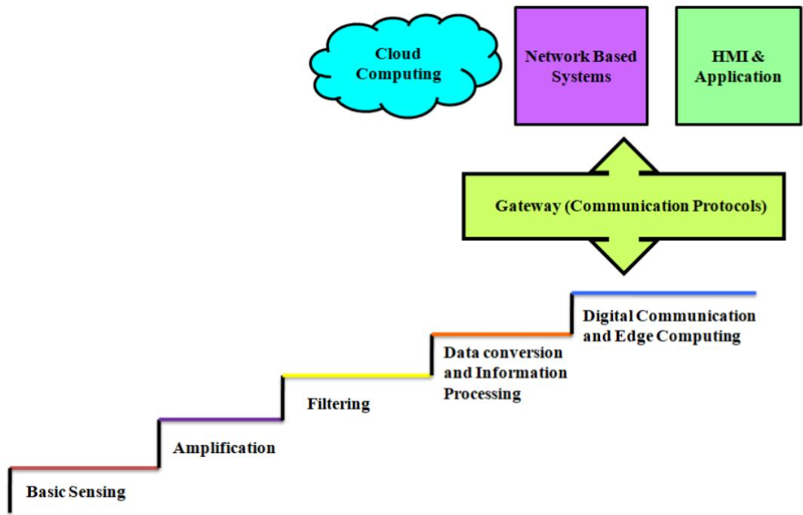
Figure 8. Intelligent Sensing in Communication Networks.
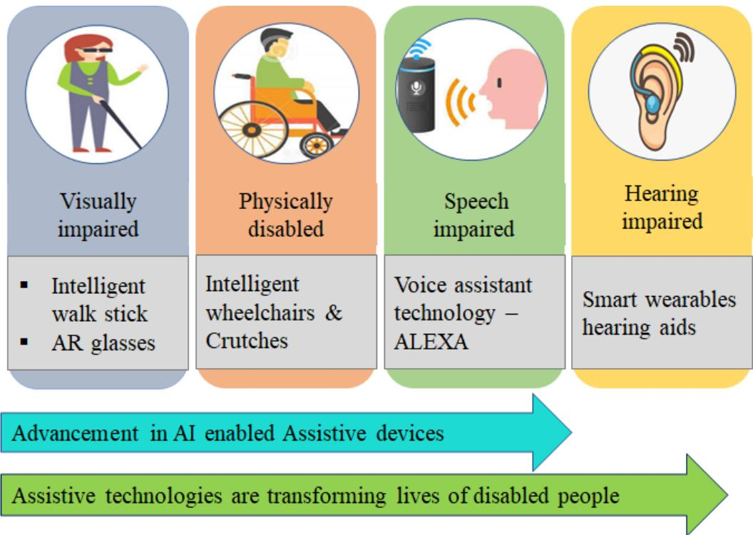
Figure 9. Intelligent Sensing for Visually Impaired.

4.2. Lessons Learned
In this section, we have identified a few ML- based foundational services in a broad range of intelligent sensing applications. We discussed how ML has been used to facilitate these services. The major contributions of this section are the coverage of the applications of intelligent sensing, which are gaining tremendous attention.
ML is a revolutionary technology which attracts every other technology through its algorithms and impressive results. Agriculture represents one sector of the future of computing and communications. Intelligent sensing applied to this domain fulfills the needs of the farmers and the population by efficiently utilizing limited resources. Smart agriculture involves the incorporation of information technology into the traditional methods of farming. When dealing with smart farming or agriculture, factors like population movement, weather conditions, and demographics play a significant role. There are other parameters that are important in the field of agriculture. These may include surveillance in agriculture, supply control, environment sensing, length analysis of crop growth, disease identification, soil parameters, etc. Intruder detection and surveillance are very important and have attracted a great deal of attention. Nowadays, nearly every shop, home, or office needs a surveillance system for intrusion detection. Signature matching algorithms are the most effective method in intrusion detection systems for detecting malicious activities. Multilayer perceptron, Bayesian and J48 algorithms are common experimental techniques in anomaly detection. Image and video recognition plays a vital role in adapting IVSS (intelligent video surveillance system). The authors observed that sensors would greatly help in improving existing systems.
Healthcare has become a high priority after the pandemic became rampant globally in 2020. AI and ML are widely used in smartizing healthcare systems. As mass spreading disease is not rare nowadays but instead has become normal, fast and reliable information helps to stop the infection to general public. Recently, CNN has been successfully adapted for healthcare and is used to classify X- ray images to diagnose heart diseases and ocular images, thereby helping in the diagnosis of cataract disease. Intelligent sensing is widely used to monitor the various parameters of the patients remotely, like pulse analysis, routine checkups, etc. Real- time PCR for diagnosing test results is also a CRISPR- based strategy and is effective for dealing with COVID- 19. Hybrid approaches such as IS with ML, edge
computing, and cloud services are also gaining attention of several corporations in this area. AI has been applied to road traffic control. However, intelligent sensing has been so improved in this domain that most of the work is done by sensors. For example, a vehicle may have an intelligent system installed inside it to help avoid accidents and recognize traffic. Some vehicles have installed cameras to monitor the surrounding. For the infrastructure part, there are speed monitoring systems with video surveillance installed at traffic signal poles or toll stations on highways to avoid road accidents. AI and ML combined proved to be successful in assistive technology. ML algorithms have improved speech intelligibility for both speech and hearing impaired people. Intelligent sensing also affects communication networks positively to make them smarter and more reliable. The omnipresent sensor network will play a very important role as one of the features of intelligence sensing. The sensor nodes will be easily traced remotely. Intelligent sensing with ML algorithms has been widely used to improve the intelligence of sensors.

5. Challenges and Future Research Directions
With the advancement of sensor technology, research has been carried out to extract useful information in various domains [166]. The adoption of AI in smart sensing has advantages associated with forecast based maintenance, adaptable manufacturing, and improvised productivity [167]. In this section, we review numerous challenges associated with particular applications and AI approaches and also briefly discuss possible future research directions.

5.1. Challenges
- Data Security and Privacy: Despite the success of AI and ML models, they face the major challenging issue of data security. ML models extract features by learning patterns that contain information, which can be vulnerable to real-world attacks [168]. One of the legitimate concerns in any real-time environment is data integrity and also it affects the quality of datasets and overall performance of the system. For example, the UAV-enabled intelligent transport system in a smart city where information about vehicle location and speed can be leaked by malicious entities [169,170]. The sensors must gather and share only essential information that is required to execute any operation. Standard rules and procedures must be applied to maintain data integrity. The presentation of information has to go through several stages in machines. Most of the machines are connected, resource-constrained devices and also available as standalone computational units. The first step in intelligent sensing is to gather the collected data from the sensors, which are then merged with information sources to identify and process accordingly. If information can be analyzed locally, further steps need to be taken. However, in most of the devices, the next step is to transfer the information to database storage or cloud services. Such a collection of information is then processed for data analysis and presentation through queries specific to user requirements. In the process from data collection to presentation, several types of security threats need to be taken care of. As illustrated in Figure 10, the process of intelligent sensing consists of multiple stages from sensing to data analysis and security needs to be handled in each of the stages.
- Data Storage and Management: The storage of an enormous amount of data in the form of audio, video, images, smart device data, and social media has become the main hurdle for several applications that need to be addressed. Mismanagement of data will make it difficult to analyze the quality of data collected by sensors and further affect the decision-making process [171]. The availability of a large amount of data motivates us to accept the ML and AI methods to enhance the overall performance of the sensor-based system. Therefore, to avoid redundancy, more advanced AI algorithms will be needed to extract meaningful data.
- Power Consumption: Nowadays, the use of wearable flexible sensors has gained significant attention in medical applications [172-174]. These sensors are placed in
contact with the clothes worn by a person to measure physiological parameters like temperature, ECG, EMG, muscle activity, and cardiovascular problems. The power consumption of these devices is an important issue that needs attention. In addition to this, the production cost of a flexible sensor is also a challenging issue that needs to be addressed [175]. Low power consumption sensors such as Shimmer and Telos should be used for monitoring the health to reduce the power consumption of wearable flexible sensors.
- Hardware Deployment: Despite the benefits of AI, designing algorithms on hardware requires sufficient computing resources, power consumption, high computational complexity, which is a very challenging task [176]. Hence, the collaboration between AI and hardware components needs serious efforts to enhance intelligent communication. The large memory footprint of the trained model and the enormous amount of sensor data affect the training accuracy and computational speed on hardware. Moreover, due to lack of specific libraries for hardware, the trained model is not properly deployed from a specific framework to low-power devices (i.e., edge or mobile) and FPGAs. These may delay the product delivery for a couple of weeks. Many researchers are focusing on reducing the complexity of AI and ML algorithms from hardware perspective and thus enhance the overall performance of the real-time inference model to make it memory-efficient [177,178].
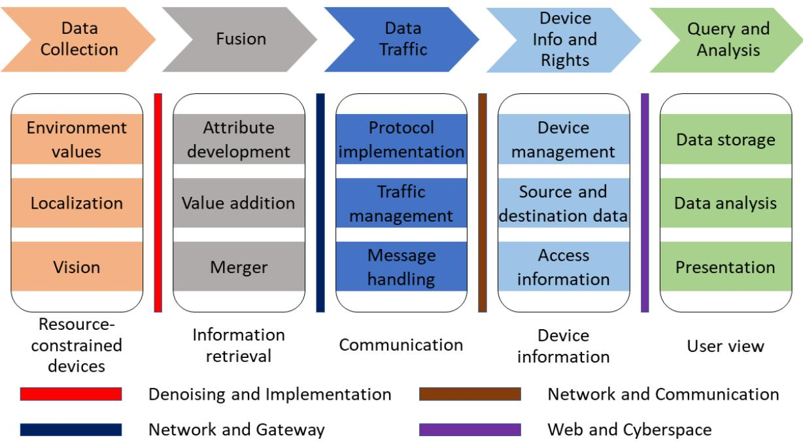
Figure 10. Layer-wise Security Challenges.

5.2. Future Directions
- Data Fusion: Recently, data fusion techniques are gaining a lot of attention in different aspects. Data fusion with big data is an area that ensures the aggregation of data that are generated either independently or collectively. It facilitates improvement in decision making through value extraction. The result of this data fusion can be further manipulated, analyzed, and stored. Data fusion in IoT [32] is more efficient in integrating, managing, storing, and manipulating the large amount of data. Data processing in IoT leads to the addition of more data by extracting meaningful information. Thus, data fusion can help to reduce the volume of that data. Emerging technologies like M2MC (machine to machine communication) allow data fusion to be performed at the edge [107]. M2MC has the ability to communicate over a dedicated medium, for
example, the internet, to enable information flow in an intelligent way through smart devices for smart homes, cities, and businesses.
- Industry 4.0: Smartization of manufacturing industries has been perceived as Industry 4.0 (fourth industrial revolution), a paradigm shift made possible by the development of new information and communication technologies (ICT) [179]. Industry 4.0 is a new industrial model that displays how production trails and deviates over time. The emerging technology means the digital factory in which intelligent devices are inter-networked with semi-finished products, raw materials, robots, machines, and workers. Industry 4.0 is characterized by the use of resources and the incorporation of customers and business partners in the business process [180]. The technologies of the future will be founded on the availability of data. Moreover, those data are becoming available in profusion thanks to Industry 4.0 that is transforming the industry digitally. Digital resources like Siemens’ Digital Enterprise portfolio are affecting every phase of industrial production, from the design of a product to its production to its use. Future technologies make it possible to analyze and exploit these data pools in completely new ways. This development will necessitate the use of technology and knowledge developed in numerous other domains. Autonomous systems need to gain trust between humans and machines [181]. The IoT vision is rooted in the belief that the advancement in communications, information technology and microelectronics we have observed in recent years will be continued into the future. Due to their small sizes, decreasing energy consumption, and falling prices, communications modules, processors, and other electronic equipment are being progressively integrated into everyday objects. At present, cities are remotely monitored and data are collected intelligently through multiple sensors embedded in surveillance systems. Fifth-generation (5G) cellular wireless can connect numerous smart objects at the same time thanks to its capacity and high speed [182].
- Industry 5.0: After Industry 4.0, intelligent sensing is discovering new heights with more strategic growth in industrial automation and control. The origin of Industry 5.0 was presented in [183]. The inclusion of ecosystem for safe operation and accelerating innovation are core features of Industry 5.0. The communication technology used in Industry 5.0 is similar to Industry 4.0, but the emphasis is on collecting more dark data from the core components of the plant or manufacturing units to enable intelligence on it. Society 5.0 is an outcome of industrial advancements which assist human and machines in making intelligent decisions [184]. Industry 5.0 includes the implementation of IoT, Big data, Artificial Intelligence, and communication technology for the digitalization of work environments. The work presented in [185] shares details about the infrastructure involved in the development of Industry 5.0 work environment and its effects on business and industries with the involvement of information technology. The work presented in [186] shows the performance of Byzantine-tolerant machine learning algorithms in Industry 5.0 with the involvement of edge computing technology. The goal of Industry 5.0 is to empower rather than replace workers. Moreover, applications of Industry 5.0 extend well beyond industrial production. For instance, Industry 5.0 can provide customized therapy and treatment to COVID-19 patients if detailed information about the patient is available [187]. Industry 5.0-based UAV secure communication using AI was presented in [188]. The work suggests mass customization and inclusion of cyber-physical systems in this area. In view of the development, Industry 5.0 will open up ample opportunities for future research.
- Explainable AI (XAI): One of the prominent future advancements is explainable AI that resolves the complexity issues of the models and enables users to understand how the models reach specific decisions and recommendations [189]. Also, users will know how the workflow of AI models leads to different conclusions for different cases and the strengths/weaknesses of the models. Black box models like ANN and RF are difficult to understand and implement due to their complexity. Therefore,
an explanation interface such as data visualization and scenario analysis has been built which presents more explanation towards models and helps humans to easily understand the relationship between input and predictions. Companies providing XAI which presents different interfaces for the explanation of complicated AI models include Google Cloud Platform, Flowcast, and Fiddler Labs [190].
- Extended Reality and AI: One of the AI-enabled future technology is the extended reality (XR) combined with all forms of real and virtual environments including augmented reality (AR), virtual reality (VR), and mixed reality (MR). XR is an immersive technology that creates training data synthetically for DNN. Moreover, it creates virtual environments [191]. XR environments include cameras, virtual machinery, sensors, human avatars, and control software, and provide much richer contents compared to virtual reality. XR and AI unlock many opportunities in various domains [192], such as mobile XR, which uses a combination of smartphones, AR glasses, and mobile VR headsets. XR solutions are also used in industries and educational institutions to offer innovative and safe training to employees based on the data collected by tracking the movement of humans and machines [193]. The healthcare industry leverages XR in medical procedures to improve surgical imaging [194]. Areas where XR solutions can be applied still need to be explored. These include 5G communication networks, public services, real estate, defense, and military applications.
- Convergence of AI and 6G: The future 6G with AI and ML methods will optimize network performance, support diverse services, and build seamless connectivity. Many researchers have started focusing on 6G with the vision of transmission over THz and mmWave and integrating communication, sensing, and control functionalities toward building a sustainable ecosystem. Studies have shown that 6G integrated with UAV-enabled networks leads to frequent handovers [38]. One of the powerful AI techniques named DRL, which is a combination of DL and RL, is capable of taking on the decision-making tasks [195] and can be adapted to provide efficient handovers, intelligent mobility, and reliable wireless connectivity. Moreover, in some complex networks, fuzzy Q-learning and LSTM-based AI techniques can be used to avoid connectivity or handover failures and enable mobility management [196].
- Channel Coding: Intelligent communication techniques extract the meaning of the information [197]. This can fulfill two purposes. One is to reduce the amount of data transmitted, and the other is to protect the information from channel distortion and noise using error control coding. Network Coding (NC) has been suggested as a promising technique for improving vehicular wireless network throughput by reducing packet loss in transmission. In [198], an adaptive network coding method is proposed with the use of the Hidden Markov Model (HMM) in the network coding scheme to regulate the rate of coding according to the estimated packet loss rate. In the near future, research work combining multipath transmission with hierarchical edge computing in the high-speed cellular-based vehicular network will be a more focused field.
Recently, Q- learning (QL), which is an ML algorithm, has shown very promising results in learning problems in energy and computation- constrained sensor devices. The intelligent collision probability inference algorithm based on Q- Learning model was proposed in [199]. It is used to optimize the performance of sensor nodes by utilizing channel collision probability and network layer ranking states with the help of an accumulated reward function. Future IoT networks will have an assortment of stimulating features that optimize network performance and communication efficiency. ML techniques allowing machine intelligence to be incorporated in IoT communication technologies are attracting much attention [200]. The MAC layer and network layer capabilities of future IoT networks can be enhanced with ML- based algorithms [199]. 8. Latency Minimization: Latency minimization is a crucial factor in the deployment of real- time applications on energy- constrained platforms such as mobile devices. In the design of AI and computer vision algorithms, latency is considered the primary
requirement for resource- intensive tasks. Researchers are exploring ways based on ML and DL methods for reducing latency and energy consumption for future 5G networks [201,202]. Some of the critical issues in intelligent 5G communication technologies include scheduling medium access control (MAC) layer resources among sensor devices, storing a large amount of data generated at the network edges, and assigning virtual network functions (vNFs) to the hosting devices. These issues can be resolved by reducing the demand on network bandwidth, latency and improving QoS. These 5G networks are capable of implementing critical tasks such as autonomous driving, remote drone control, and real- time AI on handheld devices according to their latency requirements [203].
- Future Citizenship: Due to the government initiative around the world on digitization of identity and social information documents, the resources are accessible to their citizens through various secure online portals. The citizens no longer need to stand in queues to access the resources as all information is available online. In daily life, technology is also involved in the form of smart clothing, smart homes, disease prevention, medicine, etc. It can be said that smart citizenship is the demand of the smart world. Intelligent sensing is all around the technology used by smart citizens. Work presented in [42] discusses contributions of information provided by the local community. One major benefit of such information is to strengthen the quality of government decision making. In the future, citizens will generate valuable data through intelligent sensing on mobile platforms. Thus, the challenges related to theft prevention, forgery, and right to access the information are even more critical for future citizens.
- Software Platforms in Intelligent Sensing: The platform on which algorithms can be executed in an intelligent sensing environment requires multiple software applications. The three key steps in the development of such systems are (a) hardware level integration, (b) middleware for feature enhancement, and (c) front end development. For all the three steps, multiple types of software are available which can be integrated with each other to create a single framework. The challenge in this domain is to find one single platform to perform all three steps. Usually the selection of intelligent sensing platforms is based on the familiarity of the developer with the development platform. It has been observed that manufacturers provide the development platforms but limit the use to certain levels. For example, the integration of middleware in a specific development environment depends on the compatibility of dependent libraries and the programming language. Due to such constraints, developers face challenges related to software integration and debugging. Figure 11 shows a brief overview of how intelligent sensing is applied in various domains and also lists several future research directions in intelligent sensing.
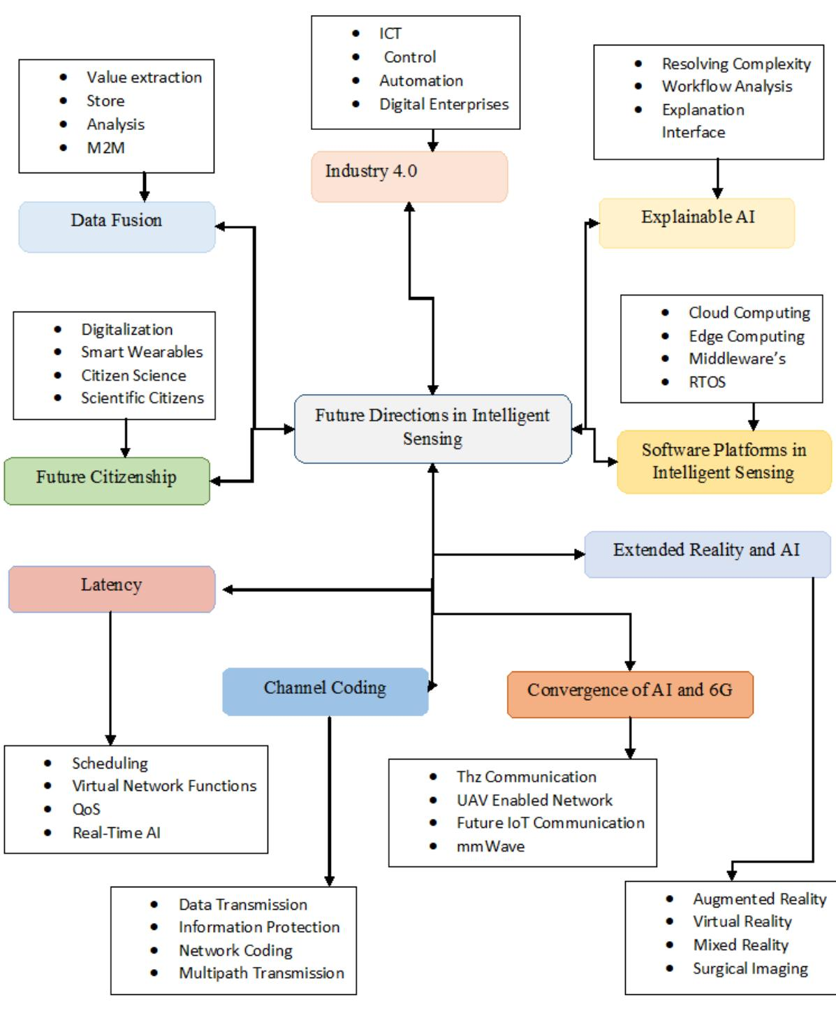
Figure 11. Future Directions.

6. Noteworthy Projects Based on Intelligent Sensing
This section presents some noteworthy research projects and initiatives around the world that are contributing to the field of intelligent sensing. We attempt to cover recent technologies that can also be helpful in the future. The projects and their technical details are presented in Tables 6. These projects belong to a variety of fields, including autonomous underwater vehicles (AUV), 6G, Industry 4.0, smart irrigation, smart farming, smart cities, smart healthcare, and smart home. The technologies used in these projects are the most recent ones such as ML, computer vision, DL, MIMO, mmWave, ultra massive MIMO, fog computing, cloud computing, artificial intelligence, IoT, wireless communication, etc. The projects spread across the world and touch on many facets of intelligent sensing. Some of the projects are supported by government agencies, some are sponsored by enterprises,
and others are pursued by academic institutions. These projects attest to the vigorous development in intelligent sensing.
Table 6. Some Noteworthy Projects in Intelligent Sensing.
Projects | Funding Firms/agencies | Technology Used in the Project | Ann of the Project
MELOA [204] | The European Union's Horizon 2020 Research and Innovation Programme | Autonomous underwater technology, GPRS, satellite communications, and solar panels. | This project design the WAVY drifter units for ocean observing and monitoring systems.
AMOGH [205] | National Institute of Ocean Technology and IT Madras, India | Artificial intelligence, underwater navigation and imaging. | It possesses intelligence for picking /placing underwater objects and processing audio signals.
Autonomous Underwater Vehicle (AUV) | CSIR-CMR, India | Autonomous underwater technology. | The vehicle is used for underwater operations like deep-sea mining, exploration, collection of various scientific data like habitat information of underwater biomass to oceanographic and bathymetric data.
SSB PANEL (Sonar Signal Behavior Panel) [206] | Defense Research Development, Organization (DRDO), India | Deep Learning, machine learning, and computer vision. | Classification of sonar signals using deep convolutional neural networks.
Beamforming using Al for 6G Net-Beamforming using | Viavi Solutions, London Brunel University, London, UK | Artificial intelligence, massive MIMO and mmWave systems. | Intelligent beamforming (IB) scheme is proposed to drive 6G.
Intelligent Environments for Wire-less Communication for 6G [208] | Broadband Wireless Networking Lab, Georgia Institute of Technology | Millimeter-wave, terahertz band communications, ultra-massive MIMO. | This project deals with the 6G wireless communications as intelligent communication environment to improve the communication distance and data rates in mmWave and THz frequency band.
6Genesis— the 6G- Enabled Wireless Smart Society and Ecosystem [209] | University of Oulu, Finland | Artificial intelligence, wireless connectivity and distributed intelligent computing, 5G/6G radio access network (RAN). | The goal of this project is to explore the development of 6G standard and the implementation of the 5G mobile communication technology.
SMEs(Smart Manufacturing) and Logistics for SMEs in an X-to-order and Mass Customization Environment [210] | European Union's Horizon 2020 R&amp;I Programme under the Marie Sklodowska-Curie | Smart logistics, smart manufacturing in Industry 4.0. | This project focuses on identifying the need and enablers for Industry 4.0 applications and implementation, also fostering SME-specific concepts and strategies in SME manufacturing and Logistics.
SmartFactory: Cold 4.0 project [211] | Gestamp, France | Smart factory, Industry 4.0 data analytics, Chassis quality Project. | This project envisions creating more efficient and flexible manufacturing plants and more consistent processes through the analysis of data, by adding intelligence to the processes.
MF2C Project [212] | European Union's Horizon 2020 research and innovation programme | Fog computing, cloud computing. | The main goal of this project is to address the need for an open and cost-effective managing of fog and cloud computing systems.
WATERBEE DA (WaterBee Smart Irrigation Systems Demonstration Ac- tion) [213] | European Union's Horizon 2020 research and innovation programme | Smart irrigation, intelligent irrigation modeling, soil sensor technology, Web and smartphone user interface, operational sensors. | Project targeted at demonstrating and evaluating a smart irrigation and water management system. It exploits recent advances in wireless networking and environmental sensors.
KisanRaja-Smart Irrigation Device [214] | Ministry of Micro, Small and Medium Enterprises (MSME), Government of India | IoT, data analytics, AI, ML, mobile pump cont-rollers, wireless valve cont-rollers, wireless sensors, and satellite data. | This project allows for the technique used by a farmer to interact with motors. This project allows a farmer to manage the agricultural operator using his mobile or landline from the comfort of his home. IoT13 operator using his mobile as starting from project for such urban areas.
Smart Cities Mission Building a Smart India [216] | Indian Government, India | Internet of Things (IoT), Information and Communication Technology (ICT), Big data, 5G Connectivity, sensor technology, Geospatial technology, Robotics. | On have all core infrastructure required for citizens to have a civilized life and a sustainable environment. These features comprise guaranteed power and electricity supplies, proper sanitation, public transport, sufficient healthcare, education facilities and affordable housing for economically weak sections of society. Beyond these, such cities must also offer robust information technology connectivity, which improves local government.
Ambulatory Sensing and Point-Of-Care Recommendation for IoT-based Healthcare [217] | Kalam Technology National fellowship (INAE), India | Cloud computing, fog computing. | This project focuses on the efficient decision delivery based on the real-time monitoring of the conditions such as patient health, road condition. Based on these decisions, the system finds a nearest hospital through a user route.
Safe: Secure And Usable IoT Ecosystem [217] | UGC-UKIERI, India | IoT, Raspberry Pi, sensor technology. | This project explores the impact of IoT in intelligent ecosystem from a perception of end-to-end security and context-aware intelligent data access.
i-Plug Control [218] | DoQuick services pvt.ltd, India | Based on Smart home technologies, intelligent sensors, automatic speech recognition, mobile development, artificial intelligence machine learning. | This project focuses on the smart home technology, which helps you to control everything at your fingertips. From turn on/off lights, you must adjust the room temperature from the tap of a Smartphone.
Hyperspectral Microscopy [219] | National Institute of Standards and Technology, USA | Optical technology, photometry, laser metrology. | This project aims at measuring the optical properties of materials through the use of commercial and custom hyper spectral images.
Ocean Color [220] | The National Institute of Standards and Technology, USA | Marine science, Optical physics and Calibration ser-vices. | Ocean color radiometry provides essential data of phytoplankton concentrations and dissolved organic matters, which allows analysis of primary and microbial carbon cycling, and the influence of both on the global climate.
Advanced Dimensional Measure-ment Systems [221] | The National Institute of Standards and Technology, USA | Dimensional metrology, Calibration services and Doc-umentary standards. | ADOMS furnishes the infrastructure needed for the adoption of new measurement technology.
Project N [222] | Shanghai-based Paleo Group Co., Shanghai, China | Wireless communication, Artificial intelligence, Au-tomation. | Smart Cars: It is a project of electric vehicles that have range extender a taxi gasoline motor that charges the battery. The car offers traffic forecused, and styles to the driver's social networks.
Smart Cities, Australia [223] | Australian Government, Australia | IoT Technologies, Artificial intelligence, sensor tech-nology, intelligent asset management. | Smart cities leverage innovative technologies to enhance quality and performance of services, reduce cost and consumption of resources, and engage inhabitants more effectively and actively.

7. Conclusions
The continuous growth in intelligent sensing raises challenges related to the integration, communication, safety, and adaptation of algorithms in different stages and applications. This paper has presented a survey of AI- enabled intelligent sensing and its technology requirements, opportunities, and future directions. In the beginning, we pointed out the AI technology in intelligent sensing. Then we summarized the contributions of the work, highlighting key areas in intelligent sensing. We have reviewed various learning models with comparative analysis. Parameters that affect the performance of
intelligent sensing are discussed based on the results of recent research. Then available datasets for use in intelligent sensing are presented to help the research community explore further. They represent a broad spectrum of datasets that have been used fruitfully in AI and intelligent sensing research. Advantages and limitations, format of information, and elucidations are provided. Next, we have presented the review of practical applications, including intelligent sensing in healthcare, pandemic monitoring, assistive technology, smart sensor networks, among others. The list is by no means exhaustive but instead serves to exemplify the ample applications of intelligent sensing. In addition, we have elaborated on the challenges and future research directions in intelligent sensing, pointing out challenges related to data security and privacy, data storage, power consumption, and hardware deployment. It is observed that intelligent sensing will grow more rapidly with communication technology and edge computing. Therefore, its involvement in data fusion, Industry 4.0, Industry 5.0, explainable AI, latency minimization, future citizenship, extended reality, convergence of AI and 6G, and software platforms in intelligent sensing is discussed in future research directions. Finally, we have presented noteworthy projects in intelligent sensing, mentioning project names, sources, technology used, and aims of the projects. These projects are dispersed in many countries and represent the use of intelligent sensing in diverse areas globally. We believe this work will help researchers get a deeper understanding of the different aspects of AI- enabled intelligent sensing.
Author Contributions: Conceptualization, A.S.; methodology, A.S.; writing—original draft preparation, A.S., V.S., M.J., H.- C.W., D.N.K.J. and C.M.W.B.; writing—review and editing, A.S., H.- C.W., D.N.K.J. and C.M.W.B.; funding acquisition, A.S., H.- C.W., D.N.K.J. and A.M. All authors have read and agreed to the published version of the manuscript.
Funding: This work was funded, in part, by the Fundação para a Ciência e a Tecnologia, Portugal under Grant No. UIDB/04111/2020 (COPELABS), by the Ministry of Science and Technology, Taiwan, and Rebit Digital, grant number MOST 110- 2622- E- 197- 001, by the International Cooperation project of the Sri Lanka Technological Campus, Sri Lanka, No. RkSG/19/5008, and Department of Science and Technology (DST), India under project name Sign Language to Regional Language Converter (SLRLO) with project number SEED/TIDE/063/2016.
Conflicts of Interest: The authors declare no conflict of interest.

Abbreviations
The following abbreviations are used in this manuscript:
Acronym Definition 5G Fifth- Generation (Mobile Telecommunications Technology) 6G Sixth- Generation (Mobile Telecommunications Technology) ADMS Advanced Dimensional Measurement System AHP Analytic Hierarchy Process AI Artificial Intelligence AM Additive Manufacturing ANN Artificial Neural Network AR Augmented Reality or Activity Recognition AUV Autonomous Underwater Vehicle BMI Body Mass Index BSI Blind System Identification CC Common Criteria CKD Chronic Kidney Disease CNN Convolutional Neural Networks CoAP Constrained Application Protocol CogMAC Cognitive Medium Access Control COVID- 19 Coronavirus Diseases- 2019 CRISPR Clustered Regularly Interspaced Short and Palindromic Repeats DL Deep Learning DNP3 Distributed Network Protocol 3 ECG Electrocardiogram EDA Electrodermal Activity EL Ensemble Learning
EMG Electromyography ENN Ensemble Neural Network ET Evapotranspiration FAME Fatty Acid Methyl Esters FID Fréchet Inception Distance FW Feature Weights GA Genetic Algorithm GAN Generative Adversarial Network GMM Gaussian Mixture Model GPRS General Packet Radio Service HMM Hidden Markov Model IB Intelligent Beamforming ICT Information and Communication Technology IoT Internet of Things ITS Intelligent Transport System IVSS Intelligent Video Surveillance System KDD Knowledge Discovery and Data Mining K- NN K- Nearest Neighbors LAN Local Area Network LDA Latent Dirichlet Allocation LIDAR Light Detection and Ranging LR Linear Regression LSTM Long Short Term Memory M2MC Machine to Machine Communication MAS Multi- Agent System MFCC Mel- Frequency Cepstral Coefficients MIMO Multiple Input Multiple Output ML Machine Learning MO- PSO Multi- Objective Particle Swarm Optimization MQTT Message Queuing Telemetry Transport MR Mixed Reality NFV Network Function Virtualization NLP Natural Language Processing NMF Non- negative Matrix Factorization NN Neural Network PCA Principal Component Analysis PLSA Probabilistic Latent Semantic Analysis QL Q- Learning QoS Quality of Service RAN Radio Access Network RF Random Forest RFID Radio Frequency Identification RL Reinforcement Learning RNN Recurrent Neural Network SARS- CoV- 2 Severe Acute Respiratory Syndrome Coronavirus 2 SCADA Supervisory Control and Data Acquisition SDAE Stacked Denoising Auto Encoders SDN Software Defined Networking SME Small to Mid- size Enterprise SVM Support Vector Machine UUV Unmanned Underwater Vehicle VR Virtual Reality WSN Wireless Sensor Network XAI Explainable AI XR Extended Reality

References
- Corsi, C. Smart sensors: Why and when the origin was and why and where the future will be. Proc. SPIE 2014, 8993, 899302. [CrossRef]
- Von Krogh, G. Artificial intelligence in organizations: New opportunities for phenomenon-based theorizing. Acad. Manag. Discov. 2018. [CrossRef]
- Kobbacy, K.A.H.; Vadera, S.; Rasmy, M.H. AI and OR in management of operations: history and trends. J. Oper. Res. Soc. 2007, 58, 10–28. [CrossRef]
- Shabbir, J.; Anwer, T. Artificial intelligence and its role in near future. arXiv 2018. arXiv:1804.01396.
- Nichols, J.A.; Chan, H.W.H.; Baker, M.A.B. Machine learning: applications of artificial intelligence to imaging and diagnosis. Biophys. Rev. 2018, 11, 111–118. [CrossRef]
- Abduljabbar, R.; Dia, H.; Liyanage, S.; Bagloee, S.A. Applications of artificial intelligence in transport: An overview. Sustainability 2019, 11, 189. [CrossRef]
- Al-Sahaf, H.; Bi, Y.; Chen, Q.; Lensen, A.; Mei, Y.; Sun, Y.; Tran, B.; Xue, B.; Zhang, M. A survey on evolutionary machine learning. J. R. Soc. N. Z 2019, 49, 205–228. [CrossRef]8. Avola, D.; Foresti, G.L.; Piciarelli, C.; Vernier, M.; Cinque, L. Mobile applications for automatic object recognition. In Advanced Methodologies and Technologies in Network Architecture, Mobile Computing, and Data Analytics; IGI Global: Hershey, PA, USA, 2019; pp. 1008–1020. [CrossRef]9. Aloufi, S.; Zhu, S.; El Saddik, A. On the Prediction of Flickr Image Popularity by Analyzing Heterogeneous Social Sensory Data. Sensors 2017, 17, 631. [CrossRef]10. Bahri, S.; Zoghlami, N.; Abed, M.; Tavares, J.M.R.S. Big data for healthcare: a survey. IEEE Access 2019, 7, 7397–7408. [CrossRef]11. Liakos, K.; Busato, P.; Moshou, D.; Pearson, S.; Bochtis, D. Machine learning in agriculture: A review. Sensors 2018, 18, 2674. [CrossRef]12. Mohammadi, V.; Minaei, S. Artificial intelligence in the production process. In Engineering Tools in the Beverage Industry; Elsevier: Amsterdam, The Netherlands, 2019; pp. 27–63.13. Woschank, M.; Rauch, E.; Zsifkovits, H. A review of further directions for artificial intelligence, machine learning, and deep learning in smart logistics. Sustainability 2020, 12, 3760. [CrossRef]14. Zhong, S.; Zhang, K.; Bagheri, M.; Burken, J.G.; Gu, A.; Li, B.; Ma, X.; Marrone, B.L.; Ren, Z.J.; Schrier, J. Machine learning: new ideas and tools in environmental science and engineering. Environ. Sci. Technol. 2021, 55, 12741–12754. [CrossRef] [PubMed]15. Chang, F.C.; Huang, H.C. A survey on intelligent sensor network and its applications. J. Netw. Intell. 2016, 1, 1–15.16. Li, B.; Hou, B.; Yu, W.; Lu, X.; Yang, C. Applications of artificial intelligence in intelligent manufacturing: A review. Front. Inf. Technol. Electron. Eng. 2017, 18, 86–96. [CrossRef]17. Ali, J.M.; Hussain, M.A.; Tade, M.O.; Zhang, J. Artificial intelligence techniques applied as estimator in chemical process systems—A literature survey. Expert Syst. Appl. 2015, 42, 5915–5931.18. Tong, W.; Hussain, A.; Bo, W.X.; Maharjan, S. Artificial intelligence for vehicle-to-everything: a survey. IEEE Access 2019, 7, 10823–10843. [CrossRef]19. Chen, Z.; Chen, Z.; Song, Z.; Ye, W.; Fan, Z. Smart gas sensor arrays powered by artificial intelligence. J. Semicond. 2019, 40, 111601. [CrossRef]20. Kumar, A.; Gupta, P.K.; Srivastava, A. A review of modern technologies for tackling COVID-19 pandemic. Diabetes Metab. Syndr. Clin. Res. Rev. 2020, 14, 569–573. [CrossRef]21. Maghded, H.S.; Ghafoor, K.; Sadiq, A.; Curran, K.; Rawat, D.B.; Rabie, K. A Novel AI-enabled Framework to Diagnose Coronavirus COVID-19 using Smartphone Embedded Sensors: Design Study. In Proceedings of the IEEE 21st International Conference on Information Reuse and Integration for Data Science (IRI), Las Vegas, NV, USA, 11–13 August 2020; pp. 180–187. [CrossRef]22. Qadri, Y.A.; Nauman, A.; Zikria, Y.B.; Vasilakos, A.V.; Kim, S.W. The Future of Healthcare Internet of Things: A Survey of Emerging Technologies. IEEE Commun. Surv. Tutor. 2020, 22, 1121–1167. [CrossRef]23. Qiu, J.; Wu, Q.; Ding, G.; Xu, Y.; Feng, S. A survey of machine learning for big data processing. EURASIP J. Adv. Signal Process. 2016, 2016, 1.24. Kumar, D.P.; Amgoth, T.; Annavarapu, C.S.R. Machine learning algorithms for wireless sensor networks: A survey. Inf. Fusion 2019, 49, 1–25. [CrossRef]25. Ramasamy Ramamurthy, S.; Roy, N. Recent trends in machine learning for human activity recognition—A survey. WIREs Data Min. Knowl. Discov. 2018, 8, e1254. [CrossRef]26. Ha, N.; Xu, K.; Ren, G.; Mitchell, A.; Ou, J.Z. Machine Learning-Enabled Smart Sensor Systems. Adv. Intell. Syst. 2020, 2, 2000063. [CrossRef]27. Namuduri, S.; Narayanan, B.N.; Davuluru, V.S.P.; Burton, L.; Bhansali, S. Review—Deep Learning Methods for Sensor Based Predictive Maintenance and Future Perspectives for Electrochemical Sensors. J. Electrochim. Soc. 2020, 167, 037552. [CrossRef]28. Mao, Q.; Hu, F.; Hao, Q. Deep Learning for Intelligent Wireless Networks: A Comprehensive Survey. IEEE Commun. Surv. Tutor. 2018, 20, 2595–2621. [CrossRef]29. Alsheikh, M.A.; Lin, S.; Niyato, D.; Tan, H.P. Machine learning in wireless sensor networks: Algorithms, strategies, and applications. IEEE Commun. Surv. Tutor. 2014, 16, 1996–2018. [CrossRef]30. Morais, C.M.D.; Sadok, D.; Kelner, J. An IoT sensor and scenario survey for data researchers. J. Braz. Comput. Soc. 2019, 25, 4. [CrossRef]31. Deng, X.; Jiang, Y.; Yang, L.T.; Lin, M.; Yi, L.; Wang, M. Data fusion based coverage optimization in heterogeneous sensor networks: A survey. Inf. Fusion 2019, 52, 90–105. [CrossRef]32. Ding, W.; Jing, X.; Yan, Z.; Yang, L.T. A survey on data fusion in internet of things: Towards secure and privacy-preserving fusion. Inf. Fusion 2019, 51, 129–144. [CrossRef]33. Zhang, R.; Nie, F.; Li, X.; Wei, X. Feature selection with multi-view data: A survey. Inf. Fusion 2019, 50, 158–167. [CrossRef]34. Meher, B.; Agrawal, S.; Panda, R.; Abraham, A. A survey on region based image fusion methods. Inf. Fusion 2019, 48, 119–132. [CrossRef]35. Jones, D.O.B.; Gates, A.R.; Huvenne, V.A.I.; Phillips, A.B.; Bett, B.J. Autonomous marine environmental monitoring: Application in decommissioned oil fields. Sci. Total Environ. 2019, 668, 835–853. [CrossRef] [PubMed]
- Villa, M.; Gofman, M.; Mitra, S. Survey of biometric techniques for automotive applications. In Information Technology-New Generations; Springer: New York, NY, USA, 2018; pp. 475-481.37. Liu, Y.; Li, Z.; Liu, H.; Kan, Z.; Xu, B. Bioinspired Embodiment for Intelligent Sensing and Dexterity in Fine Manipulation: A Survey. IEEE Trans. Ind. Inform. 2020, 16, 4308-4321. [CrossRef]38. Yang, H.; Alphones, A.; Xiong, Z.; Niyato, D.; Zhao, J.; Wu, K. Artificial-Intelligence-Enabled Intelligent 6G Networks. IEEE Netw. 2020, 34, 272-280. [CrossRef]39. Apogeweb. What is Intelligent Sensor and Its Applications. 2018. Available online: http://www.apogeweb.net/article/75.html (accessed on 6 January 2022).40. White, N. Intelligent sensors: systems or components? Integr. Vlsi. J. 2005, 3, 471-474.41. Powner, E.; Yalcinkaya, F. Intelligent sensors: structure and system. Sens. Rev. 1995, 15, 31-35. [CrossRef]42. O’Grady, M.J.; Muldoon, C.; Carr, D.; Wan, J.; Kroon, B.; O’Hare, G.M.P. Intelligent sensing for citizen science. Mobile Netw. Appl. 2016, 21, 375-385. [CrossRef]43. Chen, Z.; Fan, K.; Wang, S.; Duan, L.; Lin, W.; Kot, A.C. Toward Intelligent Sensing: Intermediate Deep Feature Compression. IEEE Trans. Image Process. 2020, 29, 2230-2243. [CrossRef]44. Shokri-Ghadikolaei, H.; Fallahi, R. Intelligent Sensing Matrix Setting in Cognitive Radio Networks. IEEE Commun. Lett. 2012, 16, 1824-1827. [CrossRef]45. Li, J.Q.; Yu, F.R.; Deng, G.; Luo, C.; Ming, Z.; Yan, Q. Industrial Internet: A Survey on the Enabling Technologies, Applications, and Challenges. IEEE Commun. Surv. Tutor. 2017, 19, 1504-1526. [CrossRef]46. Reebadiya, D.; Rathod, T.; Gupta, R.; Tanwar, S.; Kumar, N. Blockchain-based Secure and Intelligent Sensing Scheme for Autonomous Vehicles Activity Tracking Beyond 5G Networks. Peer-to-Peer Netw. Appl. 2021, 14, 2757-2774. [CrossRef]47. Putra, S.A.; Trilaksono, B.R.; Riyansyah, M.; Laila, D.S.; Harsoyo, A.; Kistijantoro, A.I. Intelligent Sensing in Multiagent-Based Wireless Sensor Network for Bridge Condition Monitoring System. IEEE Internet Things J. 2019, 6, 5397-5410. [CrossRef]48. Zhao, W.; Wu, J.; Shi, P.; Wang, H. Intelligent sensing and decision making in smart technologies. Int. J. Distrib. Sens. Netw. 2018, 14, 1550147718813754. [CrossRef]49. Duan, Y.; Zhang, L.; Fan, X.; Hou, Q.; Hou, X. Smart city oriented Ecological Sensitivity Assessment and Service Value Computing based on Intelligent sensing data processing. Comput. Commun. 2020, 160, 263-273. [CrossRef]50. Mitseva, A.; Prasad, N.R.; Todorova, P.; Fokus, F.; Aguero, R.; Garcia Armada, A.; Panayiotou, C.; Timm-Giel, A.; Maccari, L. CRUISE research activities toward ubiquitous intelligent sensing environments. IEEE Wirel. Commun. 2008, 15, 52-60. [CrossRef]51. Lu, H.; Li, Y.; Chen, M.; Kim, H.; Serikawa, S. Brain intelligence: go beyond artificial intelligence. Mob. Netw. Appl. 2018, 23, 368-375. [CrossRef]52. Scire, A.; Tropeano, F.; Anagnostopoulos, A.; Chatzigiannakis, I. Fog-Computing-Based Heartbeat Detection and Arrhythmia Classification Using Machine Learning. Algorithms 2019, 12, 32. [CrossRef]53. Zhang, C.; Ye, W.B.; Zhou, K.; Chen, H.Y.; Yang, J.Q.; Ding, G.; Chen, X.; Zhou, Y.; Zhou, L.; Li, F.; et al. Bioinspired Artificial Sensory Nerve Based on Nafion Memristor. Adv. Funct. Mater. 2019, 29, 1808783. [CrossRef]54. Evans, L.; Owda, M.; Crockett, K.; Vilas, A.F. A methodology for the resolution of cashtag collisions on Twitter—A natural language processing & data fusion approach. Expert Syst. Appl. 2019, 127, 353-369. [CrossRef]55. Wang, X.; Li, J.; Wang, L.; Yang, C.; Han, Z. Intelligent user-centric network selection: a model-driven reinforcement learning framework. IEEE Access 2019, 7, 21645-21661. [CrossRef]56. Harrington, P. Machine Learning in Action; Manning: Shelter Island, NY, USA, 2012.57. Soe, W.T.; Belleudy, C. Load Recognition from Smart Plug Sensor for Energy Management in a Smart Home. In Proceedings of the IEEE Sensors Applications Symposium (SAS), Sophia Antipolis, France, 11-13 March 2019; pp. 1-6. [CrossRef]58. Cristianini, N.; Shawe-Taylor, J. An Introduction to Support Vector Machines and Other Kernel-Based Learning Methods; Cambridge University Press: Cambridge, UK, 2000. [CrossRef]59. Zhang, S. An overview of network slicing for 5G. IEEE Wirel. Commun. 2019, 26, 111-117. [CrossRef]60. Hlynsson, H. Transfer Learning Using the Minimum Description Length Principle with a Decision Tree Application. Master’s Thesis, University of Amsterdam, Amsterdam, The Netherlands, 2007.61. Zheng, J.; Yang, S.; Wang, X.; Xia, X.; Xiao, Y.; Li, T. A decision tree based road recognition approach using roadside fixed 3d lidar sensors. IEEE Access 2019, 7, 53878-53890. [CrossRef]62. Zhou, Z.H. Ensemble Learning. In Encyclopedia of Biometrics; Li, S.Z., Jain, A., Eds.; Springer: Boston, MA, 2009; pp. 270-273. [CrossRef]63. Ahmad, I.; Ayub, A.; Ibrahim, U.; Khattak, M.K.; Kano, M. Data-Based Sensing and Stochastic Analysis of Biodiesel Production Process. Energies 2019, 12, 63. [CrossRef]64. Zhang, J.; Zulkernine, M.; Haque, A. Random-Forests-Based Network Intrusion Detection Systems. IEEE Trans. Syst. Man Cybern. Part C (Appl. Rev.) 2008, 38, 649-659. [CrossRef]65. Tan, K.; Ma, W.; Wu, F.; Du, Q. Random forest-based estimation of heavy metal concentration in agricultural soils with hyperspectral sensor data. Environ. Monit. Assess. 2019, 191, 446. [CrossRef]66. Janjua, Z.H.; Vecchio, M.; Antonini, M.; Antonelli, F. IRESE: an intelligent rare-event detection system using unsupervised learning on the IoT edge. Eng. Appl. Artif. Intell. 2019, 84, 41-50. [CrossRef]
- Fiorini, L.; Cavallo, F.; Dario, P.; Eavis, A.; Caleb-Solly, P. Unsupervised machine learning for developing personalised behaviour models using activity data. Sensors 2017, 17, 1034. [CrossRef]68. Kusetogullari, H.; Yavariabdi, A. Unsupervised change detection in landsat images with atmospheric artifacts: A fuzzy multiobjective approach. Math. Probl. Eng. 2018, 2018, 7274141. [CrossRef]69. Wang, N.; Xu, Z.S.; Sun, S.W.; Liu, Y. Pattern recognition of UAV flight data based on semi-supervised clustering. J. Phys. Conf. Ser. 2019, 1195, 012001. [CrossRef]70. Okaro, I.A.; Jayasinghe, S.; Sutcliffe, C.; Black, K.; Paoletti, P.; Green, P.L. Automatic fault detection for laser powder-bed fusion using semi-supervised machine learning. Addit. Manuf. 2019, 27, 42–53. [CrossRef]71. Fang, Y.; Zhao, H.; Zha, H.; Zhao, X.; Yao, W. Camera and LiDAR Fusion for On-road Vehicle Tracking with Reinforcement Learning. In Proceedings of the IEEE Intelligent Vehicles Symposium (IV), Paris, France, 9–12 June 2019; pp. 1723–1730. [CrossRef]72. Jiang, M.; Hai, T.; Pan, Z.; Wang, H.; Jia, Y.; Deng, C. Multi-agent deep reinforcement learning for multi-object tracker. IEEE Access 2019, 7, 32400–32407. [CrossRef]73. Guo, W.; Yan, C.; Lu, T. Optimizing the lifetime of wireless sensor networks via reinforcement-learning-based routing. Int. J. Distrib. Sens. Netw. 2019, 15, 1–20. [CrossRef]74. Li, M.; Xie, L.; Wang, Z. A transductive model-based stress recognition method using peripheral physiological signals. Sensors 2019, 19, 429. [CrossRef] [PubMed]75. Koelstra, S.; Muhl, C.; Soleymani, M.; Lee, J.S.; Yazdani, A.; Ebrahimi, T.; Pun, T.; Nijholt, A.; Patras, I. Deap: A database for emotion analysis; using physiological signals. IEEE Trans. Affect. Comput. 2011, 3, 18–31. [CrossRef]76. Abdelaziz, A.; Salama, A.S.; Riad, A.M.; Mahmoud, A.N. A Machine Learning Model for Predicting of Chronic Kidney Disease Based Internet of Things and Cloud Computing in Smart Cities. In Security in Smart Cities: Models, Applications, and Challenges; Hassanien, A.E., Elhoseny, M., Ahmed, S.H., Singh, A.K., Eds.; Springer International Publishing: Cham, Switzerland, 2019; pp. 93–114. [CrossRef]77. Palaniappan, R.; Sundaraj, K.; Sundaraj, S. A comparative study of the svm and k-nn machine learning algorithms for the diagnosis of respiratory pathologies using pulmonary acoustic signals. BMC Bioinform. 2014, 15, 223. [CrossRef]78. Pasterkamp, H. RALE Lung Sound Repository. Available online: http://www.rale.ca (accessed on 6 January 2022).79. Chua, T.S.; Tang, J.; Hong, R.; Li, H.; Luo, Z.; Zheng, Y. NUS-WIDE: a real-world web image database from National University of Singapore. In Proceedings of the ACM International Conference on Image and Video Retrieval, Santorini, Fira, Greece, 8–10 July 2009. [CrossRef]80. Thakur, S.S.; Abdul, S.S.; Chiu, H.Y.S.; Roy, R.B.; Huang, P.Y.; Malwade, S.; Nursetyo, A.A.; Li, Y.C.J. Artificial-Intelligence-Based Prediction of Clinical Events among Hemodialysis Patients Using Non-Contact Sensor Data. Sensors 2018, 18, 2833. [CrossRef]81. Yamada, Y.; Kobayashi, M. Detecting mental fatigue from eye-tracking data gathered while watching video: evaluation in younger and older adults. Artif. Intell. Med. 2018, 91, 39–48. [CrossRef]82. Kotlar, M.; Bojic, D.; Punt, M.; Milutinovic, V. A survey of deep neural networks deployment location and underlying hardware. In Proceedings of the 14th Symposium on Neural Networks and Applications (NEUREL), Belgrade, Serbia, 20–21 November 2018. [CrossRef]83. Al Machot, F.; Elmachot, A.; Ali, M.; Al Machot, E.; Kyamakya, K. A Deep-Learning Model for Subject-Independent Human Emotion Recognition Using Electrodermal Activity Sensors. Sensors 2019, 19, 1659. [CrossRef]84. Papagiannaki, A.; Zacharaki, E.I.; Kalouris, G.; Kalogiannis, S.; Deltouzos, K.; Ellul, J.; Megalooikonomou, V. Recognizing Physical Activity of Older People from Wearable Sensors and Inconsistent Data. Sensors 2019, 19, 880. [CrossRef]85. Shiva Prakash, B.; Sanjeev, K.V.; Prakash, R.; Chandrasekaran, K. A Survey on Recurrent Neural Network Architectures for Sequential Learning. In Soft Computing for Problem Solving; Bansal, J.C., Das, K.N., Nagar, A., Deep, K., Ojha, A.K., Eds.; Springer: Singapore, 2019; pp. 57–66. [CrossRef]86. Liu, H.; Liu, Z.; Dong, H.; Ge, J.; Yuan, Z.; Zhu, J.; Zhang, H.; Zeng, X. Recurrent Neural Network-Based Approach for Sparse Geomagnetic Data Interpolation and Reconstruction. IEEE Access 2019, 7, 33173–33179. [CrossRef]87. Wu, L.; Chen, C.H.; Zhang, Q. A Mobile Positioning Method Based on Deep Learning Techniques. Electronics 2019, 8, 59. [CrossRef]88. Wei, X.; Liu, Y.; Gao, S.; Wang, X.; Yue, H. An RNN-based delay-guaranteed monitoring framework in underwater wireless sensor networks. IEEE Access 2019, 7, 25959–25971. [CrossRef]89. Ferdowsi, A.; Saad, W. Generative adversarial networks for distributed intrusion detection in the internet of things. In Proceedings of the IEEE Global Communications Conference (GLOBECOM), Waikoloa, HI, USA, 9–13 December 2019; pp. 1–6. [CrossRef]90. Yang, G.; Yu, S.; Dong, H.; Slabaugh, G.; Dragotti, P.L.; Ye, X.; Liu, F.; Arridge, S.; Keegan, J.; Guo, Y.; et al. DAGAN: Deep De-Aliasing Generative Adversarial Networks for Fast Compressed Sensing MRI Reconstruction. IEEE Trans. Med. Imaging 2018, 37, 1310–1321. [CrossRef] [PubMed]91. Yang, J.; Zhao, Z.; Zhang, H.; Shi, Y. Data Augmentation for X-Ray Prohibited Item Images Using Generative Adversarial Networks. IEEE Access 2019, 7, 28894–28902. [CrossRef]92. Sherstinsky, A. Fundamentals of Recurrent Neural Network (RNN) and Long Short-Term Memory (LSTM) network. Phys. D Nonlinear Phenom. 2020, 404, 132306. [CrossRef]
- Kanjo, E.; Younis, E.M.; Ang, C.S. Deep learning analysis of mobile physiological, environmental and location sensor data for emotion detection. Inf. Fusion 2019, 49, 46–56. [CrossRef]94. Hall, E.; Kruger, R.; Dwyer, S.; Hall, D.; Mclaren, R.; Lodwick, G. A Survey of Preprocessing and Feature Extraction Techniques for Radiographic Images. IEEE Trans. Comput. 1971, C-20, 1032–1044. [CrossRef]95. Koochakzadeh, N.; Garousi, V.; Maurer, F. Test Redundancy Measurement Based on Coverage Information: Evaluations and Lessons Learned. In Proceedings of the International Conference on Software Testing Verification and Validation, Denver, CO, USA, 1–4 April 2009; pp. 220–229. [CrossRef]96. Bi, L.; Feleke, A.G.; Guan, C. A review on EMG-based motor intention prediction of continuous human upper limb motion for human-robot collaboration. Biomed. Signal Process. Control 2019, 51, 113–127. [CrossRef]97. Guerra, A.; von Stosch, M.; Glassey, J. Toward biotherapeutic product real-time quality monitoring. Crit. Rev. Biotechnol. 2019, 39, 289–305. [CrossRef]98. Qiao, Y.; Jiao, L.; Yang, S.; Hou, B. A novel segmentation based depth map up-sampling. IEEE Trans. Multimed. 2019, 21, 1–14. [CrossRef]99. Abeykoon, C. Design and applications of soft sensors in polymer processing: A review. IEEE Sens. J. 2019, 19, 2801–2813. [CrossRef]100. Wei, Y.; Xia, L.; Pan, S.; Wu, J.; Zhang, X.; Han, M.; Zhang, W.; Xie, J.; Li, Q. Prediction of occupancy level and energy consumption in office building using blind system identification and neural networks. Appl. Energy 2019, 240, 276–294. [CrossRef]101. Fang, B.; Li, Y.; Zhang, H.; Chan, J. Semi-supervised deep learning classification for hyperspectral image based on dual-strategy sample selection. Remote Sens. 2018, 10, 574. [CrossRef]102. Marques, A.F.F.; Miranda, G.; Silva, L.M.; Ávila, R.S.; Correia, L.H.A. ISCRa - an Intelligent Sensing Protocol for Cognitive Radio. In Proceedings of the IEEE Symposium on Computers and Communication (ISCC), Messina, Italy, 27–30 June 2016; pp. 385–390. [CrossRef]103. Lee, W.; Sharma, A. Smart sensing for IoT applications. In Proceedings of the 13th IEEE International Conference on Solid-State and Integrated Circuit Technology (ICSICT), Hangzhou, China, 25–28 October 2016; pp. 362–364. [CrossRef]104. Sharma, V.; You, I.; Kumar, R. ISMA: Intelligent Sensing Model for Anomalies Detection in Cross Platform OSNs with a Case Study on IoT. IEEE Access 2017, 5, 3284–3301. [CrossRef]105. Ma, M.; Wang, P.; Chu, C.H. Data management for internet of things: Challenges, approaches and opportunities. In Proceedings of the IEEE International Conference on Green Computing and Communications and IEEE Internet of Things and IEEE Cyber, Physical and Social Computing, Beijing, China, 20–23 August 2013; pp. 1144–1151. [CrossRef]106. Rahmani, A.M.; Gia, T.N.; Negash, B.; Anzanpour, A.; Azimi, I.; Jiang, M.; Liljeberg, P. Exploiting smart e-Health gateways at the edge of healthcare Internet-of-Things: A fog computing approach. Future Gener. Comput. Syst. 2018, 78, 641–658. [CrossRef]107. Hassanalieragh, M.; Page, A.; Soyata, T.; Sharma, G.; Aktas, M.; Mateos, G.; Kantarci, B.; Andreescu, S. Health Monitoring and Management Using Internet-of-Things (IoT) Sensing with Cloud-Based Processing: Opportunities and Challenges. In Proceedings of the IEEE International Conference on Services Computing, New York, NY, USA, 27 June–2 July 2015; pp. 285–292. [CrossRef]108. MathNerd. Iris Flower Dataset. Available online: https://www.kaggle.com/arshid/iris-flower-dataset (accessed on 6 January 2022).109. Lecun, Y.; Bottou, L.; Bengio, Y.; Haffner, P. Gradient-based learning applied to document recognition. Proc. IEEE 1998, 86, 2278–2324. [CrossRef]110. Kussul, E.; Baidyk, T. Improved method of handwritten digit recognition tested on MNIST database. Image Vis. Comput. 2004, 22, 971–981. [CrossRef]111. Glover-Kapfer, P.; Soto-Navarro, C.A.; Wearn, O.R. Camera-trapping version 3.0: current constraints and future priorities for development. Remote Sens. Ecol. Comput. 2019, 5, 209–223. [CrossRef]112. Xiao, H.; Rasul, K.; Vollgraf, R. Fashion-mnist: a novel image dataset for benchmarking machine learning algorithms. arXiv 2017. arXiv:1708.07747.113. Zhong, Z.; Zheng, L.; Kang, G.; Li, S.; Yang, Y. Random erasing data augmentation. In Proceedings of the AAAI conference on artificial intelligence, New York, USA, 2–9 February 2021; pp. 13001–13008. [CrossRef]114. Koelstra, S. DEAP: A Dataset for Emotion Analysis Using Physiological and Audiovisual Signals. 2020. Available online: https://www.eecs.qmul.ac.uk/mmv/datasets/deap (accessed on 6 January 2022).115. Soleymani, M.; Lichtenauer, J.; Puri, T.; Pantic, M. A Multimodal Database for Affect Recognition and Implicit Tagging. IEEE Trans. Affect. Comput. 2012, 3, 42–55. [CrossRef]116. Polatidis, N.; Georgiadis, C.K. A multi-level collaborative filtering method that improves recommendations. Expert Syst. Appl. 2016, 48, 100–110. [CrossRef]117. Zhi, D. TRSPD: Toronto Rehab Stroke Posture Dataset. 2017. Available online: https://github.com/zhiderek/TRSPD (accessed 5 December 2021).118. Zhi, Y.X.; Lukasik, M.; Li, M.H.; Dolatabadi, E.; Wang, R.H.; Taati, B. Automatic detection of compensation during robotic stroke rehabilitation therapy. IEEE J. Transl. Eng. Health Med. 2018, 6, 1–7. [CrossRef]
- Hartmann, A.K.; Marx, E.; Soru, T. Generating a large dataset for neural question answering over the DBpedia knowledge base. In Proceedings of the Workshop on Linked Data Management, co-located with the W3C WEBBR, Vienna, Austria, 17–18 April 2018. Available online: https://www.researchgate.net/publication/324482598_Generating_a_Large_Dataset_for_Neural_Question_Answering_over_the_DBpedia_Knowledge_Base (accessed on 6 January 2022).120. Soru, T.; Marx, E.; Moussallem, D.; Publio, G.; Valdestilhas, A.; Esteves, D.; Neto, C.B. SPARQL as a Foreign Language. arXiv 2017. arXiv:1708.07624.121. Zero Resource Speech Challenge. 2022. Available online: https://www.zerospeech.com (accessed on 6 January 2022).122. Versteegh, M.; Anguera, X.; Jansen, A.; Dupoux, E. The Zero Resource Speech Challenge 2015: Proposed Approaches and Results. Procedia Comput. Sci. 2016, 81, 67–72. [CrossRef]123. Lomonaco, V.; Maltoni, D. Why Core50? 2017. Available online: https://vlomonaco.github.io/core50 (accessed on 6 January 2022).124. Parisi, G.I.; Kemker, R.; Part, J.L.; Kanan, C.; Wermter, S. Continual lifelong learning with neural networks: A review. Neural. Netw. 2019, 113, 54–71. [CrossRef]125. Afifi, M. 11K hands: gender recognition and biometric identification using a large dataset of hand images. Multimed. Tools. Appl. 2019, 78, 20835–20854. [CrossRef]126. Shu, Z.; Sahasrabudhe, M.; Guler, R.A.; Samaras, D.; Paragios, N.; Kokkinos, I. Deforming autoencoders: Unsupervised disentangling of shape and appearance. In Proceedings of the European Conference on Computer Vision (ECCV), Munich, Germany, 8–14 September 2018; pp. 650–665.127. Xu, X.; Zhang, X.; Yu, B.; Hu, X.S.; Rowen, C.; Hu, J.; Shi, Y. DAC-SDC Low Power Object Detection Challenge for UAV Applications. IEEE Trans. Pattern Anal. Mach. Intell. 2021, 43, 392–403. [CrossRef]128. Sadoughi, N.; Liu, Y.; Busso, C. MSP-AVATAR Corpus: Motion Capture Recordings to Study the Role of Discourse Functions in the Design of Intelligent Virtual Agents. Available online: https://ecs.utdallas.edu/research/researchlabs/msp-lab/MSP-AVATAR.html (accessed on 6 January 2022).129. Dizaji, K.G.; Herandi, A.; Deng, C.; Cai, W.; Huang, H. Deep clustering via joint convolutional autoencoder embedding and relative entropy minimization. In Proceedings of the IEEE International Conference on Computer Vision, Venice, Italy, 22–29 October 2017; pp. 5736–5745. [CrossRef]130. Gershgorn, D. The Data That Transformed AI Research—And Possibly the World. Available online: https://qz.com/1034972/the-data-that-changed-the-direction-of-ai-research-and-possibly-the-world (accessed on 6 January 2022).131. Linjordet, T.; Balog, K. Impact of Training Dataset Size on Neural Answer Selection Models. In Proceedings of the Advances in Information Retrieval: 41st European Conference on IR Research, ECIR 2019, Cologne, Germany, 14–18 April 2019; Azzopardi, L., Stein, B., Fuhr, N., Mayr, P., Hauff, C., Hiemstra, D., Eds.; Springer International Publishing: Cham, Switzerland, 2019; pp. 828–835. [CrossRef]132. Rao, M.R.; Prasad, V.; Teja, P.; Zindravali, M.; Reddy, O.P. A survey on prevention of overfitting in convolution neural networks using machine learning techniques. Int. J. Eng. Technol. (UIAE) 2018, 7, 177–180. [CrossRef]133. Ghasemian, A.; Hosseinmardi, H.; Clauset, A. Evaluating overfit and underfit in models of network community structure. IEEE Trans. Knowl. Data Eng. 2020, 32, 1722–1735. [CrossRef]134. Mikolajczyk, A.; Grochowski, M. Data augmentation for improving deep learning in image classification problem. In Proceedings of the International Interdisciplinary PhD Workshop (IIPhDW), Swinoujscie, Poland, 9–12 May 2018; pp. 117–122. [CrossRef]135. Jha, K.; Doshi, A.; Patel, P.; Shah, M. A comprehensive review on automation in agriculture using artificial intelligence. Artif. Intell. Agric. 2019, 2, 1–12. [CrossRef]136. Banerjee, G.; Sarkar, U.; Ghosh, I. A radial basis function network based classifier for detection of selected tea pests. Int. J. Adv. Res. Comput. Sci. Softw. Eng. 2017, 7, 665–669. [CrossRef]137. Ravichandran, G.; Koteeshwari, R.S. Agricultural crop predictor and advisor using ANN for smartphones. In Proceedings of the International Conference on Emerging Trends in Engineering, Technology and Science (ICETETS), Pudukkottai, India, 24–26 February 2016. [CrossRef]138. Nema, M.K.; Khare, D.; Chandniha, S.K. Application of artificial intelligence to estimate the reference evapotranspiration in sub-humid Doon valley. Appl. Water Sci. 2017, 7, 3903–3910. [CrossRef]139. Systique, H. Machine learning based network anomaly detection. Int. J. Recent Technol. Eng. 2019, 8, 542–548. [CrossRef]140. Alkasassbeh, M.; Almseidin, M. Machine learning methods for network intrusion detection. arXiv 2018. arXiv:1809.02610.141. Pradhan, M.; Pradhan, S.K.; Sahu, S.K. Anomaly detection using artificial neural network. Int. J. Eng. Sci. Emerg. Technol. 2012, 2, 29–36.142. Elarbi-Boudihir, M.; Al-Shalfan, K.A. Intelligent video surveillance system architecture for abnormal activity detection. In Proceedings of the International Conference on Informatics and Applications (ICIA2012), Terengganu, Malaysia, 3–5 June 2012; pp. 102–111.143. Sanchez, J.; Galan, M.; Rubio, E. Applying a Traffic Lights Evolutionary Optimization Technique to a Real Case: “Las Ramblas” Area in Santa Cruz de Tenerife. IEEE Trans. Evol. Comput. 2008, 12, 25–40. [CrossRef]144. Kaur, D.; Konga, E.; Konga, E. Fuzzy traffic light controller. In Proceedings of the 37th Midwest Symposium on Circuits and Systems, Lafayette, LA, USA, 3–5 August 1994. [CrossRef]
- Jiang, F.; Jiang, Y.; Zhi, H.; Dong, Y.; Li, H.; Ma, S.; Wang, Y.; Dong, Q.; Shen, H.; Wang, Y. Artificial intelligence in healthcare: past, present and future. Stroke Vasc. Neurol. 2017, 2, 230–243. [CrossRef]146. Orru, G.; Pettersson-Yeo, W.; Marquand, A.F.; Sartori, G.; Mechelli, A. Using support vector machine to identify imaging biomarkers of neurological and psychiatric disease: a critical review. Neurosci. Biobehav. Rev. 2012, 36, 1140–1152. [CrossRef]147. Long, E.; Lin, H.; Liu, Z.; Wu, X.; Wang, L.; Jiang, J.; An, Y.; Lin, Z.; Li, X.; Chen, J. An artificial intelligence platform for the multihospital collaborative management of congenital cataracts. Nat. Biomed. Eng. 2017, 1, 1–8. [CrossRef]148. Sharma, Z.; Chauhan, A.; Ashok, L.; D’Souza, A.; Malarout, N.; Kamath, R. The Impact of Artificial Intelligence on Healthcare. Indian J. Public Health Res. Dev. 2019, 10. [CrossRef]149. Fiszman, M.; Chapman, W.W.; Aronsky, D.; Evans, R.S.; Haug, P.J. Automatic detection of acute bacterial pneumonia from chest X-ray reports. J. Am. Med. Inform. Assoc. 2000, 7, 593–604. [CrossRef] [PubMed]150. Hadaya, J.; Schumm, M.; Livingston, E.H. Testing Individuals for Coronavirus Disease 2019 (COVID-19). JAMA 2020, 323, 1981. [CrossRef] [PubMed]151. Chan, J.F.W.; Yip, C.C.Y.; To, K.K.W.; Tang, T.H.C.; Wong, S.C.Y.; Leung, K.H.; Fung, A.Y.F.; Ng, A.C.K.; Zou, Z.; Tsoi, H.W. Improved molecular diagnosis of COVID-19 by the novel, highly sensitive and specific COVID-19-RdRp/Hel real-time reverse transcription-PCR assay validated in vitro and with clinical specimens. J. Clin. Microbiol. 2020, 58, e00310–20. [CrossRef] [PubMed]152. Lan, L.; Xu, D.; Ye, G.; Xia, C.; Wang, S.; Li, Y.; Xu, H. Positive RT-PCR Test Results in Patients Recovered From COVID-19. JAMA 2020, 323, 1502–1503. [CrossRef]153. Abbott, T.R.; Dhamdhere, G.; Liu, Y.; Lin, X.; Goudy, L.; Zeng, L.; Chemparathy, A.; Chmura, S.; Heaton, N.S.; Debs, R. Development of CRISPR as an antiviral strategy to combat SARS-CoV-2 and influenza. Cell 2020, 181, 865–876. [CrossRef]154. Santosh, K.C. AI-driven tools for coronavirus outbreak: need of active learning and cross-population train/test models on multitudinal/multimodal data. J. Med. Syst. 2020, 44, 93. [CrossRef]155. Zhou, Z.; Rahman Siddiquee, M.M.; Tajbakhsh, N.; Liang, J. Unet++: A nested u-net architecture for medical image segmentation. In Deep Learning in Medical Image Analysis and Multimodal Learning for Clinical DECISION Support; Springer: Cham, Switzerland, 2018; pp. 3–11. [CrossRef]156. Lee, S.H.; Park, S.; Kim, B.N.; Kwon, O.S.; Rho, W.Y.; Jun, B.H. Emerging ultrafast nucleic acid amplification technologies for next-generation molecular diagnostics. Biosens. Bioelectron. 2019, 141, 8. [CrossRef]157. Yuan, Y.; Shi, Y.; Li, C.; Kim, J.; Cai, W.; Han, Z.; Feng, D.D. DeepGene: an advanced cancer type classifier based on deep learning and somatic point mutations. BMC Bioinform. 2016, 17, 476. [CrossRef]158. Wang, S.; Kang, B.; Ma, J.; Zeng, X.; Xiao, M.; Guo, J.; Cai, M.; Yang, J.; Li, Y.; Meng, X. A deep learning algorithm using CT images to screen for Corona Virus Disease (COVID-19). Eur. Radiol. 2021, 31, 6096–6104. [CrossRef]159. Ray, A. Navigation System for Blind People Using Artificial Intelligence. 2022. Available online: https://amitray.com/artificial-intelligence-for-assisting-blind-people (accessed on 6 January 2022).160. Rimal, K. Cash Recognition for the Visually Impaired: Part 1. Available online: https://software.intel.com/en-us/articles/cash-recognition-for-the-visually-impaired-part-1 (accessed on 6 January 2022).161. Healy, E.W.; Yoho, S.E.; Wang, Y.; Wang, D. An algorithm to improve speech recognition in noise for hearing-impaired listeners. J. Acoust. Soc. Am. 2013, 134, 3029–3038. [CrossRef]162. Sharma, M.; Tiwari, S.; Chakraborty, S.; Banerjee, D.S. Behavior Analysis through Routine Cluster Discovery in Ubiquitous Sensor Data. In Proceedings of the International Conference on COMmunication Systems NETworkS (COMSNETS), Bengaluru, India, 7–11 January 2020; pp. 267–274. [CrossRef]163. Gaussier, E.; Goutte, C. Relation between PLSA and NMF and Implications. In Proceedings of the 28th Annual International ACM SIGIR Conference on Research and Development in Information Retrieval, Salvador, Brazil, 15–19 August 2005; Association for Computing Machinery: New York, NY, USA, 2005; pp. 601–602. [CrossRef]164. Dhekane, S.G.; Vajra, K.; Banerjee, D.S. Semi-supervised Subject Recognition through Pseudo Label Generation in Ubiquitous Sensor Data. In Proceedings of the International Conference on COMmunication Systems NETworkS (COMSNETS), Bengaluru, India, 7–11 January 2020; pp. 184–191. [CrossRef]165. Dua, D.; Grafi, C. UCI Machine Learning Repository. 2017. Available online: https://archive.ics.uci.edu/ml/datasets/opportunity-activityrecognition (accessed on 6 January 2022).166. Indri, M.; Lachello, L.; Lazzero, L.; Sibona, F.; Trapani, S. Smart sensors applications for a new paradigm of a production line. Sensors 2019, 19, 650. [CrossRef] [PubMed]167. Atlam, H.F.; Walters, R.J.; Wills, G.B. Intelligence of Things: Opportunities & Challenges. In Proceedings of the 3rd Cloudification of the Internet of Things (CIoT), Paris, France, 2–4 July 2018; pp. 1–6. [CrossRef]168. Fasano, G.; Accardo, D.; Tirri, A.E.; Moccia, A.; Lellis, E.D. Radar/electro-optical data fusion for non-cooperative UAS sense and avoid. Aerosp. Sci. Technol. 2015, 46, 436–450. [CrossRef]169. Abbas, A.; Khan, S.U. A review on the state-of-the-art privacy-preserving approaches in the e-health clouds. IEEE J. Biomed. Health Inform. 2014, 18, 1431–1441. [CrossRef] [PubMed]170. Menouar, H.; Guvenc, I.; Akkaya, K.; Uluagac, A.S.; Kadri, A.; Tuncer, A. UAV-enabled intelligent transportation systems for the smart city: applications and challenges. IEEE Commun. Mag. 2017, 55, 22–28. [CrossRef]
- Kang, J.; Yin, S.; Meng, W. An Intelligent Storage Management System Based on Cloud Computing and Internet of Things. In Proceedings of the International Conference on Computer Science and Information Technology, Kunming, China, 21-23 September 2013; Patnaik, S., Li, X., Eds.; Springer: New Delhi, India, 2014; pp. 499-505. [CrossRef]172. Son, D.; Lee, J.; Qiao, S.; Ghaffari, R.; Kim, J.; Lee, J.E.; Song, C.; Kim, S.J.; Lee, D.J.; Jun, S.W.; et al. Multifunctional wearable devices for diagnosis and therapy of movement disorders. Nat. Nanotechnol. 2014, 9, 397-404. [CrossRef]173. Xu, S.; Zhang, Y.; Jia, L.; Mathewson, K.E.; Jang, K.I.; Kim, J.; Fu, H.; Huang, X.; Chava, P.; Wang, R.; et al. Soft Microfluidic Assemblies of Sensors, Circuits, and Radios for the Skin. Science 2014, 344, 70-74. [CrossRef]174. Kim, D.H.; Ghaffari, R.; Lu, N.; Rogers, J.A. Flexible and Stretchable Electronics for Biointegrated Devices. Annu. Rev. Biomed. Eng. 2012, 14, 113-128. [CrossRef]175. Nag, A.; Mukhopadhyay, S.C.; Kosel, J. Wearable Flexible Sensors: A Review. IEEE Sens. J. 2017, 17, 3949-3960. [CrossRef]176. Sze, V.; Chen, Y.H.; Emer, J.; Suleiman, A.; Zhang, Z. Hardware for machine learning: Challenges and opportunities. In Proceedings of the IEEE Custom Integrated Circuits Conference (CICC), Austin, TX, USA, 30 April-3 May 2017; pp. 1-8. [CrossRef]177. Talib, M.A.; Majzoub, S.; Nasir, Q.; Jamal, D. A systematic literature review on hardware implementation of artificial intelligence algorithms. J. Supercomput. 2021, 77, 1897-1938. [CrossRef]178. Karras, K.; Pallis, E.; Mastorakis, G.; Nikoloudakis, Y.; Batalla, J.M.; Mavromoustakis, C.X.; Markakis, E. A hardware acceleration platform for AI-based inference at the edge. Circuits Syst. Signal Process. 2019, 39, 1050-1070. [CrossRef]179. Diez-Olivan, A.; Ser, J.D.; Galar, D.; Sierra, B. Data fusion and machine learning for industrial prognosis: trends and perspectives towards industry 4.0. Inf. Fusion 2019, 50, 92-111. [CrossRef]180. Lee, J.; Davari, H.; Singh, J.; Pandhare, V. Industrial artificial intelligence for industry 4.0-based manufacturing systems. Manuf. Lett. 2018, 18, 20-23. [CrossRef]181. Bartodziej, C.J. The concept industry 4.0. In The concept industry 4.0; Springer: Wiesbaden, Germany, 2017; pp. 27-50. [CrossRef]182. Xu, L.D.; Xu, E.L.; Li, L. Industry 4.0: state of the art and future trends. Int. J. Prod. Res. 2018, 56, 2941-2962. [CrossRef]183. Ozdemir, V.; Hekim, N. Birth of Industry 5.0: Making Sense of Big Data with Artificial Intelligence, “The Internet of Things” and Next-Generation Technology Policy. OMICS J. Integr. Biol. 2018, 22, 65-76. [CrossRef] [PubMed]184. Al Faruqi, U. Future Service in Industry 5.0: Survey Paper. J. Sist. Cerdas 2019, 2, 67-79. [CrossRef]185. Massaro, A., Information Technology Infrastructures Supporting Industry 5.0 Facilities. In Electronics in Advanced Research Industries: Industry 4.0 to Industry 5.0 Advances; John Wiley & Sons, Ltd: Hoboken, NJ, USA, 2022; pp. 51-101. [CrossRef]186. Du, A.; Shen, Y.; Zhang, Q.; Tseng, P.; Aloqally, M. CRACAU: Byzantine Machine Learning Meets Industrial Edge Computing in Industry 5.0. IEEE Trans. Industr. Inform. 2022, 18, 5435-5445. [CrossRef]187. Javaid, M.; Haleem, A.; Singh, R.P.; Haq, M.I.U.; Raina, A.; Suman, R. Industry 5.0: potential applications in COVID-19. J. Ind. Integr. Manag. 2020, 5, 507-530. [CrossRef]188. Jain, D.K.; Li, Y.; Er, M.J.; Xin, Q.; Gupta, D.; Shankar, K. Enabling Unmanned Aerial Vehicle Borne Secure Communication With Classification Framework for Industry 5.0. IEEE Trans. Industr. Inform. 2022, 18, 5477-5484. [CrossRef]189. Došilović, F.K.; Brčić, M.; Hlupić, N. Explainable artificial intelligence: A survey. In Proceedings of the 41st International Convention on Information and Communication Technology, Electronics and Microelectronics (MIPRO), Opatija, Croatia, 20-24 May 2018; pp. 0210-0215. [CrossRef]190. Arrieta, A.B.; Díaz-Rodríguez, N.; Ser, J.D.; Bennetot, A.; Tabik, S.; Barbado, A.; Garcia, S.; Gil-Lopez, S.; Molina, D.; Benjamins, R.; et al. Explainable artificial intelligence (XAI): concepts, taxonomies, opportunities and challenges toward responsible AI. Inf. Fusion 2020, 58, 82-115. [CrossRef]191. Asa Fast-Berglund, Gong, L.; Li, D. Testing and validating Extended Reality (xR) technologies in manufacturing. Procedia Manuf. 2018, 25, 31-38. [CrossRef]192. Köse, A.; Tepljakov, A.; Petlenkov, E. Real Time Data Communication for Intelligent Extended Reality Applications. In Proceedings of the IEEE International Conference on Computational Intelligence and Virtual Environments for Measurement Systems and Applications (CIVEMSA), Tunis, Tunisia, 22-24 June 2020; pp. 1-6. [CrossRef]193. Ferreira, J.M.M.; Qureshi, Z.I. Use of XR technologies to bridge the gap between Higher Education and Continuing Education. In Proceedings of the IEEE Global Engineering Education Conference (EDUCON), Porto, Portugal, 27-30 April 2020; pp. 913-918. [CrossRef]194. Andrews, C.; Southworth, M.K.; Silva, J.N.A.; Silva, J.R. Extended reality in medical practice. Curr. Treat. Options Cardiovasc. Med. 2019, 21, 1-12. [CrossRef] [PubMed]195. Liu, C.H.; Chen, Z.; Tang, J.; Xu, J.; Piao, C. Energy-efficient uav control for effective and fair communication coverage: a deep reinforcement learning approach. IEEE J. Sel. Areas Commun. 2018, 36, 2059-2070. [CrossRef]196. Yang, H.; Xie, X.; Kadoch, M. Intelligent resource management based on reinforcement learning for ultra-reliable and low-latency IoV communication networks. IEEE Trans. Veh. Technol. 2019, 68, 4157-4169. [CrossRef]197. Asano, D.K.; Fujioka, S.; Matsunaga, M.; Kohno, R. Coding Techniques for Intelligent Communication over a Satellite Link. In Proceedings of the 5th COMETS Workshop, Tokyo, Japan, 10 December 1996.198. Yin, C.; Dong, P.; Du, X.; Zheng, T.; Zhang, H.; Guizani, M. An Adaptive Network Coding Scheme for Multipath Transmission in Cellular-Based Vehicular Networks. Sensors 2020, 20, 5902. [CrossRef] [PubMed]
- Musaddiq, A.; Nain, Z.; Ahmad Qadri, Y.; Ali, R.; Kim, S.W. Reinforcement Learning-Enabled Cross-Layer Optimization for Low-Power and Lossy Networks under Heterogeneous Traffic Patterns. Sensors 2020, 20, 4158. [CrossRef]200. Mahdavinejad, M.S.; Rezvan, M.; Burekatain, M.; Adibi, P.; Barnaghi, P.; Sheth, A.P. Machine learning for internet of things data analysis: a survey. Digit. Commun. Netw. 2018, 4, 161–175. [CrossRef]201. McClellan, M.; Cervelló-Pastor, C.; Sallent, S. Deep Learning at the Mobile Edge: Opportunities for 5G Networks. Appl. Sci. 2020, 10, 4735. [CrossRef]202. Haider, N.; Baig, M.Z.; Imran, M. Artificial Intelligence and Machine Learning in 5G Network Security: Opportunities, advantages, and future research trends. arXiv 2020. arXiv:2007.04490.203. Basnayaka, C.M.W.; Jayakody, D.N.K.; Perera, T.D.P.; Ribeiro, M.V. Age of Information in an URLLC-enabled Decode-and-Forward Wireless Communication System. In Proceedings of the IEEE 93rd Vehicular Technology Conference (VTC2021-Spring), Helsinki, Finland, 25–28 April 2021, pp. 1–6. [CrossRef]204. Meloa Project. 2022. Available online: https://www.ec-meloa.eu/ (accessed on 6 January 2022).205. Upadhyay, V.; Gupta, S.; Dubey, A.; Rao, M.; Siddhartha, P.; Gupta, V.; George, S.; Bobba, R.; Sirikonda, R.; Maloo, A.; et al. Design and motion control of Autonomous Underwater Vehicle, Amogh. In Proceedings of the IEEE Underwater Technology (UT), Chennai, India, 23–25 February 2015; pp. 1–9. [CrossRef]206. Completed Projects, Defence Research and Development Organisation, Ministry of Defence, Government of India. 2019. Available online: https://www.drdo.gov.in/naval-research-board/completed-projects (accessed on 6 January 2022).207. Brunel University. Beamforming Using Artificial Intelligence for 6G Networks. Available online: https://www.brunel.ac.uk/research/projects/beamforming-using-artificial-intelligence-for-6g-networks (accessed on 6 January 2022).208. Broadband Wireless Networking Lab. Intelligent Environments for Wireless Communication for 6G. Available online: https://ianakyildiz.com/bwn/projects/6G/index.html (accessed on 6 January 2022).209. University of Oulu. 6G Flagship. 2022. Available online: https://www.oulu.fi/6gflagship/ (accessed on 6 January 2022).210. SME 4.0 Consortium. Smart Manufacturing and Logistics for SMEs in an X-to-order and Mass Customization Environment. Available online: https://www.sm40.com/ (accessed on 6 January 2022).211. Industry 4.0. Available online: https://www.gestamp.com/What-we-do/Industry-4.0 (accessed on 6 January 2022).212. MF2C Consortium. Towards an Open, Secure, Decentralized and Coordinated Fog-to-Cloud Management Ecosystem. Available online: https://www.mf2c-project.eu/ (accessed on 6 January 2022).213. CORDIS, European Commission. Waterbee Smart Irrigation Systems Demonstration Action. Available online: https://cordis.europa.eu/project/id/283638/ (accessed on 6 January 2022).214. Vinfinet Technologies. Introducing Mobile Motor Controller. Available online: http://kisanraja.com/ (accessed on 6 January 2022).215. The Better India. Meet the Man Whose ‘Kisanraja’ Smart Irrigation Device Helps Over 34,200 Farmers! 2019. Available online: https://www.thebetterindia.com/204393/india-water-pumps-innovation-agritech-invention-irrigation-agriculture-farmers-kisanraja/ (accessed on 6 January 2022).216. Smart Cities Mission: A Step towards Smart India, National Portal of India. Available online: https://www.india.gov.in/spotlight//smart-cities-mission-step-towards-smart-india (accessed on 6 January 2022).217. IoT-Based Healthcare. Available online: https://cse.iitkgp.ac.in/~smisra/theme_pages/healthcare/hProject.html (accessed on 6 January 2022).218. Control Your Home Around the Globe. Available online: http://www.iplugcontrol.com/ (accessed on 6 January 2022).219. Hyperspectral Imaging Standards. 2021. Available online: https://www.nist.gov/programs-projects/hyperspectral-imaging-standards (accessed on 6 January 2022).220. Ocean Color. 2021. Available online: https://www.nist.gov/programs-projects/ocean-color (accessed on 6 January 2022).221. Advanced Dimensional Measurement Systems. 2020. Available online: https://www.nist.gov/programs-projects/advanced-dimensional-measurement-systems (accessed on 6 January 2022).222. Murphy, C. Meet Project N, China’s $60,000 Smart Car. 2015. Available online: https://blogs.wsj.com/chinarealtime/2015/04/24/meet-project-n-chinas-60000-smart-car (accessed on 6 January 2022).223. Parliament of Australia. Smart Cities. Available online: https://www.aph.gov.au/Parliamentary_Business/Committees/House/ITC/DevelopmentofCities/Report/section?id=committees%2Freportrep%2F024151%2F25695 (accessed on 6 January 2022).

