SAR Image Classification Using CNN Embeddings and Metric Learning
Yibing Li, Xiang Li, Qian Sun, and Qianhui Dong
Abstract—The method proposed in this letter for synthetic aperture radar (SAR) image classification has two main stages. In the first stage, a convolutional neural network (CNN) is trained for normal SAR image classification task. After training, the sample features can be obtained by extracting the output of middle layer in the forward propagation process of CNN. In the second stage, an end-to-end metric network is trained to measure the relations between sample features. The method proposed in this letter is tested with some of the larger targets in OpenSARShip data set which is collected from Sentinel-1 satellite, and it is also tested with the MSTAR data set which is created by the U.S. Air Force Laboratory. The experimental results show that our method can get a higher recognition accuracy than normal CNN structure.
Index Terms—Convolutional neural network (CNN), image classification, metric learning, synthetic aperture radar (SAR).

I. INTRODUCTION
SYNTHETIC aperture radar (SAR) plays an important role in many areas such as maritime surveillance and ship monitoring [1]. Because of its all-time and all-weather observing ability that covers wide areas, there is an increasing number of applications that use SAR images appear, such as SAR image classification and detection [2]–[7]. Recent years, with the increase of high-resolution SAR images and the launch of new generation satellites, it is possible to make SAR targets monitoring more accurate, and decrease the need of additional geographic information required for SAR image classification tasks. In [2], a joint feature and classifier selection method by integrating the classifier selection strategy into a wrapper feature selection framework is proposed. In [3], to break the limitation of inadequate amount of labeled data for training a classifier and make full use of automatic identification system (AIS) information during classification task, the AIS knowledge transfer method is designed. In Jiang et al. [4],
Manuscript received June 14, 2020; revised July 26, 2020 and August 28, 2020; accepted September 3, 2020. Date of publication September 17, 2020; date of current version December 21, 2021. This work was supported in part by the National Key Research and Development Program of China under Grant 2016YFF0102806, in part by the National Natural Science Foundation of China under Grant 51809056, in part by the Fundamental Research Funds for the Central Universities under Grant 3072020CF0805 and Grant 3072020CF0811, and in part by the Natural Science Foundation of Heilongjiang Province under Grant QC2018053. (Corresponding author: Qianhui Dong.)
The authors are with the Key Laboratory of Advanced Marine Communication and Information Technology, Ministry of Industry and Information Technology, Harbin Engineering University, Harbin 150001, China, and also with the College of Information and Communication Engineering, Harbin Engineering University, Harbin 150001, China (e-mail: dongqianhui0203@126.com). Digital Object Identifier 10.1109/LGRS.2020.3022435
the author used ratio of dimensions, which combines the 2-D and 3-D properties of scattering to describe the features of ships. In [5], a two-stage feature selection approach is presented.
Due to the unbalanced data of different SAR target types and the scale limitation in some of the targets, SAR image classification is still an open problem that needs more effort to be solved. Traditional classification methods tend to use a two-step strategy. In the first step, the features are extracted manually from SAR images, and in the second step, the features are taken into a classifier, and then get the output class. Such methods are not flexible and need a high cost in manual experience for both feature selection and classifier construction. So, it is a better choice to use the end-to-end deep neural network method. More specifically, deep convolutional neural networks (CNNs) can be used to address SAR image classification task. In the past few years, CNNs have already shown its superior performance on image classification task, especially when it wins the champion of ImageNet Large Scale Visual Recognition Challenge (ILSVRC). In [8], a deep CNN combined with three types of data augmentation operations in SAR target recognition is proposed. In Wu et al. [6], the author used a joint CNNs framework for small-scale ship targets classification in SAR image, where a generator and a classifier are jointly connected.
However, a normal CNNs-based method cannot achieve similar performance as for natural image classification because of the lack of enough labeled SAR images. Such annotation work often requires experts’ experience which makes it difficult to obtain large amount of data for CNNs’ training. Unfortunately, CNN is a data-driven approach, and it is a positive correlation between the amount of labeled training data and the performance of network. The lack of labeled images will lead to poor generalization of CNN which is called the overfitting. So, the improvement of performance on CNN compared to traditional classification algorithms is limited especially when the data sets are small. To solve this problem, a method called metric learning has been employed. In a metric learning model, there is a support set and a query set. Support set contains the labeled data we already have, and it could also be seen as prior information the classification task need. Query set is a collection of unlabeled samples to be classified. The basic idea of metric learning is to evaluate both intraclass similarity and interclass dissimilarity of sample features in the feature space. However, such a method has relatively high computational cost and bad noise immunity. So, the structure of prototypical networks [9] can
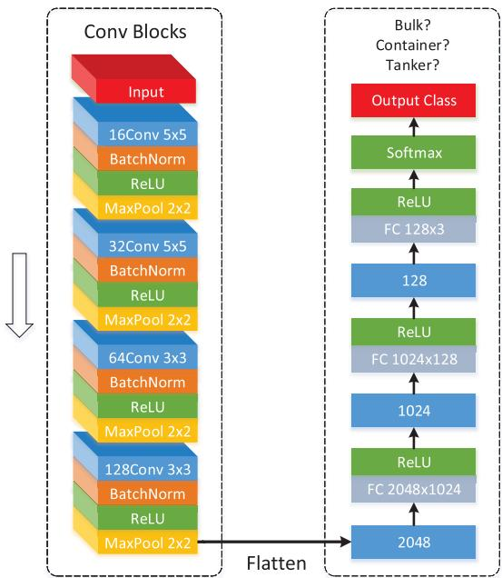
Fig. 1. Structure of CNN for ship classification (tested on the OpenSAR-Ship). (Left side) Four convolutional blocks which are used to automatically extract visual information from the original images. (Right side) Three fully connected layers combined with ReLU that are used to build a nonlinear classifier which ends with softmax. During the forward propagation process of CNN, there are three different dimensions of feature vectors which can be used for second-stage training, that is 128, 1024, and 2048.
be used to calculate the prototype of each class in support set. About the way of distance measurement, there are several choices that can be selected, such as Euclidean distance, Mahalanobis distance, and so on. Here, an end-to-end relation network [10] is designed to automatically learn a nonlinear distance measurement.
The method proposed in this letter is tested with the OpenSARShip data set [11], and MSTAR data set [12]. Experimental details can be seen in Section IV.

II. FEATURE EXTRACTION

A. Convolutional Neural Networks
The structure of CNN is shown in Fig. 1. Here, the CNN can be divided into two parts. The left part contains four convolutional blocks. Each block has four layers: convolutional layer, batch normalization, rectified linear unit (ReLU), and max-pooling layer. After the input image passes through all four blocks, the feature maps containing rich visual information can be extracted. Then the feature maps are flattened to a feature vector which has the dimension of 2048. This feature vector can be seen as the input of CNN’s nonlinear classifier. This part contains three fully connected layers combined with ReLU and ended with a softmax function to perform multiple class prediction.
At first, the CNN should be trained in a normal image classification manner. Let $x_{i}∈R^{c×h×w}$ be the input image, where each dimension represents the channel numbers, height, and width. Here, the cross-entropy loss is chosen in this letter, so the total loss function can be written as (1). We minimize
it using the stochastic gradient descent (SGD)
J(θ)=−1mi​c=1N1yi==clogPθyi=c∣xi
where $m$ is the number of all training samples, $i$ is the sample index, $N$ is the total number of classes, $c$ is the class index, $y_{i}$ is the class label, and $θ$ represents the parameters of CNN. $1(y_{i}==c)$ denotes that if the ground truth label of $i$ th sample equals $c$ , then its value is 1, otherwise 0. $P_{θ}(y_{i}=c|x_{i})$ is calculated using softmax function after getting the output feature vector of the third fully connected layer which is combined with ReLU. The details are as followed:
$$P_{θ}\left(y_{i}=c∣x_{i}\right)=\frac{exp\left(f_{θ}{\left(x_{i}\right)}_{c}\right)}{\sum_{c=1}^{N}{exp}\left(f_{θ}{\left(x_{i}\right)}_{c}\right)}$$
where $f_{θ}(x_{i})_{c}$ denotes the cth element of feature vector $f_{θ}(x_{i})$

B. Feature Selection
After the training of CNN has been done, it can be used for normal SAR image classification. The input is an SAR image, the output is probabilities this image belonging to each class. In this letter, when tested on the OpenSARShip, there are totally three types of ship to be classified, so the number of elements in final output vector is three (in MSTAR it would be ten).
However, this final output vector is not the feature we need for further use. What we actually need is the output feature vector of CNN’s middle layer which contains adequate information that benefits the second-stage metric learning. More concretely, the blue rectangles in the right part of CNN’s structure shown in Fig. 1 can be selected as feature vectors. In this letter, 2048 is chosen as the dimension of feature vector. Once the dimension has been selected, traverse all the samples to do CNN’s forward propagation and extract the corresponding feature vector which can be used as the original data for metric learning.

III. METRIC LEARNING
Normal CNN’s performance on SAR image classification is limited because of the inadequate amount of labeled training data. So, the CNN is simply used to extract samples’ feature vectors, and these vectors should be further clustered in the feature space by the way of metric learning.

A. Problem Definition
The way of episode training strategy which is proposed in [13] is used in this letter. In each training iteration, an episode is formed by the support set $S=\{(f_{θ}(x_{i}),y_{i})\}_{i=1}^{m}(m=N×K)$ and the query set $Q=\{(f_{θ}(x_{j}),y_{j})\}_{j=1}^{n}$ . Support set contains $N$ classes in total and $K$ samples in each class. The data sets used in second stage are the same with the first stage except the sample features which are extracted from the original SAR images. More concretely, during the training process, $S$ contains all the training set, and $Q$ is randomly selected from the training set. During the validation process, $S$ contains all the training set, and $Q$ is
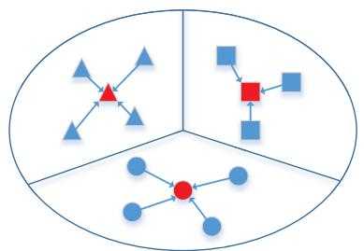
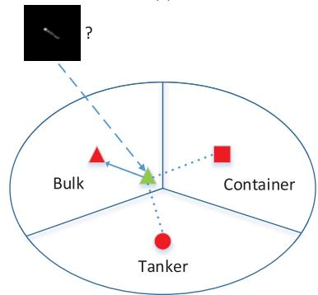
(a)
(b)
Fig. 2. Metric learning method (ship classification as an example). (a) This figure shows the prototypes’ calculation method of each class. (b) Classification process for query image, by calculating the distance between its feature vector and prototypes in the feature space.
sequentially taken from the validation set. During the test process, $S$ contains all the training set, and $Q$ is sequentially taken from the test set. The distance should be calculated between a query sample and the support samples to decide which class should this query sample belong to.

B. Prototypes Calculation
As shown in Fig. 2(a), prototypes can be obtained by calculating the average of all feature vectors in each class of support set. The formulation can be written as followed:
$$
o _ {c} = \frac {1}{K} \sum_ {i} f _ {\theta} \left(x _ {i}\right) \quad \text {s . t .} y _ {i} = c \tag {3}
$$
where $o_{c}$ denotes the prototype of class $c$ . After the calculation, distance should be measured between the query sample and N prototypes.

C. Relation Networks
The way of distance metric we choose in this letter is to design an end-to-end relation network to automatically learn a nonlinear distance measurement which has a better generalization and robustness compared with the fixed metric. The architecture of relation network is shown in Fig. 3. Suppose that the parameters of relation network are $ϕ$ , then the relation score of prototype $o_{c}$ and query sample $x_{j}$ can be written as follows:
$$r_{j,c}=g_{ϕ}\left(C\left(o_{c},f_{θ}\left(x_{j}\right)\right)\right)$$
where $C(⋅,⋅)$ indicates the concatenation of feature vectors.
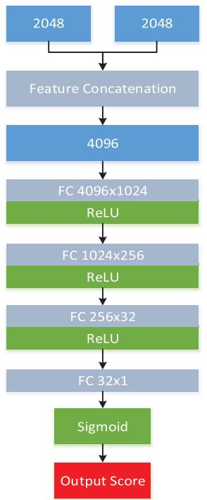
Fig. 3. This figure shows the structure of relation network. At the end of network we use a sigmoid function to let the output score ranges from 0 to 1.
The mean square error (MSE) loss is chosen as the loss function. If the query sample matches the prototype, the relation score should be 1, otherwise 0. The loss function can be written as follows:
$$loss=\frac{1}{nN}\sum_{j=1}^{n}{\sum_{c=1}^{N}{{\left(r_{j,c}−1\left(y_{j}==c\right)\right)}^{2}}}.$$
Substitute (4) into (5), we can get the objective function as follows. $θ$ is now constant
$$J(ϕ)=\frac{1}{nN}\sum_{j=1}^{n}{\sum_{c=1}^{N}{{\left(g_{ϕ}\left(C\left(o_{c},f_{θ}\left(x_{j}\right)\right)\right)−1\left(y_{j}==c\right)\right)}^{2}}}.$$

IV. EXPERIMENTAL RESULTS AND DISCUSSION

A. OpenSARShip Data Set
The OpenSARShip data set is organized in different folders which corresponding to different scenes of images. In each folder, there exist four sub folders providing four formats of ship chips. In this letter, we choose the visualized 8-bit gray images which are from the “Patch_Uint8” as the original images for network’s training, and there are three types of ships that are used for classification: bulk carrier, container, and oil tanker. Based on the detailed ship information in “Ship.xml” files we can select the exact sample images of the three ship classes. During the selection, there are two types of polarization (VV/VH) for each ship chip, which can be seen from the filenames in “Patch_Uint8” folders. In our experiment, we decided to utilize both of the VV and VH data, which means these two types of data could all be used in the training, validation, and test process. Eventually, we can
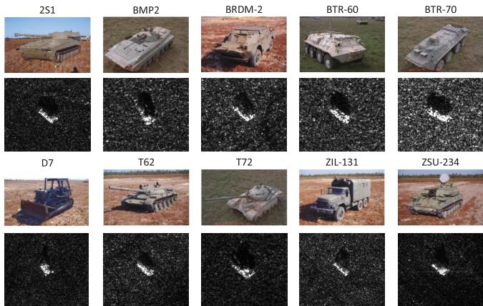
Fig. 4. This figure shows some sample images in each of the ten classes in MSTAR.
TABLEI DETAILS OF SOC EXPERIMENT
 | Train |  | Test
Class | Depression | Number of Images | Depression | Number of Images
2S1 | 17° | 299 | 15° | 274
BMP2 | 17° | 233 | 15° | 196
BRDM-2 | 17° | 298 | 15° | 274
BTR-60 | 17° | 256 | 15° | 195
BTR-70 | 17° | 233 | 15° | 196
D7 | 17° | 299 | 15° | 274
T-62 | 17° | 299 | 15° | 273
T-72 | 17° | 232 | 15° | 196
ZIL-131 | 17° | 299 | 15° | 274
ZSU-234 | 17° | 299 | 15° | 274
get 1740 chips of tanker, 1582 chips of container, and 2298 chips of bulk carrier. Then we use the OpenSARShip-Filter tool [14] which is supported by Leng et al. [15]-[17] to pick up the relatively large ship chips in each of the three classes. We choose samples larger than $35×35$ pixels to build a new subset of tanker, and similarly, $70×70$ pixels for the container and $75×75$ pixels for the bulk carrier. After the filtering, we can get 1450 chips of tanker, 1410 chips of container, and 1442 chips of bulk carrier. These samples will be used for further experiment.
Besides, all the sample images are resized to $100×100$ pixels. It is then divided randomly into three parts for each class: training set with $K$ samples, validation set with 200 samples and the rest of the images will be used for the test process.

B. MSTAR Data Set
The MSTAR data set is a public data set created by the U.S. Air Force Laboratory. In this letter, we test our method on the standard operating conditions (SOCs). There are totally ten classes. Fig. 4 shows some examples of the SAR images in MSTAR and their corresponding optical images. Table I shows the detailed information of MSTAR data set used in our experiment.
All the samples are resized to $100×100$ . In each class, we first divide the training set into two parts: $K$ samples for the training, and the rest of the training images will be used for validation. In the test process, all the images in the test set which contains 2426 images will be used.

C. Implementation Details
- Convolutional Neural Network: It should be noted that for OpenSARShip, the output of CNN will be three (as Fig. 1 shows). For MSTAR, the output of CNN will be ten (in Fig. 1, the third fully connected layer would be $128×10$ ). In the training process, the images of training set are used as the input of CNN. Do the forward propagation of CNN and then get the output vector which has three (OpenSARShip) or ten (MSTAR) elements. Each element indicates the probability this image belongs to a certain class. Then the SGD is used to minimize (1). The initial learning rate is set to 0.001. It is halved every two epochs, and verification is performed every five epochs. Once the validation accuracy not increased anymore and appears to go down, the early stopping is employed.
In the validation process, the images of validation set are used as the input of CNN. The class prediction of sample images are obtained by the equation written as followed:
$${\hat{y}}_{i}=\underset{c}{argmax}P_{θ}\left(y_{i}=c∣x_{i}\right).$$
In the test process, we use the images of test set as the input of CNN. The same equation is used to predict the class label as written in (7).
- Metirc Learning: In the training process of one episode, support set samples in $S$ are formed by the whole training set, query set samples in $Q$ are randomly selected from the training set. For OpenSARShip, $n=16$ and $N=3$ . For MSTAR, $n=16$ and $N=10$ . After getting $S$ and $Q$ , prototypes of $S$ should be calculated by using (3). Then (6) is minimized by using SGD. For OpenSARShip, the initial learning rate is set to ${10}^{−5}$ . For MSTAR, the initial learning rate is set to ${10}^{−4}$ . And for both of the data set, the learning rate is halved every 1000 episodes, and verification is performed every 100 episodes. Once the validation accuracy not increased anymore and appears to go down, the early stopping is employed.
In the validation process, $S$ does not change, $Q$ is sequentially taken from the validation set. We can get the class prediction of feature vectors using the equation written as follows:
$${\hat{y}}_{j}=\underset{c}{argmax}r_{j,c}.$$
In the test process, $S$ does not change, $Q$ is sequentially taken from the test set. The same equation is used to predict the class label as written in (8).

D. Results and Discussion
- OpenSARShip: There are different choices of $K$ for CNN’s training and metric learning. To evaluate the performance of proposed method and CNN at the conditions of
TABLE II CLASSIFICATION ACCURACY WITH DIFFERENT $K$ ON OPENSARSHIP
The Number of Training Images in Each Class (K) | CNN | CNN+Metric
50 | 62.75% | 72.86%
100 | 68.52% | 75.31%
200 | 73.68% | 77.22%
400 | 78.92% | 80.34%
600 | 81.44% | 82.07%
800 | 83.15% | 83.67%
TABLE III CLASSIFICATION ACCURACY WITH DIFFERENT $K$ ON MSTAR
The Number of Training Images in Each Class (K) | CNN | CNN+Metric
20 | 75.88% | 82.29%
50 | 91.69% | 95.47%
100 | 98.74% | 98.93%
150 | 99.31% | 99.62%
200 | 99.46% | 99.79%
different number of training samples, there are six values of $K$ are chosen: 50, 100, 200, 400, 600, 800. All of these $K$ samples are selected randomly and it has been repeated 50 times at each $K$ . The final accuracy can be calculated by the mean of it. The experimental results are shown in Table II. From this table, it can be concluded that the method proposed in this letter has a better classification accuracy than CNN on all of the $K$ values. With the decrease of training samples in each class, the classification accuracy of CNN drops quickly. Especially, when $K=50$ and 100, CNN’s accuracy is lower than $70\%$ . However, the proposed method can still maintain its performance higher than $70\%$ .
To summarize, the proposed method has a better performance on large SAR ship targets classification task compared with the normal CNN method especially when the number of training samples is small.
- MSTAR: Similar to the OpenSARShip settings, there are five different choices of $K$ : 20, 50, 100, 150, 200. All of these $K$ samples are selected randomly and it has been repeated 30 times at each $K$ . The final accuracy can be calculated by the mean of it. The experimental results are shown in Table III. From this table, it can be concluded that the method proposed in this letter has a better classification accuracy than CNN on all of the $K$ values. With the decrease of training samples in each class, the classification accuracy of CNN drops quickly. Especially when $K=20$ , CNN’s accuracy is lower than $80\%$ . However, the proposed method can still maintain its performance higher than $80\%$ .
To summarize, the proposed method has a better performance on SOCs of military targets classification task compared with the normal CNN method especially when the number of training samples is small.

V. CONCLUSION
In this letter, we proposed a two-stage training method which uses CNN and metric learning. In the first stage, an end-to-end CNN is trained to perform the normal SAR image classification task and to extract the feature vectors for further use. In the second stage, an end-to-end relation network is trained to do the metric learning using the feature vectors extracted from the first stage. Experimental results show that our method has a better classification accuracy on the large ship targets and SOCs of military targets compared with normal CNN and can perform well even the number of training images in each class is small.

REFERENCES
[1] S. Brusch, S. Lehner, T. Fritz, M. Soccorsi, A. Soloviev, and B. van Schie, “Ship surveillance with TerraSAR-X,” IEEE Trans. Geosci. Remote Sens., vol. 49, no. 3, pp. 1092-1103, Mar. 2011.
[2] H. Lang, J. Zhang, X. Zhang, and J. Meng, “Ship classification in SAR image by joint feature and classifier selection,” IEEE Geosci. Remote Sens. Lett., vol. 13, no. 2, pp. 212-216, Feb. 2016.
[3] H. Lang, S. Wu, and Y. Xu, “Ship classification in SAR images improved by AIS knowledge transfer,” IEEE Geosci. Remote Sens. Lett., vol. 15, no. 3, pp. 439-443, Mar. 2018.
[4] M. Jiang, X. Yang, Z. Dong, S. Fang, and J. Meng, “Ship classification based on superstructure scattering features in SAR images,” IEEE Geosci. Remote Sens. Lett., vol. 13, no. 5, pp. 616-620, May 2016.
[5] W.-T. Chen, K.-F. Ji, X.-W. Xing, H.-X. Zou, and H. Sun, “Ship recognition in high resolution SAR imagery based on feature selection,” in Proc. Int. Conf. Comput. Vis. Remote Sens., Dec. 2012, pp. 301-305.
[6] Y. Wu et al., “Joint convolutional neural network for small-scale ship classification in SAR images,” in Proc. IGARSS-IEEE Int. Geosci. Remote Sens. Symp., Jul. 2019, pp. 2619-2622.
[7] Z. Cui, Q. Li, Z. Cao, and N. Liu, “Dense attention pyramid networks for multi-scale ship detection in SAR images,” IEEE Trans. Geosci. Remote Sens., vol. 57, no. 11, pp. 8983–8997, Nov. 2019.
[8] J. Ding, B. Chen, H. Liu, and M. Huang, “Convolutional neural network with data augmentation for SAR target recognition,” IEEE Geosci. Remote Sens. Lett., vol. 13, no. 3, pp. 364-368, Mar. 2016.
[9] J. Snell, K. Swersky, and R. Zemel, “Prototypical networks for few-shot learning,” in Proc. Adv. Neural Inf. Process. Syst., 2017, pp. 4077–4087.
[10] F. Sung, Y. Yang, L. Zhang, T. Xiang, P. H. S. Torr, and T. M. Hospedales, “Learning to compare: Relation network for few-shot learning,” in Proc. IEEE/CVF Conf. Comput. Vis. Pattern Recognit., Jun. 2018, pp. 1199–1208.
[11] L. Huang et al., “OpenSARShip: A dataset dedicated to Sentinel-1 ship interpretation,” IEEE J. Sel. Topics Appl. Earth Observ. Remote Sens., vol. 11, no. 1, pp. 195-208, Jan. 2018.
[12] (May 1983). The Air Force Moving and Stationary Target Recognition Database. [Online]. Available: https://www.sdms.afrl.af.mil/datasets/mstar/
[13] O. Vinyals, C. Blundell, T. Lillicrap, and D. Wierstra, “Matching networks for one shot learning,” in Proc. Adv. Neural Inf. Process. Syst., 2016, pp. 3630–3638.
[14] (2020). Opensharshipfilter-Package-Sourcocode. Accessed: Aug. 2020 [Online], Available:https://ww2.mathworks.cn/matlabcentral/filex change/66929-opensharshipfilter-package-sourcecode
[15] X. Leng, K. Ji, S. Zhou, and X. Xing, “Fast shape parameter estimation of the complex generalized Gaussian distribution in SAR images,” IEEE Geosci. Remote Sens. Lett., early access, Jan. 1, 2020, doi: 10.1109/LGRS.2019.2960095.
[16] X. Leng, K. Ji, S. Zhou, X. Xing, and H. Zou, “Discriminating ship from radio frequency interference based on noncircularity and non-Gaussianity in Sentinel-1 SAR imagery,” IEEE Trans. Geosci. Remote Sens., vol. 57, no. 1, pp. 352–363, Jan. 2019.
[17] X. Leng, K. Ji, S. Zhou, and X. Xing, “Ship detection based on complex signal kurtosis in single-channel SAR imagery,” IEEE Trans. Geosci. Remote Sens., vol. 57, no. 9, pp. 6447-6461, Sep. 2019.

