信号与系统实验
第一次作业报告
学号：1120230621 姓名：闫子易

一、MATLAB实验
实验代码及图形
绘制实指数序列
%%
%绘制实指数序列
N=50;
n=0:N-1;
a=0.8;
x3=a.^n; %实指数序列
figure('name','实指数序列');
stem(x3);
绘制正弦序列
N=50;
n=(-0.1):0.1:N-1;
w0=pi/3;
ang=pi/6;
x4=sin(n*w0+ang); %正弦序列
figure('name','正弦序列');
%plot(x4); %绘制正弦函数
stem(n,x4);
axis([-100,100,-2,2]); %限幅
创建矩阵
x =
%%
x = 0:0.1:6
length(x)

列 1 至 11

0 0.1000 0.2000 0.3000 0.4000 0.5000 0.6000 0.7000 0.8000 0.9000 1.0000

列 12 至 22

1.1000 1.2000 1.3000 1.4000 1.5000 1.6000 1.7000 1.8000 1.9000 2.0000 2.1000

列 23 至 33

2.2000 2.3000 2.4000 2.5000 2.6000 2.7000 2.8000 2.9000 3.0000 3.1000 3.2000

列 34 至 44

3.3000 3.4000 3.5000 3.6000 3.7000 3.8000 3.9000 4.0000 4.1000 4.2000 4.3000

列 45 至 55

4.4000 4.5000 4.6000 4.7000 4.8000 4.9000 5.0000 5.1000 5.2000 5.3000 5.4000

列 56 至 61

5.5000 5.6000 5.7000 5.8000 5.9000 6.0000

ans =

61

x =
%%
x = sym('x')
s = x^2 -x-4*x+6
factor(s)
expand(s)
collect(s)

x

s =

x^2 - 5*x + 6

ans =

[x - 2, x - 3]

ans =

x^2 - 5*x + 6

ans =

x^2 - 5*x + 6
x - 2, x - 3]

ans =

x^2 - 5*x
%%

x = 0:pi/100:2*pi;
y1 = sin(x);
figure;

%subplot(1,2,1)
plot(x,y1,'r--');
grid on

hold on

y2 = cos(x);
%subplot(1,2,2)
plot(x,y2,'g*');

axis( [ 0 2*pi -1.2 1.2 ] )

xlabel('x value')
ylabel('y value')
title('sin(x) | cos(x) \pi \infty')
legend('y=sin(x)', 'y=cos(x)')
%%
x = sym('x')
ezplot(x^2);
ezplot(x^2,[-6,6]);

%%

x = 0:pi/100:2*pi;
y1 = sin(x);
figure;

subplot(2,2,1)
plot(x,y1,'r--');
grid on

hold on

y2 = cos(x);
subplot(2,2,2)
plot(x,y2,'g*');

axis( [ 0 2*pi -1.2 1.2 ] )

y3 = y1+y2;
subplot(2,2,3)
plot(x,y3,'b*');
axis( [ 0 2*pi -2 2 ] )

y4 = y1-y2;
subplot(2,2,4)
plot(x,y4,'y-*');
axis( [ 0 2*pi -2 2 ] )

xlabel('x value')
ylabel('y value')
title('sin(x) | cos(x) \pi \infty')
legend('y=sin(x)', 'y=cos(x)')

%%

y = 0;
x = 0:10:100;
for i = 1:10
y = y+x(i)
end
y =
0
y =
10
y =
30
y =
60
y =
100
y =
150
y =
210
y =
280
y =
360
y =
450

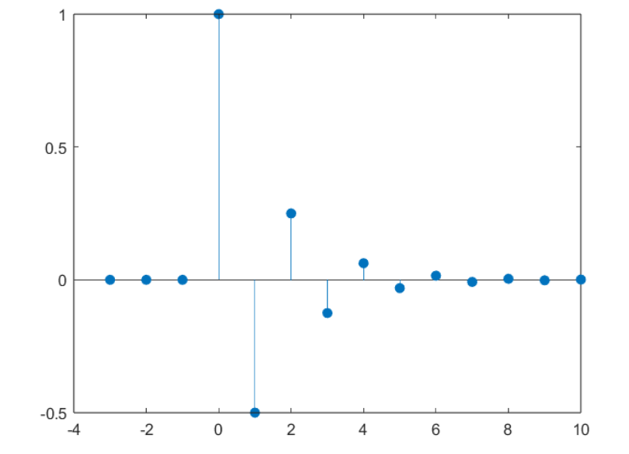
n=-3:10;
x=(-1/2).^n.*(n>=0t=-5:0.01:10;
x1=(4-t+1).*(t-1>=0&t-1<4);x2=sin(2*pi*(t-1));
x3=x1+x2;x4=sin(2*pi*t);
x6=x4*x3;figure;plot(t,x6););
figure;stem(n,x,'filled');
n=-3:10;
x=(-1/2).^n.*(n>=0);
figure;stem(n,x,'filled');

