MANDAUE CITY COMPREHENSIVE NATIONAL HIGH SCHOOL  
Plaridel Street, Reclamation Area, Mandaue City  
**SENIOR HIGH SCHOOL DEPARTMENT** TECHNICAL VOCATIONAL LIVELIHOOD (TVL) Strand

IMPROVING TYPING SKILLS

Intelink Company, May 30, 2023  
  
 Earl John Trangia John Richfield Jayag Rujzli Lavador John Harry Derojo

**Research Abstract:**

The ability to type efficiently and accurately is an essential skill in today's digital age. This abstract presents an overview of strategies and techniques aimed at improving typing skills. The objective is to enhance typing speed, accuracy, and overall productivity.

The abstract begins by highlighting the significance of proficient typing skills in various personal and professional contexts, emphasizing the advantages of improved efficiency and reduced error rates. It explores the impact of poor typing skills on productivity, efficiency, and user experience, underscoring the need for effective typing improvement methods.

**KEYWORDS:** Typing practice, touch typing, keyboarding, typing speed, accuracy, Muscle Memory, finger placement, typing techniques, home row,

**Introduction:**

Typing is not just about speed; it's also about accuracy and precision. With improved typing skills, you can minimize errors and typos, saving valuable time that would otherwise be spent on corrections. Moreover, fast and accurate typing allows you to focus more on the content itself rather than the physical act of typing, thereby enhancing your overall writing experience.

By dedicating some time and effort to improving your typing skills, you can unlock a world of possibilities. From crafting polished essays and reports to efficiently managing emails and documents, your typing proficiency will be an invaluable asset in both personal and professional contexts.

**Empathy Stage:**

Empathy helps teachers or instructors understand the challenges and frustrations faced by learners while acquiring typing skills. By putting themselves in the learner's shoes, educators can better tailor their teaching methods and support, making the learning experience more effective and enjoyable

**Research Topic:** Improving typing skills

|  |  |
| --- | --- |
| **THINK AND FEEL**  1. What typing software or tools do you currently use? 2. Do you use the correct finger placement on the keyboard? 3. Are you familiar with touch typing techniques? 4. Do you take regular breaks to avoid fatigue while typing? 5. Are you comfortable with using both hands while typing?  6. How long do you think would it take for you to encode a document with 250 word count?  CO worker | **SAY AND DO**  1. Do you maintain proper posture while typing?  2. How often do you practice typing? 3. Have you tried using typing games or challenges to improve your skills?  4. Do you utilize auto correct features effectively? 5. Do you use keyboard shortcuts for copy, paste, undo, and other common actions?  6. how long have you been working on a secretary / office assistant / officer etc. |
| **HEAR**  1. Do you pay attention to your typing speed and accuracy?  2. Are you familiar with the QWERTY keyboard layout? 3. Are you comfortable typing numbers and symbols without looking at the keyboard?  4. Do you use typing exercises that focus on improving your typing rhythm?  5. Have you customized your keyboard settings to your preferences?  6. Have you Beard of typing apps to game based tools to help improve typing skills? | **SEE**  1. Do you set personal goals for improving your typing speed and work towards them?  2. Are you familiar with the concept of “typing flow” and how to achieve it?  3. Are you open to attending typing workshops or training sessions to further improve your skills? 4. Have you tried typing with your eyes closed to enhance your muscle memory?  5. Do you actively challenge yourself to type faster while maintaining accuracy? |

**Define Stage:**

The stage of improving typing skills refers to the process and progress of developing one's ability to type efficiently and accurately on a keyboard. It typically involves a series of steps or milestones as individuals work towards becoming proficient typists. The stages can vary depending on the learning method and individual progress, but generally, they include.

**Research title:** Improving typing skills

|  |  |  |
| --- | --- | --- |
| **USER** | **USER’S NEED** | **INSIGHTS** |
| CO workers | Learning to type fast and accurately will help you in many ways in life | Improving typing skills can be a valuable asset in today's digital world. Whether you want to increase your typing speed, accuracy, or overall efficiency, here are some insights and tips to help you improve your typing skills. Accuracy is crucial when learning to type. Focus on hitting the correct keys without making mistakes. Gradually increase your speed as your accuracy improves. |

**Ideation stage:**

Design thinkers generate ideas – in the form of questions and answers – in the ideation stage by engaging in creative and curious activities such as brainstorming and coming up with the worst possible concept. The ideation stage of the design thinking process commonly follows the first two stages, which are the empathy and define stages. The following are the top 9 solutions we’ve found to the problem

1. Typing Courses and Programs
2. Gamified learning
3. Touch typing
4. Daily typing practice
5. Typing speed test
6. Typing games
7. Keyboarding techniques
8. Specialized training tools
9. Typing challenges

**Prototype stage:**

Prototype are often used in final testing phase in a design thinking process in order to determine how users behave with the prototype, to reveal new solutions to problems, or to find out whether or not the implemented solutions have been successful. The results generated from these tests are then used to redefine one or more of the problems established in the earlier phases of the project, and to build a more robust understanding of the problems users may face when interacting with the product in the intended environment.

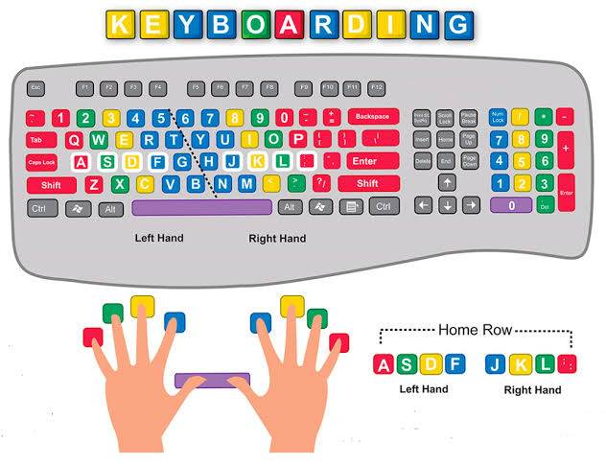

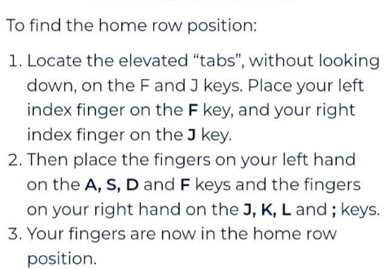

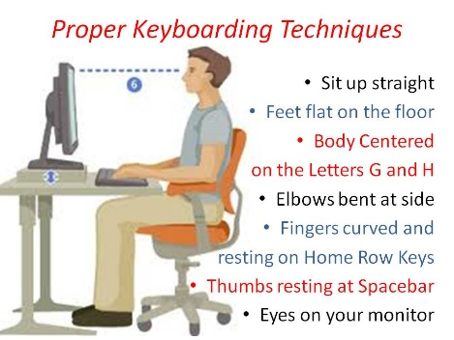

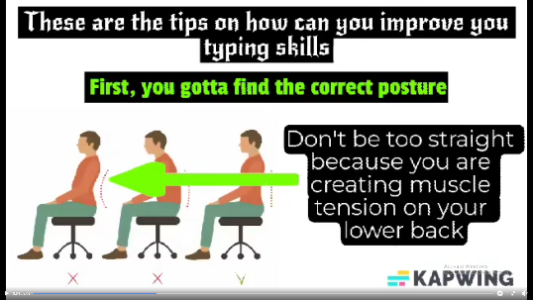

A typing skills prototype may involve developing a basic software application, tool, or learning system that incorporates various features and techniques to facilitate skill development. Designing and implementing specific typing exercises or drills that focus on different aspects of typing, such as speed, accuracy, and technique. Creating an interface that allows learners to interact with the prototype, providing them with a platform to practice and improve their typing skills. Implementing a system that tracks learners' progress over time, allowing them to monitor their improvement and set goals for further development.

**Reference:**

TypingClub ([www.typingclub.com](http://www.typingclub.com/)): TypingClub is a popular online platform that offers interactive typing lessons and exercises for all skill levels. It provides a structured curriculum, fun games, and real-time feedback to help you improve your typing speed and accuracy.

Keybr ([www.keybr.com](http://www.keybr.com/)): Keybr is another free online typing tutor that focuses on teaching touch typing skills. It generates random exercises and adapts to your typing patterns, gradually introducing new keys and words to practice.