


Product Requirements Document
From Lagacy System to New Cecos Modern Web

Executive Summary
CECOS needs a new public website built as a fresh product, not as a direct redesign of the old WordPress implementation. The old website is used only as a content and navigation reference. The new website will have a new UI, new database structure, new content model and clear ownership for who can change each type of data.
The most important product decision is controlled editing. Super Admin can manage all website content and user accounts. Each HOD can manage only the data of their own department and the faculty records belonging to that department. Each Center has its own access area for its own content. Marketing manages public-facing admissions content and deadlines. Faculty access is limited to the faculty functions assigned to them. Every approved content change must be recorded with who changed it, what changed and when it changed, and this audit record is visible to Super Admin.

Product Principle
Keep the website simple for visitors and simple for content owners. The PRD defines the product behavior and boundaries; it does not add unnecessary workflows, approvals or technical processes that are not required for the first release.

Why the new platform
The current site has missing information, weak search/discovery, and slow response caused in part by the legacy WordPress stack. The new platform should defensively protect performance and data quality while making routine updates easy for the staff who own the content.

1. Product Overview
The product is the main public CECOS institutional website plus a secure administration area. The public side helps prospective students, current students, parents, faculty, alumni and general visitors discover programs, departments, centers, admissions information, policies, events, projects and institutional information. The administration side lets authorized staff manage the content they own without giving broad access to unrelated parts of the website.

2. Problem Statement
The current website contains useful sections but is not presenting the institution as a complete, searchable and up-to-date digital experience. Key data is missing or incomplete, some navigation areas are hard to use, the presentation is inconsistent, and ownership of content is not clearly separated. The result is extra manual work, slow updates and a higher risk that the public sees outdated or incomplete information.

3. Goals and Objectives
• Build a fast, responsive public website that works well on mobile, tablet and desktop.
• Create a clean information architecture for About, Centers, Departments, Admissions, Projects, Quick Links, Portals and Merit Lists.
• Adding missing academic and institutional content, including BS Software Engineering and complete teacher profiles.
• Make search and discovery easier through clear filters, program cards and department/center pages.
• Provide secure role-based content access so users can edit only the data they own.
• Keep an audit log for every successful content change and make the log visible to Super Admin.
• Use a new PostgreSQL data model so the new site is not dependent on the old WordPress structure.

4. Target Users and Stakeholders
User / Stakeholder | Main Need
Prospective student / visitor | Find programs, departments, fees, scholarships, dates and how to apply.
Current student / parent / alumni | Find notices, portals, services, contacts and institutional information.
HOD | Manage own department information and faculty records for that department.
Center content owner | Manage content for the assigned center only.
Marketing team | Manage public admissions content, deadlines, notifications and similar public content.
Faculty | Access faculty functions assigned to their account; no broad site editing.
Super Admin | Manage all website data, user accounts, roles and audit logs.
University management | Review website quality, completeness and change history.

5. Product Scope
In scope: public website, search/filtering, program and course presentation, department and center pages, admissions information, teacher profiles, policies, events/projects, responsive UI, admin CMS, role-based access, Supabase/PostgreSQL data, authentication and audit logs. Out of scope for the first release: replacing the existing student/faculty ERP, building a new LMS, or adding complex approval chains that are not required by CECOS.

6. Architecture and Public User Flow

The new website should retain the useful top-level areas identified in the current site, while making the structure easier to scan and search. The following list is the target content map for the first release.

Top-level area Header | Required sections / content
About | About CECOS; History; President’s Message; Vice President’s Message; Vice Chancellor’s Message; Board of Governors
Centers | ORIC; Quality Enhancement Cell; Career Development Center; CDGAI; Peshawar Light Engineering Centre; OSA
Departments | Civil Engineering; Electrical Engineering; Mechanical Engineering; Architecture; Management Sciences; Basic Science & Humanities; Computer Science; Nursing; Allied Health Sciences; Integrative Biosciences; BS Software Engineering
Admissions | Admissions; How to Apply; Tuition Fees; Scholarships; Dates & Deadlines; Notifications; Prospectus 2026; Contact Us; FAQs
Our Projects | CECOS College London; CECOS Digital; Enskilled; CECOS Innovations; KGems Day Nurseries; Rafsan School; The Edex School; Xareya
Quick Links | Policies; Careers; Contact Us; FYP / Capstone
Portals Login | Faculty; Student; Parents; Alumni
Merit Lists | Department-wise merit lists with clear filtering and search

Key Improvements from the Old Website Review
1. Add a proper notice board and departmental event content.
2. Add FYP / Capstone showcase data and searchable project content.
3. Add missing policies, including OBE, HSC and NSEC, and keep policy pages maintainable.
4. Add Physiotherapy Lab information and the missing Library,OSA center content.
5. Add a complete Student Life section describing campus environment, activities and services.
6. Add proper course/program cards, complete fee structure and search/filter functions.
7. Fix layout alignment, image quality, typography consistency and mobile responsiveness.
8. Add complete teacher profiles covering education background, designation and current details.

Reference diagram: public discovery and application flow supplied in the project material

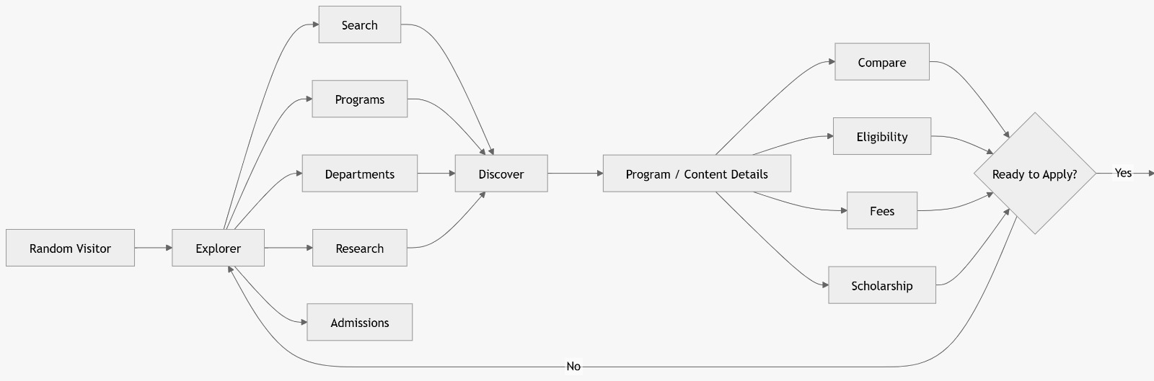

7. Functional Requirements

7.1 Public Website
ID | Area | Requirement
FR-01 | Navigation | The header must provide clear access to About, Centers, Departments, Admissions, Our Projects, Quick Links, Portals Login and Merit Lists.
FR-02 | Search and filters | Users must be able to search relevant content and filter department/program/merit-list information where applicable.
FR-03 | Program and course cards | Programs offered by CECOS must be shown using consistent cards with title, level/discipline summary and a clear path to details.
FR-04 | Program details | Program pages must present overview, eligibility, fees, scholarship information and application action when applicable.
FR-05 | Department pages | Each department must have its own page containing description, programs, faculty and relevant notices/events.
FR-06 | Faculty profiles | Faculty pages must support full profiles including name, photo, designation, education, experience and current details.
FR-07 | Admissions | Admissions content must include how to apply, tuition fees, scholarships, dates/deadlines, notifications, prospectus and FAQs.
FR-08 | Content updates | Public pages must reflect approved/active content entered by authorized staff without requiring developer changes for normal updates.
FR-09 | Merit lists | Merit lists must be organized by department/program and be searchable or filterable rather than shown as one undifferentiated list.
FR-10 | Media | Images and documents must support standard upload, replacement and basic validation so poor or inconsistent assets are not published.

7.2 Admin and Content Management

• Admin users sign in using authenticated accounts. Access is determined by role and, where required, by department/center ownership.

• Super Admin can create, disable and manage website user accounts and assign the correct role.

• HOD can edit only their own department information and can view/manage faculty records belonging to that department.

• A Center content owner can edit only content assigned to that center.

• Marketing can manage the public content assigned to the marketing role, especially admissions, deadlines and notifications.

• A faculty account can use the faculty functions assigned to it; it must not become a general website editor.

• A successful content update writes an audit record containing the user, timestamp, affected area and change summary.

• Super Admin can view the audit log to identify who changed content, what changed and when it changed.

7.3 Basic Acceptance Rule
A normal content owner must never be able to edit a record outside the department or center assigned to the account. This is a hard product rule, not only a UI rule; the permission boundary must also be enforced by the backend/data access layer.

8. Role-Based Access and Content Ownership

The access model is designed to prevent accidental or unauthorized changes. Users are given only the minimum access needed for their job. This keeps content ownership clear and reduces the risk that a user changes another department’s information.

Role | Access boundary | Main permissions
Super Admin | Entire website | Full content editing; create/manage website accounts; manage roles; view audit log; review changes.
HOD | Own department only | Edit department information; manage department pages; view/manage all faculty records under own department.
Center Content Owner | Assigned center only | Create and update content for that center; cannot edit other centers or departments.
Marketing Team | Assigned public content | Manage admissions content, deadlines, notifications and other marketing-owned public content.
Faculty | Assigned faculty functions | Use faculty functions assigned to the account; no broad CMS permissions.

Important HOD Rule
For example, the Computer Science HOD can edit Computer Science department details and can manage the faculty records belonging to Computer Science. The same HOD cannot edit Civil Engineering, Electrical Engineering or another department. This is the intended operating model and should be enforced consistently across the application.

Reference diagram: role authority and audit flow supplied in the project material

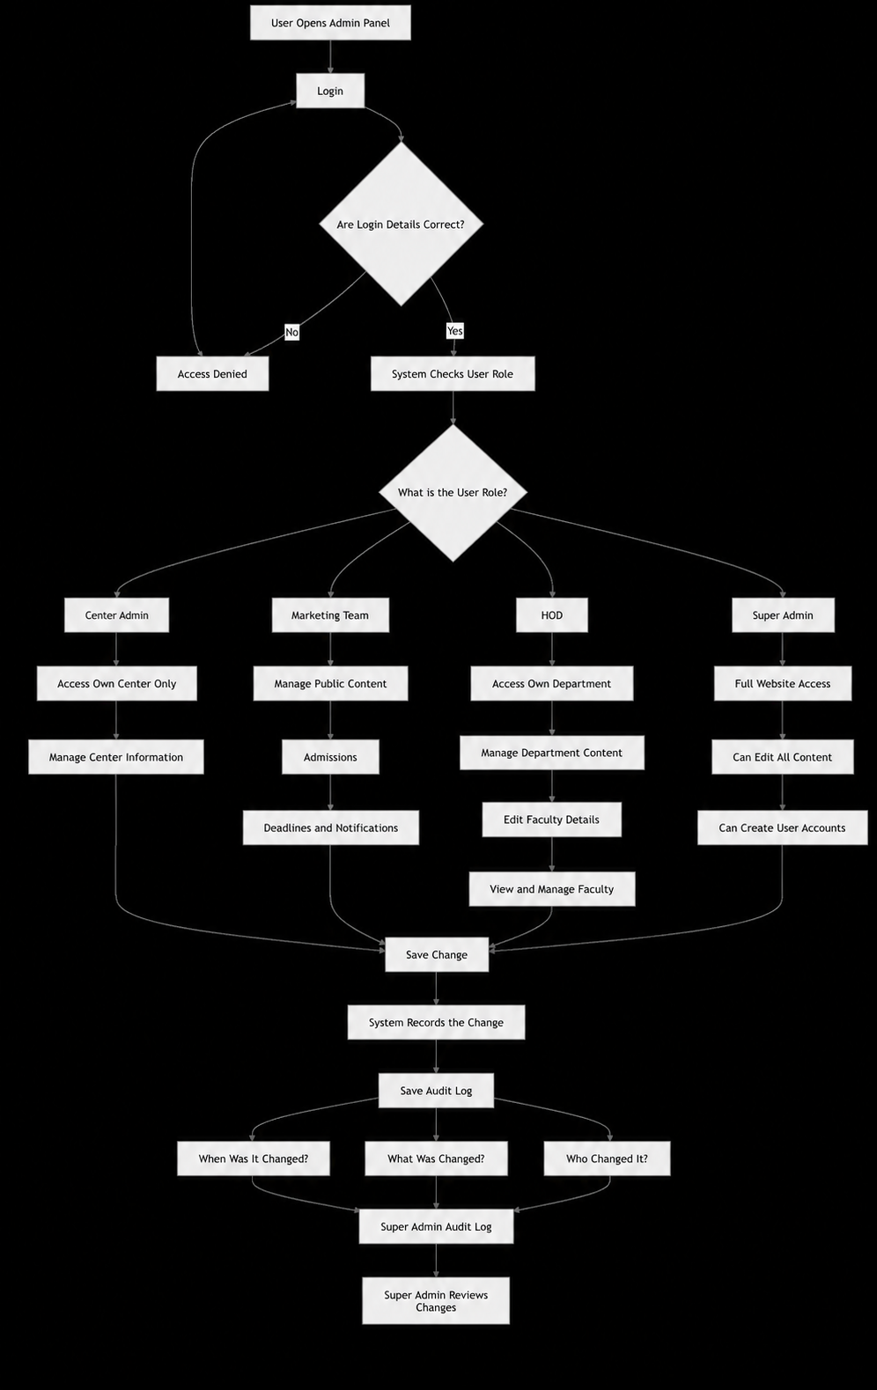

9. Non-Functional Requirements

Area | Requirement
Performance | Pages should load quickly on common mobile and desktop connections. Use server-side rendering/static generation where useful and avoid unnecessary client-side work.
Scalability | The platform must support high student/visitor traffic without the content model becoming a bottleneck. Supabase PostgreSQL should be designed with indexes and efficient queries for common read paths.
Security | Authentication, role checks and data access rules must be enforced on the server/data layer. Client-side hiding alone is not sufficient.
Availability | Public content should remain available during normal traffic peaks; content editing failures must not corrupt existing published data.
Usability | Navigation, forms, search and content pages should be easy to understand for users who are not technical.
Responsive design | The public website and admin pages must work on mobile, tablet and desktop.
Accessibility | Use readable typography, meaningful labels, alt text, keyboard-friendly interactions and sufficient structure for assistive technologies.
Maintainability | Normal content changes should be possible without developer intervention. Reusable components should keep page layouts consistent.

10. Data Requirements
• Use a fresh relational data model in PostgreSQL. The old WordPress database structure is not the target schema.
• Core entities should include users/roles, departments, centers, programs/courses, faculty, admissions items, fees, scholarships, deadlines, notices, events, projects, policies, merit lists, media and audit logs.
• Department and center ownership must be represented as data relationships so access rules can be checked reliably.
• Faculty records must support both public profile information and the department relationship used for HOD access control.
• Published content should have a clear active/inactive state so old material can be retired without deleting historical records unnecessarily.

11. Technical Direction and Constraints

Technology | Role in product | Reason
Next.js + React | Web application and public pages | Strong fit for responsive React UI, server rendering and good page performance.
Tailwind CSS | Using Tailwind for designing | Creates unique website designs that do not look like generic
Supabase PostgreSQL | Database and managed backend services | Reliable relational storage for structured academic/content data, with a practical path for access control.
Supabase Auth / equivalent auth layer | Login and session management | Centralized identity for Super Admin, HOD, centers, marketing and faculty accounts.
Responsive CSS/component system | UI | Consistent layouts across desktop, tablet and mobile without separate codebases.
Framer Motion | For Smooth Animations | Animations like header bar animations etc

Why this stack is defended for this project

The stack is chosen to reduce performance and security risk, not to add technology for its own sake. Next.js supports a fast public site and lets the team avoid sending unnecessary application code to visitors. PostgreSQL is a strong fit for the structured relationships between departments, faculty, programs, admissions and ownership. Supabase reduces the amount of custom backend infrastructure that must be maintained while still giving the project a clear database and authentication layer. Most importantly, authorization should be checked server-side and at the data-access boundary so a user cannot bypass UI restrictions by calling an API directly.

12. Acceptance Criteria
• The public website exposes the approved top-level navigation and all required launch content areas, including BS Software Engineering.
• Search/filter functions work for agreed content types, and department/center owners can update only their assigned scope.
• HOD can access all faculty records belonging to their department and cannot modify another department’s faculty records.
• Super Admin can create/manage website accounts and can access all content areas.
• Every successful content change produces an audit record that includes who, what and when.
• Super Admin can review audit records from the admin area.
• Public pages are responsive and pass agreed browser/device checks.
• No routine content update needs developer/database manual editing after the CMS is released.

13. Success Metrics
Metric | Target / outcome
Content completeness | All agreed launch sections populated, including missing programs, policies, centers, labs, faculty and notices.
Update ownership | 100% of CMS-managed content has a clear owner role and scope.
Unauthorized editing | 0 successful out-of-scope edits by non-Super-Admin roles in acceptance testing.
Audit coverage | 100% of successful CMS content changes create an auditable record.
Findability | Users can locate program, department and admissions information through navigation and search without relying on hidden/manual links.
Performance | Measured against an agreed performance budget on representative mobile and desktop pages before release.

14. Risks and Mitigations
Risk | Mitigation
Incomplete content at launch | Use a content checklist and assign each section to an owner before release.
Wrong role permissions | Test each role with positive and negative access cases; enforce rules in backend/data access.
Poor data quality | Use required fields, validation and consistent content templates for programs and faculty.
Traffic spikes | Use caching/server rendering where useful, efficient PostgreSQL queries and performance testing before launch.
Old site assumptions leak into new design | Treat the legacy site as a reference only; approve the new information architecture and fresh data model.

15. Release / Milestones
Phase | Deliverable
1.Requirement Gathering | Gathering Requirements From stakeholders through Meeting etc.
2. Product and content setup | Finalize sitemap, content owners, data fields and launch content list.
3. UX/UI | Approve responsive design for public site and admin screens.
4. Core build | Build Next.js application, PostgreSQL schema, authentication and role boundaries.
5. Content modules | Build departments, centers, programs, admissions, faculty, notices, projects and policies.
6. Audit and QA | Validate permissions, audit logging, data quality, responsiveness and performance.
7. Launch | Publish the new website and monitor content/performance after release.

