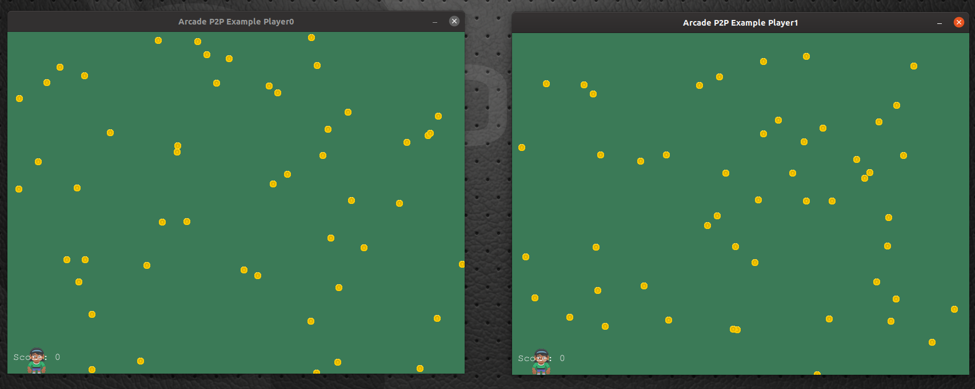
Click This Screenshot To Watch The Video

