基于Django的web项目—Index页面

index主要包括head体、导航栏、大屏幕、项目栏、优秀文章、能力、生活、静态框、其他几个部分：具体见下图

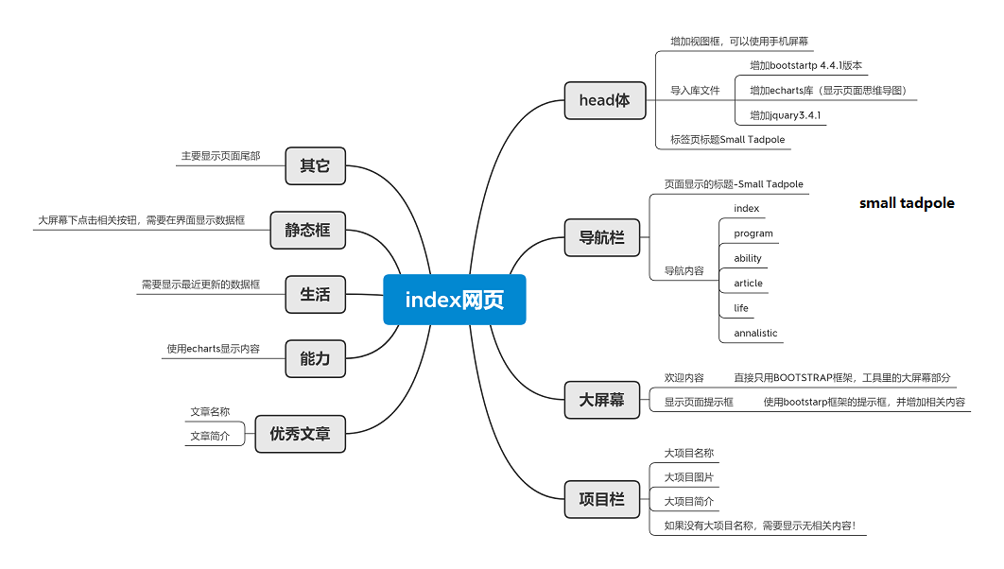

head体内容：

<**head**>  
 *<!-- Required meta tags -->* <**meta charset="utf-8"**>  
 <**meta name="viewport" content="width=device-width, initial-scale=1, shrink-to-fit=no"**>  
 *<!-- Bootstrap CSS -->* <**link rel="stylesheet" href="https://cdn.jsdelivr.net/npm/bootstrap@4.4.1/dist/css/bootstrap.min.css"  
 integrity="sha384-Vkoo8x4CGsO3+Hhxv8T/Q5PaXtkKtu6ug5TOeNV6gBiFeWPGFN9MuhOf23Q9Ifjh" crossorigin="anonymous"**>  
 <**link rel="stylesheet" href="/static/css/index.css"**>  
 <**script type="text/javascript" src="/static/js/echarts.min.js"**></**script**>  
 <**script type="text/javascript" src="/static/js/jquery-3.4.1.min.js"**></**script**>  
 <**script type="text/javascript" src="/static/js/echartsEx.js"**></**script**>  
 *<!-- <script type="text/javascript" src="./js/index.js"></script>-->* <**title**>Small Tadpole</**title**>  
</**head**>

导航栏内容：

<**div class="col-md-12"**>  
 <**nav class="navbar navbar-expand-lg navbar-light bg-light row justify-content-between"**>  
 <**a class="navbar-brand col-5" href="{% url 'index' %}"**>A Small Tadpole</**a**>  
 <**button class="navbar-toggler" type="button" data-toggle="collapse" data-target="#navbarNav"  
 aria-controls="navbarNav" aria-expanded="false" aria-label="Toggle navigation"**>  
 <**span class="navbar-toggler-icon"**></**span**>  
 </**button**>  
 <**div class="collapse navbar-collapse col-6" id="navbarNav"**>  
 <**ul class="navbar-nav"**>  
 <**li class="nav-item active"**>  
 <**a class="nav-link" href="{% url 'index' %}"**>Home <**span class="sr-only"**>(current)</**span**></**a**>  
 </**li**>  
 <**li class="nav-item"**>  
 <**a class="nav-link" href="{% url 'program' %}"**>Program</**a**>  
 </**li**>  
 <**li class="nav-item"**>  
 <**a class="nav-link" href="{% url 'ability' %}"**>Ability</**a**>  
 </**li**>  
 <**li class="nav-item"**>  
 <**a class="nav-link" href="{% url 'article' %}"**>Article</**a**>  
 </**li**>  
 <**li class="nav-item"**>  
 <**a class="nav-link" href="{% url 'life' %}"**>Life</**a**>  
 </**li**>  
 <**li class="nav-item"**>  
 <**a class="nav-link" href="#"**>Annalistic</**a**>  
 </**li**>  
 <**li class="nav-item"**>  
 <**a class="nav-link disabled" href="#" tabindex="-1" aria-disabled="true"**>About</**a**>  
 </**li**>  
 </**ul**>  
 </**div**>  
 </**nav**>  
</**div**

大屏幕内容：

<**div class="jumbotron BigSrceenClass"**>  
 <**h1 class="display-4"**>WELCOME！</**h1**>  
 <**p class="lead"**>钢是在烈火里燃烧、高度冷却中炼成的，因此它很坚固。我们这一代人也是在斗争中和艰苦考验中锻炼出来的，并且学会了在生活中从不灰心丧气。</**p**>  
 <**hr class="my-4"**>  
 <**p**>Don't be afraid to shoot a single horse. What about being alone and brave? You can cry all the way, but  
 you can't be angry. You have to go through the days when nobody cares about it to welcome applause and  
 flowers.</**p**>  
 <**button type="button" class="btn btn-primary" data-toggle="modal" data-target="#exampleModalLong"**>  
 Know me!  
 </**button**>  
</**div**>

项目栏内容：

<**div class="GodProgram col-md-12"**>  
 <**div class="ProgramNavClass"**>  
 <**ul class="nav"**>  
 <**li class="nav-item"**>  
 <**a class="nav-link" href="{% url 'program' %}"**><**h4**>Program</**h4**></**a**>  
 </**li**>  
 </**ul**>  
 </**div**>  
 <**div class="row justify-content-between"**>  
 {% for BigProgram in BigProgramtemp %}  
 <**div class="col-md-6 cardProgramClass"**>  
 <**a href="{% url 'programUnqul' BigProgram.id %}"  
 class="card mb-3 card1Class text-decoration-none " style=""**>  
 <**div class="row no-gutters"**>  
 <**div class="col-md-8"**>  
 <**div class="card-body"**>  
 <**h5 class="card-title"**>{{ BigProgram.ProgramName }}</**h5**>  
 <**p class="card-text"**>{{ BigProgram.ProgramBrief }}</**p**>  
 <**p class="card-text"**><**small class="text-muted"**>Last  
 updated {{ BigProgram.update_time }}</**small**></**p**>  
 </**div**>  
 </**div**>  
 <**div class="col-md-4"**>  
 <**img src="/media/{{ BigProgram.ProgramIcon }}" class="card-img" alt="这是一个项目图标"**>  
 </**div**>  
 </**div**>  
 </**a**>  
 </**div**>  
 {% empty %} <**p**>无相关内容！</**p**>  
 {% endfor %}  
 </**div**>  
</**div**>

优秀文章内容：

<**div class="GoodPClass col-md-12"**>  
 <**div class="ArticleNavClass"**>  
 <**ul class="nav"**>  
 <**li class="nav-item"**>  
 <**a class="nav-link" href="{% url 'article' %}"**><**h4**>Article</**h4**></**a**>  
 </**li**>  
 </**ul**>  
 </**div**>  
 {% for Article in ArticleModelsTmp %}  
 <**div class="ArticleClass"**>  
 <**a href="{% url 'articleDetil' Article.id %}" class="card"**>  
 <**h5 class="card-header"**>{{ Article.ArticleName }}</**h5**>  
 <**div class="card-body"**>  
 <**p class="card-text font-weight-light"**>  
 {{ Article.ArticleBrief }}  
 </**p**>  
 </**div**>  
 </**a**>  
 </**div**>  
 {% empty %} <**p**>文章内容为空</**p**>  
 {% endfor %}  
  
</**div**>

能力内容：

<**div class="skill col-md-12"**>  
 <**div class="ArticleNavClass"**>  
 <**ul class="nav"**>  
 <**li class="nav-item"**>  
 <**a class="nav-link" href="{% url 'ability' %}"**><**h4**>Ability</**h4**></**a**>  
 </**li**>  
 </**ul**>  
 </**div**>  
  
 <**div id="main" class="col-md-12" style="height**: 500**px"**></**div**>  
</**div**>

生活内容：

<**div class="live col-md-12"**>  
 <**div class="ArticleNavClass"**>  
 <**ul class="nav"**>  
 <**li class="nav-item"**>  
 <**a class="nav-link" href="{% url 'life' %}"**><**h4**>Life</**h4**></**a**>  
 </**li**>  
 </**ul**>  
 </**div**>  
  
 <**div class="row"**>  
 {% for Life in LiftModelsTmp %}  
 <**a class="col-3 livePhotoClass" href="{% url 'life' %}"**>  
 <**div class="card lifeClass" style=""**>  
 <**img src="/media/{{ Life.LiftIcon }}" class="card-img-top" alt="{{ Life.LiftName }}"**>  
 <**div class="card-body"**>  
 <**p class="card-text"**>{{ Life.LiftName }}</**p**>  
 </**div**>  
 </**div**>  
  
 </**a**>  
 {% empty %}<**p**>无生活相关内容</**p**>  
 {% endfor %}

**</div>**