Assignment 2 - Software Fault-Tolerant Design
AITU Student Scholarship and Tuition Payment Processing
Course: Fault Tolerance and Reliability
Student: Zhubanysh Burlibayev
Instructor: Serek Azamat
All results come from one run of fault_tolerant_processor.py (commit 871f0e6, Python 3.11.15). Logs are in the output folder.

Design
Each transaction goes through Validate, Process and Record. Faults are simulated using the fault rules table, so every run gives the same result.
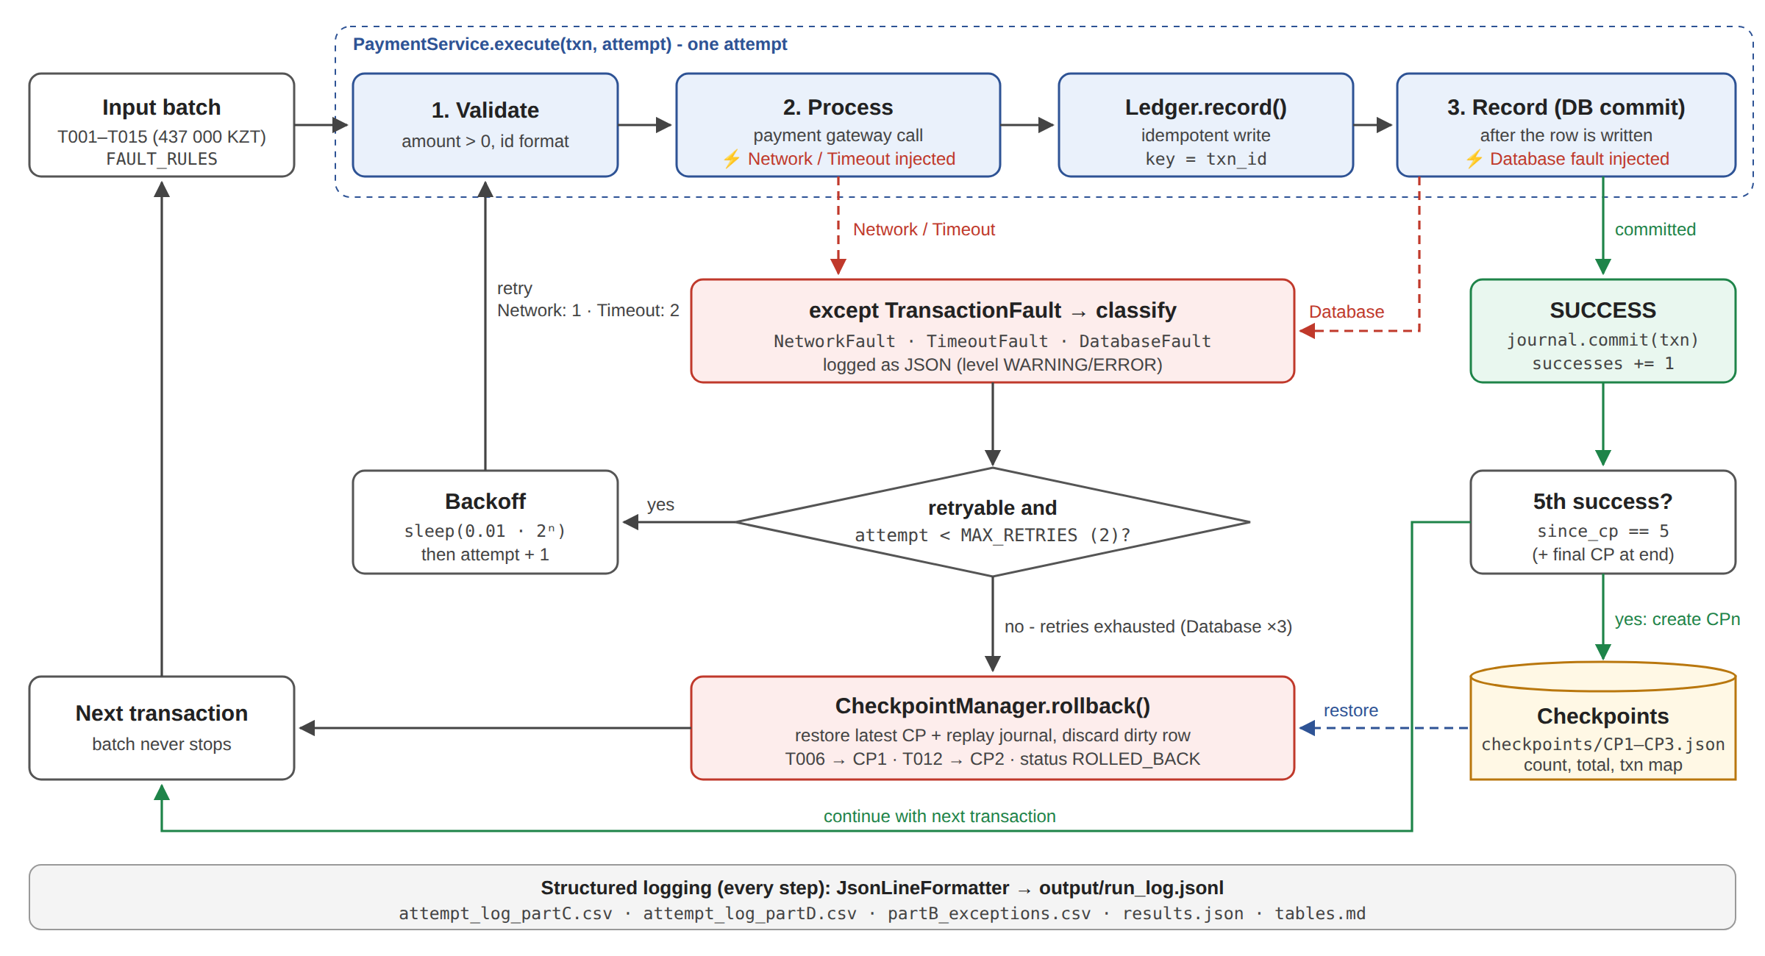
Figure 1. Architecture of the processor

Part A - Baseline Implementation
The baseline has no error handling. It stops at the first failure (T002, Network).
Metric | Result
Transactions attempted | 2
Successful transactions | 1
Transactions lost | 14
Processed amount (KZT) | 12 000
Lost amount (KZT) | 425 000

Lost = 437 000 - 12 000 = 425 000 KZT. T003-T015 were never processed.
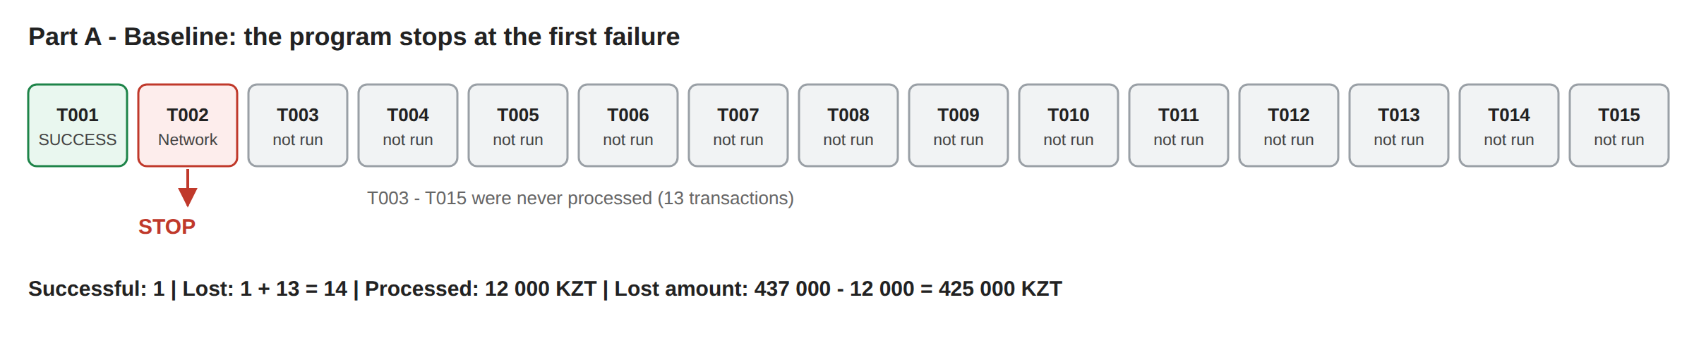
Figure 2. Part A - baseline stops at T002

Part B - Exception Handling
Each transaction has its own try/except. The error is logged and the program moves to the next transaction.
Transaction | Failure | Exception | Recovery Action | Final Status
T002 | Network | NetworkFault | Logged, skipped, continued | FAILED
T004 | Timeout | TimeoutFault | Logged, skipped, continued | FAILED
T006 | Database | DatabaseFault | Logged, skipped, continued | FAILED
T008 | Network | NetworkFault | Logged, skipped, continued | FAILED
T010 | Timeout | TimeoutFault | Logged, skipped, continued | FAILED
T012 | Database | DatabaseFault | Logged, skipped, continued | FAILED
T015 | Network | NetworkFault | Logged, skipped, continued | FAILED

Result: 8 successful, 7 failed, 96 000 KZT processed.
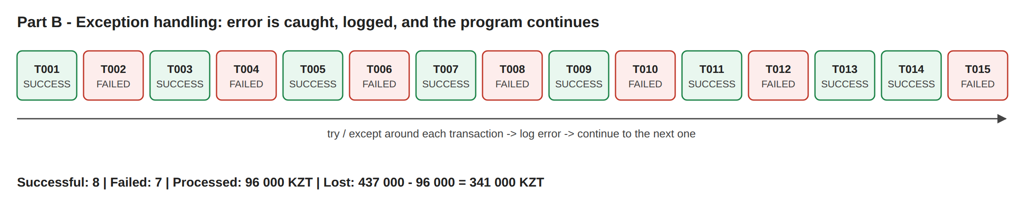
Figure 3. Part B - failed transactions are skipped

Part C - Retry Mechanism
Max 2 retries per transaction. Network succeeds on retry 1, Timeout on retry 2, Database fails 3 times and is rolled back. The log is saved to attempt_log_partC.csv.
Timestamp/Step | Transaction | Attempt | Failure | Action | Result
1 19:17:54 | T001 | Initial | None | Processed | SUCCESS
2 19:17:54 | T002 | Initial | Network | Retry | FAIL
3 19:17:54 | T002 | Retry 1 | None | Processed | SUCCESS
4 19:17:54 | T003 | Initial | None | Processed | SUCCESS
5 19:17:54 | T004 | Initial | Timeout | Retry | FAIL
6 19:17:54 | T004 | Retry 1 | Timeout | Retry | FAIL
7 19:17:54 | T004 | Retry 2 | None | Processed | SUCCESS
8 19:17:54 | T005 | Initial | None | Processed | SUCCESS
9 19:17:54 | T006 | Initial | Database | Retry | FAIL
10 19:17:54 | T006 | Retry 1 | Database | Retry | FAIL
11 19:17:54 | T006 | Retry 2 | Database | Rollback | ROLLBACK
12 19:17:54 | T007 | Initial | None | Processed | SUCCESS
13 19:17:54 | T008 | Initial | Network | Retry | FAIL
14 19:17:54 | T008 | Retry 1 | None | Processed | SUCCESS
15 19:17:54 | T009 | Initial | None | Processed | SUCCESS
16 19:17:54 | T010 | Initial | Timeout | Retry | FAIL
17 19:17:54 | T010 | Retry 1 | Timeout | Retry | FAIL
18 19:17:54 | T010 | Retry 2 | None | Processed | SUCCESS
19 19:17:54 | T011 | Initial | None | Processed | SUCCESS
20 19:17:54 | T012 | Initial | Database | Retry | FAIL
21 19:17:54 | T012 | Retry 1 | Database | Retry | FAIL
22 19:17:54 | T012 | Retry 2 | Database | Rollback | ROLLBACK
23 19:17:54 | T013 | Initial | None | Processed | SUCCESS
24 19:17:54 | T014 | Initial | None | Processed | SUCCESS
25 19:17:54 | T015 | Initial | Network | Retry | FAIL
26 19:17:54 | T015 | Retry 1 | None | Processed | SUCCESS

Total: 26 attempts, 11 retries, 2 rollbacks, 13 successful.
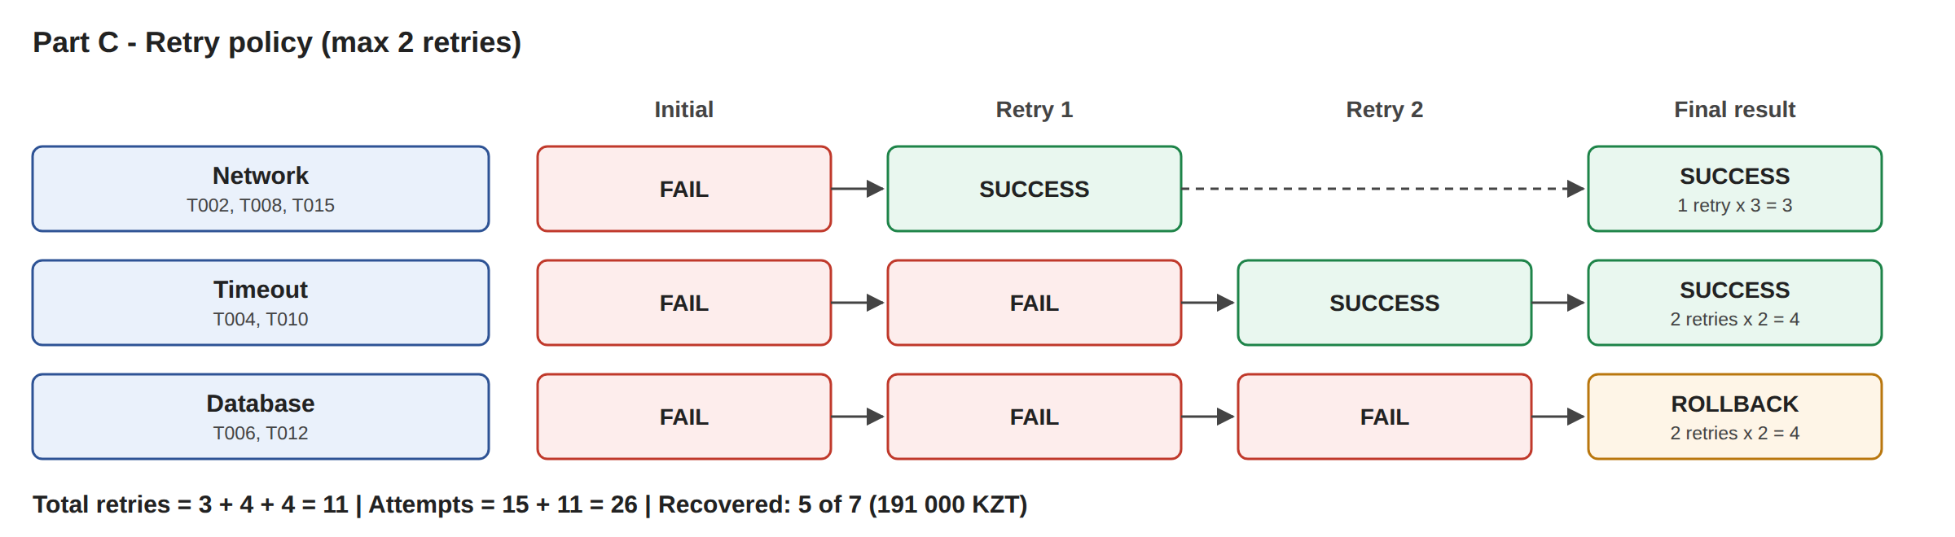
Figure 4. Part C - retry policy

Part D - Checkpoint and Rollback
A checkpoint is saved after every 5 successful transactions. If a Database error fails 3 times, the data goes back to the last checkpoint and processing continues.
Checkpoint | Successful transactions | Total amount (KZT) | State saved
CP1 | 5 | 103 000 | T001-T005 (CP1.json)
CP2 | 10 | 214 000 | T001-T011 (CP2.json)
CP3 | 13 | 287 000 | T001-T015 (CP3.json)

T006 was rolled back to CP1, T012 to CP2. Only 13 transactions succeed, so CP3 is saved at the end of the batch.
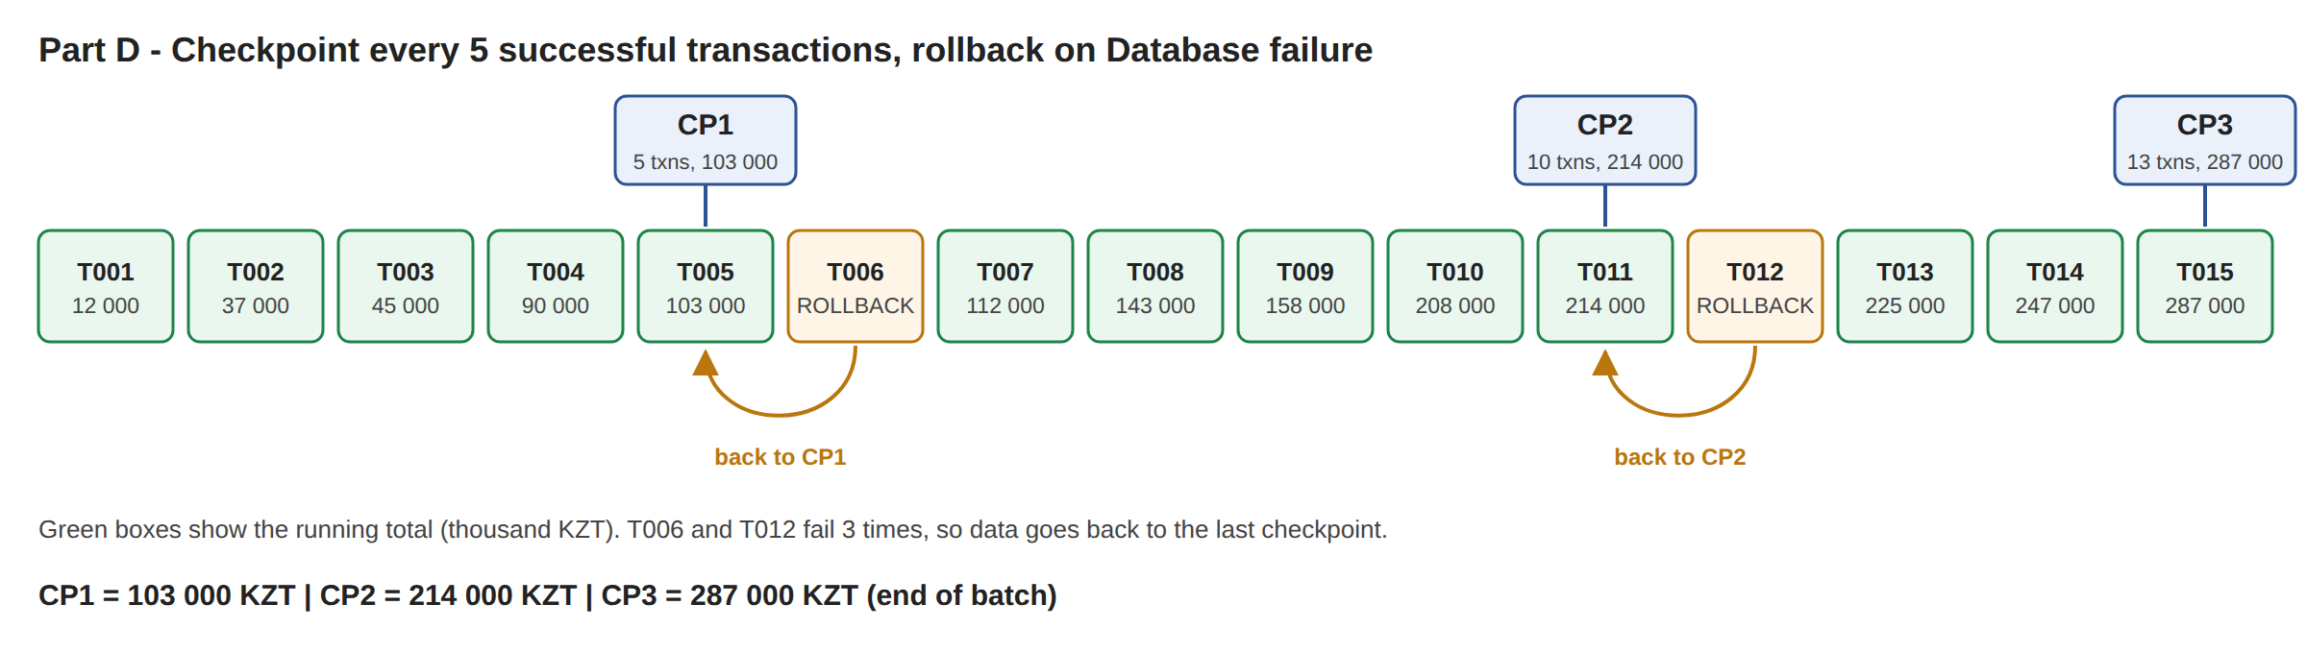
Figure 5. Part D - checkpoints and rollback

Part E - Before/After Analysis
Metric | Baseline | Fault-tolerant | Improvement
Successful transactions | 1 | 13 | +12
Failed transactions | 14 | 2 | -12
Lost amount (KZT) | 425 000 | 150 000 | -275 000
Retries | 0 | 11 | +11
Rollbacks | 0 | 2 | +2
Completion rate | 6.67% | 86.67% | +80%
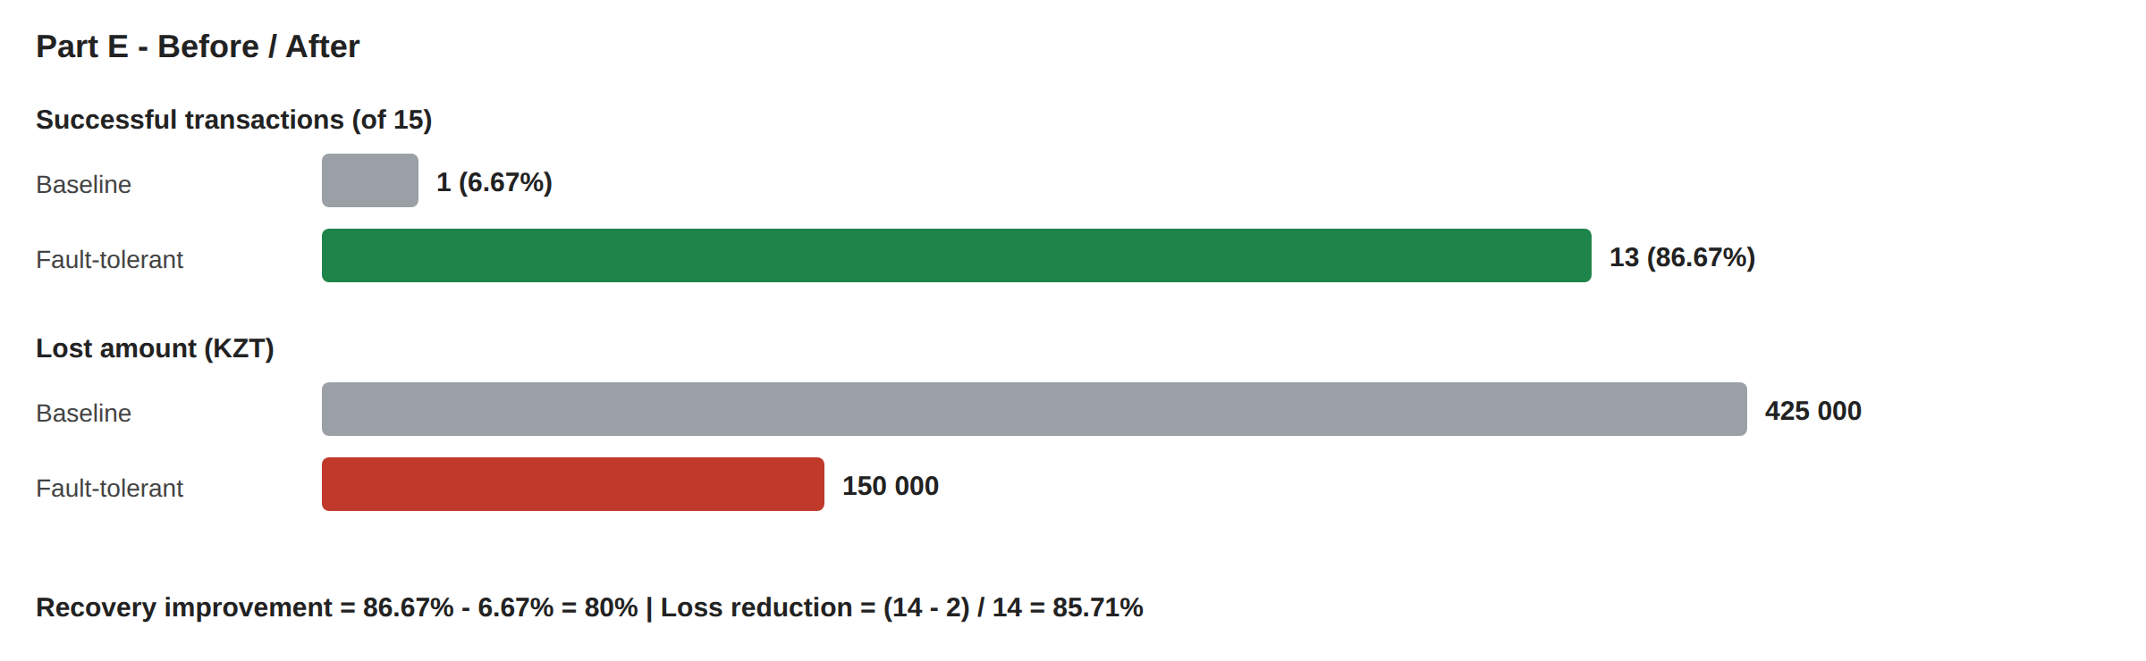
Figure 6. Part E - before and after

1. Recovery improvement
Baseline: 1/15 = 6.67%. Fault-tolerant: 13/15 = 86.67%. Improvement = 86.67% - 6.67% = 80%.

2. Transaction-loss reduction
(14 - 2) / 14 = 85.71%. By amount: (425 000 - 150 000) / 425 000 = 64.71%.

3. Which mechanism contributed most?
Retry. It recovered 5 of 7 failed transactions (191 000 KZT). Exception handling was also important because without it the program stops at the first error.

4. When is retry unsafe or inappropriate?
- When the operation is not idempotent - the student can be charged twice.
- For permanent errors like wrong amount or not enough money. Retry will not fix them.
- When the server is overloaded. Many retries make it worse.

5. Why is rollback required for database failure?
A database error can leave half-written data. Rollback returns the system to the last correct state, so a payment is either fully saved or not saved at all.

6. Why is idempotency important in student payment processing?
With retries the same payment can be sent more than once. Idempotency makes sure it is recorded only once, so a student does not pay twice or get a scholarship twice. In my code the transaction ID is used as the key.

Conclusion
The baseline processed only 1 of 15 transactions. With exception handling, retry and rollback, 13 of 15 were processed. The 2 Database failures were rolled back, so the data stays correct.

STUDENT TECHNICAL WORK REPORT / SUBMISSION RECORD

1. Student and Submission Information
Required field | Student entry
Student full name | Zhubanysh Burlibayev
Student ID | 255255625
Group / cohort | CSE-2502M
Instructor | Serek Azamat
Date of submission | 27 September 2026
Git repository | https://github.com/MrZhorik09/Ass2
Attached code / file names | fault_tolerant_processor.py, run_log.jsonl, attempt_log_partC.csv, attempt_log_partD.csv, CP1-CP3.json

2. Work Period and Task Record
Item | Student entry
Work start date/time | ________________________
Work completion date/time | ________________________
Main task completed | Fault-tolerant payment processor (Parts A-E)
Tools / technologies used | Python, Git
Main technical output produced | Python program, logs, checkpoint files, result tables

3. Report Structure

1. Baseline Implementation
Required content | Student response / evidence
Summary | No error handling. The program stops at T002. 1 successful, 14 lost.
Evidence / calculation / artifact reference | Lost = 437 000 - 12 000 = 425 000 KZT. See run_log.jsonl.
Student-specific decision or observation | One network error stopped the whole batch.

2. Exception Handling
Required content | Student response / evidence
Summary | Separate exception classes for Network, Timeout and Database. Each transaction has its own try/except. 8 successful, 7 failed.
Evidence / calculation / artifact reference | partB_exceptions.csv, run_log.jsonl.
Student-specific decision or observation | I log each error as a JSON line so it is easy to search.

3. Retry Mechanism
Required content | Student response / evidence
Summary | Max 2 retries. Network succeeds on retry 1, Timeout on retry 2, Database is rolled back.
Evidence / calculation / artifact reference | attempt_log_partC.csv (26 rows, 11 retries).
Student-specific decision or observation | I added a small delay before each retry (0.01 s, then 0.02 s).

4. Checkpoint and Rollback
Required content | Student response / evidence
Summary | Checkpoint after every 5 successes. T006 rolled back to CP1, T012 to CP2.
Evidence / calculation / artifact reference | CP1.json, CP2.json, CP3.json.
Student-specific decision or observation | CP3 is saved at the end because only 13 transactions succeed.

5. Before/After Analysis
Required content | Student response / evidence
Summary | Successful 1 -> 13, lost amount 425 000 -> 150 000 KZT.
Evidence / calculation / artifact reference | Improvement = 80%. Loss reduction = (14 - 2)/14 = 85.71%.
Student-specific decision or observation | Amount reduction is lower because T006 and T012 are the biggest payments.

6. Technical Reflection
Required content | Student response / evidence
Summary | Retry is safe only with idempotency. Rollback keeps data correct after a DB error.
Evidence / calculation / artifact reference | Duplicate writes were skipped (see run_log.jsonl).
Student-specific decision or observation | Transaction ID is used as the idempotency key.

4. Individual Work and Anti-Plagiarism Record
Individual evidence | Student entry
My unique technical decision | The transaction ID is used as an idempotency key, so a payment is never recorded twice during retries. I also added a small delay before each retry (0.01 s, then 0.02 s).
My own implementation / calculation evidence | Recovery improvement = 86.67% - 6.67% = 80%. Loss reduction = (14 - 2) / 14 = 85.71%. Retries = 3 + 4 + 4 = 11. Checkpoints: 103 000, 214 000, 287 000 KZT.
Exact file, code, commit, notebook, or log reference | fault_tolerant_processor.py, https://github.com/MrZhorik09/Ass2, commit ________, logs: output/run_log.jsonl, output/attempt_log_partC.csv
One problem I personally encountered and how I solved it | When I filled the Part C table, I wrote the first attempt of T004 as Retry 1 instead of Initial, and the table had only 6 rows. I checked it against FAULT_RULES and attempt_log_partC.csv and fixed it: Timeout needs 3 attempts (Initial, Retry 1, Retry 2), and the full log has 26 rows.
One limitation of my own solution | Data is stored in memory, so if the program crashes, everything after the last checkpoint is lost. Failures come from a fixed table, so random real-world errors are not tested.

5. Evidence Checklist
☑ Completed required tables and calculations
☑ Architecture / RBD / FTA / security diagram where applicable
☑ Source code or configuration files where applicable
☑ Execution logs / experiment results where applicable
☐ Screenshots or other reproducible evidence where applicable
☑ Links to code, datasets, notebooks, or artifacts
☑ Before/after comparison where applicable
☑ Final technical conclusion

6. Student Declaration
I confirm that this report describes my own work. I have not copied another student's report, code, calculations, diagrams, logs, screenshots, or conclusions. Any external source or reused material has been identified. I understand that I may be asked to reproduce or explain any part of this submission during the oral defense.
Role | Name | Signature | Date
Student / Executor | Zhubanysh Burlibayev
Instructor / Accepted by | Serek Azamat

