# [StCatsHacks.org](http://StCatsHacks.org)| hosted by **cs@stcats** | [hack@stcatherines.gr](mailto:hack@stcatherines.gr) *

**About**

StCatsHacks is a student hackathon, run by CS students at St. Catherine’s British School. On 31st of September - 1st of October, 2017, 100 makers and hackers will join us for 24 hours (in total) of hard work and loads of fun.

**Scope**

We were hoping that the hackathon, as well as being educational for those involved, is impactful to the greater community. With the refugee crisis still raging and greatly affecting Greece, we thought about the many problems within refugee camps that could be solved through dedicated apps, systems or websites. Thus, we decided to gear the 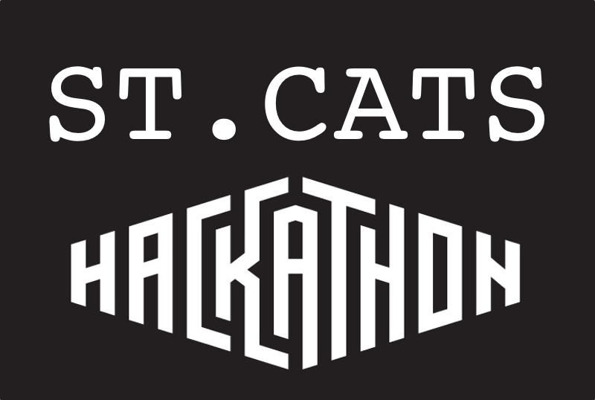hackathon towards helping the refugee community (either with day-to-day problems or with long-term needs such as education). We are going to limit the creations of the participants in this way only and therefore allow them to find their own imaginative ways to help the refugee community. The ‘winner’ of the hackathon is going to be primarily determined by the extent to which the program created fulfills its aims. The extent to which the program helps the target population would be a secondary criterion in the selection of the winning team.

**Who we are**

We are computer science students from St. Catherine’s British School hoping to organize an inter-school hackathon that will incentivize people to put their innovative skills to the test and help the refugee community. The competitive nature of the hackathon allows for rigorous and collaborative thinking. We hope to create a annual hackathon for high-school students to showcase their skills in the field of STEM.

**Where**

We are considering:

* Stavros Niarchos Foundation
* Onassis Cultural Centre
* Divani Caravel Hotel
* The Cube
* St. Catherine’s main hall

**When**

September 31st - October 1st, starting at 4 PM. Students will be able to register via [Eventbrite](https://www.eventbrite.com/) until 1 week before the event.

**Who**

We expect 100 high-school and university students.

**Why we want you**

We would like you to be a part of StCatsHacks because we know that you will add value and help us organize an awesome event.

**How you can get involved**

* cover venue expenses
* cover expenses in wish list
* offer internships to winners
* send mentor(s) and/or judges
* provide exclusive access to courses

**How you will benefit**

* **Gain Student Awareness**:thanked at kickoff & award, logos on online & print material, company banner
* **Run workshops & Tutorials**: Catch students’ eyes with your breaking technology

**Prizes**

* Cheque
* Internship
* Exclusive access to courses
* Mentoring

**Wish list**

* Snacks & Drinks
* Shirts
* Badges
* Coffee

**Interested in becoming a sponsor?**

Contact us at [nikolas.kamarinakis@stcatherines.gr](mailto:nikolas.kamarinakis@stcatherines.gr)