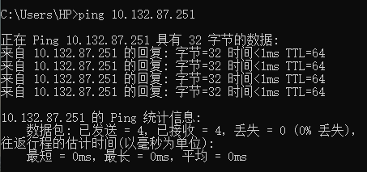

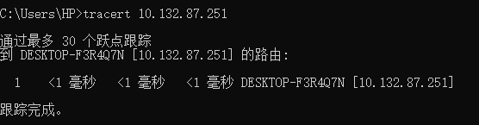

P5.

a.

收费站将整个车队推向公路的时间为 d1 = 12s*10 = 120s =2min；

两收费站之间距离 150km / 2=75 km，

从一个收费站到另一个的时间 d2 =75km/(100km/h)= 0.75 h

总时间 d = 3d1 + 2d2

= 3 * 2min + 2 * 0.75h * (60min/h) = 6min + 90 min = 96min

b.

d1’ = 12s * 8 = 96s = 1.6min

d’ = 3d1’ + 2d2 = 3 * 1.6min + 2 * 0.75h * (60min/h) = 94.8min

**P7.**

主机 A 产生 56 字节的分组需要 = 56 * 8b / 64kbps = 7ms  
传输时延 = 56 * 8b / 2Mbps = 0.224ms  
总时间 = 7ms + 10ms + 0.224ms = 17.224ms

**P8.**

**a.**  
3Mbps/150kbps = 20个用户

**b.**  
p = 10% = 0.1

