**DOCTOR**

**PROJECT GROUP MEMBERS**

|  |  |
| --- | --- |
| **Students id** | **Students name** |
| ***Student1449863*** | ***M.ADEEL CHOWDHRY*** |
| ***Student1452450*** | ***M.ALI*** |
| ***Student1413553*** | ***MURTAZA*** |
| ***Student1450989*** | ***ABDUL SAMAD*** |

**CURRICULUM BATCH**

**7062 2301C2**

**FACULTY**

**SIR HARIS NASEER**

**CO-ORDINATOR**

**MISS MAHA HAIDER**

**Certificate**

This is to certify that the dissertation entitled **“DOCTOR”** is

***M.ADEEL CHOWDHRY* *Student1449863*,**

***M.ALI*  *Student1452450*,**

***MURTAZA* *Student1413553 and***

***ABDUL SAMAD Student1450989*** in their partial fulfilment of the requirement of the award of the Aptech Computer Certified.

**Acknowledgement**

The success and final outcome of this project required a lot of guidance and assistance from many people and I am extremely privileged to have got this all along the completion of my project. All that I have done is only due to such supervision and assistance and I would not forget to thank them.

I respect and thank Aptech for providing me an opportunity to do the project work in ACE and giving us all support and guidance, which made me complete the project duly. I am extremely thankful to Aptech for providing such a nice support and guidance.

I owe my deep gratitude to our project guide **SIR HARIS NASEER**, who took keen interest on our project work and guided us all along, till the completion of our project work by providing all the necessary information for developing a good system.

|  |
| --- |
| **STUDENTY1449863 M. ADEEL CHOWDHRY**  **STUDENTY 1452450 M.ALI**  **STUDENTY 1413553 MURTAZA**  **STUDENTY 1450989 ABDUL SAMAD** |

**Abstract**

This project is aimed at developing an DOCTOR for the facilities in the campus. This is an internet based application that can be accessed throughout the campus. This system can be used to automate the workflow of service requests for the various facilities in the campus. This is an integrated system that covers different kinds of facilities like class-rooms, labs, hostels, mess, canteen, gymnasium, computer center, faculty club etc. Registered users (students, faculty, lab-assistants and others) will be able to log in a request for service for any of the supported facilities.

These requests will be sent to the concerned people, who are also valid users of the system, to get them resolved. There are features like email notifications/reminders,

# INTRODUCTION

**Introduction:**

Across the world, people are facing unforeseen challenges due to Coronavirus

pandemic. Design and develop a web application for online test and vaccination booking

system for patient. The Docter web app connects the people with the hospital and the

administration to come together and fight the pandemic. With this web app, one can

track the vaccination appointment, history and Docter solution guidelines for symptoms.

**Modules:**

The entire project mainly consists of 3 modules, which are

* + - Admin
    - hospital
    - patient

#### admin:

#### all patients details

#### report of Docter/vaccination

#### test report, vaccination (date/week/monthly report)

#### list of vaccine

#### approval hospital login

#### list of hospitals

#### booking details

#### hospital:

#### Register

#### Login

#### List of patient details

#### Request from patient (Docter)

#### Approve or Reject

#### Update Docter test result

#### Update Vaccination status

#### Patient:

#### Register

#### Login

#### List of patient details

#### Request from patient (Docter)

#### Approve or Reject

#### Update Docter test result

#### Update Vaccination status

# 

# REQUIREMENTS

**Requirements:**

**User Registration:**

* Admin, Hospital, and Patient should be able to create accounts with their

respective details.

* They must provide necessary information like name, address, and login

credentials (username and password).

**Admin Functions:**

* View All Patient Details: The admin can see profiles of all registered patients.
* DOCTER Reports: Admin can generate reports on patients,

including test reports, in date-wise formats.

* Vaccine Availability: Admin can check the availability of vaccines.
* Hospital Approval: Admin can approve or reject hospital login requests.
* Hospital Listings: Admin can view details of hospitals**.**
* Booking Details: Admin can view DOCTER test booking details made by

patients.

**Hospital Functions:**

* Hospital Registration and Login: Hospitals can register and log in with their

details.

* View Patient Details: Hospitals can see the details of patients approved for

DOCTER tests.

* Patient Requests: Hospitals can receive requests from patients for

tests or vaccinations and can approve or reject them.

* Update Results: Hospitals can update the DOCTER test results for

patients.

* Update Vaccination Status: Hospitals can update the vaccination status of

patients.

**Patient Functions:**

* Patient Registration and Login: Patients can register and log in with their

details.

* Search Hospitals: Patients can search for hospitals offering DOCTER or

vaccinations.

* Request for Testing/Vaccination: Patients can request DOCTER testing or

vaccinations from hospitals.

* Report Access: Patients can access their DOCTER test result reports and

vaccination recommendations.

* Hospital Appointments: Patients can book appointments for DOCTER at

hospitals.

View Appointments: Patients can check their appointment details.

* View Results: Patients can view their DOCTER results and vaccination

suggestions.

* Profile Management: Patients can check and edit their profile details.
* These requirements aim to create a web application that connects patients with

hospitals for DOCTER and vaccination services. The system allows for

user registration, appointment scheduling, and management of DOCTER-

related data by administrators, hospitals, and patients.

# REQUIREMENT SPECIFICATION

**Hardware**

* A minimum computer system that will help you access all the tools in the

courses is a Pentium 166 or better

* 128 Megabytes of RAM or better

**Operating System**

* LINUX / Windows 2000 Server (or higher if possible)

**Software**

* PHP
* MySQL
* PERL
* Apache

**DIAGRAM**

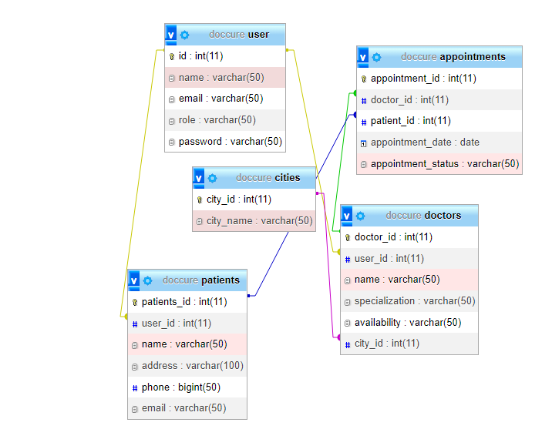

**ADMIN**

**SCREENSHOTS**

## LOGIN

## Doccure - Login - Google Chrome

**CHANGE PASS**

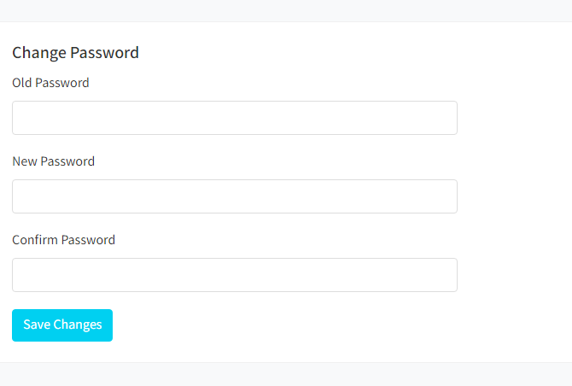

## HEADER

## 

**SIDEBAR**

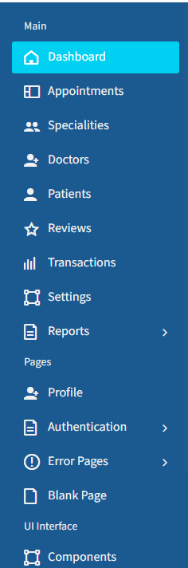

**HOME**

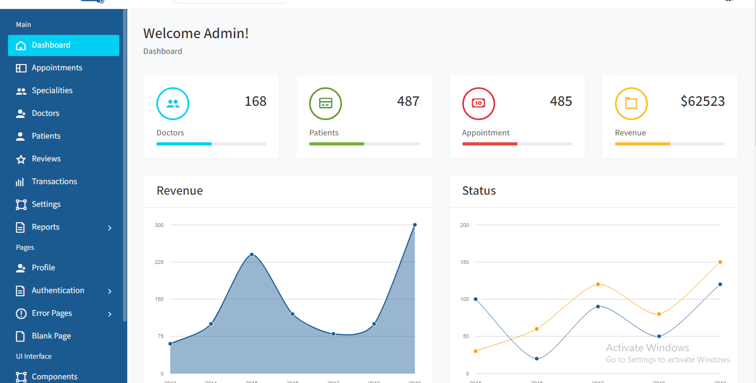

**PROFILE**

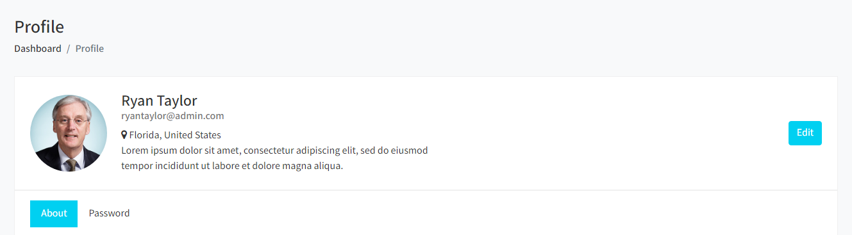

**DOCTOR LIST**

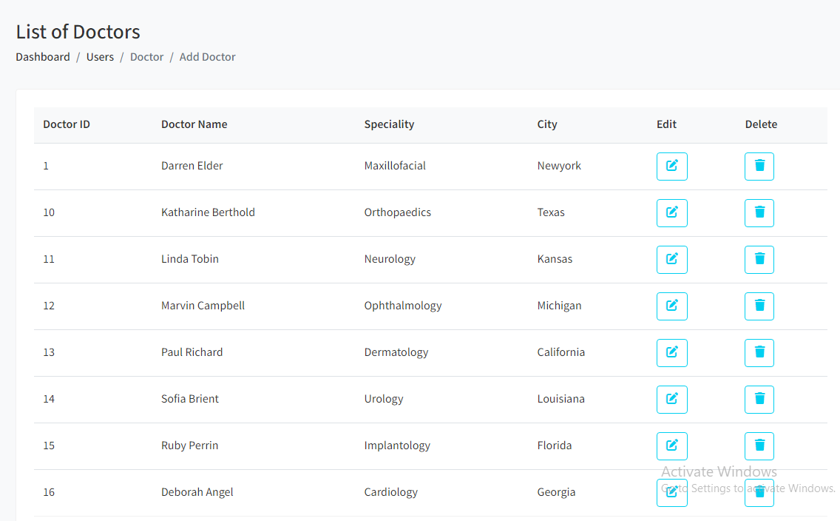

**THANK YOU!**