**Exp. 1** Design an LED flasher

**Circuit Diagram:**

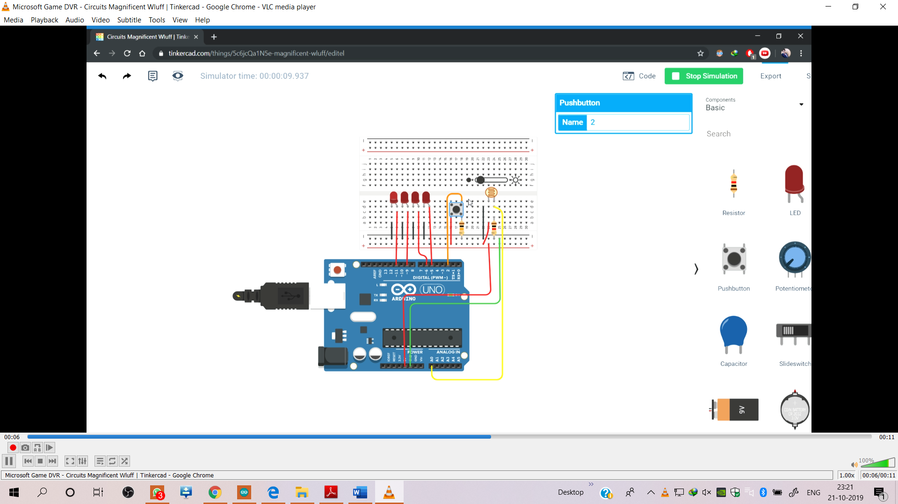

**Theory:**  A Light Dependent Resistor (LDR) is also called a photoresistor or a cadmium sulfide (CdS) cell. It is also called a photoconductor. It is basically a photocell that works on the principle of photoconductivity. The passive component is basically a resistor whose resistance value decreases when the intensity of light decreases. This  is mostly used in light varying sensor circuit, and light and dark activated switching circuits. Some of its applications include camera light meters, street lights, clock radios, light beam alarms, reflective smoke alarms, and outdoor clocks.

**Concept Used :**

This system works by sensing the intensity of light in its environment. The sensor that can be used to detect light is an [LDR](https://en.wikipedia.org/wiki/Photoresistor). It's inexpensive, and you can buy it from any local electronics store or online.

The LDR gives out an analog voltage when connected to VCC (5V), which varies in magnitude in direct proportion to the input light intensity on it. That is, the greater the intensity of light, the greater the corresponding voltage from the LDR will be. Since the LDR gives out an analog voltage, it is connected to the analog input pin on the Arduino. The Arduino, with its built-in ADC (analog-to-digital converter), then converts the analog voltage (from 0-5V) into a digital value in the range of (0-1023). When there is sufficient light in its environment or on its surface, the converted digital values read from the LDR through the Arduino will be in the range of 800-1023.

**Learning & Observations:**

We observed that photo resistor works on the principle of voltage which is converted into the digital range value by coding in Aurduino Uno Software

**Problems & Troubleshooting :**

Hardware may not be connect correctly.

**Precautions**

Don’t put wires in front of photoresistor

**Learning Outcomes**

We learnt about the working of photoresistor