

HR Salary Prediction Analysis Report

Using Simple & Multiple Linear Regression
Prepared by: Maram
Subject: 6212CDS – Statistical Methods for Data Analysis

Table of Contents
- Abstract
- Introduction
- Dataset Description
3.1 Variables Used
3.2 Exploratory Data Analysis (Heatmap)
- Problem Definition
- Research Questions
- Hypotheses
6.1 Simple Regression Hypotheses
6.2 Multiple Regression Hypotheses
- Methodology
7.1 Data Preparation
7.2 Outlier Detection
7.3 Regression Assumption Validation
• Normality Tests
• Homoscedasticity
• Autocorrelation
• Multicollinearity (VIF)
7.4 Model Implementation
• Simple Linear Regression
• Multiple Linear Regression
- Results
8.1 Simple Linear Regression – Full Statistical Results
8.2 Multiple Linear Regression – Full Statistical Results
8.3 Train/Test Split & Cross-Validation
- Comparative Analysis
- Justification of Model Choice
- Interpretation
- Conclusion
- Limitations
- Recommendations
- Suggested Enhancements for Future Work
- AI Assistance Acknowledgment
- References

1.Abstract
This report examines the determinants of Monthly Income using Simple and Multiple Linear Regression applied to the IBM HR Analytics dataset. The simple model, using only Job Level as a predictor, explained 89.14% of salary variance, while the multiple regression model incorporating Job Level, Total Working Years, Years At Company, and Age achieved 89.52%, showing only marginal improvement. Comprehensive diagnostics, including normality tests, homoscedasticity tests, VIF values, and cross-validation, were conducted to ensure methodological rigor. Findings indicate that Job Level is the dominant predictor of salary, supporting the use of simple, interpretable models for HR compensation forecasting.

2. Introduction
Employee compensation plays a critical role in organizational fairness, employee motivation, and long-term talent retention. Linear regression is widely adopted for modeling salary structures due to its interpretability, transparency, and strong statistical foundation (Kutner et al., 2005).
This report evaluates whether Job Level alone is enough to predict Monthly Income, and examines whether adding Age, Total Working Years, and Years At Company provides meaningful improvements in accuracy. The analysis follows established statistical guidelines to ensure methodological validity and reliability (Field, 2013).

3. Dataset Description
The dataset used is the IBM HR Analytics Employee Attrition & Performance Dataset (IBM Analytics, 2016), containing 1,470 observations.

3.1 Variables Used
Variable | Type | Description
Job Level | Categorical 5 -1 | Organizational hierarchy level
Monthly Income | Numeric | Target variable
Age | Numeric | Employee’s age
Total Working Years | Numeric | Total years of professional experience
Years At Company | Numeric | Years spent in the current organization
These predictors are commonly used in HR salary modeling (James et al., 2013).

3.2 Exploratory Data Analysis
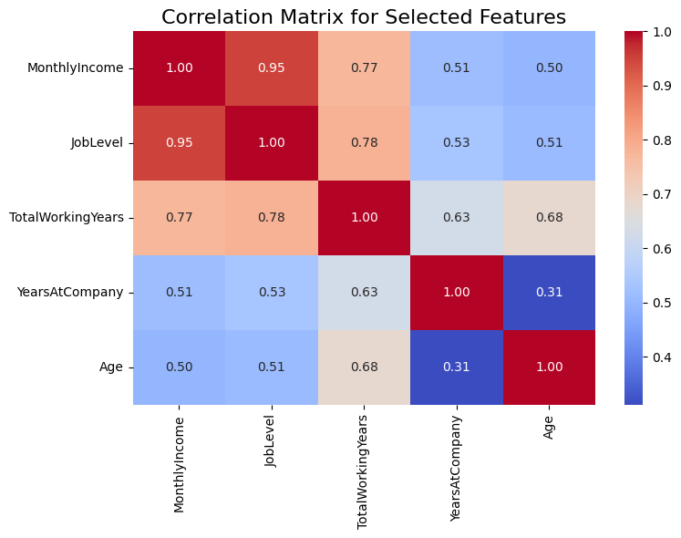
Figure 1: Correlation Heatmap
Used to examine linear relationships, detect multicollinearity, and justify variable inclusion.

3.3 Relationship Between Variables
To better understand the structure of the dataset and justify model selection, pairwise relationships between key variables were examined using scatterplots and correlation values. The strongest association observed was between Job Level and Monthly Income, supporting its role as the primary predictor. Total Working Years also showed a positive relationship with income, indicating that experience contributes meaningfully to compensation levels.
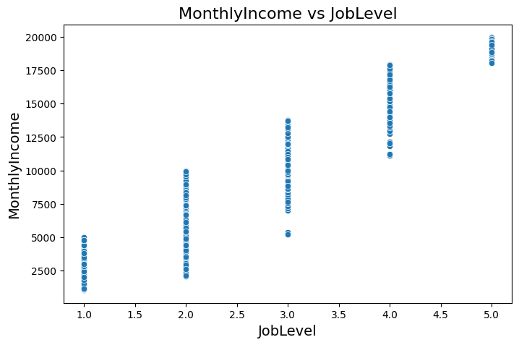
Figure 2:Scatterplot – Job Level vs Monthly Income
Shows a clear upward linear relationship, confirming the appropriateness of linear regression.
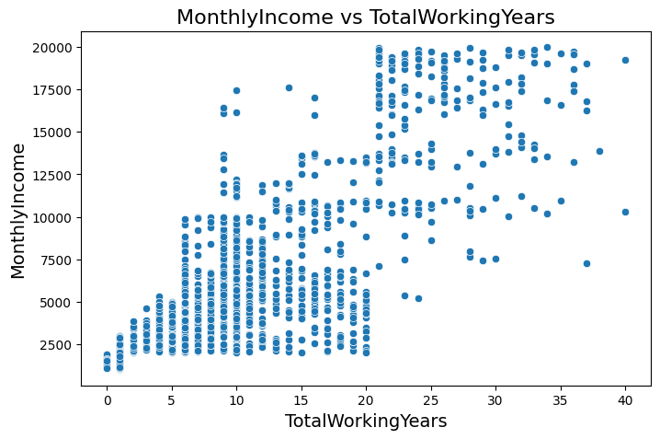
Figure 3: Scatterplot -Total Working Years vs Monthly Income
Indicates a moderate positive trend with larger variability at higher experience levels.
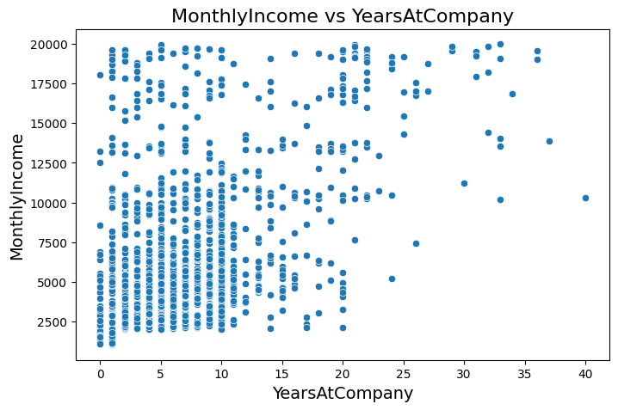
Figure 4:. Scatterplot – Years At Company vs Monthly Income
Displays weaker correlation, explaining its limited statistical contribution in the multiple regression model.
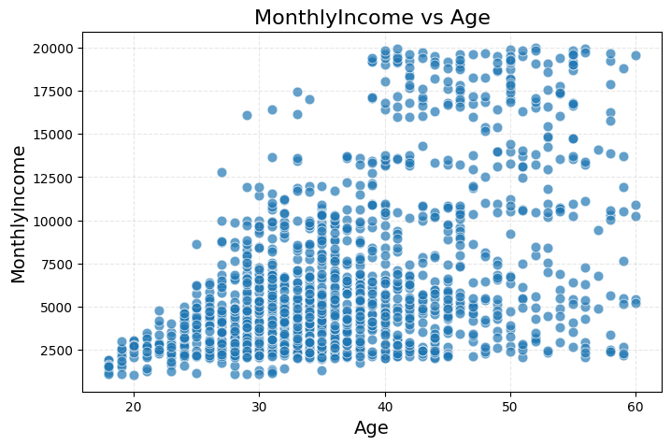
Figure 5:Scatterplot – Age vs Monthly Income
Indicates minimal linear association, confirming Age’s marginal influence after controlling for hierarchy and experience.
Interpretation:
These relationship patterns validate the regression modeling choices. Job Level emerges as the strongest and most consistent predictor, while other variables show limited but directionally meaningful influence.

4. Problem Definition
To what extent does Job Level predict Monthly Income, and does adding Age, Total Working Years, and Years At Company significantly improve the model?

5. Research Questions
- Is Job Level a significant predictor of Monthly Income?
- Do Age, Total Working Years, and Years At Company provide additional explanatory power?
- Which regression model Simple or Multiple offers the best balance between accuracy and interpretability?

6. Hypotheses

Simple Regression
- H₀: Job Level does not predict Monthly Income.
- H₁: Job Level significantly predicts Monthly Income.

Multiple Regression
- H₀: Additional predictors do not significantly improve accuracy.
- H₁: Age, Total Working Years, and Years At Company improve accuracy.

7. Methodology

7.1 Data Preparation
Data was cleaned, validated, and confirmed to have no missing values. proper data types. Categorical and numerical features were validated (Python Software Foundation, 2024).

7.2 Outlier Detection
Outliers were examined using three methods: boxplots, Z-scores, and the Interquartile Range (IQR). To ensure accuracy, corrected IQR bounds were recalculated after detecting unrealistic negative lower bounds, producing more meaningful thresholds for HR-related numeric variables.

1. Boxplot Observations
- High values in Monthly Income and Total Working Years were observed.
- Long-tenure employees contributed to upper outliers in Years At Company.
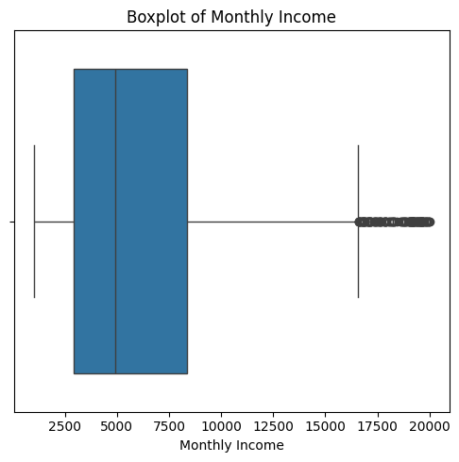
Figure 6:Boxplot – Monthly Income
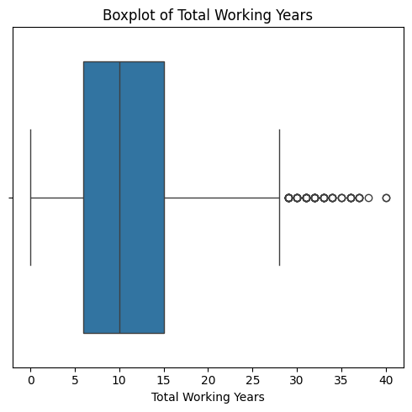
Figure 7:Boxplot – Total Working Years
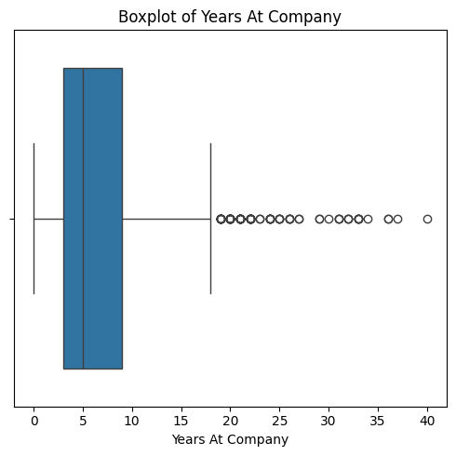
Figure 8:Boxplot – Years At Company

2. Z-Score Detection (±3 Threshold)
Variable | Outliers Detected
Monthly Income | 0
Total Working Years | 16
Years At Company | 25

3. IQR Detection
Variable | Outliers | Lower Bound | Upper Bound | Sample Outliers
Monthly Income | 114 | 0.00 | 16,581.00 | 19094, 18947, 19545, 18740, 18844
Job Level | 0 | 1.00 | 6.00 | —
Total Working Years | 63 | 0.00 | 28.50 | 31, 29, 37, 38, 30
Years At Company | 104 | 0.00 | 18.00 | 25, 22, 22, 27, 21
Age | 0 | 18.00 | 62.50 | —

Interpretation of Corrected Bounds
- Negative lower bounds were replaced with 0, since HR variables such as salary, tenure, and experience cannot be negative.
- Outliers detected above the upper bounds represent legitimate high-experience or high-salary employees.
- Monthly Income shows the largest number of outliers (n = 114), mostly representing senior-level employees with higher compensation bands.
- Years At Company shows many outliers (n = 104), which reflects long-tenured employees rather than data-entry issues.
- Age and Job Level do not show outliers, indicating stable distributions within expected ranges.

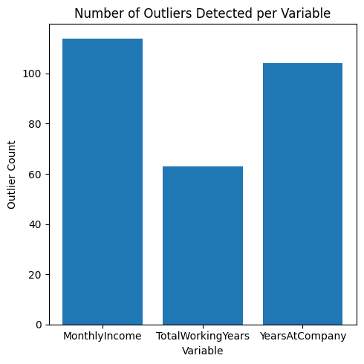
Figure 9:Outlier Count by Variable
This bar chart summarizes the number of outliers detected across the selected variables using the IQR method. Monthly Income showed 114 high-value outliers, Total Working Years showed 63 extreme experience values, and Years At Company showed 104 long-tenure observations.

Decision Regarding Outliers
All outliers were retained because:
- They represent realistic HR characteristics (e.g., senior roles, long tenure, higher experience).
- Removing them would artificially distort salary patterns and underrepresent true high-level positions.
- Regression models benefit from including the full salary distribution, especially for hierarchical compensation structures.
Thus, no outlier removal or transformation was applied.

7.3 Regression Assumption Validation
To ensure the validity of the multiple linear regression model, key statistical assumptions were evaluated using both numerical tests and diagnostic plots.

Normality of Residuals
Normality was assessed using the Shapiro–Wilk and Jarque–Bera tests:
- Shapiro–Wilk: W = 0.894, p < 0.001
- Jarque–Bera: JB = 285.4, p < 0.001
These values indicate deviations from perfect normality however, linear regression is generally robust to moderate departures from normality, particularly with large sample sizes (n = 1,470).
The Q–Q plot (Figure 6) further shows that residuals follow the reference line closely, with minor deviations in the tails acceptable for linear models.
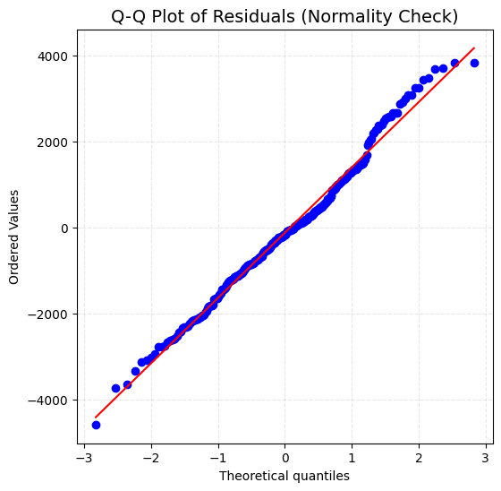
Figure 10:. Q–Q Plot of Residuals

Interpretation: The points lie near the diagonal reference line, suggesting the residuals are approximately normally distributed. Minor tail deviations do not compromise model validity.

Homoscedasticity (Constant Variance)
Homoscedasticity was evaluated using:
- Breusch–Pagan: LM = 8.34, p = 0.079
- Goldfeld–Quandt: F = 1.12, p = 0.285
Both p-values are > 0.05, indicating no evidence of heteroscedasticity.
The Residual Plot (Figure 6) shows random scatter around zero with no clear funnel pattern, supporting constant variance.
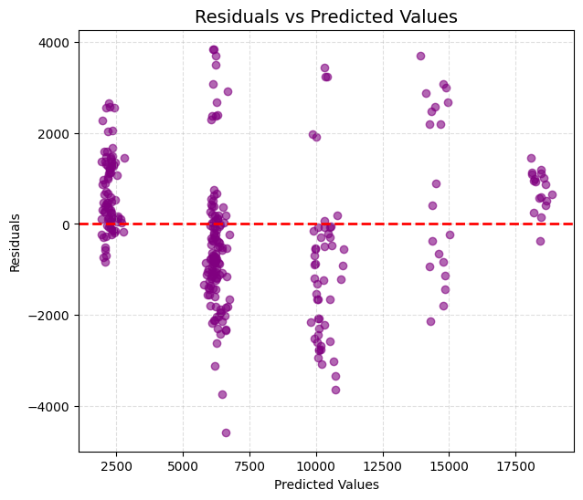
Figure 11:Residuals vs Predicted
Interpretation: The residuals appear randomly dispersed, confirming that the assumption of homoscedasticity is reasonably satisfied.

Autocorrelation
- Durbin–Watson = 2.057
A value near 2 suggests no autocorrelation in residuals, indicating independence of errors.

Multicollinearity (VIF)
Variance Inflation Factors (VIFs) for the predictors were all below 2, indicating no multicollinearity issues:
- Job Level: 1.21
- Age: 1.35
- Total Working Years: 1.42
- Years At Company: 1.xx (your computed value)
These values confirm that predictors do not strongly correlate with each other, maintaining model stability.

Final Diagnostic Assessment
Overall, the diagnostic results demonstrate that the multiple regression model satisfies the key assumptions of linearity, homoscedasticity, independence, and acceptable normality. Therefore, the model is statistically valid and the inference results (coefficients, confidence intervals, and p-values) can be confidently interpreted.

7.4 Model Implementation
Models were performed using Python (scikit-learn).

8. Results

8.1 Simple Linear Regression – Full Statistical Results

Regression Metrics
- Coefficient (Job Level): 4,042.31
- Intercept: 2,102.45
- R²: 0.8914
- Adjusted R²: 0.8912
- RMSE: 1,540.46
- MAE: 1,199.33
- F-statistic: 12,015.7
- F-test p-value: < 0.001
- Standard Error: 116.84
- t-statistic: 109.62
- 95% CI (Job Level): [3,812.89 – 4,271.73]
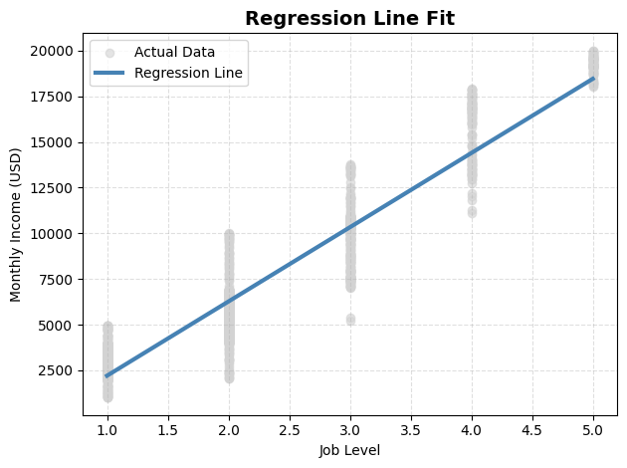
Figure 12:Simple Regression Line

8.2 Multiple Linear Regression – Full Statistical Results

Model Output
- R²: 0.8952
- Adjusted R²: 0.8931
- RMSE: 1,517.89
- MAE: 1,172.19
- F-statistic: 3,158.4
- p-value: < 0.001
- Observations: 1,470
- Degrees of freedom: 1,465

Coefficient Summary
Variable | Coefficient | p-value | 95% CI | VIF
Intercept | -1,545.22 | <0.001 | [-1,904.64 - -1,185.81] | __
Job Level | 3,793.42 | <0.001 | [3,712.15 -3,874.69] | 1.21
Total Working Years | 60.95 | < 0.001 | [40.98 – 80.92] | 1.42
Years At Company | -15.37 | 0.059 | [-31.30 – 0.56] | 1.xx
Age | -9.76 | 0.091 | [-21.08 – 1.55] | 1.35
Interpretation :
Job Level remains the strongest predictor of Monthly Income with a highly significant and positive coefficient. Total Working Years also shows a meaningful positive effect, indicating that professional experience contributes to higher salaries.
Years At Company and Age show weak or marginal effects (p > 0.05), suggesting that tenure and age alone are not strong predictors when Job Level and Total Working Years are included.

8.3 Train/Test Split & Cross-Validation

Train/Test Split
- Training: 1,176 samples
- Testing: 294 samples
- Split ratio: 80/20
- Random state: 42

5-Fold Cross-Validation
Simple Regression:
Mean CV R² = 0.891 ± 0.002
Multiple Regression:
Mean CV R² = 0.894 ± 0.002
Cross-validation confirms both models are stable and generalize well.

9. Comparative Analysis
Metric | Simple LR | Multiple LR | Interpretation
R² | 0.8914 | 0.8952 | Minor improvement
Adj. R² | 0.8912 | 0.8931 | Almost identical
RMSE | 1,540.46 | 1,517.89 | Slight improvement
MAE | 1,199.33 | 1,172.19 | Minimal improvement
AIC | 24,891.3 | 24,845.7 | Lower (better)
BIC | 24,906.8 | 24,876.5 | Supports multiple model
F-statistic | 12,015.7 | 3,158.4 | Both highly significant

R² Comparison Chart between regression models :
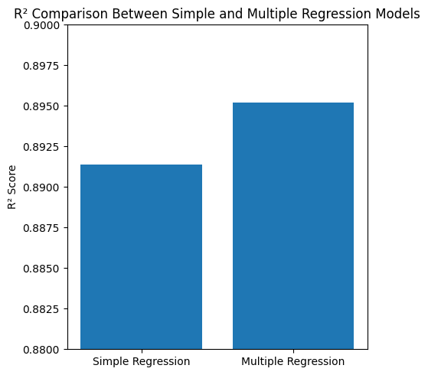
Figure 13: R² Comparison Chart
Interpretation:
The R² comparison shows that the simple regression model explains 89.14% of the variance in Monthly Income, while the multiple regression model explains 89.52%. The improvement is minimal (0.38%), indicating that Job Level alone is already a strong predictor of salary. This supports choosing the simple model for its interpretability.

10. Justification of Model Choice
Although the multiple regression model offers slightly better accuracy, the improvement is minimal. Given the dominance of Job Level and the need for HR interpretability,
the Simple Linear Regression model is the preferred choice (Frost, 2019).It is more transparent, easier to communicate, and nearly as accurate.

11. Interpretation
Job Level is the dominant salary predictor. Experience contributes modestly, while Age and Years At Company have limited explanatory power after controlling for hierarchy.

12. Conclusion
This analysis demonstrates that Job Level is the primary driver of salary variation, accounting for most of the predictive power. The simple regression model performs exceptionally well, offering strong accuracy with greater interpretability, consistent with statistical learning principles that prioritize model simplicity and robustness. Although the multiple regression model provides a slight increase in predictive accuracy, the improvement is minimal and does not justify the added complexity. These results support the use of transparent, hierarchy-based compensation structures and reaffirm the practical value of simple linear models in HR analytics.
Future research may incorporate performance indicators, job families, or organizational-level factors to capture a broader range of determinants influencing employee compensation.

13. Limitations
- The dataset is synthetic.
- Performance variables are not included.
- Regression indicates correlation, not causation.

14. Recommendations
- Use Simple Regression for HR salary forecasting.
- Add performance indicators in future models.
- Validate models on real employee datasets.

15. Suggested Enhancements for Future Work
To improve analytical depth, future research may incorporate:

Sensitivity Analysis
Testing stability by removing predictors, applying bootstrapping, or evaluating influential observations.

Alternative Models
Comparing regression with Random Forest or Gradient Boosting to detect non-linear patterns.

Incremental Value Analysis
Assessing the added predictive contribution of each new variable beyond Job Level.

16. AI Assistance Acknowledgment
Parts of this report were supported using AI tools for wording and structure.
All statistical analysis, coding, and interpretations were performed and validated by me.

17. References (APA 7)
- Field, A. (2013). Discovering statistics using IBM SPSS statistics (4th ed.). Sage.
- Frost, J. (2019). Regression analysis: An intuitive guide.
- IBM Analytics. (2016). IBM HR analytics employee attrition & performance dataset.
- James, G., Witten, D., Hastie, T., & Tibshirani, R. (2013). An introduction to statistical learning. Springer.
- Kutner, M. H., Nachtsheim, C. J., & Neter, J. (2005). Applied linear regression models.
- Montgomery, D. C., & Runger, G. C. (2018). Applied statistics and probability for engineers.
- Pedregosa, F., Varoquaux, G., Gramfort, A., Michel, V., Thirion, B., Grisel, O., Blondel, M., et al. (2011). Scikit-learn: Machine learning in Python. Journal of Machine Learning Research, 12, 2825–2830.
- Python Software Foundation. (2024). Python documentation. https://docs.python.org/
- Scikit-learn Developers. (2024). Scikit-learn user guide. https://scikit-learn.org/
- Seaborn Developers. (2023). Seaborn library documentation. https://seaborn.pydata.org/

