# Web Based Case Study

**PROBLEM STATEMENT:**

The requirement is to develop a Web application which will read data from a .csv file and perform various operations mentioned below.

* Create a csv file by the name **students.csv** with the following content:

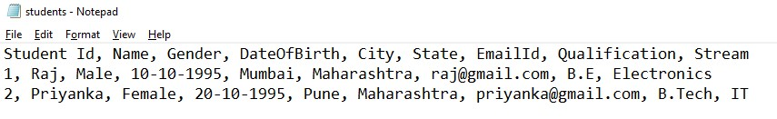

* This application should be developed using combination of client/server web technologies. For the client side code, combination of HTML/CSS/JS should be used

and for the server side code, you can use any technology of choice like Servlet/JSP/PHP/.NET/Python.

* Create an **index.html** page which will display the following options to the user:
  + Add New Student o Search for a Student by Id
  + Display all the Students

* Based on the selection done by the user, create separate pages for processing the request accordingly.

* + **Step 1:** create **add-student.html** page which will display a form to the user like this:

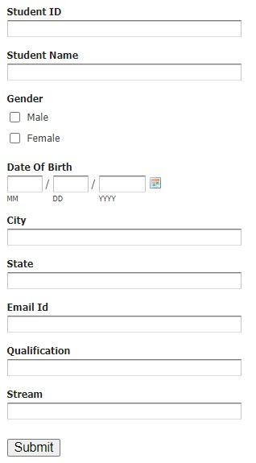

* + - When the user submits the form, some server side code should be written to save the data in the students.csv file.

* + **Step 2:** create a page called as **search-student.html** file which will look like this:

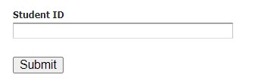

* + - When the user submits this form, some server side code should read the data from the csv file and display the same to the user like this:

|  |  |
| --- | --- |
| **Student ID** | 1 |
| **Student Name** | Raj |
| **Gender** | Male |
| **DateOfBirth** | 10-10-1995 |
| **City** | Mumbai |
| **State** | Maharashtra |
| **EmailId** | raj@gmail.com |
| **Qualification** | B.E |
| **Stream** | Electronics |

* + Similarly try to complete the 3rd scenario which will display all the students data in an HTML page.

**SOLUTION**:

CLIENT SIDE (FRONT-END) TECHNOLOGIES USED:

* HTML
* CSS
* JavaScript
* JavaScript library- jQuery

SERVER SIDE (BACK-END) TECHNOLOGIES USED:

* Node.js
* Node.js Modules:
  + - * + cors
        + csv-paser
        + csv-write-stream
        + fs
* Node.js frameworks:
  + - * + express.js

CODE EDITOR:

* Visual Studio Code

**Server side code:**

**File : Index.js**

const express = require('express');

const csv = require('csv-parser');

const fs = require('fs');

var cors = require('cors');

var csvWriter = require('csv-write-stream');

var writer = csvWriter({ sendHeaders: false });

const app = express();

app.use(cors());

app.use(express.json());

var students = []

fs.createReadStream('db.csv')

  .pipe(csv())

  .on('data', (row) => {

    students.push(row)

  })

  .on('end', () => {

    console.log('CSV file successfully processed');

    console.log("DATABASE:");

    console.log(students);

  });

console.log('Database:');

console.log(students);

const port = process.env.PORT || 3000

//taking port from environment variable PORT (previously set by the user)

// and if PORT variable is not present then the default port value will be 3000.

//ROUTE TO DISPLAY ALL COURSES

app.get('/students', (req, res) => {

  res.send(students);

});

//ROUTE TO FETCH COURSE DATA BY COURSE ID

app.post('/student/search', (req, res) => {

  let studid = students.find((c) => parseInt(c.StudentId) === parseInt(req.body.id));

  if (!studid)

    res.status(404).send(`Student with id=${req.body.id} could not be found!`);

  console.log(studid);

  if (studid)

    res.send(studid);

});

//ROUTE TO ADD A COURSE TO CSV FILE

app.post('/students', (req, res) => {

  writer = csvWriter({ sendHeaders: false });

  writer.pipe(fs.createWriteStream('db.csv', { flags: 'a' }));

  writer.write({

    header1: req.body.id,

    header2: req.body.name,

    header3: req.body.gender,

    header4: req.body.dob,

    header5: req.body.city,

    header6: req.body.state,

    header7: req.body.email,

    header8: req.body.qual,

    header9: req.body.stream

  });

  writer.end();

  student = {

    StudentId: req.body.id,

    Name: req.body.name,

    Gender: req.body.gender,

    DateOfBirth: req.body.dob,

    City: req.body.city,

    State: req.body.state,

    EmailId: req.body.email,

    Qualification: req.body.qual,

    Stream: req.body.stream

  }

  students.push(student);

  console.log('Database successfully updated!- Query Add');

});

app.listen(port, () => { console.log(`Listening on port ${port}`) });

**Database Present State**

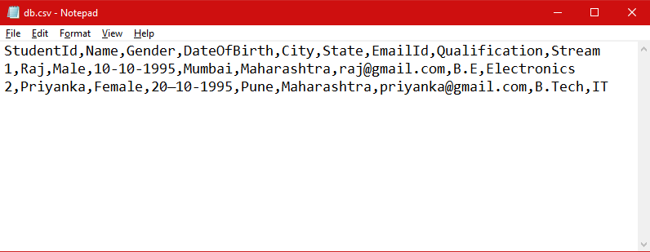**File: db.csv**

**Client side code:**

**File list:**

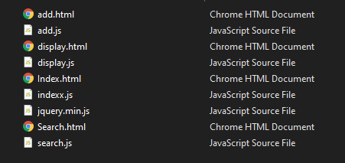

**Index.html**

<!DOCTYPE html>

<html lang="en">

<head>

    <meta charset="UTF-8">

    <meta name="viewport" content="width=device-width, initial-scale=1.0">

    <title>LBJ-CYCLE-02-CS-02</title>

    <style>

        .center {

            margin: auto;

            width: 60%;

            border: 2px solid grey;

            padding: 10px;

            text-align: center;

            background-color: black;

            color: white;

            box-shadow: 2px;

        }

    </style>

</head>

<body>

    <div class="center">

        <H1>LBJ MODULE - CYCLE 02 - CASE STUDY 02</H1>

    </div>

    <br><br>

    <div class="center" style="font-family: Verdana, Geneva, Tahoma, sans-serif;border: 0px ;">

        Select the desired opion and click on the OK button to proceed.

    </div>

    <div class="center" style="border: 0px ; height: 150px;line-height: 50px;">

        <input type="radio" id="add" name="choice" value="add"> Add A New Student

        <input type="radio" id="search" name="choice" value="search"> Search Student By Id

        <input type="radio" id="display" name="choice" value="display"> Display all the Students

        </br><input type="button" id="btn" value="OK">

    <script src="indexx.js"></script>

</body>

</html>

**indexx.js**

console.log("Indexx loaded");

const btn = document.querySelector('#btn');

btn.onclick = function () {

    const rbs = document.querySelectorAll('input[name="choice"]');

    let selectedValue;

    for (const rb of rbs) {

        if (rb.checked) {

            selectedValue = rb.value;

            break;

        }

    }

    if (selectedValue == "add") {

        location.href = "add.html"

    } else if (selectedValue == "search") {

        location.href = "search.html"

    } else if (selectedValue == "display") {

        location.href = "display.html"

    }

};

**add.html**

<!DOCTYPE html>

<html lang="en">

<head>

    <meta charset="UTF-8">

    <meta name="viewport" content="width=device-width, initial-scale=1.0">

    <title>Add student</title>

    <style>

        .center {

            margin: auto;

            width: 60%;

            border: 2px solid grey;

            padding: 10px;

            background-color: black;

            color: white;

            box-shadow: 2px;

            padding-top: 50px;

        }

    </style>

    <script src="jquery.min.js"></script>

</head>

<body>

    <div class="center">

        <h1>Student Enrollment Form:</h1>

    </div>

    <div class="center" style="line-height:30px;">

        <form id="form" method="POST">

            Student Id: <br>

            <input type="number" id="id"><br>

            Student Name: <br>

            <input type="text" id="name"><br>

            Gender:<br>

            <input type="checkbox" id="male"> Male <br>

            <input type="checkbox" id="female"> Female<br>

            <input type="date" id="dob"><br>

            City:<br>

            <input type="text" id="city"><br>

            State:<br>

            <input type="text" id="state"><br>

            Email Id:<br>

            <input type="email" id="email"><br>

            Qualification:<br>

            <input type="text" id="qualification"><br>

            Stream:<br>

            <input type="text" id="stream"><br>

            <input type="submit" form="form" value="Submit" onclick="add(event)">

            <input type="button" value="Back" onclick="back()">

        </form>

    </div>

    <script src="add.js"></script>

</body>

</html>

**add.js**

function back() {

    location.href = "index.html";

}

function add(event) {

    event.preventDefault();

    const id = document.getElementById("id").value.trim();

    const name = document.getElementById("name").value.trim();

    const state = document.getElementById("state").value.trim();

    const email = document.getElementById("email").value.trim();

    const dob = document.getElementById("dob").value.trim();

    const stream = document.getElementById("stream").value.trim();

    const qual = document.getElementById("qualification").value.trim();

    const city = document.getElementById("city").value.trim();

    if (document.getElementById("male").checked === true) {

        var gender = "male";

    } else if (document.getElementById("female").checked === true) {

        var gender = "female";

    }

    const student = {

        id: id,

        name: name,

        gender: gender,

        dob: dob,

        city: city,

        state: state,

        email: email,

        qual: qual,

        stream: stream

    }

    yourUrl = 'http://localhost:3000/students';

    data = JSON.stringify(student)

    $.ajax({

        url: 'http://localhost:3000/students',

        dataType: "json",

        type: "POST",

        contentType: "application/json",

        data: JSON.stringify(student),

        success: function (data2) {

            console.log(data2)

        },

        error: function () {

        },

        failure: function (response) {

            console.log("call failed");

            console.log(response);

        }

    });

    console.log(student)

    alert("Form submitted successfully!");

}

**search.html**

<!DOCTYPE html>

<html lang="en">

<head>

    <meta charset="UTF-8">

    <meta name="viewport" content="width=device-width, initial-scale=1.0">

    <title>Search student</title>

    <style>

        .center {

            margin: auto;

            width: 60%;

            border: 2px solid grey;

            padding: 10px;

            background-color: black;

            color: white;

            box-shadow: 2px;

            padding-top: 50px;

        }

        table {

            background-color: white;

            color: black;

            border-collapse: collapse;

            border: solid grey;

            mask-border-width: 2px;

        }

    </style>

    <script src="jquery.min.js"></script>

</head>

<body>

    <div class="center">

        <h1>Student Search:</h1>

    </div>

    <div class="center" style="line-height:30px;">

        <form id="form" action="index.html" method="POST">

            Student Id: <br>

            <input type="number" id="id"><br>

            <input type="submit" form="form" value="Submit" onclick="search(event)">

            <input type="button" value="Back" onclick="back()">

            <button type="button" onclick="reset2()">clear</button>

        </form>

    </div>

    <div id="searchResult" class="center" style="display: none;">

    </div>

    <script src="search.js"></script>

</body>

</html>

**search.js**

function reset2() {

    console.log("pass");

    temp = document.getElementById("searchResult");

    $("#searchResult").hide("slow");

}

function back() {

    location.href = "index.html";

}

function search(event) {

    event.preventDefault()

    const id = document.getElementById("id").value.trim();

    console.log("Searching id");

    const studentsearch = {

        id: id

    }

    yourUrl = 'http://localhost:3000/student/search';

    data = JSON.stringify(studentsearch)

    $.ajax({

        url: 'http://localhost:3000/student/search',

        dataType: "json",

        type: "POST",

        contentType: "application/json",

        data: JSON.stringify(studentsearch),

        success: function (data2) {

            console.log(data2);

            temp = document.getElementById("searchResult");

            temp.innerHTML = (

                `<h1>Details of searched student are as follows:</h1>

                <table border = "1px solid white" color : "black"

                cellpadding="2px" width="100%" border-collapse = "collapse">

                    <tr>

                        <th>Field</th>

                        <th>Data</th>

                    </tr>

                    <tr>

                        <td><strong>Name</strong></td>

                        <td> ${data2.Name}</td>

                    </tr>

                    <tr>

                        <td><strong>Student ID</strong></td>

                        <td>${data2.StudentId}</td>

                    </tr>

                    <tr>

                        <td><strong>Gender</strong></td>

                        <td> ${data2.Gender}</td>

                    </tr>

                    <tr>

                        <td><strong>City</strong></td>

                        <td>${data2.City}</td>

                    </tr>

                    <tr>

                        <td><strong>State</strong></td>

                        <td>${data2.State}</td>

                    </tr>

                    <tr>

                        <td><strong>Email</strong></td>

                        <td>${data2.EmailId}</td>

                    </tr>

                    <tr>

                        <td><strong>Qualification</strong></td>

                        <td>${data2.Qualification}</td>

                    </tr>

                    <tr>

                        <td><strong>Stream</strong></td>

                        <td>${data2.Stream}</td>

                    </tr>

                    <tr>

                        <td><strong>Date of Birth</strong></td>

                        <td>${data2.DateOfBirth}</td>

                    </tr>

                </table>`

            )

            $("#searchResult").show("slow");

        },

        error: function () {

            temp = document.getElementById("searchResult");

            temp.innerHTML = (

                "<strong>Student Not Found!!<strong>"

            )

            $("#searchResult").show("slow");

        },

        failure: function (response) {

            console.log("call failed");

            console.log(response);

        }

    });

}

**display.html**

<!DOCTYPE html>

<html lang="en">

<head>

    <meta charset="UTF-8">

    <meta name="viewport" content="width=device-width, initial-scale=1.0">

    <title>All records</title>

    <style>

        .center {

            margin: auto;

            width: 60%;

            border: 2px solid grey;

            padding: 10px;

            background-color: black;

            color: white;

            box-shadow: 2px;

            padding-top: 50px;

        }

        table {

            background-color: white;

            color: black;

            border-collapse: collapse;

            border: solid grey;

            mask-border-width: 2px;

        }

    </style>

    <script src="jquery.min.js"></script>

</head>

<body>

    <div class="center">

        <h1>All Records</h1>

    </div>

    <div class="center" style="line-height:30px;">

        <input type="button" value="Back" onclick="back()">

        <button type="button" onclick="reset2()">clear</button>

    </div>

    <div id="result" class="center" style="display: none;">

    </div>

    <script src="display.js"></script>

</body>

</html>

**display.js**

function reset2() {

    console.log("pass");

    temp = document.getElementById("result");

    $("#result").hide("slow");

}

function back() {

    location.href = "index.html";

}

$.get('http://localhost:3000/students', function (data2) {

    console.log(data2);

    temp = document.getElementById("result");

    for (i = 0; i < data2.length; i++) {

        temp.innerHTML += (

            `

                <table border = "1px solid white" color : "black"

                cellpadding="2px" width="100%" border-collapse = "collapse">

                    <tr>

                        <th>Field</th>

                        <th>Data</th>

                    </tr>

                    <tr>

                        <td><strong>Name</strong></td>

                        <td> ${data2[i].Name}</td>

                    </tr>

                    <tr>

                        <td><strong>Student ID</strong></td>

                        <td>${data2[i].StudentId}</td>

                    </tr>

                    <tr>

                        <td><strong>Gender</strong></td>

                        <td> ${data2[i].Gender}</td>

                    </tr>

                    <tr>

                        <td><strong>City</strong></td>

                        <td>${data2[i].City}</td>

                    </tr>

                    <tr>

                        <td><strong>State</strong></td>

                        <td>${data2[i].State}</td>

                    </tr>

                    <tr>

                        <td><strong>Email</strong></td>

                        <td>${data2[i].EmailId}</td>

                    </tr>

                    <tr>

                        <td><strong>Qualification</strong></td>

                        <td>${data2[i].Qualification}</td>

                    </tr>

                    <tr>

                        <td><strong>Stream</strong></td>

                        <td>${data2[i].Stream}</td>

                    </tr>

                    <tr>

                        <td><strong>Date of Birth</strong></td>

                        <td>${data2[i].DateOfBirth}</td>

                    </tr>

                </table><br>`)

    }

    $("#result").show("slow");

});

**Screenshots:**

1) Starting the server

Current db.csv file contents displayed.

Server is listening on port 3000

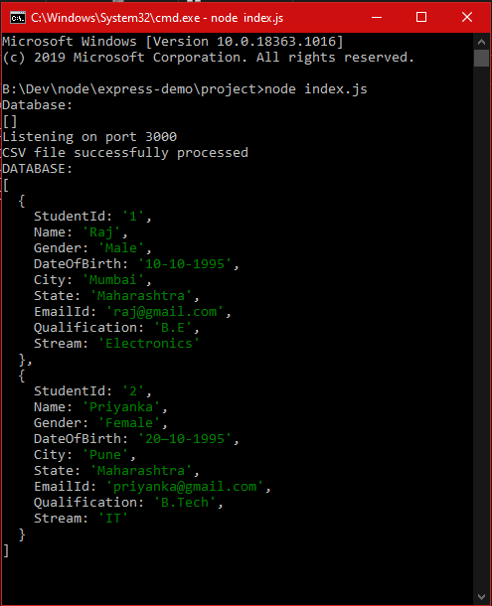

2) Index.html

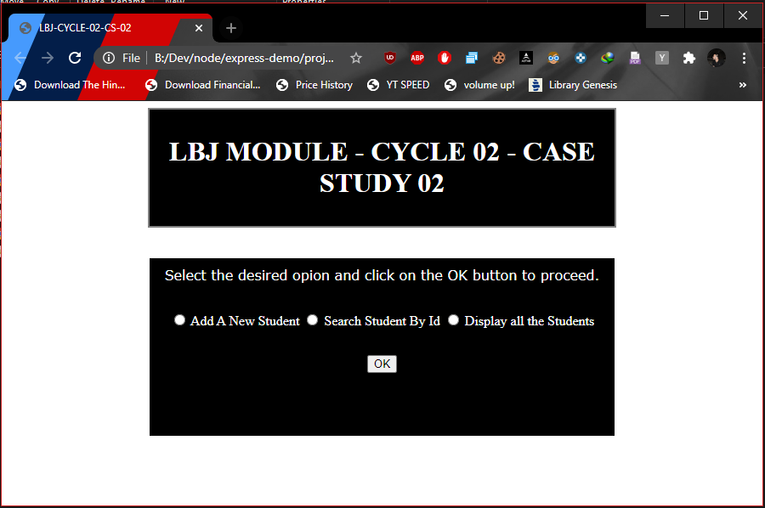This page provides the functionality to select the desired option.

After selecting the <Add A New student> radio button and pressing <OK> button.

Landing page: add.html

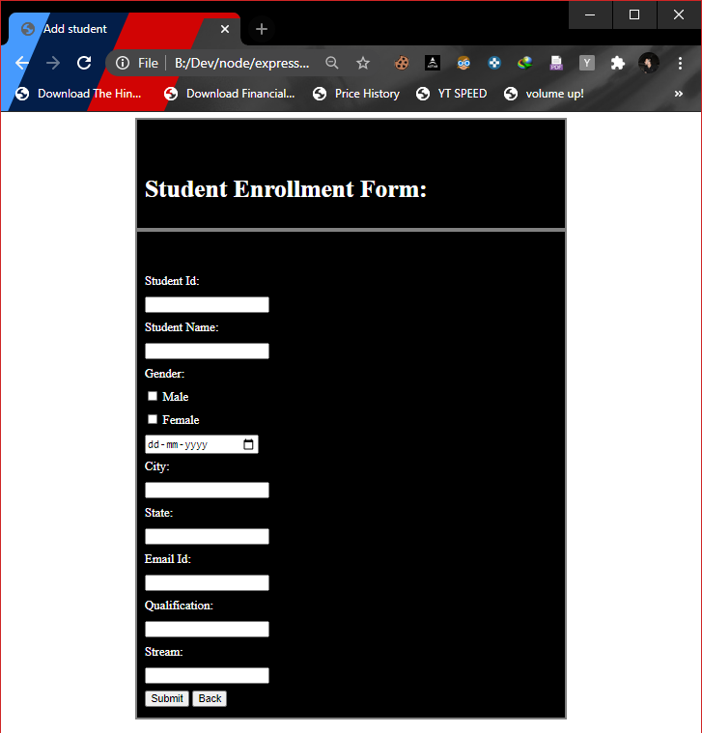3) add.html

db.csv: present state

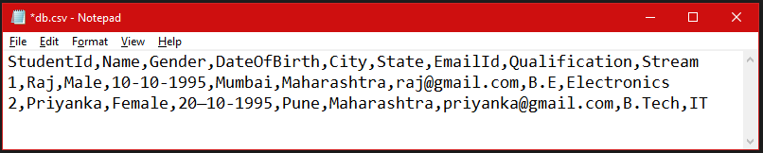

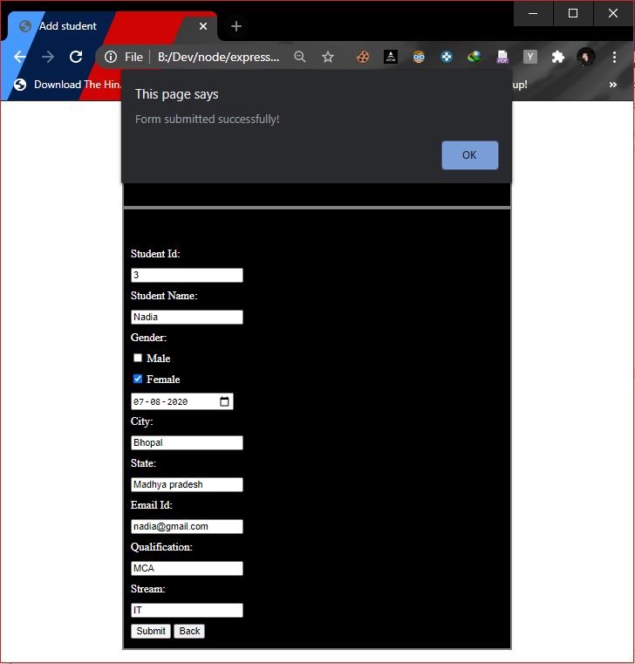After filling all the details and clicking on the <submit> button.

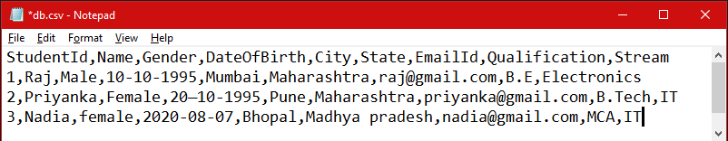db.csv: present state

After pressing the <back> button and then selecting the <Search Student By Id> option.

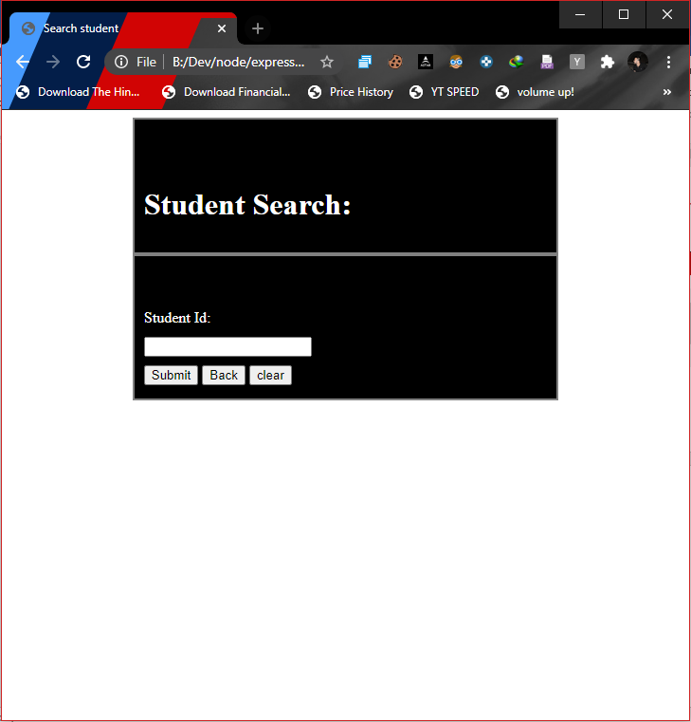Landing page: search.html

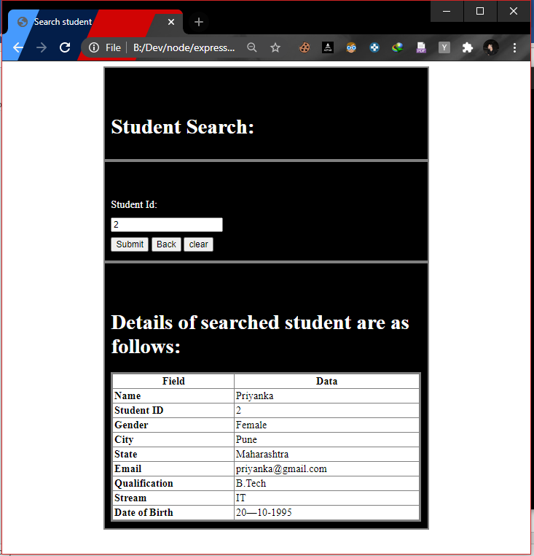After entering the student Id to search for student details and pressing <Submit> button:

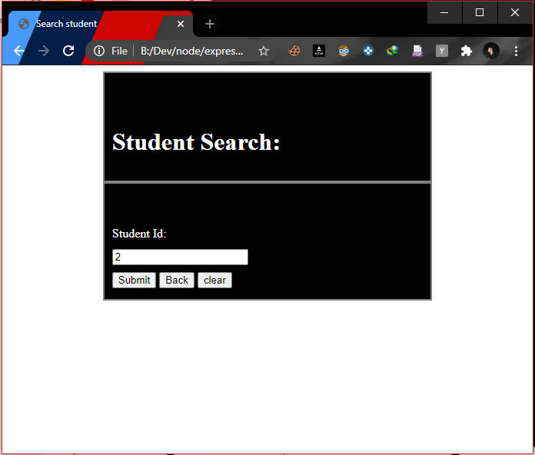After pressing the clear button:

When a wrong student Id is provided:

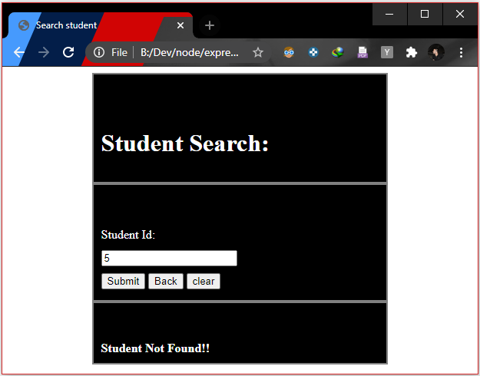Student Not Found!!

After clicking on the <back> button and selecting the <Display all the students> option

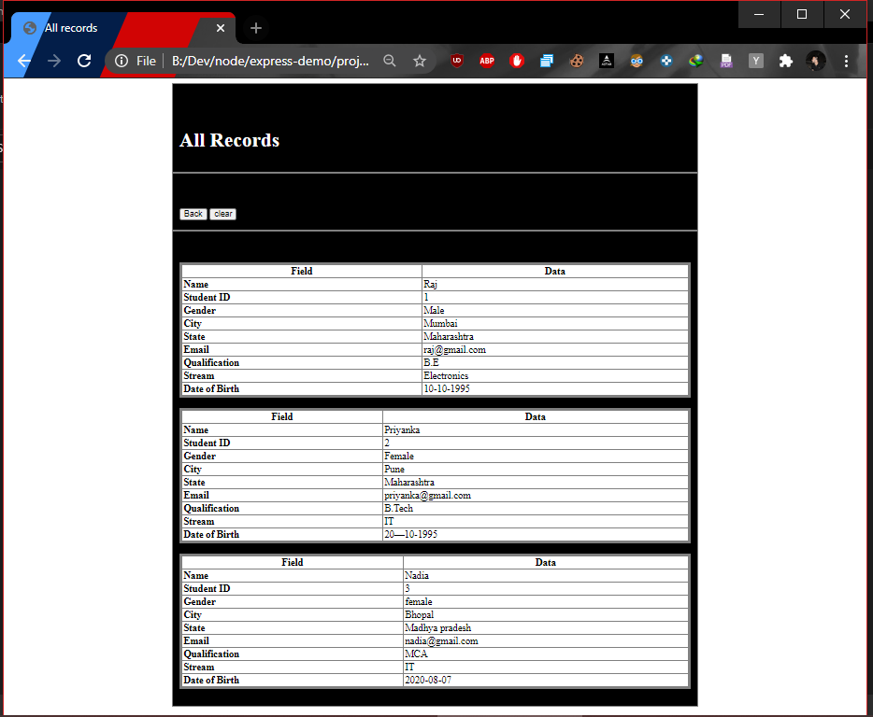Landing page: display.html

db.csv : present state

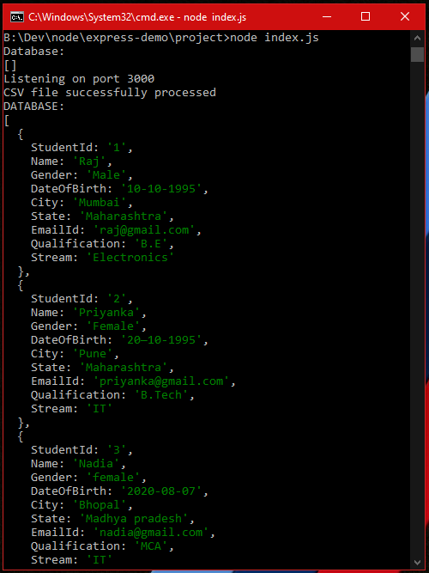After restarting the server to read the db.csv contents.

Hence the csv file is successfully updated with new records!