# Assignment 3

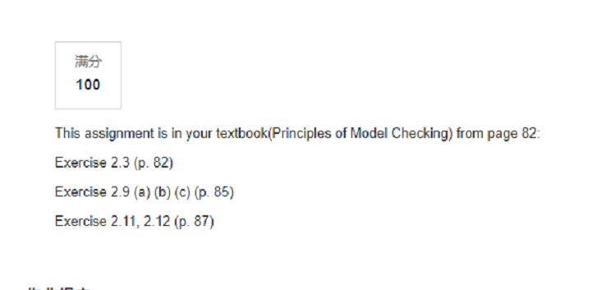

Exercise 2.3.

Consider the following street junction with the specification of a traffic light as outlined on the right.

(a) Choose appropriate actions and label the transitions of the traffic light transition system accordingly.

(b) Give the transition system representation of a (reasonable) controller C that switches the green signal lamps in the following order: A1,A2,A3, A1,A2,A3, . . ..

(Hint: Choose an appropriate communication mechanism.)

(c) Outline the transition system A1||A2||A3||C

Exercise 2.9

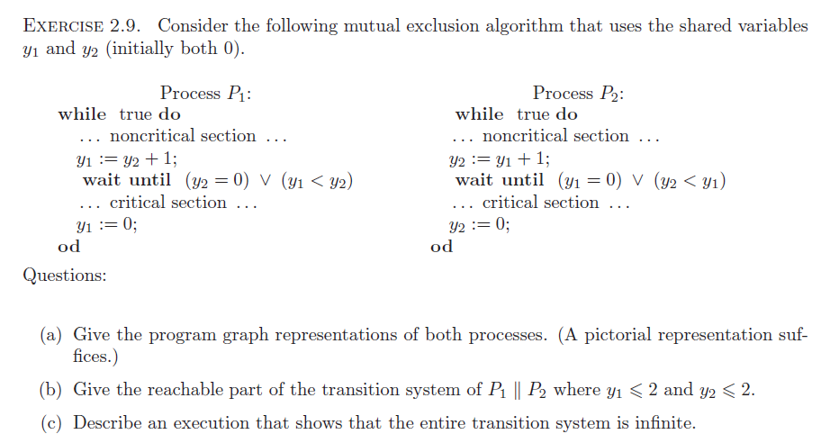

Exercise 2.11

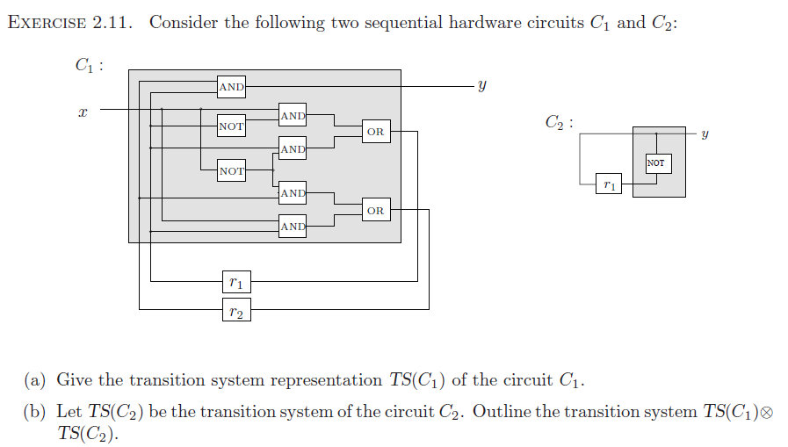

Exercise 2.12

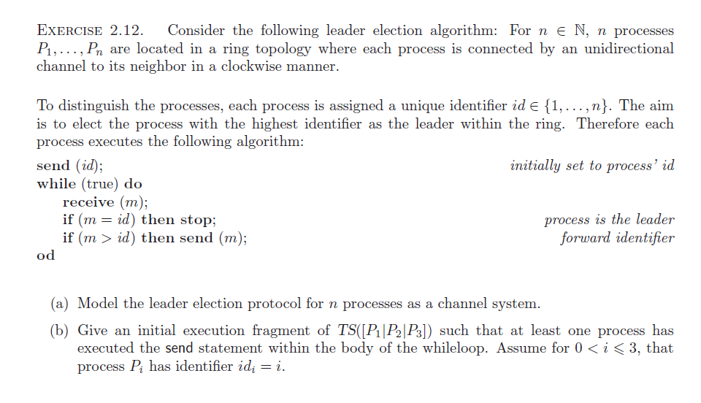

# Assignment 4

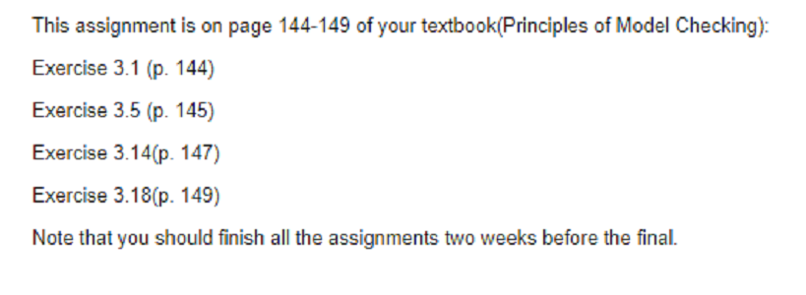

Exercise 3.1

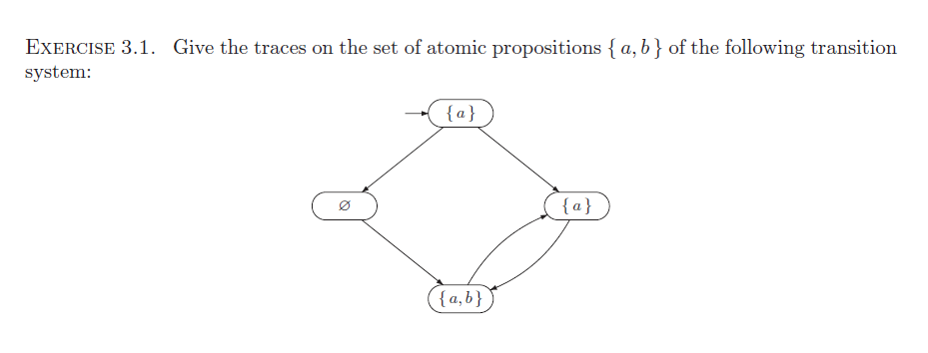

Exercise 3.5

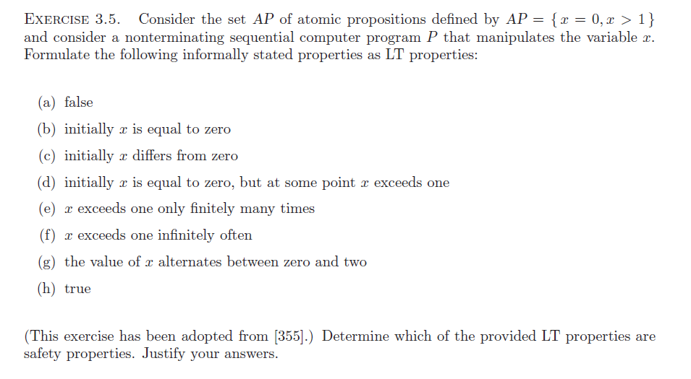

Exercise 3.14

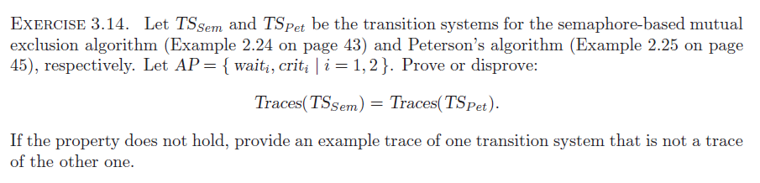

Exercise 3.18

