Section 1 — Visual / Interface Designs
Your interface designs need to show both technical and non-technical readers what the site will look like and how users will navigate it. You should produce wireframes or annotated mockups for at least these screens: homepage, product listing page, individual product page, shopping cart, checkout, login/register, and the admin dashboard.
Here is an example paragraph you could adapt for your design document:
"The interface has been designed with usability as the primary consideration, ensuring that both first-time visitors and returning customers can navigate the site intuitively. The homepage presents a navigation bar containing links to product categories, a search bar, a login button, and a cart icon displaying the current item count. Below the hero banner, featured products are displayed in a responsive grid layout. Each product card shows the product image, name, price, and an 'Add to Cart' button, allowing users to browse and purchase without needing to visit individual product pages. The colour scheme uses a neutral white background with a contrasting accent colour for call-to-action buttons, ensuring accessibility and visual clarity across all devices."
Tips for this section: annotate your wireframes — label every element and explain its purpose. Mention responsiveness (how the layout shifts on mobile vs desktop). Reference accessibility considerations such as colour contrast and alt text for images. You can sketch wireframes by hand and photograph them, or use a free tool like Figma or even draw them in PowerPoint.

Section 2 — Data Requirements
This section needs to show what data your system stores, where it comes from, how it is structured, and how different pieces of data relate to each other. You should include a database schema / entity relationship diagram and a data dictionary.
Here is the ERD for your e-commerce database:
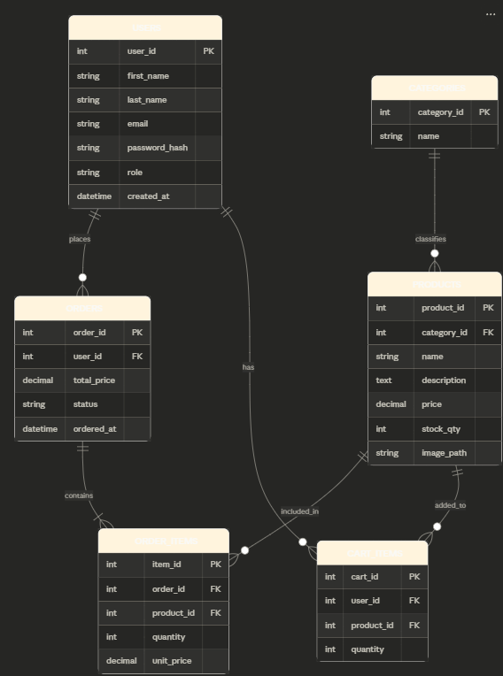
Here is an example paragraph for your data requirements section:
"The system requires six database tables to store and manage all data associated with the e-commerce platform. The users table stores account credentials and personal information for both customers and administrators, differentiated by a role field. Each user can place multiple orders, which are recorded in the orders table along with the total cost and current fulfilment status. The individual products within each order are stored separately in order_items, which records the quantity and unit price at the time of purchase — this is important because product prices may change after an order is placed. Products are organised into categories via a foreign key relationship, and each product record stores pricing, stock quantity, and an image path for display on the front end. The cart_items table provides temporary storage for items a user has added to their basket before completing checkout."
Tips for this section: include a data dictionary table beneath the ERD that lists every field, its data type, whether it is required, and a brief description. Mention data validation (e.g. email format checking, price must be a positive decimal). Mention any security considerations around stored data, such as hashing passwords with password_hash() in PHP rather than storing them in plain text.

Section 3 — Algorithm Designs
You need up to five complex algorithms shown in pseudocode or flowcharts. Here are the five most appropriate for your project, with pseudocode written out for each.
Algorithm 1 — User login and authentication
BEGIN login
GET email, password FROM form input
SANITISE email and password inputs
QUERY database: SELECT user WHERE email = input_email
IF no user found THEN
DISPLAY "Invalid email or password"
END
END IF
IF password_verify(input_password, stored_hash) = TRUE THEN
CREATE session: session[user_id], session[role]
IF role = "admin" THEN
REDIRECT to admin dashboard
ELSE
REDIRECT to homepage
END IF
ELSE
DISPLAY "Invalid email or password"
END IF
END login
Algorithm 2 — Add to cart
BEGIN addToCart
GET product_id, quantity FROM request
IF user is NOT logged in THEN
REDIRECT to login page
END IF
QUERY database: SELECT stock_qty FROM products WHERE product_id = input_id
IF stock_qty < requested_quantity THEN
DISPLAY "Insufficient stock"
END
END IF
QUERY database: SELECT * FROM cart_items WHERE user_id = session_user AND product_id = input_id
IF cart item exists THEN
UPDATE cart_items SET quantity = quantity + input_quantity
ELSE
INSERT INTO cart_items (user_id, product_id, quantity)
END IF
DISPLAY updated cart count in navigation bar
END addToCart
Algorithm 3 — Checkout and order creation
BEGIN checkout
GET all cart_items WHERE user_id = session_user
IF cart is empty THEN
DISPLAY "Your cart is empty"
END
END IF
total = 0
FOR EACH item IN cart_items DO
QUERY product price and stock
IF product stock < item quantity THEN
DISPLAY "Item [name] is out of stock"
END
END IF
total = total + (item.quantity * product.price)
END FOR
INSERT INTO orders (user_id, total_price, status="pending", ordered_at=NOW())
FOR EACH item IN cart_items DO
INSERT INTO order_items (order_id, product_id, quantity, unit_price)
UPDATE products SET stock_qty = stock_qty - item.quantity
END FOR
DELETE FROM cart_items WHERE user_id = session_user
DISPLAY order confirmation page with order_id
END checkout
Algorithm 4 — Product search and filter
BEGIN searchProducts
GET search_term, category_filter, sort_order FROM request
base_query = "SELECT * FROM products WHERE 1=1"
IF search_term is NOT empty THEN
base_query += " AND name LIKE '%search_term%'"
END IF
IF category_filter is NOT empty THEN
base_query += " AND category_id = category_filter"
END IF
IF sort_order = "price_asc" THEN
base_query += " ORDER BY price ASC"
ELSE IF sort_order = "price_desc" THEN
base_query += " ORDER BY price DESC"
ELSE
base_query += " ORDER BY product_id DESC"
END IF
EXECUTE query using prepared statement
RETURN results as product grid
END searchProducts
Algorithm 5 — Admin stock update
BEGIN updateStock
VERIFY session role = "admin", else REDIRECT to 403 page
GET product_id, new_stock_qty FROM admin form
IF new_stock_qty < 0 THEN
DISPLAY "Stock quantity cannot be negative"
END
END IF
QUERY database: SELECT product WHERE product_id = input_id
IF product NOT found THEN
DISPLAY "Product not found"
END
END IF
UPDATE products SET stock_qty = new_stock_qty WHERE product_id = input_id
LOG change: admin_id, product_id, old_qty, new_qty, timestamp
DISPLAY "Stock updated successfully"
END updateStock
Tips for this section: use consistent pseudocode conventions throughout — the examiner wants to see logical thinking, not perfect syntax. Each algorithm should have a brief introductory sentence explaining what problem it solves and why it is important to the system. You can draw these as flowcharts instead of pseudocode if you prefer — both are acceptable.

Section 4 — Test Strategy
Here is a complete test strategy table for your project. You should include this in your document along with the introductory paragraph below.
"The test strategy outlines the order in which components of the e-commerce system will be tested, the types of tests to be performed, and the rationale for this sequence. Testing will follow a bottom-up approach, beginning with individual units of back-end functionality before progressing to integration testing and finally end-to-end user testing. This ensures that fundamental components such as database connectivity and authentication are verified before more complex features that depend on them are tested. Both valid (normal), boundary, and invalid (erroneous) data will be used throughout to ensure the system handles all input scenarios correctly."
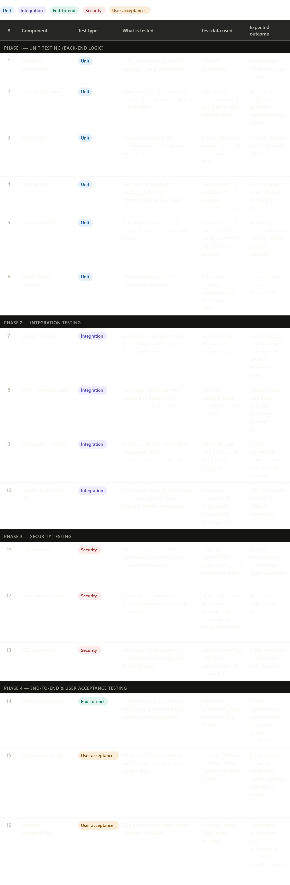
Tips for the test strategy section: the brief says you don't need to test every single thing, but you do need to show the order and the types of tests. The table above covers all four types the examiner will be looking for — unit, integration, security, and user acceptance. Make sure you explain in a short paragraph why you have chosen to test in this order (bottom-up: units first, then integration, then security, then end-to-end). You can also note that you would use var_dump() and echo statements in PHP during unit testing for early debugging.

A few things worth noting across all four sections. For the brief's requirement that a third-party developer could build from your documents alone, make sure your pseudocode uses consistent naming that matches your database field names, and that your wireframes reference real page filenames (e.g. login.php, cart.php). For the non-technical stakeholder requirement, keep your introductory paragraphs in plain English before going into technical detail. Let me know if you want me to expand on any section, generate wireframe mockups, or write more paragraphs for a specific part.

