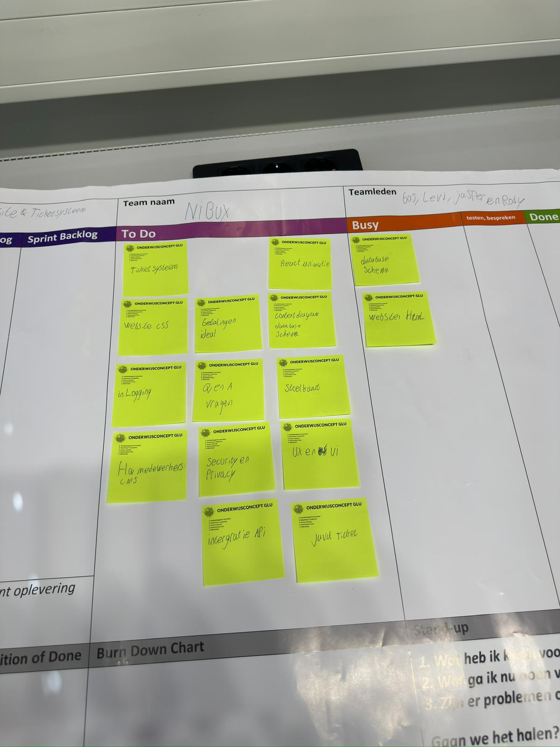
SCUM-Bord

https://trello.com/invite/b/68c14ffac6884d19364d9a98/ATTI9def8b59c8661bc144bd0c591193e5f04D1ABAD8/biscoop-opdracht

