**Aditya Ganesh Kumbhar(19049)**

**GIS Project 12th March, 2025**

**Antarctica Map**

**Aim:** To show the places and water present in Antarctica.

* Go to Web Menu → OpenLayerPlugin → OpenStreetMap→ OpenStreetMap

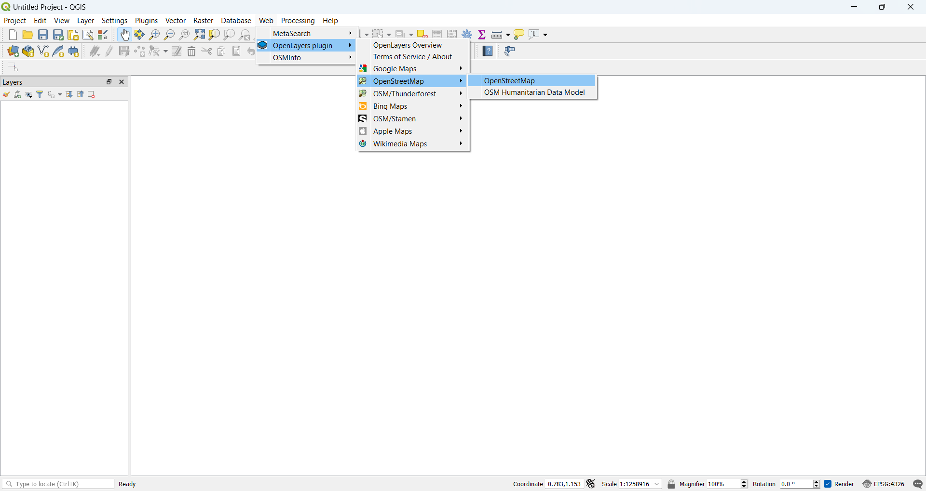

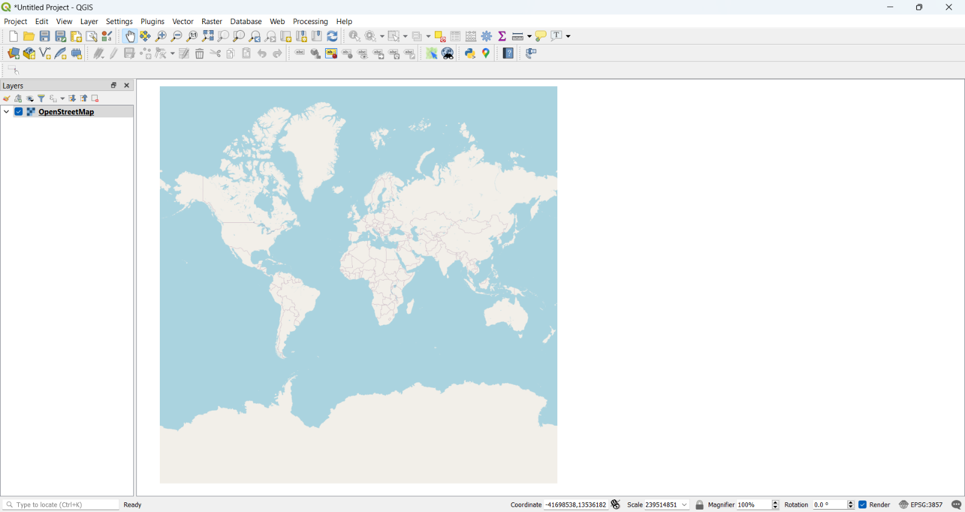

* Go to Layer → Add Layer → Add Vector Layer
* Select “\antartica-latest-free.shp\gis_osm_water_a_free_1.shp”

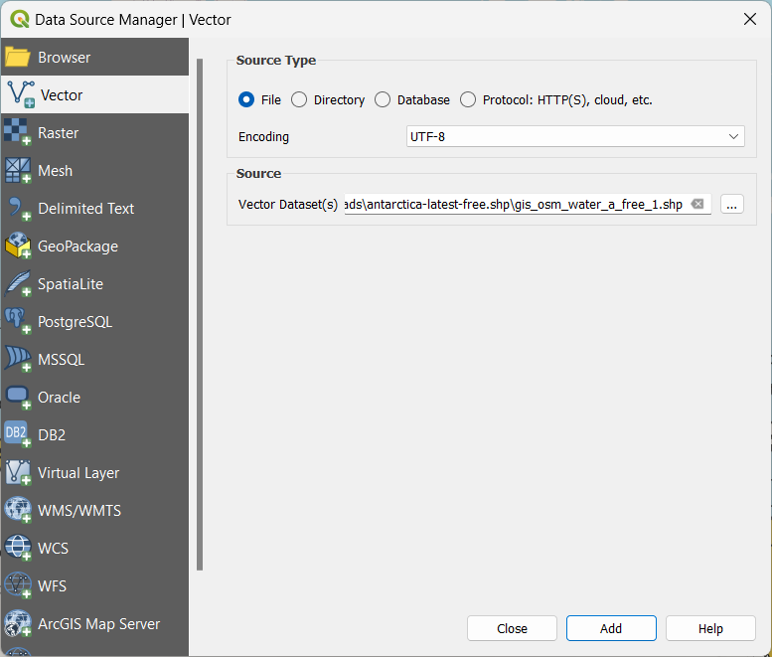

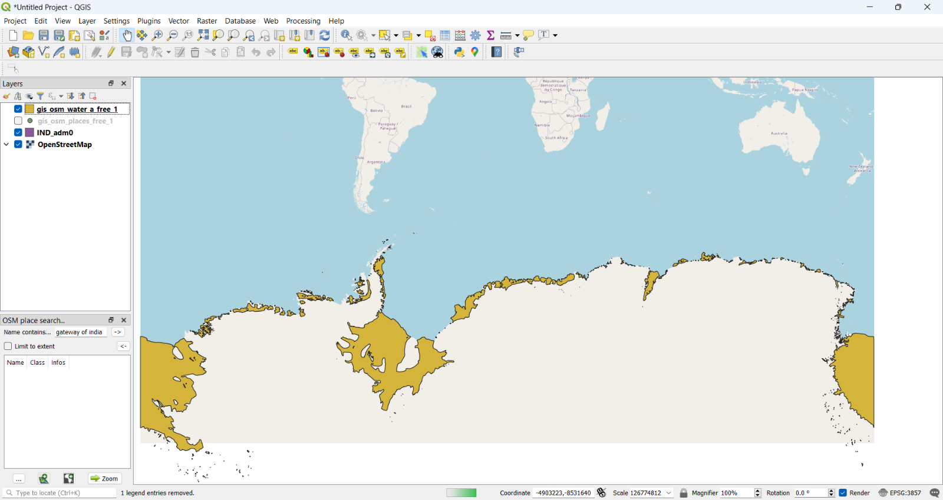

* Go to Layer → Add Layer → Add Vector Layer
* Select “\antartica-latest-free.shp\gis_osm_places_a_free_1.shp”

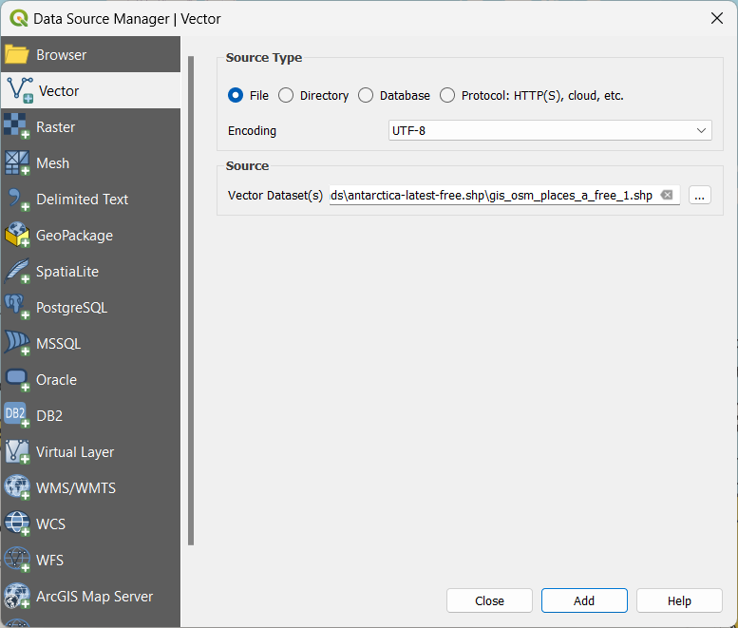

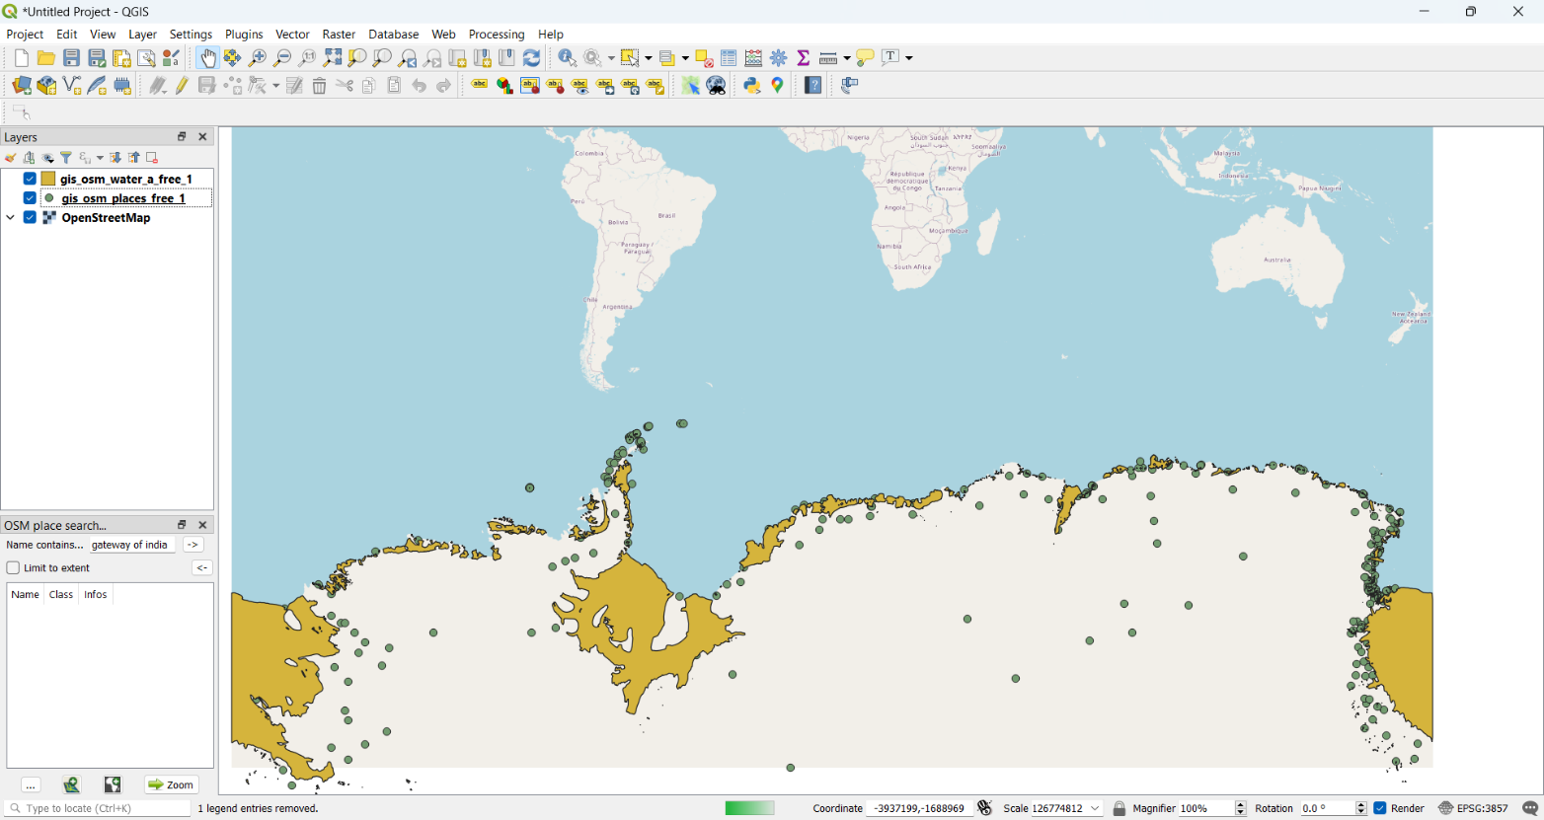

* Right click on gis_osm_water_a_free_1 🡪 Properties 🡪 Labels 🡪Single Label 🡪 name

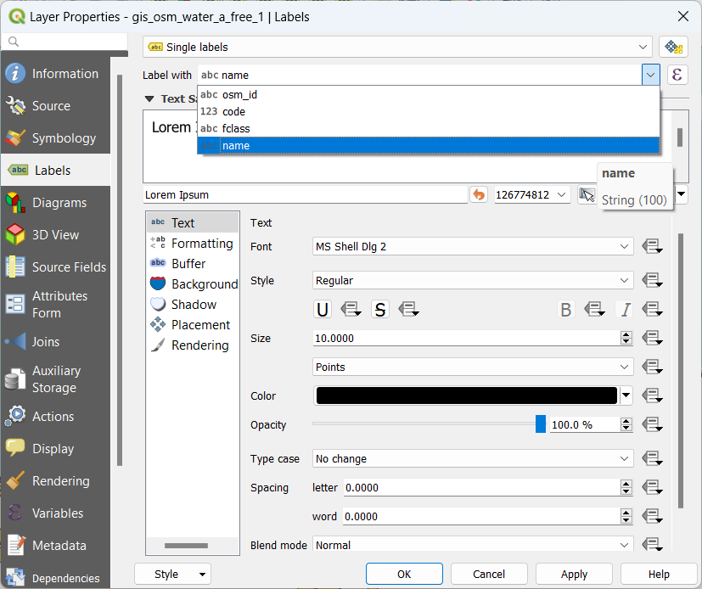

* Right click on gis_osm_places_a_free_1 🡪 Properties 🡪 Labels 🡪Single Label 🡪 name

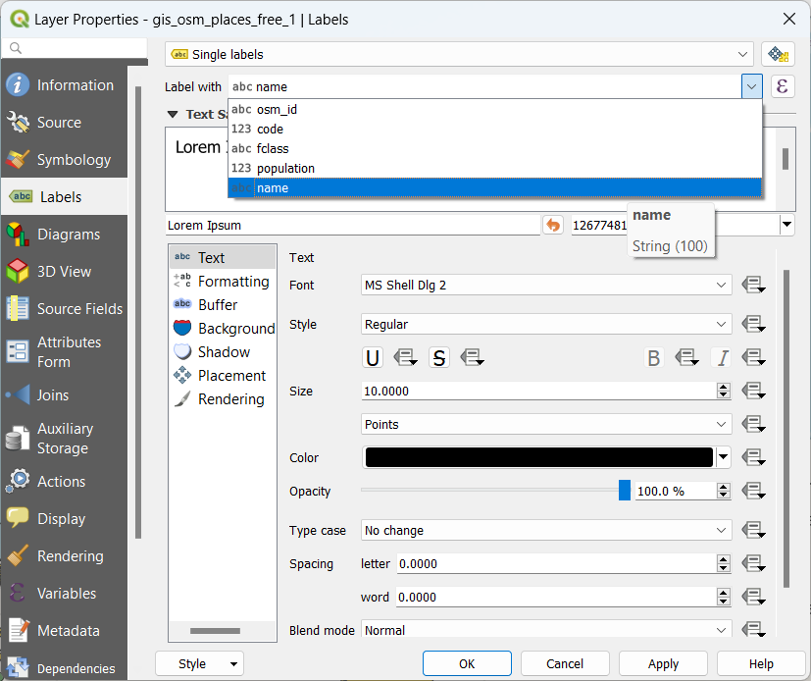

* Final Output:

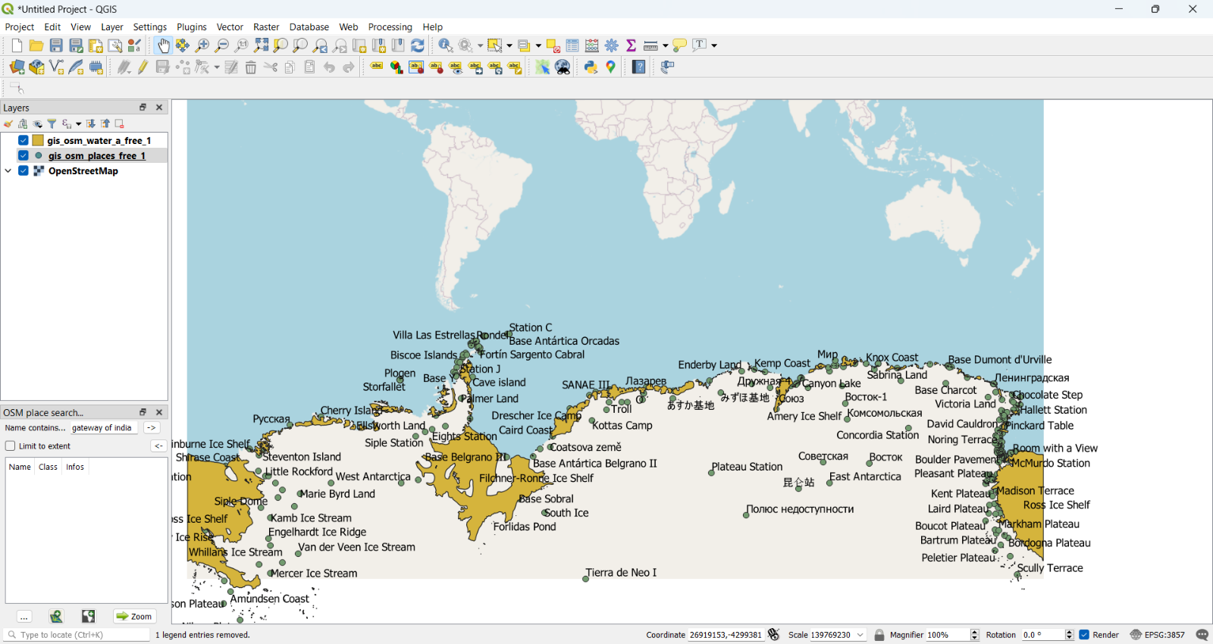

**Conclusion:** The above project has been performed and executed successfully.

**Project Link:** https://qgiscloud.com/Adityaa/Project1/?l=gis_osm_water_a_free_1%2Cgis_osm_places_free_1&bl=mapnik&t=Project1&e=-8671652%2C-19545015%2C15855223%2C-177515

**Github Link:** https://github.com/Mrchamp143/QGIS/tree/main