

By Christopher Ross

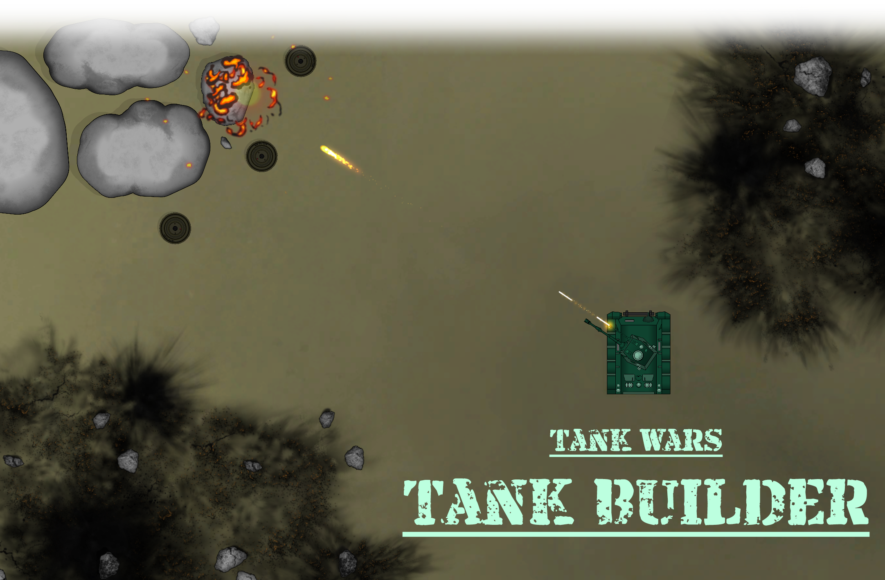

Contents

Introduction 3

# Introduction

Thank you for purchasing the Tank Wars – Tank Builder! This documentation has been written to give you a detailed overview of the asset. The aim of the tank builder is to help you create a playable tank as quickly and efficiently as possible. It was developed with flexibility and customizability in mind allowing you to quickly add new and exciting options to your tank. Once complete, you may then play with it at the click of a button.

This manual will help you learn how the tank builder works, how to set it up properly, and how to use all the additional systems in place. While this manual cannot cover every possible eventuality, there are various methods of contacting me which can be seen in the contact section.

# Quick Setup

To quickly step up your own tank, please follow the steps below:

## Step 1 - Adding the Tank

|  |  |
| --- | --- |
| In the hierarchy, right click an open space and hover over Tank Wars.  Click the option “Create Tank”. |  |

## Step 2 - Setting the Sorting layer

|  |  |
| --- | --- |
| With the gizmos enabled, a new tank will have appeared with the name “New Tank”. If the tank is not visible and only the outline (polygon collider) is seen as shown in image on the right, a sorting layer must be set. |  |

|  |  |
| --- | --- |
| To change the tanks current sorting layer, click the sorting layer dropdown and choose between the existing options. To create a new sorting layer, click the “Add Sorting Layer” option. Once a sorting layer has been selected, click the “Set” button on the right.  If done correctly, your tank should automatically appear above the sprites that were covering it. |  |

## Step 3

|  |  |
| --- | --- |
| A hull and cannon will already have been added and will now seen along with the outline (polygon collider). To configure these two objects, click the dropdown arrows as seen the image on the right. |  |

Each element will come with its own set of options, below is an example of the cannon object:

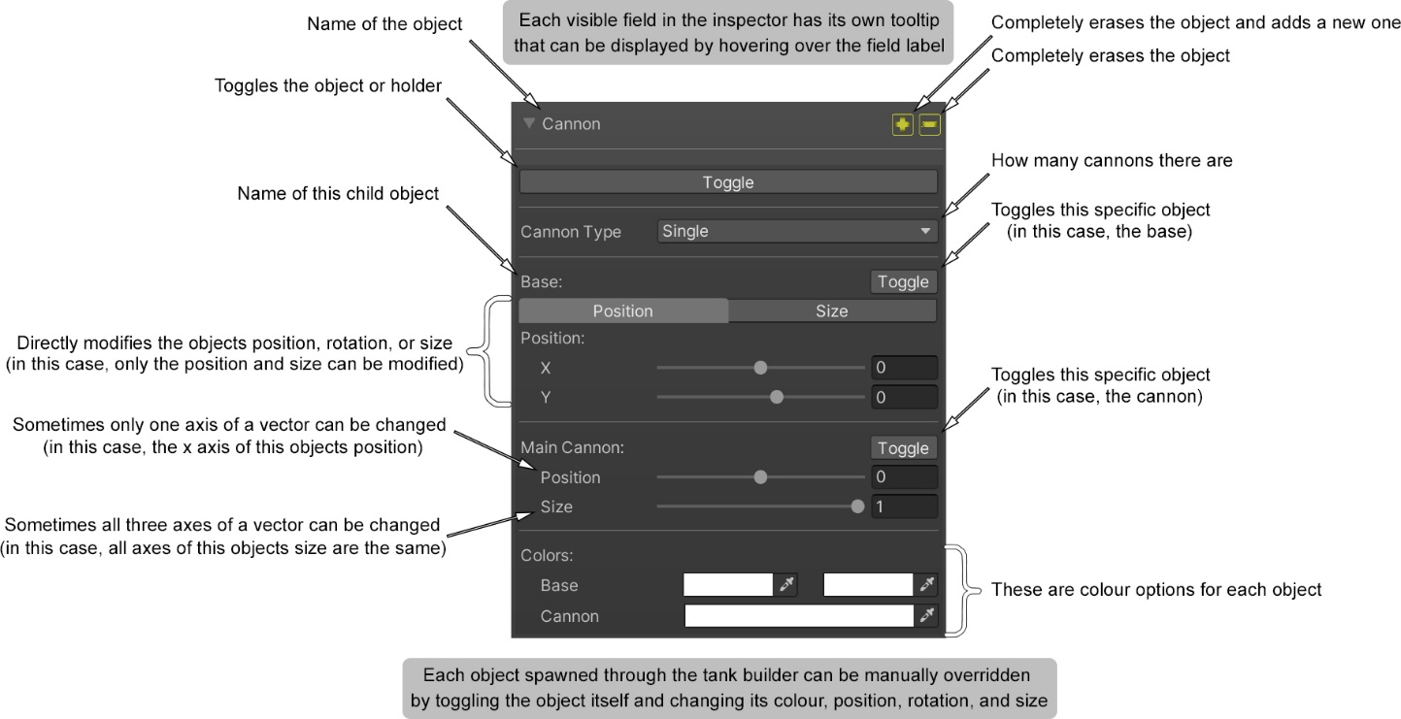

# Tank Builder Component

# Demo

[Demo](https://mrchrissross.github.io/Tank-Wars-WebGL/)

# Video Tutorials

[YouTube Video](https://www.youtube.com/watch?v=xKNka2dr0Ok)

# Contact

Please see my portfolio in the link below and I can be contacted either through LinkedIn or Twitter.

[Portfolio](https://activedeveloper.wordpress.com/)