Statistika Deskriptif Gizi Balita

di Jawa Tengah 2024

Marcella Ariani (20254920003)

2025-10-15



Analisis deskriptif ini dilakukan untuk melihat gambaran secara umum mengenai status gizi di Provinsi Jawa Tengah. Data ini mencakup beberapa indikator seperti stunting, gizi buruk, dan gizi kurang di tiap kabupaten/kota. Melalui perhitungan nilai rata-rata, median, serta penyebaran data, analisis ini membantu memahami bagaimana kondisi gizi tersebar di berbagai daerah. Visualisasi seperti barchart, piechart, dan plot digunakan agar hasilnya lebih mudah dibaca dan dipahami. Hasil analisis ini diharapkan memberi gambaran awal tentang pola dan perbedaan status gizi di Jawa Tengah.

## [Sumber Data: Bps.go.id](https://jateng.bps.go.id/id/statistics-table/2/MjU1NCMy/status-gizi-balita-berdasarkan-indeks-bb-u--tb-u--dan-bb--tb-menurut-kabupaten-kota-di-provinsi-jawa-tengah.html)

## Lets Import the Dataset

library(readxl)  
library(tidyverse)

## ── Attaching core tidyverse packages ──────────────────────── tidyverse 2.0.0 ──  
## ✔ dplyr 1.1.4 ✔ readr 2.1.5  
## ✔ forcats 1.0.1 ✔ stringr 1.5.2  
## ✔ ggplot2 4.0.0 ✔ tibble 3.3.0  
## ✔ lubridate 1.9.4 ✔ tidyr 1.3.1  
## ✔ purrr 1.1.0   
## ── Conflicts ────────────────────────────────────────── tidyverse_conflicts() ──  
## ✖ dplyr::filter() masks stats::filter()  
## ✖ dplyr::lag() masks stats::lag()  
## ℹ Use the conflicted package (<http://conflicted.r-lib.org/>) to force all conflicts to become errors

data <- read_excel("C:/Users/Marcella/Downloads/data.xlsx")  
View(data)  
print(data)

## # A tibble: 35 × 12  
## Kabupaten Jumlah_Balita BB_Kurang Persentase TB_Balita TB_Pendek  
## <chr> <dbl> <dbl> <dbl> <dbl> <dbl>  
## 1 3301 Kab. Cilacap 106892 8956 8.4 106892 5235  
## 2 3302 Kab. Banyumas 95468 12538 13.1 95468 14477  
## 3 3303 Kab. Purbalingga 57631 6424 11.1 57631 7114  
## 4 3304 Kab. Banjarnegara 52667 6020 11.4 52667 9018  
## 5 3305 Kab. Kebumen 73895 9266 12.5 73895 6870  
## 6 3306 Kab. Purworejo 38335 5208 13.6 38335 6107  
## 7 3307 Kab. Wonosobo 47922 4919 10.3 47922 8741  
## 8 3308 Kab. Magelang 71428 8598 12 71428 10914  
## 9 3309 Kab. Boyolali 58437 5224 8.9 58437 6994  
## 10 3310 Kab. Klaten 61905 8636 14 61905 8620  
## # ℹ 25 more rows  
## # ℹ 6 more variables: Persentase_TB <dbl>, Gizi_Balita <dbl>,  
## # Gizi_Kurang <dbl>, Persentase_Gizi <dbl>, Gizi_Buruk <dbl>,  
## # Persentase_GB <dbl>

summary(data)

## Kabupaten Jumlah_Balita BB_Kurang Persentase   
## Length:35 Min. : 4518 Min. : 429 Min. : 4.20   
## Class :character 1st Qu.: 43416 1st Qu.: 4266 1st Qu.: 9.20   
## Mode :character Median : 53761 Median : 5711 Median :11.30   
## Mean : 56231 Mean : 6005 Mean :10.99   
## 3rd Qu.: 74936 3rd Qu.: 7997 3rd Qu.:13.10   
## Max. :106892 Max. :13008 Max. :17.90   
## TB_Balita TB_Pendek Persentase_TB Gizi_Balita   
## Min. : 4518 Min. : 503 Min. : 2.50 Min. : 4518   
## 1st Qu.: 43416 1st Qu.: 2874 1st Qu.: 7.40 1st Qu.: 43416   
## Median : 53761 Median : 5235 Median : 9.80 Median : 53761   
## Mean : 56231 Mean : 5630 Mean :10.08 Mean : 56231   
## 3rd Qu.: 74936 3rd Qu.: 7054 3rd Qu.:13.10 3rd Qu.: 74936   
## Max. :106892 Max. :15750 Max. :18.20 Max. :106892   
## Gizi_Kurang Persentase_Gizi Gizi_Buruk Persentase_GB   
## Min. : 168 Min. :2.200 Min. : 0.0 Min. :0.0000   
## 1st Qu.:1837 1st Qu.:3.950 1st Qu.: 47.0 1st Qu.:0.1500   
## Median :2814 Median :5.200 Median : 159.0 Median :0.3000   
## Mean :3081 Mean :5.474 Mean : 246.8 Mean :0.3771   
## 3rd Qu.:3955 3rd Qu.:7.050 3rd Qu.: 308.0 3rd Qu.:0.4500   
## Max. :7507 Max. :8.900 Max. :1091.0 Max. :1.3000

The Main Focus Jumlah Balita Diukur, Balita Pendek, Gizi Kurang, dan Gizi Buruk

Jumlah Balita Diukur TB(Mean, Median, Mod)

summary(data$TB_Balita)

## Min. 1st Qu. Median Mean 3rd Qu. Max.   
## 4518 43416 53761 56231 74936 106892

mean(data$TB_Balita)

## [1] 56231.31

median(data$TB_Balita)

## [1] 53761

names(sort(-table(data$TB_Balita)))[1]

## [1] "4518"

Balita Pendek (Mean, Median, Mod)

summary(data$TB_Pendek)

## Min. 1st Qu. Median Mean 3rd Qu. Max.   
## 503 2874 5235 5630 7054 15750

mean(data$TB_Pendek)

## [1] 5630.229

median(data$TB_Pendek)

## [1] 5235

names(sort(-table(data$TB_Pendek)))[1]

## [1] "503"

Gizi Balita (Mean, Median, Mod)

summary(data$Gizi_Balita)

## Min. 1st Qu. Median Mean 3rd Qu. Max.   
## 4518 43416 53761 56231 74936 106892

mean(data$Gizi_Balita)

## [1] 56231.31

median(data$Gizi_Balita)

## [1] 53761

names(sort(-table(data$Gizi_Balita)))[1]

## [1] "4518"

Gizi Kurang (Mean, Median, Mod)

summary(data$Gizi_Kurang)

## Min. 1st Qu. Median Mean 3rd Qu. Max.   
## 168 1837 2814 3081 3955 7507

mean(data$Gizi_Kurang)

## [1] 3080.829

median(data$Gizi_Kurang)

## [1] 2814

names(sort(-table(data$Gizi_Kurang)))[1]

## [1] "168"

Gizi Buruk (Mean, Median, Mod)

summary(data$Gizi_Buruk)

## Min. 1st Qu. Median Mean 3rd Qu. Max.   
## 0.0 47.0 159.0 246.8 308.0 1091.0

mean(data$Gizi_Buruk)

## [1] 246.8286

median(data$Gizi_Buruk)

## [1] 159

names(sort(-table(data$Gizi_Buruk)))[1]

## [1] "19"

BARCHART, SCATTERPLOT, and PIE CHART BALITA PENDEK DI JAWA TENGAH 2024

Jumlah_Balita_diukur <- c(data$TB_Balita)  
TB_Pendek <- c(data$TB_Pendek)  
  
barplot(Jumlah_Balita_diukur, names.arg = TB_Pendek, main = "Balita Pendek di Provinsi Jawa Tengah 2024")

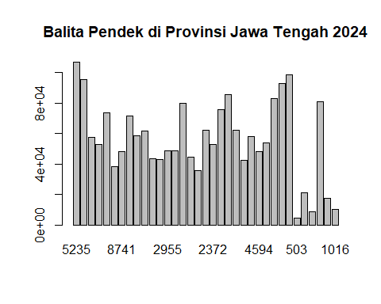

plot(Jumlah_Balita_diukur, TB_Pendek, main = "Balita Pendek di Provinsi Jawa Tengah 2024")

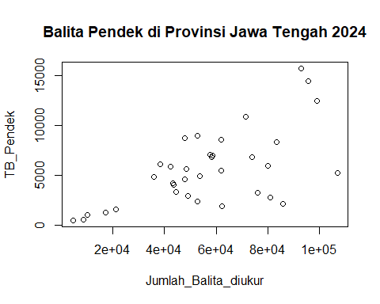

balita_pendek = c(3,12,10,8,2)  
Gizi_Balita= c(12.001-15.000,3.001-6.000,500-3.000,6.001-9.000,9.001-12.000)  
pct <- round(balita_pendek/sum(balita_pendek)*100)  
Gizi_Balita <- paste(Gizi_Balita,"=", pct)  
  
Gizi_Balita <- paste(Gizi_Balita, "%",sep = "")  
pie(balita_pendek, labels = Gizi_Balita,col = rainbow(length(Gizi_Balita)), main = "Balita Pendek di Provinsi Jawa Tengah 2024")

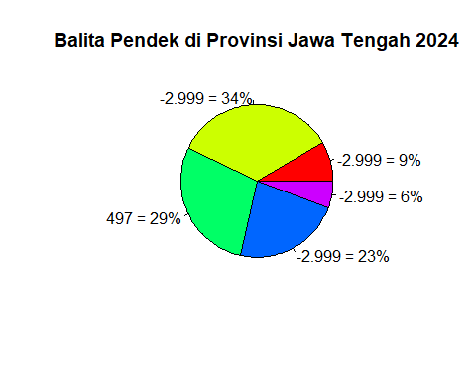

BALITA GIZI KURANG DI JAWA TENGAH 2024

Gizi_Balita <- c(data$Gizi_Balita)  
Gizi_Kurang <- c(data$Gizi_Kurang)  
  
barplot(Gizi_Balita, names.arg = Gizi_Kurang, main = "Gizi Kurang di Provinsi Jawa Tengah 2024")

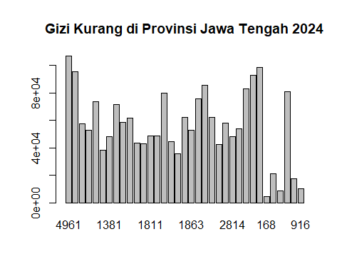

plot(Gizi_Balita, Gizi_Kurang, main = "Gizi Kurang di Provinsi Jawa Tengah 2024")

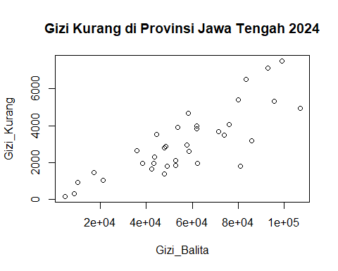

Gizi_Kurang = c(14,6,8,4,3)  
Gizi_Balita= c(1.501-3.000, 150-1.500,3.001-4.500,4.501-6.000,6.000-8.000)  
pct <- round(Gizi_Kurang/sum(Gizi_Kurang)*100)  
Gizi_Balita <- paste(Gizi_Balita,"=", pct)  
  
Gizi_Balita <- paste(Gizi_Balita, "%",sep = "")  
pie(Gizi_Kurang, labels = Gizi_Balita,col = rainbow(length(Gizi_Balita)), main = "Gizi Balita Kurang di Provinsi Jawa Tengah 2024")

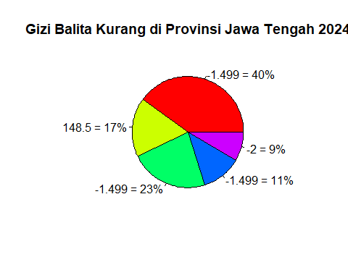

GIZI BURUK BALITA DI JAWA TENGAH 2024

Gizi_Balita <- c(data$Gizi_Balita)  
Gizi_Buruk <- c(data$Gizi_Buruk)  
  
barplot(Gizi_Balita, names.arg = Gizi_Buruk, main = "Gizi Buruk Balita di Provinsi Jawa Tengah 2024")

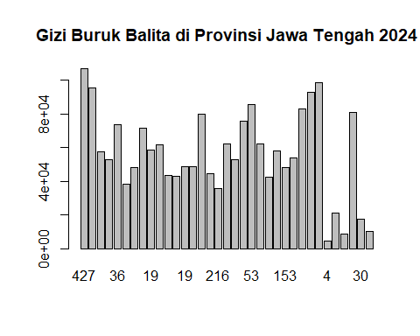

plot(Gizi_Balita, Gizi_Buruk, main = "Gizi Buruk Balita di Provinsi Jawa Tengah 2024")

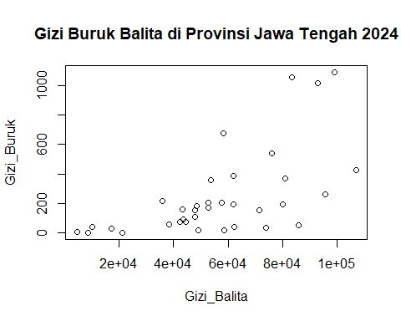

Gizi_Buruk = c(22,7,2,1,3)  
Gizi_Balita= c("0-200","201-400","401-600","601-800","801-1.100")  
pct <- round(Gizi_Buruk/sum(Gizi_Buruk)*100)  
Gizi_Balita <- paste(Gizi_Balita,"=", pct)  
  
Gizi_Balita <- paste(Gizi_Balita, "%",sep = "")  
pie(Gizi_Buruk, labels = Gizi_Balita,col = rainbow(length(Gizi_Balita)), main = "Gizi Buruk Balita di Provinsi Jawa Tengah 2024")

