DESIGN AND IMPLEMENTATION OF A WEB-BASED AI-POWERED CHATBOT FOR STUDENT ENQUIRY SERVICES IN EBONYI STATE UNIVERSITY, ABAKALIKI
BY
[TO FILL: YOUR FULL NAME IN CAPITALS]
[TO FILL: REGISTRATION NUMBER]
A PROJECT SUBMITTED TO THE DEPARTMENT OF COMPUTER SCIENCE, FACULTY OF SCIENCE, EBONYI STATE UNIVERSITY, ABAKALIKI, IN PARTIAL FULFILMENT OF THE REQUIREMENTS FOR THE AWARD OF THE BACHELOR OF SCIENCE (B.Sc.) DEGREE IN COMPUTER SCIENCE
[TO FILL: MONTH, YEAR]

DECLARATION
I, [TO FILL: full name], with registration number [TO FILL], declare that this project, titled “Design and Implementation of a Web-Based AI-Powered Chatbot for Student Enquiry Services in Ebonyi State University, Abakaliki”, is my own work carried out under the supervision of [TO FILL: supervisor's name and title], and that it has not been submitted for any other degree. All sources used have been acknowledged in the references.
______________________________ ______________________
Student Date

CERTIFICATION
This is to certify that this project was carried out by [TO FILL: full name] ([TO FILL: registration number]) in the Department of Computer Science, Faculty of Science, Ebonyi State University, Abakaliki, and that it meets the requirements for the award of the Bachelor of Science (B.Sc.) degree in Computer Science.
______________________________ ______________________
[TO FILL: Supervisor's name] Date
Project Supervisor
______________________________ ______________________
[TO FILL: Head of Department's name] Date
Head of Department
______________________________ ______________________
[TO FILL: External Examiner's name] Date
External Examiner

DEDICATION
[TO FILL: Dedicate the work, for example to God and to your family. One or two sentences.]

ACKNOWLEDGEMENTS
[TO FILL: Thank God; your supervisor by name; the Head of Department and lecturers of the Department of Computer Science; any EBSU office staff who answered your questions; classmates who tested the chatbot; and your family. Keep it to one page.]

ABSTRACT
Students of Ebonyi State University, Abakaliki (EBSU) need quick and accurate answers to routine questions about admission, fees, registration, results, transcripts and the offices that handle them. The answers exist, but they are spread across several university websites and portals, some are out of date, and students often phrase their questions in Nigerian Pidgin, in short forms or with spelling errors that a keyword search does not handle. This project designed and implemented a web-based chatbot that answers such enquiries in natural language. The system uses a retrieval-based natural language processing approach: each message is cleaned, typing errors are corrected with edit distance, Pidgin words and abbreviations are translated with a rule table, words are reduced to their roots with the Porter stemmer, and the message is compared with every stored question using TF-IDF cosine similarity combined with character-trigram similarity. A confidence threshold decides whether the bot answers, offers the closest questions, or refers the student to the responsible office and saves the question for an administrator. The system was built with Next.js and TypeScript and stores its knowledge base, chat logs and administrator accounts in MySQL. It runs on a single computer without internet access. The knowledge base holds 85 answers taken from 42 official EBSU web pages, 377 alternative phrasings and 307 language rules. On a held-out set of 30 test questions written in formal English, Pidgin, short forms and with typing errors, the system handled 29 correctly (96.7 per cent), gave no wrong answers and declined all five out-of-scope questions. The median response time was under five milliseconds. The study concludes that a transparent, retrieval-based chatbot can serve as a reliable first point of contact for student enquiries, provided the university keeps its knowledge base current.
Keywords: chatbot, natural language processing, information retrieval, TF-IDF, cosine similarity, edit distance, Nigerian Pidgin, student enquiry, Ebonyi State University.

TABLE OF CONTENTS

LIST OF TABLES

LIST OF FIGURES

LIST OF ABBREVIATIONS
Abbreviation | Meaning
AI | Artificial Intelligence
AIML | Artificial Intelligence Markup Language
API | Application Programming Interface
CAPS | Central Admissions Processing System (JAMB)
DE | Direct Entry
DFD | Data Flow Diagram
EBSU | Ebonyi State University, Abakaliki
ERD | Entity Relationship Diagram
FAQ | Frequently Asked Questions
IDF | Inverse Document Frequency
IR | Information Retrieval
JAMB | Joint Admissions and Matriculation Board
NLP | Natural Language Processing
PG / SPGS | Postgraduate / School of Postgraduate Studies
SQL | Structured Query Language
SUS | System Usability Scale
TAM | Technology Acceptance Model
TF-IDF | Term Frequency x Inverse Document Frequency
UI | User Interface
UML | Unified Modelling Language
UTME | Unified Tertiary Matriculation Examination

CHAPTER ONE
INTRODUCTION

1.1 Background of the Study
Universities answer the same questions every admission season and every semester. How much is the Post-UTME form? What is the cut-off mark for my course? How do I check my admission status, pay my acceptance fee, create my portal account or apply for my transcript? At Ebonyi State University, Abakaliki (EBSU), the answers to many of these questions are published, but they are spread across the main website (ebsu.edu.ng) and several portals and subdomains, among them portal.ebsu.edu.ng, iportal.ebsu.edu.ng, spgs.ebsu.edu.ng and services.ebsu.edu.ng. A student who needs one fact must know which page to open, read through notices written for many audiences, and judge whether the notice is still current.
Conversational agents, commonly called chatbots, offer a different way to reach the same information. A chatbot lets a person type a question in ordinary language and returns a direct answer (Adamopoulou & Moussiades, 2020). In education, chatbots have been used to answer administrative questions, support learning and reduce the load on staff (Okonkwo & Ade-Ibijola, 2021; Kuhail et al., 2023). In Nigeria, Adesina (2021) built iNOUN, a chatbot that answers academic enquiries for students of the National Open University of Nigeria, and reported good usability results.
Many chatbots depend on cloud services or on large language models. These need a constant internet connection, may cost money to run, and can produce fluent answers that are wrong and cannot be traced to a source. For a university information service an answer is only useful if it is correct and can be checked. A retrieval-based chatbot meets this need: it does not invent text, it selects an answer that a person has written and verified, and it can show where that answer came from (Abu Shawar & Atwell, 2007; Manning et al., 2008).
Students also write the way they speak. Nigerian students mix English with Nigerian Pidgin (“wetin be the putme fee?”), use short forms (“sch fees”, “PUTME”, “DE”) and make spelling errors. Switching between English and Pidgin is common in Nigerian online writing (Ndubuisi-Obi et al., 2019), and tools built for standard English misread Pidgin words (Oyewusi et al., 2020). A chatbot for EBSU students must therefore normalise this kind of language before it tries to match a question.
This project designs and implements such a system: a web-based chatbot that answers student enquiries about EBSU from a knowledge base built only from official university sources, understands Pidgin, abbreviations and misspellings, and refers students to the responsible office when it does not know the answer.

1.2 Statement of the Problem
Getting a simple answer from EBSU's public information takes more effort than it should. The following problems were observed while the knowledge base for this project was being compiled from the university's official web pages:
- Information is scattered. Admission, payment, portal, transcript and postgraduate information sit on at least seven different EBSU websites and subdomains. A student has to know where to look.
- Some information is out of date or inconsistent. When this study was carried out, the homepage still announced that the 2026/2027 Post-UTME screening “has commenced” after the application window had closed; the acceptance fee table on the admission procedures page belongs to the 2022/2023 session and the same page mentions a different amount; and the academic calendar page showed the 2023/2024 session.
- Search depends on exact wording. A page search does not connect “how much be putme form” with “Post-UTME fee”, or “admision” with “admission”.
- Unanswered questions leave no trace. When a student cannot find an answer online, the university has no record of what was asked, so the same gap remains for the next student.
- Offices answer the same questions repeatedly, in person or by phone, which takes staff time away from other work. [TO FILL: support this point with your interview or questionnaire results, for example how many students said they had to visit an office for routine information.]
These problems call for a single, always available point of contact that understands how students actually ask questions, answers only from verified sources, and records what it cannot answer so the gaps can be closed.

1.3 Aim and Objectives of the Study
The aim of this study is to design and implement a web-based, AI-powered chatbot that answers student enquiries about Ebonyi State University, Abakaliki, accurately and in natural language. The specific objectives are:
- To collect frequently needed information about EBSU (admission, Post-UTME, fees, registration, faculties, results, transcripts, postgraduate studies and contacts) from official university sources and organise it as a question-and-answer knowledge base in MySQL.
- To build a text normalisation module that handles Nigerian Pidgin, common abbreviations and spelling errors.
- To implement a matching engine based on TF-IDF cosine similarity and fuzzy string matching, with a confidence threshold and a fallback that refers students to the responsible office.
- To develop a web interface for students and an administration panel for maintaining the knowledge base and reviewing unanswered questions.
- To evaluate the accuracy of the system on a labelled set of test questions and to gather feedback from users.

1.4 Significance of the Study
The study is significant to the following groups:
- Students get answers at any time of day without travelling to an office. They can type in their own words, and every answer links to the official page it came from.
- The university administration and staff receive fewer repeated enquiries, gain a record of what students ask and what the published information lacks, and have one place to update common answers.
- The Department of Computer Science and future researchers gain a documented, reproducible example of retrieval-based natural language processing adapted to Nigerian student language, together with a labelled test set.
- Other Nigerian institutions can reuse the design with their own knowledge base, because the matching engine does not depend on a paid cloud service.

1.5 Scope of the Study
The study covers undergraduate and postgraduate enquiries that can be answered from EBSU's public information: admission and Post-UTME screening, cut-off marks, acceptance and payment procedures, the student portal, faculties and departments, results, transcripts and certificate verification, postgraduate admission, the library and office contacts. Questions may be typed in English, Nigerian Pidgin or common short forms. The system is text-based and web-based, runs on a single computer with MySQL, and does not generate new text: every answer is written in advance and linked to its source. Questions in Igbo, voice input and personal records such as a student's own result are outside the scope of this work.

1.6 Limitations of the Study
- Access to official information. During compilation the official website could only be read through a search engine restricted to ebsu.edu.ng, so some facts were taken from search extracts of the pages rather than the full page text. These facts are listed for verification.
- Missing information. Several topics students ask about, such as current school fee amounts, hostels, course registration steps, examination rules and the academic calendar, were not published on the website and are not yet in the knowledge base. For these the chatbot refers students to the relevant office.
- Currency. The knowledge base reflects the 2025/2026 and 2026/2027 sessions and must be updated each session.
- Method. Retrieval-based matching cannot answer a question for which no answer has been stored, and the system does not remember earlier messages in a conversation.
- Evaluation size. The accuracy test used 30 held-out questions prepared by the developer. A larger evaluation with questions collected from students is recommended.
- [TO FILL: add any time or financial constraints you faced.]

1.7 Organisation of the Work
Chapter One introduces the study, states the problem, aim and objectives, and defines its scope. Chapter Two reviews the literature on chatbots, natural language processing, information retrieval and the use of chatbots in higher education, and identifies the gap this work addresses. Chapter Three analyses the existing way students obtain information and presents the design of the proposed system, including its architecture, models, algorithm and database. Chapter Four describes the implementation, testing and results. Chapter Five summarises the work, draws conclusions and makes recommendations.

1.8 Definition of Terms
- Artificial intelligence (AI): the study and design of computer systems that perform tasks normally associated with human intelligence, such as understanding language.
- Chatbot: a computer program that converses with users in natural language, usually by text.
- Natural language processing (NLP): the branch of AI concerned with processing and understanding human language.
- Knowledge base: the stored collection of questions and answers the chatbot can draw on.
- Retrieval-based chatbot: a chatbot that selects a stored answer instead of generating new text.
- Normalisation: converting text into a standard form, for example lower case without punctuation, with short forms expanded.
- Tokenisation: splitting text into individual words (tokens).
- Stopword: a very common word that carries little meaning for matching, such as “the”, “is” or the Pidgin “abeg”.
- Stemming: reducing a word to its root, so that “registering” and “registered” are treated alike.
- TF-IDF: term frequency multiplied by inverse document frequency; a weight that is high for words that occur in a question but are rare across the knowledge base.
- Cosine similarity: a measure of how closely two weighted word vectors point in the same direction, from 0 (nothing in common) to 1 (identical).
- Edit distance: the smallest number of single-letter insertions, deletions, substitutions or swaps that turn one word into another (Levenshtein, 1966).
- Character trigram: a sequence of three consecutive characters, used to compare strings in a way that tolerates spelling errors.
- Confidence threshold: the minimum similarity score at which the chatbot gives an answer.
- Fallback: the reply the chatbot gives when no stored question is similar enough; it names the office to contact.
- Nigerian Pidgin: an English-based creole widely spoken across Nigeria.
- Code-switching: mixing two languages, such as English and Pidgin, in one sentence or conversation.
- Next.js: a framework built on React for creating web applications in JavaScript or TypeScript.
- MySQL / MariaDB: relational database management systems; XAMPP ships MariaDB, which is compatible with MySQL.

CHAPTER TWO
LITERATURE REVIEW

2.1 Introduction
This chapter reviews the concepts and theories on which the system is built, traces the development of chatbots, examines their use in higher education and reviews related systems in order to identify the gap that this project addresses.

2.2 Conceptual Framework

2.2.1 Artificial Intelligence and Natural Language Processing
Turing (1950) reframed the question “can machines think?” as an imitation game in which a machine succeeds if a judge cannot tell its written replies from a person's. The test made conversation in natural language a central goal of artificial intelligence. Natural language processing is the part of AI that enables computers to read, interpret and respond to human language. Closely related is information retrieval (IR), the task of finding, among a collection of stored documents, those that best satisfy a request expressed in words (Manning et al., 2008). A question-answering chatbot built on a knowledge base is an application of IR: each stored question is a document, and the student's message is the query.

2.2.2 Chatbots: Definition and Classification
Adamopoulou and Moussiades (2020) classify chatbots by the knowledge domain they cover (open or closed), the service they provide, their goals, how they process input and how they produce responses. On the last criterion there are three broad families:
- Rule-based chatbots match the input against hand-written patterns and fill in a response template. ELIZA and chatbots written in the Artificial Intelligence Markup Language (AIML) belong here.
- Retrieval-based chatbots compare the input with a repository of stored responses or question-answer pairs and return the most similar one, using a similarity measure.
- Generative chatbots compose new responses word by word with a language model. They are flexible but may produce confident statements that are false.
For a closed-domain information service such as a university enquiry desk, the retrieval approach has clear advantages: every possible answer is written and checked in advance, each answer can carry its source, and the behaviour of the system can be explained and tested. Its weakness is coverage, because it cannot answer a question for which no answer is stored. That weakness is managed by detecting low-confidence matches and referring the student to a person.

2.2.3 Knowledge Bases and FAQ Retrieval
In FAQ retrieval each stored question is treated as a document and the user's message as a query; the system returns the answer attached to the most similar stored question. Because people ask the same thing in many ways, storing several phrasings for each answer improves the chance of a match, and it is the main way the knowledge base is improved over time. Abu Shawar and Atwell (2007) describe chatbots used in this way as a natural-language front end to information that would otherwise have to be searched or browsed.

2.2.4 Text Normalisation, Stemming and Nigerian Pidgin
Before texts can be compared they are normalised: case is folded, punctuation removed, the text split into tokens, and very common words (stopwords) removed (Manning et al., 2008). Stemming then reduces related word forms to a common root. The Porter (1980) algorithm removes English suffixes in a sequence of steps, so that “register”, “registered” and “registering” become “regist”. Stemming increases the number of matches between differently worded questions.
Nigerian students add a further layer. Nigerian Pidgin is a widely used, low-resource language; Ogueji and Ahia (2019) describe what they present as the first natural language processing work on it, including a corpus of more than 56,000 sentences. Oyewusi et al. (2020) show that tools built for standard English misinterpret Pidgin because familiar English words change meaning, and they build a Pidgin lexicon to correct this. Ndubuisi-Obi et al. (2019) find that switching between Nigerian Pidgin and English is common in online discussions and depends on topic and audience. These studies support the decision to normalise student messages with an explicit table that maps Pidgin expressions, campus abbreviations and common misspellings to standard words before matching.

2.2.5 The Vector Space Model, TF-IDF and Cosine Similarity
Salton et al. (1975) proposed representing each document as a vector of term weights, so that the similarity of two documents can be computed from the angle between their vectors. Spärck Jones (1972) showed that a term which appears in many documents is a poor discriminator and introduced inverse document frequency (IDF) to give such terms less weight. Combining the frequency of a term in a document with its IDF gives the TF-IDF weight, and Salton and Buckley (1988) compared many such weighting schemes, showing the value of length normalisation. In this project the weights are computed as follows, where N is the number of stored phrasings and df(t) is the number of phrasings that contain term t:
tf(t, d) = number of times term t occurs in phrasing d
idf(t) = ln( (1 + N) / (1 + df(t)) ) + 1
w(t, d) = tf(t, d) x idf(t)
cos(q, d) = sum over t of w(t, q) x w(t, d) / ( |q| x |d| )
A word that the student typed but that appears in no stored question receives the largest possible IDF in the query vector. This lowers the cosine score for messages that contain much that the knowledge base does not know about, which helps the system recognise questions outside its scope.

2.2.6 Approximate String Matching
Levenshtein (1966) defined the edit distance between two strings as the minimum number of insertions, deletions and substitutions needed to change one into the other. The variant used here also counts the swap of two neighbouring letters as one edit, which catches errors such as “hostle” for “hostel”. Character n-grams offer a second, complementary measure: Kondrak (2005) shows that similarity based on overlapping character sequences generalises edit distance and performs well on spelling variation. This project uses character trigrams compared with the Dice coefficient, 2|A ∩ B| / (|A| + |B|), as a secondary score that tolerates spelling and spacing differences.

2.2.7 Confidence Thresholds and Fallback Handling
A retrieval system always returns a best match, even when nothing stored is relevant. A threshold on the similarity score separates confident answers from uncertain ones. Raising the threshold makes the answers given more likely to be correct (higher precision) but leaves more questions unanswered (lower recall); measures such as accuracy, precision, recall and F1 describe this trade-off (Sokolova & Lapalme, 2009). A good fallback tells the user honestly that no answer is available, offers the closest alternatives when there are some, points to human help, and records the question so that the knowledge base can be improved.

2.2.8 Web Technologies
The system is a web application. Next.js is a framework built on React that renders pages on the server and lets the same project define server-side endpoints (API routes) and server actions. TypeScript adds static types to JavaScript, which catches many errors before the program runs. MySQL is a widely used relational database management system; the XAMPP package, common in Nigerian computer laboratories, includes MariaDB, a compatible fork, together with the phpMyAdmin management tool.

2.3 Theoretical Framework
The study draws on two theories. The first is the Technology Acceptance Model (Davis, 1989), which holds that people adopt a technology when they find it useful (perceived usefulness) and easy to use (perceived ease of use). The design targets both constructs: answers are direct and carry their official source, which supports usefulness, while students can type in their own words, including Pidgin and short forms, which supports ease of use. The user feedback form in Appendix E measures both constructs. The second is the vector space model of information retrieval (Salton et al., 1975), which provides the mathematical basis of the matching engine described in Chapter Three.

2.4 Historical Development of Chatbots
ELIZA (Weizenbaum, 1966) was the first widely known chatbot. It matched keywords in the user's sentence and reassembled parts of the sentence into a reply, imitating a psychotherapist. Its replies were convincing in short exchanges but it had no knowledge of the world. ALICE, built on AIML, organised knowledge into thousands of pattern and template categories and won the Loebner Prize several times (Wallace, 2009). Abu Shawar and Atwell (2007) argued that chatbots of this kind are useful beyond entertainment, in education, information retrieval and e-commerce. More recent systems combine machine learning with large training corpora and, most recently, large language models (Adamopoulou & Moussiades, 2020). Across this history the trade-off between flexibility and control remains: the more freely a chatbot generates text, the harder it is to guarantee that what it says is true.

2.5 Chatbots in Higher Education
Okonkwo and Ade-Ibijola (2021) reviewed 53 articles on chatbots in education. They report benefits such as quick access to information, round-the-clock availability, support for teaching and help with administrative services, and challenges that include limited understanding of user input and the effort needed to maintain content. Kuhail et al. (2023) reviewed 36 educational chatbots and found that most were delivered through the web. Hwang and Chang (2023) concluded that research on educational chatbots was still at an early stage and that more empirical evaluation was needed, which supports measuring this system's accuracy and collecting user feedback rather than only describing its design.

2.6 Review of Related Works
Table 2.1 summarises systems and studies closely related to this project.
Table 2.1: Review of related works
Author (year) | System or study | Technique | Evaluation | Gap addressed by this project
Ranoliya et al. (2017) | Chatbot for university-related FAQs (India) | AIML for greetings and templates; Latent Semantic Analysis for service questions | Design described; no quantitative results reported in the abstract | Measured accuracy, precision and recall on a held-out test set
Adesina (2021) | iNOUN, academic enquiries at the National Open University of Nigeria | Dialogflow (cloud natural language service) with a content management system | Think-aloud testing and System Usability Scale | Self-hosted engine with no paid cloud service; explicit Pidgin and abbreviation handling; office referral
Adigun et al. (2023) | Survey of 206 undergraduates on chatbots for library reference services in Nigerian universities | Questionnaire comparing ChatGPT with conventional reference help | Descriptive statistics | A working system for enquiries, rather than a perception study
Paul-Ojimadu (2026) | AI-powered chatbot for student support in African universities (undergraduate project) | Intent recognition with a rule-based knowledge base; Next.js | Functional testing with input cases | Quantitative retrieval evaluation; sources shown with every answer
Ojamiren (2025) | Intelligent chatbot course adviser (undergraduate project) | AI, machine learning and NLP techniques | Survey and user acceptance testing | University-wide enquiries rather than course advice alone

2.7 Summary of the Literature and Research Gap
The literature establishes that chatbots can give students quick access to information and that retrieval methods built on the vector space model, TF-IDF weighting and approximate string matching are well understood and easy to explain. It also shows that Nigerian Pidgin and code-switching are common in student writing and that standard tools handle them poorly. Most related systems either depend on cloud natural language services such as Dialogflow or on AIML templates, and several report little or no quantitative evaluation. None of the systems reviewed combines explicit handling of Pidgin and campus abbreviations, answers that are tied to official sources, an honest fallback that names the responsible office, and a mechanism that turns unanswered questions into new knowledge-base entries. This project addresses that gap for EBSU.

CHAPTER THREE
SYSTEM ANALYSIS AND DESIGN

3.1 Introduction
This chapter explains how the system was developed and how it is designed. It names the development methodology, describes how the information in the knowledge base was collected, analyses the way students obtain information at present and the problems with it, and then presents the proposed system: its requirements, architecture, models, matching algorithm, database, input and output design and security design.

3.2 Development Methodology
The system was developed with the incremental prototyping model, and it was analysed and designed with the object-oriented analysis and design method (OOADM), using diagrams from the Unified Modelling Language (UML) together with data flow diagrams. In incremental development a system is built as a series of versions, each adding working functionality that can be tested and shown to users before the next version is started (Sommerville, 2016; Pressman & Maxim, 2020). This model suited the project for three reasons. First, the exact questions students ask were not known at the start, so the knowledge base and the language rules had to grow as the matcher was tested. Second, the matching engine needed repeated tuning against a set of test questions, which is easier when each increment is small. Third, every increment produced something that could be demonstrated, which reduced the risk of reaching the end of the project with an unfinished system.
Table 3.1 lists the increments in the order they were built.
Table 3.1: Development increments
Increment | What was built | How it was checked
1. Knowledge base | Facts collected from official EBSU pages; database schema; seed data with a source link for every answer | Every answer traced back to its source page; the database imported into MariaDB
2. Matching engine | Text cleaning, typo correction, language rules, stopwords, stemming, TF-IDF cosine and trigram scoring, thresholds | 22 automated unit tests; 30 development questions
3. Student interface | Chat page with suggested questions, answers with sources, “Did you mean” suggestions, fallback with office contact, match details | Browser tests on desktop and phone screen sizes
4. Administration | Login, knowledge base editor, unanswered questions, chat logs, test bench, offices and settings | End-to-end browser tests of each admin task
5. Evaluation | Accuracy test on 30 held-out questions; threshold sweep; response-time measurement | Results in Chapter Four

3.3 Methods of Data Collection

3.3.1 Official University Documents
The main source of data was the university's own published information. Facts about admission, Post-UTME screening, cut-off marks, fees and payments, the student portal, faculties and departments, results, transcripts, certificate verification, postgraduate study, the library and office contacts were collected from 42 official EBSU web pages on seven sites: ebsu.edu.ng and the subdomains portal.ebsu.edu.ng, iportal.ebsu.edu.ng, spgs.ebsu.edu.ng, services.ebsu.edu.ng, mail.ebsu.edu.ng and orphanproject.ebsu.edu.ng. The compilation was carried out on 9 and 10 October 2026. Because the official website could not be opened directly from the development computer, the pages were read through a search engine restricted to the ebsu.edu.ng domain. A rule was applied throughout: a fact entered the knowledge base only if it appeared on an official EBSU page, and the address of that page is stored with the answer and shown to the student. Facts that were not published, such as current school fee amounts, hostel allocation and course registration steps, were not guessed; they are listed in Appendix B for the responsible offices to supply.

3.3.2 Student Language
To understand questions written the way students write, a table of 307 language rules was compiled: 61 Nigerian Pidgin expressions (for example “wetin be” for “what is” and “how much e be” for “how much”), 137 abbreviations and campus short forms (“putme”, “sch fees”, “pg”, “o level”), 36 common misspellings (“admision”, “trancript”) and 73 synonyms that map different words for the same idea to one form (“fee” and “how much” both become “cost”). [TO FILL: if you collected real questions from students, for example through a WhatsApp poll or a short questionnaire, describe how many you collected and how they were used to extend the rules.]

3.3.3 Interviews and Questionnaire
[TO FILL: describe any interviews you held with staff of the Admissions Office, the Registry (Exams and Records), the Bursary, Student Affairs or the ICT and Research Centre, and any questionnaire given to students about how they get information today. Give the number of people, the dates and the main findings. If none were held, delete this subsection and renumber.]

3.3.4 Test Questions
Sixty questions were written to measure how well the matcher works. They cover the five styles in which students ask questions: formal English, Nigerian Pidgin, short forms, questions with typing errors, and questions that are outside the scope of the knowledge base. The questions were divided into two sets of 30. The development set was used while the matcher and the thresholds were being tuned. The test set was kept aside and used only for the final measurement reported in Chapter Four, so that the reported accuracy is not inflated by tuning.

3.4 Analysis of the Existing System
At present a student who needs information about EBSU has to find it on the university's websites or ask a member of staff. Figure 3.1 shows the process. The student searches the web or opens the main website, ebsu.edu.ng, and must then guess which of several sites holds the answer. During data collection, admission and Post-UTME notices were found on the main site, admission applications, the student portal and transcript applications on iportal.ebsu.edu.ng, results on portal.ebsu.edu.ng, postgraduate admission requirements on spgs.ebsu.edu.ng, online clearance on services.ebsu.edu.ng, and fee instalment and supplementary payment notices on an older site, mail.ebsu.edu.ng. Having found a notice, the student must also judge whether it applies to the current session.
When the student cannot find or understand the information, the alternative is to visit or telephone the responsible office during office hours, or to ask other students, whose answers may be wrong or out of date. In either case nothing records what was asked, so the university does not learn which information is missing or hard to find. [TO FILL: add what your interviews or questionnaire showed, for example the offices students visit most often and how long they wait.]
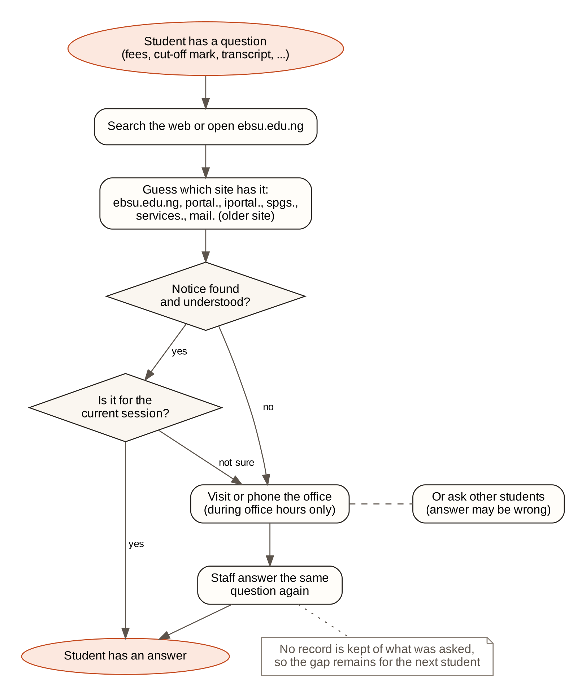
Figure 3.1: How a student obtains information in the existing system

3.5 Problems of the Existing System
- Scattered information. Answers are spread over at least seven websites and subdomains. A student has to know where to look before the answer can be found.
- Outdated or conflicting notices. Some pages describe earlier sessions. For example, the academic calendar page showed the 2023/2024 session, and the acceptance fee table on the admission procedures page was for 2022/2023 while the same page mentioned a different amount.
- Exact-wording search. Website search and browsing do not connect a question written in Pidgin, in short forms or with spelling errors to the notice that answers it.
- Limited availability. Offices can only be reached during working hours, and the same routine questions are answered again and again.
- No feedback loop. Questions that the published information does not answer are not recorded, so the gaps are never closed.

3.6 The Proposed System
The proposed system, the EBSU Enquiry Bot, is a web-based chatbot that answers student enquiries from a single knowledge base built from official EBSU sources. The student opens one page, sees suggested questions, and types a question in their own words. The system cleans the message, corrects typing errors, translates Pidgin and short forms, and compares the result with every stored phrasing of every question. If the best match is good enough, it replies with the stored answer, a link to the official page the answer came from, and the office responsible. If the match is uncertain, it offers the closest questions. If nothing matches, it says honestly that it does not have the answer yet, names the office to contact, and saves the question. Administrators log in to maintain the knowledge base and turn saved questions into new answers.
The advantages of the proposed system over the existing one are:
- One point of contact for information that is otherwise spread across several sites, available at any time.
- Natural language input, including Nigerian Pidgin, abbreviations and misspellings.
- Traceable answers: every answer shows the official page it came from, so students can check it.
- Honest fallback: the system does not guess. When it is not confident it says so and refers the student to the right office.
- A feedback loop: unanswered questions are grouped and counted for the administrator, so the knowledge base improves with use.
- No running cost and no internet requirement: the system runs on one computer with free software.

3.7 Requirements Specification

3.7.1 Functional Requirements
Table 3.2: Functional requirements
ID | Requirement
FR1 | A student can type a question of up to 500 characters in English, Nigerian Pidgin or common short forms.
FR2 | The chat page shows suggested questions that a student can select instead of typing.
FR3 | When the best match scores at or above the answer threshold, the system shows the stored answer, a link to its official source and the responsible office.
FR4 | When the best match scores between the suggestion threshold and the answer threshold, the system offers up to three closest questions.
FR5 | When no stored question is close enough, the system says that it does not have the answer, names the office to contact with its email or phone number, and saves the question.
FR6 | A student can open a panel that shows how the message was processed and scored.
FR7 | A student can rate an answer as helpful or not helpful.
FR8 | A student can view a page that lists the university offices and their contacts.
FR9 | An administrator must log in with a username and password before any administration page or action can be used.
FR10 | An administrator can add, edit, deactivate and delete question-and-answer pairs, each with alternative phrasings, a category, an office and a source.
FR11 | An administrator can see unanswered questions grouped and counted, answer one by writing a new entry, link it to an existing answer as another phrasing, or dismiss it.
FR12 | An administrator can view a dashboard of usage, the chat logs and the accuracy of the system on the test questions.
FR13 | An administrator can update office contacts, the matching thresholds and their own password.

3.7.2 Non-Functional Requirements
Table 3.3: Non-functional requirements
ID | Quality | Requirement
NFR1 | Performance | A reply is returned in under one second on an ordinary laptop.
NFR2 | Offline operation | After installation, the system works without an internet connection. It calls no external service and loads no fonts or scripts from the internet.
NFR3 | Accuracy | At least 90 per cent of held-out test questions are handled correctly, and a wrong answer is never preferred to a fallback.
NFR4 | Usability | Plain language; works on phone and desktop screens; usable with the keyboard; text contrast of at least 4.5:1.
NFR5 | Security | Passwords stored only as hashes; sessions expire; repeated failed logins are locked out; database queries are parameterised.
NFR6 | Maintainability | Administrators update answers without programming, and the matcher picks up every change automatically.
NFR7 | Traceability | Every answer records the official source it came from.
NFR8 | Portability | Runs on Windows, macOS or Linux with Node.js and XAMPP, and starts with one command.

3.8 System Architecture
The system follows a three-tier architecture, shown in Figure 3.2. The presentation tier is the set of pages that run in the web browser: the student chat, the “How it works” page, the contacts page and the administration pages. The application tier is a Next.js server written in TypeScript. It exposes three API routes for the chat (/api/chat for messages, /api/explain for the live matcher on the “How it works” page and /api/feedback for ratings), server actions for the administration forms, the authentication module and the NLP matching engine. The matching engine keeps an index of all stored phrasings in memory and rebuilds it whenever a question, phrasing or language rule changes. The data tier is a MySQL (MariaDB) database called ebsu_chatbot. Because all three tiers run on the same computer, the system needs no internet connection; students on the same campus network can reach it through the computer's address.
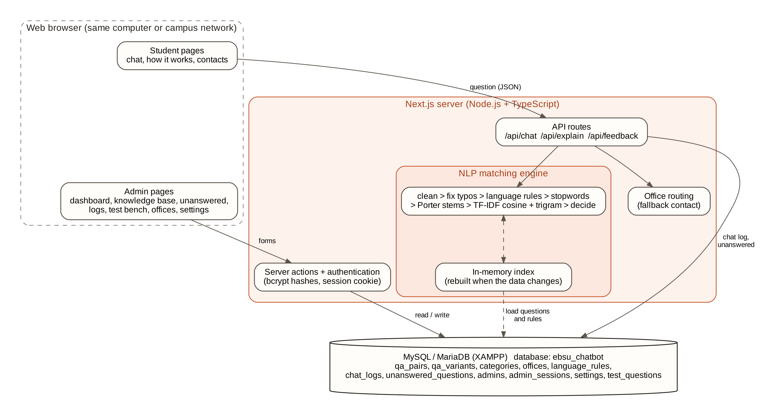
Figure 3.2: Architecture of the EBSU Enquiry Bot

3.9 System Modelling

3.9.1 Use Case Diagram
The system has two actors (Figure 3.3). The student asks questions in their own words, views answers with their sources, picks suggested questions, opens the match details, rates answers and views office contacts. The administrator logs in and out, maintains questions and answers, reviews unanswered questions and links them to existing answers, views the dashboard and chat logs, runs the test bench and updates offices, thresholds and the password. Every administrator use case includes logging in.
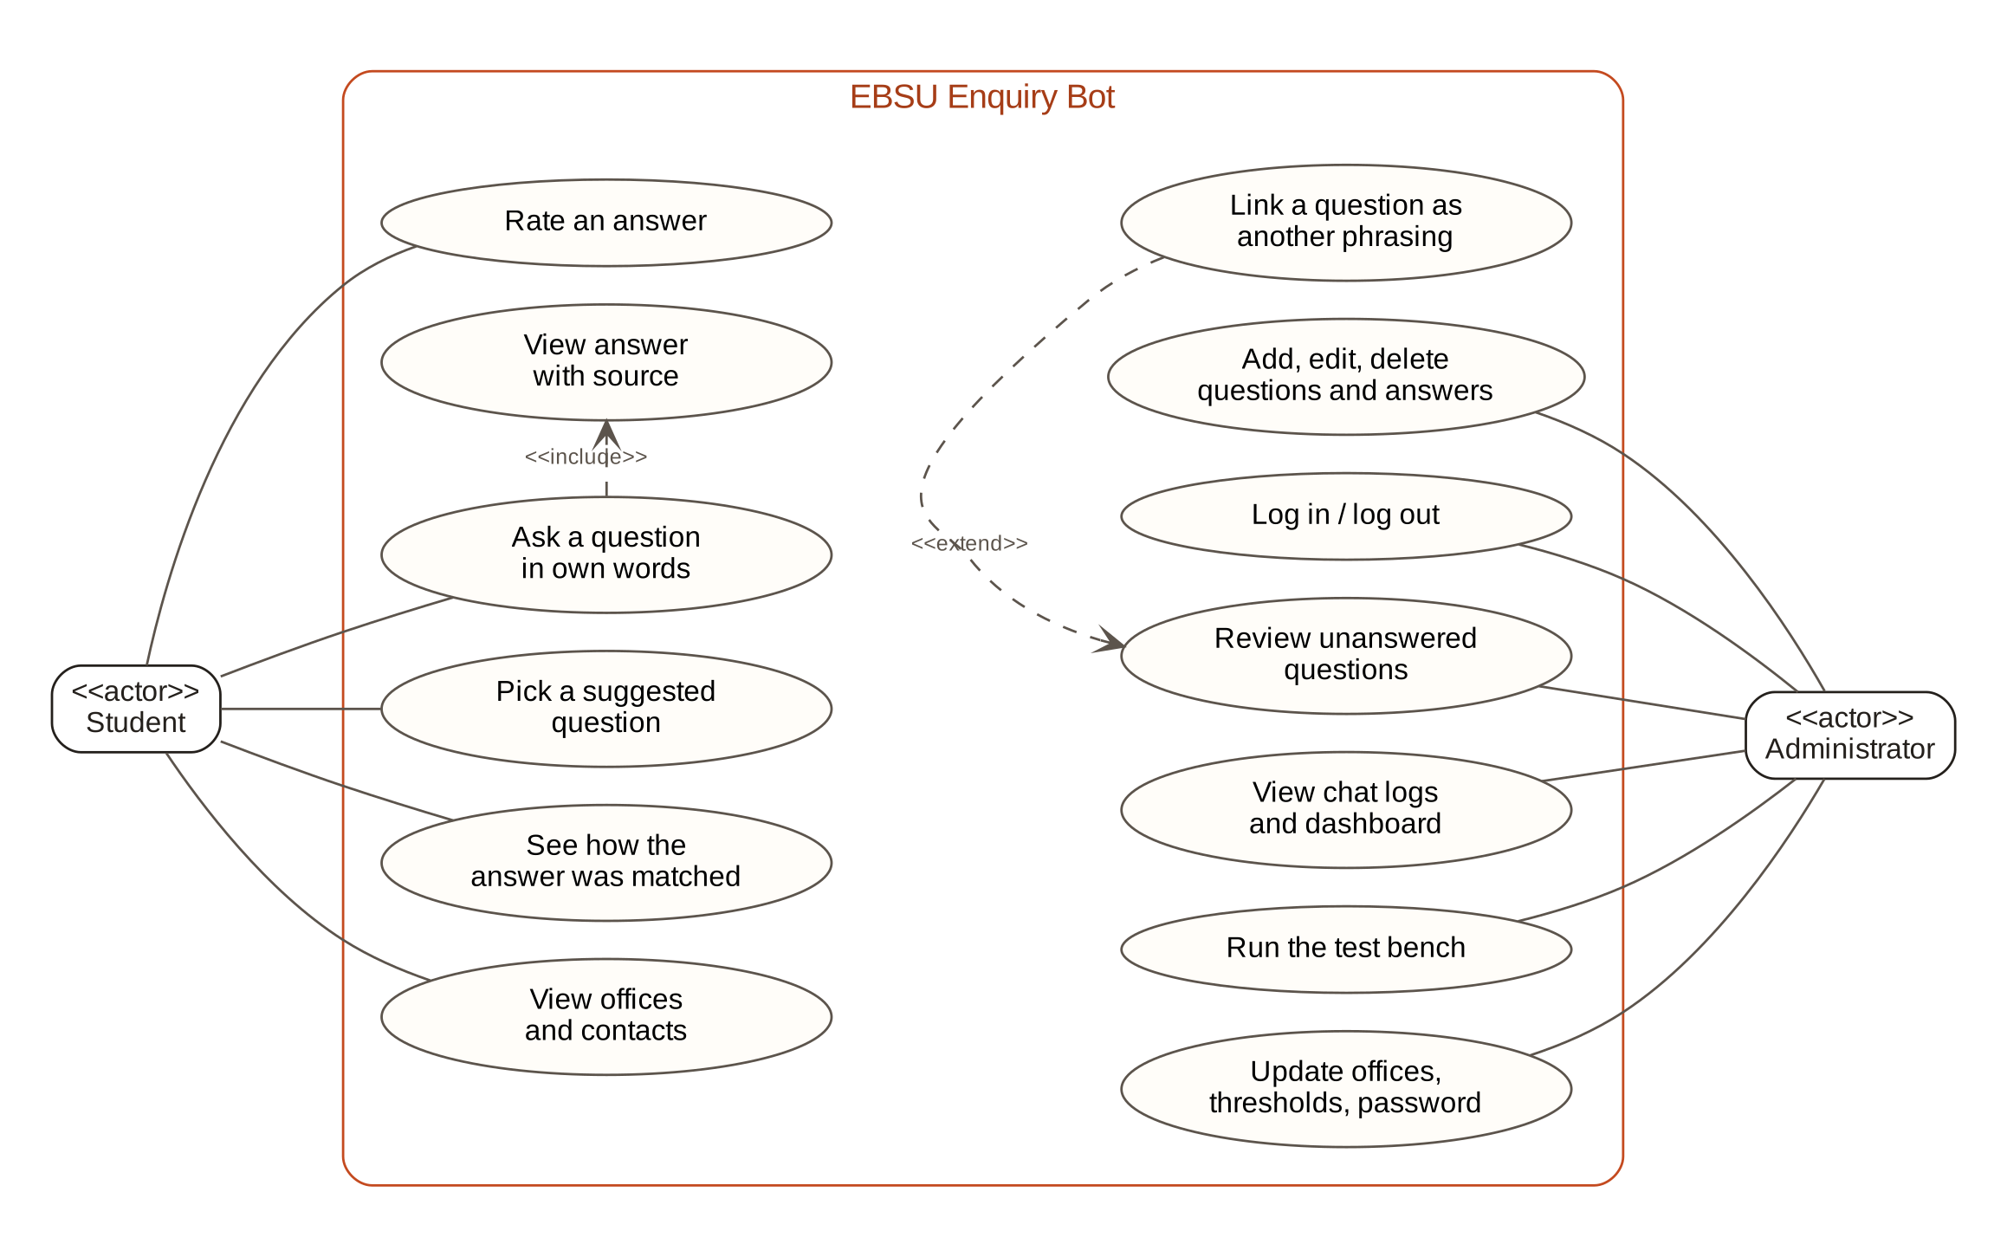
Figure 3.3: Use case diagram

3.9.2 Data Flow Diagrams
The context diagram (Figure 3.4) shows the system as a single process. Students send question text and ratings and receive answers with their sources, suggestions or an office contact. Administrators send login details, new or edited answers, thresholds and office details, and receive the dashboard, the list of unanswered questions, chat logs and test results.
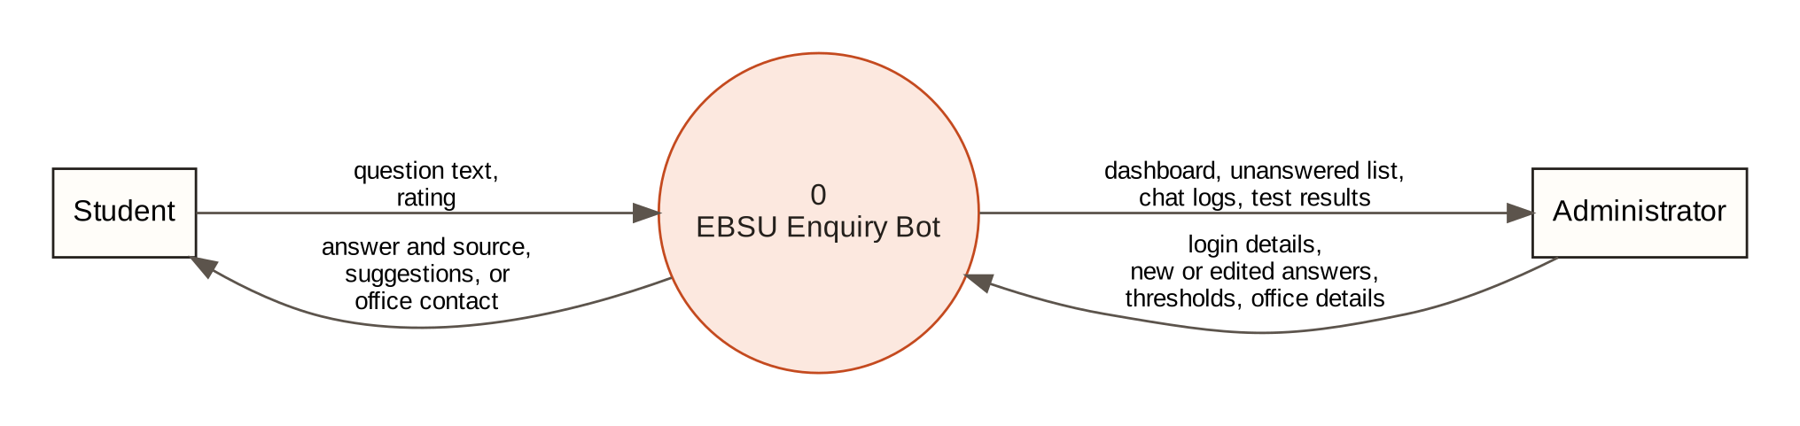
Figure 3.4: Context diagram (level 0 data flow diagram)
The level 1 diagram (Figure 3.5) breaks the system into six processes: receiving and cleaning the message (1.0), matching it against the knowledge base (2.0), composing the reply (3.0), logging the message and recording unanswered questions (4.0), authenticating the administrator (5.0) and managing the knowledge base and offices (6.0). The data stores are the knowledge base (D1), the language rules (D2), the chat logs (D3), the unanswered questions (D4), the administrator accounts and sessions (D5) and the offices and settings (D6).
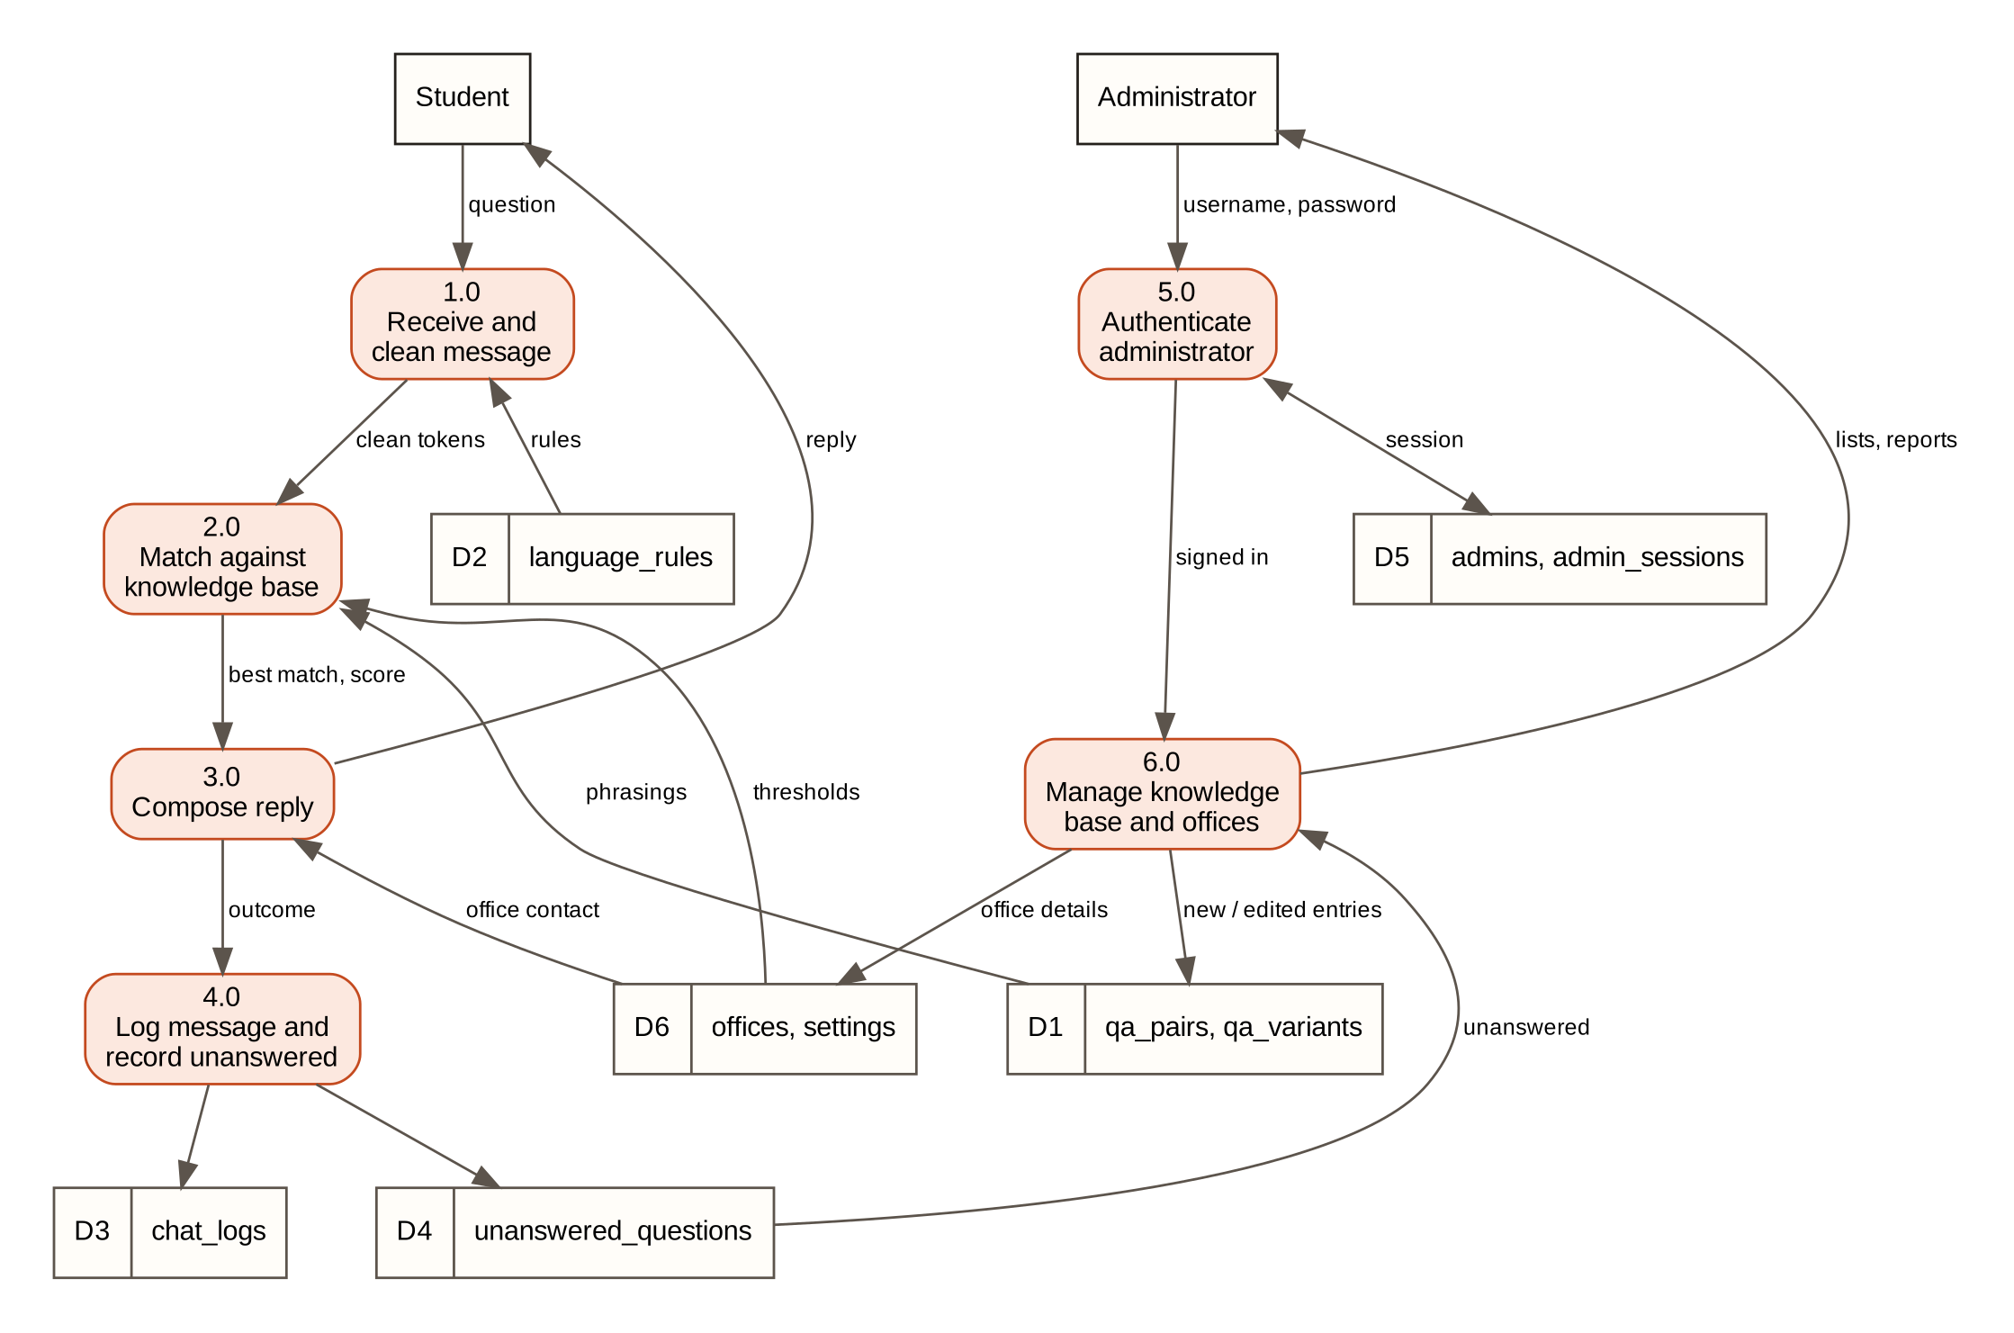
Figure 3.5: Level 1 data flow diagram

3.9.3 Flowchart of the Matching Process
Figure 3.6 shows the steps the system follows for every message, from cleaning the text to choosing between an answer, suggestions and the fallback.
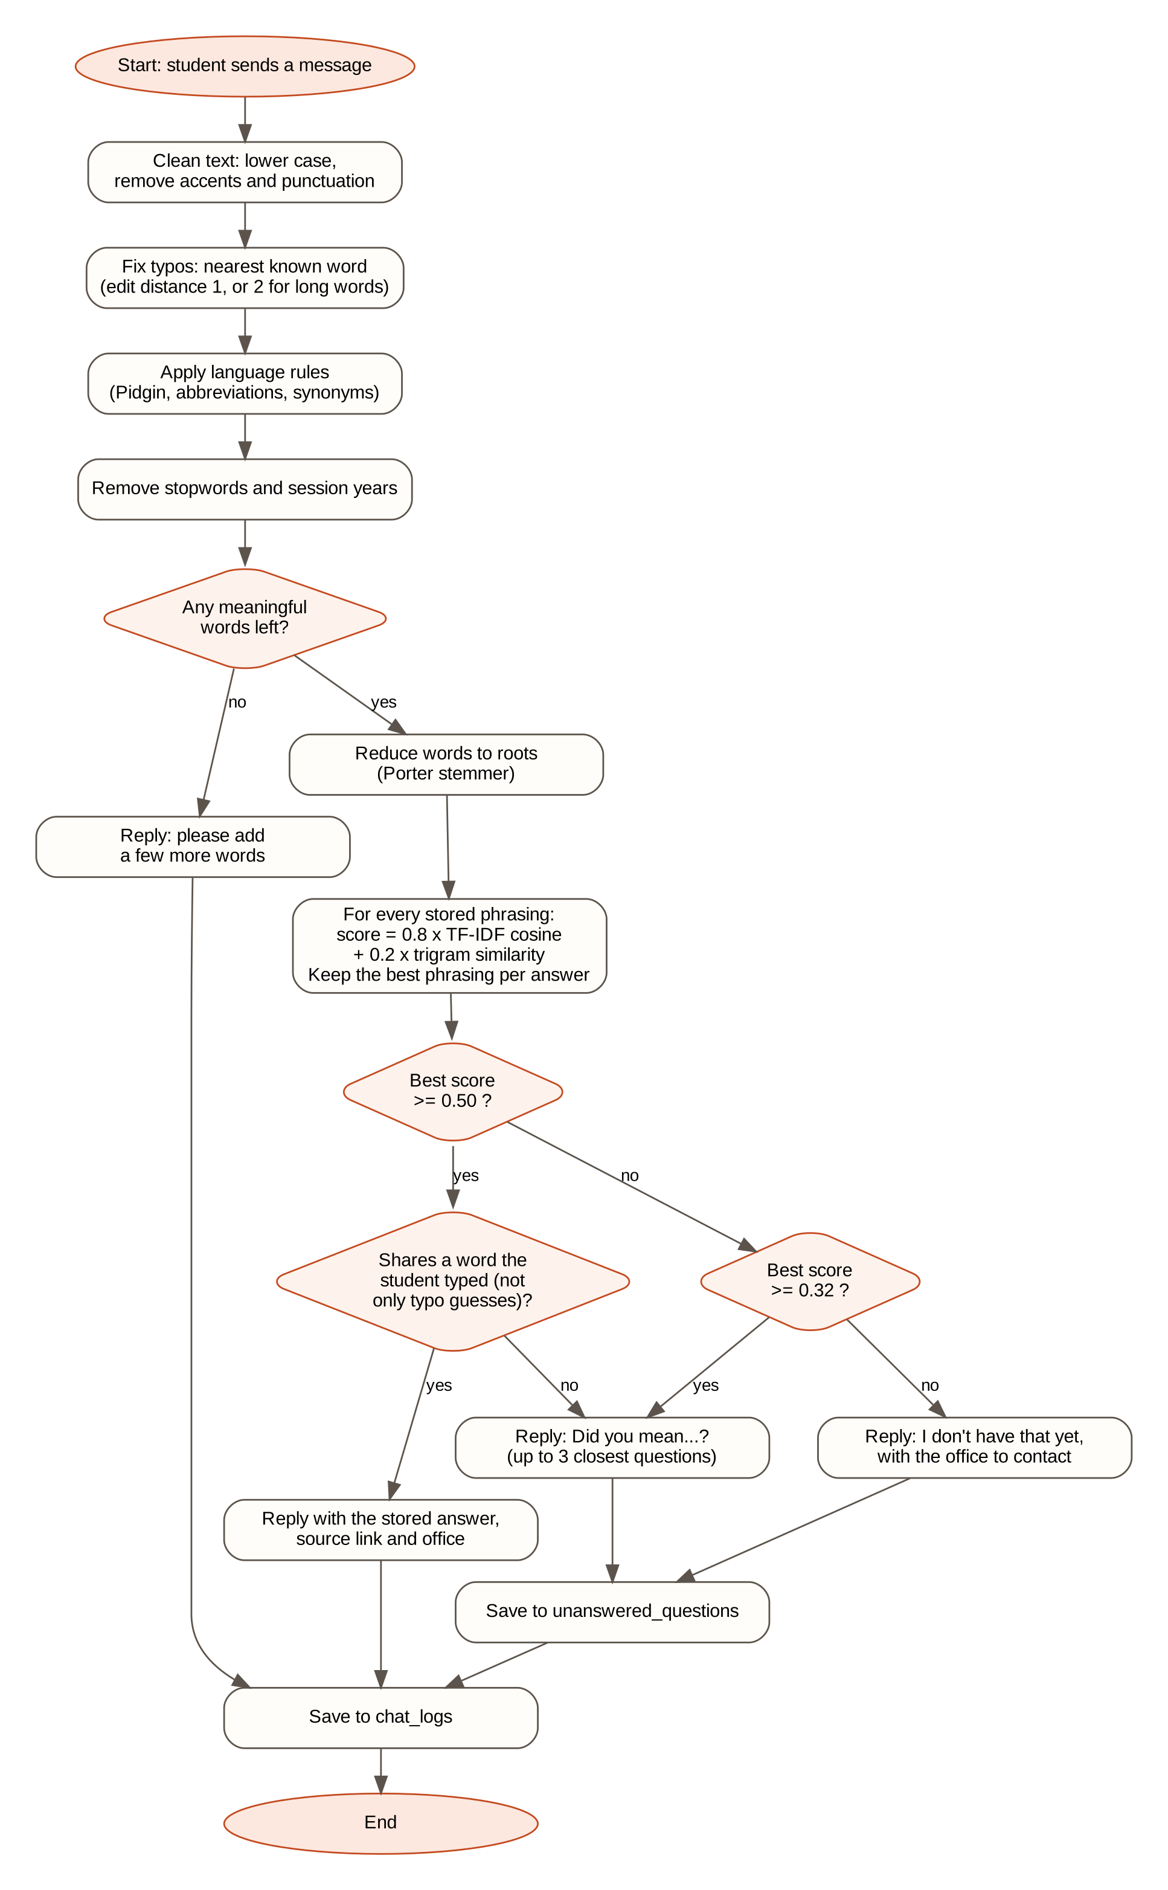
Figure 3.6: Flowchart of the matching process

3.10 Algorithm Design

3.10.1 Processing Steps
Every message passes through seven steps. The same cleaning, rules, stopword removal and stemming are applied to the stored questions when the index is built, so that both sides are compared in the same form.
- Clean. Convert to lower case, remove accents (for example Igbo tone marks) and replace punctuation with spaces. “Wetin be the PUTME fee??” becomes “wetin be the putme fee”.
- Correct typing errors. Each word that is not in the vocabulary of the knowledge base is compared with the known words using the Damerau-Levenshtein edit distance. Words of up to three letters are never corrected, words of four to seven letters may differ by one edit, and longer words by two. The correction must keep the first letter (or swap the first two), which prevents corrections such as “sports” to “scores”. A corrected word is marked as a guess.
- Apply language rules. Pidgin expressions, abbreviations, misspellings and synonyms are replaced by their standard form, trying the longest phrase first, so that “how much e be” is matched before “how much”.
- Remove stopwords. Very common English and Pidgin words (“the”, “is”, “abeg”, “dey”) and words found in almost every enquiry (“EBSU”, “university”) are removed, as are session years such as “2026”.
- Stem. Each remaining word is reduced to its root with the Porter (1980) stemmer.
- Score. The message is compared with every stored phrasing using TF-IDF cosine similarity on the roots and character-trigram similarity on the words. The best phrasing of each answer represents that answer.
- Decide. The best score is compared with the two thresholds to choose an answer, suggestions or the fallback.

3.10.2 Scoring Formulas
Let N be the number of stored phrasings, df(t) the number of phrasings that contain root t, and tf(t, d) the number of times t occurs in phrasing d. The weights and scores are:
idf(t) = ln( (1 + N) / (1 + df(t)) ) + 1
idf(unknown) = ln(1 + N) + 1 (a root that no stored phrasing contains)
w(t, d) = tf(t, d) x idf(t) (x 0.75 for a root that came from a typo guess)
cos(q, d) = sum of w(t, q) x w(t, d) / ( |q| x |d| )
tri(q, d) = 2 |G(q) n G(d)| / ( |G(q)| + |G(d)| ) (G = character trigrams)
score(q, d) = 0.8 x cos(q, d) + 0.2 x tri(q, d)
The cosine carries most of the weight because it measures whether the message and the stored question share the informative words. The trigram score adds tolerance for spelling and spacing differences that the typo corrector does not fix. Roots that came from a typo guess carry less weight than roots the student typed, because a guess may be wrong.

3.10.3 Decision Rule
Two thresholds, stored in the settings table and adjustable by the administrator, divide the scores into three bands:
- score ≥ 0.50: answer. The stored answer is shown with its source and office, provided the message shares at least one root that the student actually typed with the best phrasing. If the only shared roots came from typo guesses, the system offers suggestions instead of answering.
- 0.32 ≤ score < 0.50: suggest. The system replies “Did you mean one of these?” with up to three closest questions, and the message is saved for the administrator.
- score < 0.32: fallback. The system says it does not have the answer yet, names the office to contact and saves the message.
The values 0.50 and 0.32 were chosen on the development set (Section 3.3.4) and then fixed before the test set was used. Greetings and other small talk (“hello”, “thank you”) are stored as ordinary entries in a hidden category; they win only when they are a near-exact match or when nothing else qualifies, so that “good morning, where is the library?” is answered as a library question. When the system falls back, it chooses the office from the topic words in the message: for example “hostel” points to Student Affairs, “transcript” to the Records Unit, “portal” to the ICT and Research Centre and “postgraduate” to the School of Postgraduate Studies. If the chosen office has no published email or telephone number, the general contact of the Office of the Registrar is shown as well.

3.10.4 Pseudocode
ALGORITHM MatchMessage(message, index, answerT = 0.50, suggestT = 0.32)
words <- split(clean(message))
FOR EACH word w IN words
IF w is not known AND not a stopword AND has no digit THEN
c <- nearest known word with the same first letter
and editDistance(w, c) <= allowedEdits(length(w))
IF c exists THEN replace w with c and mark it as a guess
words <- applyLanguageRules(words) // longest phrase first
words <- remove stopwords and session years
IF words is empty THEN RETURN 'Please type a few more words'
roots <- PorterStem(words)
q <- unit-length TF-IDF vector of roots (guessed roots x 0.75)
FOR EACH stored phrasing d
score(d) <- 0.8 x cosine(q, d) + 0.2 x dice(trigrams(words), trigrams(d))
best <- answer whose best phrasing has the highest score
IF score(best) >= answerT AND best shares a typed (not guessed) root THEN
RETURN answer(best) with its source link and office
ELSE IF score(best) >= suggestT THEN
SAVE message as unanswered
RETURN 'Did you mean...?' with up to three closest questions
ELSE
SAVE message as unanswered
RETURN fallback with routeToOffice(words)

3.10.5 Examples of Language Rules
Table 3.4: Examples of language rules
Kind | Student types | Standard form
Pidgin | wetin be | what
Pidgin | how much e be / how much | cost
Pidgin | don comot / drop | release
Pidgin | wen | date
Abbreviation | putme | postutme
Abbreviation | sch fees / schfees | schoolfee
Abbreviation | pg | postgraduate
Abbreviation | o level / waec / neco | olevel
Abbreviation | vc | vicechancellor
Spelling | admision | admission
Spelling | trancript | transcript
Spelling | hostle | hostel
Synonym | fee | cost
Synonym | when | date

3.10.6 Worked Example
To show how the scores are computed, consider a knowledge base of only four questions and the Pidgin message “wetin be the putme fee”. After the processing steps, the stored questions reduce to the roots shown in Table 3.5. With N = 4, a root that occurs in one question has idf = ln(5/2) + 1 = 1.9163, and a root that occurs in two questions has idf = ln(5/3) + 1 = 1.5108.
Table 3.5: Roots of the four stored questions
Doc | Stored question | Roots after processing
D1 | How much is the EBSU Post-UTME form? | cost (1.5108), postutm (1.5108), form (1.9163)
D2 | How much is the EBSU acceptance fee? | cost (1.5108), accept (1.9163)
D3 | When does the EBSU Post-UTME application open and close? | date, appli, open, close (1.9163 each), postutm (1.5108)
D4 | What is the cut-off mark for Computer Science? | cutoff, comput, scienc (1.9163 each)

The message is processed as follows: “wetin be” becomes “what” (a stopword), “the” is a stopword, “putme” becomes “postutme” and “fee” becomes “cost”. The roots of the message are therefore postutm and cost, each with weight 1.5108, which gives the unit vector q = (0.7071, 0.7071). For D1 the vector length is √(1.5108² + 1.5108² + 1.9163²) = 2.8701, so its normalised weights for cost and postutm are 1.5108 / 2.8701 = 0.5264, and
cos(q, D1) = 0.7071 x 0.5264 + 0.7071 x 0.5264 = 0.744
score(q, D1) = 0.8 x 0.744 + 0.2 x 0.727 = 0.741
Table 3.6 gives the result for all four questions, computed by the system's own matching code (npm run example). D1 scores 0.741, which is above the answer threshold of 0.50, and the student typed both shared words, so the system answers with D1. D2 shares only “cost” and scores 0.404, which would have produced a suggestion if it had been the best match.
Table 3.6: Scores for the message “wetin be the putme fee”
Doc | Cosine | Trigram | Score | Band
D1 | 0.744 | 0.727 | 0.741 | Answer (≥ 0.50)
D2 | 0.438 | 0.267 | 0.404 | Suggest (0.32 to 0.49)
D3 | 0.259 | 0.356 | 0.279 | Below 0.32
D4 | 0.000 | 0.053 | 0.011 | Below 0.32

3.11 Database Design
The database, ebsu_chatbot, has eleven tables. Their relationships are shown in the entity relationship diagram in Figure 3.7 and summarised in Table 3.7. The design is in third normal form: alternative phrasings are kept in their own table instead of repeating columns (first normal form); every non-key column depends on the whole key of its table (second normal form); and office and category details are stored once and referenced by foreign keys rather than repeated in every question, so no non-key column depends on another non-key column (third normal form).
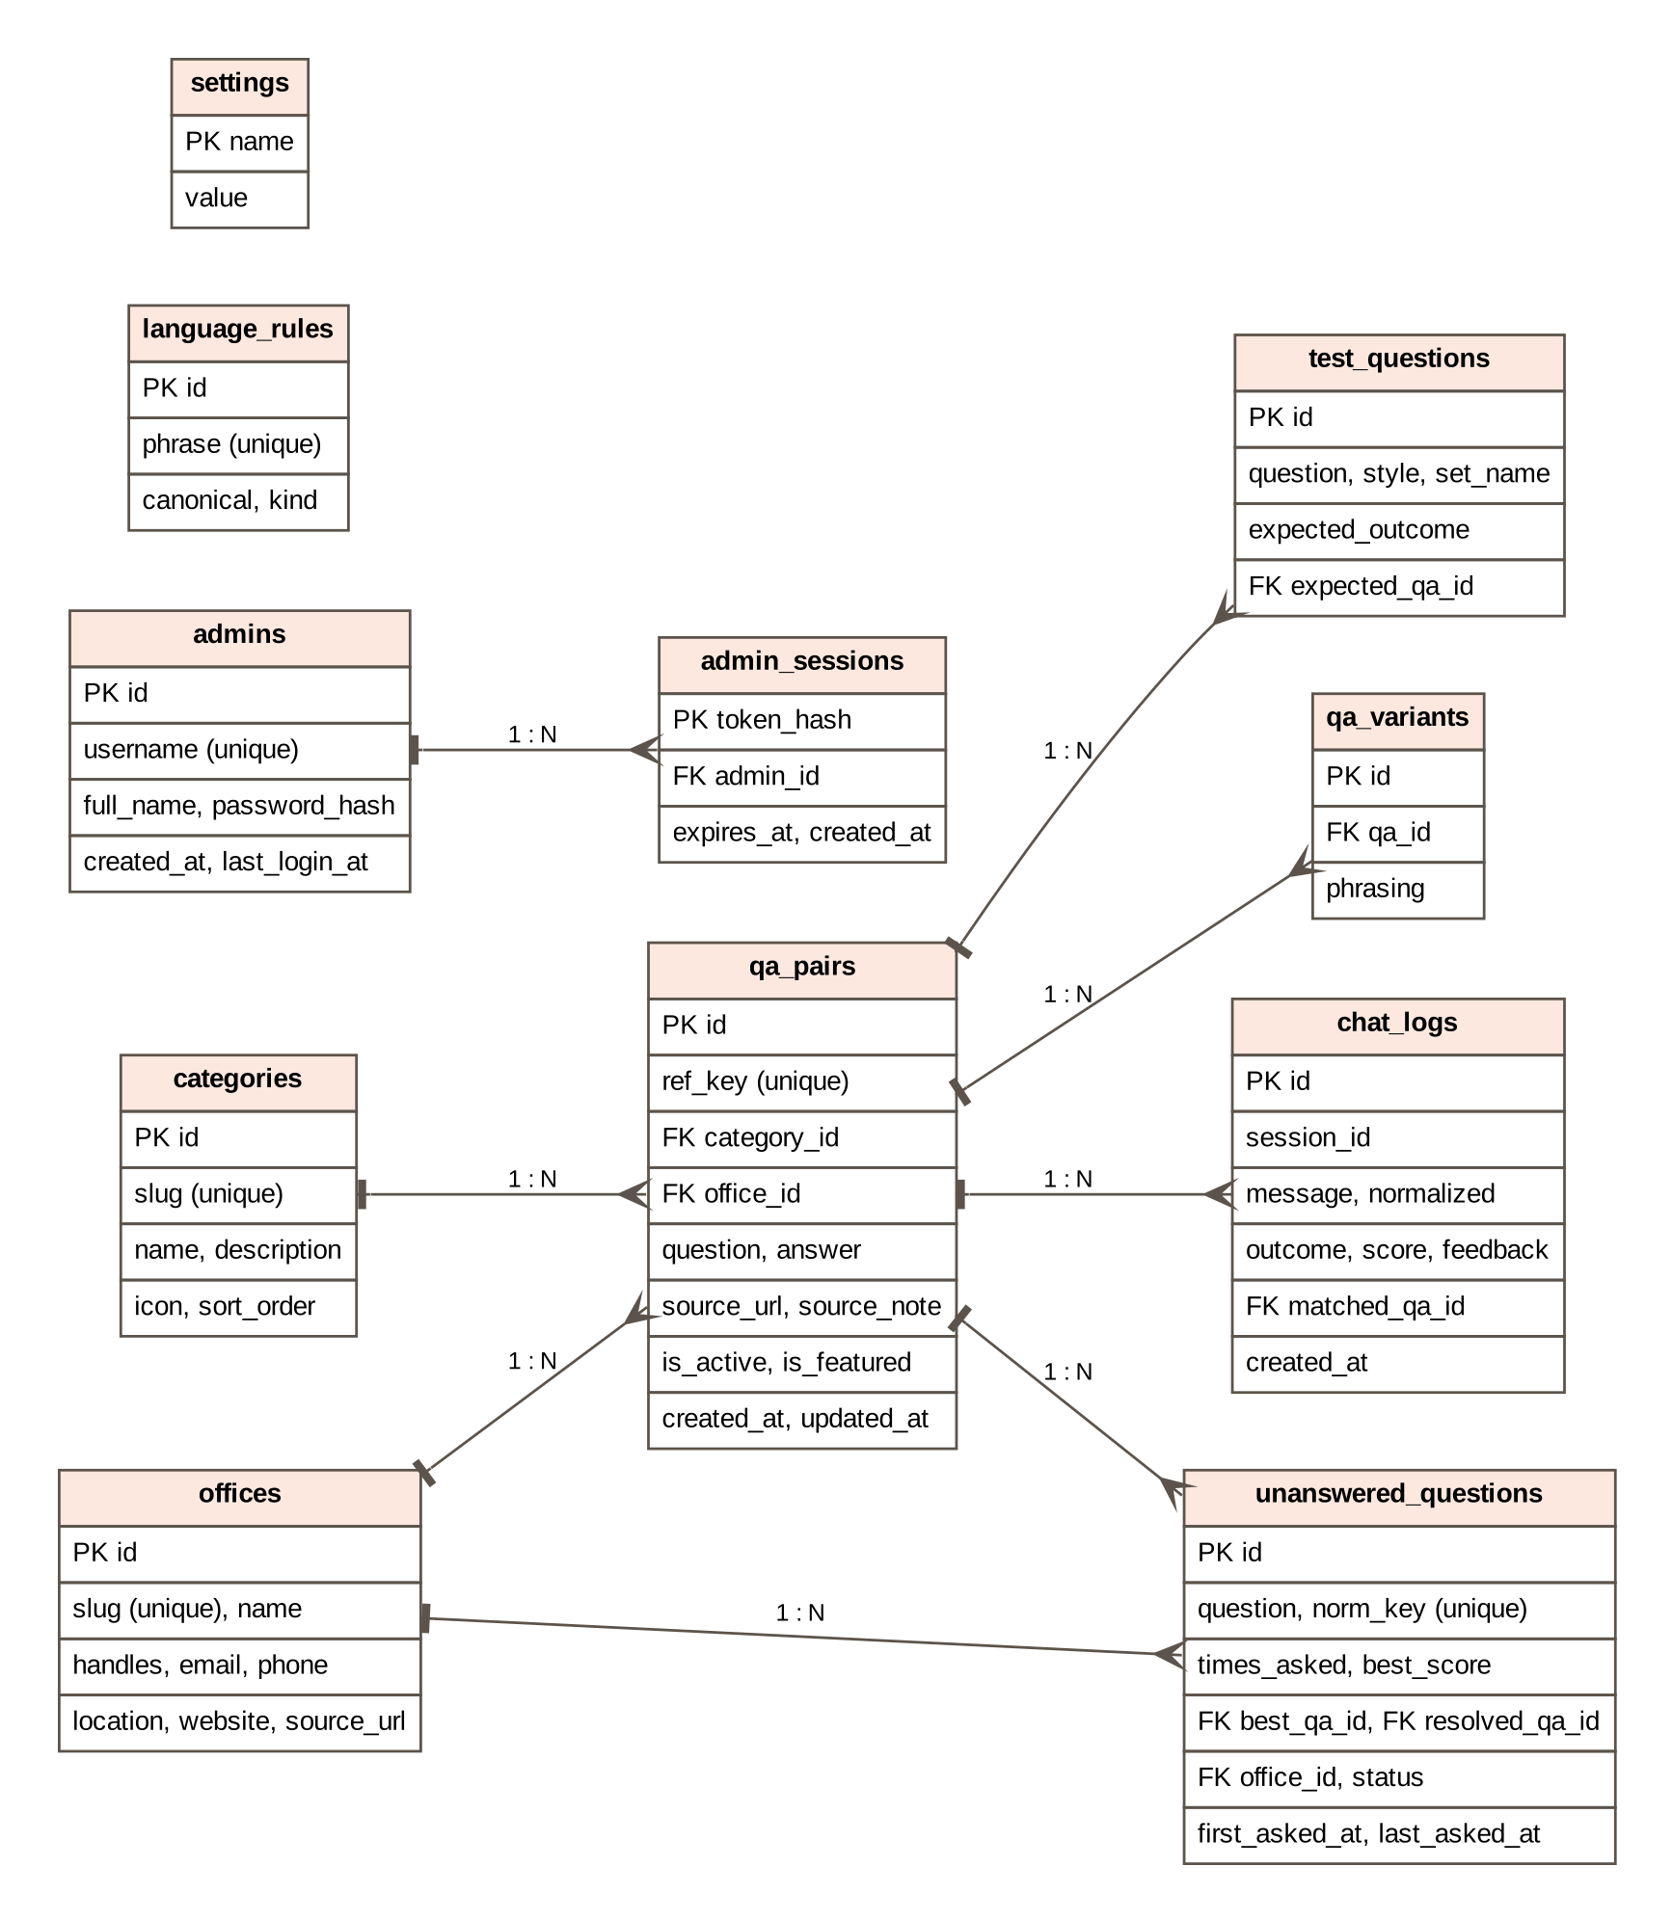
Figure 3.7: Entity relationship diagram
Table 3.7: Database tables
Table | Purpose | Keys
categories | Topics that group the questions (Admission, Fees, Results, ...) | PK id; slug unique
offices | University offices with what they handle and their contacts | PK id; slug unique
qa_pairs | The knowledge base: one question and its answer, source and status | PK id; FK category_id, office_id
qa_variants | Other ways of asking the same question | PK id; FK qa_id (deleted with its question)
language_rules | Pidgin, abbreviation, spelling and synonym rules | PK id; phrase unique
chat_logs | Every message, the outcome, score and rating | PK id; FK matched_qa_id
unanswered_questions | Questions the bot could not answer, grouped and counted | PK id; norm_key unique; FK best_qa_id, resolved_qa_id, office_id
admins | Administrator accounts with hashed passwords | PK id; username unique
admin_sessions | Signed-in administrator sessions | PK token_hash; FK admin_id
settings | Answer and suggestion thresholds | PK name
test_questions | Labelled questions for the test bench | PK id; FK expected_qa_id

Tables 3.8 to 3.10 give the data dictionary for the three tables at the centre of the system.
Table 3.8: Data dictionary for qa_pairs
Field | Type | Null | Description
id | INT, auto increment | No | Primary key
ref_key | VARCHAR(60), unique | Yes | Stable name used by the seed data, e.g. putme-fee
category_id | INT | No | Foreign key to categories
office_id | INT | Yes | Foreign key to offices; the office shown with the answer
question | VARCHAR(500) | No | The main wording of the question
answer | TEXT | No | The answer shown to the student
source_url | VARCHAR(500) | Yes | Official page the answer came from
source_note | VARCHAR(255) | Yes | Notice title or date of the source
is_active | TINYINT(1) | No | 1 = used by the bot, 0 = hidden
is_featured | TINYINT(1) | No | 1 = shown as a suggested question
created_at, updated_at | DATETIME | No | When the entry was added and last changed

Table 3.9: Data dictionary for chat_logs
Field | Type | Null | Description
id | BIGINT, auto increment | No | Primary key
session_id | VARCHAR(64) | Yes | Random browser identifier; no name or matric number is stored
message | VARCHAR(1000) | No | What the student typed
normalized | VARCHAR(1000) | Yes | The words left after processing
outcome | ENUM | No | answered, suggested, fallback, smalltalk or empty
matched_qa_id | INT | Yes | Foreign key to the answer given or suggested first
score | DECIMAL(5,3) | Yes | Best similarity score
feedback | TINYINT | Yes | 1 = helpful, −1 = not helpful
created_at | DATETIME | No | Time of the message

Table 3.10: Data dictionary for unanswered_questions
Field | Type | Null | Description
id | INT, auto increment | No | Primary key
question | VARCHAR(1000) | No | Latest wording of the question
norm_key | CHAR(64), unique | No | SHA-256 of the sorted roots, so repeats of the same question are counted together
times_asked | INT | No | How many times it has been asked
best_score, best_qa_id | DECIMAL, INT | Yes | Closest existing answer and its score
office_id | INT | Yes | Office the student was referred to
status | ENUM | No | pending, resolved or dismissed
resolved_qa_id | INT | Yes | Answer that now covers the question
first_asked_at, last_asked_at | DATETIME | No | When it was first and last asked

3.12 Input Design
- Chat input: a text box labelled “Type your question” that accepts up to 500 characters. Enter sends the message and Shift+Enter starts a new line. Suggested questions can be selected instead of typing.
- Login form: username and password.
- Question editor: the main question (required, up to 500 characters); other phrasings, one per line; the answer (required); the category; the office; the source address and a source note; and two switches, “active” and “show as a suggested question”.
- Office form: what the office handles, its email, telephone, location and website.
- Settings: the answer and suggestion thresholds, and a change-password form.

3.13 Output Design
- Answer: the answer text, the official source as a link (“Source: ebsu.edu.ng/...”), the responsible office with its contact details, helpful and not helpful buttons, and a “How I matched this” panel that lists every processing step, the top candidates and their scores.
- Suggestions: “I am not fully sure what you mean. Did you mean one of these?” with up to three questions that can be selected.
- Fallback: “I don't have that answer yet. I have saved your question so the knowledge base can be updated. For now, please contact the office below,” followed by the office card.
- Administration outputs: the dashboard (answers in the knowledge base, questions asked, share answered directly, questions waiting, ratings, accuracy on the test questions and the most asked topics), the unanswered list, the chat logs and the test bench report.
Screens of each output are shown in Chapter Four.

3.14 Security Design
- Passwords are stored only as bcrypt hashes. A wrong username and a wrong password take the same time to reject, so usernames cannot be discovered by timing.
- Sessions use a random 32-byte token in an HTTP-only cookie that expires after eight hours. Only a SHA-256 hash of the token is stored in the database, so a copy of the database cannot be used to sign in.
- Lockout: five wrong passwords lock the username for five minutes.
- Access control: every administration page and every administration action checks the session on the server before doing anything.
- SQL injection is prevented by passing all user input to MySQL as query parameters, never as part of the SQL text.
- Cross-site scripting is prevented because the interface displays stored text as text, never as HTML.
- Privacy: the chat asks for no name, registration number or other personal data, and a rating can only be given from the browser that asked the question. [TO FILL: if required, relate this to the Nigeria Data Protection Act 2023.]

CHAPTER FOUR
SYSTEM IMPLEMENTATION, TESTING AND RESULTS

4.1 Introduction
This chapter describes how the design in Chapter Three was implemented: the tools chosen and why, the requirements for running the system, each module with a short extract of its code, and the screens of the finished system. It then reports how the system was tested and evaluated: unit tests of the matching engine, system tests of every function, the accuracy of the chatbot on 30 held-out test questions, the choice of the confidence threshold and the response time.

4.2 Choice of Programming Language and Tools
The whole system is written in TypeScript and runs on Node.js. One language is used for the student pages, the administration pages, the server and the matching engine, so the matching code that is tested is exactly the code that answers students. PHP would have required a separate JavaScript program for the interactive chat, and Python would have added a second language and runtime to install on the demonstration computer. Table 4.1 lists the tools and the reason for each.
Table 4.1: Tools used and the reason for each
Tool (version) | Used for | Reason
TypeScript 5.9 | All program code | Static types catch errors before the program runs
Next.js 16.3 with React 19.2 | Pages, API routes, server actions | One project for the interface and the server; pages are rendered on the server
Node.js 20.9 or newer | Running the server | Free, runs on Windows, macOS and Linux
MySQL / MariaDB (XAMPP) | Knowledge base, logs, accounts | Free, relational, already common in Nigerian computer laboratories; phpMyAdmin for inspection
mysql2 3.24 | Database driver | Connection pool and parameterised queries
stemmer 2.0 | Porter stemming | A small, offline implementation of the Porter (1980) algorithm
bcryptjs 3.0 | Password hashing | Pure JavaScript, so it installs on Windows without a compiler
Tailwind CSS 4.3 | Page styling | Consistent layout; compiled at build time, so no internet is needed
Phosphor Icons 2.1, Outfit font | Icons and typeface | One icon set and one font, both stored with the project (MIT and Open Font licences)
node:test with tsx | Unit tests | Built into Node.js; no extra test framework
Graphviz | Diagrams in this report | Diagrams are generated from text files kept with the code

4.3 System Requirements
Table 4.2: Hardware and software requirements
Item | Requirement
Processor and memory | A 64-bit computer with at least 4 GB of RAM (8 GB is more comfortable while the app is being built)
Disk space | About 1 GB free for the installed packages (about 460 MB) and the built app (about 240 MB)
Operating system | Windows 10 or 11, macOS or Linux
Software | Node.js 20.9 or newer; XAMPP with MySQL/MariaDB (MariaDB 10.4 or newer, or MySQL 8)
Browser | A current version of Chrome, Edge, Firefox or Safari, on a computer or phone
Network | Internet only for the first installation of packages; none afterwards. Phones on the same Wi-Fi network can open the app through the computer's address.
Computer used for the tests | Intel(R) Xeon(R) Processor @ 2.10GHz, 4 cores, 16 GB RAM, Node.js v22.22.0; MariaDB 10.11; Chromium browser

4.4 Implementation of the Modules

4.4.1 Project Structure
Table 4.3: Main folders and files
Path | Contents
src/lib/nlp/text.ts | Text cleaning, tokenising and the stopword list
src/lib/nlp/fuzzy.ts | Edit distance, typo allowance and character-trigram similarity
src/lib/nlp/matcher.ts | Language rules, typo correction, TF-IDF index, scoring and the decision rule
src/lib/chat.ts | Handles one message: match, compose the reply, log it, save unanswered questions
src/lib/routing.ts | Chooses the office to suggest when there is no answer
src/lib/kb.ts | Loads the knowledge base from MySQL and rebuilds the index when it changes
src/lib/auth.ts | Administrator login, sessions and access control
src/app/ | Pages (chat, how it works, contacts, administration) and API routes
database/schema.sql, database/seed/ | Tables and the starting data, with a source link for every answer
scripts/ | One-command start, database set-up, evaluation, benchmark and the worked example
tests/matcher.test.ts | Unit tests of the matching engine

4.4.2 Database and One-Command Start
The command npm start runs four steps: it installs the Node.js packages the first time, creates the ebsu_chatbot database with its tables and starting data if they do not exist, builds the web app if the code has changed since the last build, and starts the server on port 3000. The set-up script loads the 85 answers and 6 small-talk replies with their 414 extra phrasings, 307 language rules, 11 categories, 10 offices and 60 test questions from the seed files, and creates the first administrator account. For computers where the script cannot create a database, npm run db:export writes a single SQL file that can be imported in phpMyAdmin.

4.4.3 Text Cleaning
The first stage brings every message to one plain form. The function below is applied to the stored questions when the index is built and to every message a student sends.
export function cleanText(raw: string): string {
return raw
.normalize("NFKD")
.replace(/[̀-ͯ]/g, "") // remove accent marks: "Daalụ" -> "Daalu"
.toLowerCase()
.replace(/['’‘`]/g, "") // "o'level" -> "olevel", "don't" -> "dont"
.replace(/&/g, " and ")
.replace(/[^a-z0-9]+/g, " ") // every other symbol becomes a space
.replace(/\s+/g, " ")
.trim();
}

4.4.4 Typo Correction and Trigram Similarity
The number of typing errors tolerated depends on the length of the word. Short words are never corrected because they are too easily confused with each other (“fee” and “see”).
export function allowedEdits(length: number): number {
if (length <= 3) return 0; // short words ("fee", "dey") are too easy to confuse
if (length <= 7) return 1; // "reslt" -> "result", but not "sports" -> "scores"
return 2; // long words: "trancsript" -> "transcript"
}

4.4.5 Matching Engine
The matcher compares the weighted query vector with every stored phrasing, keeps the best phrasing for each answer and then applies the decision rule. The extract below is the scoring loop and the decision; the full file is in Appendix D.
for (const doc of index.docs) {
const cos = cosine(queryVector, doc.vector);
const tri = diceSimilarity(queryGrams, doc.grams);
const score = COSINE_WEIGHT * cos + (1 - COSINE_WEIGHT) * tri;
const current = bestPerEntry.get(doc.entryId);
if (!current || score > current.score) {
bestDoc.set(doc.entryId, doc);
bestPerEntry.set(doc.entryId, {
entryId: doc.entryId,
question: index.entries.get(doc.entryId)?.question ?? doc.phrasing,
phrasing: doc.phrasing,
cosine: round(cos),
trigram: round(tri),
score: round(score),
});
}
}
let decision: Decision = "fallback";
if (best && best.score >= thresholds.answer) {
decision = index.entries.get(best.entryId)?.smallTalk ? "smalltalk" : "answered";
// Never answer outright when the only words in common are typo guesses:
// "sports facilities" must not become a confident answer about "faculties".
const doc = bestDoc.get(best.entryId);
const confirmed = doc ? [...queryVector.keys()].some((s) => !analysis.guessed.has(s) && doc.vector.has(s)) : false;
if (!confirmed) decision = "suggested";
} else if (best && best.score >= thresholds.suggest) {
decision = "suggested";
}

4.4.6 Chat Service and Unanswered Questions
The chat service runs the matcher, composes the reply and writes the message to chat_logs. When the reply is a suggestion or a fallback, the question is saved in unanswered_questions. Repeats of the same question are grouped by a key made from its sorted word roots, so “hostel fees?” and “fees for hostel” are counted as one question asked twice.
if ((reply.kind === "fallback" || reply.kind === "suggestions") && result.analysis.stems.length > 0) {
const officeId = reply.office ? (offices.find((o) => o.name === reply.office?.name)?.id ?? null) : null;
await execute(
`INSERT INTO unanswered_questions (question, norm_key, best_score, best_qa_id, office_id)
VALUES (?, ?, ?, ?, ?)
ON DUPLICATE KEY UPDATE times_asked = times_asked + 1, last_asked_at = NOW(), question = VALUES(question),
best_score = VALUES(best_score), best_qa_id = VALUES(best_qa_id),
status = IF(status = 'resolved', 'pending', status)`,
[message, normKey(result.analysis.stems), best?.score ?? null, best?.entryId ?? null, officeId],
);
}

4.4.7 Access Control
Every administration page and every administration action begins by calling requireAdmin, which looks up the session token's hash in admin_sessions and sends anyone without a valid session to the login page.
export async function currentAdmin(): Promise<Admin | null> {
const jar = await cookies();
const token = jar.get(COOKIE)?.value;
if (!token) return null;
const [admin] = await query<Admin>(
`SELECT a.id, a.username, a.full_name FROM admin_sessions s JOIN admins a ON a.id = s.admin_id
WHERE s.token_hash = ? AND s.expires_at > NOW()`,
[hashToken(token)],
);
return admin ?? null;
}

export async function requireAdmin(): Promise<Admin> {
const admin = await currentAdmin();
if (!admin) redirect("/admin/login");
return admin;
}

4.5 The Finished System

4.5.1 Student Pages
Figure 4.1 shows the chat page as a student first sees it. The left column holds the navigation and the staff area link, the centre holds the conversation, and the right column lists suggested questions by topic, which a student can select instead of typing.
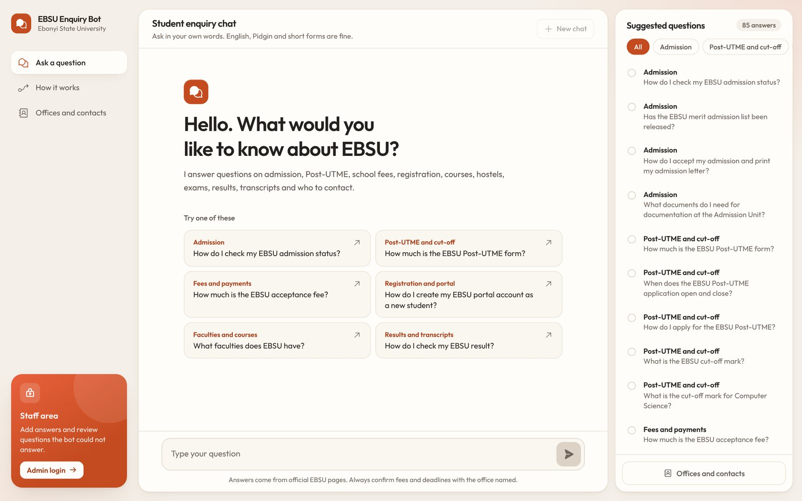
Figure 4.1: The chat page on first visit
Figure 4.2 shows two answers. The first question is in Pidgin with a short form (“wetin be the putme fee”), the second has two spelling errors (“how do i chek my admision status”). Each answer shows its topic, the answer text, the official page it came from, rating buttons and the match score.
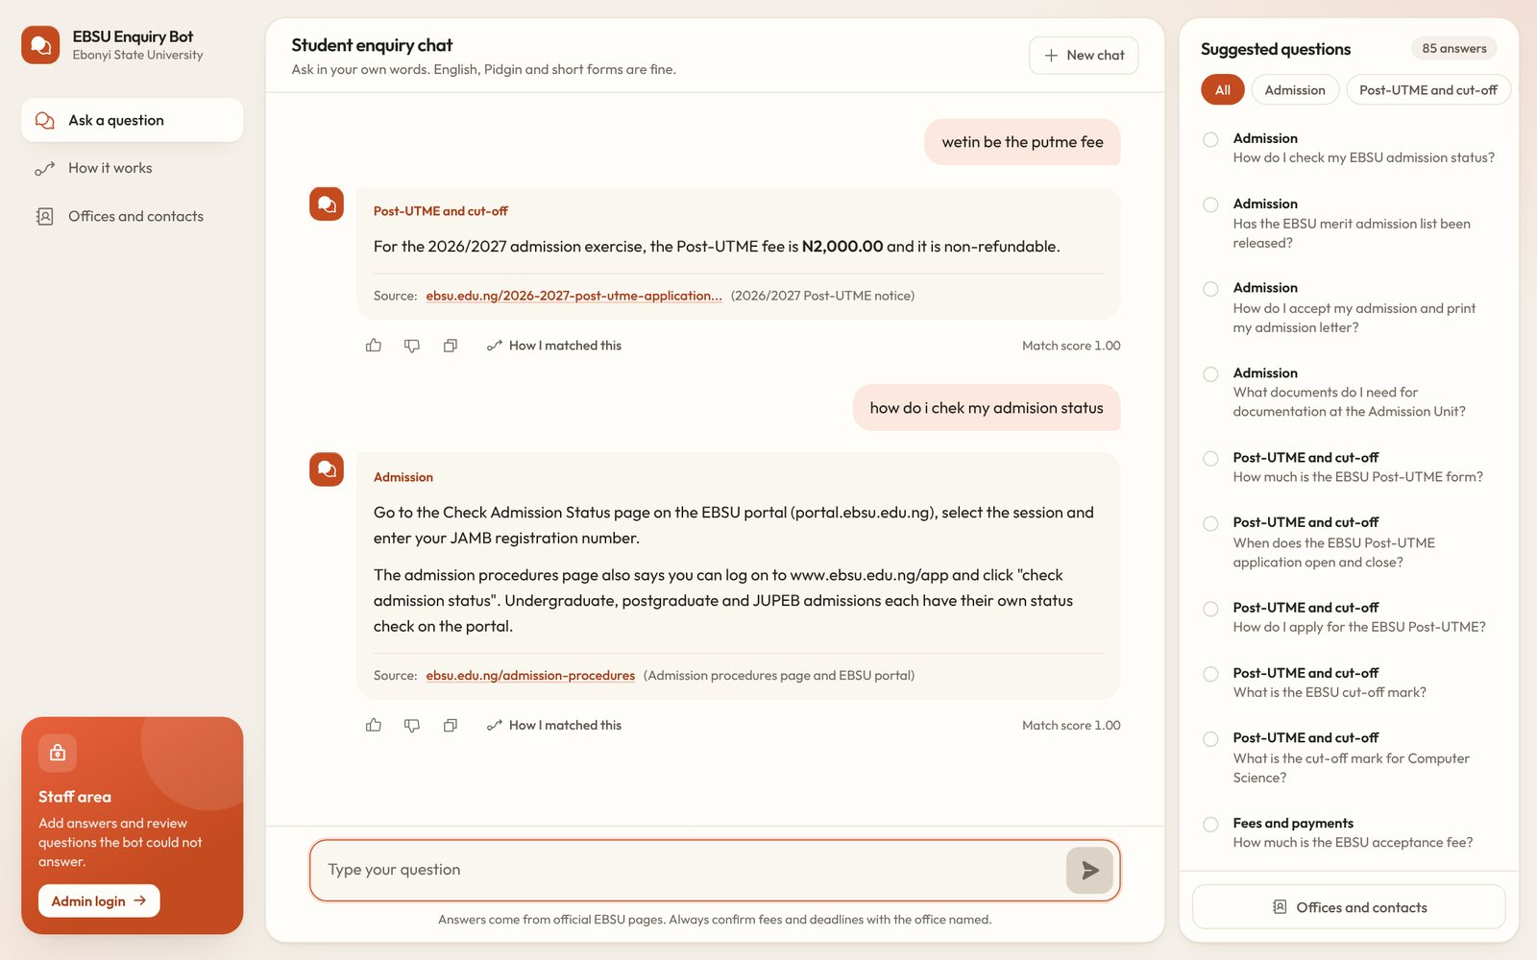
Figure 4.2: Answers to a Pidgin question and a misspelt question, each with its official source
Selecting “How I matched this” opens the panel in Figure 4.3. It shows every step of Chapter Three for the student's own message: the cleaned text, typo fixes, the language rules applied, the keywords kept, their roots and the five closest stored questions with their TF-IDF, trigram and final scores. This panel is how the system explains its “intelligence” to a student or an examiner.
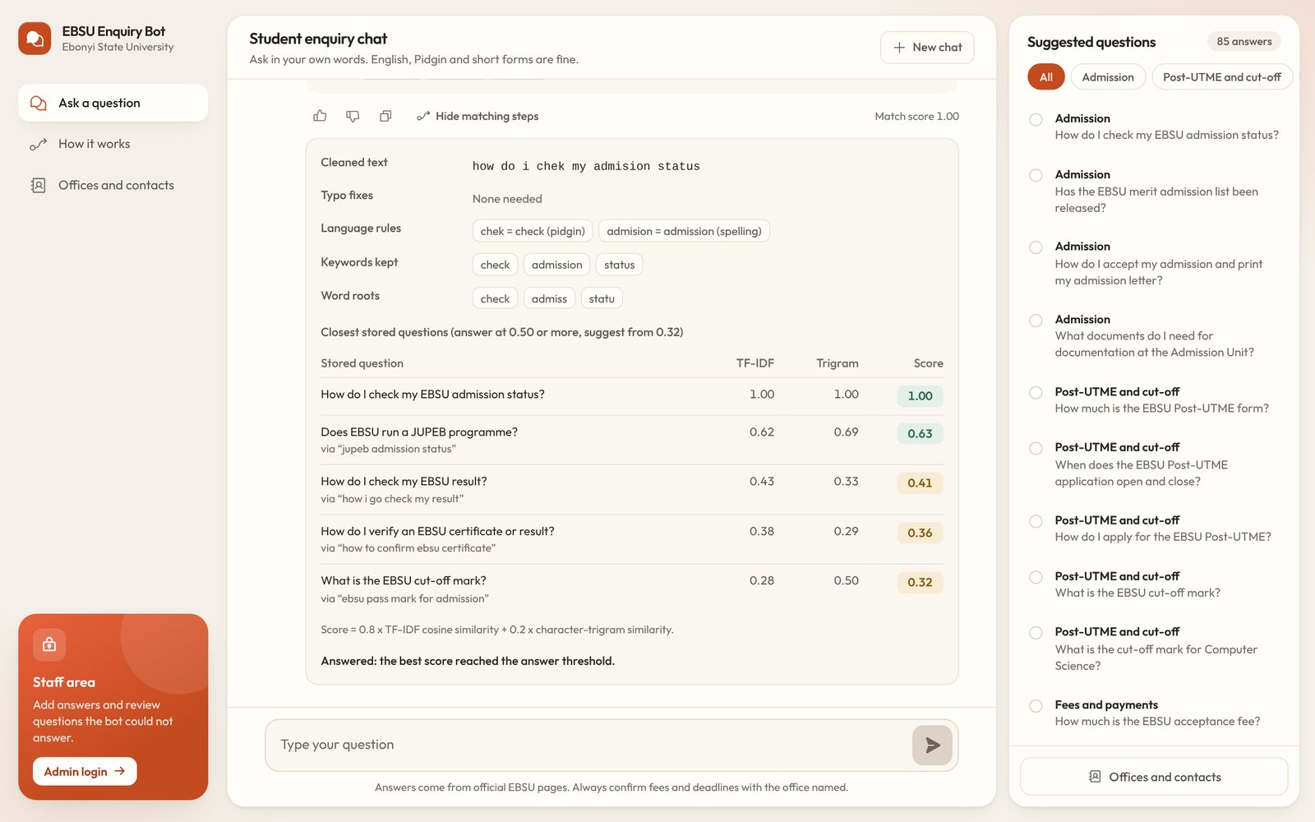
Figure 4.3: The “How I matched this” panel
Figure 4.4 shows the fallback. The question about hostel accommodation is not covered by any official page that was found, so the bot says it does not have the answer, saves the question and names the Office of Student Affairs. Because no contact details for that office were published, it also shows the general contact of the Office of the Registrar.
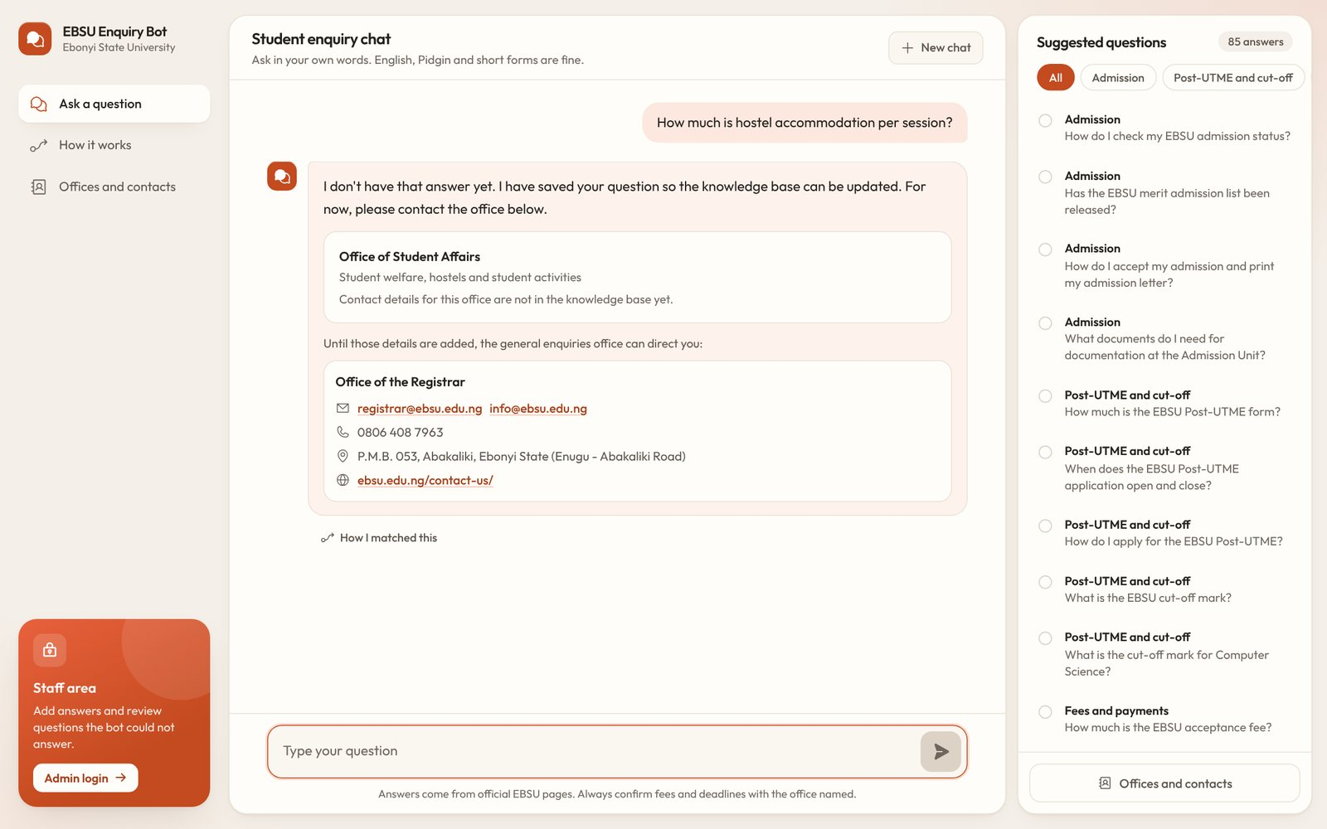
Figure 4.4: Fallback reply with the office to contact
Figure 4.5 shows the suggestion reply. The message “transcrpt” only matches after a typo correction, so instead of answering outright the bot asks which of three transcript questions the student meant, and names the Records Unit in case none of them fits.
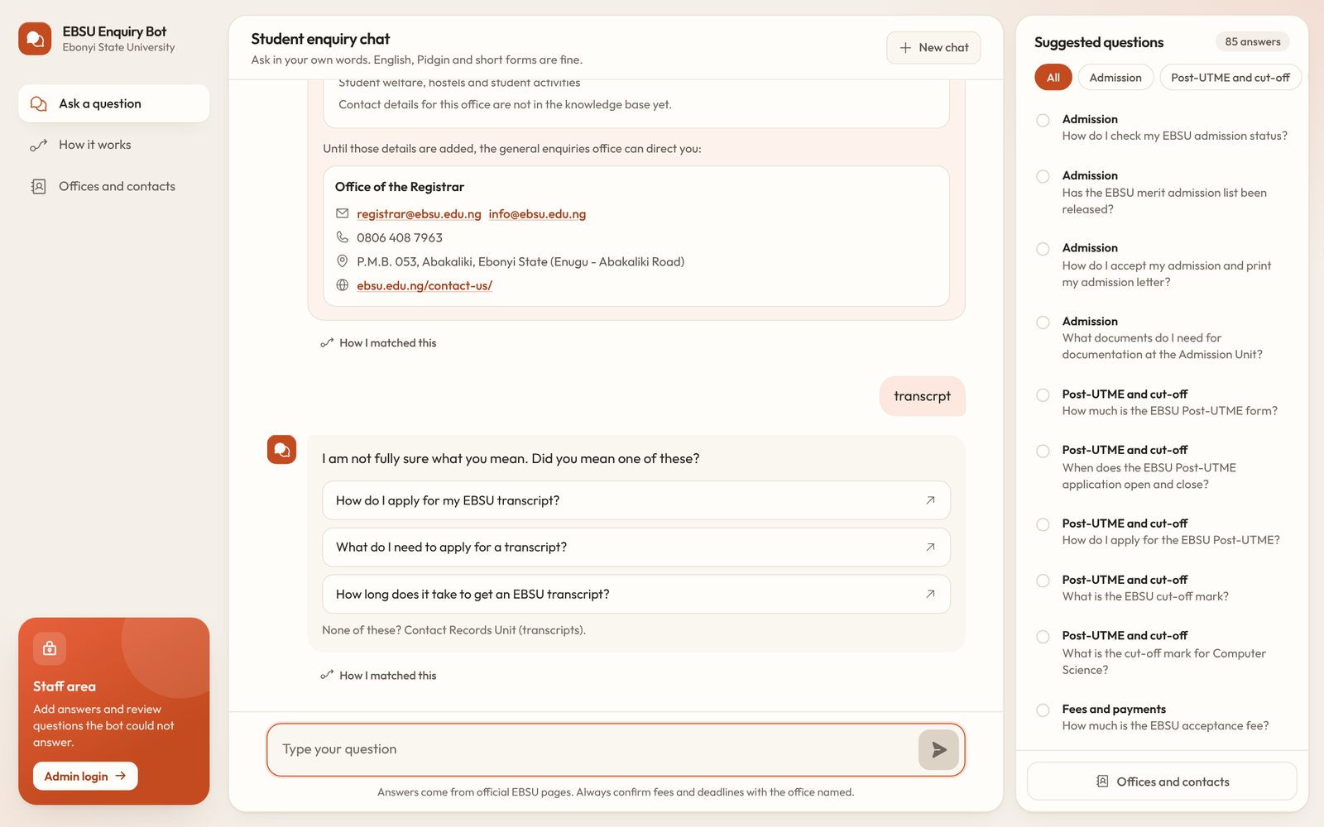
Figure 4.5: “Did you mean” suggestions for a misspelt one-word message
The “How it works” page (Figures 4.6 and 4.7) explains the method in plain language for students and examiners: the processing steps, the three score bands and a live matcher where any question can be typed to see its scores without it being logged.
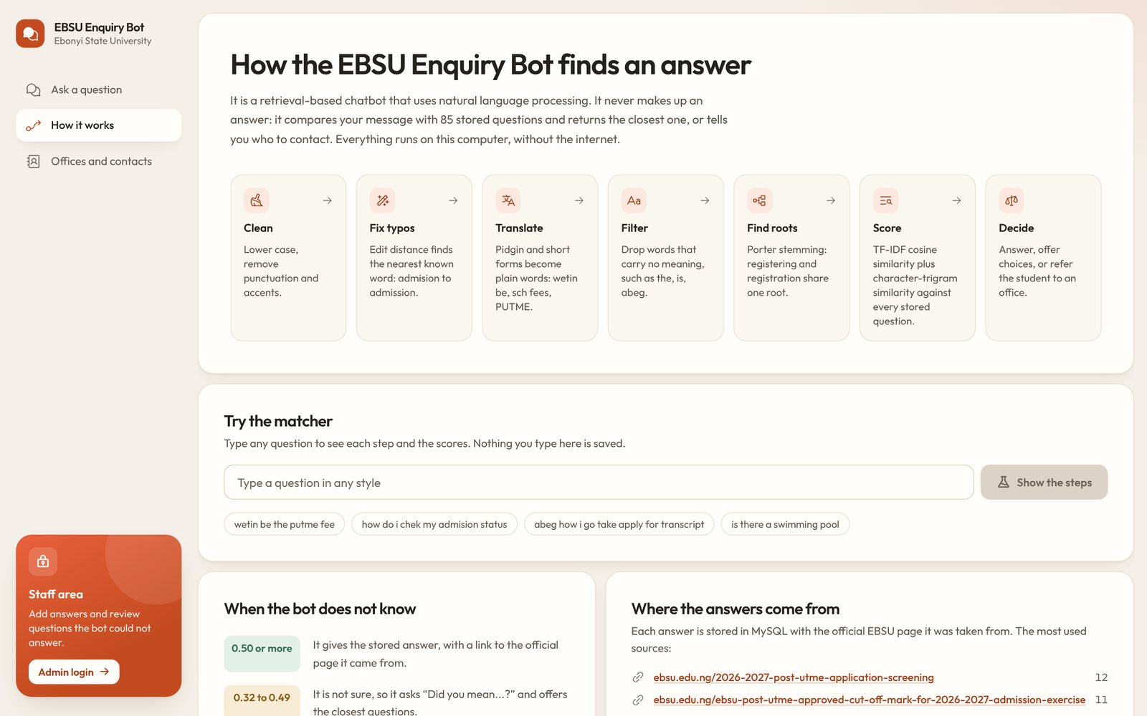
Figure 4.6: The “How it works” page
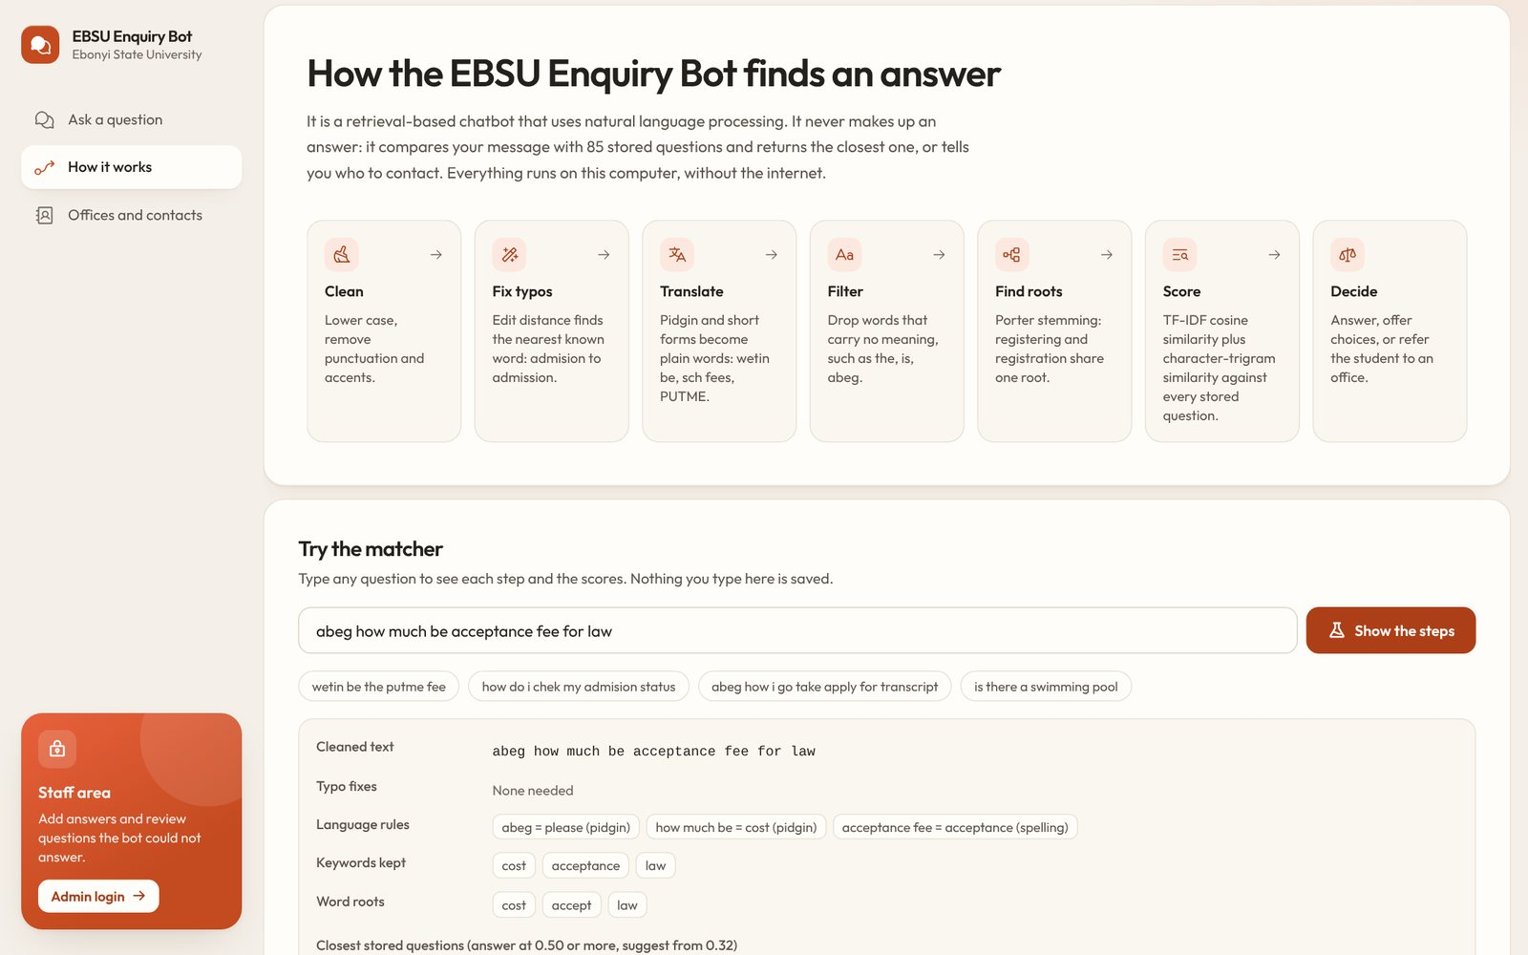
Figure 4.7: The live matcher on the “How it works” page
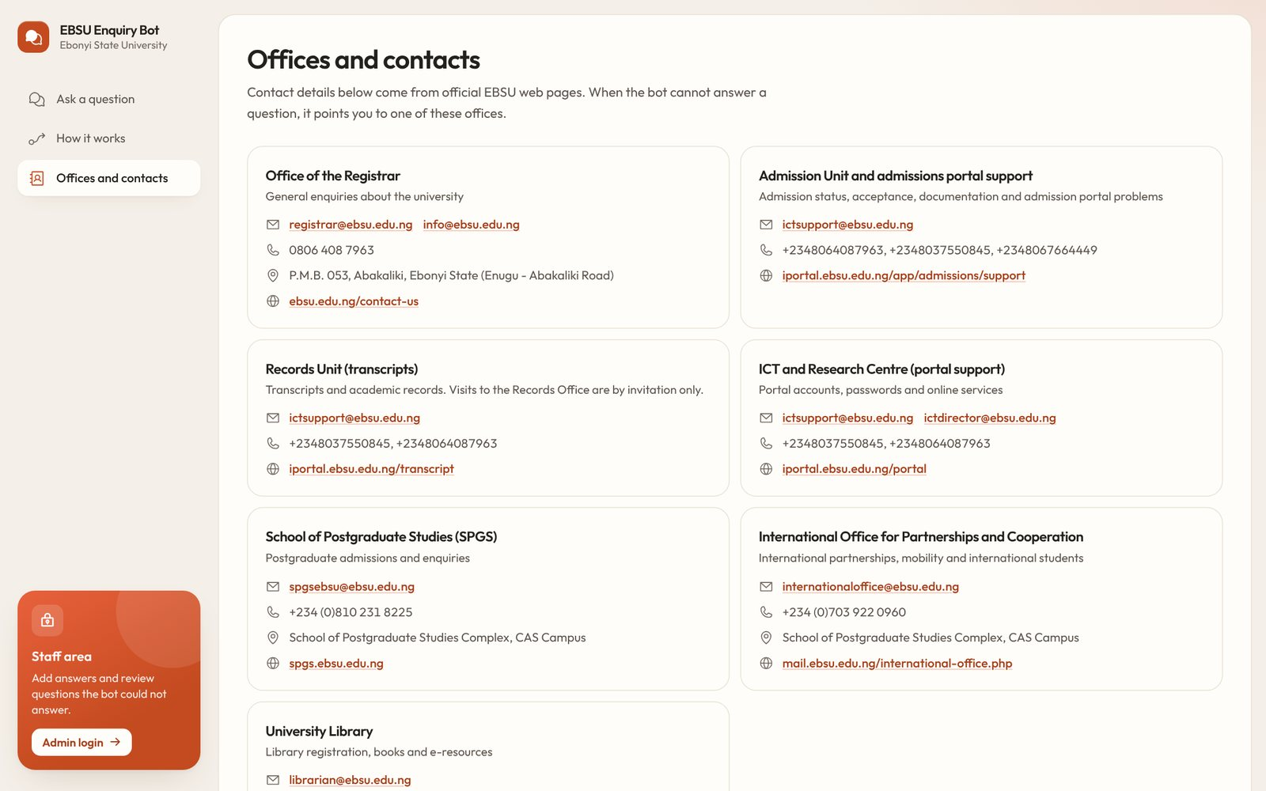
Figure 4.8: Offices and contacts page

4.5.2 Administration Pages
The administration area is reached from the staff area link and requires a login (Figure 4.9). The dashboard (Figure 4.10) summarises use of the chatbot: the number of answers, questions asked, the share answered directly, questions waiting for an answer, ratings, the accuracy on the test questions recalculated live, and the most asked topics.
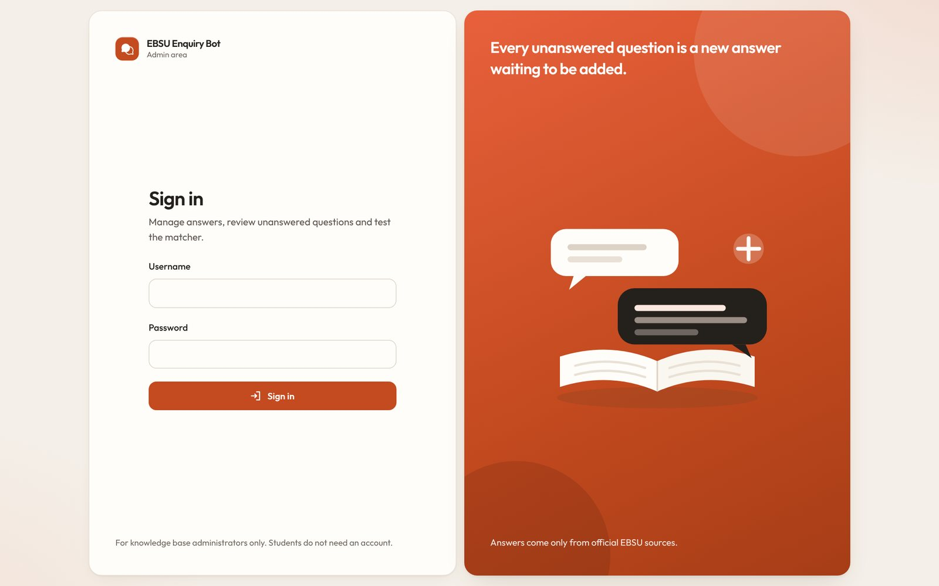
Figure 4.9: Administrator login
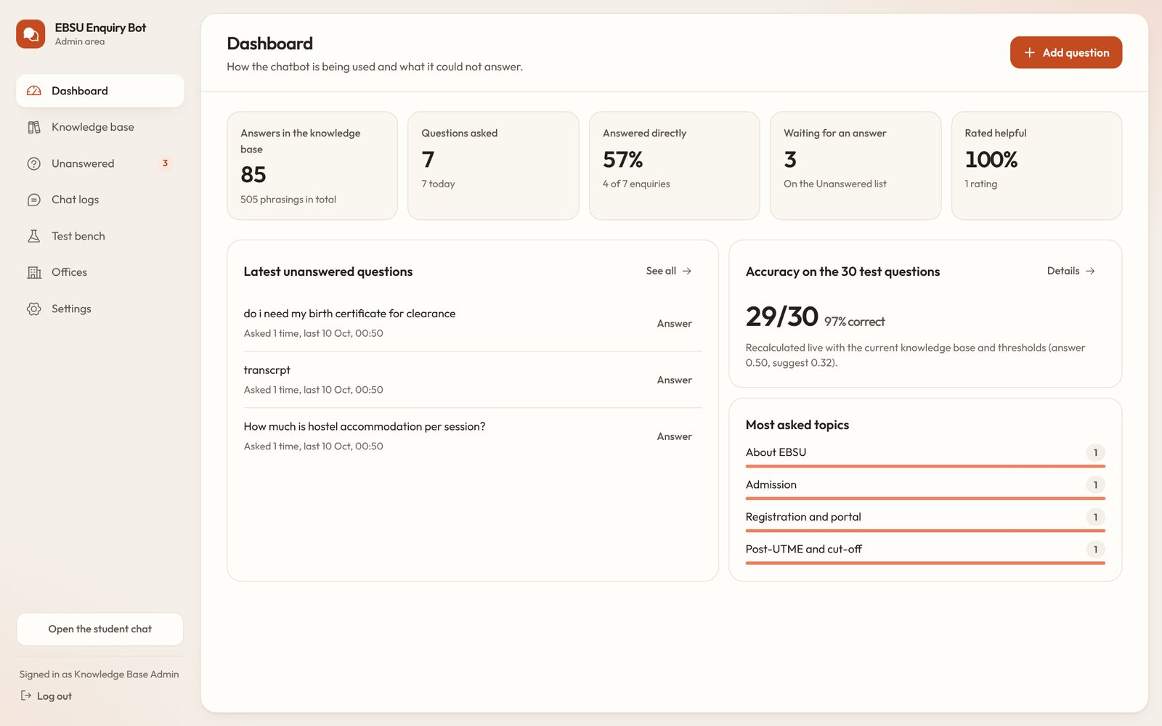
Figure 4.10: Administration dashboard
The knowledge base page (Figure 4.11) lists every answer with its topic, office, number of phrasings and source, and can be searched and filtered. The editor (Figure 4.12) holds the question, other phrasings, the answer, the category, the office and the source.
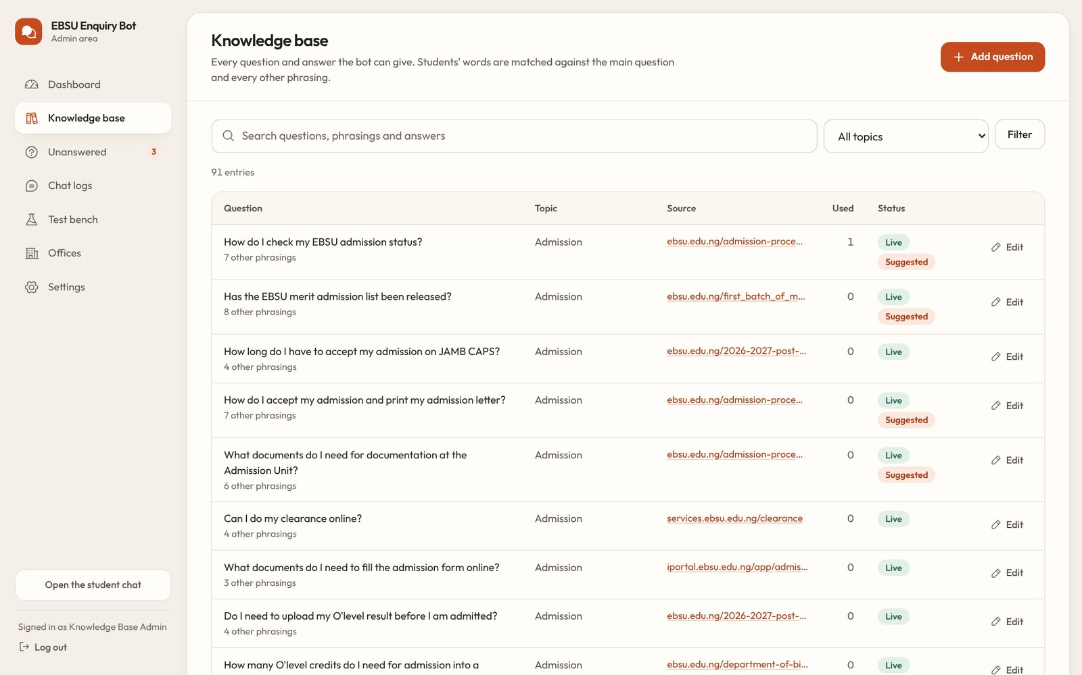
Figure 4.11: Knowledge base list
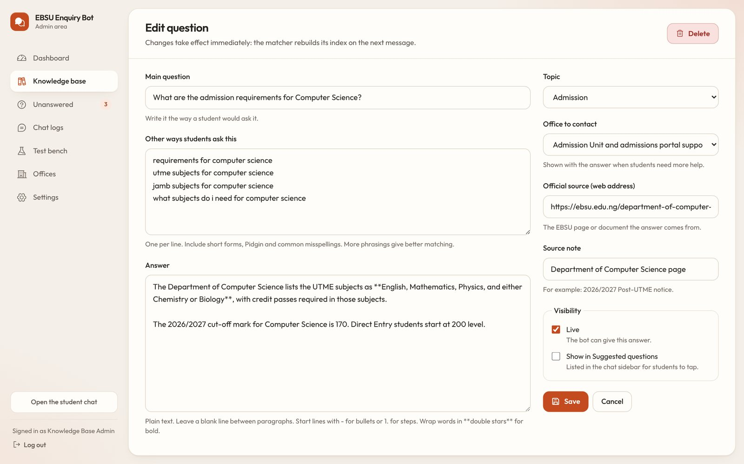
Figure 4.12: Editing a question and its answer
The unanswered questions page (Figure 4.13) is the feedback loop. Each question shows how many times it was asked, the office the student was referred to and the closest stored question with its score. The administrator can write a new answer, which opens the editor with the question already filled in, or add the question as another phrasing of an existing answer with one click, after which the bot answers it directly.
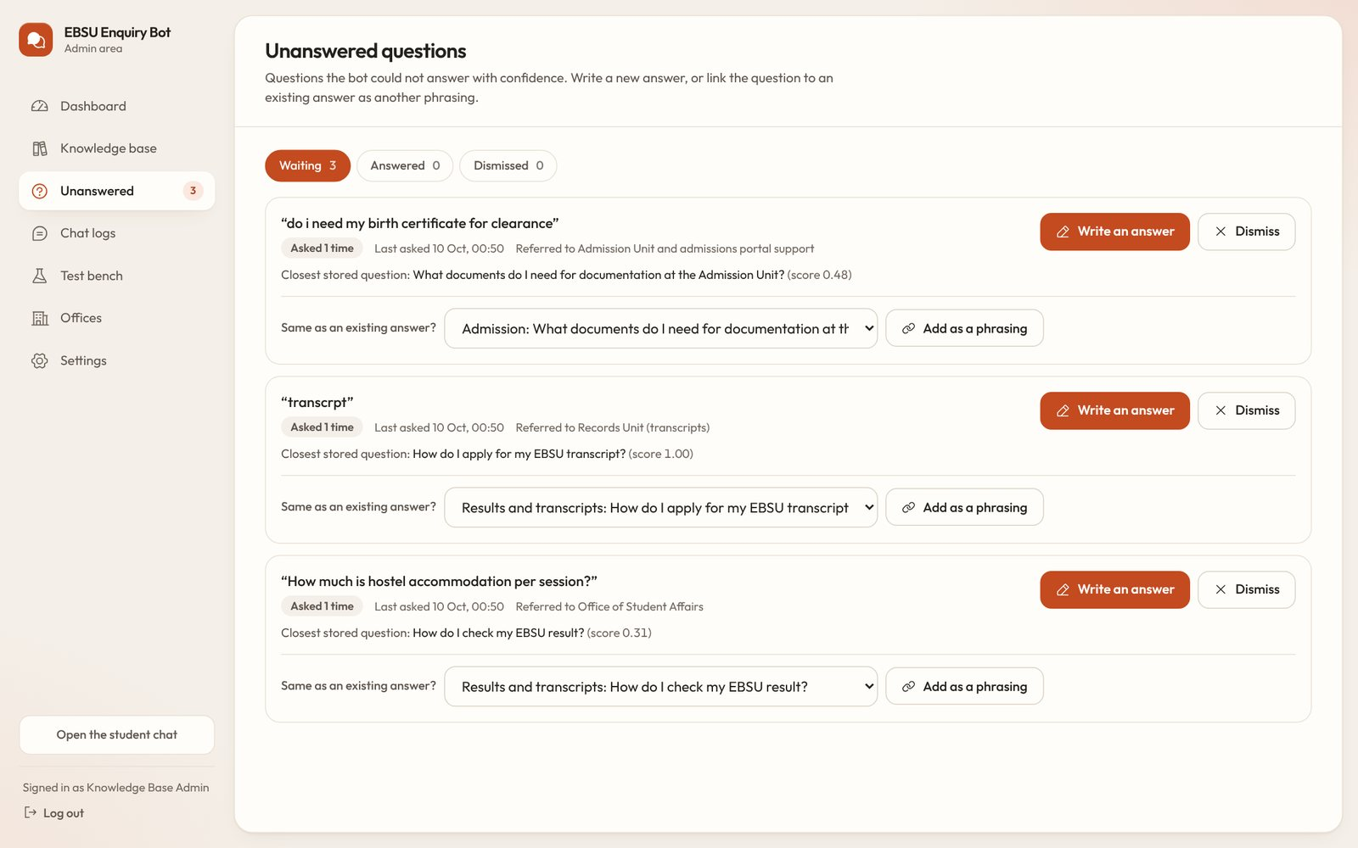
Figure 4.13: Unanswered questions waiting for an answer
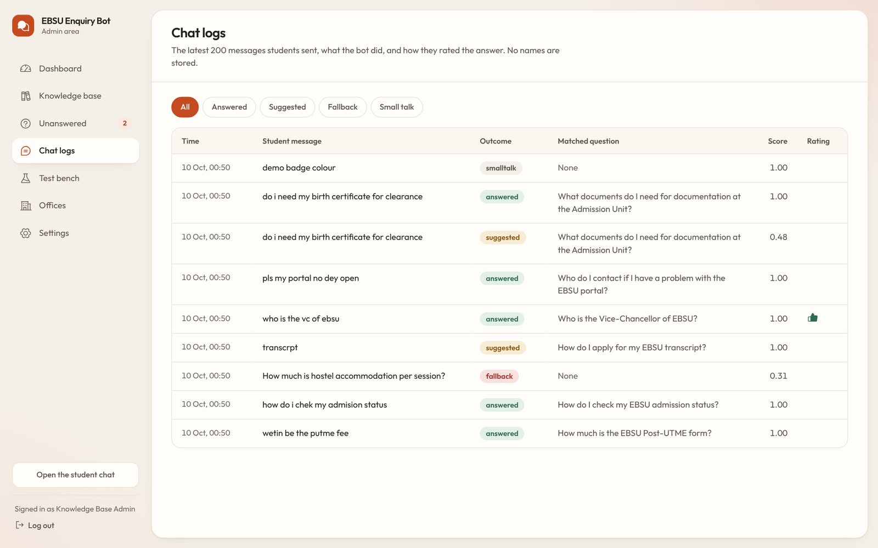
Figure 4.14: Chat logs with outcome, score and rating
The test bench (Figure 4.15) runs all 30 held-out test questions through the live matcher whenever it is opened, so the effect of any change to the knowledge base or the thresholds can be seen at once. The settings page (Figure 4.16) holds the two thresholds and the password form.
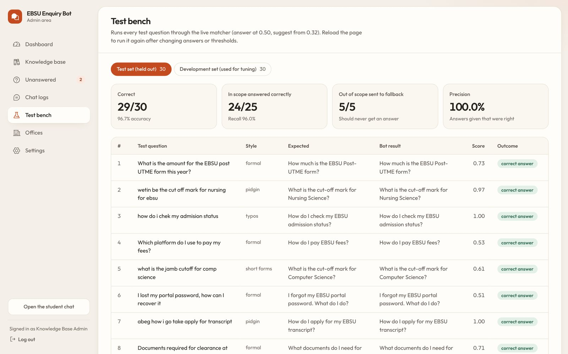
Figure 4.15: Test bench
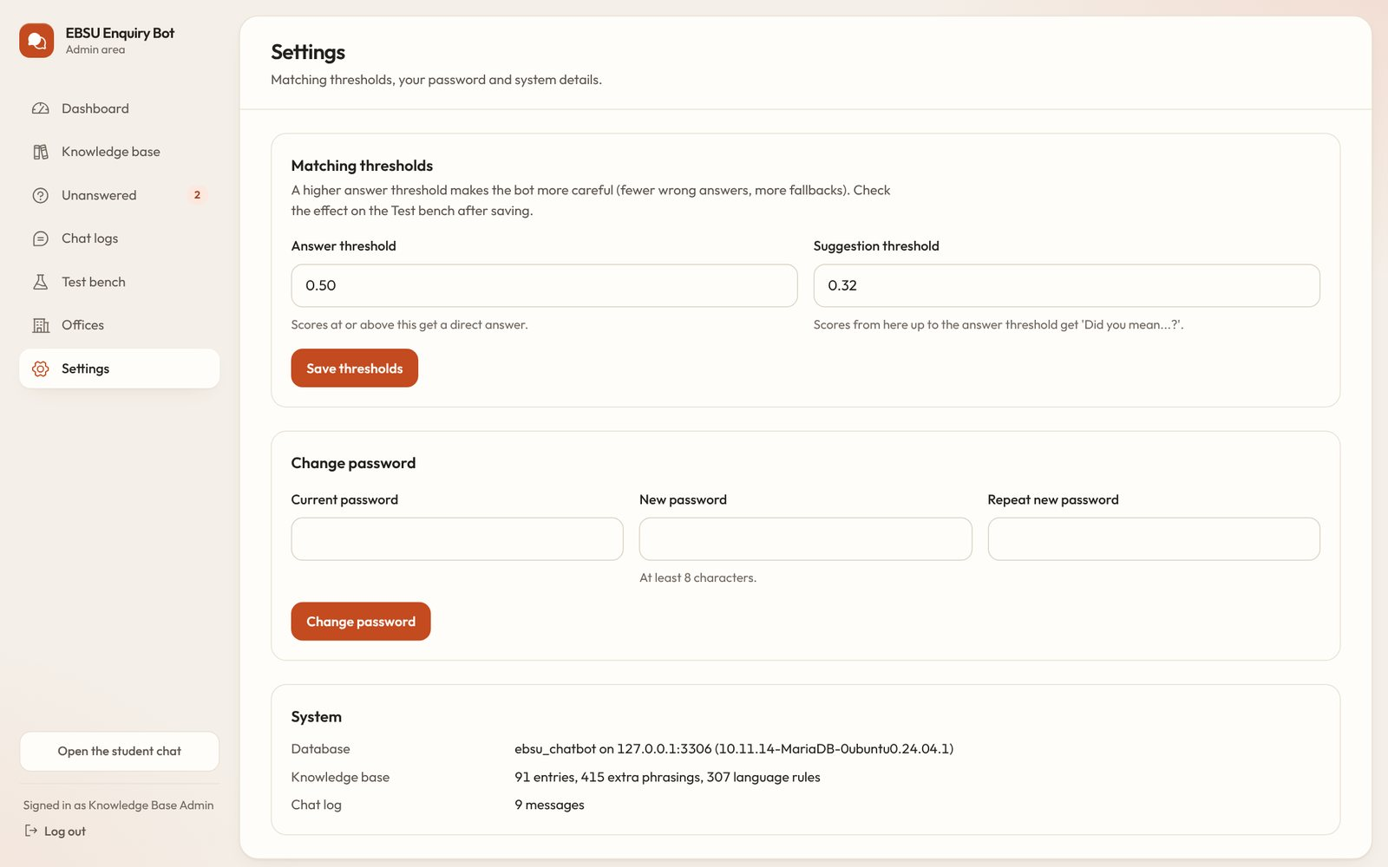
Figure 4.16: Settings: thresholds and password

4.5.3 Phone Screens
Most students will use a phone. On a narrow screen the chat fills the page and the suggested questions open from a button (Figure 4.17).
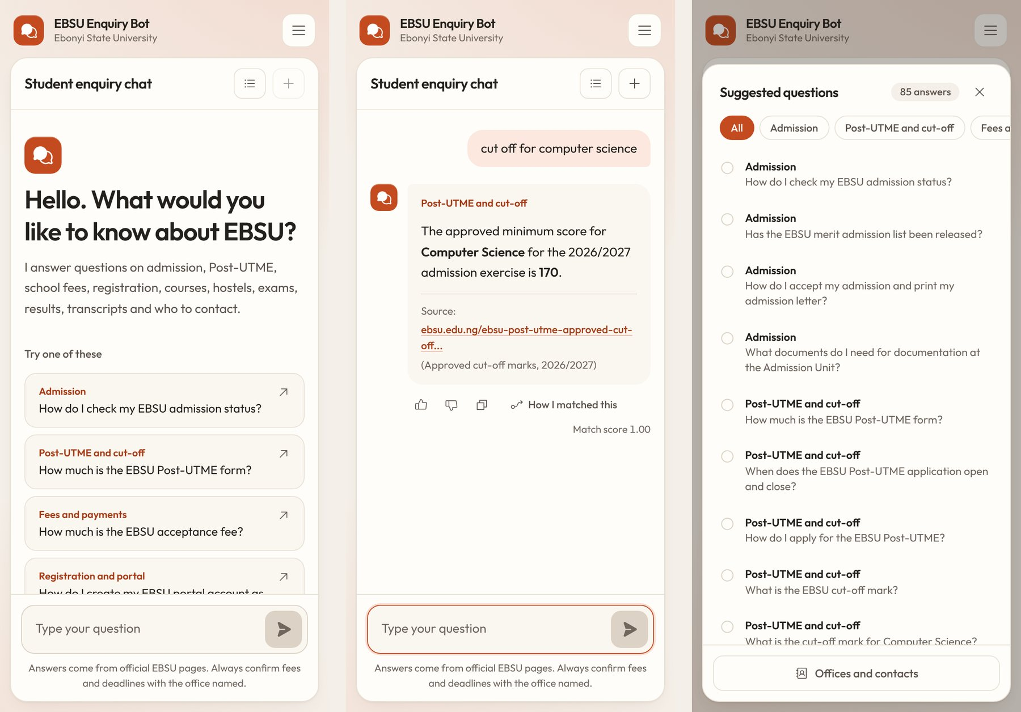
Figure 4.17: The chat on a phone: welcome, an answer and the suggested questions

4.6 System Testing

4.6.1 Unit Testing
The matching engine was tested with 22 automated unit tests written with the test runner built into Node.js (npm test). Table 4.4 groups them. All 22 tests pass.
Table 4.4: Unit tests of the matching engine
Group | What is checked | Tests | Result
Text cleaning | Lower case, accents, punctuation and tokens | 2 | Pass
Fuzzy matching | Edit distance with swapped letters, typo allowance by word length, trigram similarity | 3 | Pass
Matching questions | Plain English, Pidgin (including time words and meaning words), abbreviations, typos, out-of-scope fallback, guessed-only words, small talk mixed with real questions, greetings, empty messages, session years | 13 | Pass
Language rules data | No rule maps onto another rule's phrase; no duplicate phrases | 2 | Pass
Fallback routing | Each topic is sent to the right office | 1 | Pass
Development set | Accuracy of at least 90% with no wrong answers | 1 | Pass
Total |  | 22 | All pass

4.6.2 System Testing
System tests exercised every function through the browser, as a student and as an administrator, on a desktop screen (1440 × 900) and a phone screen (390 × 844). They were run with an automated browser during development and can be repeated by hand in a few minutes. Table 4.5 lists the test cases; all of them passed on the final version.
Table 4.5: System test cases
ID | Test | Expected result | Result
ST1 | Open the chat page | At least ten suggested questions are listed | Pass
ST2 | Ask “wetin be the putme fee” | Answer N2,000.00 with a link to the official notice | Pass
ST3 | Ask “how do i chek my admision status” | Answer about the Check Admission Status page | Pass
ST4 | Open “How I matched this” | Steps and the table of closest stored questions are shown | Pass
ST5 | Ask about hostel accommodation fees | “I don't have that answer yet” with the office to contact | Pass
ST6 | Type only “transcrpt” | “Did you mean” with transcript questions, no direct answer | Pass
ST7 | Rate an answer | The rating is saved and acknowledged | Pass
ST8 | Ask about a portal problem in Pidgin | Answer with the ICT support email | Pass
ST9 | Use the live matcher on “How it works” | Steps and scores are shown; nothing is logged | Pass
ST10 | Open the contacts page | Registrar's email and the other offices are listed | Pass
ST11 | Open /admin without logging in | Redirected to the login page | Pass
ST12 | Log in with a wrong password | “That username and password do not match.” | Pass
ST13 | Log in correctly | Dashboard is shown | Pass
ST14 | Open the knowledge base | All 91 entries are listed (85 answers and 6 small-talk replies) | Pass
ST15 | Open Unanswered after ST5 | The hostel question is listed with its office | Pass
ST16 | Link an unanswered question as a phrasing, then ask it again | The bot now answers it directly | Pass
ST17 | Add a new answer, ask it, then delete it | Answered immediately; removed after deletion | Pass
ST18 | Open chat logs and the test bench | Messages are listed; the 30 test questions run | Pass
ST19 | Phone screen | No sideways scrolling; suggestions open from a button | Pass
ST20 | Watch the browser's network activity | No request leaves the computer; no errors in the console | Pass

4.7 Performance Evaluation

4.7.1 Procedure
The accuracy of the chatbot was measured on the 30 held-out test questions described in Section 3.3.4, which were not used while the system was tuned. Of these, 25 are in scope (16 formal English, 4 Pidgin, 3 short forms and 2 with typing errors) and 5 are deliberately out of scope. An in-scope question is counted as correct when the bot answers it with the expected entry. An out-of-scope question is counted as correct when the bot does not give an answer, that is, when it falls back or only offers suggestions; in both cases the question is saved and an office is named. The evaluation is repeated with npm run evaluate, which writes the results to docs/results/.

4.7.2 Results
Table 4.6 gives the result for every test question. The bot handled 29 of the 30 questions correctly (96.7%). It answered 24 of the 25 in-scope questions with the right entry, gave no wrong answer, and did not answer any of the 5 out-of-scope questions.
Table 4.6: Results on the 30 held-out test questions
# | Test question | Style | Bot result | Score | Outcome
1 | What is the amount for the EBSU post UTME form this year? | formal | How much is the EBSU Post-UTME form? | 0.73 | ✓ correct answer
2 | wetin be the cut off mark for nursing for ebsu | pidgin | What is the cut-off mark for Nursing Science? | 0.97 | ✓ correct answer
3 | how do i chek my admision status | typos | How do I check my EBSU admission status? | 1.00 | ✓ correct answer
4 | Which platform do I use to pay my fees? | formal | How do I pay EBSU fees? | 0.53 | ✓ correct answer
5 | what is the jamb cutoff for comp science | short forms | What is the cut-off mark for Computer Science? | 0.61 | ✓ correct answer
6 | I lost my portal password, how can I recover it | formal | I forgot my EBSU portal password. What do I do? | 0.51 | ✓ correct answer
7 | abeg how i go take apply for transcript | pidgin | How do I apply for my EBSU transcript? | 1.00 | ✓ correct answer
8 | Documents required for clearance at the admission unit | formal | What documents do I need for documentation at the Admission Unit? | 0.71 | ✓ correct answer
9 | when is the last day to accept admission on caps | formal | How long do I have to accept my admission on JAMB CAPS? | 0.81 | ✓ correct answer
10 | who is the current vice chancellor of ebonyi state university | formal | Who is the Vice-Chancellor of EBSU? | 1.00 | ✓ correct answer
11 | how much is acceptance fee for nursing | formal | How much is the EBSU acceptance fee? | 0.75 | ✓ correct answer
12 | can i pay sch fees in two parts | short forms | Can I pay my school fees in instalments? | 0.81 | ✓ correct answer
13 | Where is the university located? | formal | Where is EBSU located? | 1.00 | ✓ correct answer
14 | what time does the library open and close | formal | What are the EBSU library opening hours? | 0.59 | ✓ correct answer
15 | What is the procedure to apply for an MSc programme? | formal | How do I apply for postgraduate studies at EBSU? | 0.90 | ✓ correct answer
16 | list the departments under faculty of science | formal | What departments are in the Faculty of Science? | 0.83 | ✓ correct answer
17 | Do candidates have to travel to the campus for the screening exercise? | formal | Is there a physical screening for the EBSU Post-UTME? | 0.58 | ✓ correct answer
18 | how many days before transcript get delivered | pidgin | How long does it take to get an EBSU transcript? | 0.67 | ✓ correct answer
19 | admission list for 2026 don drop? | pidgin | Has the EBSU merit admission list been released? | 1.00 | ✓ correct answer
20 | trancript requirments | typos | What do I need to apply for a transcript? | 1.00 | ✓ correct answer
21 | what is the pg application fee and deadline | short forms | When is the EBSU postgraduate admission form for 2026/2027? | 0.85 | ✓ correct answer
22 | I have been offered admission, what are the next steps? | formal | How do I accept my admission and print my admission letter? | 0.50 | ✓ correct answer
23 | how do i confirm that an ebsu certificate is genuine | formal | How do I verify an EBSU certificate or result? | 0.73 | ✓ correct answer
24 | who do i call when the portal is not loading | formal | (suggestions) | 0.43 | ✗ suggested
25 | When was EBSU founded and who was the first VC? | formal | When was EBSU established? | 0.71 | ✓ correct answer
26 | How much is hostel accommodation per session? | out of scope | (fallback) | 0.31 | ✓ correct fallback
27 | Is there a swimming pool on campus? | out of scope | (fallback) | 0.30 | ✓ correct fallback
28 | Who won the last NUGA games? | out of scope | (fallback) | 0.03 | ✓ correct fallback
29 | What is the exam timetable for first semester? | out of scope | (suggestions) | 0.33 | ✓ correct fallback
30 | Can I bring a car to school as a fresher? | out of scope | (suggestions) | 0.36 | ✓ correct fallback

Total: 29 of 30 correct (96.7%).
Table 4.7: Results by question style
Style | Questions | Correct | Accuracy
Formal | 16 | 15 | 93.8%
Pidgin | 4 | 4 | 100.0%
Short forms | 3 | 3 | 100.0%
Typos | 2 | 2 | 100.0%
Out of scope | 5 | 5 | 100.0%
All | 30 | 29 | 96.7%

4.7.3 Confusion Matrix and Measures
Following Sokolova and Lapalme (2009), the answer-or-not decision can be summarised in a confusion matrix. A true positive is an in-scope question answered with the right entry; a false positive is a wrong answer or an answer to an out-of-scope question; a false negative is an in-scope question that was not answered correctly; a true negative is an out-of-scope question that was not answered.
Table 4.8: Confusion matrix for the test set
 | Bot answered correctly | Bot did not answer (or answered wrongly)
In scope (25) | True positive: 24 | False negative: 1
Out of scope (5) | False positive: 0 | True negative: 5

Table 4.9: Performance measures
Measure | Formula | Value
Accuracy | (TP + TN) / all | 96.7%
Precision | TP / (TP + FP) | 100.0%
Recall | TP / (TP + FN) | 96.0%
F1 score | 2 × precision × recall / (precision + recall) | 98.0%
Out-of-scope questions not answered | TN / (TN + FP) | 100.0%

A precision of 100 per cent means that every answer the bot gave on the test set was the right one. For an information service this is the most important property: a wrong fee or deadline given with confidence is worse than no answer, because a fallback at least tells the student where to go.

4.7.4 Choice of the Answer Threshold
The answer threshold was chosen on the development set before the test set was used. Table 4.10 shows how the development set results change as the threshold is raised from 0.30 to 0.70. All thresholds up to 0.60 handle the 30 development questions correctly; above that, correct answers start to be lost. The value 0.50 was chosen near the middle of the safe range, so that small changes to the knowledge base do not push correct answers below the threshold or let wrong ones above it. The suggestion threshold of 0.32 sits above the highest score among the development questions that should fall back directly (0.24), so unrelated questions receive a plain fallback while partial matches still receive suggestions.
Table 4.10: Threshold sweep on the development set
Answer threshold | Correct | Accuracy | Wrong answers | Answers to out-of-scope questions | Missed or suggested
0.30 | 30/30 | 100.0% | 0 | 0 | 0
0.35 | 30/30 | 100.0% | 0 | 0 | 0
0.40 | 30/30 | 100.0% | 0 | 0 | 0
0.45 | 30/30 | 100.0% | 0 | 0 | 0
0.50 | 30/30 | 100.0% | 0 | 0 | 0
0.55 | 30/30 | 100.0% | 0 | 0 | 0
0.60 | 30/30 | 100.0% | 0 | 0 | 0
0.65 | 29/30 | 96.7% | 0 | 0 | 1
0.70 | 29/30 | 96.7% | 0 | 0 | 1

4.7.5 Response Time
The response time was measured with npm run benchmark, which sends the 30 test questions ten times each (300 requests) to the running system on the computer described in Table 4.2. Each time covers the whole request, including the check for knowledge-base changes in MySQL and the matching (Table 4.11). The median of 3.6 ms is far below the one-second requirement (NFR1); the time a student notices is dominated by the browser drawing the reply, not by the matching.
Table 4.11: Response time
Measure | Time
Median | 3.6 ms
Mean | 3.8 ms
95th percentile | 5.3 ms
Slowest | 7.2 ms

4.7.6 Error Analysis
Test question 24, “who do i call when the portal is not loading” scored 0.43, below the answer threshold, so the bot offered suggestions instead of answering. The expected answer (“Who do I contact if I have a problem with the EBSU portal?”) was the first suggestion, so the student reaches it with one more click. The score was lowered by two words: “call” is mapped to “phone” as intended, but “when” is mapped to “date”, a synonym meant for questions such as “when is the screening”, and here it adds a root that the expected question does not contain; “loading” appears in no stored question. A rule that maps “when” to “date” only at the start of a question, or an extra phrasing such as “portal not loading”, would fix this case. The change was not made, because tuning the system on the test set would make the reported accuracy unreliable.
Two out-of-scope questions (“What is the exam timetable for first semester?” and “Can I bring a car to school as a fresher?”) received suggestions rather than a plain fallback, because they share ordinary words such as “semester”, “first” and “bring” with stored phrasings. No answer was given and an office was named, so they are counted as correct; under the stricter rule that only a plain fallback counts, 3 of the 5 out-of-scope questions would be correct and the overall accuracy would be 90.0%. The hostel question scored 0.31, just under the suggestion threshold of 0.32, which shows that the thresholds should be checked again whenever many new answers are added.

4.8 Comparison with the University FAQ Page
A panel may ask how the chatbot differs from an FAQ page or a website search. Table 4.12 compares them; the same comparison is shown in the system on the “How it works” page (Figure 4.18).
Table 4.12: The chatbot compared with an FAQ page
Aspect | EBSU Enquiry Bot | FAQ page or website search
Asking | The student types the question in their own words | The student must find the right heading and read through a list
Language | Understands typos, Pidgin and short forms (sch fees, PUTME, wetin be) | Only exact wording helps, and only with the browser's find tool
Answer | One focused answer with its official source link | Every question is shown; the student reads many to find one
No answer | Refers the student to the right office | Silent when the answer is not on the page
Learning | Saves unanswered questions so the administrator can add them | No record of what students looked for and did not find
Measurement | Logs questions, outcomes and ratings, so use and accuracy can be measured | No usage data

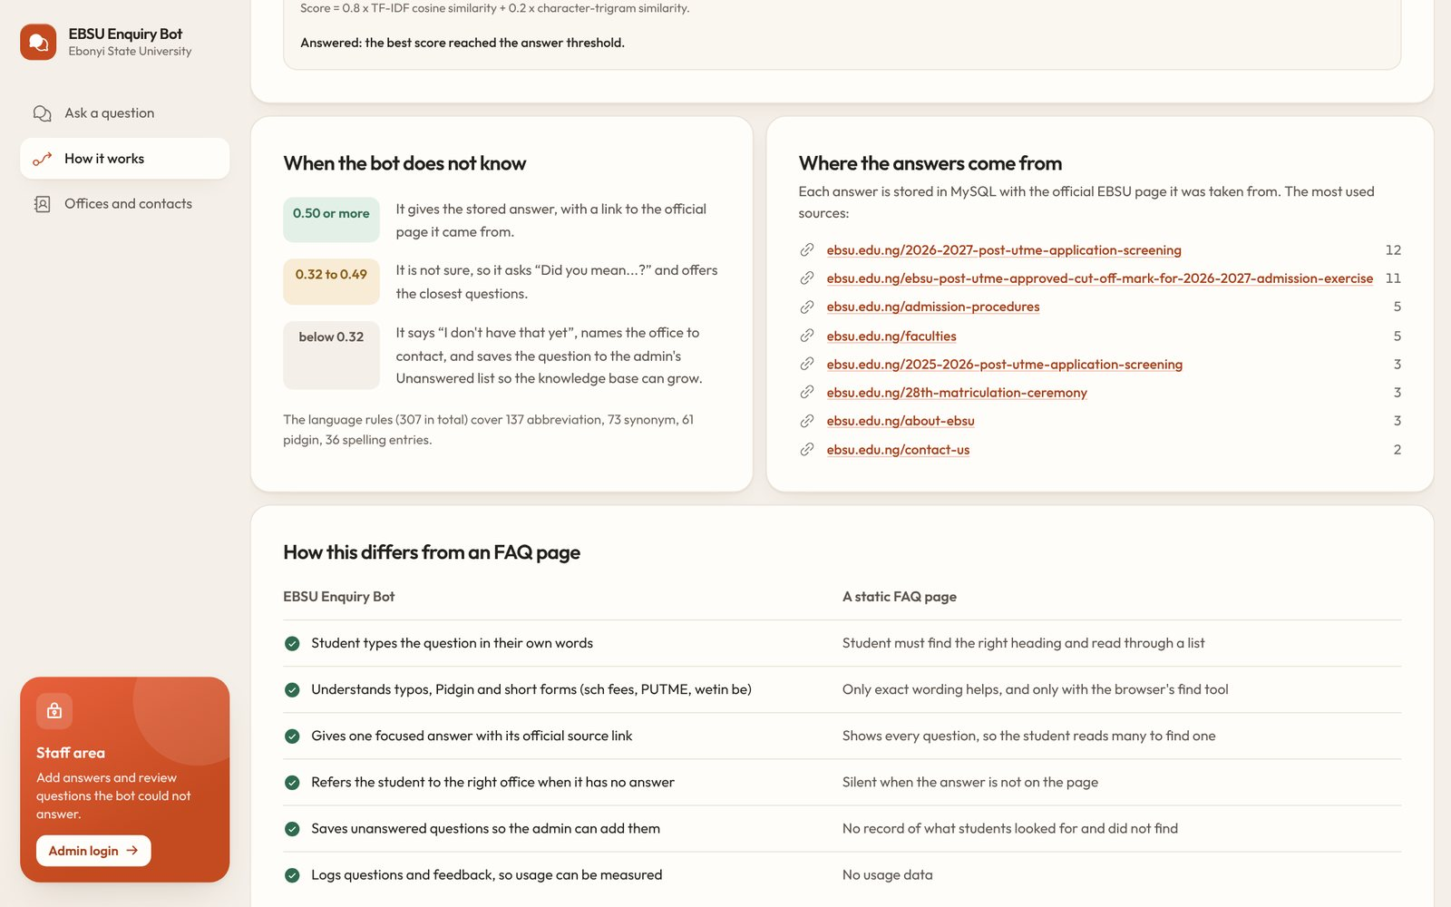
Figure 4.18: The comparison as shown on the “How it works” page

4.9 User Acceptance Evaluation
Usability and acceptance are to be measured with the one-page feedback form in Appendix E. It asks each student to try three tasks and then rate the ten items of the System Usability Scale (Brooke, 1996) and four items on perceived usefulness and ease of use from the Technology Acceptance Model (Davis, 1989). The SUS score is computed for each student as follows: for the odd-numbered items subtract 1 from the rating; for the even-numbered items subtract the rating from 5; add the ten results and multiply by 2.5 to give a score from 0 to 100. The mean of the students' scores is reported. Adesina (2021) reported a SUS result for the iNOUN chatbot at the 77th percentile, which provides a Nigerian point of comparison.
Table 4.13: User feedback results
Measure | Result
Number of students | [TO FILL: for example 25]
Levels and faculties | [TO FILL]
Mean SUS score (0 to 100) | [TO FILL]
Share who agreed the answers were useful | [TO FILL] %
Share who agreed it was easy to ask in their own words | [TO FILL] %
Tasks completed without help (out of 3) | [TO FILL]
Most common suggestions | [TO FILL]

[TO FILL: after collecting the forms, describe the results in two or three paragraphs. Report the mean SUS score and what it means, the questions students asked that the bot could not answer (these also appear on the Unanswered page), and any changes you made as a result.]

4.10 Discussion of Results
The results show that the system meets its main requirements. It answered 96.0% of the in-scope test questions correctly, including every Pidgin question, every question with short forms and every question with typing errors, and it gave no wrong answers. This supports the design choice of normalising student language with an explicit rule table before matching: without the rules, “wetin be the cut off mark for nursing” and “trancript requirments” share almost no words with the stored questions. The one miss was not a wrong answer but a cautious suggestion, which is the intended behaviour when the system is not sure.
The high precision comes from three safeguards working together: the answer threshold, the rule that a message must share at least one word the student actually typed with the matched question, and the extra weight given to words that the knowledge base does not know, which lowers the score of questions that are mostly about something else. The cost of this caution is that some questions which could have been answered are met with suggestions instead, and the knowledge base must keep growing through the Unanswered page. The response time of 3.6 ms (95th percentile 5.3 ms) shows that a retrieval approach needs no special hardware.
The evaluation has limits. The 60 questions were written by the developer rather than collected from students, and 30 test questions are enough to show that the approach works but not to estimate its accuracy precisely. A larger test set drawn from real chat logs, which the system records automatically, is recommended once students start using it.

4.11 System Documentation and Changeover
The installation and user guide is in Appendix A and in the README file of the project. For introduction at EBSU a pilot changeover is recommended: the system is first offered to one group, for example new students during an admission exercise, while the existing channels continue. The administrator reviews the Unanswered page daily during the pilot and adds missing answers, after which the system can be linked from the university website and the student portal. Because the existing channels are not replaced, the risk of the changeover is low.

CHAPTER FIVE
SUMMARY, CONCLUSION AND RECOMMENDATIONS

5.1 Summary
This project set out to give students of Ebonyi State University, Abakaliki, a quick and reliable way to get answers to routine enquiries. Information about admission, Post-UTME screening, fees, the student portal, results, transcripts and postgraduate study is published, but it is spread over several university websites, some of it is out of date, and students often ask in Nigerian Pidgin, in short forms or with spelling errors that a website search does not handle.
The literature on chatbots, information retrieval and Nigerian Pidgin was reviewed, and a retrieval-based design was chosen because it can only give answers that a person has written and checked, each linked to its source. The system was developed incrementally. A knowledge base of 85 answers was compiled from 42 official EBSU web pages, together with 377 alternative phrasings and 307 language rules for Pidgin, abbreviations, misspellings and synonyms. The matching engine cleans each message, corrects typing errors with edit distance, applies the language rules, removes stopwords, reduces words to their roots with the Porter stemmer, and scores the message against every stored phrasing with TF-IDF cosine similarity and character-trigram similarity. Two thresholds decide whether the bot answers, suggests the closest questions or refers the student to the responsible office, and every question it cannot answer is saved for the administrator.
The system was implemented as a Next.js web application in TypeScript with a MySQL database, and it starts with one command on a computer running XAMPP, without an internet connection. On 30 held-out test questions it handled 29 correctly (96.7 per cent), with a precision of 100 per cent, a recall of 96.0 per cent and a median response time of a few milliseconds.

5.2 Conclusion
Each objective stated in Section 1.3 was addressed as follows:
- Knowledge base from official sources. Achieved. The knowledge base holds 85 answers taken only from official EBSU web pages, each stored with its source link. Information that was not published, such as current school fees, hostels and course registration, was not invented; it is listed in Appendix B for the responsible offices to supply.
- Normalisation of student language. Achieved. A table of 307 rules and an edit-distance typo corrector allow the system to understand questions such as “wetin be the cut off mark for nursing” and “trancript requirments”. Every Pidgin, short-form and misspelt question in the test set was answered correctly.
- Matching engine with threshold and fallback. Achieved. TF-IDF cosine similarity combined with trigram similarity, a confidence threshold and an office referral gave no wrong answers on the test set and declined all out-of-scope questions.
- Student interface and administration panel. Achieved. Students can ask, see sources and suggested questions, view the matching steps and rate answers. Administrators can maintain the knowledge base, answer saved questions, view logs and measure accuracy on the test bench.
- Evaluation. The accuracy evaluation was completed and is reported in Chapter Four. [TO FILL: the user feedback evaluation, once the forms in Appendix E have been collected and scored.]
The study concludes that a transparent, retrieval-based chatbot that understands how Nigerian students write can serve as a reliable first point of contact for routine student enquiries. Its usefulness depends less on the matching method than on the knowledge base: the system can only be as complete and current as the information the university gives it. Because it records every question it cannot answer, it also shows the university exactly which information students need and cannot find.

5.3 Recommendations
The following recommendations are made to the university:
- Adopt the system as a first point of contact for student enquiries, starting with a pilot during the next admission exercise, and link it from the university website and the student portal.
- Give each office responsibility for its own answers. The Admission Unit, Registry, Bursary, Student Affairs and the ICT and Research Centre should each review their entries at the start of every session, when fees, dates and procedures change.
- Publish the missing information. Current school fee amounts, hostel allocation, course registration steps, examination regulations, the current academic calendar and contact details for the Bursary, Student Affairs and the health centre should be published on the website so that they can be added to the knowledge base.
- Review the Unanswered page every week. It is a direct list of what students need and cannot find.
- Host the system on a university server so that it is available to all students, with regular database backups.
To future researchers, it is recommended that the test set be extended with questions collected from real chat logs and that the language rules be checked and extended with students from different parts of the country.

5.4 Contribution to Knowledge
- A rule table of 307 entries that maps Nigerian Pidgin expressions, campus abbreviations and common misspellings to standard words, for use with student enquiries.
- A transparent, self-hosted retrieval pipeline that needs no paid cloud service and no internet connection, explains every match, and refers students to the responsible office when it is not confident.
- A knowledge base of EBSU enquiries in which every answer is tied to an official source, together with a documented list of the information the university does not yet publish.
- A labelled set of 60 EBSU enquiry questions in five styles, split into development and test sets, and measured results for the approach on that set.

5.5 Suggestions for Further Work
- Igbo language support, since many EBSU students speak Igbo, using a rule table first and, later, a translation model that runs locally.
- Meaning-based matching with sentence embeddings computed on the server, to match questions that share no words with the stored phrasings.
- Conversation memory, so that a follow-up such as “and for Law?” is understood in the context of the previous question.
- Personal information through the portal, such as a student's own registration status, behind the portal's login.
- Other channels, such as WhatsApp or Telegram, and voice input.
- A language-rules editor in the administration area; at present the rules are edited in phpMyAdmin.

REFERENCES
Abu Shawar, B., & Atwell, E. (2007). Chatbots: Are they really useful? LDV Forum, 22(1), 29–49. https://doi.org/10.21248/jlcl.22.2007.88
Adamopoulou, E., & Moussiades, L. (2020). Chatbots: History, technology, and applications. Machine Learning with Applications, 2, Article 100006. https://doi.org/10.1016/j.mlwa.2020.100006
Adesina, A. (2021). iNOUN: Architecture and usability of a chatbot for academic enquiries. West African Journal of Open and Flexible Learning, 10(1), 1–21. https://wajofel.org/index.php/wajofel/article/view/80
Adigun, G. O., Ajani, Y. A., & Aboyade, M. A. (2023). Undergraduate students' perspectives in optimising chatbot for reference services in Nigerian higher institutions: A comparative analysis of ChatGPT and conventional reference assistance. Journal of Library, Science Education and Learning Technology, 4(1), 27–39.
Brooke, J. (1996). SUS: A “quick and dirty” usability scale. In P. W. Jordan, B. Thomas, B. A. Weerdmeester, & I. L. McClelland (Eds.), Usability evaluation in industry (pp. 189–194). Taylor & Francis.
Davis, F. D. (1989). Perceived usefulness, perceived ease of use, and user acceptance of information technology. MIS Quarterly, 13(3), 319–340. https://doi.org/10.2307/249008
Hwang, G.-J., & Chang, C.-Y. (2023). A review of opportunities and challenges of chatbots in education. Interactive Learning Environments, 31(7), 4099–4112. https://doi.org/10.1080/10494820.2021.1952615
Kondrak, G. (2005). N-gram similarity and distance. In String processing and information retrieval: SPIRE 2005 (Lecture Notes in Computer Science, Vol. 3772, pp. 115–126). Springer. https://doi.org/10.1007/11575832_13
Kuhail, M. A., Alturki, N., Alramlawi, S., & Alhejori, K. (2023). Interacting with educational chatbots: A systematic review. Education and Information Technologies, 28(1), 973–1018. https://doi.org/10.1007/s10639-022-11177-3
Levenshtein, V. I. (1966). Binary codes capable of correcting deletions, insertions, and reversals. Soviet Physics Doklady, 10(8), 707–710.
Manning, C. D., Raghavan, P., & Schütze, H. (2008). Introduction to information retrieval. Cambridge University Press. https://doi.org/10.1017/CBO9780511809071
Ndubuisi-Obi, I., Ghosh, S., & Jurgens, D. (2019). Wetin dey with these comments? Modeling sociolinguistic factors affecting code-switching behavior in Nigerian online discussions. In Proceedings of the 57th Annual Meeting of the Association for Computational Linguistics (pp. 6204–6214). Association for Computational Linguistics. https://aclanthology.org/P19-1625/
Ogueji, K., & Ahia, O. (2019). PidginUNMT: Unsupervised neural machine translation from West African Pidgin to English (arXiv:1912.03444). arXiv. https://arxiv.org/abs/1912.03444
Ojamiren, H. I. (2025). Design and implementation of an intelligent chatbot course adviser system [Undergraduate project, University of Benin]. UNIBEN Repository. https://repository.uniben.edu/sites/default/files/2026-03/OJAMIREN%20HEPHZIBAH_0.pdf
Okonkwo, C. W., & Ade-Ibijola, A. (2021). Chatbots applications in education: A systematic review. Computers and Education: Artificial Intelligence, 2, Article 100033. https://doi.org/10.1016/j.caeai.2021.100033
Oyewusi, W. F., Adekanmbi, O., & Akinsande, O. (2020). Semantic enrichment of Nigerian Pidgin English for contextual sentiment classification (arXiv:2003.12450). arXiv. https://arxiv.org/abs/2003.12450
Paul-Ojimadu, N. (2026). Development of an AI-powered chatbot system for student support and administrative services in African universities [Bachelor's project, Godfrey Okoye University]. GOUNI Eprints. https://eprints.gouni.edu.ng/5919/
Porter, M. F. (1980). An algorithm for suffix stripping. Program, 14(3), 130–137. https://doi.org/10.1108/eb046814
Pressman, R. S., & Maxim, B. R. (2020). Software engineering: A practitioner's approach (9th ed.). McGraw-Hill Education.
Ranoliya, B. R., Raghuwanshi, N., & Singh, S. (2017). Chatbot for university related FAQs. In 2017 International Conference on Advances in Computing, Communications and Informatics (ICACCI) (pp. 1525–1530). IEEE. https://doi.org/10.1109/ICACCI.2017.8126057
Salton, G., & Buckley, C. (1988). Term-weighting approaches in automatic text retrieval. Information Processing & Management, 24(5), 513–523. https://doi.org/10.1016/0306-4573(88)90021-0
Salton, G., Wong, A., & Yang, C. S. (1975). A vector space model for automatic indexing. Communications of the ACM, 18(11), 613–620. https://doi.org/10.1145/361219.361220
Sokolova, M., & Lapalme, G. (2009). A systematic analysis of performance measures for classification tasks. Information Processing & Management, 45(4), 427–437. https://doi.org/10.1016/j.ipm.2009.03.002
Sommerville, I. (2016). Software engineering (10th ed.). Pearson.
Spärck Jones, K. (1972). A statistical interpretation of term specificity and its application in retrieval. Journal of Documentation, 28(1), 11–21. https://doi.org/10.1108/eb026526
Turing, A. M. (1950). Computing machinery and intelligence. Mind, 59(236), 433–460. https://doi.org/10.1093/mind/LIX.236.433
Wallace, R. S. (2009). The anatomy of A.L.I.C.E. In R. Epstein, G. Roberts, & G. Beber (Eds.), Parsing the Turing test: Philosophical and methodological issues in the quest for the thinking computer (pp. 181–210). Springer. https://doi.org/10.1007/978-1-4020-6710-5_13
Weizenbaum, J. (1966). ELIZA—A computer program for the study of natural language communication between man and machine. Communications of the ACM, 9(1), 36–45. https://doi.org/10.1145/365153.365168

APPENDIX A: INSTALLATION AND USER GUIDE

A.1 What is needed
- XAMPP (any recent version). Open the XAMPP Control Panel and click Start next to MySQL. Apache is not needed.
- Node.js 20.9 or newer (the LTS version from nodejs.org).

A.2 Starting the system
Open a terminal (Command Prompt on Windows) in the project folder and run:
npm start
The first time, this installs the packages (internet is needed for this step only), creates the ebsu_chatbot database with its starting data, builds the app and opens http://localhost:3000 in the browser. Later runs start in a few seconds and work with the network switched off. Press Ctrl+C to stop the server. If MySQL uses a password or a different port, copy .env.example to .env and edit the values.
Table A.1: Pages of the system
Page | Address
Student chat | http://localhost:3000
How it works | http://localhost:3000/how-it-works
Offices and contacts | http://localhost:3000/contacts
Administration | http://localhost:3000/admin (username admin, password ebsu-admin-2026; change it under Settings after the first login)

Table A.2: Useful commands
Command | What it does
npm start | Set up the database if needed, build and start on port 3000
npm run db:reset | Delete the database and reload the starting data (removes logs and edits)
npm run db:export | Write database/ebsu_chatbot.sql for importing in phpMyAdmin
npm test | Run the unit tests of the matching engine
npm run evaluate | Measure accuracy on the 30 held-out questions; writes docs/results/
npm run benchmark | Measure response time (with the app running)
npm run example | Print the worked example of Section 3.10.6

A.3 Using the chatbot (students)
- Type a question in the box at the bottom of the chat and press Enter, or select a suggested question on the right.
- Read the answer and, if you need to, open the official source link under it.
- If the bot asks “Did you mean one of these?”, select the question that matches yours.
- If the bot does not have the answer, contact the office it names. Your question has been saved so the answer can be added.
- Use the thumbs up or down buttons to say whether the answer helped.

A.4 Maintaining the knowledge base (administrators)
- Log in at /admin.
- Open Unanswered to see what students asked that the bot could not answer. Either select Write an answer (the question is copied into the editor) or choose an existing answer and select Add as a phrasing.
- Open Knowledge base to add, edit, hide or delete answers. Always fill in the source with the official page or document the answer came from.
- Open Test bench after large changes to check that accuracy has not dropped.
- Open Offices to add or correct office contact details, and Settings to change the thresholds or the password.

A.5 Problems and solutions
Table A.3: Troubleshooting
Problem | Solution
“Cannot reach MySQL at 127.0.0.1:3306” | Start MySQL in the XAMPP Control Panel.
“MySQL refused the user root” | Root has a password: put it in .env as DB_PASSWORD=...
Port 3000 is already in use | Set PORT=3001 in .env, or close the other program.
The first npm start fails while installing packages | Connect to the internet for the first installation only.
The page says the knowledge base is not reachable | MySQL has stopped. Start it again in XAMPP and refresh the page.
The database cannot be created by the script | In phpMyAdmin create a database called ebsu_chatbot (collation utf8mb4_unicode_ci), import database/ebsu_chatbot.sql, then run npm start.

APPENDIX B: KNOWLEDGE BASE SOURCES AND MISSING INFORMATION
Every answer in the knowledge base was taken from one of the 42 official EBSU pages below, read on 9 and 10 October 2026. The number shows how many of the 85 answers came from each page.
Table B.1: Official sources of the knowledge base
# | Official page | Answers
1 | ebsu.edu.ng/ | 1
2 | ebsu.edu.ng/2025-2026-application-form-for-supplementary-admission-is-out/ | 1
3 | ebsu.edu.ng/2025-2026-post-utme-application-screening/ | 3
4 | ebsu.edu.ng/2026-2027-post-utme-application-screening/ | 12
5 | ebsu.edu.ng/28th-matriculation-ceremony/ | 3
6 | ebsu.edu.ng/about-ebsu/ | 3
7 | ebsu.edu.ng/admission-procedures/ | 5
8 | ebsu.edu.ng/contact-us/ | 2
9 | ebsu.edu.ng/courses/applied-sciences/ | 1
10 | ebsu.edu.ng/department-of-applied-microbiology/ | 1
11 | ebsu.edu.ng/department-of-biochemistry/ | 1
12 | ebsu.edu.ng/department-of-computer-science/ | 1
13 | ebsu.edu.ng/deputy-vice-chancellor-academics/ | 1
14 | ebsu.edu.ng/directorates/ | 1
15 | ebsu.edu.ng/document-verification/ | 1
16 | ebsu.edu.ng/ebsu-post-utme-approved-cut-off-mark-for-2026-2027-admission-exercise/ | 11
17 | ebsu.edu.ng/electronic-digital-library/ | 1
18 | ebsu.edu.ng/faculties/ | 5
19 | ebsu.edu.ng/first_batch_of_merit_list_2026/ | 1
20 | ebsu.edu.ng/health-and-safety/ | 1
21 | ebsu.edu.ng/ict-and-research-center/ | 1
22 | ebsu.edu.ng/jupeb/ | 1
23 | ebsu.edu.ng/physical-library/ | 2
24 | ebsu.edu.ng/postgraduate-admissions-for-2026-2027-academic-session/ | 2
25 | ebsu.edu.ng/registrar/ | 1
26 | iportal.ebsu.edu.ng/app/admissions/start_application | 1
27 | iportal.ebsu.edu.ng/app/admissions/support | 2
28 | iportal.ebsu.edu.ng/portal/ | 2
29 | iportal.ebsu.edu.ng/transcript/ | 2
30 | iportal.ebsu.edu.ng/transcript/site/about_transcripts | 2
31 | iportal.ebsu.edu.ng/transcript/site/start_application | 1
32 | mail.ebsu.edu.ng/feepayment.php | 1
33 | mail.ebsu.edu.ng/international-office.php | 1
34 | mail.ebsu.edu.ng/supp_payment.php | 1
35 | orphanproject.ebsu.edu.ng/ | 1
36 | portal.ebsu.edu.ng/index.html | 1
37 | services.ebsu.edu.ng/ | 1
38 | services.ebsu.edu.ng/clearance | 1
39 | spgs.ebsu.edu.ng/ | 1
40 | spgs.ebsu.edu.ng/admissionreq.php | 2
41 | spgs.ebsu.edu.ng/deanspgs.php | 1
42 | spgs.ebsu.edu.ng/studentidcard.php | 1

The following information was not published on the official website when the knowledge base was compiled. The chatbot refers students to the office named until the information is added.
Table B.2: Information to be supplied by the university
Topic | What is missing | Office to ask
School fees | Current tuition and school fee amounts by faculty and level. The site has a "Schedule of Fees" link but no amounts were retrievable. The entry "How much is EBSU school fees?" says so and should be updated. | Bursary Unit
Acceptance fee | An amount newer than the 2022/2023 table (N50,050 / N30,050). | Bursary Unit
Hostels | Availability, how to apply, fees, rules. Only a menu link "International Students Hostel" exists. | Student Affairs
Course registration | Steps, deadlines, late registration, who to see. | Registry / Faculty Officers
Exams | Undergraduate exam regulations, malpractice rules, grading scale and degree classes, exam timetable. | Registry (Exams and Records)
Academic calendar | 2025/2026 or 2026/2027 dates (resumption, exams, holidays). The calendar page shows 2023/2024. | Academic Planning
ID card | Undergraduate ID card procedure and fee (only the PG process is published). | Student Affairs / ICT
Transcript and verification fees | Amounts (the processes are covered). | Records Unit, ICT Director
Convocation | Dates, graduand lists. | Registry
UTME subjects | Subject combinations for Medicine, Law, Nursing, Mass Communication, Accountancy, engineering and most arts courses (only some science departments publish them). | Admissions Office
Cut-off marks | Separate 2026/2027 figures for Pharmacy, Mechanical Engineering, Agricultural Engineering, Radiography, Public Health (none were published). | Admissions Office
Office contacts | Email or phone for the Bursary, Student Affairs and the health centre. Until added, the bot shows the Registrar's general contact. | Each office
Officers | Names of the Chancellor, Pro-Chancellor, Bursar and Dean of Student Affairs. | Registry
Campuses | Which faculties sit on which campus (Main, CAS, Ishieke). | Registry
Student life | SUG, clubs, sports, Wi-Fi and student email, NYSC mobilisation, undergraduate scholarships. | Student Affairs / ICT

The following answers are in the knowledge base but should be confirmed with the office concerned before the system is used publicly.
Table B.3: Answers to verify
Answer | Why it should be checked | Source
Acceptance fee | The same page also mentions "N30,000" in one step, and the table is for 2022/2023. The answer tells students to confirm with the Bursary. | ebsu.edu.ng/admission-procedures
Campus security and health numbers | The Health and Safety page lists 08037550845 and 08064087963, which are the same as the ICT support lines, so they may be placeholders. | ebsu.edu.ng/health-and-safety
Deputy Vice-Chancellor (Administration) | The main site says Prof. Michael Ajanwachukwu (about March 2025); an older copy of the site says Prof. Happiness Oselebe. | ebsu.edu.ng/ebsu-dvc-admin
Registrar | Ugochinyere Mba Uka on the Registrar page (about July 2025). A 2023 memo was signed by Jeremiah Nwamgbo. | ebsu.edu.ng/registrar
School fees in two instalments | Announced in August 2023 for 2023/2024; no later confirmation was found. | mail.ebsu.edu.ng/feepayment.php
PG email | The 2026/2027 notice uses spgs@ebsu.edu.ng; the SPGS site uses spgsebsu@ebsu.edu.ng. Both are shown. | spgs.ebsu.edu.ng
Founding year | The services site shows 1999; the history page says the law (No. 7 of 1999) was signed on 14 January 2000. The answer gives both facts. | ebsu.edu.ng/about-ebsu
Computer Science requirements, Direct Entry starting level | Read from a search summary of the department page rather than page text. | ebsu.edu.ng/department-of-computer-science
Checking results ("Sessional Result" link) | Read from a search summary of the portal page. | portal.ebsu.edu.ng
Post-UTME dates, merit list, supplementary | These are 2026/2027 or 2025/2026 notices. When a new session's notice appears, update the answers. | ebsu.edu.ng

APPENDIX C: SAMPLE OF THE LANGUAGE RULES
The full table has 307 rules (61 pidgin, 137 abbreviation, 36 spelling, 73 synonym) and is in database/seed/language-rules.json and the language_rules table. An empty standard form means the phrase is ignored.
Table C.1: Sample of the language rules
Student types | Standard form | Kind
wetin | what | pidgin
watin | what | pidgin
wetin be | what | pidgin
watin be | what | pidgin
how far | hello | pidgin
how una dey | hello | pidgin
how you dey | hello | pidgin
how u dey | hello | pidgin
kedu | hello | pidgin
nno | hello | pidgin
good day | hello | pidgin
abeg | please | pidgin
biko | please | pidgin
how much | cost | pidgin
how much be | cost | pidgin
na how much | cost | pidgin
how much e be | cost | pidgin
how much e cost | cost | pidgin
wen | date | pidgin
which time | date | pidgin
sch fees | schoolfee | abbreviation
sch fee | schoolfee | abbreviation
skul fees | schoolfee | abbreviation
skul fee | schoolfee | abbreviation
skool fees | schoolfee | abbreviation
school fees | schoolfee | abbreviation
school fee | schoolfee | abbreviation
tuition | schoolfee | abbreviation
tuition fee | schoolfee | abbreviation
tuition fees | schoolfee | abbreviation
schfees | schoolfee | abbreviation
schoolfees | schoolfee | abbreviation
sch | school | abbreviation
skul | school | abbreviation
skool | school | abbreviation
post utme | postutme | abbreviation
putme | postutme | abbreviation
pume | postutme | abbreviation
post ume | postutme | abbreviation
postume | postutme | abbreviation
admision | admission | spelling
admisson | admission | spelling
addmission | admission | spelling
admissions | admission | spelling
admitted | admission | spelling
admit | admission | spelling
admited | admission | spelling
hostels | hostel | spelling
hostle | hostel | spelling
accommodation | hostel | spelling
accomodation | hostel | spelling
acommodation | hostel | spelling
fee | cost | synonym
fees | cost | synonym
charge | cost | synonym
charges | cost | synonym
price | cost | synonym
amount | cost | synonym
levy | cost | synonym
how much is | cost | synonym
payment | pay | synonym
payments | pay | synonym
paying | pay | synonym
paid | pay | synonym

APPENDIX D: SELECTED SOURCE CODE
The complete source code is in the project folder. The two files below form the core of the matching engine.

D.1 src/lib/nlp/matcher.ts
/**
* The EBSU Enquiry Bot matching engine (retrieval-based NLP).
*
* Pipeline for every message:
* 1. clean lower case, strip accents and punctuation (text.ts)
* 2. correct fix typos against the knowledge-base vocabulary (fuzzy.ts)
* 3. translate apply language rules: Pidgin, abbreviations, synonyms
* 4. filter drop stopwords that carry no meaning
* 5. stem reduce words to their root (Porter, 1980): "registering" -> "regist"
* 6. score TF-IDF cosine similarity + character-trigram similarity
* against every stored phrasing of every question
* 7. decide best score >= answer threshold -> give the answer
* suggest threshold <= score < answer -> "Did you mean...?"
* below the suggest threshold -> fallback to an office
*
* Everything runs locally in Node.js. No external AI service is called.
*/
import { stemmer } from "stemmer";
import { allowedEdits, diceSimilarity, editDistance, trigrams } from "./fuzzy";
import { cleanText, isStopword, tokenize } from "./text";

export type LanguageRule = {
phrase: string; // what students type, e.g. "sch fees" or "wetin"
canonical: string; // what it means, e.g. "schoolfee" ("" = ignore the phrase)
kind: "pidgin" | "abbreviation" | "spelling" | "synonym";
};

export type KnowledgeEntry = {
id: number;
question: string;
variants: string[];
category: string;
smallTalk?: boolean;
};

export type Thresholds = { answer: number; suggest: number };

export const DEFAULT_THRESHOLDS: Thresholds = { answer: 0.5, suggest: 0.32 };

/** Share of the final score taken from TF-IDF cosine; the rest is trigram similarity. */
export const COSINE_WEIGHT = 0.8;

/** Small talk must score at least this to beat a real answer that also qualifies. */
export const SMALL_TALK_EXACT = 0.9;

/** A word we had to guess (typo fix) counts for less than a word typed correctly. */
export const CORRECTION_WEIGHT = 0.75;

type Analysis = {
cleaned: string;
corrections: { from: string; to: string }[];
rulesApplied: { phrase: string; canonical: string; kind: string }[];
tokens: string[]; // meaningful words after rules and stopword removal
stems: string[];
guessed: Set<string>; // stems that came from a typo correction
};

type IndexedDoc = {
entryId: number;
phrasing: string;
vector: Map<string, number>; // stem -> normalised TF-IDF weight
grams: Map<string, number>;
};

export type MatcherIndex = {
entries: Map<number, KnowledgeEntry>;
docs: IndexedDoc[];
idf: Map<string, number>;
maxIdf: number;
vocabulary: Map<string, number>; // known word -> how many phrasings use it
rules: Map<string, LanguageRule>;
maxRuleWords: number;
};

export type Candidate = {
entryId: number;
question: string;
phrasing: string;
cosine: number;
trigram: number;
score: number;
};

export type Decision = "answered" | "suggested" | "fallback" | "smalltalk" | "empty";

export type MatchResult = {
decision: Decision;
best: Candidate | null;
candidates: Candidate[]; // top candidates, best first
analysis: Analysis;
thresholds: Thresholds;
};

const SESSION_YEAR = /^(19|20)\d\d$/; // "2026" in "2026/2027" says nothing about the topic

function stem(token: string): string {
return /^\d+$/.test(token) ? token : stemmer(token);
}

function buildRuleMap(rules: LanguageRule[]) {
const map = new Map<string, LanguageRule>();
let maxWords = 1;
for (const rule of rules) {
const phrase = cleanText(rule.phrase);
if (!phrase) continue;
map.set(phrase, { ...rule, phrase, canonical: cleanText(rule.canonical) });
maxWords = Math.max(maxWords, phrase.split(" ").length);
}
return { map, maxWords };
}

type Word = { text: string; guessed: boolean }; // guessed = produced by a typo correction

/** Replace known phrases (longest first) with their canonical meaning. */
function applyRules(
words: Word[],
rules: Map<string, LanguageRule>,
maxWords: number,
applied: Analysis["rulesApplied"],
): Word[] {
const out: Word[] = [];
let i = 0;
while (i < words.length) {
let matched = false;
for (let n = Math.min(maxWords, words.length - i); n >= 1; n--) {
const span = words.slice(i, i + n);
const rule = rules.get(span.map((w) => w.text).join(" "));
if (rule) {
const guessed = span.some((w) => w.guessed);
if (rule.canonical) out.push(...rule.canonical.split(" ").map((text) => ({ text, guessed })));
applied.push({ phrase: rule.phrase, canonical: rule.canonical, kind: rule.kind });
i += n;
matched = true;
break;
}
}
if (!matched) {
out.push(words[i]);
i += 1;
}
}
return out;
}

/** Find the closest known word within the allowed number of typos. */
function correctToken(token: string, vocabulary: Map<string, number>): string | null {
const max = allowedEdits(token.length);
if (max === 0) return null;
let best: string | null = null;
let bestDistance = max + 1;
let bestFrequency = -1;
for (const [word, frequency] of vocabulary) {
if (Math.abs(word.length - token.length) > max) continue;
// Typos rarely change the first letter; this avoids silly corrections.
if (word[0] !== token[0] && !(word[0] === token[1] && word[1] === token[0])) continue;
const distance = editDistance(token, word, max);
if (distance < bestDistance || (distance === bestDistance && frequency > bestFrequency)) {
best = word;
bestDistance = distance;
bestFrequency = frequency;
}
}
return bestDistance <= max ? best : null;
}

function analyse(
text: string,
index: Pick<MatcherIndex, "rules" | "maxRuleWords">,
vocabulary: Map<string, number> | null,
): Analysis {
const cleaned = cleanText(text);
const corrections: Analysis["corrections"] = [];
const rulesApplied: Analysis["rulesApplied"] = [];

let words: Word[] = tokenize(cleaned).map((text) => ({ text, guessed: false }));
if (vocabulary) {
words = words.map((word) => {
const token = word.text;
if (vocabulary.has(token) || isStopword(token) || /\d/.test(token)) return word;
const fixed = correctToken(token, vocabulary);
if (fixed && fixed !== token) {
corrections.push({ from: token, to: fixed });
return { text: fixed, guessed: true };
}
return word;
});
}

words = applyRules(words, index.rules, index.maxRuleWords, rulesApplied);
words = words.filter((w) => w.text.length > 0 && !isStopword(w.text) && !SESSION_YEAR.test(w.text));
const tokens = words.map((w) => w.text);
const stems = tokens.map(stem);
// A root counts as guessed only if every occurrence of it came from a typo fix.
const typed = new Set(stems.filter((_, i) => !words[i].guessed));
const guessed = new Set(stems.filter((s, i) => words[i].guessed && !typed.has(s)));
return { cleaned, corrections, rulesApplied, tokens, stems, guessed };
}

/** Build the searchable index from the knowledge base. Run again whenever the data changes. */
export function buildIndex(entries: KnowledgeEntry[], rules: LanguageRule[]): MatcherIndex {
const { map, maxWords } = buildRuleMap(rules);
const ruleIndex = { rules: map, maxRuleWords: maxWords };

const analysed: { entryId: number; phrasing: string; analysis: Analysis }[] = [];
for (const entry of entries) {
for (const phrasing of [entry.question, ...entry.variants]) {
if (!phrasing.trim()) continue;
analysed.push({ entryId: entry.id, phrasing, analysis: analyse(phrasing, ruleIndex, null) });
}
}

// Words the typo corrector may correct towards: knowledge-base words and rule phrases.
const vocabulary = new Map<string, number>();
for (const { analysis } of analysed) {
for (const t of new Set(analysis.tokens)) vocabulary.set(t, (vocabulary.get(t) ?? 0) + 1);
}
for (const [phrase, rule] of map) {
for (const word of `${phrase} ${rule.canonical}`.split(" ")) {
if (word && !vocabulary.has(word) && !isStopword(word)) vocabulary.set(word, 0);
}
}

// Inverse document frequency: rare words are more informative than common ones.
const N = analysed.length;
const df = new Map<string, number>();
for (const { analysis } of analysed) {
for (const s of new Set(analysis.stems)) df.set(s, (df.get(s) ?? 0) + 1);
}
const idf = new Map<string, number>();
for (const [s, n] of df) idf.set(s, Math.log((1 + N) / (1 + n)) + 1);
const maxIdf = Math.log(1 + N) + 1; // weight for a word no stored question uses

const docs: IndexedDoc[] = analysed.map(({ entryId, phrasing, analysis }) => ({
entryId,
phrasing,
vector: weigh(analysis.stems, idf, maxIdf),
grams: trigrams(analysis.tokens.join(" ")),
}));

return {
entries: new Map(entries.map((e) => [e.id, e])),
docs,
idf,
maxIdf,
vocabulary,
rules: map,
maxRuleWords: maxWords,
};
}

/** Term frequency x inverse document frequency, scaled to unit length. */
function weigh(stems: string[], idf: Map<string, number>, maxIdf: number, guessed?: Set<string>): Map<string, number> {
const tf = new Map<string, number>();
for (const s of stems) tf.set(s, (tf.get(s) ?? 0) + 1);
const vector = new Map<string, number>();
let norm = 0;
for (const [s, n] of tf) {
const w = n * (idf.get(s) ?? maxIdf) * (guessed?.has(s) ? CORRECTION_WEIGHT : 1);
vector.set(s, w);
norm += w * w;
}
norm = Math.sqrt(norm);
if (norm > 0) for (const [s, w] of vector) vector.set(s, w / norm);
return vector;
}

function cosine(a: Map<string, number>, b: Map<string, number>): number {
let dot = 0;
const [small, large] = a.size < b.size ? [a, b] : [b, a];
for (const [s, w] of small) {
const v = large.get(s);
if (v) dot += w * v;
}
return dot;
}

const round = (n: number) => Math.round(n * 1000) / 1000;

/** Compare a student's message with every stored question and decide how to reply. */
export function match(
index: MatcherIndex,
message: string,
thresholds: Thresholds = DEFAULT_THRESHOLDS,
limit = 3,
): MatchResult {
const analysis = analyse(message, index, index.vocabulary);
if (analysis.stems.length === 0) {
return { decision: "empty", best: null, candidates: [], analysis, thresholds };
}

const queryVector = weigh(analysis.stems, index.idf, index.maxIdf, analysis.guessed);
const queryGrams = trigrams(analysis.tokens.join(" "));

// Keep the best-scoring phrasing for each knowledge-base entry.
const bestPerEntry = new Map<number, Candidate>();
const bestDoc = new Map<number, IndexedDoc>();
for (const doc of index.docs) {
const cos = cosine(queryVector, doc.vector);
const tri = diceSimilarity(queryGrams, doc.grams);
const score = COSINE_WEIGHT * cos + (1 - COSINE_WEIGHT) * tri;
const current = bestPerEntry.get(doc.entryId);
if (!current || score > current.score) {
bestDoc.set(doc.entryId, doc);
bestPerEntry.set(doc.entryId, {
entryId: doc.entryId,
question: index.entries.get(doc.entryId)?.question ?? doc.phrasing,
phrasing: doc.phrasing,
cosine: round(cos),
trigram: round(tri),
score: round(score),
});
}
}

let ranked = [...bestPerEntry.values()].sort((a, b) => b.score - a.score);
// Small talk ("hello", "help", "see you") wins only when it is a near-exact match
// or nothing else qualifies. "where i fit get help with my payment" is a payment
// question, not a request for the help menu.
const isTalk = (c: Candidate) => Boolean(index.entries.get(c.entryId)?.smallTalk);
const top = ranked[0];
if (top && isTalk(top)) {
const realAnswer = ranked.some((c) => !isTalk(c) && c.score >= thresholds.answer);
if (top.score < thresholds.answer || (top.score < SMALL_TALK_EXACT && realAnswer)) ranked = ranked.filter((c) => !isTalk(c));
}
const candidates = ranked.slice(0, Math.max(limit, 1));
const best = candidates[0] ?? null;

let decision: Decision = "fallback";
if (best && best.score >= thresholds.answer) {
decision = index.entries.get(best.entryId)?.smallTalk ? "smalltalk" : "answered";
// Never answer outright when the only words in common are typo guesses:
// "sports facilities" must not become a confident answer about "faculties".
const doc = bestDoc.get(best.entryId);
const confirmed = doc ? [...queryVector.keys()].some((s) => !analysis.guessed.has(s) && doc.vector.has(s)) : false;
if (!confirmed) decision = "suggested";
} else if (best && best.score >= thresholds.suggest) {
decision = "suggested";
}

return { decision, best, candidates, analysis, thresholds };
}

D.2 src/lib/nlp/fuzzy.ts
/**
* Fuzzy (approximate) string matching. Two measures are used:
*
* 1. Damerau-Levenshtein edit distance: how many single-letter insertions,
* deletions, substitutions or swaps turn one word into another
* ("transcrip" -> "transcript" is 1 edit). Used to correct typos.
* 2. Character trigram (3-letter chunk) overlap, measured with the Dice
* coefficient. Used as a second, spelling-tolerant similarity score
* between a whole message and a whole stored question.
*/

/** Optimal string alignment distance (Damerau-Levenshtein with adjacent swaps). */
export function editDistance(a: string, b: string, max = Infinity): number {
if (a === b) return 0;
if (Math.abs(a.length - b.length) > max) return max + 1;
const rows = a.length + 1;
const cols = b.length + 1;
const d: number[][] = Array.from({ length: rows }, () => new Array<number>(cols).fill(0));
for (let i = 0; i < rows; i++) d[i][0] = i;
for (let j = 0; j < cols; j++) d[0][j] = j;
for (let i = 1; i < rows; i++) {
let rowMin = Infinity;
for (let j = 1; j < cols; j++) {
const cost = a[i - 1] === b[j - 1] ? 0 : 1;
let v = Math.min(
d[i - 1][j] + 1, // deletion
d[i][j - 1] + 1, // insertion
d[i - 1][j - 1] + cost, // substitution
);
if (i > 1 && j > 1 && a[i - 1] === b[j - 2] && a[i - 2] === b[j - 1]) {
v = Math.min(v, d[i - 2][j - 2] + 1); // swap of two neighbouring letters
}
d[i][j] = v;
if (v < rowMin) rowMin = v;
}
if (rowMin > max) return max + 1; // early exit: already too different
}
return d[a.length][b.length];
}

/** How many typos we tolerate for a word of this length. */
export function allowedEdits(length: number): number {
if (length <= 3) return 0; // short words ("fee", "dey") are too easy to confuse
if (length <= 7) return 1; // "reslt" -> "result", but not "sports" -> "scores"
return 2; // long words: "trancsript" -> "transcript"
}

/** Character trigrams of a string, padded so word starts and ends count. */
export function trigrams(text: string): Map<string, number> {
const grams = new Map<string, number>();
const padded = ` ${text} `;
for (let i = 0; i < padded.length - 2; i++) {
const g = padded.slice(i, i + 3);
grams.set(g, (grams.get(g) ?? 0) + 1);
}
return grams;
}

/** Dice coefficient between two trigram bags: 2|A n B| / (|A| + |B|), from 0 to 1. */
export function diceSimilarity(a: Map<string, number>, b: Map<string, number>): number {
let sizeA = 0;
let sizeB = 0;
let overlap = 0;
for (const n of a.values()) sizeA += n;
for (const n of b.values()) sizeB += n;
if (sizeA === 0 || sizeB === 0) return 0;
for (const [g, n] of a) {
const m = b.get(g);
if (m) overlap += Math.min(n, m);
}
return (2 * overlap) / (sizeA + sizeB);
}

APPENDIX E: STUDENT FEEDBACK FORM
The form below is also provided as a separate one-page document (docs/student-feedback-form.docx) for printing.

Part A: Tasks
- Ask how much the Post-UTME form costs, in your own words.
- Ask a question about your own department or faculty.
- Ask something you really want to know about EBSU, in English or Pidgin.

Part B: Rate each statement (1 = strongly disagree, 5 = strongly agree)
# | Statement | 1 | 2 | 3 | 4 | 5
1 | I think that I would like to use this chatbot frequently.
2 | I found the chatbot unnecessarily complex.
3 | I thought the chatbot was easy to use.
4 | I think that I would need the support of a technical person to be able to use this chatbot.
5 | I found the various functions in this chatbot were well integrated.
6 | I thought there was too much inconsistency in this chatbot.
7 | I would imagine that most people would learn to use this chatbot very quickly.
8 | I found the chatbot very cumbersome to use.
9 | I felt very confident using the chatbot.
10 | I needed to learn a lot of things before I could get going with this chatbot.
11 | Using the chatbot would help me get information about EBSU more quickly.
12 | The answers the chatbot gave me were useful.
13 | It was easy to ask the chatbot a question in my own words.
14 | The chatbot understood me even when I used Pidgin, short forms or made spelling mistakes.

Part C: Your comments
- What did you ask that the chatbot could not answer?
- What would you change or add?

APPENDIX F: DEVELOPMENT SET RESULTS
These 30 questions were used to tune the matcher and choose the thresholds (Section 4.7.4). They are separate from the 30 test questions in Table 4.6.
Table F.1: Results on the development set
# | Question | Style | Bot result | Score | Outcome
1 | how much be the screening form | pidgin | How much is the EBSU Post-UTME form? | 1.00 | correct answer
2 | cut off for medicine 2026/2027 | short forms | What is the cut-off mark for Medicine and Surgery? | 0.97 | correct answer
3 | law jamb cut off | short forms | What is the cut-off mark for Law? | 0.82 | correct answer
4 | what is ebsu cutoff | short forms | What is the EBSU cut-off mark? | 1.00 | correct answer
5 | how i fit print my admission letter | pidgin | How do I accept my admission and print my admission letter? | 1.00 | correct answer
6 | documents needed for documentation | formal | What documents do I need for documentation at the Admission Unit? | 0.81 | correct answer
7 | check result on portal | short forms | How do I check my EBSU result? | 0.83 | correct answer
8 | my transcript fit go my papa house? | pidgin | Where can my transcript be sent? | 0.60 | correct answer
9 | requirements for phd admission | formal | What are the requirements for a PhD at EBSU? | 0.86 | correct answer
10 | pg school email address | short forms | How do I contact the EBSU School of Postgraduate Studies? | 1.00 | correct answer
11 | ebsu contact number | short forms | What are EBSU's contact email and phone number? | 0.70 | correct answer
12 | how many faculties are in ebsu | formal | What faculties does EBSU have? | 1.00 | correct answer
13 | where is the e library | formal | Does EBSU have an e-library? | 1.00 | correct answer
14 | what is the vision of ebsu | formal | What is the vision and mission of EBSU? | 1.00 | correct answer
15 | who is ebsu registrar | formal | Who is the Registrar of EBSU? | 1.00 | correct answer
16 | do they have jupeb | short forms | Does EBSU run a JUPEB programme? | 0.77 | correct answer
17 | can i study part time while working | formal | Does EBSU have a part-time programme for workers? | 0.76 | correct answer
18 | post utme closing date | short forms | When does the EBSU Post-UTME application open and close? | 1.00 | correct answer
19 | can i apply if i am still waiting for my waec result | formal | Who can apply for the EBSU Post-UTME? | 0.90 | correct answer
20 | o level credits needed for science | short forms | How many O'level credits do I need for admission into a science course? | 0.82 | correct answer
21 | what subjects for computer science jamb | short forms | What are the admission requirements for Computer Science? | 0.98 | correct answer
22 | engineering cut off marks | short forms | What is the cut-off mark for Engineering courses? | 1.00 | correct answer
23 | accountancy cut off | short forms | What is the cut-off mark for Accountancy and Management Sciences courses? | 0.97 | correct answer
24 | how to verify certificate | short forms | How do I verify an EBSU certificate or result? | 0.87 | correct answer
25 | hi there | small talk | Hello | 1.00 | correct answer
26 | thanks so much | small talk | Thank you | 1.00 | correct answer
27 | what is the weather today | out of scope | (fallback) | 0.03 | correct fallback
28 | how much is a plate of rice in the cafeteria | out of scope | (fallback) | 0.24 | correct fallback
29 | are there sports facilities | out of scope | (suggestions) | 0.44 | correct fallback
30 | hostel | out of scope | (fallback) | 0.03 | correct fallback

