07601

https://mega.nz/#!CXYXBQAK!6eLJSXvAfGnemqWpNbLQtOHBvtkCzA7-zycVjhHPYQQ I think I lost my flag in there. Hopefully, it won't get attacked…

After downloading .png file from this url I used binwalk to check for hidden files. Type command: binwalk <filename>. The following files appears on terminal:

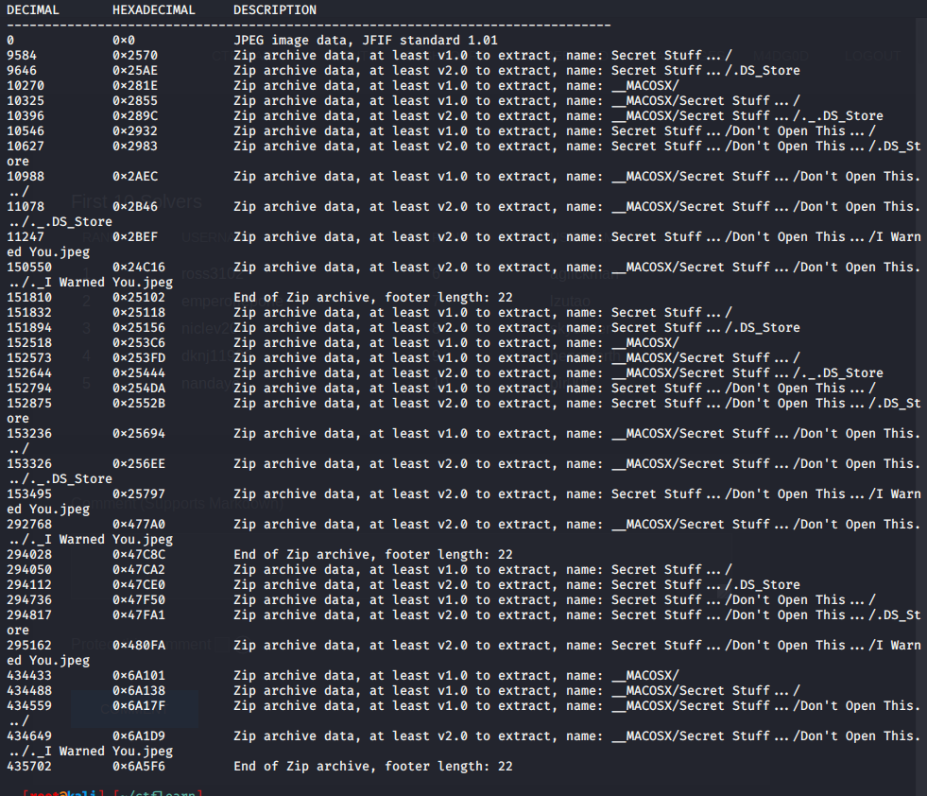

Then I extracted all the files using command: binwalk –extract –d=”.*” <filename>

A new directory will be made after extraction. In that you will find a ’I warned You.jpeg’ file.

Use strings <filename> display all the readable characters. You will find the flag in that: ABCTF{Du$t1nS_D0jo}