AMBUSH MISSION

Hi, i can't tell you my name since now i'm in a mission. In case to arrest our fugitive target, our team had been intercepted communication between the target with his fellow and found this image (https://mega.nz/#!TKZ3DabY!BEUHD7VJvq_b-M22eD4VfHv_PPBnW2m7CZUfMbveZYw). It looks like they are going to meet in specific place, but we still don't know the time yet. Can you help me?

After downloading .png file from above link I looked for some hidden files using binwalk, but there were none. I also applied strings command on the file but was not successful.

At the end I tried to solve it with Stegsolve. I typed java -jar stegsolve.jar and search the png file in that.

After changing some color filters I was able to get a base64 encoded text

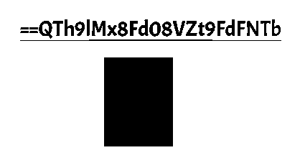

But this text was in reverse. So I used cyberchef to decode the text and got the flag as: flag{m3Et_me_4t_12_aM}