### Don't Bump Your Head(er)

Try to bypass my security measure on this site! http://165.227.106.113/header.php

After viewing page source of this site it showed this :

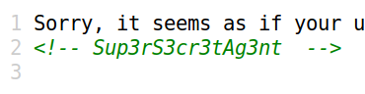

The first line gave hint about the User-Agent. I used curl command to change the User-Agent. The command was:

curl -H "User-Agent: Sup3rS3cr3tAg3nt" http://165.227.106.113/header.ph

After this the terminal showed :



This means it the website requires a referer too. Again I used curl to add a referer:

curl -H "User-Agent: Sup3rS3cr3tAg3nt" -H "Referer: awesomesauce.com" http://165.227.106.113/header.php

After this it gave the flag :



Flag : flag{did_this_m3ss_with_y0ur_h34d}