LAZY GAME CHALLENGE

I found an interesting game made by some guy named "John_123". It is some betting game. I made some small fixes to the game; see if you can still pwn this and steal $1000000 from me!

To get flag, pwn the server at: nc thekidofarcrania.com 10001

Well this was an interesting question and just requires basic arithmetic knowledge.

After pwn the server in your terminal it looks like this:

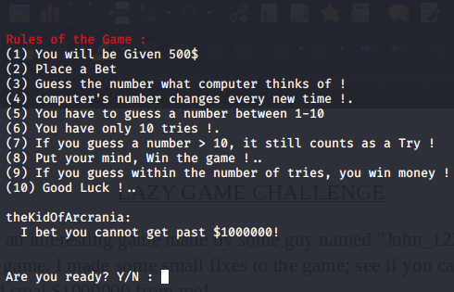

After pressing Y this occurs:



Type a negative number such as -1000000 and then your guess should be in two digit number such that you fail every time. After 10 guesses your bet would be deducted from the total amount given to you, which in this case, is 500$. Since you have entered -1000000 and subtract it from 500 you will get 1000500$ which is greater than 1000000$. It is simple arithmetic as two minus makes a + (500 - (- 1000000) ) . So you got past $1000000 and you will see your flag after completing the game.

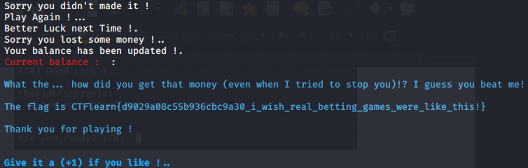

You can clearly see the flag here as : CTFlearn{d9029a08c55b936cbc9a30_i_wish_real_betting_games_were_like_this!}

PS: If you want to look at source code for this challenge , it is written in python and can be found on https://repl.it/@ragsdale/Lazy-Game-Challenge-1